UML CLASS DIAGRAM-TO-TEXT
TRANSLATOR
USER GUIDE
A practical guide to creating, loading and translating UML class diagrams
CREATE → EXPORT SVG → LOAD → TRANSLATE → REVIEW
Prepared for the final UML Class Diagram-to-Text Translator artefact

1. Introduction
The UML Class Diagram-to-Text Translator converts UML class diagrams into textual descriptions. It was developed to support computing instructors in preparing accessible representations of UML class diagrams for visually impaired students.
The artefact processes UML class diagrams exported from UMLet in Scalable Vector Graphics (SVG) format and produces two complementary outputs: a literal translation and a model translation. The literal translation describes the visible structure and arrangement of the diagram, while the model translation describes the UML concepts and relationships represented in the diagram.
Quick workflow: Create a UML class diagram in UMLet, export it as SVG, load the SVG file into the translator, generate a literal or model translation, and review the resulting text file.

2. Requirements
- Microsoft Windows computer.
- UML Class Diagram-to-Text Translator application.
- UMLet for creating UML class diagrams.
- Java Runtime Environment (JRE) required by UMLet.
- Permission to read and write files on the computer.
Input format: The artefact is designed to process UML class diagrams exported from UMLet in SVG format.

3. Main interface
Start the UML Class Diagram Translator. The main screen provides the workflow options shown below.
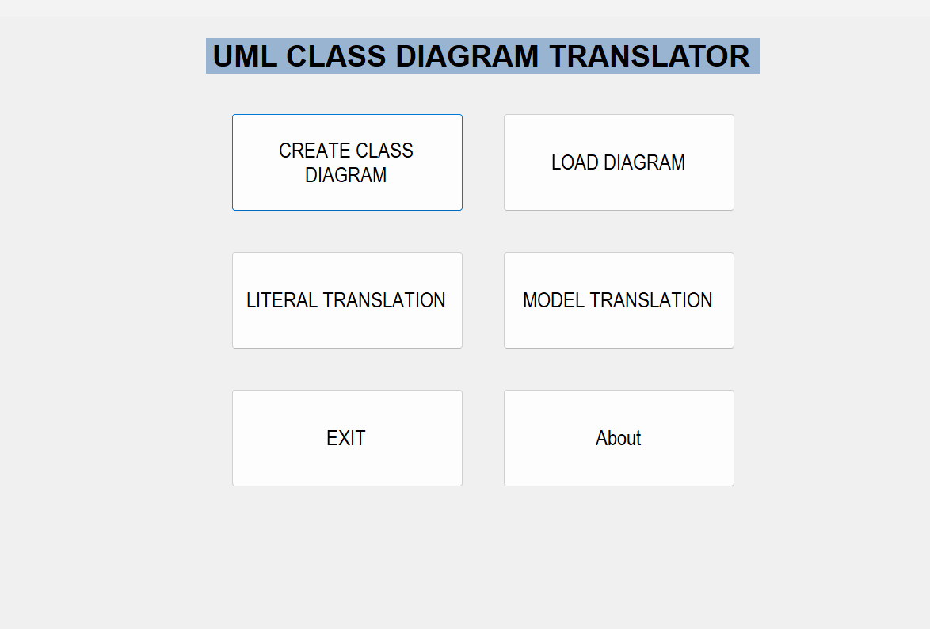
Figure 1: Main interface of the UML Class Diagram Translator
Control | Purpose
CREATE CLASS DIAGRAM | Opens UMLet so that a UML class diagram can be created.
LOAD DIAGRAM | Loads an existing UML class diagram that has been exported as an SVG file.
LITERAL TRANSLATION | Generates a textual description of the graphical structure and layout of the loaded diagram.
MODEL TRANSLATION | Generates a textual description of the UML concepts and relationships represented in the loaded diagram.
EXIT | Closes the application.
About | Displays information about the application.

4. Creating a UML class diagram
A diagram can be created directly from the translator by opening the integrated UMLet environment.
1. Select CREATE CLASS DIAGRAM from the main interface.
2. Create the required UML class diagram in UMLet.
3. Add the required classes, attributes, methods and relationships.
4. Check that the diagram is complete before exporting it.
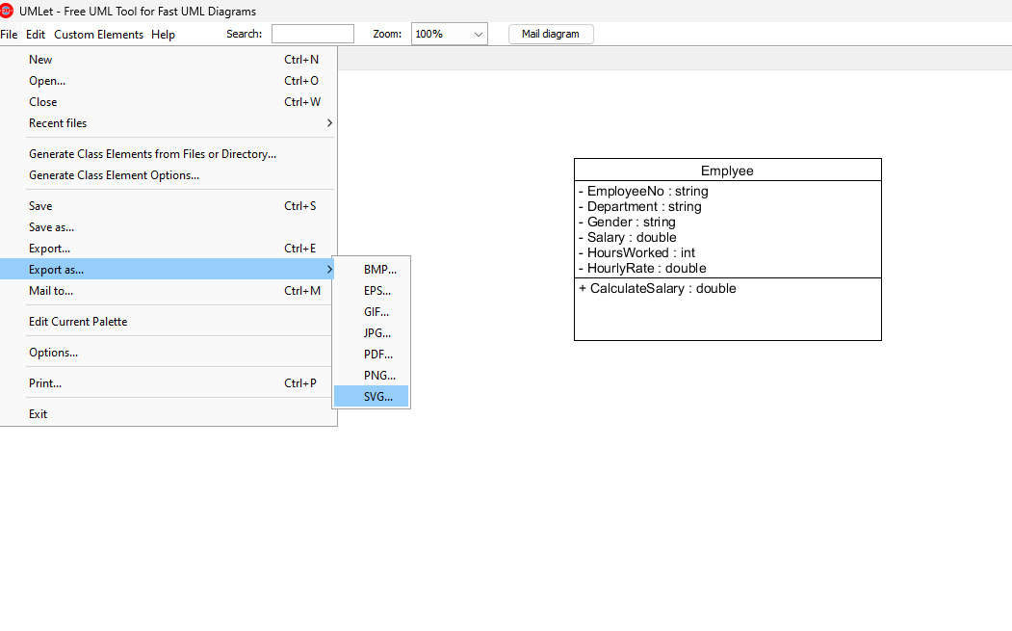
Figure 2: UMLet environment used to create and export a UML class diagram

5. Exporting the diagram as SVG
After the diagram has been completed in UMLet, export it in SVG format and save it in a location that can easily be found. SVG is a structured, text-based graphics format. It retains information about text, shapes, paths and positions that the translator can process.
Important: Use SVG for the diagram that will be loaded into the translator. Other image formats do not provide the structured information used by the artefact.

6. Loading an SVG diagram
1. Return to the UML Class Diagram Translator.
2. Select LOAD DIAGRAM.
3. Browse to the location of the exported SVG file.
4. Select the required SVG file and open it.
5. After the diagram has been processed, choose the required translation option.
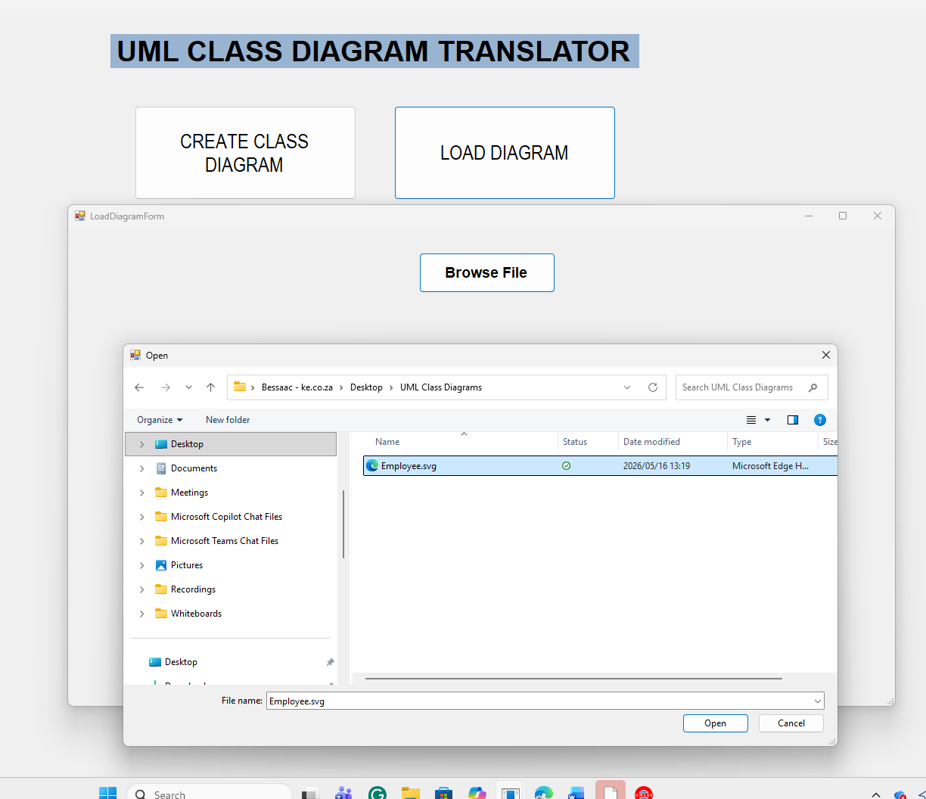
Figure 3: Loading an exported SVG UML class diagram into the translator

7. Generating a literal translation
After loading the SVG file, select LITERAL TRANSLATION. The artefact describes the graphical information represented in the diagram. The literal translation focuses on visible diagram elements and their arrangement rather than on interpreting the UML model semantically.
The output can include text representing class names, attributes, methods, compartments, relationship labels, connectors and other visible elements detected in the SVG file.
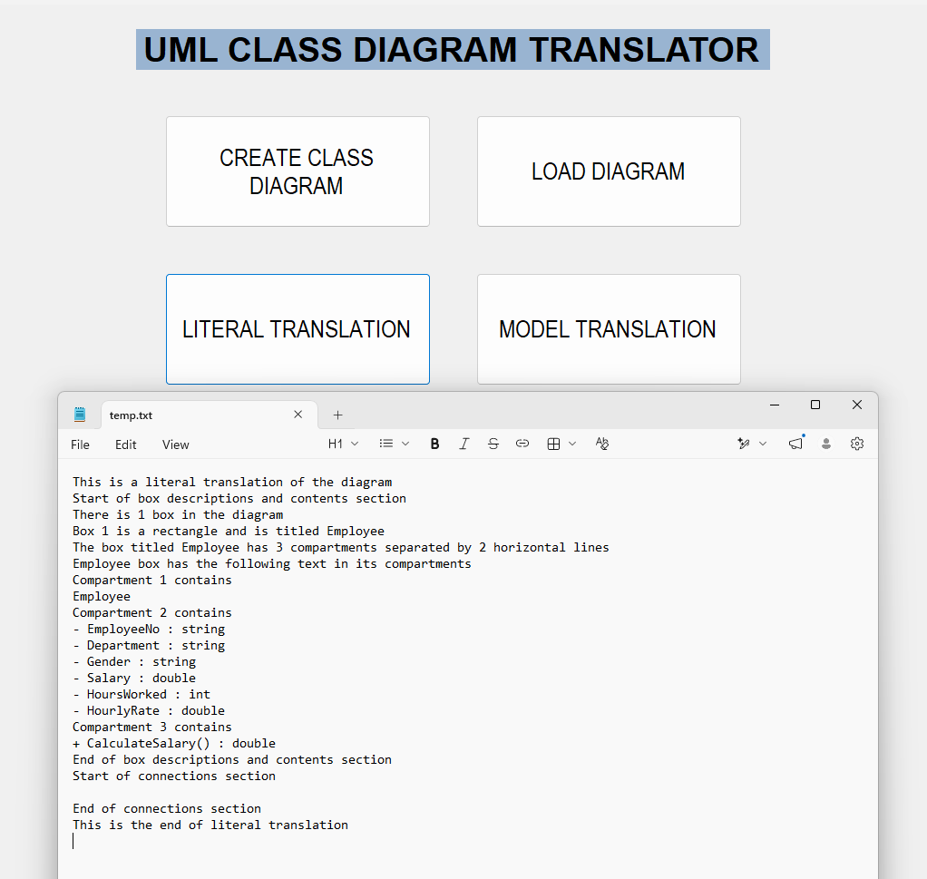
Figure 4: Example literal translation generated from a UML class diagram

8. Generating a model translation
Select MODEL TRANSLATION to generate a semantic description of the loaded UML class diagram. This output interprets the UML notation and describes the meaning of the model.
- classes, attributes and methods;
- associations;
- generalisation relationships;
- aggregation and composition relationships;
- multiplicities; and
- supported self-referencing relationships.
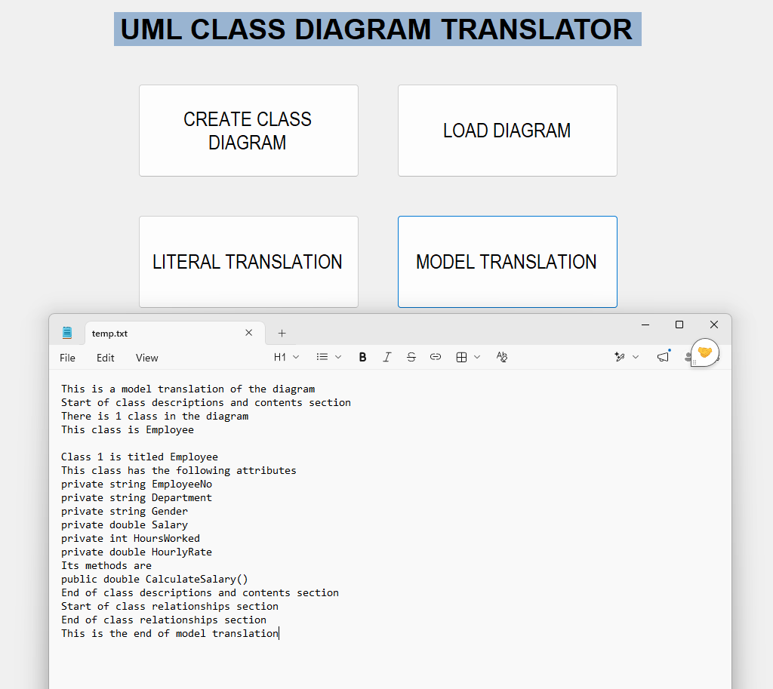
Figure 5: Example model translation generated from a UML class diagram

9. How the artefact processes the SVG file
When an SVG file is loaded, the artefact parses its structured content and extracts information required to interpret the diagram. This includes textual content, coordinates and positions, class rectangles and compartments, connector paths, arrowheads, relationship indicators and multiplicity information.
The extracted information is then processed by the translation rules. The literal translation describes the graphical representation, while the model translation interprets the UML meaning represented by those elements.

10. Recommended workflow
Step | Action | Result
1 | Create | Create the UML class diagram in UMLet.
2 | Export | Export the completed diagram as an SVG file.
3 | Load | Load the exported SVG file into the translator.
4 | Translate | Generate a literal translation and/or a model translation.
5 | Review | Review the generated plain-text output before use or distribution.

11. Output files and accessibility
The generated textual output is stored in plain-text files. Plain text can be opened using standard text-processing software and is suitable for access using screen-reading software. The generated translation should be reviewed before it is distributed as learning material, particularly when the source diagram contains complex UML relationships.

12. Current scope
- UML class diagrams only.
- UMLet SVG files are used as input.
- English textual output.
- Literal and model translation modes.
- Plain-text translation output.
Other UML diagram types, multilingual translation and text-to-UML generation are outside the current scope of the artefact.

13. Closing the application
When the translation task has been completed, select EXIT on the main interface to close the UML Class Diagram Translator.
Good practice: Keep the original UMLet diagram, the exported SVG file and the generated text files together so that the translation can be traced back to its source diagram.

