# Informações do estudo

Referência: Aouici

Grandeza: Força

Tipo: Fx

Material: X38CrMoV5-1 (50 HRC)

Ferramenta: CBN7020

Número de experimentos: 27

Observações:  
Tool holder: PSBNR 25 x 25 K12  
Diameter: 80 mm  
Dynanometer: Kistler 9257B

# Unidades

Velocidade: m/min

Avanço: mm/rev

Profundidade de corte: mm

Força: N

# Dados de teste

|  |  |  |  |
| --- | --- | --- | --- |
| Força | n | f | a |
| 50.53 | 240.0 | 0.16 | 0.15 |
| 305.0 | 180.0 | 0.16 | 0.45 |
| 156.7 | 180.0 | 0.16 | 0.3 |
| 185.95 | 240.0 | 0.12 | 0.45 |
| 80.47 | 180.0 | 0.08 | 0.3 |
| 110.04 | 240.0 | 0.16 | 0.3 |

# Dados de treino

|  |  |  |  |
| --- | --- | --- | --- |
| Força | n | f | a |
| 289.7 | 120.0 | 0.12 | 0.45 |
| 140.85 | 120.0 | 0.16 | 0.15 |
| 200.12 | 180.0 | 0.08 | 0.45 |
| 208.57 | 180.0 | 0.12 | 0.45 |
| 171.03 | 120.0 | 0.08 | 0.3 |
| 40.26 | 180.0 | 0.12 | 0.15 |
| 98.13 | 240.0 | 0.08 | 0.3 |
| 393.7 | 120.0 | 0.16 | 0.45 |
| 315.74 | 240.0 | 0.16 | 0.45 |
| 89.78 | 240.0 | 0.12 | 0.3 |
| 87.42 | 180.0 | 0.12 | 0.3 |
| 78.26 | 180.0 | 0.08 | 0.15 |
| 188.55 | 120.0 | 0.12 | 0.3 |
| 97.42 | 120.0 | 0.08 | 0.15 |
| 87.86 | 180.0 | 0.16 | 0.15 |
| 267.41 | 120.0 | 0.08 | 0.45 |
| 65.95 | 240.0 | 0.08 | 0.15 |
| 38.5 | 240.0 | 0.12 | 0.15 |
| 238.59 | 120.0 | 0.16 | 0.3 |
| 162.68 | 240.0 | 0.08 | 0.45 |
| 123.65 | 120.0 | 0.12 | 0.15 |

# RN

Número de neurônios: 29

Taxa de aprendizado: 1.000000e-03

Número de épocas: 469

2° camada: False

Função de ativação: relu

# Erros

**Dados de teste**

* Erro relativo médio: 42.97
* Coeficiente de correlação: 0.98
* Coeficiente de determinação: 0.96
* MSE: 2420.05
* RMSE: 49.19

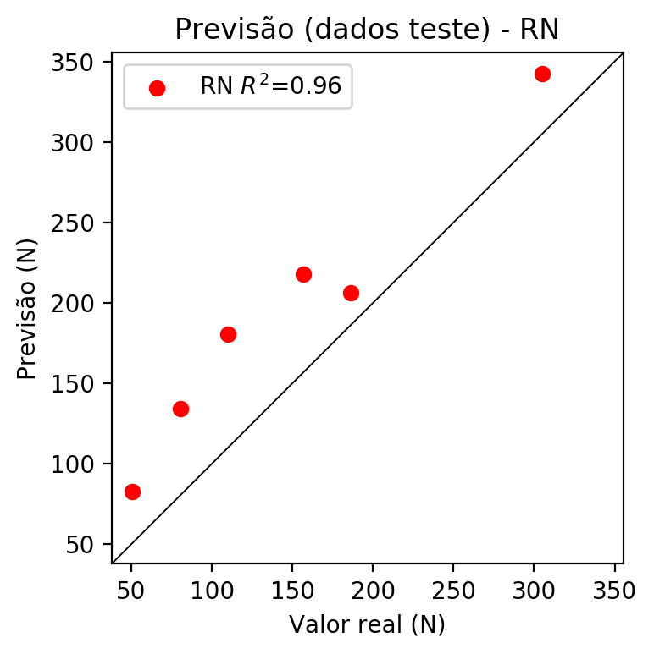

**Dados de treino**

* Erro relativo médio: 8.98
* Coeficiente de correlação: 0.99
* Coeficiente de determinação: 0.98
* MSE: 211.87
* RMSE: 14.56

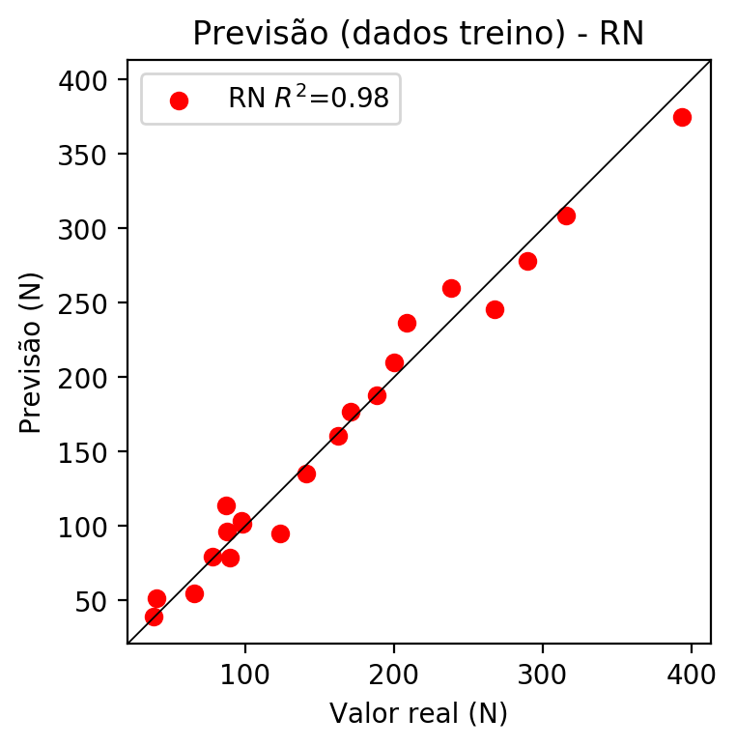

# Pesos

Pesos - camada oculta 1

[[ 1.14169270e-01 1.37341665e-02 -1.23884782e-01 3.14315110e-01  
 7.45077804e-02 -8.77537653e-02 -3.44815075e-01 3.84833455e-01  
 2.39243507e-02 -1.33959904e-01 -2.55128115e-01 1.22592010e-01  
 -1.27053618e-01 -4.03433651e-01 -3.76052596e-02 1.03363805e-01  
 -2.71221370e-01 1.69954747e-01 -1.82782605e-01 1.11111261e-01  
 1.83386534e-01 1.07966065e-01 -6.31019101e-02 7.46947154e-02  
 2.20644519e-01 -1.46285668e-01 2.63712198e-01 -2.14688882e-01  
 1.67716041e-01]  
 [-2.19862700e-01 -4.27189888e-03 -3.30677867e-01 -2.52873540e-01  
 -2.55278528e-01 -1.83773472e-03 -8.60803574e-02 8.49257633e-02  
 1.60826504e-01 -6.31538570e-01 2.52027567e-02 2.41574883e-01  
 4.25871700e-01 5.71700275e-01 2.40679517e-01 2.22739801e-01  
 1.91949606e-01 -7.53346905e-02 -6.60142601e-02 5.81424057e-01  
 6.02325678e-01 4.21023160e-01 2.03751296e-01 1.62893996e-01  
 -1.04890019e-01 -5.70766777e-02 1.25851318e-01 2.07746744e-01  
 1.27919480e-01]  
 [-3.16484571e-01 -3.14192235e-01 2.66879648e-01 -2.09482685e-01  
 -2.90868849e-01 2.73609679e-04 5.87083757e-01 -2.95556128e-01  
 -1.73426405e-01 2.29831606e-01 -4.59413320e-01 -1.22692734e-01  
 -3.64379594e-05 -4.61896649e-04 -1.32052958e-01 -3.88677120e-01  
 3.25147927e-01 -3.57087463e-01 3.04156076e-02 5.09320557e-01  
 1.73015490e-01 9.35339928e-03 2.53653318e-01 -3.30418855e-01  
 -5.03982604e-01 -1.20179221e-01 -1.15563571e-01 5.62211633e-01  
 6.18701726e-02]]

Bias - camada oculta

[-1.23886831e-01 -6.58023059e-02 -1.17535934e-01 2.70015419e-01  
 -1.03424475e-01 -1.18585363e-01 -8.16112012e-03 2.96396136e-01  
 -6.27228990e-02 -1.83408260e-02 -8.15597102e-02 -1.45108014e-01  
 2.21778446e-05 -5.33144281e-04 -1.42857477e-01 2.85269976e-01  
 2.28690296e-01 2.56449699e-01 -1.83707625e-01 -9.59849283e-02  
 -2.07874030e-01 -9.43120122e-02 -5.09237573e-02 -1.06521897e-01  
 2.26475134e-01 -1.63108170e-01 -1.58083707e-01 1.16593972e-01  
 -1.42852217e-01]

Pesos - camada saída

[[ 0.18382174 0.01729464 -0.15693654 -0.14416227 0.15233317 -0.13360825  
 0.19329241 -0.19551599 -0.0905544 0.4157677 -0.09869513 0.1611251  
 0.27655914 0.25740764 -0.07094523 -0.40049165 0.45096782 -0.33099458  
 -0.22581995 0.59867597 0.2980638 0.185146 0.050403 0.12057496  
 -0.24939889 -0.14780554 0.30380946 0.3653836 0.21370757]]

# Iterações

|  |  |  |  |  |  |  |
| --- | --- | --- | --- | --- | --- | --- |
| Média | Desvio | n | ln | 2° camada | Função | Épocas |
| -0.2357 | 0.2431 | 10 | 0.1 | False | relu | 38 |
| -0.3377 | 0.44 | 17 | 0.1 | True | relu | 716 |
| -0.3501 | 0.2895 | 7 | 0.01 | True | tanh | 130 |
| -0.5008 | 0.2396 | 19 | 0.001 | False | tanh | 282 |
| -0.1312 | 0.0641 | 29 | 0.001 | False | relu | 469 |
| -0.4673 | 0.3668 | 88 | 0.1 | False | tanh | 926 |
| -0.2774 | 0.3599 | 95 | 0.0001 | True | relu | 984 |
| -0.263 | 0.3113 | 10 | 0.01 | True | tanh | 865 |
| -0.705 | 0.6993 | 58 | 0.001 | True | relu | 8 |
| -0.301 | 0.3127 | 9 | 0.01 | False | tanh | 514 |
| -0.3452 | 0.4748 | 73 | 0.0001 | True | relu | 729 |
| -0.2539 | 0.3822 | 22 | 0.001 | True | relu | 543 |
| -0.1825 | 0.1466 | 25 | 0.1 | True | relu | 562 |
| -0.1989 | 0.1385 | 53 | 0.001 | False | relu | 498 |
| -0.2064 | 0.2635 | 83 | 0.01 | True | relu | 337 |
| -0.5105 | 0.2852 | 99 | 0.01 | False | tanh | 16 |
| -0.1848 | 0.181 | 23 | 0.01 | False | relu | 472 |
| -0.2864 | 0.3384 | 24 | 0.001 | True | relu | 778 |
| -0.2463 | 0.2139 | 58 | 0.01 | True | tanh | 382 |
| -0.4892 | 0.3036 | 35 | 0.1 | False | tanh | 596 |

# RL

# Coeficientes

[ 0. -0.33937859 0.30853571 0.78405624]

# Erros

**Dados de teste**

* Erro relativo médio: 33.45
* Coeficiente de correlação: 0.97
* Coeficiente de determinação: 0.95
* MSE: 1427.16
* RMSE: 37.78

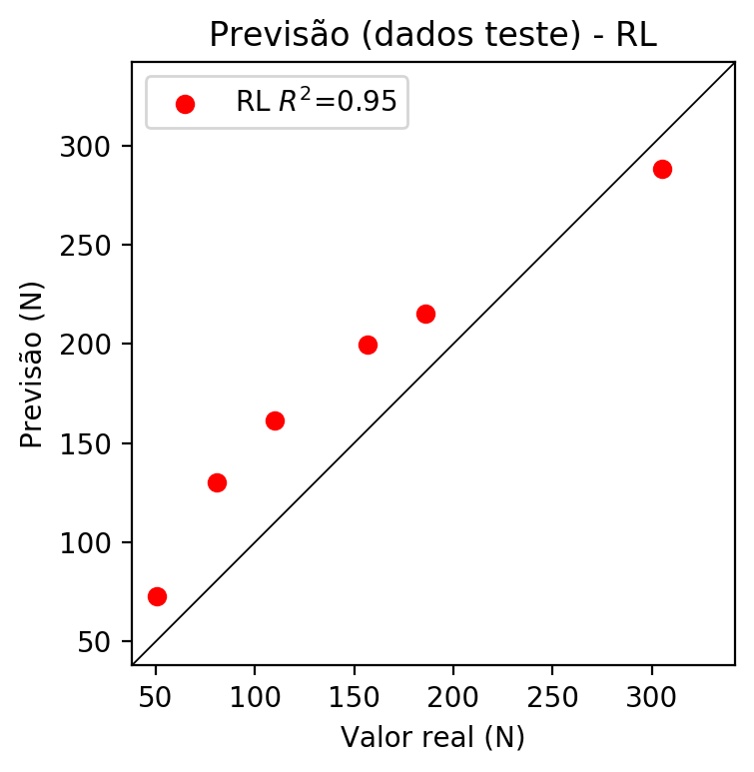

**Dados de treino**

* Erro relativo médio: 24.84
* Coeficiente de correlação: 0.93
* Coeficiente de determinação: 0.86
* MSE: 1277.59
* RMSE: 35.74

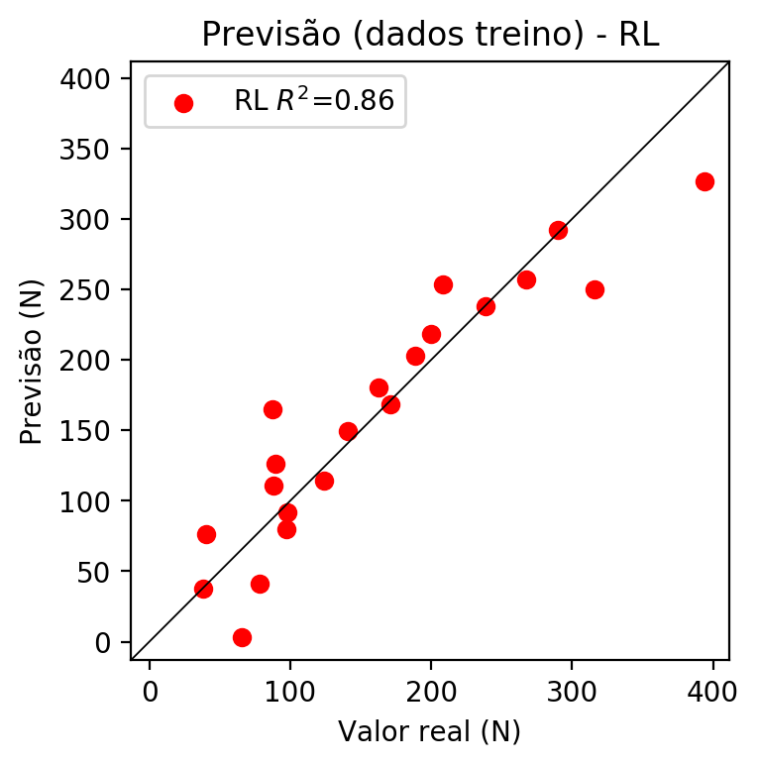

# RP2

# Coeficientes

[ 0. -0.3320544 0.34038923 0.78388075 0.22534309 0.00810666  
 -0.06318137 0.25990893 0.19620915 0.19703017]

# Erros

**Dados de teste**

* Erro relativo médio: 30.79
* Coeficiente de correlação: 0.98
* Coeficiente de determinação: 0.97
* MSE: 1088.4
* RMSE: 32.99

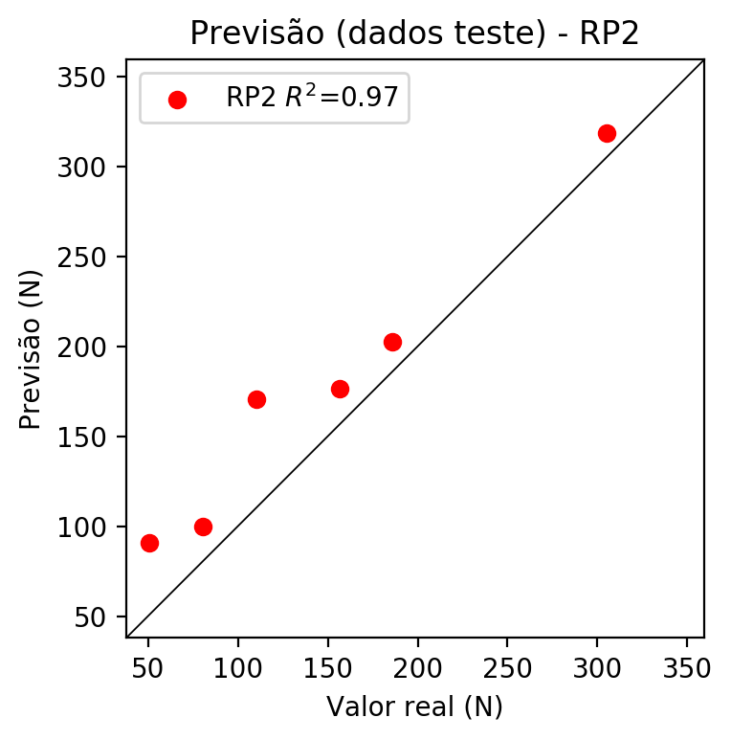

**Dados de treino**

* Erro relativo médio: 7.07
* Coeficiente de correlação: 0.99
* Coeficiente de determinação: 0.99
* MSE: 127.34
* RMSE: 11.28

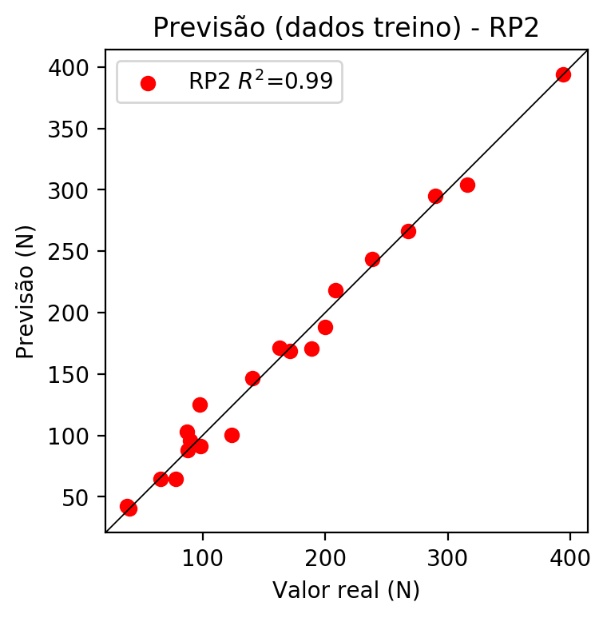

# RP3

# Coeficientes

[ 0. -0.14643713 0.05958942 0.22189667 0.23850614 0.04206829  
 -0.10640782 0.30948831 0.16583436 0.1656291 -0.2115203 0.11947234  
 -0.00368065 0.13506389 0.00846975 -0.00075296 0.08607361 0.06275911  
 0.04544277 0.32051742]

# Erros

**Dados de teste**

* Erro relativo médio: 48.03
* Coeficiente de correlação: 0.91
* Coeficiente de determinação: 0.82
* MSE: 2394.48
* RMSE: 48.93

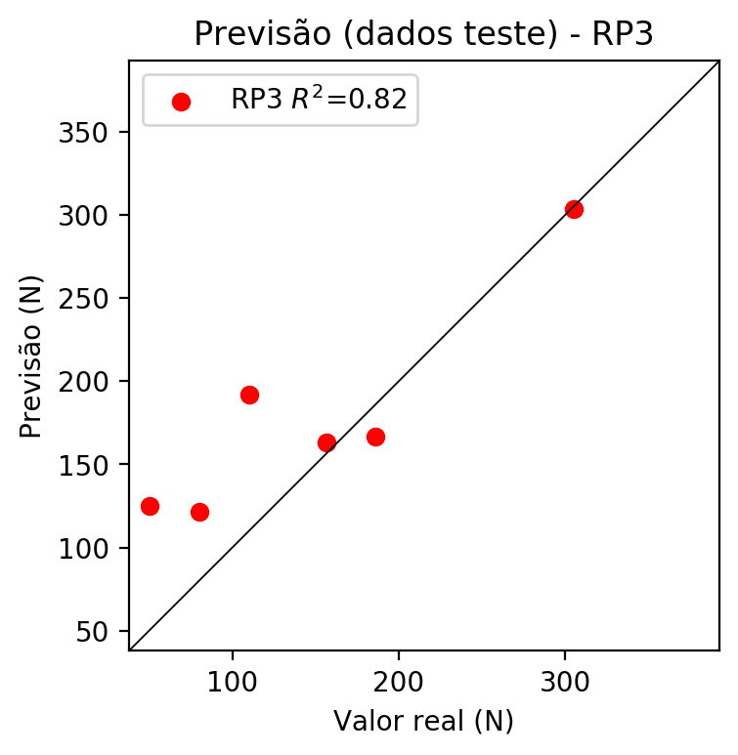

**Dados de treino**

* Erro relativo médio: 4.38
* Coeficiente de correlação: 1.0
* Coeficiente de determinação: 1.0
* MSE: 31.6
* RMSE: 5.62

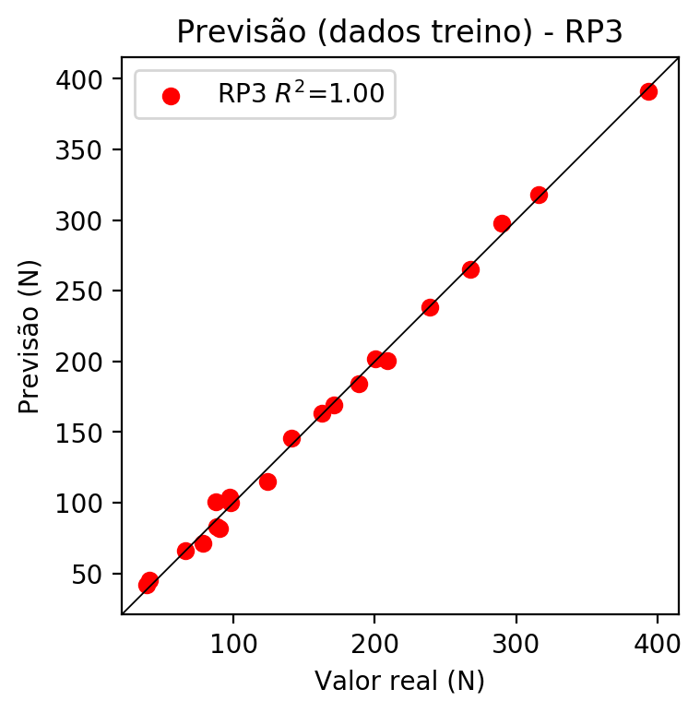

# RP4

# Coeficientes

[-2.77555756e-17 -1.41485586e-01 3.95019866e-02 2.41099919e-01  
 1.23348851e-01 -2.65637584e-03 4.59742947e-03 1.02372506e-01  
 3.59564314e-02 8.81880522e-02 -2.04368069e-01 1.10951504e-01  
 1.28701154e-02 6.77508437e-02 5.61833956e-03 6.14763289e-02  
 5.70584252e-02 1.25824976e-02 9.97368873e-02 3.48255439e-01  
 1.78170563e-01 -3.83698733e-03 6.64073145e-03 -7.95513823e-02  
 -1.85793489e-02 -4.49639556e-02 -3.83698733e-03 -1.05077989e-01  
 3.89268693e-02 6.64073145e-03 1.47871397e-01 5.19370676e-02  
 9.72868704e-03 5.19370676e-02 1.27382742e-01]

# Erros

**Dados de teste**

* Erro relativo médio: 45.08
* Coeficiente de correlação: 0.95
* Coeficiente de determinação: 0.9
* MSE: 1823.13
* RMSE: 42.7

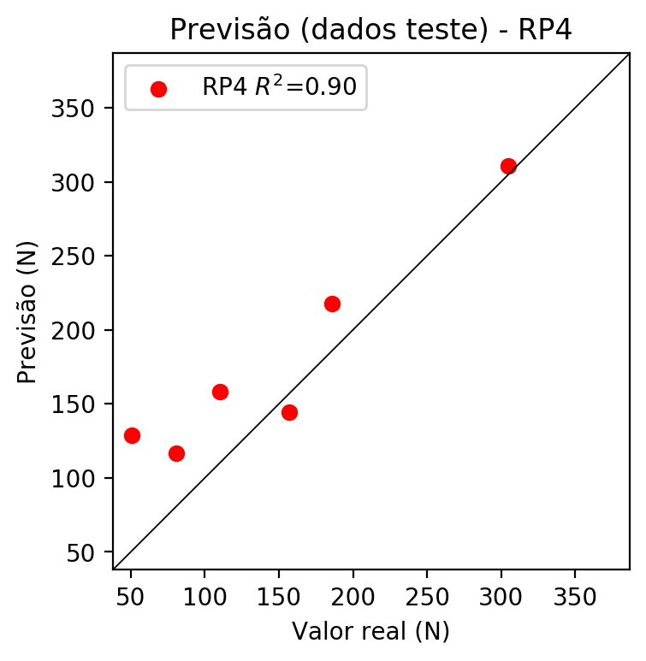

**Dados de treino**

* Erro relativo médio: 0.0
* Coeficiente de correlação: 1.0
* Coeficiente de determinação: 1.0
* MSE: 0.0
* RMSE: 0.0

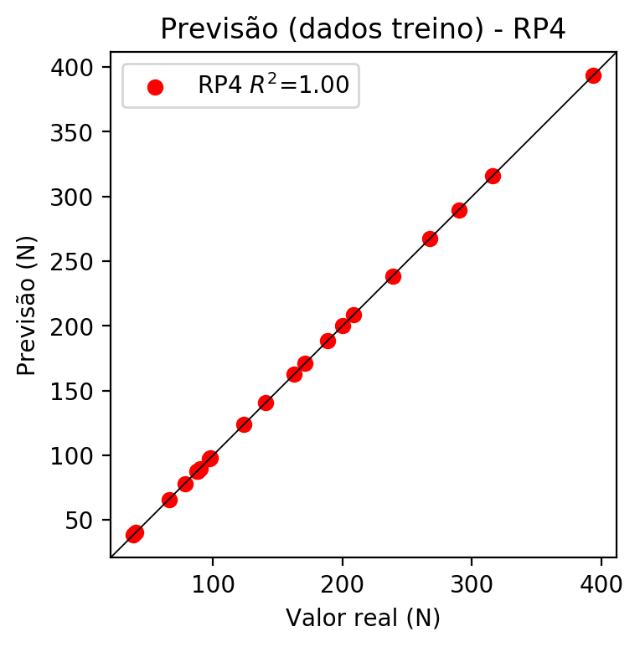

# Geral

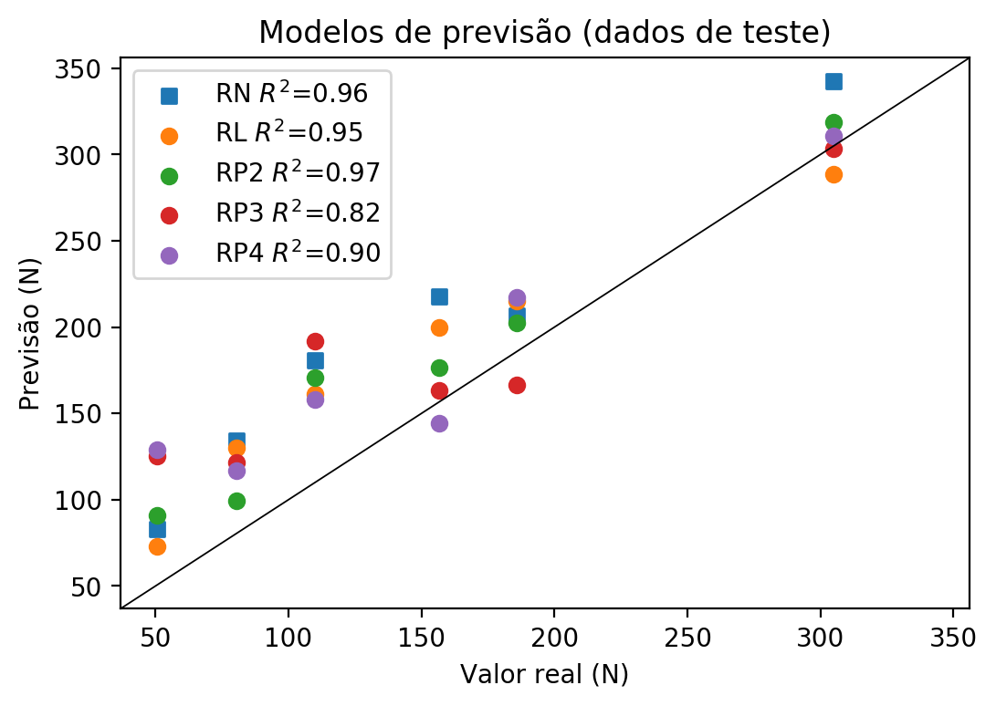

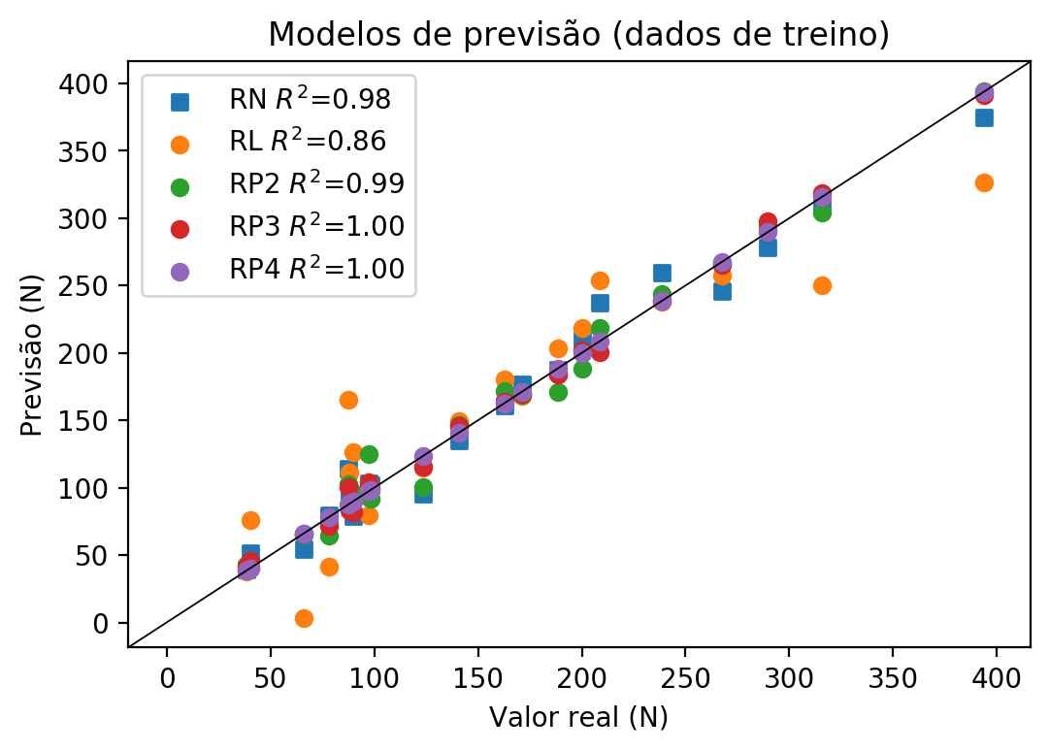

**Dados de teste**

|  |  |  |  |  |  |  |  |  |  |  |
| --- | --- | --- | --- | --- | --- | --- | --- | --- | --- | --- |
| Valor real | RN Previsto | RN Erro (%) | RL Previsto | RL Erro (%) | RP2 Previsto | RP2 Erro (%) | RP3 Previsto | RP3 Erro (%) | RP4 Previsto | RP4 Erro (%) |
| 50.53 | 82.96 | 64.18 | 72.72 | 43.91 | 90.79 | 79.68 | 125.08 | 147.54 | 128.81 | 154.92 |
| 305.0 | 342.4 | 12.26 | 288.44 | 5.43 | 318.66 | 4.48 | 303.41 | 0.52 | 310.84 | 1.91 |
| 156.7 | 217.81 | 39.0 | 199.77 | 27.49 | 176.56 | 12.67 | 163.23 | 4.17 | 144.15 | 8.01 |
| 185.95 | 206.46 | 11.03 | 215.16 | 15.71 | 202.66 | 8.99 | 166.45 | 10.49 | 217.48 | 16.96 |
| 80.47 | 134.42 | 67.04 | 129.98 | 61.53 | 99.57 | 23.74 | 121.63 | 51.15 | 116.58 | 44.87 |
| 110.04 | 180.78 | 64.29 | 161.39 | 46.66 | 170.74 | 55.16 | 191.83 | 74.33 | 158.22 | 43.78 |

**Dados de treino**

|  |  |  |  |  |  |  |  |  |  |  |
| --- | --- | --- | --- | --- | --- | --- | --- | --- | --- | --- |
| Valor real | RN Previsto | RN Erro (%) | RL Previsto | RL Erro (%) | RP2 Previsto | RP2 Erro (%) | RP3 Previsto | RP3 Erro (%) | RP4 Previsto | RP4 Erro (%) |
| 289.7 | 278.51 | 3.86 | 291.93 | 0.77 | 294.94 | 1.81 | 297.85 | 2.81 | 289.7 | 0.0 |
| 140.85 | 135.02 | 4.14 | 149.48 | 6.13 | 146.51 | 4.02 | 145.83 | 3.54 | 140.85 | 0.0 |
| 200.12 | 209.91 | 4.89 | 218.65 | 9.26 | 188.33 | 5.89 | 201.89 | 0.88 | 200.12 | 0.0 |
| 208.57 | 236.93 | 13.6 | 253.54 | 21.56 | 218.17 | 4.6 | 200.33 | 3.95 | 208.57 | 0.0 |
| 171.03 | 177.0 | 3.49 | 168.36 | 1.56 | 168.85 | 1.27 | 169.3 | 1.01 | 171.03 | 0.0 |
| 40.26 | 51.38 | 27.62 | 76.21 | 89.29 | 40.87 | 1.52 | 45.43 | 12.84 | 40.26 | 0.0 |
| 98.13 | 101.56 | 3.5 | 91.6 | 6.65 | 91.54 | 6.72 | 99.77 | 1.67 | 98.13 | 0.0 |
| 393.7 | 374.85 | 4.79 | 326.82 | 16.99 | 394.32 | 0.16 | 391.28 | 0.61 | 393.7 | 0.0 |
| 315.74 | 308.76 | 2.21 | 250.06 | 20.8 | 304.25 | 3.64 | 318.21 | 0.78 | 315.74 | 0.0 |
| 89.78 | 78.6 | 12.45 | 126.49 | 40.89 | 95.81 | 6.72 | 81.67 | 9.03 | 89.78 | 0.0 |
| 87.42 | 114.14 | 30.57 | 164.88 | 88.61 | 102.74 | 17.52 | 100.37 | 14.81 | 87.42 | 0.0 |
| 78.26 | 79.27 | 1.29 | 41.31 | 47.21 | 64.37 | 17.75 | 71.56 | 8.56 | 78.26 | 0.0 |
| 188.55 | 187.62 | 0.49 | 203.26 | 7.8 | 170.92 | 9.35 | 183.9 | 2.47 | 188.55 | 0.0 |
| 97.42 | 103.21 | 5.94 | 79.69 | 18.2 | 125.06 | 28.37 | 104.1 | 6.86 | 97.42 | 0.0 |
| 87.86 | 96.38 | 9.7 | 111.1 | 26.45 | 88.02 | 0.18 | 82.92 | 5.62 | 87.86 | 0.0 |
| 267.41 | 245.75 | 8.1 | 257.03 | 3.88 | 266.2 | 0.45 | 264.92 | 0.93 | 267.41 | 0.0 |
| 65.95 | 54.5 | 17.36 | 2.93 | 95.56 | 64.93 | 1.55 | 66.01 | 0.09 | 65.95 | 0.0 |
| 38.5 | 39.06 | 1.45 | 37.82 | 1.77 | 42.53 | 10.47 | 41.67 | 8.23 | 38.5 | 0.0 |
| 238.59 | 259.81 | 8.89 | 238.15 | 0.18 | 243.64 | 2.12 | 238.5 | 0.04 | 238.59 | 0.0 |
| 162.68 | 160.76 | 1.18 | 180.27 | 10.81 | 171.72 | 5.56 | 163.45 | 0.47 | 162.68 | 0.0 |
| 123.65 | 95.13 | 23.07 | 114.59 | 7.33 | 100.46 | 18.75 | 115.22 | 6.82 | 123.65 | 0.0 |