# Informações do estudo

Referência: Aouici

Grandeza: Força

Tipo: Fy

Material: X38CrMoV5-1 (50 HRC)

Ferramenta: CBN7020

Número de experimentos: 27

Observações:  
Tool holder: PSBNR 25 x 25 K12  
Diameter: 80 mm  
Dynanometer: Kistler 9257B

# Unidades

Velocidade: m/min

Avanço: mm/rev

Profundidade de corte: mm

Força: N

# Dados de teste

|  |  |  |  |
| --- | --- | --- | --- |
| Força | n | f | a |
| 74.56 | 240.0 | 0.16 | 0.15 |
| 329.03 | 180.0 | 0.16 | 0.45 |
| 180.74 | 180.0 | 0.16 | 0.3 |
| 210.01 | 240.0 | 0.12 | 0.45 |
| 104.51 | 180.0 | 0.08 | 0.3 |
| 134.09 | 240.0 | 0.16 | 0.3 |

# Dados de treino

|  |  |  |  |
| --- | --- | --- | --- |
| Força | n | f | a |
| 313.73 | 120.0 | 0.12 | 0.45 |
| 164.88 | 120.0 | 0.16 | 0.15 |
| 224.15 | 180.0 | 0.08 | 0.45 |
| 232.6 | 180.0 | 0.12 | 0.45 |
| 195.07 | 120.0 | 0.08 | 0.3 |
| 60.12 | 180.0 | 0.12 | 0.15 |
| 122.17 | 240.0 | 0.08 | 0.3 |
| 396.67 | 120.0 | 0.16 | 0.45 |
| 339.77 | 240.0 | 0.16 | 0.45 |
| 113.83 | 240.0 | 0.12 | 0.3 |
| 111.46 | 180.0 | 0.12 | 0.3 |
| 102.29 | 180.0 | 0.08 | 0.15 |
| 211.19 | 120.0 | 0.12 | 0.3 |
| 121.45 | 120.0 | 0.08 | 0.15 |
| 111.89 | 180.0 | 0.16 | 0.15 |
| 291.44 | 120.0 | 0.08 | 0.45 |
| 89.98 | 240.0 | 0.08 | 0.15 |
| 43.28 | 240.0 | 0.12 | 0.15 |
| 262.63 | 120.0 | 0.16 | 0.3 |
| 186.71 | 240.0 | 0.08 | 0.45 |
| 147.68 | 120.0 | 0.12 | 0.15 |

# RN

Número de neurônios: 29

Taxa de aprendizado: 1.000000e-03

Número de épocas: 469

2° camada: False

Função de ativação: relu

# Erros

**Dados de teste**

* Erro relativo médio: 32.24
* Coeficiente de correlação: 0.98
* Coeficiente de determinação: 0.95
* MSE: 2257.87
* RMSE: 47.52

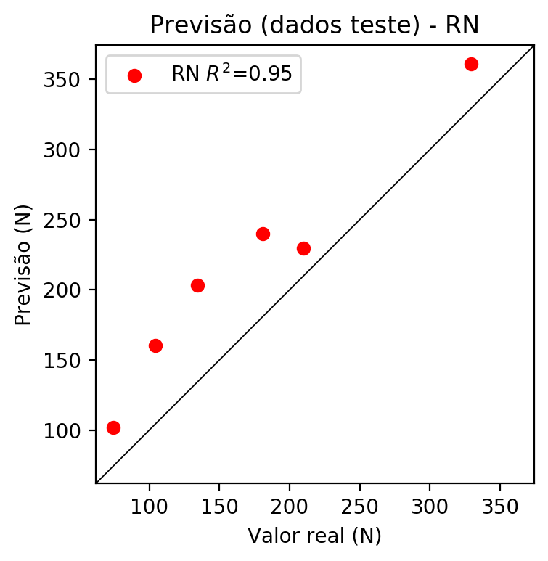

**Dados de treino**

* Erro relativo médio: 8.73
* Coeficiente de correlação: 0.99
* Coeficiente de determinação: 0.98
* MSE: 212.47
* RMSE: 14.58

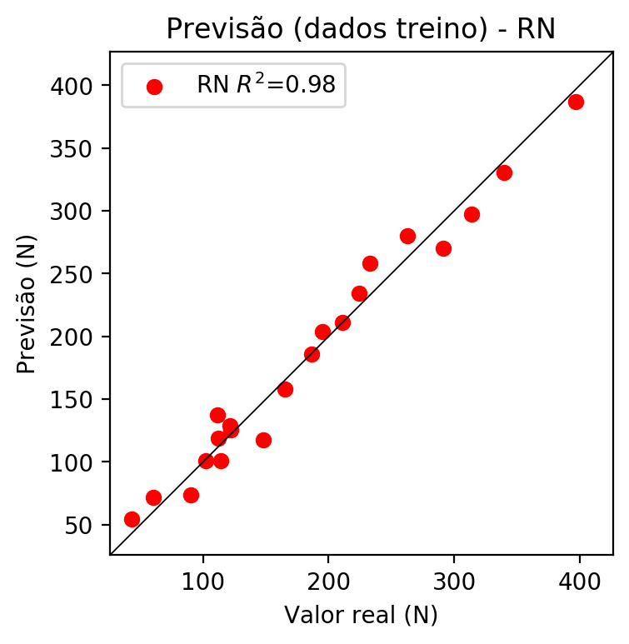

# Pesos

Pesos - camada oculta 1

[[ 1.11792549e-01 1.43151321e-02 -1.21832915e-01 3.20638567e-01  
 7.21524507e-02 -8.77100378e-02 -3.31382513e-01 3.90643865e-01  
 3.69706899e-02 -1.38755664e-01 -2.50561088e-01 1.15492553e-01  
 -1.10919431e-01 -4.00817066e-01 -4.02516238e-02 1.09720379e-01  
 -2.67851472e-01 1.73663333e-01 -1.74748600e-01 1.18079968e-01  
 1.91415906e-01 1.07715510e-01 -5.66153638e-02 7.07163513e-02  
 2.24868417e-01 -1.45611092e-01 2.62261540e-01 -2.08159775e-01  
 1.70653179e-01]  
 [-2.28380337e-01 -3.53121571e-03 -3.22459608e-01 -2.66303629e-01  
 -2.64209121e-01 2.05532205e-03 -5.91789447e-02 8.09121281e-02  
 1.63833216e-01 -6.80180311e-01 7.93962460e-03 2.61658043e-01  
 4.16768581e-01 5.59495866e-01 2.46136650e-01 2.05138877e-01  
 2.13376358e-01 -7.40045905e-02 -3.64473574e-02 5.70755661e-01  
 6.00632250e-01 4.22261328e-01 1.95073649e-01 1.59076244e-01  
 -9.78635475e-02 -6.16599247e-02 1.28391460e-01 2.05887333e-01  
 1.36066034e-01]  
 [-3.10872108e-01 -3.12836021e-01 2.61694461e-01 -2.29886502e-01  
 -2.84086347e-01 6.48742367e-04 5.74509144e-01 -3.17100406e-01  
 -1.75416157e-01 2.30447441e-01 -4.61498976e-01 -1.14672206e-01  
 -8.40927896e-05 -3.39609087e-02 -1.20695606e-01 -3.99125546e-01  
 3.09071779e-01 -3.63678396e-01 1.50026372e-02 5.06935477e-01  
 1.61803067e-01 1.20322220e-02 2.51173198e-01 -3.27696294e-01  
 -5.11524916e-01 -1.14512071e-01 -1.07672073e-01 5.56161344e-01  
 6.90892786e-02]]

Bias - camada oculta

[-1.26494095e-01 -6.67830780e-02 -1.20299615e-01 2.76696861e-01  
 -1.07549384e-01 -1.18043527e-01 -8.57578125e-03 2.91188955e-01  
 -6.35274723e-02 -4.45213576e-04 -7.67299756e-02 -1.46197245e-01  
 4.33672212e-05 4.17285971e-02 -1.39595821e-01 2.74774283e-01  
 2.39240766e-01 2.60394990e-01 -1.92032486e-01 -8.07947591e-02  
 -1.94431290e-01 -1.02067254e-01 -5.11824451e-02 -1.08029425e-01  
 2.29209512e-01 -1.65115267e-01 -1.58261895e-01 1.18849427e-01  
 -1.40372008e-01]

Pesos - camada saída

[[ 0.18149643 0.01380941 -0.1587524 -0.15259872 0.15047114 -0.13299097  
 0.18171704 -0.20299627 -0.09999216 0.44312802 -0.09917141 0.16022997  
 0.25578701 0.25424683 -0.06602021 -0.40918753 0.4422499 -0.3404661  
 -0.23229711 0.5811163 0.29338765 0.18900792 0.04557543 0.11626951  
 -0.25648844 -0.14888157 0.3009525 0.35741043 0.21875463]]

# Iterações

|  |  |  |  |  |  |  |
| --- | --- | --- | --- | --- | --- | --- |
| Média | Desvio | n | ln | 2° camada | Função | Épocas |
| -0.299 | 0.3763 | 10 | 0.1 | False | relu | 38 |
| -0.3096 | 0.4231 | 17 | 0.1 | True | relu | 716 |
| -0.3397 | 0.2624 | 7 | 0.01 | True | tanh | 130 |
| -0.4803 | 0.1794 | 19 | 0.001 | False | tanh | 282 |
| -0.1091 | 0.0356 | 29 | 0.001 | False | relu | 469 |
| -0.4998 | 0.3606 | 88 | 0.1 | False | tanh | 926 |
| -0.2493 | 0.3223 | 95 | 0.0001 | True | relu | 984 |
| -0.2818 | 0.3028 | 10 | 0.01 | True | tanh | 865 |
| -0.698 | 0.6259 | 58 | 0.001 | True | relu | 8 |
| -0.3087 | 0.3267 | 9 | 0.01 | False | tanh | 514 |
| -0.3092 | 0.4074 | 73 | 0.0001 | True | relu | 729 |
| -0.2113 | 0.2873 | 22 | 0.001 | True | relu | 543 |
| -0.178 | 0.1304 | 25 | 0.1 | True | relu | 562 |
| -0.1635 | 0.0891 | 53 | 0.001 | False | relu | 498 |
| -0.1816 | 0.2131 | 83 | 0.01 | True | relu | 337 |
| -0.492 | 0.2703 | 99 | 0.01 | False | tanh | 16 |
| -0.1775 | 0.1444 | 23 | 0.01 | False | relu | 472 |
| -0.2534 | 0.2952 | 24 | 0.001 | True | relu | 778 |
| -0.183 | 0.1722 | 58 | 0.01 | True | tanh | 382 |
| -0.4722 | 0.3109 | 35 | 0.1 | False | tanh | 596 |

# RL

# Coeficientes

[ 0. -0.34758696 0.29037546 0.79021413]

# Erros

**Dados de teste**

* Erro relativo médio: 23.93
* Coeficiente de correlação: 0.97
* Coeficiente de determinação: 0.94
* MSE: 1231.41
* RMSE: 35.09

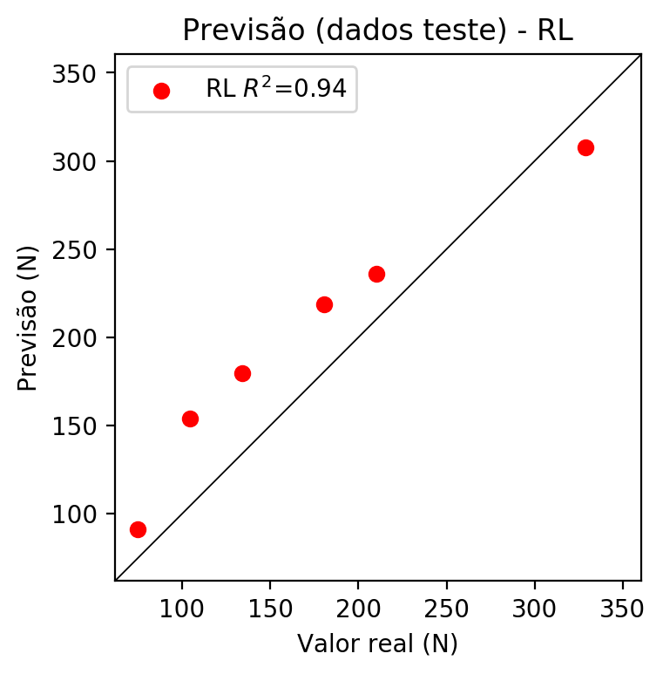

**Dados de treino**

* Erro relativo médio: 20.52
* Coeficiente de correlação: 0.93
* Coeficiente de determinação: 0.86
* MSE: 1190.04
* RMSE: 34.5

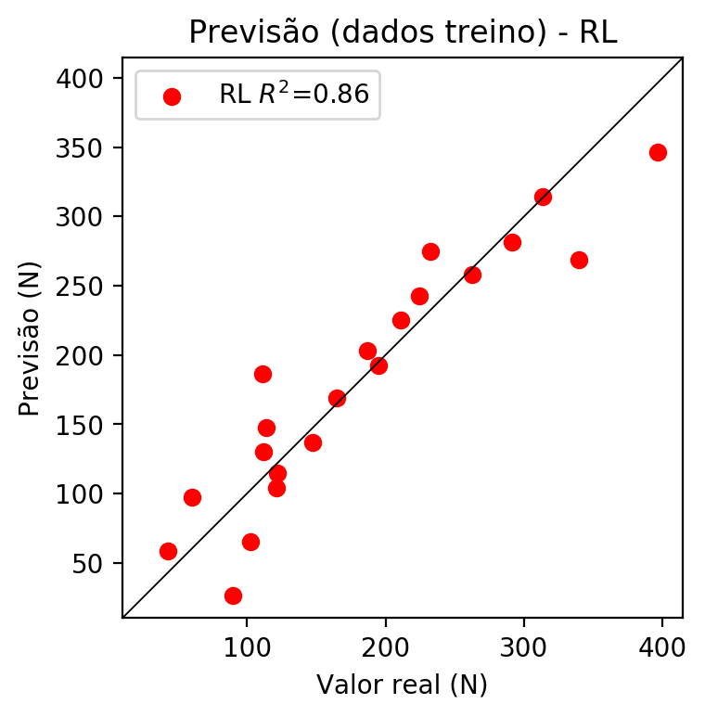

# RP2

# Coeficientes

[ 0. -0.33892995 0.32277172 0.79268338 0.20919192 0.01455381  
 -0.03418073 0.26984652 0.18704229 0.17414522]

# Erros

**Dados de teste**

* Erro relativo médio: 21.6
* Coeficiente de correlação: 0.99
* Coeficiente de determinação: 0.97
* MSE: 946.1
* RMSE: 30.76

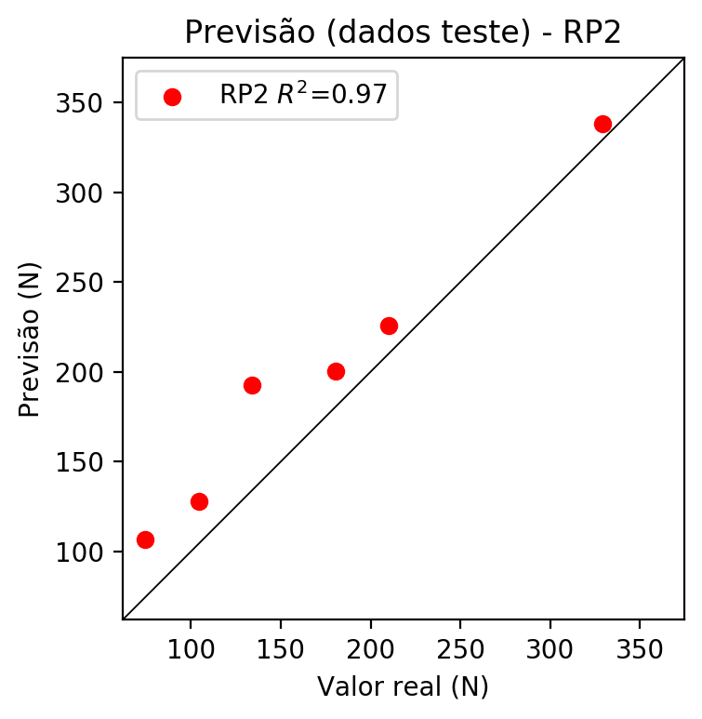

**Dados de treino**

* Erro relativo médio: 7.65
* Coeficiente de correlação: 0.99
* Coeficiente de determinação: 0.98
* MSE: 152.71
* RMSE: 12.36

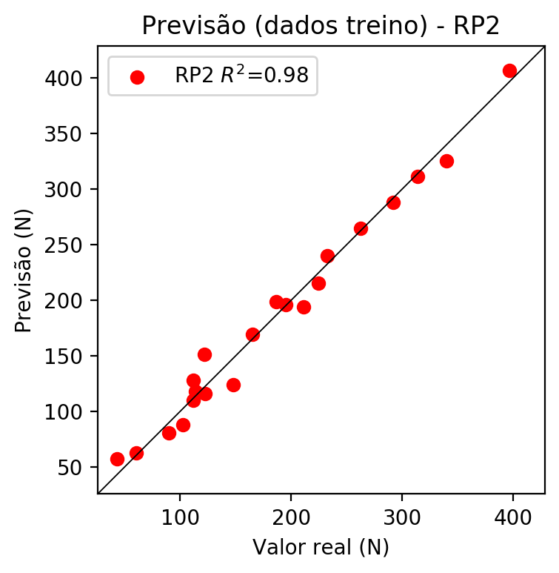

# RP3

# Coeficientes

[ 0. -0.15177288 0.07216518 0.2322241 0.2236033 0.04961506  
 -0.07290756 0.31919355 0.15922415 0.13173929 -0.2192275 0.10296052  
 0.00573249 0.16003051 0.03621858 -0.01425393 0.1042386 0.03210263  
 0.00975113 0.33543481]

# Erros

**Dados de teste**

* Erro relativo médio: 33.75
* Coeficiente de correlação: 0.91
* Coeficiente de determinação: 0.83
* MSE: 2230.69
* RMSE: 47.23

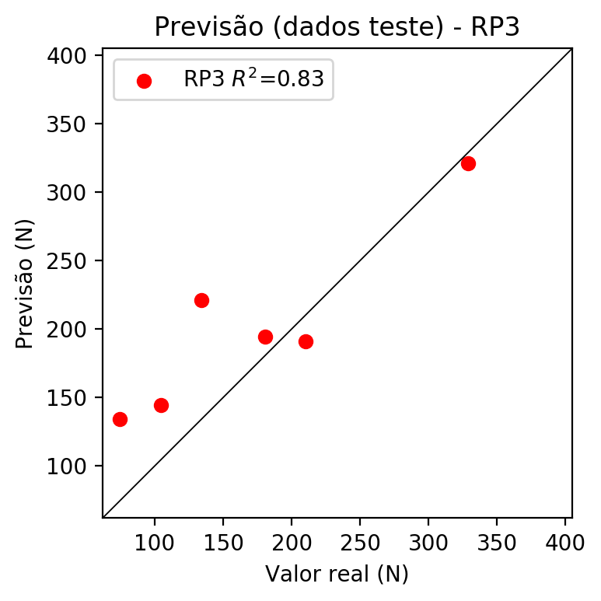

**Dados de treino**

* Erro relativo médio: 3.81
* Coeficiente de correlação: 1.0
* Coeficiente de determinação: 1.0
* MSE: 35.72
* RMSE: 5.98

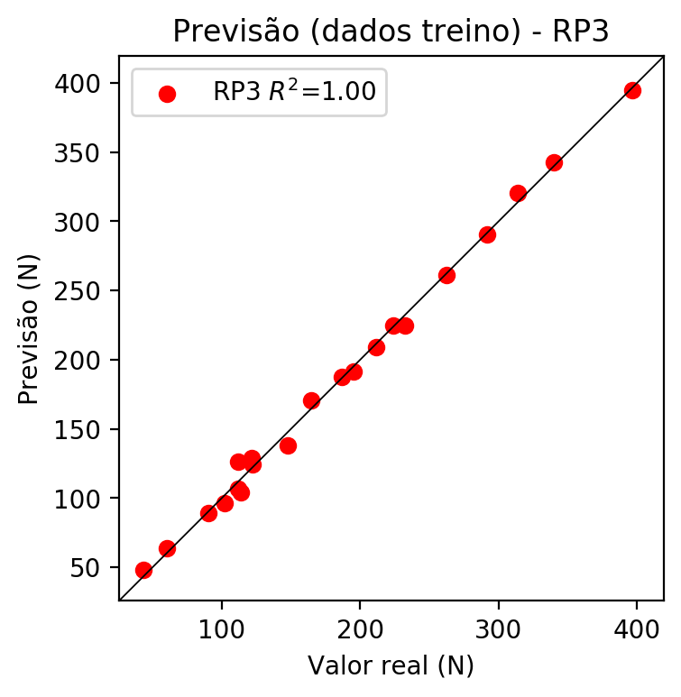

# RP4

# Coeficientes

[ 0. -0.1405866 0.04860159 0.24905892 0.12267009 0.00064307  
 0.01546045 0.11219878 0.02907227 0.08386261 -0.20306953 0.1073708  
 0.04670335 0.07823776 0.04100943 0.04482123 0.0702023 -0.03105627  
 0.05089956 0.35975178 0.17719013 0.00092888 0.02233176 -0.08396818  
 0.00933624 -0.04170057 0.00092888 -0.11528314 0.02497075 0.02233176  
 0.1620649 0.04199327 -0.02441449 0.04199327 0.12113488]

# Erros

**Dados de teste**

* Erro relativo médio: 29.59
* Coeficiente de correlação: 0.96
* Coeficiente de determinação: 0.92
* MSE: 1592.08
* RMSE: 39.9

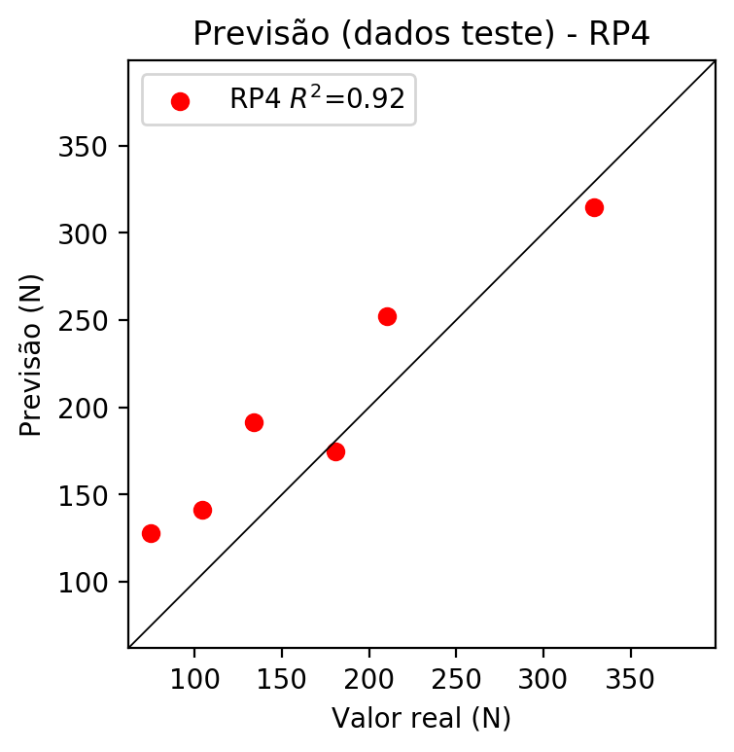

**Dados de treino**

* Erro relativo médio: 0.0
* Coeficiente de correlação: 1.0
* Coeficiente de determinação: 1.0
* MSE: 0.0
* RMSE: 0.0

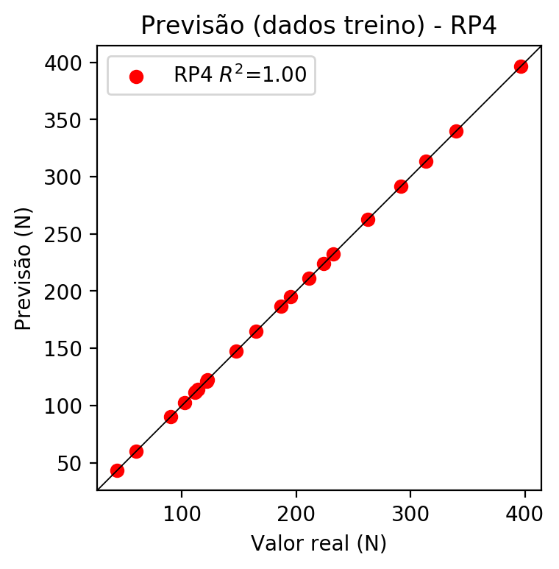

# Geral

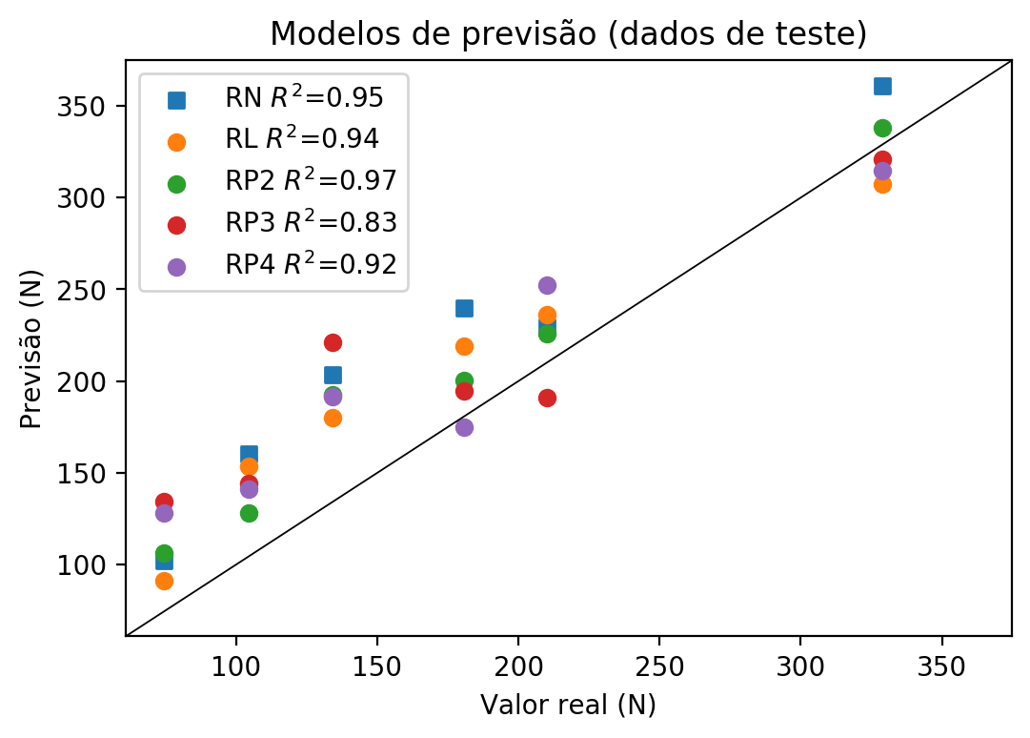

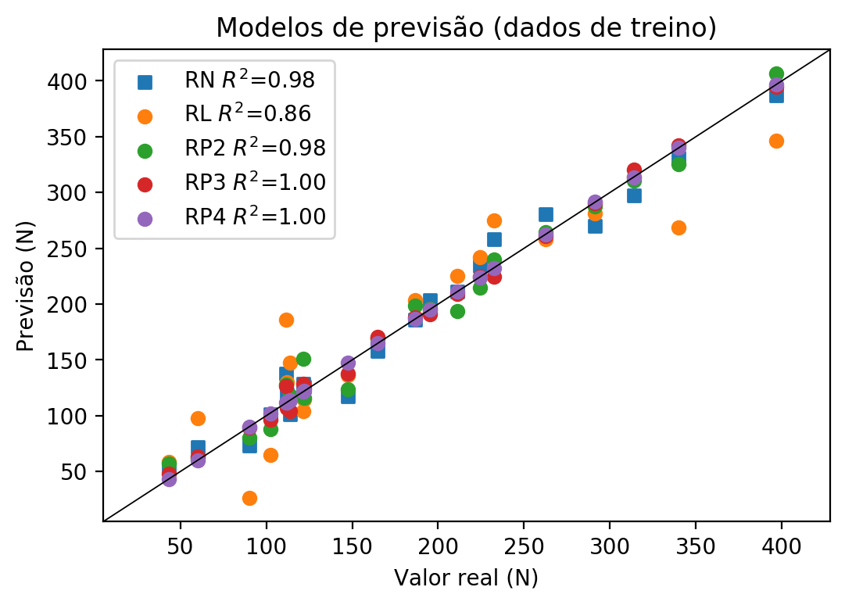

**Dados de teste**

|  |  |  |  |  |  |  |  |  |  |  |
| --- | --- | --- | --- | --- | --- | --- | --- | --- | --- | --- |
| Valor real | RN Previsto | RN Erro (%) | RL Previsto | RL Erro (%) | RP2 Previsto | RP2 Erro (%) | RP3 Previsto | RP3 Erro (%) | RP4 Previsto | RP4 Erro (%) |
| 74.56 | 102.02 | 36.83 | 91.23 | 22.36 | 106.4 | 42.7 | 134.29 | 80.11 | 128.07 | 71.77 |
| 329.03 | 361.17 | 9.77 | 307.53 | 6.53 | 337.95 | 2.71 | 320.82 | 2.5 | 314.86 | 4.31 |
| 180.74 | 239.7 | 32.62 | 218.88 | 21.1 | 200.32 | 10.83 | 194.4 | 7.56 | 174.98 | 3.19 |
| 210.01 | 229.36 | 9.21 | 235.96 | 12.36 | 225.7 | 7.47 | 190.93 | 9.09 | 252.46 | 20.21 |
| 104.51 | 160.3 | 53.38 | 153.73 | 47.1 | 127.89 | 22.37 | 144.42 | 38.19 | 141.32 | 35.22 |
| 134.09 | 203.35 | 51.65 | 179.89 | 34.16 | 192.46 | 43.53 | 221.3 | 65.04 | 191.52 | 42.83 |

**Dados de treino**

|  |  |  |  |  |  |  |  |  |  |  |
| --- | --- | --- | --- | --- | --- | --- | --- | --- | --- | --- |
| Valor real | RN Previsto | RN Erro (%) | RL Previsto | RL Erro (%) | RP2 Previsto | RP2 Erro (%) | RP3 Previsto | RP3 Erro (%) | RP4 Previsto | RP4 Erro (%) |
| 313.73 | 297.51 | 5.17 | 313.95 | 0.07 | 310.97 | 0.88 | 320.32 | 2.1 | 313.73 | 0.0 |
| 164.88 | 158.3 | 3.99 | 169.22 | 2.63 | 169.31 | 2.69 | 170.84 | 3.61 | 164.88 | 0.0 |
| 224.15 | 234.15 | 4.46 | 242.38 | 8.13 | 215.08 | 4.05 | 224.75 | 0.27 | 224.15 | 0.0 |
| 232.6 | 257.96 | 10.9 | 274.96 | 18.21 | 240.13 | 3.24 | 224.55 | 3.46 | 232.6 | 0.0 |
| 195.07 | 203.78 | 4.47 | 192.72 | 1.2 | 196.09 | 0.52 | 191.2 | 1.98 | 195.07 | 0.0 |
| 60.12 | 71.9 | 19.59 | 97.65 | 62.43 | 62.27 | 3.58 | 63.72 | 5.99 | 60.12 | 0.0 |
| 122.17 | 125.55 | 2.77 | 114.73 | 6.09 | 116.11 | 4.96 | 124.58 | 1.97 | 122.17 | 0.0 |
| 396.67 | 387.0 | 2.44 | 346.53 | 12.64 | 406.82 | 2.56 | 394.79 | 0.47 | 396.67 | 0.0 |
| 339.77 | 330.73 | 2.66 | 268.54 | 20.96 | 325.48 | 4.21 | 342.39 | 0.77 | 339.77 | 0.0 |
| 113.83 | 101.0 | 11.27 | 147.31 | 29.41 | 117.9 | 3.58 | 103.97 | 8.66 | 113.83 | 0.0 |
| 111.46 | 137.72 | 23.56 | 186.3 | 67.15 | 127.72 | 14.59 | 126.37 | 13.38 | 111.46 | 0.0 |
| 102.29 | 101.23 | 1.04 | 65.07 | 36.39 | 87.66 | 14.3 | 96.46 | 5.7 | 102.29 | 0.0 |
| 211.19 | 211.16 | 0.01 | 225.3 | 6.68 | 193.95 | 8.16 | 209.07 | 1.0 | 211.19 | 0.0 |
| 121.45 | 128.58 | 5.87 | 104.07 | 14.31 | 151.25 | 24.54 | 128.92 | 6.15 | 121.45 | 0.0 |
| 111.89 | 118.86 | 6.23 | 130.23 | 16.39 | 109.65 | 2.0 | 106.66 | 4.67 | 111.89 | 0.0 |
| 291.44 | 270.4 | 7.22 | 281.38 | 3.45 | 287.89 | 1.22 | 290.46 | 0.34 | 291.44 | 0.0 |
| 89.98 | 73.39 | 18.44 | 26.08 | 71.02 | 80.49 | 10.55 | 89.08 | 1.0 | 89.98 | 0.0 |
| 43.28 | 54.48 | 25.88 | 58.66 | 35.54 | 57.06 | 31.84 | 47.91 | 10.7 | 43.28 | 0.0 |
| 262.63 | 280.38 | 6.76 | 257.88 | 1.81 | 264.58 | 0.74 | 261.16 | 0.56 | 262.63 | 0.0 |
| 186.71 | 186.22 | 0.26 | 203.39 | 8.93 | 198.69 | 6.42 | 187.82 | 0.59 | 186.71 | 0.0 |
| 147.68 | 117.72 | 20.29 | 136.65 | 7.47 | 123.89 | 16.11 | 137.98 | 6.57 | 147.68 | 0.0 |