# Informações do estudo

Referência: Aouici

Grandeza: Rugosidade

Tipo: Ra

Material: X38CrMoV5-1 (50 HRC)

Ferramenta: CBN7020

Número de experimentos: 27

Observações:  
Tool holder: PSBNR 25 x 25 K12  
Diameter: 80 mm  
Dynanometer: Kistler 9257B

# Unidades

Velocidade: m/min

Avanço: mm/rev

Profundidade de corte: mm

Rugosidade: μm

# Dados de teste

|  |  |  |  |
| --- | --- | --- | --- |
| Rugosidade | n | f | a |
| 0.24 | 240.0 | 0.08 | 0.3 |
| 0.76 | 120.0 | 0.16 | 0.45 |
| 0.48 | 240.0 | 0.16 | 0.15 |
| 0.51 | 240.0 | 0.16 | 0.3 |
| 0.28 | 180.0 | 0.08 | 0.45 |
| 0.42 | 240.0 | 0.12 | 0.3 |

# Dados de treino

|  |  |  |  |
| --- | --- | --- | --- |
| Rugosidade | n | f | a |
| 0.69 | 120.0 | 0.12 | 0.45 |
| 0.46 | 180.0 | 0.12 | 0.45 |
| 0.59 | 180.0 | 0.16 | 0.3 |
| 0.59 | 180.0 | 0.16 | 0.45 |
| 0.49 | 240.0 | 0.16 | 0.45 |
| 0.24 | 240.0 | 0.08 | 0.45 |
| 0.42 | 240.0 | 0.12 | 0.45 |
| 0.8 | 120.0 | 0.16 | 0.15 |
| 0.79 | 120.0 | 0.16 | 0.3 |
| 0.4 | 120.0 | 0.08 | 0.15 |
| 0.38 | 120.0 | 0.08 | 0.45 |
| 0.28 | 180.0 | 0.08 | 0.3 |
| 0.58 | 180.0 | 0.16 | 0.15 |
| 0.41 | 120.0 | 0.08 | 0.3 |
| 0.39 | 240.0 | 0.12 | 0.15 |
| 0.68 | 120.0 | 0.12 | 0.3 |
| 0.27 | 180.0 | 0.08 | 0.15 |
| 0.22 | 240.0 | 0.08 | 0.15 |
| 0.66 | 120.0 | 0.12 | 0.15 |
| 0.48 | 180.0 | 0.12 | 0.3 |
| 0.44 | 180.0 | 0.12 | 0.15 |

# RN

Número de neurônios: 25

Taxa de aprendizado: 1.000000e-01

Número de épocas: 562

2° camada: True

Função de ativação: relu

# Erros

**Dados de teste**

* Erro relativo médio: 10.04
* Coeficiente de correlação: 0.98
* Coeficiente de determinação: 0.95
* MSE: 0.0
* RMSE: 0.0

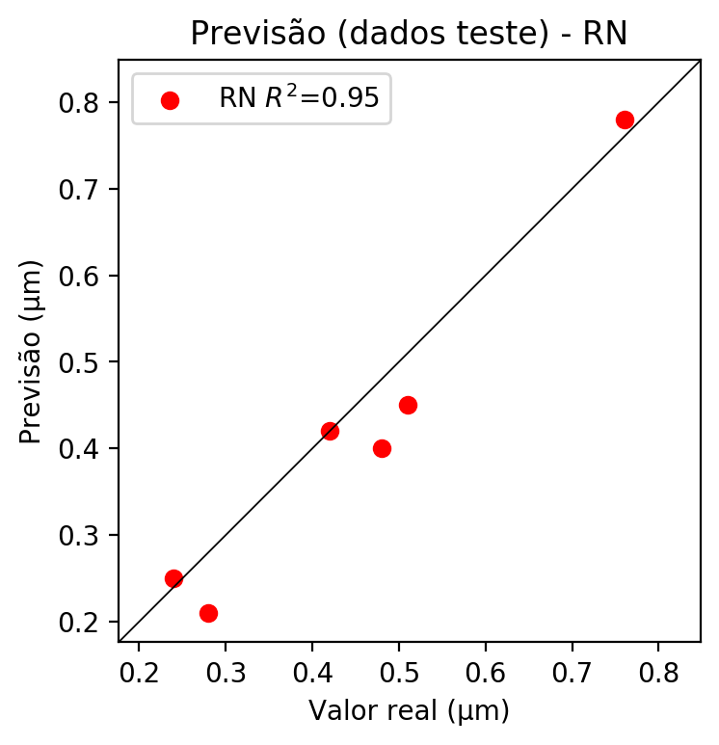

**Dados de treino**

* Erro relativo médio: 0.0
* Coeficiente de correlação: 1.0
* Coeficiente de determinação: 1.0
* MSE: 0.0
* RMSE: 0.0

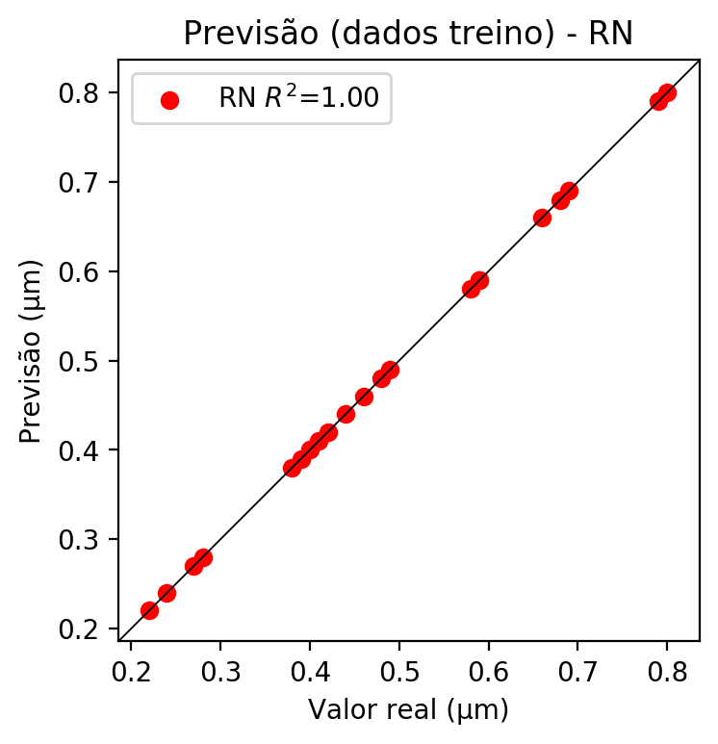

# Pesos

Pesos - camada oculta 1

[[-3.4459186e-01 2.5103205e-01 2.1249960e-04 5.7024646e-01  
 1.0399023e-01 3.6834487e-01 -2.6183507e-01 3.1434226e-01  
 -3.5296673e-01 2.2135752e-01 -9.3593907e-01 -3.2797199e-01  
 3.4611911e-01 -2.4673958e-01 -5.4002804e-01 1.8944278e-01  
 5.4884565e-01 -5.1295704e-01 -1.0528001e+00 -3.9134894e-02  
 3.8232055e-01 1.6285615e-01 -2.6278996e-01 -2.7543902e-01  
 -9.8603660e-01]  
 [ 3.1774405e-01 4.7985937e-02 -2.9949486e-01 -5.3816166e-02  
 -1.2909347e+00 -3.0773425e-01 -1.1091262e-01 5.0672984e-01  
 1.4912917e-01 3.8140774e-01 4.4405782e-01 6.9474858e-01  
 4.1042736e-01 2.0483160e-01 7.6416105e-01 -5.0515449e-01  
 -3.4697759e-01 3.4713674e-01 4.8859885e-01 7.0860702e-01  
 -4.4757685e-01 -4.0451068e-01 -2.7899516e-01 5.0242782e-01  
 4.6731517e-01]  
 [ 6.3481629e-01 3.0587405e-01 3.6190838e-01 1.9858855e-01  
 -2.9343501e-02 7.5205520e-02 6.1068422e-01 -2.9979321e-01  
 -2.7109912e-01 1.7792314e-01 -3.1501937e-01 -5.9847277e-02  
 2.4391869e-01 7.5702566e-01 2.0269440e-01 2.8980854e-01  
 -5.6395084e-01 1.5794957e-01 7.0930280e-02 4.4718087e-01  
 -3.0067128e-01 1.7148988e-01 6.6672689e-01 -1.4910480e-01  
 1.6327776e-01]]

Bias - camada oculta

[-0.5847159 -0.33407795 -0.6239025 -0.5334226 0.02137771 -0.82051843  
 -0.32863662 -0.8625321 -0.5817636 -0.53765756 0.18903688 -0.4798143  
 -0.8334088 -0.6525107 -0.11498157 -0.91077733 -0.6825961 -0.22979884  
 0.19261521 -0.49161807 0.47781485 -0.0727144 -0.20166224 0.06557868  
 0.25329912]

Pesos - camada oculta 2

[[-0.39855707 -0.52586967 0.41047248 -0.4801811 -0.10008962 0.23949489  
 0.6477615 -0.49648222 0.5050107 -0.5150014 0.26450202 -0.3889165  
 -0.5226282 0.6569778 0.43751746 0.6052513 -0.7112261 0.4086042  
 0.0704862 -0.3153659 -0.3111759 -0.35895613 0.13247164 -0.44148615  
 0.3240386 ]  
 [-0.1278687 -0.26036593 -0.30248696 0.02906612 -0.11738326 -0.84968  
 -1.2316786 -0.14370781 -0.54974365 -0.5507318 -0.7241362 0.19940202  
 -0.03529835 -0.13008884 -0.691002 -0.08946253 0.18451753 -0.48520836  
 0.01535918 0.0727131 0.14687358 -0.60549414 -0.8313387 0.06814174  
 -0.4621235 ]  
 [ 0.8572961 0.8183272 -0.01797799 -0.08482307 0.27612317 -0.48943505  
 -0.43764788 0.23905946 -0.21872693 0.2792123 -0.3266642 0.32610086  
 0.32174703 -0.05518809 -0.2713781 -1.0259228 0.46116835 -0.48771435  
 -0.9205479 0.41976184 0.56335163 -0.56311905 -0.62991804 0.17651793  
 -0.52590317]  
 [ 0.25416598 0.715411 -0.29666302 0.05884623 0.10689126 -0.3633453  
 -1.2961107 -0.3657837 0.12170009 0.3080473 -0.34179696 0.51002616  
 0.04635963 -1.1968346 -0.3416919 -0.14465627 0.04605012 -1.1078482  
 -0.3712631 0.3542867 0.25473604 0.263533 -0.5131147 0.45966178  
 -0.78501576]  
 [-0.40270054 -0.77215576 0.7979014 -1.2200922 -0.6635767 -0.5051802  
 -0.1443337 -1.2103465 0.14046492 -0.3122178 0.19995172 -0.8278098  
 -0.30581954 0.38387382 -0.24225262 0.4391715 -0.47307566 -0.50846  
 -0.2693095 -0.78744596 -0.4091192 -0.83532983 -0.5581964 -0.73401546  
 0.06218459]  
 [ 0.37779263 -0.30362093 0.35162765 0.33067968 0.01475526 -0.02196888  
 0.20211266 -0.10955963 0.54844123 -0.30580354 -0.40670255 -0.59271  
 0.81885165 0.019166 -0.33300397 0.03458912 0.0814518 -0.6188602  
 -0.42598513 -0.5462058 0.0781013 -0.2935259 -0.5279127 -0.33275864  
 -0.7988892 ]  
 [-0.27142498 -0.85522145 0.59716886 -0.86162037 0.11570764 -0.14314438  
 0.57015634 0.04418556 0.52887374 -0.63229555 0.34378943 -0.37760484  
 -0.8397796 0.37732914 -0.98864317 0.1140657 -0.28345534 0.3590126  
 -0.12806322 -0.7318512 -0.60259736 -0.4022569 -1.1591059 -0.36592945  
 0.10572175]  
 [-0.4086296 -0.91901934 0.71723706 -0.5404888 -0.16478309 0.40448922  
 0.6306057 -0.16757792 0.36275575 -0.6642551 0.44880074 -0.32771394  
 -0.3127905 0.33955634 -0.71971416 0.545686 -0.8042659 0.48844218  
 0.36046016 -0.4514812 -0.6689205 -0.36341324 0.72781503 -0.7390039  
 0.54252565]  
 [-0.21770358 -0.3108906 0.65620583 -0.422677 0.4506295 -0.9665881  
 -0.14551297 -0.08597287 0.06656264 -0.48556763 0.28960764 -0.6312961  
 -0.71273357 0.13856466 -0.6768411 0.00317638 0.0511496 0.3458511  
 0.20180415 -0.33519715 -0.15983105 -0.4614175 -0.7491207 -0.4067648  
 0.34975836]  
 [-0.7685907 -0.0385026 0.09992968 -0.36157462 0.29561186 -0.9138297  
 -0.39338163 -0.1944963 -0.15029624 -0.6156433 0.51256937 0.10992797  
 -0.64907223 0.27921748 -0.98036087 0.09517047 -0.3115783 0.13568278  
 -0.0039549 -0.38562596 -0.13296764 -0.56015027 -0.6332711 -0.5715475  
 0.32916293]  
 [-0.11941828 -0.78104174 0.5381877 -0.5810848 0.5760805 0.020369  
 0.1152469 0.08717141 0.2355114 -1.1922654 -0.9172856 -0.24895895  
 0.0243689 -0.3564518 -0.83473206 -0.75117177 -0.06654048 -0.8273687  
 -0.827577 -0.330805 -0.0607172 -0.527936 -0.861054 -0.9539853  
 -1.0199739 ]  
 [-0.7832196 -0.4665322 -0.20764288 -0.5928421 0.27253988 -0.6270302  
 -0.11218302 -0.5080317 -0.37497798 -0.7243366 0.3698078 -0.07858662  
 -0.6838947 -0.314422 -0.662605 -0.1019484 -0.24554072 -0.72058177  
 -0.03154746 -0.39258102 0.02272473 -0.67362744 -1.0121808 -0.9824744  
 0.14792225]  
 [-0.9401397 -0.14215538 -0.40741232 0.61114234 0.77175957 -0.48185396  
 -0.685222 -0.24544589 -0.05217541 0.23635653 -0.43552175 0.0481351  
 -0.748296 -0.55882174 -0.6668533 0.12923546 -0.1692527 -0.5930911  
 -0.19565412 -0.2991085 0.17687689 -0.7790433 -0.66794556 -0.81962216  
 -0.34611467]  
 [-0.7409357 -0.8651141 0.4185001 -0.70958734 0.2589387 0.04472595  
 0.58693695 -0.25278777 0.17363903 -0.39823267 0.2976891 -0.59258217  
 -0.270235 0.6225293 -0.8360096 0.17567086 -0.90904105 0.6619217  
 0.01577968 -0.54249626 -0.18922642 -0.49508727 -1.0285206 -0.85440415  
 0.31704587]  
 [-0.19608308 -0.6339583 0.12012423 -0.5499646 0.2973875 -0.23646535  
 -0.03893914 0.07922157 0.1577927 -0.9934789 -0.7372098 -0.774567  
 -0.73774904 0.21003382 -0.52341247 -0.4122819 -0.25887346 -0.55346656  
 -0.0707602 -0.84955657 -0.03045077 -0.72268283 -0.45407307 -1.044924  
 -0.26521248]  
 [ 0.74234694 0.02911428 0.00980582 0.6027114 0.6219096 -0.46767464  
 -0.72407687 0.20405097 -0.43226212 0.5295857 -0.43659124 0.6661928  
 0.70046043 -0.32489842 -0.29103345 -0.05894297 0.50411594 -0.13244148  
 0.38482404 0.34366658 0.4824643 -0.48111024 -0.27177632 -0.6111188  
 -0.56408614]  
 [ 0.2000112 0.3679131 0.486881 -0.18446006 0.36243883 -0.05308494  
 -0.36867672 0.07985292 0.21577151 0.92018884 -0.96808434 0.37589556  
 0.47517776 0.04293874 -0.73071367 -0.59247875 0.5304995 -1.2740135  
 -0.8135332 0.19522351 0.36323234 -0.7007224 -0.82131433 0.25633758  
 -1.191574 ]  
 [ 0.36563665 0.6550965 -0.47895822 0.07530493 0.43685085 -1.0187707  
 -0.675977 0.4090064 -0.76314414 -0.17534132 -0.50825095 0.2925258  
 0.2892837 -0.25777286 -0.44214284 -0.11775872 0.02882924 -0.41958392  
 -0.38974038 0.23981163 0.44113666 0.32052562 -0.28455594 0.00963421  
 -1.1224982 ]  
 [ 0.31530687 0.3471044 -0.6548499 -0.6024913 0.32175353 -0.76996315  
 -0.5460944 0.48718762 -0.5697579 -0.18500547 -0.5391228 0.5011277  
 0.51141363 -0.96364903 -0.8101482 -0.14945799 0.3625033 -0.7147784  
 -0.88781506 0.7333579 0.6954179 0.5751023 -0.484985 -1.0668252  
 -0.5365006 ]  
 [-0.7474062 -0.8878633 0.03104284 -0.7535044 -0.07702067 -0.1637217  
 -0.2796598 -0.7510198 0.3204434 -0.5562977 0.61400616 -0.35535148  
 -0.5920958 0.16233076 -0.32301944 0.15149921 -0.7183233 -0.02563017  
 0.10091745 -0.40852988 -0.41063303 -0.67045194 0.5302192 -0.6218424  
 0.05672578]  
 [-0.3326074 -0.26110145 0.2632439 -0.5569386 -0.05869666 0.29359335  
 -0.0305236 -1.0908484 0.05811425 -0.60349005 0.26118422 -1.012773  
 -0.8585213 0.16439141 -0.25647718 0.00591659 -1.0062917 -0.23934372  
 -0.54388463 -0.94374937 -0.4443746 -0.6558578 -0.52317643 -0.8827598  
 -0.16338849]  
 [-0.789508 -0.4925873 0.52196497 -0.23683251 0.0841013 -0.2791729  
 -0.14061911 -0.7670476 0.16829053 -0.45003083 0.09172139 -0.80506235  
 -0.85525733 0.0051343 -0.28978872 0.14040494 -0.76536536 -0.02045866  
 -0.4256033 -0.44024006 -0.31713036 -0.30178577 0.01226137 -0.7774322  
 0.17604913]  
 [-0.6288482 0.25356156 0.7558099 -0.62385976 0.284407 0.21027349  
 -0.3618483 0.14498955 0.17774527 -0.7694327 0.14779933 -0.61328655  
 -0.10004313 0.12604104 -0.92679304 -0.03439045 -0.03398679 0.46101117  
 -0.31556994 -0.32993257 -0.1949893 -0.84496164 -0.78126603 -0.29823437  
 0.09326038]  
 [-0.15867685 -0.57715696 -0.00906262 -0.43017426 0.08233173 -0.51930875  
 -1.3665086 -0.3995057 -0.03749418 -0.14528598 -0.95611095 0.31125724  
 -0.26669255 -1.232215 -0.6978706 -0.2128885 0.01302726 -0.36822155  
 -0.15130672 0.17395483 0.3675967 -0.2543368 -0.8431879 -0.30390194  
 -0.4284075 ]  
 [ 0.3252704 0.36723924 -0.872151 -0.35463482 0.55178356 -1.1685354  
 -1.204276 0.36674646 -0.9945595 -0.21306194 -0.6601908 0.18843508  
 -0.2692119 -0.02625144 -0.7169266 -0.4204367 0.145361 -0.7655402  
 0.01485481 0.15033723 0.6822551 -0.7343249 -0.6160267 0.34670413  
 -0.809559 ]]

Bias - camada oculta 2

[-0.5534826 -0.60030544 0.222299 -0.4677556 0.2997658 -0.61607623  
 -0.18539707 -0.29405612 0.08472023 -0.8449549 -0.70692873 -0.71701854  
 -0.61944693 -0.01395611 -0.7102293 -0.08292121 -0.27171063 -0.81959623  
 -0.2232761 -0.5846101 -0.32532847 -0.6005442 -0.7289267 -0.68260455  
 -0.7680765 ]

Pesos - camada saída

[[-0.09895814 -0.49715146 -0.43654007 0.3267343 0.35061094 0.06656623  
 -0.12897432 0.0815139 -0.0615131 -0.12853262 0.23547362 0.01044857  
 -0.24551423 -0.07746281 0.592836 -0.03273283 0.00342007 0.4891183  
 0.3149957 -0.03810205 0.14976393 -0.26552856 0.36562493 -0.57253367  
 0.13618165]]

# Iterações

|  |  |  |  |  |  |  |
| --- | --- | --- | --- | --- | --- | --- |
| Média | Desvio | n | ln | 2° camada | Função | Épocas |
| -0.0272 | 0.0186 | 10 | 0.1 | False | relu | 38 |
| -0.0208 | 0.0128 | 17 | 0.1 | True | relu | 716 |
| -0.125 | 0.1229 | 7 | 0.01 | True | tanh | 130 |
| -0.5413 | 0.3184 | 19 | 0.001 | False | tanh | 282 |
| -0.1611 | 0.1548 | 29 | 0.001 | False | relu | 469 |
| -0.0339 | 0.0363 | 88 | 0.1 | False | tanh | 926 |
| -0.0371 | 0.0155 | 95 | 0.0001 | True | relu | 984 |
| -0.0625 | 0.0387 | 10 | 0.01 | True | tanh | 865 |
| -0.7716 | 0.534 | 58 | 0.001 | True | relu | 8 |
| -0.0704 | 0.0638 | 9 | 0.01 | False | tanh | 514 |
| -0.0839 | 0.0621 | 73 | 0.0001 | True | relu | 729 |
| -0.1012 | 0.0423 | 22 | 0.001 | True | relu | 543 |
| -0.0161 | 0.0071 | 25 | 0.1 | True | relu | 562 |
| -0.1589 | 0.1517 | 53 | 0.001 | False | relu | 498 |
| -0.0241 | 0.0127 | 83 | 0.01 | True | relu | 337 |
| -0.7361 | 0.3532 | 99 | 0.01 | False | tanh | 16 |
| -0.0549 | 0.0789 | 23 | 0.01 | False | relu | 472 |
| -0.0365 | 0.0223 | 24 | 0.001 | True | relu | 778 |
| -0.0658 | 0.0274 | 58 | 0.01 | True | tanh | 382 |
| -0.087 | 0.1241 | 35 | 0.1 | False | tanh | 596 |

# RL

# Coeficientes

[ 0. -0.60239617 0.78402027 0.0244216 ]

# Erros

**Dados de teste**

* Erro relativo médio: 10.22
* Coeficiente de correlação: 0.98
* Coeficiente de determinação: 0.95
* MSE: 0.0
* RMSE: 0.0

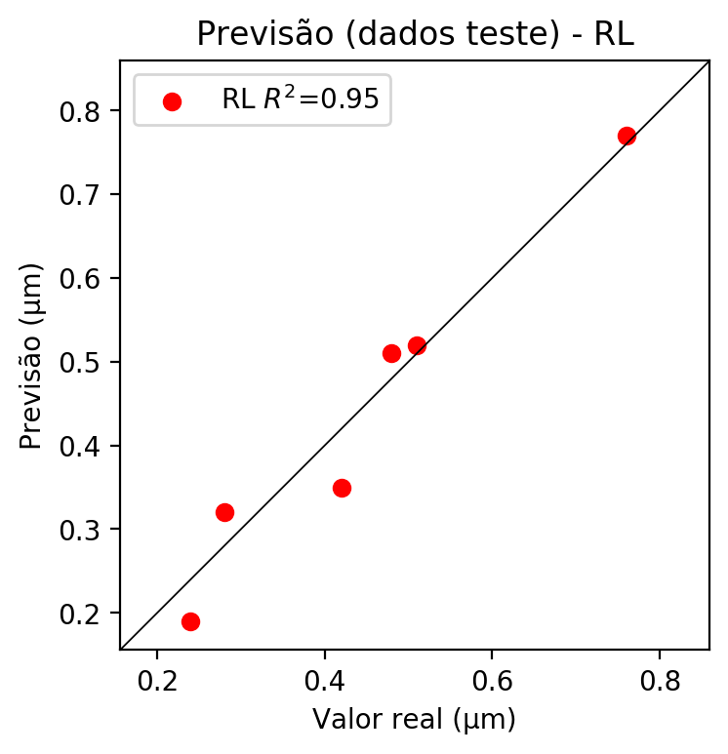

**Dados de treino**

* Erro relativo médio: 9.81
* Coeficiente de correlação: 0.96
* Coeficiente de determinação: 0.92
* MSE: 0.0
* RMSE: 0.0

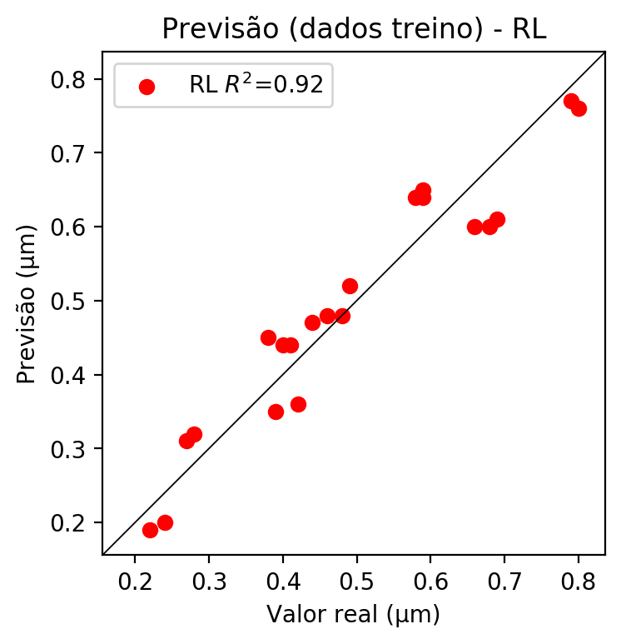

# RP2

# Coeficientes

[ 0. -0.61015372 0.771944 0.0349186 0.23865709 -0.16540043  
 0.02282816 -0.22075846 0.02489849 -0.0401214 ]

# Erros

**Dados de teste**

* Erro relativo médio: 4.71
* Coeficiente de correlação: 0.99
* Coeficiente de determinação: 0.99
* MSE: 0.0
* RMSE: 0.0

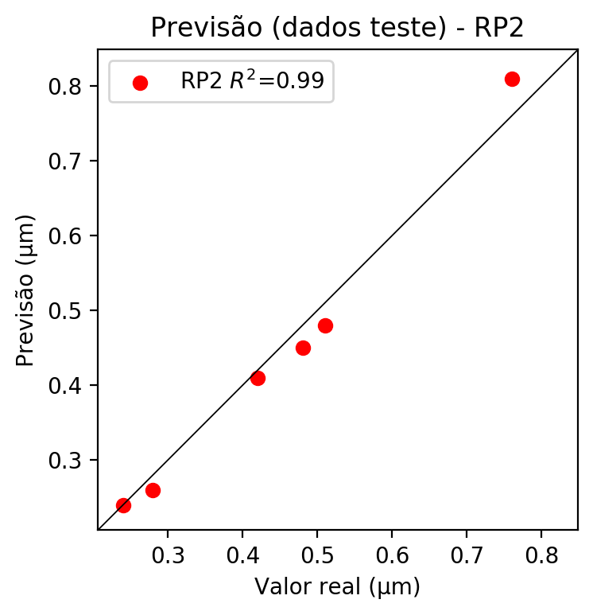

**Dados de treino**

* Erro relativo médio: 1.7
* Coeficiente de correlação: 1.0
* Coeficiente de determinação: 0.99
* MSE: 0.0
* RMSE: 0.0

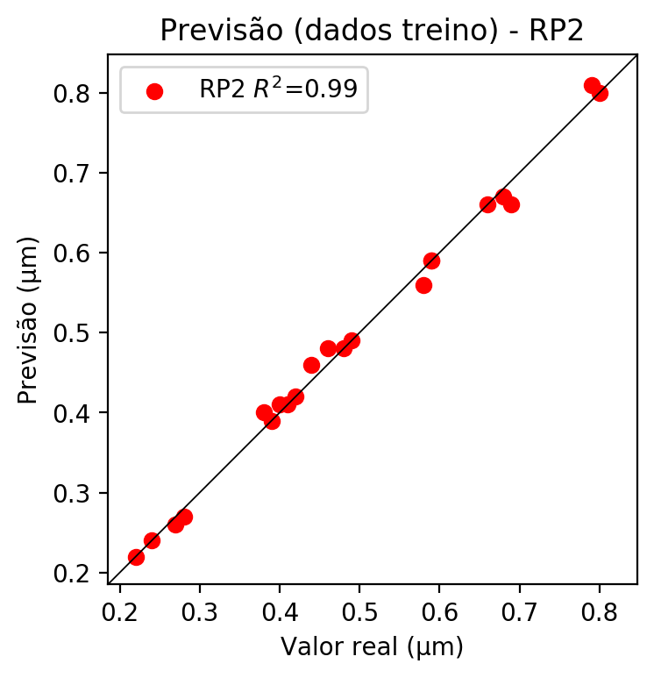

# RP3

# Coeficientes

[ 0. -0.1759949 0.23522748 0.01074188 0.30225676 -0.16190086  
 -0.00650467 -0.1978242 0.0280757 -0.08845234 -0.25421486 0.0117915  
 0.03233882 0.05665039 -0.04150228 -0.08226298 0.33977302 -0.04467241  
 0.06587023 0.01551605]

# Erros

**Dados de teste**

* Erro relativo médio: 11.66
* Coeficiente de correlação: 0.98
* Coeficiente de determinação: 0.97
* MSE: 0.0
* RMSE: 0.0

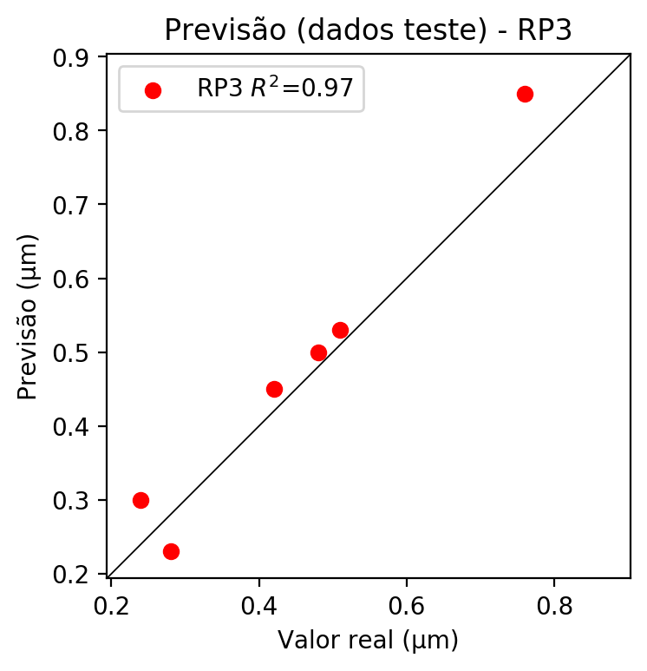

**Dados de treino**

* Erro relativo médio: 1.52
* Coeficiente de correlação: 1.0
* Coeficiente de determinação: 1.0
* MSE: 0.0
* RMSE: 0.0

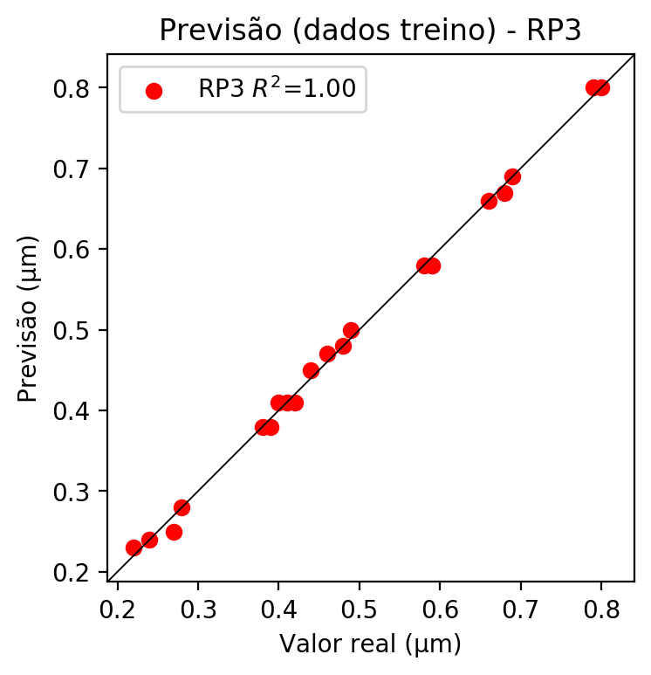

# RP4

# Coeficientes

[ 0.00000000e+00 -1.67872524e-01 2.42167281e-01 1.56236956e-02  
 1.20315627e-01 -1.38214085e-02 2.70526930e-16 -5.84986522e-02  
 8.00412004e-03 -3.89991015e-02 -2.42482535e-01 5.73556694e-02  
 1.66919824e-02 5.94882077e-02 -6.67679298e-02 -9.19815513e-02  
 3.49797184e-01 -5.11422164e-02 3.44502340e-02 2.25675603e-02  
 1.73789239e-01 -1.99642567e-02 1.74436640e-16 -4.77228016e-02  
 -2.95515169e-02 -7.09043234e-03 -1.99642567e-02 -2.77771378e-02  
 -5.37798966e-02 1.74436640e-16 -8.44980532e-02 1.15615067e-02  
 4.07785172e-02 1.15615067e-02 -5.63320355e-02]

# Erros

**Dados de teste**

* Erro relativo médio: 13.36
* Coeficiente de correlação: 0.99
* Coeficiente de determinação: 0.98
* MSE: 0.0
* RMSE: 0.0

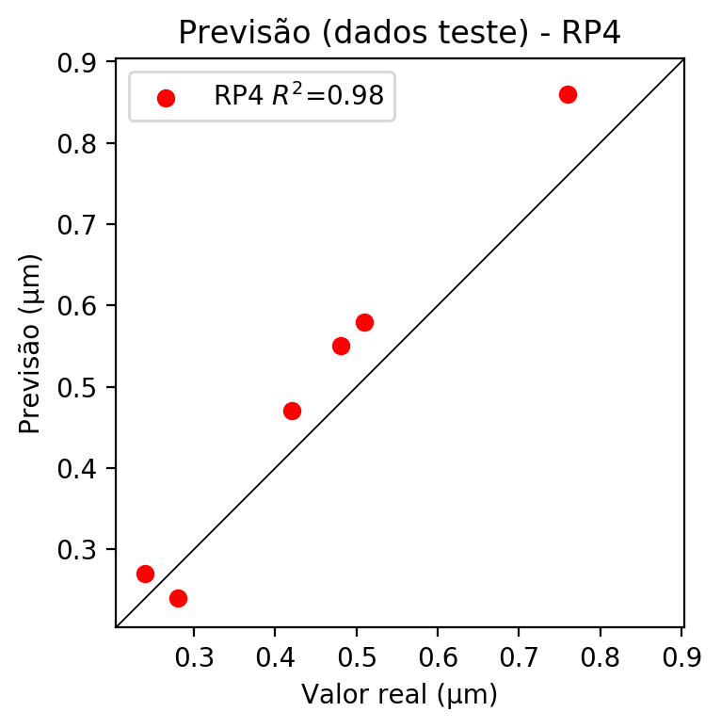

**Dados de treino**

* Erro relativo médio: 0.0
* Coeficiente de correlação: 1.0
* Coeficiente de determinação: 1.0
* MSE: 0.0
* RMSE: 0.0

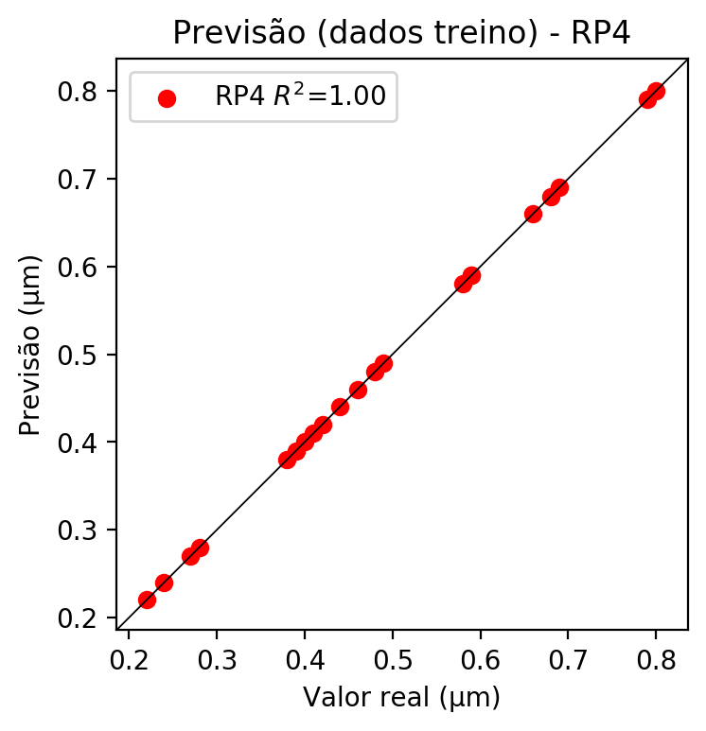

# Geral

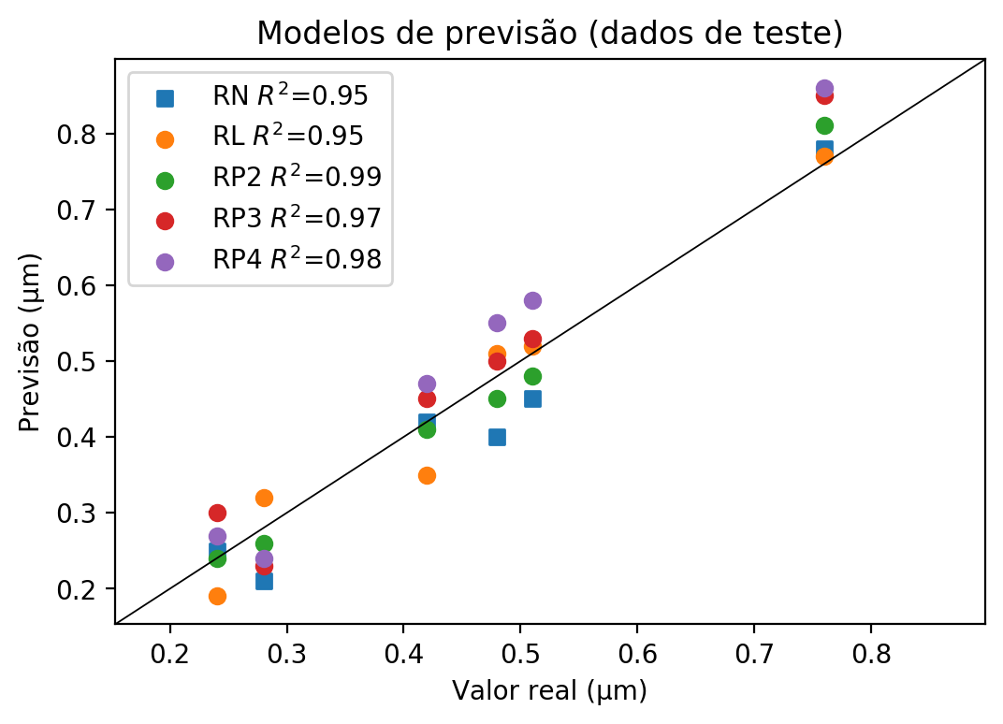

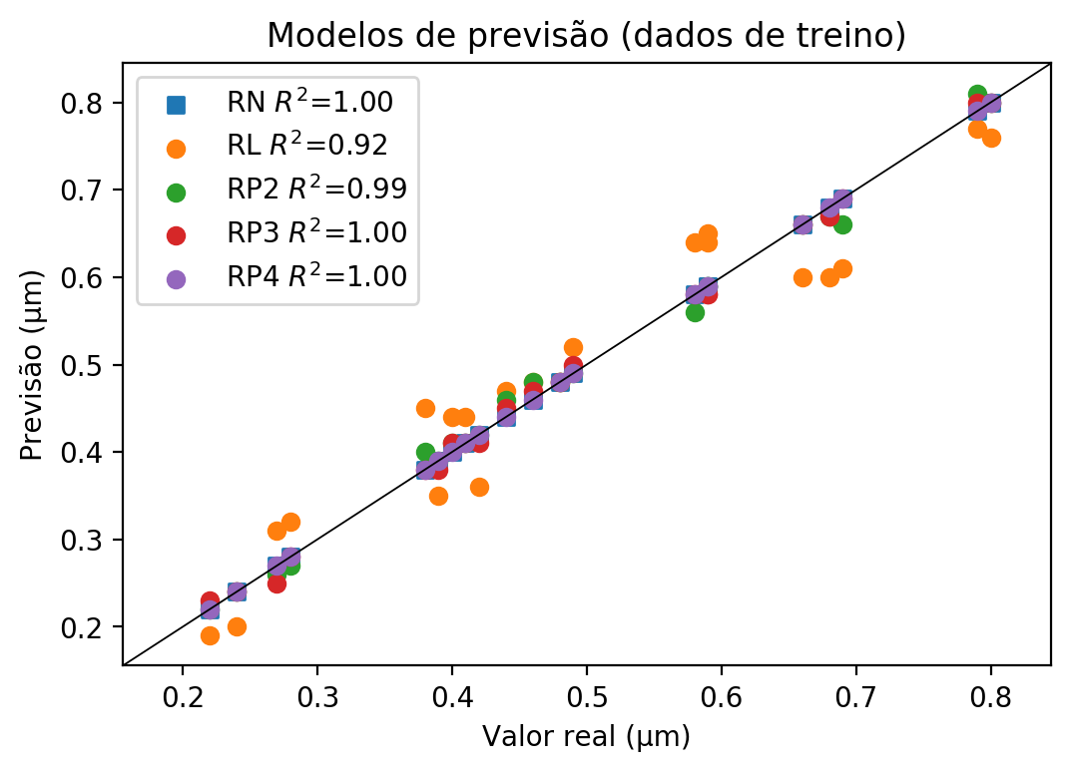

**Dados de teste**

|  |  |  |  |  |  |  |  |  |  |  |
| --- | --- | --- | --- | --- | --- | --- | --- | --- | --- | --- |
| Valor real | RN Previsto | RN Erro (%) | RL Previsto | RL Erro (%) | RP2 Previsto | RP2 Erro (%) | RP3 Previsto | RP3 Erro (%) | RP4 Previsto | RP4 Erro (%) |
| 0.24 | 0.25 | 4.17 | 0.19 | 20.83 | 0.24 | 0.0 | 0.3 | 25.0 | 0.27 | 12.5 |
| 0.76 | 0.78 | 2.63 | 0.77 | 1.32 | 0.81 | 6.58 | 0.85 | 11.84 | 0.86 | 13.16 |
| 0.48 | 0.4 | 16.67 | 0.51 | 6.25 | 0.45 | 6.25 | 0.5 | 4.17 | 0.55 | 14.58 |
| 0.51 | 0.45 | 11.76 | 0.52 | 1.96 | 0.48 | 5.88 | 0.53 | 3.92 | 0.58 | 13.73 |
| 0.28 | 0.21 | 25.0 | 0.32 | 14.29 | 0.26 | 7.14 | 0.23 | 17.86 | 0.24 | 14.29 |
| 0.42 | 0.42 | 0.0 | 0.35 | 16.67 | 0.41 | 2.38 | 0.45 | 7.14 | 0.47 | 11.9 |

**Dados de treino**

|  |  |  |  |  |  |  |  |  |  |  |
| --- | --- | --- | --- | --- | --- | --- | --- | --- | --- | --- |
| Valor real | RN Previsto | RN Erro (%) | RL Previsto | RL Erro (%) | RP2 Previsto | RP2 Erro (%) | RP3 Previsto | RP3 Erro (%) | RP4 Previsto | RP4 Erro (%) |
| 0.69 | 0.69 | 0.0 | 0.61 | 11.59 | 0.66 | 4.35 | 0.69 | 0.0 | 0.69 | 0.0 |
| 0.46 | 0.46 | 0.0 | 0.48 | 4.35 | 0.48 | 4.35 | 0.47 | 2.17 | 0.46 | 0.0 |
| 0.59 | 0.59 | 0.0 | 0.64 | 8.47 | 0.59 | 0.0 | 0.58 | 1.69 | 0.59 | 0.0 |
| 0.59 | 0.59 | 0.0 | 0.65 | 10.17 | 0.59 | 0.0 | 0.58 | 1.69 | 0.59 | 0.0 |
| 0.49 | 0.49 | 0.0 | 0.52 | 6.12 | 0.49 | 0.0 | 0.5 | 2.04 | 0.49 | 0.0 |
| 0.24 | 0.24 | 0.0 | 0.2 | 16.67 | 0.24 | 0.0 | 0.24 | 0.0 | 0.24 | 0.0 |
| 0.42 | 0.42 | 0.0 | 0.36 | 14.29 | 0.42 | 0.0 | 0.41 | 2.38 | 0.42 | 0.0 |
| 0.8 | 0.8 | 0.0 | 0.76 | 5.0 | 0.8 | 0.0 | 0.8 | 0.0 | 0.8 | 0.0 |
| 0.79 | 0.79 | 0.0 | 0.77 | 2.53 | 0.81 | 2.53 | 0.8 | 1.27 | 0.79 | 0.0 |
| 0.4 | 0.4 | 0.0 | 0.44 | 10.0 | 0.41 | 2.5 | 0.41 | 2.5 | 0.4 | 0.0 |
| 0.38 | 0.38 | 0.0 | 0.45 | 18.42 | 0.4 | 5.26 | 0.38 | 0.0 | 0.38 | 0.0 |
| 0.28 | 0.28 | 0.0 | 0.32 | 14.29 | 0.27 | 3.57 | 0.28 | 0.0 | 0.28 | 0.0 |
| 0.58 | 0.58 | 0.0 | 0.64 | 10.34 | 0.56 | 3.45 | 0.58 | 0.0 | 0.58 | 0.0 |
| 0.41 | 0.41 | 0.0 | 0.44 | 7.32 | 0.41 | 0.0 | 0.41 | 0.0 | 0.41 | 0.0 |
| 0.39 | 0.39 | 0.0 | 0.35 | 10.26 | 0.39 | 0.0 | 0.38 | 2.56 | 0.39 | 0.0 |
| 0.68 | 0.68 | 0.0 | 0.6 | 11.76 | 0.67 | 1.47 | 0.67 | 1.47 | 0.68 | 0.0 |
| 0.27 | 0.27 | 0.0 | 0.31 | 14.81 | 0.26 | 3.7 | 0.25 | 7.41 | 0.27 | 0.0 |
| 0.22 | 0.22 | 0.0 | 0.19 | 13.64 | 0.22 | 0.0 | 0.23 | 4.55 | 0.22 | 0.0 |
| 0.66 | 0.66 | 0.0 | 0.6 | 9.09 | 0.66 | 0.0 | 0.66 | 0.0 | 0.66 | 0.0 |
| 0.48 | 0.48 | 0.0 | 0.48 | 0.0 | 0.48 | 0.0 | 0.48 | 0.0 | 0.48 | 0.0 |
| 0.44 | 0.44 | 0.0 | 0.47 | 6.82 | 0.46 | 4.55 | 0.45 | 2.27 | 0.44 | 0.0 |