# Informações do estudo

Referência: Aouici

Grandeza: Rugosidade

Tipo: Rt

Material: X38CrMoV5-1 (50 HRC)

Ferramenta: CBN7020

Número de experimentos: 27

Observações:  
Tool holder: PSBNR 25 x 25 K12  
Diameter: 80 mm  
Dynanometer: Kistler 9257B

# Unidades

Velocidade: m/min

Avanço: mm/rev

Profundidade de corte: mm

Rugosidade: μm

# Dados de teste

|  |  |  |  |
| --- | --- | --- | --- |
| Rugosidade | n | f | a |
| 2.1 | 240.0 | 0.08 | 0.3 |
| 5.1 | 120.0 | 0.16 | 0.45 |
| 3.5 | 240.0 | 0.16 | 0.45 |
| 3.7 | 240.0 | 0.16 | 0.3 |
| 2.4 | 180.0 | 0.08 | 0.3 |
| 3.2 | 240.0 | 0.12 | 0.3 |

# Dados de treino

|  |  |  |  |
| --- | --- | --- | --- |
| Rugosidade | n | f | a |
| 5.0 | 120.0 | 0.12 | 0.15 |
| 3.4 | 180.0 | 0.12 | 0.15 |
| 4.2 | 180.0 | 0.16 | 0.3 |
| 4.2 | 180.0 | 0.16 | 0.45 |
| 3.6 | 240.0 | 0.16 | 0.15 |
| 2.0 | 240.0 | 0.08 | 0.15 |
| 3.2 | 120.0 | 0.08 | 0.45 |
| 5.6 | 120.0 | 0.16 | 0.15 |
| 5.4 | 120.0 | 0.16 | 0.3 |
| 3.1 | 240.0 | 0.12 | 0.45 |
| 3.0 | 120.0 | 0.08 | 0.15 |
| 2.3 | 180.0 | 0.08 | 0.15 |
| 4.2 | 180.0 | 0.16 | 0.15 |
| 3.1 | 120.0 | 0.08 | 0.3 |
| 3.0 | 240.0 | 0.12 | 0.15 |
| 4.8 | 120.0 | 0.12 | 0.3 |
| 2.2 | 180.0 | 0.08 | 0.45 |
| 2.0 | 240.0 | 0.08 | 0.45 |
| 4.6 | 120.0 | 0.12 | 0.45 |
| 3.5 | 180.0 | 0.12 | 0.3 |
| 3.3 | 180.0 | 0.12 | 0.45 |

# RN

Número de neurônios: 83

Taxa de aprendizado: 1.000000e-02

Número de épocas: 337

2° camada: True

Função de ativação: relu

# Erros

**Dados de teste**

* Erro relativo médio: 2.54
* Coeficiente de correlação: 0.99
* Coeficiente de determinação: 0.99
* MSE: 0.02
* RMSE: 0.14

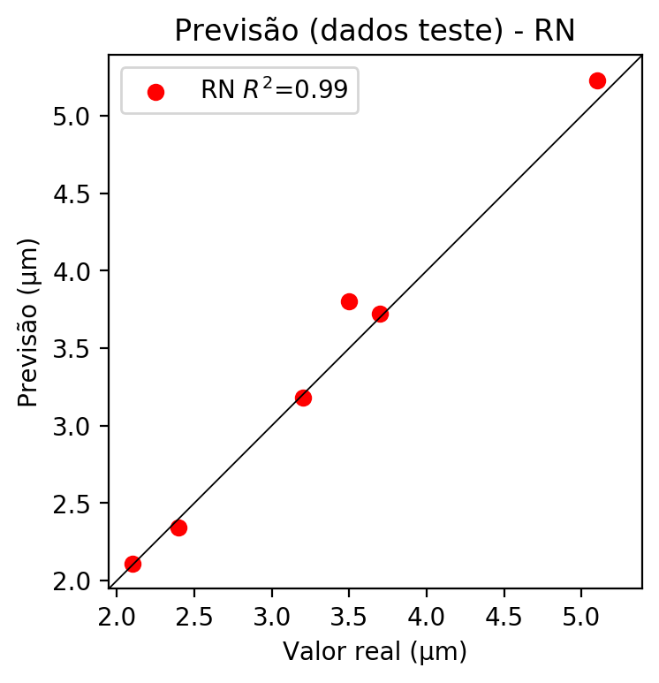

**Dados de treino**

* Erro relativo médio: 0.0
* Coeficiente de correlação: 1.0
* Coeficiente de determinação: 1.0
* MSE: 0.0
* RMSE: 0.0

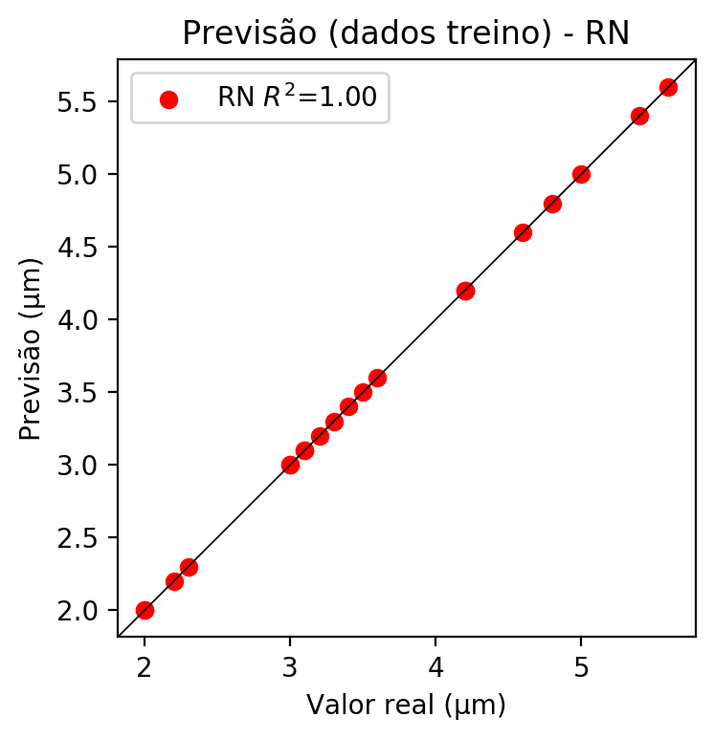

# Pesos

Pesos - camada oculta 1

[[ 1.21658169e-01 7.60501623e-02 -2.15048209e-01 -3.25456299e-02  
 1.40286729e-01 -1.10876910e-01 -3.87933552e-02 6.74773231e-02  
 -5.73533140e-02 1.03370532e-01 -3.29369485e-01 1.51549846e-01  
 5.29350108e-03 -8.20929185e-02 -1.42987311e-01 -4.08982448e-02  
 1.05431981e-01 -3.89406569e-02 -1.59184843e-01 2.71484464e-01  
 1.43967554e-01 2.24757910e-01 -3.43459211e-02 9.27546993e-02  
 4.29413980e-03 -2.65307426e-01 2.56777078e-01 3.45190242e-02  
 1.31972849e-01 -2.62501597e-01 5.14475256e-02 -3.21451932e-01  
 -1.83344066e-01 -1.93094507e-01 5.68451956e-02 -3.12803328e-01  
 3.10852961e-03 1.19656324e-01 -1.64957196e-01 -7.17071369e-02  
 1.12584829e-01 1.97586775e-01 1.69718519e-01 1.93860710e-01  
 6.00192100e-02 7.60738598e-03 -8.69390666e-02 -2.52364904e-01  
 2.00540692e-01 2.55380213e-01 1.57815441e-01 1.42969593e-01  
 1.11535966e-01 -3.92141826e-02 -2.17213165e-02 -2.23000385e-02  
 2.68596467e-02 -4.67952341e-02 -1.45455614e-01 -2.68050641e-01  
 8.00635219e-02 -1.45064041e-01 -1.45855576e-01 1.47838607e-01  
 2.33976394e-01 -2.92114198e-01 -1.12634115e-01 1.22390240e-02  
 -2.27684468e-01 -8.69004130e-02 1.90353636e-02 -1.79695387e-04  
 1.26998546e-02 -1.46627128e-01 9.71852839e-02 -2.57841468e-01  
 5.37823774e-02 1.13400422e-01 4.56593335e-02 -5.24313971e-02  
 1.25692859e-01 -1.72197923e-01 -3.13179821e-01]  
 [ 2.18648929e-02 -8.87207165e-02 2.40071833e-01 3.86503749e-02  
 -2.85130799e-01 -2.69272000e-01 1.71882510e-01 -5.15805334e-02  
 -2.11501762e-01 -3.40618610e-01 1.05587102e-01 -1.39840156e-01  
 -2.30823234e-01 -1.86412781e-01 9.95311365e-02 5.83191551e-02  
 -2.08414704e-01 7.10507855e-02 -1.62843525e-01 2.09314480e-01  
 -1.22772276e-01 -2.69309253e-01 -2.75779694e-01 -8.02474022e-02  
 -1.31851166e-01 8.22959542e-02 1.48417771e-01 8.71603377e-03  
 -1.14996836e-01 2.55043179e-01 1.49760067e-01 9.10872743e-02  
 2.28474110e-01 -9.36350152e-02 -1.23074792e-01 1.20528035e-01  
 -5.69001101e-02 3.84413190e-02 -2.30444133e-01 4.72149719e-03  
 -1.51771635e-01 1.79996192e-01 5.97707368e-02 1.97439179e-01  
 3.01061682e-02 -2.81204194e-01 -2.80606430e-02 1.52198464e-01  
 5.85002191e-02 -3.12981382e-02 3.63529697e-02 2.17940763e-01  
 1.08473584e-01 -6.83396533e-02 3.12149469e-02 -1.15831554e-01  
 1.29331917e-01 -5.03435992e-02 -3.06013256e-01 -7.29131401e-02  
 2.15216614e-02 -6.41075522e-02 -1.67834774e-01 1.88678533e-01  
 1.22277305e-01 2.32902542e-01 1.23231284e-01 2.47363880e-01  
 -3.16441178e-01 -7.07125589e-02 -2.65878260e-01 -1.57558680e-01  
 -3.30559701e-01 1.34089366e-01 1.28921449e-01 1.44889534e-01  
 3.70474346e-02 -6.57096356e-02 1.52371600e-01 -2.50481963e-01  
 -2.53117513e-02 -2.71131366e-01 -1.47922784e-01]  
 [ 1.26024842e-01 -1.46262527e-01 -1.39121249e-01 -4.57858518e-02  
 -1.29445076e-01 9.52578858e-02 -1.63238540e-01 9.57694128e-02  
 -2.38666683e-01 1.05123945e-01 -1.84546381e-01 1.76232427e-01  
 3.33082937e-02 -2.22759411e-01 1.97194800e-01 2.18800485e-01  
 1.23938866e-01 -2.42061242e-02 -9.41740647e-02 -7.23638386e-02  
 1.66516185e-01 2.31511176e-01 1.35737692e-03 -1.52686387e-01  
 -2.44676564e-02 -9.72769931e-02 -1.37211502e-01 8.11428204e-02  
 7.98878968e-02 -7.57685825e-02 4.80404757e-02 7.78681040e-02  
 -1.03955038e-01 -1.84438359e-02 1.42390668e-01 -1.44298702e-01  
 1.69523537e-01 1.15621455e-01 -8.14681202e-02 -3.57319675e-02  
 -1.42922968e-01 1.46923950e-02 -1.04258358e-01 1.87560022e-01  
 6.02104850e-02 -1.05792940e-01 -1.62569329e-01 1.07213683e-01  
 1.57937109e-01 1.22919187e-01 1.80852398e-01 1.24914221e-01  
 7.76216015e-02 1.48055583e-01 1.87201381e-01 1.51858672e-01  
 -4.97823916e-02 3.56101319e-02 1.80059597e-01 -6.19985983e-02  
 2.76292171e-02 -3.59088257e-02 1.17528379e-01 -1.88286945e-01  
 -2.50023782e-01 -8.24953765e-02 -3.51891033e-02 -2.52490640e-01  
 1.60542622e-01 1.61493212e-01 -4.39097099e-02 -9.35934409e-02  
 2.06197634e-01 -1.09244570e-01 6.24506287e-02 -1.97955500e-02  
 7.65202418e-02 -1.12928018e-01 1.52535036e-01 1.36424527e-01  
 1.04893139e-02 2.46377159e-02 -7.23999552e-03]]

Bias - camada oculta

[-0.07852255 -0.0490646 -0.0209167 -0.03683583 0.03320222 -0.04873523  
 -0.05071357 -0.08250394 -0.02352869 0.04881093 0.03649573 -0.01003785  
 -0.01463701 0.00117036 -0.00415066 0.01512393 0.01325933 -0.08147386  
 -0.13115028 -0.06360862 -0.07453139 0.00666196 0.01754419 0.03883505  
 -0.11148816 0.01247461 -0.0494765 -0.03385743 -0.05513315 0.01827435  
 -0.08469968 -0.00698167 -0.03406935 -0.00673744 -0.05553237 -0.01646051  
 -0.0812344 -0.03247495 0.03950718 -0.07211855 0.03949757 -0.10425762  
 0.02655522 -0.11776179 -0.10016821 0.02982979 -0.00065955 0.02257118  
 -0.03711416 0.05457845 -0.01157897 -0.05632346 -0.10923963 -0.08544431  
 -0.11326242 -0.07263584 -0.06237581 -0.11008744 0.02608743 -0.01330915  
 -0.10166047 -0.09299084 -0.08868007 -0.07386956 -0.04833519 -0.00980202  
 0.01447007 -0.02433464 -0.00441571 -0.07600497 0.00497629 -0.06105187  
 0.00355984 -0.07510782 -0.07919877 0.02251521 -0.06762749 -0.09177987  
 -0.03335482 0.02349395 -0.06813387 -0.10577581 0.01536254]

Pesos - camada oculta 2

[[ 0.11514182 -0.02328157 -0.14851798 ... 0.00781628 -0.1306509  
 -0.20031142]  
 [-0.03559602 -0.17772855 0.19107458 ... -0.09131205 -0.09094961  
 -0.1611433 ]  
 [ 0.12015989 -0.0879219 -0.2044773 ... 0.0659909 -0.08765224  
 -0.03441227]  
 ...  
 [ 0.07297013 0.01526847 0.1657197 ... -0.02897266 -0.07596741  
 0.14273083]  
 [-0.18904698 -0.09626146 0.14121471 ... 0.1647367 0.0828317  
 -0.07836517]  
 [ 0.09931418 -0.04762377 0.04302381 ... 0.13116342 0.08066152  
 -0.19443782]]

Bias - camada oculta 2

[-1.68750063e-02 -1.08024970e-01 -1.63033213e-02 -2.70282310e-02  
 -6.90783039e-02 -5.48278801e-02 3.24436650e-02 3.60170077e-03  
 -1.07360957e-02 -3.56531190e-03 -3.05497479e-02 1.37327081e-02  
 -7.11240806e-03 -2.81804067e-04 -7.43579715e-02 -7.64804408e-02  
 -2.11189613e-02 3.28515694e-02 5.45722432e-02 2.73607653e-02  
 -1.99521370e-02 2.90764160e-02 2.91958805e-02 -4.96376451e-05  
 -1.53703904e-02 3.22921164e-02 -5.18780723e-02 -7.17153922e-02  
 2.09814943e-02 -5.95658571e-02 -1.42084941e-01 4.57424857e-02  
 6.91574216e-02 -5.45963980e-02 -3.59182362e-03 7.80779077e-03  
 -7.93470666e-02 -2.04189159e-02 -1.31000221e-01 -3.66680464e-03  
 2.32228544e-02 -9.45047140e-02 -6.54271394e-02 -4.58580777e-02  
 -4.53746282e-02 5.66177396e-03 -7.98177496e-02 -7.62470514e-02  
 5.02204932e-02 -6.96157739e-02 3.87668274e-02 -6.84556216e-02  
 -1.43211219e-03 5.63961156e-02 -8.99554715e-02 -1.00192092e-01  
 -1.24246128e-01 -4.26355377e-02 -2.30684672e-02 -9.18181166e-02  
 2.79592499e-02 -6.96835145e-02 3.70728932e-02 -6.00490011e-02  
 2.29877383e-02 -1.85204148e-02 -9.91094951e-03 1.72443874e-02  
 -6.00524656e-02 -5.27624413e-02 3.34394947e-02 -1.36884496e-01  
 -1.22586966e-01 0.00000000e+00 1.09722954e-03 3.64176966e-02  
 -1.04848482e-02 -7.56860077e-02 -1.45713962e-03 -9.81215835e-02  
 1.54684158e-02 3.88724282e-02 -8.42693448e-02]

Pesos - camada saída

[[ 0.10783331 -0.05786817 -0.13086563 0.01896617 0.08570991 -0.03908146  
 -0.02033633 -0.00227217 -0.01923486 0.08899851 -0.26079535 0.14845331  
 0.05490473 -0.04166362 -0.05692023 -0.0340195 0.00418826 -0.03107656  
 -0.21734075 0.23261996 0.18889068 0.17102496 -0.06440928 0.11529783  
 -0.03611989 -0.15672803 0.18400896 0.00257274 0.21159714 -0.09663466  
 0.0423895 -0.26417944 -0.1676612 -0.11726744 0.04499239 -0.18765503  
 0.01632744 0.0773232 -0.14088036 -0.04822179 0.07142515 0.04099297  
 0.12477206 0.15027028 0.04579419 -0.05432677 0.01384118 -0.10539585  
 0.25679868 0.20011915 0.17986967 0.10347319 0.03272332 -0.03911266  
 -0.02948832 -0.05866846 -0.02886418 0.03092913 -0.18151155 -0.11360961  
 0.2126063 -0.1139333 -0.22321971 0.00926583 0.27996275 -0.2266049  
 -0.03361223 0.09892538 -0.16696486 -0.05034588 -0.08297075 -0.02749244  
 0.04436926 -0.19389391 0.05449077 -0.10805923 0.00051253 0.10744975  
 0.02237919 0.00766927 0.20645326 -0.26002684 -0.16774102]]

# Iterações

|  |  |  |  |  |  |  |
| --- | --- | --- | --- | --- | --- | --- |
| Média | Desvio | n | ln | 2° camada | Função | Épocas |
| -0.0503 | 0.0268 | 10 | 0.1 | False | relu | 38 |
| -0.0284 | 0.0152 | 17 | 0.1 | True | relu | 716 |
| -0.0759 | 0.0603 | 7 | 0.01 | True | tanh | 130 |
| -0.3902 | 0.2322 | 19 | 0.001 | False | tanh | 282 |
| -0.2432 | 0.1956 | 29 | 0.001 | False | relu | 469 |
| -0.0387 | 0.0148 | 88 | 0.1 | False | tanh | 926 |
| -0.0331 | 0.0184 | 95 | 0.0001 | True | relu | 984 |
| -0.0255 | 0.0165 | 10 | 0.01 | True | tanh | 865 |
| -0.781 | 0.4592 | 58 | 0.001 | True | relu | 8 |
| -0.0829 | 0.0604 | 9 | 0.01 | False | tanh | 514 |
| -0.0603 | 0.025 | 73 | 0.0001 | True | relu | 729 |
| -0.0904 | 0.0605 | 22 | 0.001 | True | relu | 543 |
| -0.0413 | 0.017 | 25 | 0.1 | True | relu | 562 |
| -0.1814 | 0.1364 | 53 | 0.001 | False | relu | 498 |
| -0.0164 | 0.0093 | 83 | 0.01 | True | relu | 337 |
| -0.6088 | 0.3716 | 99 | 0.01 | False | tanh | 16 |
| -0.0485 | 0.0344 | 23 | 0.01 | False | relu | 472 |
| -0.0484 | 0.0269 | 24 | 0.001 | True | relu | 778 |
| -0.0465 | 0.056 | 58 | 0.01 | True | tanh | 382 |
| -0.2424 | 0.1604 | 35 | 0.1 | False | tanh | 596 |

# RL

# Coeficientes

[ 0. -0.62945466 0.7798766 -0.0220685 ]

# Erros

**Dados de teste**

* Erro relativo médio: 7.97
* Coeficiente de correlação: 0.98
* Coeficiente de determinação: 0.96
* MSE: 0.07
* RMSE: 0.26

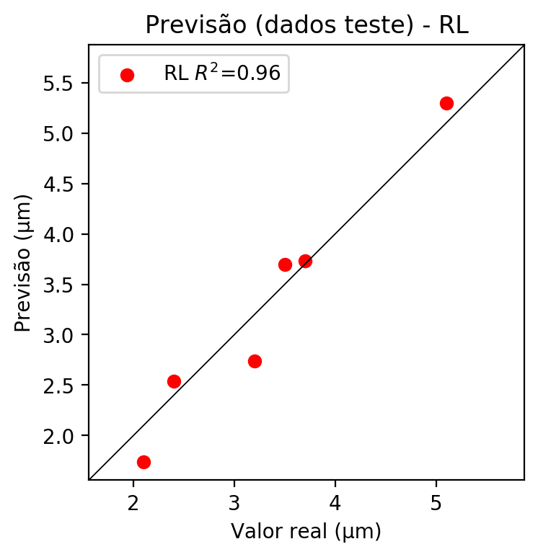

**Dados de treino**

* Erro relativo médio: 8.12
* Coeficiente de correlação: 0.96
* Coeficiente de determinação: 0.92
* MSE: 0.09
* RMSE: 0.3

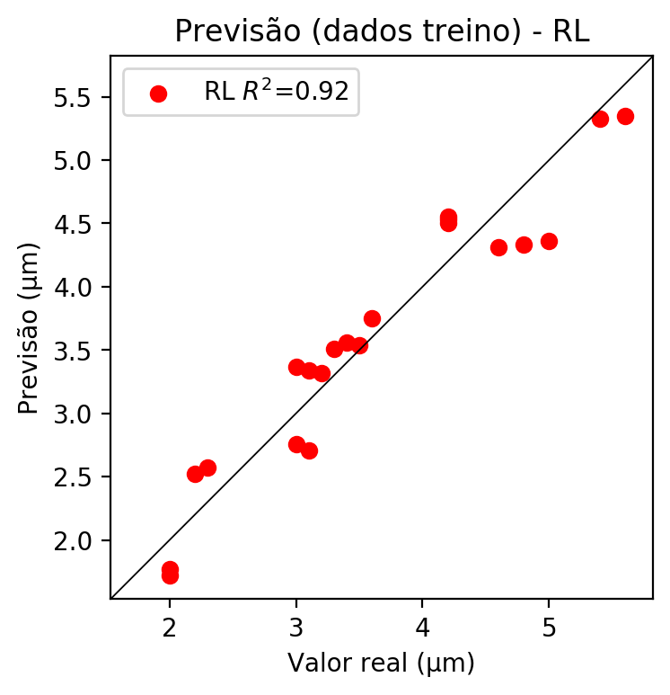

# RP2

# Coeficientes

[ 0. -0.6290882 0.77688685 -0.02280718 0.25506482 -0.13652795  
 0.01865655 -0.21492665 -0.01754851 0.00685912]

# Erros

**Dados de teste**

* Erro relativo médio: 5.28
* Coeficiente de correlação: 1.0
* Coeficiente de determinação: 0.99
* MSE: 0.04
* RMSE: 0.2

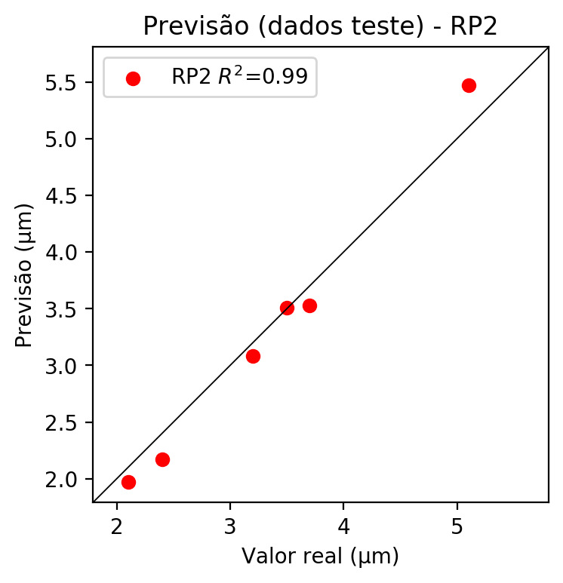

**Dados de treino**

* Erro relativo médio: 2.32
* Coeficiente de correlação: 0.99
* Coeficiente de determinação: 0.99
* MSE: 0.01
* RMSE: 0.1

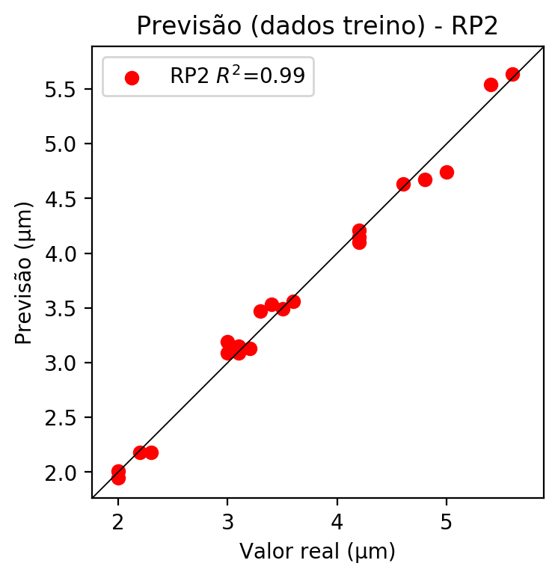

# RP3

# Coeficientes

[ 0. -0.2093752 0.24606615 -0.02770043 0.30320275 -0.04592211  
 0.08452502 -0.16103843 0.01937178 -0.03928453 -0.30243084 0.06017018  
 0.03428458 0.14479461 0.09868125 -0.03297477 0.35542889 0.061534  
 0.00429401 -0.04001173]

# Erros

**Dados de teste**

* Erro relativo médio: 8.52
* Coeficiente de correlação: 0.95
* Coeficiente de determinação: 0.9
* MSE: 0.19
* RMSE: 0.44

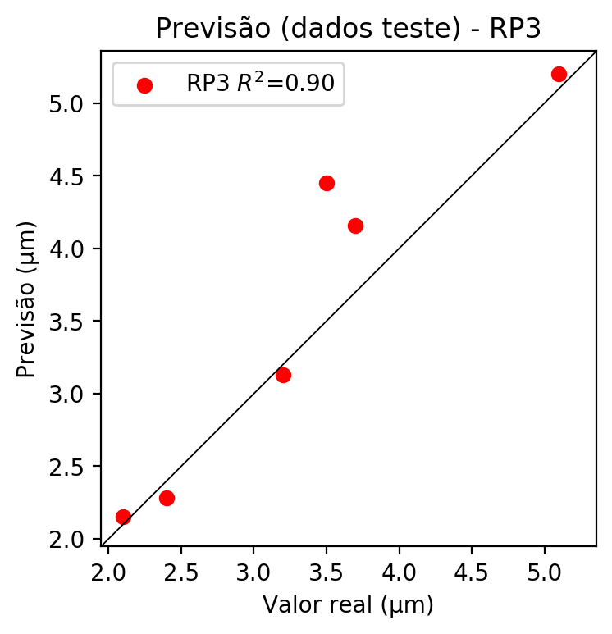

**Dados de treino**

* Erro relativo médio: 0.91
* Coeficiente de correlação: 1.0
* Coeficiente de determinação: 1.0
* MSE: 0.0
* RMSE: 0.0

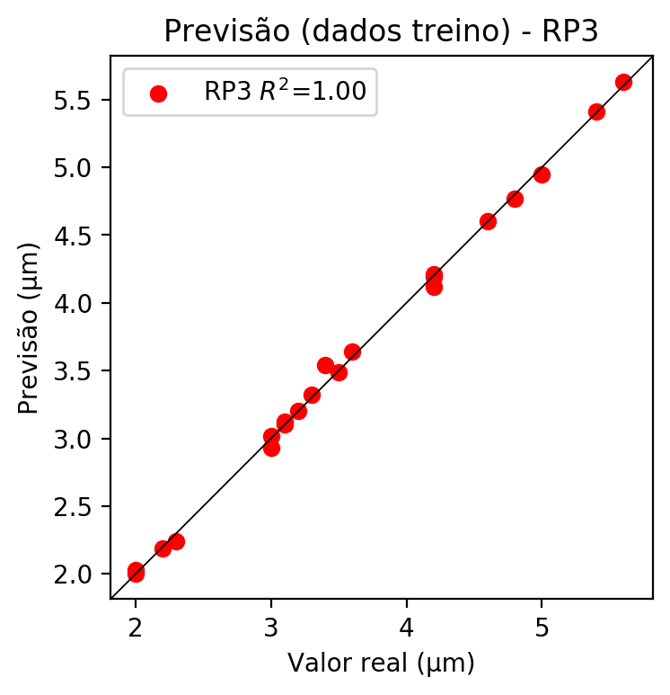

# RP4

# Coeficientes

[-2.77555756e-17 -1.78529899e-01 2.08269654e-01 -1.27527286e-02  
 1.27337845e-01 -4.53851997e-02 1.58277321e-02 -2.47380652e-02  
 3.16554641e-03 -3.18327347e-02 -2.57876521e-01 -1.36247100e-02  
 -1.36247100e-02 7.27183521e-02 3.18442220e-02 -9.53907068e-02  
 3.00833945e-01 1.36247100e-02 8.63430621e-02 -1.84206080e-02  
 1.83932443e-01 -6.55563996e-02 2.28622796e-02 -1.36037328e-01  
 -5.66822199e-02 -1.13512018e-02 -6.55563996e-02 -5.28591136e-02  
 7.56648766e-02 2.28622796e-02 -3.57327608e-02 4.57245593e-03  
 -3.82310633e-03 4.57245593e-03 -4.59806168e-02]

# Erros

**Dados de teste**

* Erro relativo médio: 8.06
* Coeficiente de correlação: 0.98
* Coeficiente de determinação: 0.95
* MSE: 0.07
* RMSE: 0.26

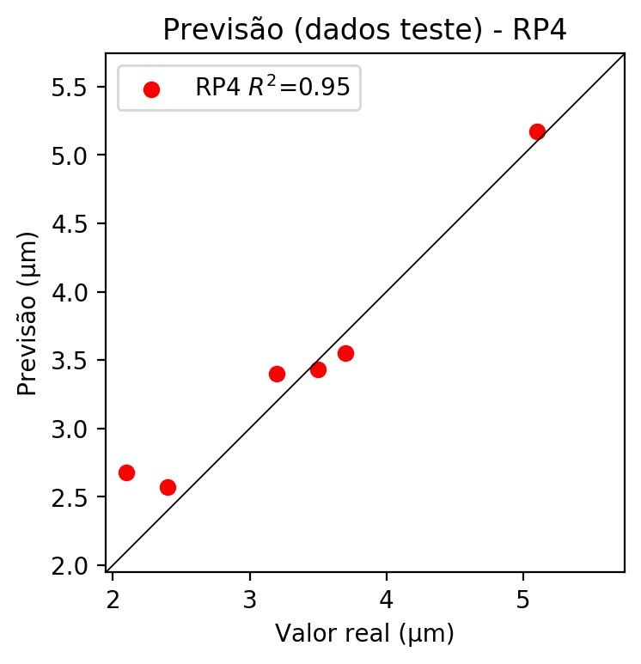

**Dados de treino**

* Erro relativo médio: 0.0
* Coeficiente de correlação: 1.0
* Coeficiente de determinação: 1.0
* MSE: 0.0
* RMSE: 0.0

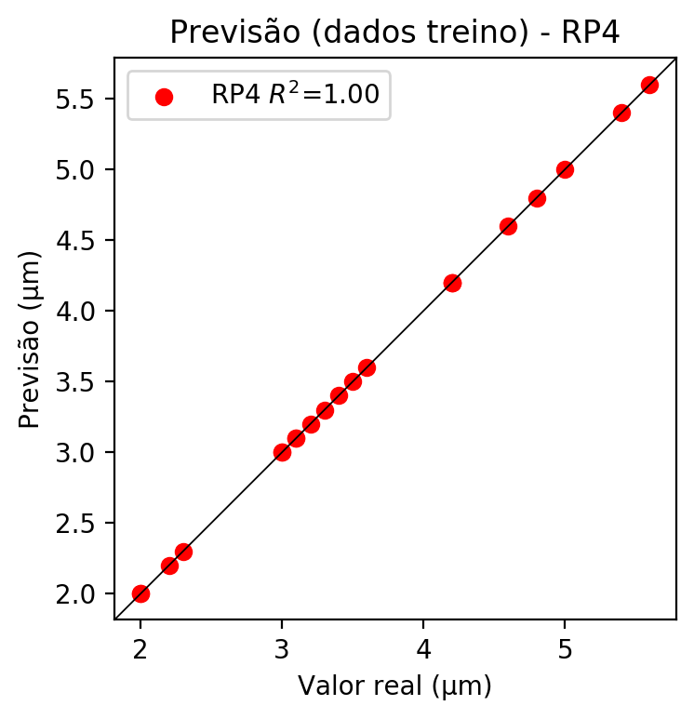

# Geral

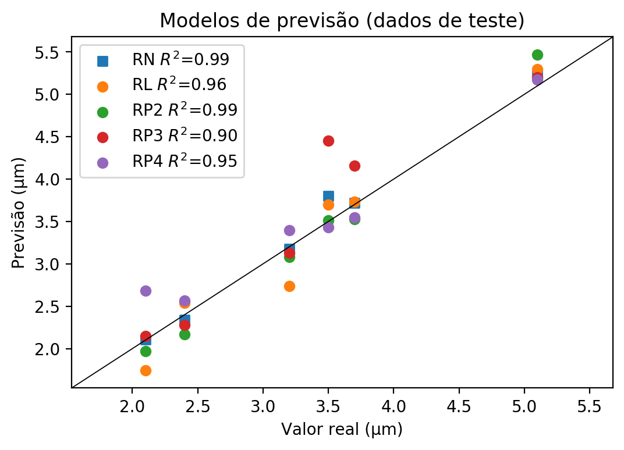

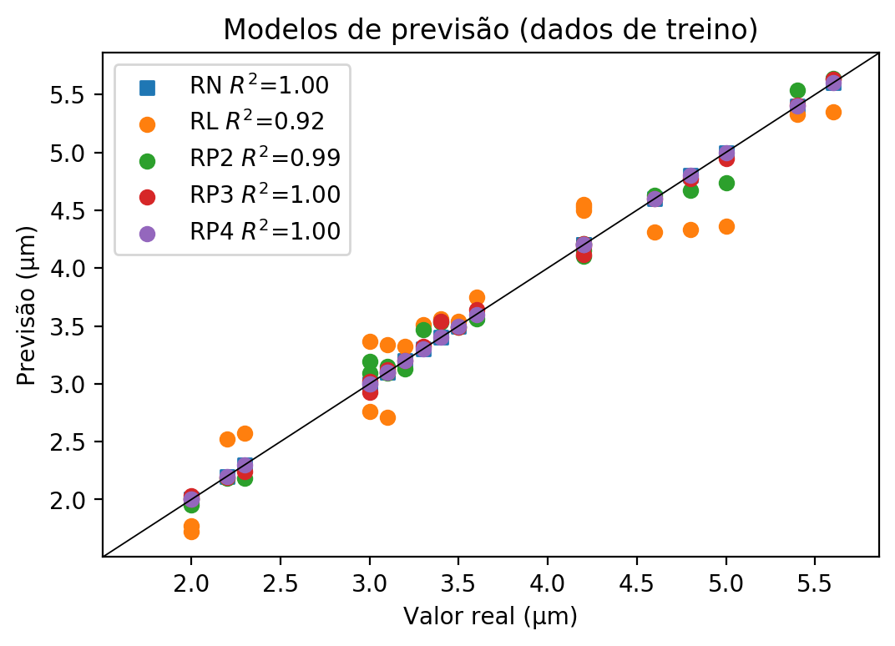

**Dados de teste**

|  |  |  |  |  |  |  |  |  |  |  |
| --- | --- | --- | --- | --- | --- | --- | --- | --- | --- | --- |
| Valor real | RN Previsto | RN Erro (%) | RL Previsto | RL Erro (%) | RP2 Previsto | RP2 Erro (%) | RP3 Previsto | RP3 Erro (%) | RP4 Previsto | RP4 Erro (%) |
| 2.1 | 2.11 | 0.48 | 1.74 | 17.14 | 1.97 | 6.19 | 2.15 | 2.38 | 2.68 | 27.62 |
| 5.1 | 5.23 | 2.55 | 5.3 | 3.92 | 5.47 | 7.25 | 5.2 | 1.96 | 5.17 | 1.37 |
| 3.5 | 3.8 | 8.57 | 3.7 | 5.71 | 3.51 | 0.29 | 4.45 | 27.14 | 3.43 | 2.0 |
| 3.7 | 3.72 | 0.54 | 3.73 | 0.81 | 3.53 | 4.59 | 4.16 | 12.43 | 3.55 | 4.05 |
| 2.4 | 2.34 | 2.5 | 2.54 | 5.83 | 2.17 | 9.58 | 2.28 | 5.0 | 2.57 | 7.08 |
| 3.2 | 3.18 | 0.63 | 2.74 | 14.38 | 3.08 | 3.75 | 3.13 | 2.19 | 3.4 | 6.25 |

**Dados de treino**

|  |  |  |  |  |  |  |  |  |  |  |
| --- | --- | --- | --- | --- | --- | --- | --- | --- | --- | --- |
| Valor real | RN Previsto | RN Erro (%) | RL Previsto | RL Erro (%) | RP2 Previsto | RP2 Erro (%) | RP3 Previsto | RP3 Erro (%) | RP4 Previsto | RP4 Erro (%) |
| 5.0 | 5.0 | 0.0 | 4.36 | 12.8 | 4.74 | 5.2 | 4.95 | 1.0 | 5.0 | 0.0 |
| 3.4 | 3.4 | 0.0 | 3.56 | 4.71 | 3.53 | 3.82 | 3.54 | 4.12 | 3.4 | 0.0 |
| 4.2 | 4.2 | 0.0 | 4.53 | 7.86 | 4.15 | 1.19 | 4.21 | 0.24 | 4.2 | 0.0 |
| 4.2 | 4.2 | 0.0 | 4.5 | 7.14 | 4.1 | 2.38 | 4.19 | 0.24 | 4.2 | 0.0 |
| 3.6 | 3.6 | 0.0 | 3.75 | 4.17 | 3.56 | 1.11 | 3.64 | 1.11 | 3.6 | 0.0 |
| 2.0 | 2.0 | 0.0 | 1.77 | 11.5 | 1.95 | 2.5 | 2.03 | 1.5 | 2.0 | 0.0 |
| 3.2 | 3.2 | 0.0 | 3.32 | 3.75 | 3.13 | 2.19 | 3.2 | 0.0 | 3.2 | 0.0 |
| 5.6 | 5.6 | 0.0 | 5.35 | 4.46 | 5.64 | 0.71 | 5.63 | 0.54 | 5.6 | 0.0 |
| 5.4 | 5.4 | 0.0 | 5.33 | 1.3 | 5.54 | 2.59 | 5.41 | 0.19 | 5.4 | 0.0 |
| 3.1 | 3.1 | 0.0 | 2.71 | 12.58 | 3.09 | 0.32 | 3.1 | 0.0 | 3.1 | 0.0 |
| 3.0 | 3.0 | 0.0 | 3.37 | 12.33 | 3.19 | 6.33 | 3.02 | 0.67 | 3.0 | 0.0 |
| 2.3 | 2.3 | 0.0 | 2.57 | 11.74 | 2.18 | 5.22 | 2.24 | 2.61 | 2.3 | 0.0 |
| 4.2 | 4.2 | 0.0 | 4.55 | 8.33 | 4.21 | 0.24 | 4.12 | 1.9 | 4.2 | 0.0 |
| 3.1 | 3.1 | 0.0 | 3.34 | 7.74 | 3.15 | 1.61 | 3.12 | 0.65 | 3.1 | 0.0 |
| 3.0 | 3.0 | 0.0 | 2.76 | 8.0 | 3.09 | 3.0 | 2.93 | 2.33 | 3.0 | 0.0 |
| 4.8 | 4.8 | 0.0 | 4.33 | 9.79 | 4.67 | 2.71 | 4.77 | 0.63 | 4.8 | 0.0 |
| 2.2 | 2.2 | 0.0 | 2.52 | 14.55 | 2.18 | 0.91 | 2.19 | 0.45 | 2.2 | 0.0 |
| 2.0 | 2.0 | 0.0 | 1.72 | 14.0 | 2.01 | 0.5 | 2.0 | 0.0 | 2.0 | 0.0 |
| 4.6 | 4.6 | 0.0 | 4.31 | 6.3 | 4.63 | 0.65 | 4.6 | 0.0 | 4.6 | 0.0 |
| 3.5 | 3.5 | 0.0 | 3.54 | 1.14 | 3.49 | 0.29 | 3.49 | 0.29 | 3.5 | 0.0 |
| 3.3 | 3.3 | 0.0 | 3.51 | 6.36 | 3.47 | 5.15 | 3.32 | 0.61 | 3.3 | 0.0 |