# Informações do estudo

Referência: Aouici

Grandeza: Rugosidade

Tipo: Rz

Material: X38CrMoV5-1 (50 HRC)

Ferramenta: CBN7020

Número de experimentos: 27

Observações:  
Tool holder: PSBNR 25 x 25 K12  
Diameter: 80 mm  
Dynanometer: Kistler 9257B

# Unidades

Velocidade: m/min

Avanço: mm/rev

Profundidade de corte: mm

Rugosidade: μm

# Dados de teste

|  |  |  |  |
| --- | --- | --- | --- |
| Rugosidade | n | f | a |
| 0.6 | 240.0 | 0.08 | 0.3 |
| 3.0 | 120.0 | 0.16 | 0.3 |
| 1.73 | 180.0 | 0.12 | 0.3 |
| 2.0 | 120.0 | 0.08 | 0.45 |
| 1.07 | 180.0 | 0.08 | 0.45 |
| 1.63 | 180.0 | 0.12 | 0.15 |

# Dados de treino

|  |  |  |  |
| --- | --- | --- | --- |
| Rugosidade | n | f | a |
| 2.8 | 120.0 | 0.12 | 0.45 |
| 1.7 | 120.0 | 0.08 | 0.15 |
| 2.16 | 180.0 | 0.16 | 0.3 |
| 2.28 | 180.0 | 0.16 | 0.45 |
| 1.8 | 180.0 | 0.12 | 0.45 |
| 0.6 | 240.0 | 0.08 | 0.15 |
| 1.6 | 240.0 | 0.16 | 0.3 |
| 3.4 | 120.0 | 0.16 | 0.45 |
| 3.03 | 120.0 | 0.16 | 0.15 |
| 1.4 | 240.0 | 0.12 | 0.45 |
| 1.27 | 240.0 | 0.12 | 0.15 |
| 0.86 | 180.0 | 0.08 | 0.3 |
| 2.1 | 180.0 | 0.16 | 0.15 |
| 1.57 | 240.0 | 0.16 | 0.15 |
| 1.33 | 240.0 | 0.12 | 0.3 |
| 2.5 | 120.0 | 0.12 | 0.15 |
| 0.73 | 240.0 | 0.08 | 0.45 |
| 0.5 | 180.0 | 0.08 | 0.15 |
| 2.43 | 120.0 | 0.12 | 0.3 |
| 1.8 | 120.0 | 0.08 | 0.3 |
| 1.7 | 240.0 | 0.16 | 0.45 |

# RN

Número de neurônios: 25

Taxa de aprendizado: 1.000000e-01

Número de épocas: 562

2° camada: True

Função de ativação: relu

# Erros

**Dados de teste**

* Erro relativo médio: 7.13
* Coeficiente de correlação: 0.99
* Coeficiente de determinação: 0.98
* MSE: 0.01
* RMSE: 0.1

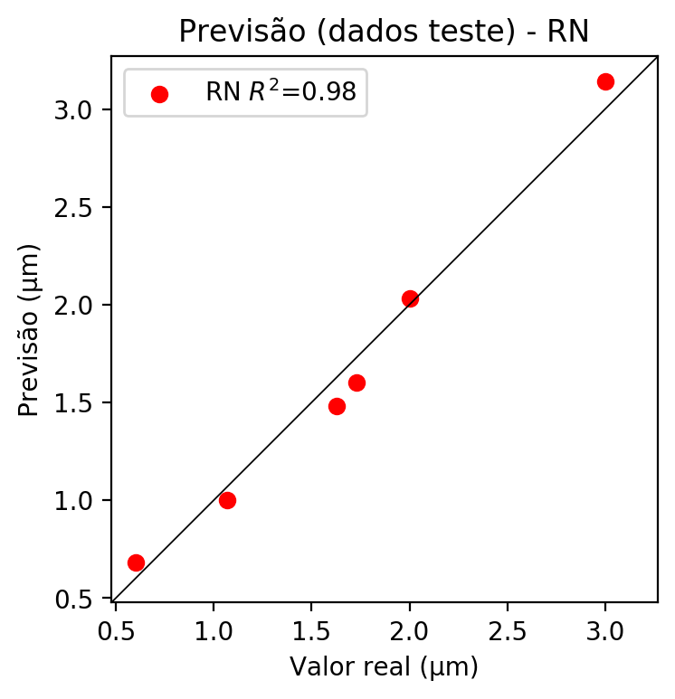

**Dados de treino**

* Erro relativo médio: 0.0
* Coeficiente de correlação: 1.0
* Coeficiente de determinação: 1.0
* MSE: 0.0
* RMSE: 0.0

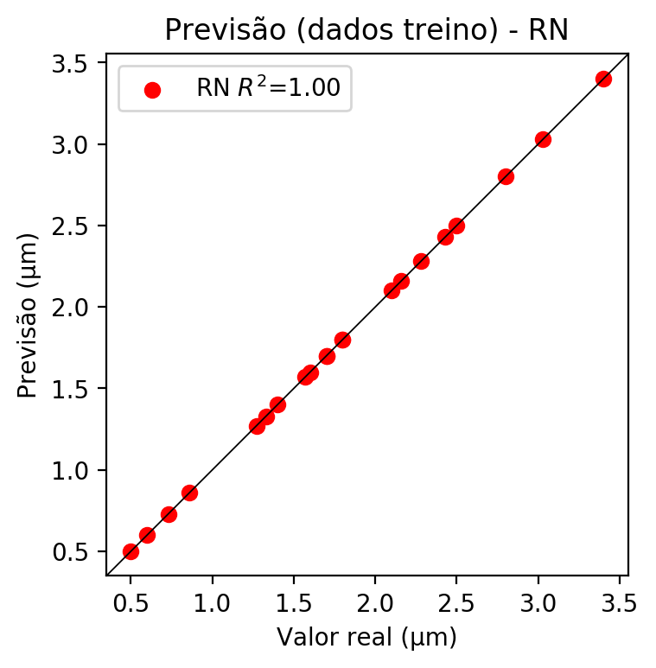

# Pesos

Pesos - camada oculta 1

[[-5.5208877e-02 4.1434535e-01 5.5100858e-01 4.1064572e-01  
 3.3206946e-01 2.1050908e-01 1.1712586e-01 5.5904454e-01  
 -1.7930487e-01 -4.5243013e-01 -7.9265565e-01 -3.5191044e-01  
 -5.9430999e-01 -3.0551776e-01 -4.1123241e-01 -1.9570343e-01  
 3.0495730e-01 -9.3430477e-01 -1.0212483e+00 4.6519884e-01  
 6.3901132e-01 2.0157704e-01 2.9197565e-01 -6.6709942e-01  
 -1.0112293e+00]  
 [ 1.0135324e-01 -1.4448337e-01 -6.5561539e-01 -5.7108390e-01  
 -1.3743645e+00 -3.9582934e-02 -1.0503496e-03 -2.1989523e-01  
 -1.3751909e-01 1.1019757e+00 7.3453385e-01 -2.3241378e-01  
 -5.2497238e-01 3.0082837e-01 1.6334489e-01 -3.5579848e-01  
 -7.8027129e-01 2.7949697e-01 2.4671862e-01 4.9209464e-01  
 -6.1382359e-01 -1.0855044e+00 9.4565272e-02 1.4413171e-01  
 4.1085160e-01]  
 [-1.2716272e-01 -3.9407337e-01 1.3544967e-02 5.0392723e-01  
 -1.2459052e-01 -3.4779683e-01 -2.1927847e-02 1.1099936e-01  
 -5.7917947e-01 4.0413311e-01 -9.8462582e-02 1.9226487e-01  
 6.6082966e-01 1.4667478e-01 2.4910441e-01 -2.6208109e-01  
 2.5801009e-01 2.7475530e-01 -1.3640527e-01 8.4186986e-02  
 -2.1055315e-01 1.0744432e-01 3.4925628e-01 7.0148492e-01  
 7.0849210e-02]]

Bias - camada oculta

[-0.83710915 -0.73499554 -0.76540804 -0.96909684 0.10648974 -0.8184176  
 -0.8233777 -0.73681885 -0.2748632 -0.55513275 -0.068634 -0.86941856  
 -0.7299865 -0.69370455 -0.41023597 -0.24095497 -0.4693852 -0.14209603  
 -0.07441262 -0.33509108 0.4768161 -0.08290782 -1.0500766 -0.8039484  
 -0.04111019]

Pesos - camada oculta 2

[[-0.4696751 -0.38760442 0.31814724 -0.569702 -0.11747716 0.42068398  
 0.34872082 -0.4974093 0.40518326 -0.55049014 0.3314434 -0.3844777  
 -0.5137852 0.27279964 0.2926721 0.5220756 -0.8173842 0.5133324  
 0.35464725 -0.3277341 -0.34855065 -0.35895568 0.07418675 -0.43042573  
 0.13514 ]  
 [-0.4064706 1.3125178 -0.66609645 -0.34175682 -0.55036527 -0.64986414  
 -1.0533844 -0.56841516 -0.2826843 0.7065205 -0.14054008 -0.0402308  
 -0.5997979 0.32299322 -0.82675165 -0.142003 -0.16340843 -0.32793754  
 0.27125695 -0.70795035 -0.24771133 -0.6055107 -0.83148324 -0.46864614  
 -0.4533322 ]  
 [ 0.7037738 0.99572134 -0.35261038 0.51028323 0.09907939 -0.5188289  
 -0.38672188 -0.09286701 -0.49990278 0.28514954 -0.19623478 0.11987825  
 0.09423519 -0.6630268 -0.27137947 -0.689523 -0.09578 -0.47830942  
 -0.8887581 0.18410051 0.39102373 0.6374049 -0.62564373 0.34866962  
 -0.48158163]  
 [ 0.04656748 1.0405685 0.36406806 -0.54670036 0.14927907 -0.3632231  
 -1.1769494 -0.42030013 -0.972211 0.51589376 -0.26113915 0.36922237  
 0.04635043 -0.66356105 -0.5376629 -0.23395745 -0.23965538 -1.017301  
 -0.25202838 0.15736888 0.15574236 0.26383832 -0.5150798 0.4224913  
 -0.95717657]  
 [-0.5158925 -0.77480996 0.65965223 -0.83941674 -0.63109326 0.31857577  
 -0.00528073 -0.91979617 0.16422506 -0.36101535 0.45010048 -0.68894076  
 -0.33563188 0.43027973 -0.18511328 0.5927053 -0.5707942 -0.45049495  
 0.04688263 -0.8148932 -0.5261245 -0.8353303 -0.5175163 -0.7340181  
 0.40142155]  
 [ 0.5173421 0.8913365 -0.12489276 0.2938395 0.05248419 -0.42296907  
 0.06898798 -0.1120498 0.65476567 0.9026756 0.22505309 0.31971323  
 0.7855475 0.17205083 -0.33301523 0.09529885 -0.33947867 -0.55456126  
 -0.6813003 0.2808349 0.4031359 -0.29294857 -0.5260784 -0.33266035  
 -0.67511636]  
 [-0.26545793 -1.2026341 0.27930078 -0.22644316 0.6088295 0.24649341  
 0.20334232 0.3957921 0.20687847 -0.635636 0.45371908 0.02789922  
 -0.86286926 -0.28558946 -0.9037356 -0.02633069 -0.46570167 0.55678785  
 0.192387 -0.7440798 -0.54130405 -0.40225437 -1.2460335 -0.36592925  
 0.16666628]  
 [-0.4122695 -1.0355871 0.5027049 -0.5415203 0.3687014 0.9290232  
 0.08772031 0.4939292 -0.12213849 -0.8038554 0.35334742 0.15548976  
 -0.32588544 -0.42597333 0.46369466 0.34491566 -0.97821385 0.5137513  
 0.38229337 -0.46462226 -0.47802293 -0.36341044 0.07211854 -0.7390054  
 0.43649587]  
 [-0.30264458 -0.94582367 0.6259121 -0.40518382 0.5333628 -0.7280713  
 -0.07398719 -0.15912059 0.0976993 -0.49187967 0.35670605 0.01128025  
 -0.9381574 0.12640415 -0.5534618 0.22170441 -0.32199 0.6382381  
 0.6295961 -0.4711156 -0.2087258 -0.46141607 -0.93427557 -0.40676457  
 0.66558677]  
 [-0.8902647 -0.9217591 -0.08309131 -0.75209266 0.9550411 -0.91379213  
 -0.52987903 0.24362414 -0.51729304 -0.84806335 0.50708073 0.66574264  
 -0.9420966 0.12512313 -0.57781637 0.06479182 -0.37163287 -0.01428776  
 -0.01287251 -0.54220307 0.10904983 -0.56015116 -0.6257042 -0.5553033  
 0.17264953]  
 [ 0.15346958 -0.4355128 -0.45041102 -0.3548882 0.51635396 -0.42341828  
 -0.05643798 0.0337845 -0.12970828 -1.7318149 0.2758171 0.356327  
 -0.77431846 -0.8586213 -0.831385 -0.9626013 -0.3550315 -0.74798274  
 -1.0073345 -0.69472134 0.13791138 -0.52791184 -0.89900297 -0.9381152  
 -0.7762896 ]  
 [-0.7659106 -0.65085965 -0.20651011 -0.74917364 -0.08779135 -0.62691385  
 -0.08848687 -0.5160387 -0.4640815 -0.33367383 0.3326726 0.00187637  
 -0.8115861 -0.12137584 -0.20376107 -0.2010181 -0.2459412 -0.6922756  
 0.16467099 -0.53959775 -0.23445648 -0.6736309 -1.0047579 -0.83083457  
 -0.04861943]  
 [-0.86746585 -0.5855437 -0.34020263 -0.2877634 0.54007494 -0.48181278  
 -0.37243515 0.03411435 -0.04311511 -0.1812509 0.06093763 0.0080831  
 -0.72606206 -0.22701414 -0.49368376 -0.06120202 -0.03334748 -0.569203  
 -0.07838246 -0.56514573 -0.19174483 -0.7790471 -0.8680335 -0.80878186  
 -0.50171053]  
 [-0.73321503 -1.0391338 -0.13462447 -0.5468886 0.7926545 -0.65736586  
 -0.01282093 0.1690163 -0.45210576 -0.529344 0.57737094 0.0842836  
 -0.3460661 -0.4366487 -0.8360159 0.01698455 -1.0458864 0.90171945  
 0.27863848 -0.6016378 0.12080728 -0.49508253 -1.0879441 -0.8544038  
 0.3598405 ]  
 [ 0.04190906 -0.0137509 -0.8232071 -0.79064775 0.2234923 -0.6705847  
 -0.2814372 0.11862497 -0.03969565 -1.5016114 0.6661711 -0.0954797  
 -1.041831 -0.36972713 -0.5234416 -0.2679125 -0.24827188 -0.48432073  
 -0.01763254 -1.0382597 0.22012867 -0.722664 -0.38421884 -0.80717653  
 -0.4001871 ]  
 [ 0.03601086 -0.56380206 0.03390188 -0.7783949 0.16769446 -0.46765676  
 -0.27235436 0.01582891 -0.4338112 -0.22669734 0.1307129 0.06098256  
 0.06129334 0.14911911 -0.46283332 -0.32002014 -0.14416063 -0.55738306  
 0.4604146 -0.36862373 -0.14927696 -0.48017508 -0.6294882 -0.59860504  
 -0.4415333 ]  
 [-0.6861243 0.20461452 -0.13453099 -0.7199741 -0.06612781 -0.05308494  
 -0.7686152 -0.2775881 -0.29636127 0.936427 -0.479075 -0.2894968  
 -0.57720715 0.29953223 -0.7495316 -0.44562438 -0.10591748 -1.0214988  
 0.16577736 -1.0929464 -0.46686575 -0.70135707 -1.0483161 -0.9609192  
 -0.7087443 ]  
 [-0.08226498 0.09598866 -1.3511764 0.11017822 0.4185911 -0.82963336  
 -0.7452281 0.24001722 -0.8750341 -0.3631199 -0.08769862 0.03751639  
 -0.02246996 -0.62645584 -0.49316415 -0.9722642 -0.29428893 -0.41647914  
 -0.2790905 -0.26739597 0.12560354 0.31881538 -0.28447458 0.353587  
 -1.1043848 ]  
 [-0.08929753 -0.5159599 -1.3200244 -0.5212937 0.35576853 -0.5859928  
 -0.5485386 0.31706062 -0.83090556 -0.5080936 -0.5745484 0.3117401  
 0.0677359 -1.2461294 -0.8900847 -0.7438505 -0.052017 -0.53341615  
 -0.89724886 0.12967372 0.39854324 0.5751131 -0.48497292 -0.8363579  
 -0.4904108 ]  
 [-0.8908114 -0.6897565 -0.1913973 -1.0507226 -0.21470179 -0.1637217  
 -0.49339804 -0.51379627 -0.32803404 -0.4722402 0.44327974 -0.23133685  
 -0.6269994 0.013918 -0.09770306 0.10162762 -0.7483861 -0.04094311  
 0.24257034 -0.4968867 -0.32738712 -0.6704585 0.48551843 -0.39797148  
 -0.30429518]  
 [-0.50216866 0.13590305 0.2171605 -0.6009546 -0.31686342 0.29359335  
 0.12228607 -0.53366506 0.05822626 -0.5913347 0.4106343 -0.8919668  
 -0.8844041 0.28741 -0.16849363 0.21411368 -0.88881797 -0.10020913  
 -0.21959715 -1.0102615 -0.6096451 -0.6558603 -0.5671316 -0.8725347  
 -0.07398777]  
 [-0.9810017 -0.19839993 0.3646893 -0.28205138 -0.08472501 -0.2791729  
 -0.16030456 -0.54338276 0.15970008 -0.44201162 0.2809316 -0.74464786  
 -0.88988906 0.15519986 -0.1709431 0.27079672 -0.51735866 0.07853276  
 -0.0698647 -0.49478468 -0.53263104 -0.30178964 -0.13820277 -0.752443  
 0.0920215 ]  
 [-0.736605 0.7293298 0.7313479 -0.16703002 0.46293342 -0.299728  
 0.0200866 -0.12471129 0.5470298 -0.7703192 0.27880916 -0.59812844  
 -0.24711812 0.34979308 -0.81438684 0.47038203 -0.32128614 0.72574186  
 0.25689694 -0.3928158 -0.3589368 -0.84495634 -0.6210772 -0.29823348  
 0.26393437]  
 [-0.37236604 -0.30120337 -0.04639124 -0.96553725 0.30615166 -0.51920795  
 -1.1134318 -0.20971264 -0.30290905 -0.4642336 -0.13662592 0.5513011  
 -0.73574823 -0.03371015 -0.37973014 -0.4968646 -0.28677303 -0.21465482  
 0.01508892 -0.45829973 0.05884163 -0.254353 -0.8431208 -0.81208813  
 -0.21062747]  
 [-0.01650174 -0.14572276 -1.4582806 -0.31346643 0.5277644 -0.9378847  
 -1.0154717 0.20956652 -0.7437468 -0.36090186 -0.29501867 -0.02218833  
 -0.55107594 -0.33410862 -0.79541767 -0.94584167 -0.12871973 -0.7669101  
 0.17135856 -0.31684092 0.3518369 -0.7343832 -0.6158882 0.6465671  
 -0.78050816]]

Bias - camada oculta 2

[-0.71396047 -0.526261 0.10208655 -0.88307434 0.19089583 -0.6005119  
 -0.2684839 -0.37056798 -0.20136581 -1.1633189 0.3687006 0.00198611  
 -0.8469647 -0.16819759 -0.81433845 0.13142404 -0.53087175 -0.80296254  
 0.08700436 -0.79538846 -0.44228807 -0.6005435 -0.89290553 -0.61122453  
 -0.31240696]

Pesos - camada saída

[[-2.94797093e-01 -2.99439915e-02 -3.80437583e-01 -4.28390175e-01  
 2.98509806e-01 3.66494447e-01 5.17315984e-01 4.24333587e-02  
 3.06444705e-01 -4.68392015e-01 -2.09724620e-01 1.42156601e-01  
 -4.04569924e-01 4.09382832e-04 4.94576067e-01 -1.05093852e-01  
 -2.21047223e-01 7.06889629e-01 -1.23235375e-01 -3.38651568e-01  
 6.81196079e-02 -2.65526205e-01 1.22573897e-01 -3.54940653e-01  
 -1.59923732e-01]]

# Iterações

|  |  |  |  |  |  |  |
| --- | --- | --- | --- | --- | --- | --- |
| Média | Desvio | n | ln | 2° camada | Função | Épocas |
| -0.108 | 0.0617 | 10 | 0.1 | False | relu | 38 |
| -0.0645 | 0.0408 | 17 | 0.1 | True | relu | 716 |
| -0.1016 | 0.0654 | 7 | 0.01 | True | tanh | 130 |
| -0.5418 | 0.3766 | 19 | 0.001 | False | tanh | 282 |
| -0.1617 | 0.1073 | 29 | 0.001 | False | relu | 469 |
| -0.1704 | 0.1514 | 88 | 0.1 | False | tanh | 926 |
| -0.0634 | 0.0435 | 95 | 0.0001 | True | relu | 984 |
| -0.0581 | 0.0493 | 10 | 0.01 | True | tanh | 865 |
| -0.7617 | 0.4888 | 58 | 0.001 | True | relu | 8 |
| -0.0652 | 0.0611 | 9 | 0.01 | False | tanh | 514 |
| -0.0921 | 0.0292 | 73 | 0.0001 | True | relu | 729 |
| -0.0577 | 0.0376 | 22 | 0.001 | True | relu | 543 |
| -0.0352 | 0.0247 | 25 | 0.1 | True | relu | 562 |
| -0.136 | 0.0853 | 53 | 0.001 | False | relu | 498 |
| -0.0864 | 0.0565 | 83 | 0.01 | True | relu | 337 |
| -0.7737 | 0.4357 | 99 | 0.01 | False | tanh | 16 |
| -0.1573 | 0.1505 | 23 | 0.01 | False | relu | 472 |
| -0.0941 | 0.0609 | 24 | 0.001 | True | relu | 778 |
| -0.0561 | 0.0306 | 58 | 0.01 | True | tanh | 382 |
| -0.3096 | 0.2459 | 35 | 0.1 | False | tanh | 596 |

# RL

# Coeficientes

[ 0. -0.70986612 0.64839027 0.14656303]

# Erros

**Dados de teste**

* Erro relativo médio: 7.3
* Coeficiente de correlação: 0.99
* Coeficiente de determinação: 0.98
* MSE: 0.01
* RMSE: 0.1

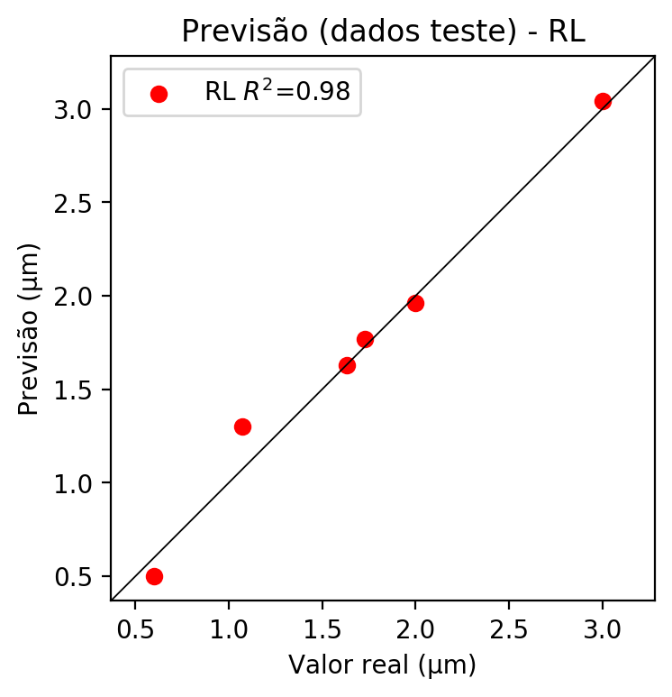

**Dados de treino**

* Erro relativo médio: 15.38
* Coeficiente de correlação: 0.96
* Coeficiente de determinação: 0.93
* MSE: 0.04
* RMSE: 0.2

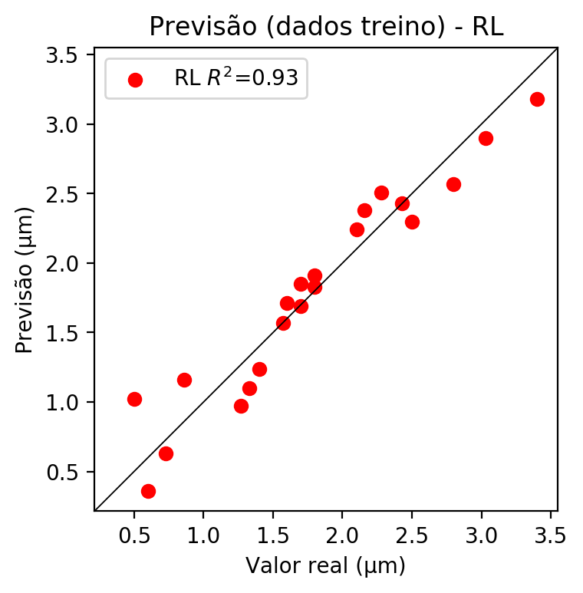

# RP2

# Coeficientes

[ 0. -0.71321956 0.66487966 0.13924705 0.29225867 -0.08839068  
 -0.04168864 -0.12100358 -0.02012373 0.03844368]

# Erros

**Dados de teste**

* Erro relativo médio: 4.11
* Coeficiente de correlação: 0.99
* Coeficiente de determinação: 0.99
* MSE: 0.01
* RMSE: 0.1

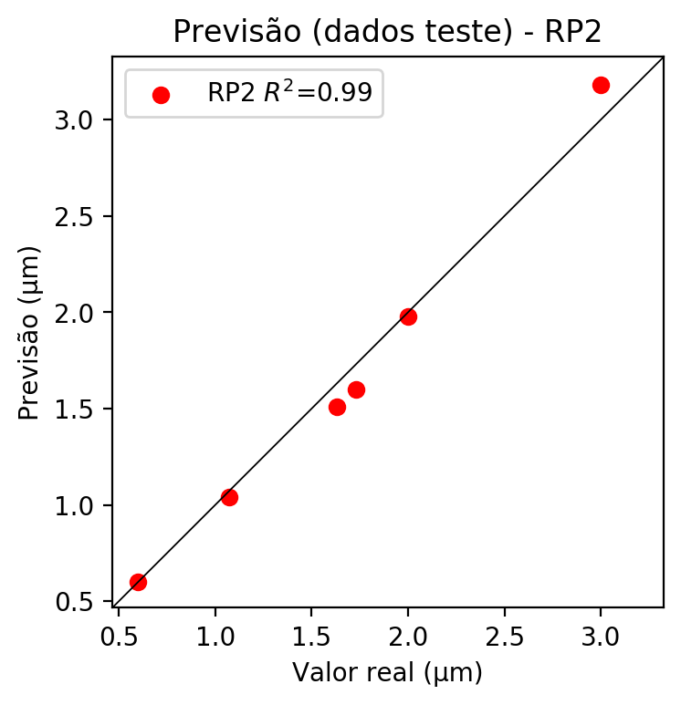

**Dados de treino**

* Erro relativo médio: 5.35
* Coeficiente de correlação: 0.99
* Coeficiente de determinação: 0.99
* MSE: 0.01
* RMSE: 0.1

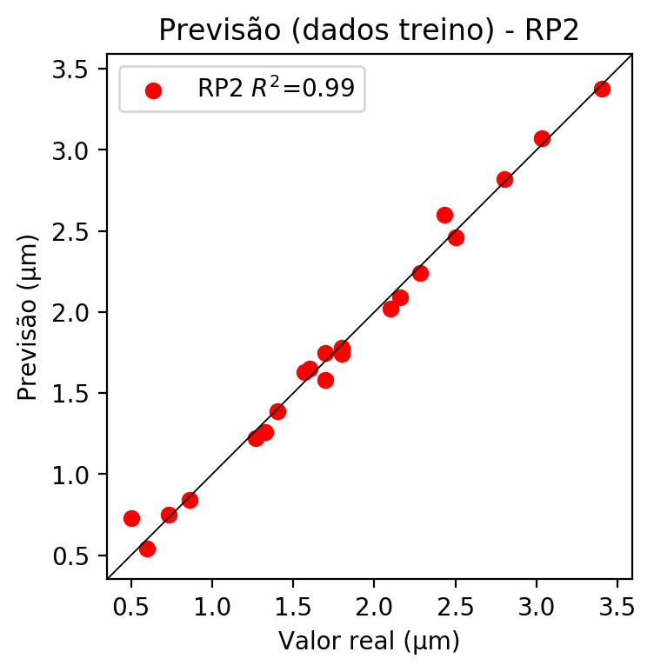

# RP3

# Coeficientes

[ 0. -0.18960833 0.22548434 0.0528277 0.31270701 -0.07772938  
 -0.05163975 -0.11159022 -0.02455735 0.04279107 -0.2738787 -0.11716386  
 -0.02895037 -0.0347796 0.00439639 -0.08151517 0.3256996 0.01062101  
 0.05630348 0.07630668]

# Erros

**Dados de teste**

* Erro relativo médio: 11.56
* Coeficiente de correlação: 0.98
* Coeficiente de determinação: 0.97
* MSE: 0.02
* RMSE: 0.14

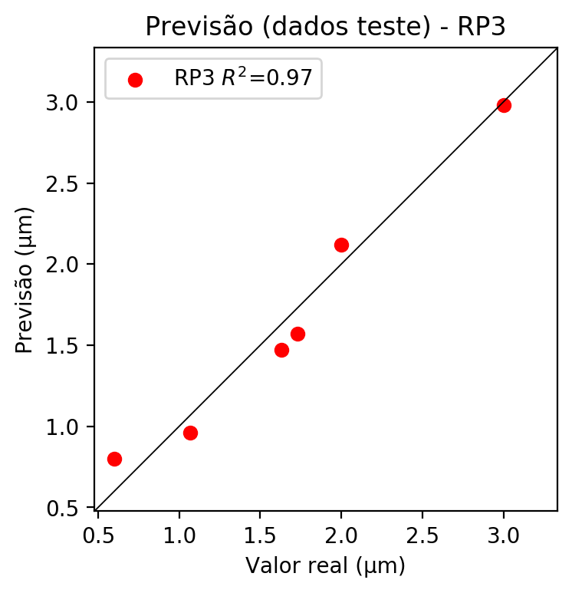

**Dados de treino**

* Erro relativo médio: 2.61
* Coeficiente de correlação: 1.0
* Coeficiente de determinação: 1.0
* MSE: 0.0
* RMSE: 0.0

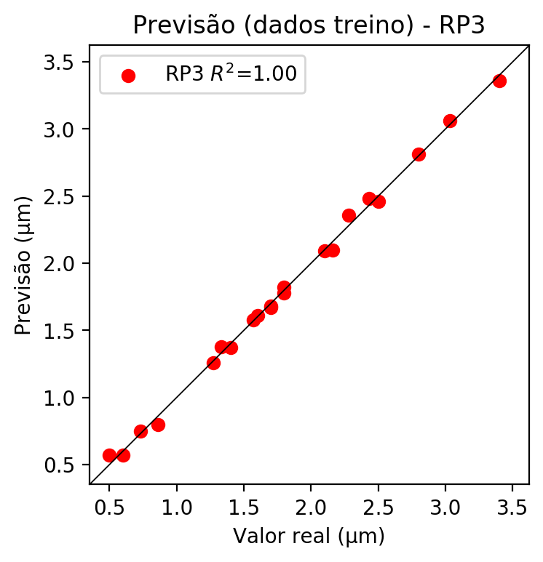

# RP4

# Coeficientes

[ 2.77555756e-17 -1.90250806e-01 2.24841861e-01 5.18108925e-02  
 6.54277002e-02 -1.33540636e-02 -7.29841089e-03 -4.10638424e-02  
 -1.49509865e-02 -7.06766533e-04 -2.74806720e-01 -1.09182688e-01  
 -3.12510848e-02 -3.86423360e-02 7.22951843e-03 -7.94559504e-02  
 3.24771578e-01 2.01642080e-02 4.65187855e-02 7.48379558e-02  
 9.45066781e-02 -1.92892029e-02 -1.05421491e-02 2.48687105e-02  
 4.75270989e-02 7.06964782e-02 -1.92892029e-02 -1.67776352e-02  
 -1.51018490e-03 -1.05421491e-02 -5.93144390e-02 -2.15958694e-02  
 -1.87461061e-02 -2.15958694e-02 -1.02088499e-03]

# Erros

**Dados de teste**

* Erro relativo médio: 8.36
* Coeficiente de correlação: 0.99
* Coeficiente de determinação: 0.98
* MSE: 0.01
* RMSE: 0.1

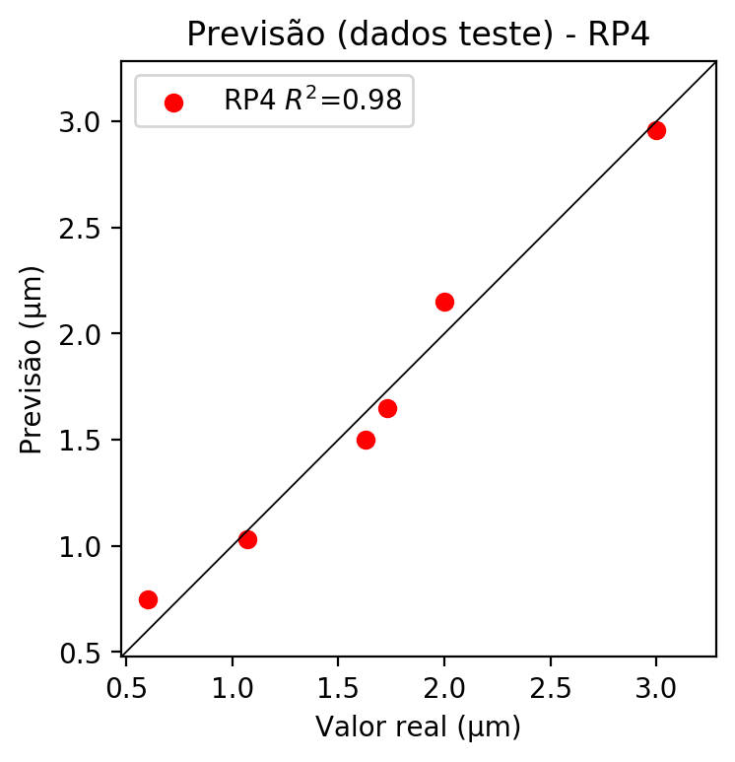

**Dados de treino**

* Erro relativo médio: 0.0
* Coeficiente de correlação: 1.0
* Coeficiente de determinação: 1.0
* MSE: 0.0
* RMSE: 0.0

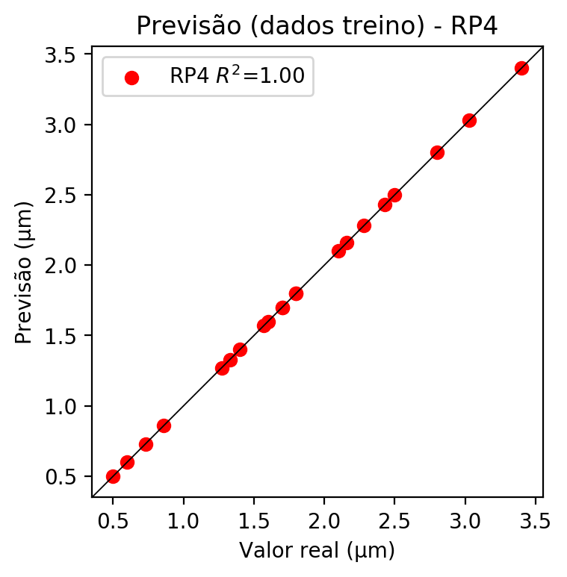

# Geral

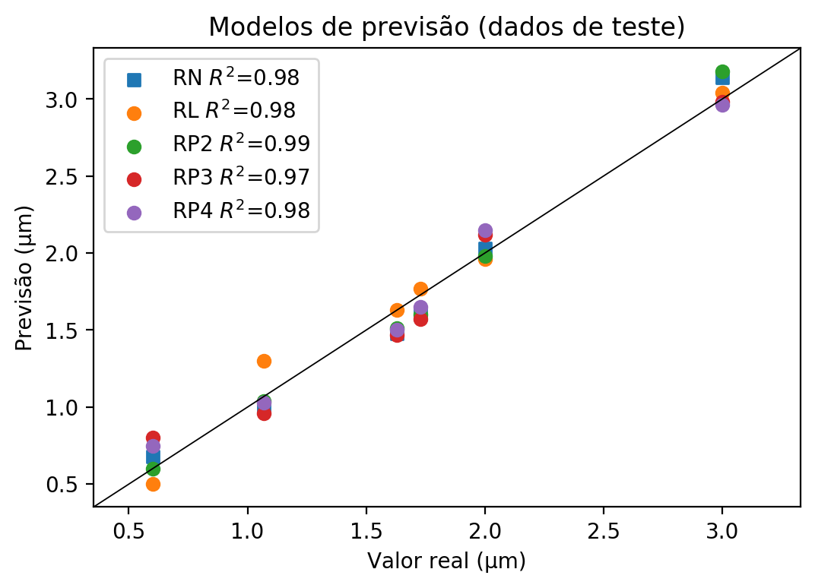

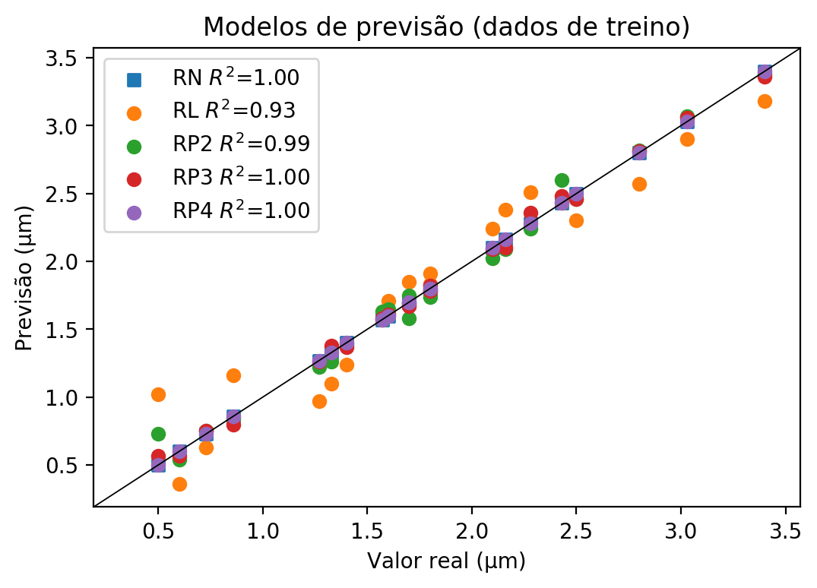

**Dados de teste**

|  |  |  |  |  |  |  |  |  |  |  |
| --- | --- | --- | --- | --- | --- | --- | --- | --- | --- | --- |
| Valor real | RN Previsto | RN Erro (%) | RL Previsto | RL Erro (%) | RP2 Previsto | RP2 Erro (%) | RP3 Previsto | RP3 Erro (%) | RP4 Previsto | RP4 Erro (%) |
| 0.6 | 0.68 | 13.33 | 0.5 | 16.67 | 0.6 | 0.0 | 0.8 | 33.33 | 0.75 | 25.0 |
| 3.0 | 3.14 | 4.67 | 3.04 | 1.33 | 3.18 | 6.0 | 2.98 | 0.67 | 2.96 | 1.33 |
| 1.73 | 1.6 | 7.51 | 1.77 | 2.31 | 1.6 | 7.51 | 1.57 | 9.25 | 1.65 | 4.62 |
| 2.0 | 2.03 | 1.5 | 1.96 | 2.0 | 1.98 | 1.0 | 2.12 | 6.0 | 2.15 | 7.5 |
| 1.07 | 1.0 | 6.54 | 1.3 | 21.5 | 1.04 | 2.8 | 0.96 | 10.28 | 1.03 | 3.74 |
| 1.63 | 1.48 | 9.2 | 1.63 | 0.0 | 1.51 | 7.36 | 1.47 | 9.82 | 1.5 | 7.98 |

**Dados de treino**

|  |  |  |  |  |  |  |  |  |  |  |
| --- | --- | --- | --- | --- | --- | --- | --- | --- | --- | --- |
| Valor real | RN Previsto | RN Erro (%) | RL Previsto | RL Erro (%) | RP2 Previsto | RP2 Erro (%) | RP3 Previsto | RP3 Erro (%) | RP4 Previsto | RP4 Erro (%) |
| 2.8 | 2.8 | 0.0 | 2.57 | 8.21 | 2.82 | 0.71 | 2.81 | 0.36 | 2.8 | 0.0 |
| 1.7 | 1.7 | 0.0 | 1.69 | 0.59 | 1.58 | 7.06 | 1.68 | 1.18 | 1.7 | 0.0 |
| 2.16 | 2.16 | 0.0 | 2.38 | 10.19 | 2.09 | 3.24 | 2.1 | 2.78 | 2.16 | 0.0 |
| 2.28 | 2.28 | 0.0 | 2.51 | 10.09 | 2.24 | 1.75 | 2.36 | 3.51 | 2.28 | 0.0 |
| 1.8 | 1.8 | 0.0 | 1.91 | 6.11 | 1.78 | 1.11 | 1.78 | 1.11 | 1.8 | 0.0 |
| 0.6 | 0.6 | 0.0 | 0.36 | 40.0 | 0.54 | 10.0 | 0.57 | 5.0 | 0.6 | 0.0 |
| 1.6 | 1.6 | 0.0 | 1.71 | 6.87 | 1.65 | 3.12 | 1.61 | 0.63 | 1.6 | 0.0 |
| 3.4 | 3.4 | 0.0 | 3.18 | 6.47 | 3.38 | 0.59 | 3.36 | 1.18 | 3.4 | 0.0 |
| 3.03 | 3.03 | 0.0 | 2.9 | 4.29 | 3.07 | 1.32 | 3.06 | 0.99 | 3.03 | 0.0 |
| 1.4 | 1.4 | 0.0 | 1.24 | 11.43 | 1.39 | 0.71 | 1.37 | 2.14 | 1.4 | 0.0 |
| 1.27 | 1.27 | 0.0 | 0.97 | 23.62 | 1.22 | 3.94 | 1.26 | 0.79 | 1.27 | 0.0 |
| 0.86 | 0.86 | 0.0 | 1.16 | 34.88 | 0.84 | 2.33 | 0.8 | 6.98 | 0.86 | 0.0 |
| 2.1 | 2.1 | 0.0 | 2.24 | 6.67 | 2.02 | 3.81 | 2.09 | 0.48 | 2.1 | 0.0 |
| 1.57 | 1.57 | 0.0 | 1.57 | 0.0 | 1.63 | 3.82 | 1.58 | 0.64 | 1.57 | 0.0 |
| 1.33 | 1.33 | 0.0 | 1.1 | 17.29 | 1.26 | 5.26 | 1.38 | 3.76 | 1.33 | 0.0 |
| 2.5 | 2.5 | 0.0 | 2.3 | 8.0 | 2.46 | 1.6 | 2.46 | 1.6 | 2.5 | 0.0 |
| 0.73 | 0.73 | 0.0 | 0.63 | 13.7 | 0.75 | 2.74 | 0.75 | 2.74 | 0.73 | 0.0 |
| 0.5 | 0.5 | 0.0 | 1.02 | 104.0 | 0.73 | 46.0 | 0.57 | 14.0 | 0.5 | 0.0 |
| 2.43 | 2.43 | 0.0 | 2.43 | 0.0 | 2.6 | 7.0 | 2.48 | 2.06 | 2.43 | 0.0 |
| 1.8 | 1.8 | 0.0 | 1.83 | 1.67 | 1.74 | 3.33 | 1.82 | 1.11 | 1.8 | 0.0 |
| 1.7 | 1.7 | 0.0 | 1.85 | 8.82 | 1.75 | 2.94 | 1.67 | 1.76 | 1.7 | 0.0 |