# Informações do estudo

Referência: Bartarya

Grandeza: Força

Tipo: Fy

Material: EN31 bearing steel (60±2 HRc)

Ferramenta: TNGA160408 S01525

Número de experimentos: 27

Observações:  
Tool holder: PTGNR 2020 K16  
Dynamometer: 5233A

# Unidades

Velocidade: m/min

Avanço: mm/rev

Profundidade de corte: mm

Força: N

# Dados de teste

|  |  |  |  |
| --- | --- | --- | --- |
| Força | n | f | a |
| 54.0 | 261.1 | 0.08 | 0.1 |
| 178.6 | 167.0 | 0.15 | 0.2 |
| 76.74 | 261.1 | 0.15 | 0.1 |
| 134.0 | 204.0 | 0.08 | 0.2 |
| 60.68 | 167.0 | 0.11 | 0.1 |
| 69.5 | 167.0 | 0.15 | 0.1 |

# Dados de treino

|  |  |  |  |
| --- | --- | --- | --- |
| Força | n | f | a |
| 166.2 | 261.1 | 0.11 | 0.2 |
| 75.4 | 167.0 | 0.15 | 0.15 |
| 142.7 | 261.1 | 0.11 | 0.15 |
| 154.8 | 167.0 | 0.11 | 0.2 |
| 121.4 | 261.1 | 0.08 | 0.15 |
| 53.4 | 204.0 | 0.08 | 0.1 |
| 69.4 | 204.0 | 0.15 | 0.1 |
| 185.25 | 204.0 | 0.15 | 0.2 |
| 184.8 | 261.1 | 0.15 | 0.2 |
| 64.7 | 167.0 | 0.11 | 0.15 |
| 60.8 | 204.0 | 0.11 | 0.15 |
| 55.0 | 167.0 | 0.08 | 0.15 |
| 138.1 | 261.1 | 0.08 | 0.2 |
| 66.8 | 204.0 | 0.15 | 0.15 |
| 61.3 | 204.0 | 0.11 | 0.1 |
| 165.0 | 204.0 | 0.11 | 0.2 |
| 54.0 | 204.0 | 0.08 | 0.15 |
| 51.1 | 167.0 | 0.08 | 0.1 |
| 157.0 | 261.1 | 0.15 | 0.15 |
| 111.35 | 167.0 | 0.08 | 0.2 |
| 70.4 | 261.1 | 0.11 | 0.1 |

# RN

Número de neurônios: 58

Taxa de aprendizado: 1.000000e-02

Número de épocas: 382

2° camada: True

Função de ativação: tanh

# Erros

**Dados de teste**

* Erro relativo médio: 7.57
* Coeficiente de correlação: 0.99
* Coeficiente de determinação: 0.98
* MSE: 77.93
* RMSE: 8.83

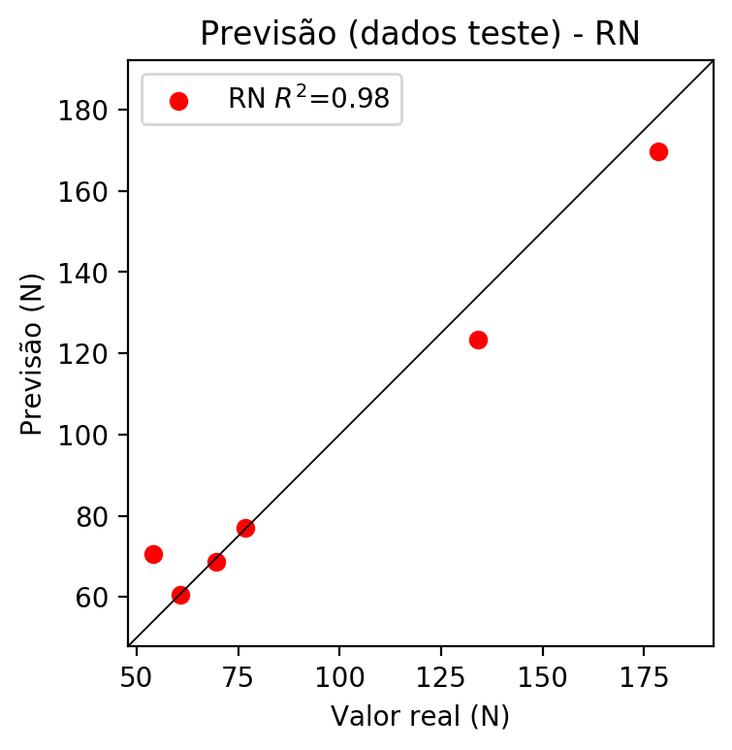

**Dados de treino**

* Erro relativo médio: 0.02
* Coeficiente de correlação: 1.0
* Coeficiente de determinação: 1.0
* MSE: 0.0
* RMSE: 0.0

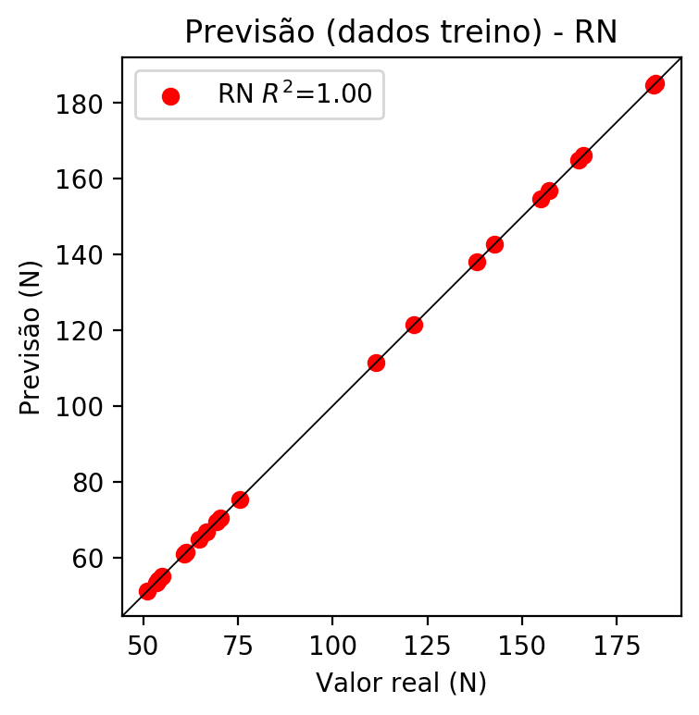

# Pesos

Pesos - camada oculta 1

[[ 2.12307677e-01 1.37029186e-01 -1.99386373e-01 2.87392288e-02  
 1.58240080e-01 -1.89880654e-01 -1.01915687e-01 -1.31780710e-02  
 -1.12075992e-01 7.01512024e-02 -5.02825916e-01 2.24450037e-01  
 7.76872933e-02 -3.23847798e-03 -1.13089561e-01 -1.42719835e-01  
 3.14254798e-02 -7.06101656e-02 -2.80163944e-01 2.23596975e-01  
 5.70779443e-01 2.38481566e-01 -5.16790599e-02 1.81797028e-01  
 -6.40879273e-02 -3.83854479e-01 3.98809135e-01 7.14891180e-02  
 2.49236971e-01 -2.29894981e-01 2.46805057e-01 -3.60573888e-01  
 -2.20066577e-01 -4.85516265e-02 -8.01776126e-02 -2.62626410e-01  
 4.38926667e-02 1.60792083e-01 -2.98664212e-01 -1.35914832e-01  
 1.67449236e-01 2.06767604e-01 2.87075013e-01 2.28709877e-01  
 -4.10026126e-02 2.48009041e-01 -6.49928376e-02 -2.30719224e-01  
 4.81890827e-01 3.16726595e-01 3.46677601e-01 2.71601677e-01  
 9.14239213e-02 -3.49551003e-04 -1.51874095e-01 5.62672578e-02  
 1.12988010e-01 -4.27537821e-02]  
 [-2.71064192e-01 -3.09141755e-01 2.82557487e-01 -2.34221771e-01  
 -2.79544711e-01 1.15648225e-01 2.63575643e-01 -3.72088790e-01  
 -1.37346119e-01 1.15458682e-01 -1.98997438e-01 -1.83473453e-01  
 -8.80958810e-02 5.60232401e-02 -3.59743647e-02 -2.66512543e-01  
 1.55091286e-01 -2.29630709e-01 1.03707083e-01 2.17539489e-01  
 7.13523105e-03 -8.35599154e-02 2.50444531e-01 -2.89052129e-01  
 -3.70279044e-01 3.94209800e-03 -1.91149190e-01 2.32240945e-01  
 -7.53116375e-03 -3.07886779e-01 -1.17327139e-01 2.08125368e-01  
 -1.23349920e-01 -4.16985862e-02 -3.13735306e-01 9.12090912e-02  
 -2.28877574e-01 -2.32214779e-01 -2.98509002e-01 1.36444360e-01  
 1.59204558e-01 -1.82156011e-01 1.52201459e-01 -1.88412577e-01  
 8.56099129e-02 7.44506484e-03 -3.07416618e-01 -2.51497954e-01  
 -3.79777327e-02 -1.41106009e-01 9.24779549e-02 1.84151307e-01  
 4.36544120e-02 -1.40069053e-01 2.70096660e-01 3.22244704e-01  
 2.25380793e-01 2.47825727e-01]  
 [ 5.55135459e-02 -1.22521155e-01 -1.43270358e-01 -2.02248350e-01  
 4.45445664e-02 -2.68466324e-01 1.46528641e-02 -2.59431541e-01  
 2.88113385e-01 3.10610607e-02 4.88567501e-01 -4.77161929e-02  
 -2.76169598e-01 -7.70517737e-02 2.02108949e-01 -1.54370433e-02  
 -1.82196195e-03 4.77636047e-02 2.53152847e-01 1.54088661e-01  
 -6.64360523e-02 1.65972754e-01 -2.73950517e-01 4.25887436e-01  
 -2.30136886e-01 -5.14229536e-01 1.70044065e-01 -1.62488729e-01  
 7.44495774e-03 -1.43669441e-01 6.34271622e-01 9.26569477e-02  
 3.00523669e-01 2.99178451e-01 3.27573895e-01 -3.10336083e-01  
 -1.52296498e-01 -1.87527940e-01 -3.56519401e-01 -3.52175295e-01  
 3.24343234e-01 2.98100621e-01 2.19464675e-01 -1.38483280e-02  
 -5.16525388e-01 6.02436662e-01 -2.89804906e-01 -1.26360640e-01  
 -1.21139456e-02 -2.27770716e-01 4.33092326e-01 5.34070283e-03  
 -2.77164996e-01 -5.24269603e-02 -6.32090718e-02 2.56736666e-01  
 -2.12877765e-01 1.73873514e-01]]

Bias - camada oculta

[ 0.07430743 -0.03722952 -0.13702714 0.06600025 -0.06093996 -0.04875092  
 0.05476937 0.20611325 -0.01470938 -0.19462013 -0.37697777 0.03982358  
 0.18436237 -0.04722152 -0.09137329 -0.13583906 -0.2756298 0.19613318  
 -0.06642675 -0.2907083 -0.4756377 -0.17315012 -0.04102463 0.04257667  
 0.12299757 0.24726373 0.14998177 -0.60069007 -0.08751714 0.11146709  
 -0.1797166 -0.09831292 0.04648862 -0.33626118 -0.17684455 0.05017229  
 0.20985901 0.1325193 0.329465 -0.01597196 -0.1602443 -0.26055142  
 -0.04726599 -0.2972752 0.14425014 -0.08563609 0.09869883 0.16716221  
 0.02648949 0.23532055 -0.29808253 -0.2123752 0.15448226 0.21887468  
 0.08033756 -0.12377764 -0.17534804 0.16733521]

Pesos - camada oculta 2

[[ 0.06379613 -0.00443531 -0.06618785 ... 0.0127787 -0.00731859  
 0.01508099]  
 [-0.24433061 -0.21864018 0.19301797 ... 0.16702029 0.06193569  
 0.21807766]  
 [ 0.0395612 -0.10173999 -0.09982496 ... 0.11125805 -0.18368638  
 0.12884086]  
 ...  
 [-0.117315 -0.07319351 -0.14382176 ... -0.11876448 -0.16699149  
 0.21890235]  
 [ 0.1949947 0.17633788 0.06996168 ... -0.10679892 0.15565982  
 0.12018269]  
 [ 0.16073208 0.11822114 0.03288677 ... 0.12732151 0.03950351  
 -0.0915076 ]]

Bias - camada oculta 2

[ 0.06512956 0.1736512 -0.13535592 -0.06336245 -0.00136334 -0.0880167  
 -0.0567327 -0.0504449 -0.03186671 0.04851666 -0.00202085 -0.08775567  
 0.02443146 -0.02686475 -0.02402399 -0.06684912 -0.04009851 -0.12507306  
 -0.10791998 0.08020604 0.03862886 0.17100096 0.15856193 0.03879312  
 0.3093291 0.0612112 -0.0235618 -0.0410475 0.09570724 0.04908726  
 -0.08740506 0.09269811 -0.13818783 0.1040169 0.0481903 -0.10517199  
 0.10828031 0.06717811 -0.11218973 -0.02952274 -0.0941851 0.08062585  
 0.05617202 0.071665 0.11067132 -0.05063049 0.07873198 -0.05075574  
 -0.06680965 0.18360722 -0.15270367 0.02818211 -0.03625232 0.02200131  
 0.1394496 0.11700227 -0.0303916 -0.11680665]

Pesos - camada saída

[[ 0.19044937 0.05860987 -0.18784791 -0.03491369 0.18008767 -0.13065797  
 -0.02018229 -0.0085629 -0.03815648 0.04421934 -0.24757117 0.22490907  
 -0.02035943 -0.01755215 0.03402165 -0.04494107 0.05551556 -0.03126035  
 -0.2779661 0.2532765 0.21760707 0.19850014 -0.06784245 0.10756739  
 -0.32199982 -0.11130697 0.26750275 0.03230745 0.18641582 -0.2923725  
 -0.01198564 -0.3053167 -0.13276929 -0.16925226 0.03106323 -0.16014144  
 0.03623769 0.06192549 -0.18604618 -0.03883662 0.12169178 0.12123983  
 0.26747245 0.23960014 0.07827684 0.03639226 0.02132986 -0.17643222  
 0.28380772 0.27470374 0.2111955 0.14411731 0.01168433 0.0394856  
 -0.18420301 0.05589869 -0.01214849 0.01390215]]

# Iterações

|  |  |  |  |  |  |  |
| --- | --- | --- | --- | --- | --- | --- |
| Média | Desvio | n | ln | 2° camada | Função | Épocas |
| -0.2659 | 0.1958 | 10 | 0.1 | False | relu | 38 |
| -0.1029 | 0.0729 | 17 | 0.1 | True | relu | 716 |
| -0.1309 | 0.0644 | 7 | 0.01 | True | tanh | 130 |
| -0.2172 | 0.0769 | 19 | 0.001 | False | tanh | 282 |
| -0.3348 | 0.1567 | 29 | 0.001 | False | relu | 469 |
| -0.0993 | 0.0469 | 88 | 0.1 | False | tanh | 926 |
| -0.2806 | 0.0937 | 95 | 0.0001 | True | relu | 984 |
| -0.1095 | 0.0767 | 10 | 0.01 | True | tanh | 865 |
| -0.5991 | 0.229 | 58 | 0.001 | True | relu | 8 |
| -0.1316 | 0.0591 | 9 | 0.01 | False | tanh | 514 |
| -0.2362 | 0.0852 | 73 | 0.0001 | True | relu | 729 |
| -0.1503 | 0.0392 | 22 | 0.001 | True | relu | 543 |
| -0.1514 | 0.0777 | 25 | 0.1 | True | relu | 562 |
| -0.3776 | 0.1369 | 53 | 0.001 | False | relu | 498 |
| -0.2215 | 0.0905 | 83 | 0.01 | True | relu | 337 |
| -0.297 | 0.0915 | 99 | 0.01 | False | tanh | 16 |
| -0.2491 | 0.1416 | 23 | 0.01 | False | relu | 472 |
| -0.2544 | 0.158 | 24 | 0.001 | True | relu | 778 |
| -0.0751 | 0.0402 | 58 | 0.01 | True | tanh | 382 |
| -0.1072 | 0.0487 | 35 | 0.1 | False | tanh | 596 |

# RL

# Coeficientes

[0. 0.39636891 0.22192009 0.78794963]

# Erros

**Dados de teste**

* Erro relativo médio: 24.49
* Coeficiente de correlação: 0.89
* Coeficiente de determinação: 0.79
* MSE: 556.73
* RMSE: 23.6

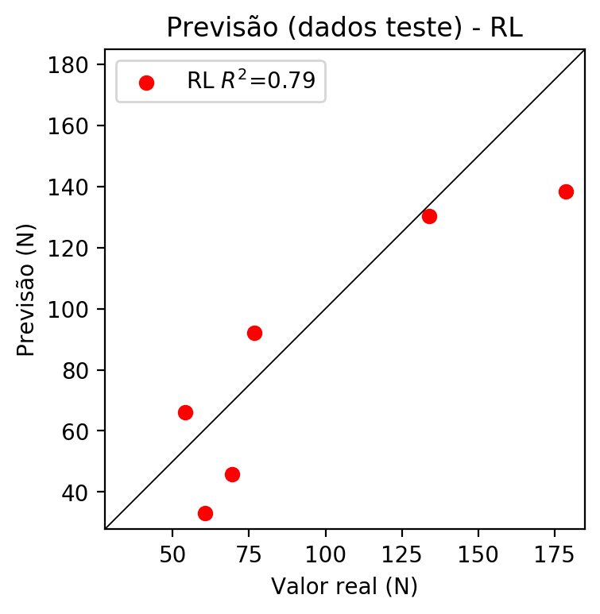

**Dados de treino**

* Erro relativo médio: 22.41
* Coeficiente de correlação: 0.9
* Coeficiente de determinação: 0.81
* MSE: 452.36
* RMSE: 21.27

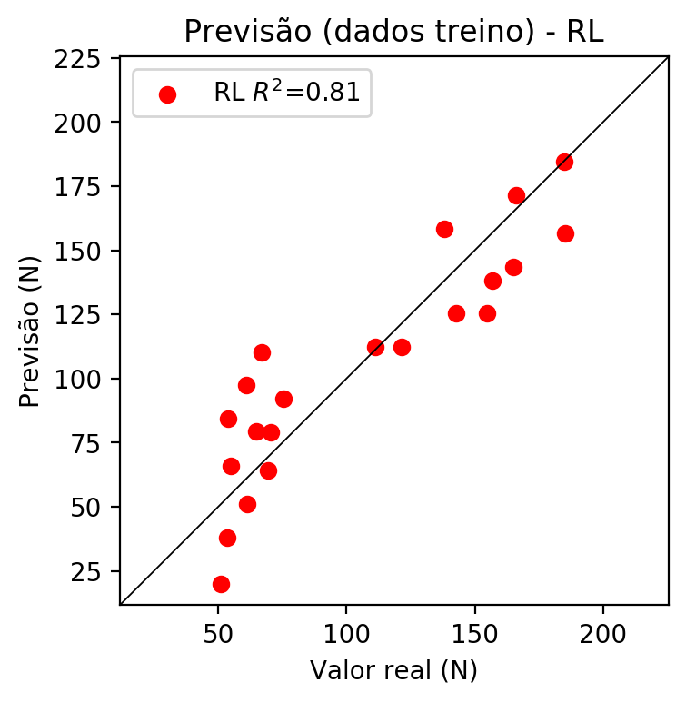

# RP2

# Coeficientes

[ 0. 0.38140739 0.23358622 0.76305303 0.15745274 0.01626967  
 -0.1184153 0.0085987 0.20046977 0.30602421]

# Erros

**Dados de teste**

* Erro relativo médio: 37.27
* Coeficiente de correlação: 0.81
* Coeficiente de determinação: 0.65
* MSE: 818.79
* RMSE: 28.61

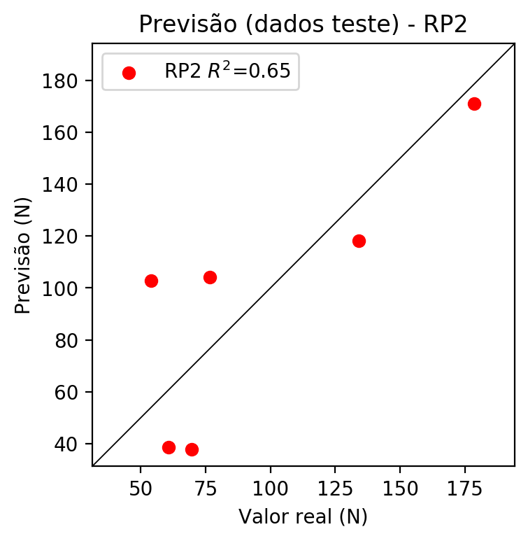

**Dados de treino**

* Erro relativo médio: 14.92
* Coeficiente de correlação: 0.94
* Coeficiente de determinação: 0.89
* MSE: 255.9
* RMSE: 16.0

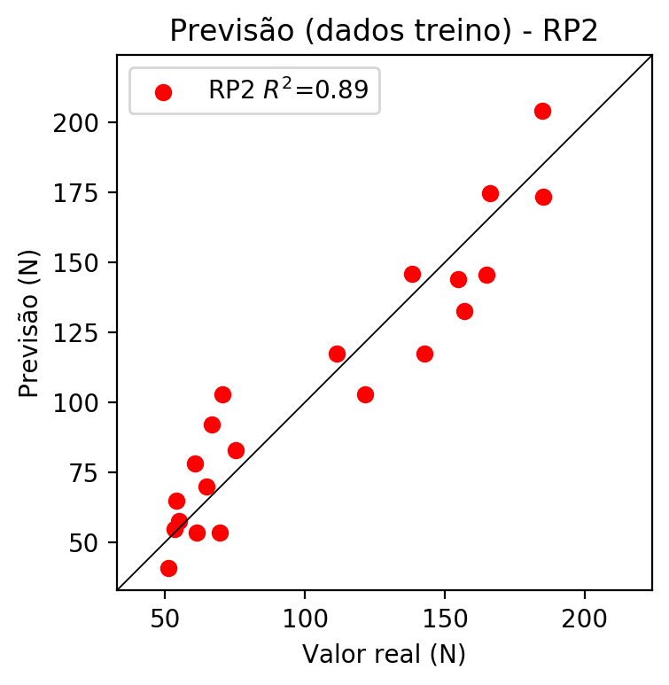

# RP3

# Coeficientes

[ 0. 0.20347923 0.02010044 0.27490618 0.25365154 -0.03144723  
 0.02004443 -0.01172122 0.09148096 0.37237436 0.29391444 0.13852163  
 -0.06116621 -0.00317624 -0.12666851 -0.45192578 0.02903396 -0.02790715  
 0.20029912 0.3970867 ]

# Erros

**Dados de teste**

* Erro relativo médio: 26.69
* Coeficiente de correlação: 0.92
* Coeficiente de determinação: 0.85
* MSE: 592.82
* RMSE: 24.35

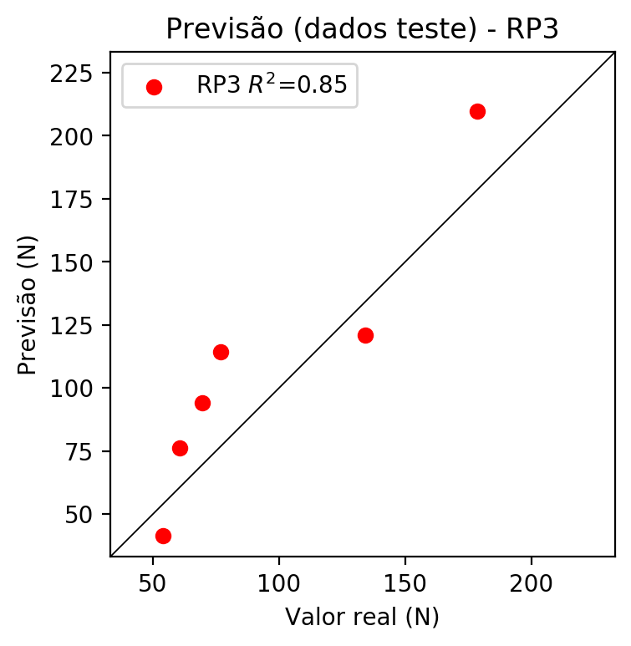

**Dados de treino**

* Erro relativo médio: 8.72
* Coeficiente de correlação: 0.99
* Coeficiente de determinação: 0.97
* MSE: 60.98
* RMSE: 7.81

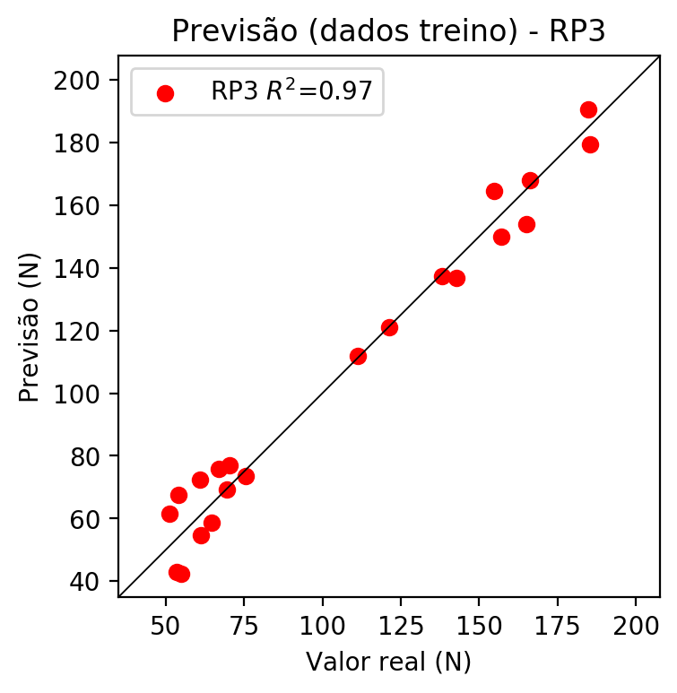

# RP4

# Coeficientes

[-8.32667268e-17 1.68277700e-01 3.53712308e-02 2.83906393e-01  
 1.49819572e-01 6.00732677e-03 -1.68518176e-02 -2.35412433e-03  
 2.07230343e-02 2.25486161e-01 2.43067789e-01 8.51866497e-02  
 -5.19590625e-02 -2.21593503e-02 -6.49572335e-02 -3.32835628e-01  
 5.10917778e-02 -1.83609719e-02 1.01423481e-01 4.10087013e-01  
 2.56868551e-01 1.71822894e-02 4.39239964e-02 -6.08577316e-03  
 2.46800696e-02 -3.77949105e-01 6.08081075e-03 1.50548098e-02  
 -6.60687438e-02 -2.43415144e-02 -3.94616185e-03 2.55527410e-02  
 -1.22827279e-02 2.99332717e-02 3.25702233e-01]

# Erros

**Dados de teste**

* Erro relativo médio: 4.47
* Coeficiente de correlação: 1.0
* Coeficiente de determinação: 1.0
* MSE: 30.2
* RMSE: 5.5

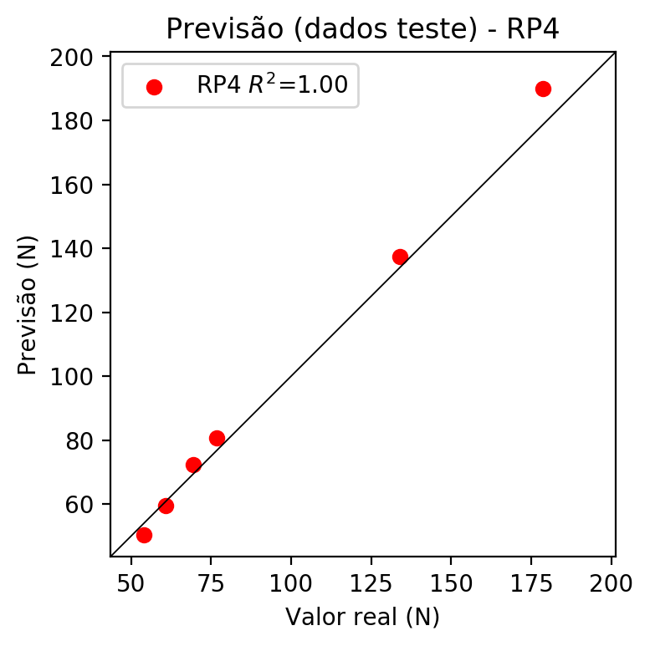

**Dados de treino**

* Erro relativo médio: 0.0
* Coeficiente de correlação: 1.0
* Coeficiente de determinação: 1.0
* MSE: 0.0
* RMSE: 0.0

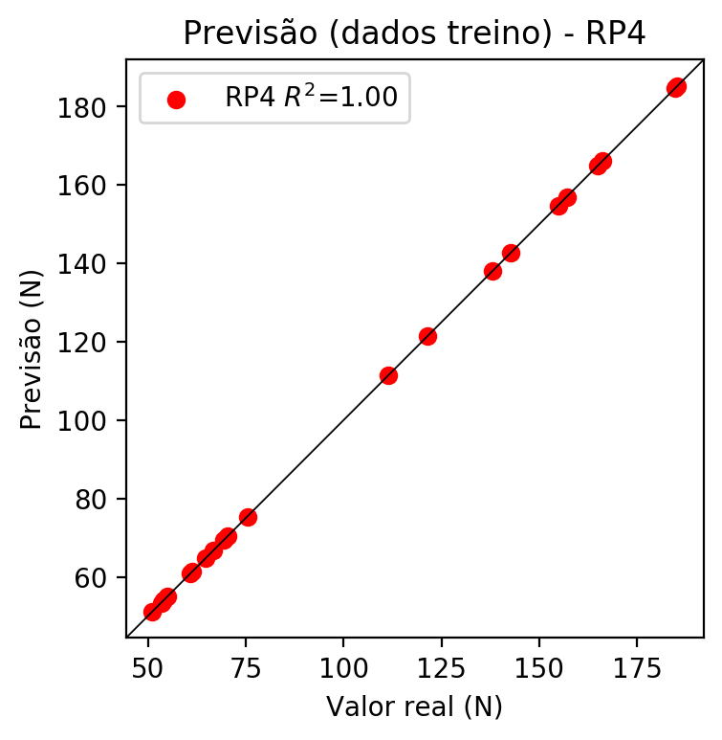

# Geral

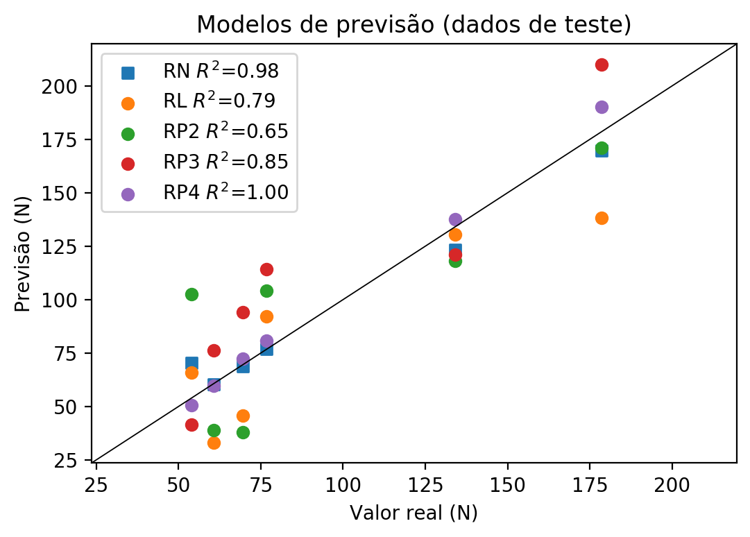

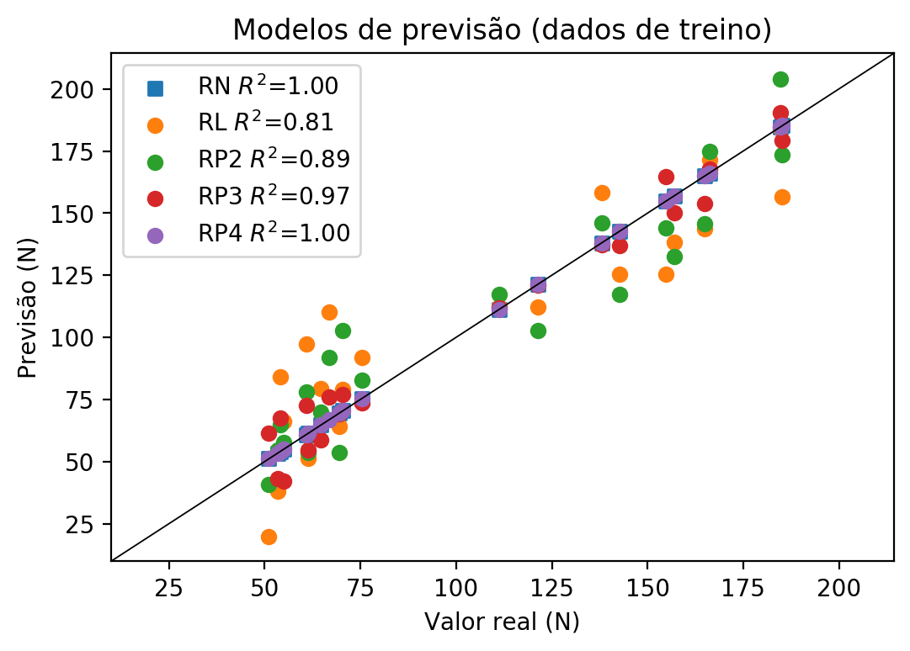

**Dados de teste**

|  |  |  |  |  |  |  |  |  |  |  |
| --- | --- | --- | --- | --- | --- | --- | --- | --- | --- | --- |
| Valor real | RN Previsto | RN Erro (%) | RL Previsto | RL Erro (%) | RP2 Previsto | RP2 Erro (%) | RP3 Previsto | RP3 Erro (%) | RP4 Previsto | RP4 Erro (%) |
| 54.0 | 70.51 | 30.57 | 65.97 | 22.17 | 102.68 | 90.15 | 41.41 | 23.31 | 50.46 | 6.56 |
| 178.6 | 169.71 | 4.98 | 138.27 | 22.58 | 170.91 | 4.31 | 209.92 | 17.54 | 190.04 | 6.41 |
| 76.74 | 76.99 | 0.33 | 91.99 | 19.87 | 104.24 | 35.84 | 114.33 | 48.98 | 80.76 | 5.24 |
| 134.0 | 123.27 | 8.01 | 130.38 | 2.7 | 118.22 | 11.78 | 121.11 | 9.62 | 137.44 | 2.57 |
| 60.68 | 60.49 | 0.31 | 33.01 | 45.6 | 38.77 | 36.11 | 76.14 | 25.48 | 59.55 | 1.86 |
| 69.5 | 68.65 | 1.22 | 45.85 | 34.03 | 37.9 | 45.47 | 93.98 | 35.22 | 72.42 | 4.2 |

**Dados de treino**

|  |  |  |  |  |  |  |  |  |  |  |
| --- | --- | --- | --- | --- | --- | --- | --- | --- | --- | --- |
| Valor real | RN Previsto | RN Erro (%) | RL Previsto | RL Erro (%) | RP2 Previsto | RP2 Erro (%) | RP3 Previsto | RP3 Erro (%) | RP4 Previsto | RP4 Erro (%) |
| 166.2 | 166.17 | 0.02 | 171.57 | 3.23 | 174.86 | 5.21 | 167.82 | 0.97 | 166.2 | 0.0 |
| 75.4 | 75.38 | 0.03 | 92.06 | 22.1 | 82.84 | 9.87 | 73.53 | 2.48 | 75.4 | 0.0 |
| 142.7 | 142.74 | 0.03 | 125.36 | 12.15 | 117.3 | 17.8 | 136.77 | 4.16 | 142.7 | 0.0 |
| 154.8 | 154.8 | 0.0 | 125.43 | 18.97 | 143.9 | 7.04 | 164.54 | 6.29 | 154.8 | 0.0 |
| 121.4 | 121.38 | 0.02 | 112.17 | 7.6 | 102.79 | 15.33 | 120.91 | 0.4 | 121.4 | 0.0 |
| 53.4 | 53.41 | 0.02 | 37.97 | 28.9 | 54.75 | 2.53 | 42.97 | 19.53 | 53.4 | 0.0 |
| 69.4 | 69.4 | 0.0 | 64.0 | 7.78 | 53.56 | 22.82 | 69.32 | 0.12 | 69.4 | 0.0 |
| 185.25 | 185.24 | 0.01 | 156.41 | 15.57 | 173.54 | 6.32 | 179.4 | 3.16 | 185.25 | 0.0 |
| 184.8 | 184.81 | 0.01 | 184.41 | 0.21 | 204.12 | 10.45 | 190.57 | 3.12 | 184.8 | 0.0 |
| 64.7 | 64.73 | 0.05 | 79.22 | 22.44 | 69.77 | 7.84 | 58.66 | 9.34 | 64.7 | 0.0 |
| 60.8 | 60.76 | 0.07 | 97.36 | 60.13 | 78.02 | 28.32 | 72.47 | 19.19 | 60.8 | 0.0 |
| 55.0 | 54.99 | 0.02 | 66.03 | 20.05 | 57.57 | 4.67 | 42.22 | 23.24 | 55.0 | 0.0 |
| 138.1 | 138.11 | 0.01 | 158.38 | 14.69 | 146.04 | 5.75 | 137.41 | 0.5 | 138.1 | 0.0 |
| 66.8 | 66.83 | 0.04 | 110.2 | 64.97 | 91.98 | 37.69 | 75.82 | 13.5 | 66.8 | 0.0 |
| 61.3 | 61.29 | 0.02 | 51.16 | 16.54 | 53.54 | 12.66 | 54.75 | 10.69 | 61.3 | 0.0 |
| 165.0 | 165.01 | 0.01 | 143.57 | 12.99 | 145.64 | 11.73 | 153.8 | 6.79 | 165.0 | 0.0 |
| 54.0 | 54.02 | 0.04 | 84.18 | 55.89 | 64.92 | 20.22 | 67.43 | 24.87 | 54.0 | 0.0 |
| 51.1 | 51.1 | 0.0 | 19.83 | 61.19 | 40.89 | 19.98 | 61.45 | 20.25 | 51.1 | 0.0 |
| 157.0 | 156.98 | 0.01 | 138.2 | 11.97 | 132.61 | 15.54 | 150.01 | 4.45 | 157.0 | 0.0 |
| 111.35 | 111.35 | 0.0 | 112.24 | 0.8 | 117.39 | 5.42 | 111.96 | 0.55 | 111.35 | 0.0 |
| 70.4 | 70.4 | 0.0 | 79.15 | 12.43 | 102.87 | 46.12 | 77.11 | 9.53 | 70.4 | 0.0 |