# Informações do estudo

Referência: Bartarya

Grandeza: Força

Tipo: Fz

Material: EN31 bearing steel (60±2 HRc)

Ferramenta: TNGA160408 S01525

Número de experimentos: 27

Observações:  
Tool holder: PTGNR 2020 K16  
Dynamometer: 5233A

# Unidades

Velocidade: m/min

Avanço: mm/rev

Profundidade de corte: mm

Força: N

# Dados de teste

|  |  |  |  |
| --- | --- | --- | --- |
| Força | n | f | a |
| 36.5 | 261.1 | 0.08 | 0.1 |
| 98.7 | 204.0 | 0.15 | 0.2 |
| 58.6 | 261.1 | 0.08 | 0.2 |
| 69.3 | 167.0 | 0.15 | 0.15 |
| 44.5 | 204.0 | 0.11 | 0.1 |
| 53.7 | 204.0 | 0.11 | 0.15 |

# Dados de treino

|  |  |  |  |
| --- | --- | --- | --- |
| Força | n | f | a |
| 87.1 | 261.1 | 0.15 | 0.15 |
| 54.55 | 167.0 | 0.11 | 0.15 |
| 79.3 | 204.0 | 0.08 | 0.2 |
| 80.55 | 167.0 | 0.11 | 0.2 |
| 63.6 | 204.0 | 0.15 | 0.15 |
| 32.63 | 167.0 | 0.08 | 0.1 |
| 51.9 | 204.0 | 0.15 | 0.1 |
| 111.09 | 261.1 | 0.15 | 0.2 |
| 103.0 | 167.0 | 0.15 | 0.2 |
| 48.5 | 204.0 | 0.08 | 0.15 |
| 45.0 | 167.0 | 0.08 | 0.15 |
| 39.86 | 261.1 | 0.11 | 0.1 |
| 74.5 | 167.0 | 0.08 | 0.2 |
| 51.84 | 261.1 | 0.15 | 0.1 |
| 48.5 | 261.1 | 0.08 | 0.15 |
| 86.0 | 204.0 | 0.11 | 0.2 |
| 39.1 | 167.0 | 0.11 | 0.1 |
| 32.6 | 204.0 | 0.08 | 0.1 |
| 83.2 | 261.1 | 0.11 | 0.2 |
| 61.5 | 261.1 | 0.11 | 0.15 |
| 53.9 | 167.0 | 0.15 | 0.1 |

# RN

Número de neurônios: 99

Taxa de aprendizado: 1.000000e-02

Número de épocas: 16

2° camada: False

Função de ativação: tanh

# Erros

**Dados de teste**

* Erro relativo médio: 14.75
* Coeficiente de correlação: 0.94
* Coeficiente de determinação: 0.88
* MSE: 84.76
* RMSE: 9.21

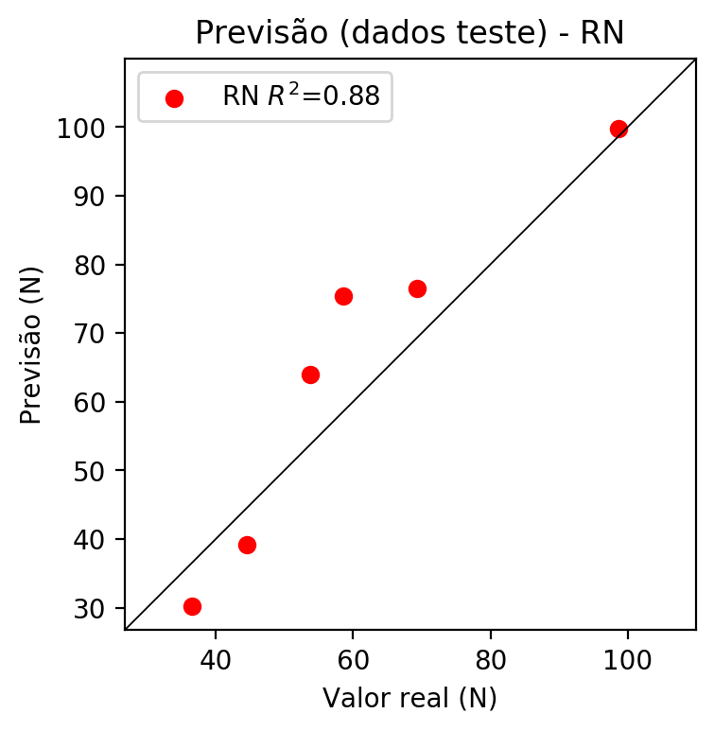

**Dados de treino**

* Erro relativo médio: 7.69
* Coeficiente de correlação: 0.97
* Coeficiente de determinação: 0.93
* MSE: 33.3
* RMSE: 5.77

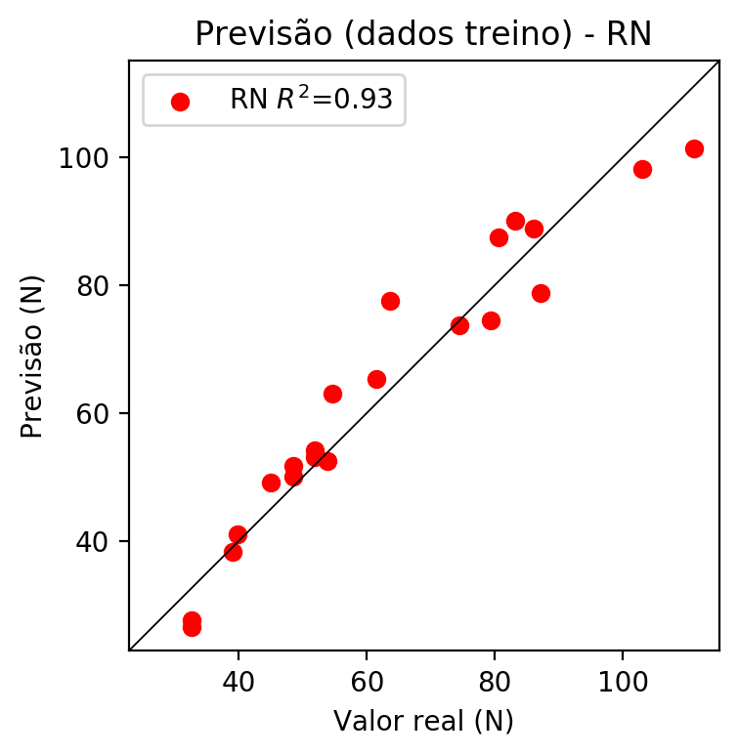

# Pesos

Pesos - camada oculta 1

[[ 0.03679267 -0.03476208 -0.04232086 0.0482511 0.0190239 -0.00119439  
 0.12883265 0.06832457 0.0268252 -0.02475137 -0.10558093 0.03666747  
 -0.02643007 0.09452896 0.00668565 0.01423721 -0.07572441 0.03061571  
 -0.07851154 0.08252767 0.08413325 0.04653807 0.02836624 0.00893918  
 0.08692031 -0.04881656 0.11110758 -0.03255423 0.05616668 -0.05322791  
 0.01435049 -0.11576936 -0.02358245 -0.06346525 0.00777555 -0.04677139  
 -0.06956642 -0.00351805 -0.05690458 0.04164884 0.00094164 0.00350699  
 0.07872597 0.09414078 -0.01154128 0.06779766 -0.12364584 -0.03286963  
 0.07909158 0.11347445 0.02849403 0.03253254 -0.06279583 0.05014627  
 0.00975718 -0.03185128 -0.13675988 -0.13505384 -0.09695416 -0.08806807  
 0.07065091 -0.07618621 -0.07615024 -0.06151539 0.10368849 -0.09929245  
 0.09415516 -0.02303571 -0.08091296 -0.01599049 0.09486285 -0.10191172  
 -0.07152326 -0.05254119 -0.01598692 -0.04088445 -0.02532006 0.06774177  
 -0.11927889 0.03144616 0.04226358 -0.11236208 -0.11066625 0.02626293  
 -0.01872556 0.06882018 -0.12047119 -0.08958785 -0.10849319 0.07048848  
 0.02226599 -0.06019161 -0.11423913 -0.07102298 0.01464694 -0.04030701  
 -0.10720893 -0.08329919 -0.01608463]  
 [-0.05953052 0.19234131 -0.23465979 0.21082903 -0.06501937 -0.31542575  
 -0.3223049 -0.08734139 -0.20158586 0.1295013 0.07405991 0.10386444  
 -0.05677447 0.09777589 0.10178061 -0.04832718 0.33379608 -0.07293969  
 -0.20472449 0.03599216 -0.03762503 0.15708947 -0.23658493 0.11422972  
 -0.19417666 0.27789593 0.12710838 0.2854921 0.05704013 -0.31589264  
 -0.13596149 0.01875127 -0.1013888 -0.0925059 0.09303886 0.09896827  
 0.2557383 -0.01166906 -0.01550102 -0.2670854 0.28661892 -0.00276856  
 -0.22236207 0.14089583 0.0423145 -0.07973734 0.01823689 0.17702158  
 0.22704974 0.30537486 0.18068203 0.31409845 -0.08012056 -0.1001275  
 -0.26022246 -0.08704536 -0.09472848 0.30419546 0.1878423 0.00415724  
 0.09005524 -0.26795605 0.04559039 -0.06701068 0.08824848 -0.2949159  
 -0.32915336 0.25741458 -0.20945972 -0.31610757 -0.23011251 0.03592847  
 0.17084269 -0.32322687 0.26327544 -0.32074797 0.19397432 -0.22924125  
 0.27832228 -0.05236837 -0.21719787 0.3235453 0.08631249 0.06428394  
 -0.18271615 0.06958625 -0.01385988 0.20347865 0.27976146 0.08254839  
 -0.18672328 -0.12141087 -0.26899952 0.0191771 -0.07009766 -0.00408757  
 -0.18220168 0.2952812 0.20206031]  
 [ 0.00714288 0.05114728 0.0723999 -0.18193427 0.3355487 -0.02752993  
 -0.19114581 -0.07850984 -0.1835365 0.04874762 -0.11689063 0.27877936  
 0.13884027 -0.15474 -0.28546256 0.00969775 0.19685307 -0.03461964  
 0.00296909 0.22279909 0.30130637 0.20005083 0.06551342 0.2005041  
 -0.1807954 0.03187068 0.24477853 -0.04242337 0.07839208 -0.21285172  
 0.00480571 -0.3003392 -0.3242175 -0.22415033 0.00057802 -0.323108  
 0.29680222 0.22086051 -0.20220765 -0.17073406 0.33568978 -0.00517194  
 0.17065214 0.06003591 0.17954701 -0.1040949 0.15295619 0.05656276  
 0.13444073 0.08256696 0.135775 0.12959963 0.2516095 -0.22044201  
 0.10367505 -0.04404838 0.21190086 0.23089814 0.09830459 -0.03294827  
 0.22571507 -0.2675124 -0.27224633 0.2938084 0.0829739 -0.24206857  
 -0.27084887 0.06930578 -0.17040592 -0.21513952 -0.32156 0.12890041  
 0.03617277 -0.05290712 -0.08204745 -0.34197572 0.02722039 0.12806141  
 0.19106475 -0.1398664 -0.00188475 -0.14635728 -0.127213 0.10390519  
 -0.28323188 -0.02233796 0.09699681 0.14087598 -0.02923108 0.12398909  
 -0.09300391 -0.05718509 -0.11076538 0.27979198 -0.2777784 0.02817505  
 0.08142643 0.34196523 0.04905831]]

Bias - camada oculta

[ 0.00598358 0.0016957 -0.01660327 0.01445375 -0.01362821 -0.00990448  
 0.00584879 0.01935142 -0.00091855 0.00499492 -0.01836766 -0.00168932  
 -0.00179484 -0.06003158 0.01026887 -0.00349496 0.01424497 -0.00093572  
 -0.03072622 0.01289803 -0.00100267 0.01260091 0.00685478 0.00527952  
 -0.03324446 0.00760396 0.01916921 -0.00334023 0.01999183 -0.00936514  
 -0.00078772 -0.00501749 0.01195814 -0.01145657 0.01739342 0.01005169  
 -0.00291818 -0.00121029 -0.00988766 -0.00431572 -0.02016761 0.00455448  
 0.00199359 0.03356567 0.00269148 -0.05284467 -0.02166114 0.00641485  
 0.02775712 0.03998977 0.01561239 0.0139785 0.01385618 -0.00969184  
 -0.00059371 -0.01327552 0.03266799 -0.00906258 -0.00357961 -0.02098861  
 0.01251563 -0.00653329 -0.00148789 0.00834785 0.0321819 -0.01679656  
 0.01709482 0.004954 -0.02443895 -0.00082792 0.01885507 0.06574751  
 -0.02444091 -0.02281982 0.00114152 0.01794126 0.00467985 0.00113175  
 -0.00017766 -0.00169717 -0.00379697 -0.00274733 -0.01837236 0.01840738  
 0.0057997 0.02097065 -0.01936358 0.0035523 -0.00739069 0.02264805  
 -0.00592061 -0.02468992 -0.03919305 0.01448138 0.0075856 -0.00987406  
 -0.03102537 -0.02780717 0.00796484]

Pesos - camada saída

[[ 0.04177276 -0.02128673 -0.04924652 -0.06402485 0.01377649 -0.00725633  
 -0.17655715 -0.07392817 0.01191247 -0.01904671 -0.10886315 0.03439381  
 -0.02159279 -0.07845943 0.00798158 0.00945331 0.11609803 0.02636128  
 -0.08417498 0.08313825 0.08238212 0.04726582 0.03580551 0.01009252  
 -0.10740925 -0.05381208 0.11159717 -0.02922266 0.06008305 -0.05330735  
 0.02849692 -0.11490908 -0.01872221 -0.06368264 -0.01585621 -0.04302559  
 0.1527958 -0.00257944 -0.05771148 -0.01681905 -0.00387382 0.00854169  
 0.08012289 0.09866865 -0.00828302 -0.05876231 0.14202057 -0.03842483  
 0.0818361 0.11755349 0.03115805 0.03533189 0.04882894 -0.03412602  
 0.00277824 -0.03932548 0.13611893 0.16660778 -0.10358573 -0.0929604  
 0.0709411 -0.07486932 -0.07514152 0.06344679 0.10782959 -0.09926747  
 -0.2014649 -0.01505565 -0.08278231 -0.01641477 -0.19609012 0.09315042  
 0.0724619 -0.05708743 -0.00940582 -0.03438638 -0.01901959 0.06996445  
 0.18001917 0.02083378 0.04688103 -0.11452463 -0.11376555 0.0467122  
 -0.01604174 0.074703 0.1290378 -0.09675564 -0.11294894 0.07348465  
 0.01519209 -0.06461658 -0.11778747 0.09788051 0.01086738 -0.04607201  
 -0.11423403 0.20381446 -0.01008675]]

# Iterações

|  |  |  |  |  |  |  |
| --- | --- | --- | --- | --- | --- | --- |
| Média | Desvio | n | ln | 2° camada | Função | Épocas |
| -0.1482 | 0.0991 | 10 | 0.1 | False | relu | 38 |
| -0.1805 | 0.0972 | 17 | 0.1 | True | relu | 716 |
| -0.2362 | 0.1735 | 7 | 0.01 | True | tanh | 130 |
| -0.1455 | 0.0907 | 19 | 0.001 | False | tanh | 282 |
| -0.1441 | 0.0925 | 29 | 0.001 | False | relu | 469 |
| -0.2818 | 0.2828 | 88 | 0.1 | False | tanh | 926 |
| -0.1802 | 0.1816 | 95 | 0.0001 | True | relu | 984 |
| -0.1731 | 0.1776 | 10 | 0.01 | True | tanh | 865 |
| -0.6287 | 0.4975 | 58 | 0.001 | True | relu | 8 |
| -0.2084 | 0.1709 | 9 | 0.01 | False | tanh | 514 |
| -0.1577 | 0.1427 | 73 | 0.0001 | True | relu | 729 |
| -0.1396 | 0.1159 | 22 | 0.001 | True | relu | 543 |
| -0.1297 | 0.092 | 25 | 0.1 | True | relu | 562 |
| -0.1376 | 0.0959 | 53 | 0.001 | False | relu | 498 |
| -0.149 | 0.1289 | 83 | 0.01 | True | relu | 337 |
| -0.0821 | 0.0677 | 99 | 0.01 | False | tanh | 16 |
| -0.2123 | 0.1291 | 23 | 0.01 | False | relu | 472 |
| -0.1782 | 0.178 | 24 | 0.001 | True | relu | 778 |
| -0.1435 | 0.1429 | 58 | 0.01 | True | tanh | 382 |
| -0.3299 | 0.2754 | 35 | 0.1 | False | tanh | 596 |

# RL

# Coeficientes

[0. 0.06480999 0.48155558 0.88323641]

# Erros

**Dados de teste**

* Erro relativo médio: 14.45
* Coeficiente de correlação: 0.94
* Coeficiente de determinação: 0.88
* MSE: 82.13
* RMSE: 9.06

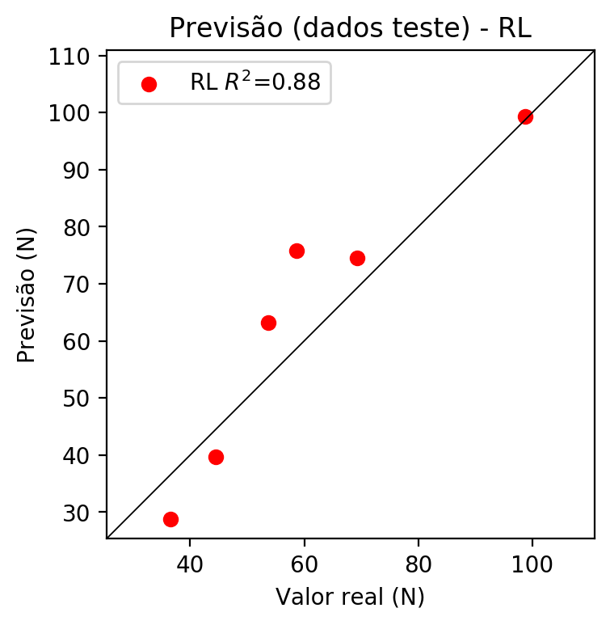

**Dados de treino**

* Erro relativo médio: 7.82
* Coeficiente de correlação: 0.97
* Coeficiente de determinação: 0.94
* MSE: 30.94
* RMSE: 5.56

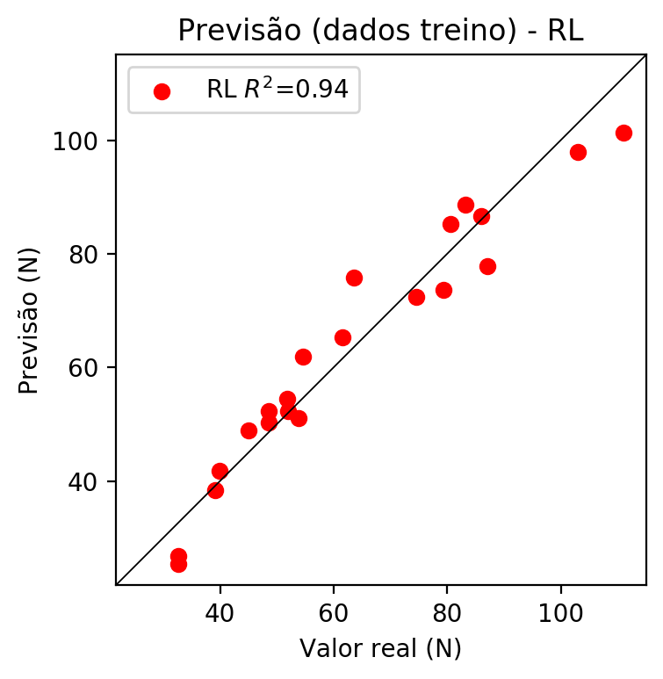

# RP2

# Coeficientes

[0. 0.07738493 0.47028182 0.89748556 0.05098511 0.0465968  
 0.03961493 0.17610372 0.06552694 0.18031806]

# Erros

**Dados de teste**

* Erro relativo médio: 11.84
* Coeficiente de correlação: 0.94
* Coeficiente de determinação: 0.89
* MSE: 85.96
* RMSE: 9.27

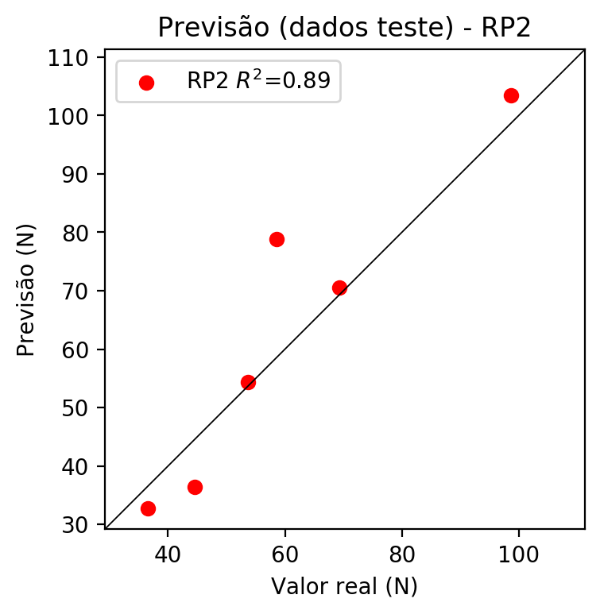

**Dados de treino**

* Erro relativo médio: 4.22
* Coeficiente de correlação: 0.99
* Coeficiente de determinação: 0.97
* MSE: 13.46
* RMSE: 3.67

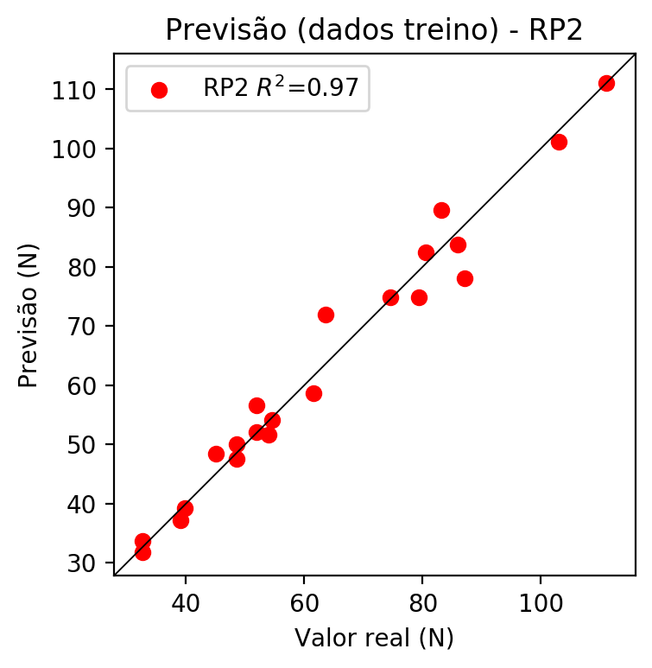

# RP3

# Coeficientes

[ 0. 0.07003681 0.11023331 0.27659778 0.00236989 0.08050139  
 0.03708208 0.1157985 0.07277787 0.15568167 0.10116428 0.13747507  
 -0.02912974 -0.01098435 0.03628245 -0.16069614 0.15922589 0.05615105  
 0.02912433 0.39953013]

# Erros

**Dados de teste**

* Erro relativo médio: 11.64
* Coeficiente de correlação: 0.98
* Coeficiente de determinação: 0.95
* MSE: 43.27
* RMSE: 6.58

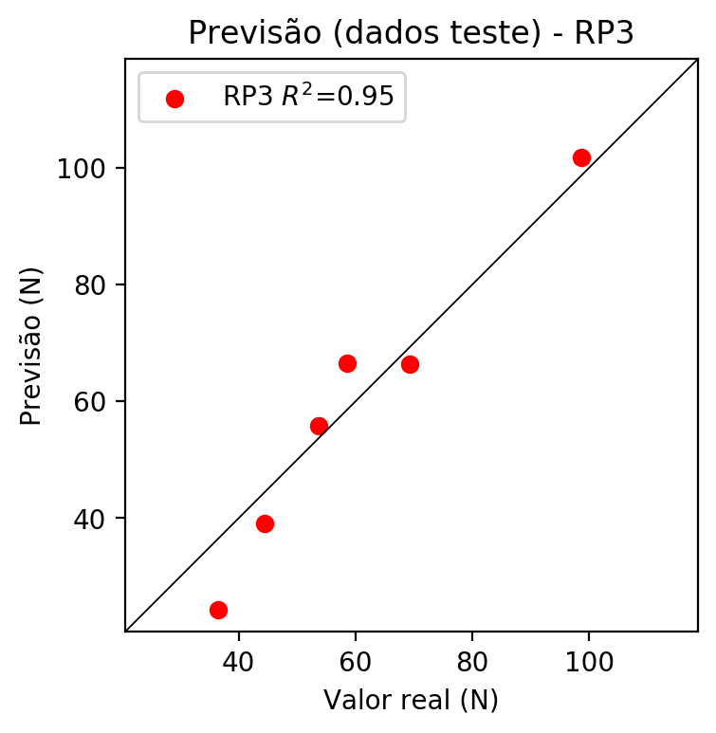

**Dados de treino**

* Erro relativo médio: 2.92
* Coeficiente de correlação: 1.0
* Coeficiente de determinação: 0.99
* MSE: 4.32
* RMSE: 2.08

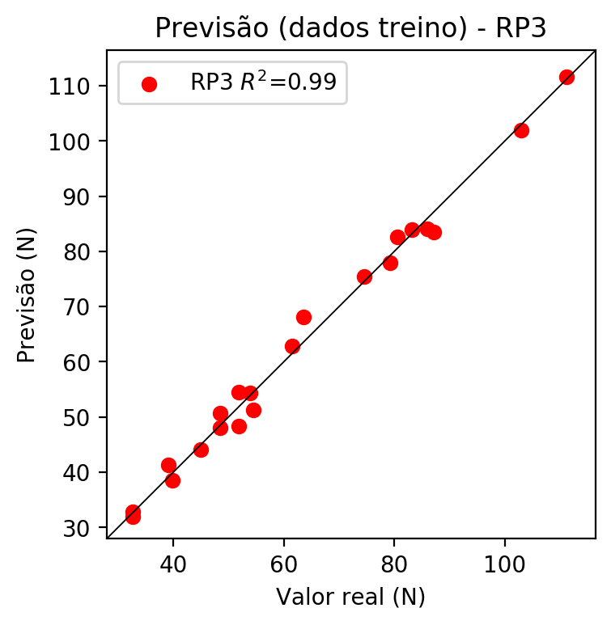

# RP4

# Coeficientes

[-1.11022302e-16 6.94199670e-02 8.76911191e-02 2.07827717e-01  
 -1.04771942e-01 -5.66057146e-04 -1.47122060e-02 -1.07357277e-01  
 -3.52753177e-02 2.20474368e-02 1.00273286e-01 2.55858514e-01  
 1.02773776e-01 -4.95060689e-02 8.31464701e-02 -7.10506347e-02  
 1.26664950e-01 -1.53619429e-02 -1.13453051e-01 3.00195591e-01  
 -1.34645165e-01 2.02677590e-02 2.87213701e-02 3.68747319e-01  
 2.74085715e-01 1.56157030e-02 -1.88875276e-03 -6.19102241e-02  
 -4.45399580e-02 -2.12509643e-02 -1.56424652e-01 -5.41599123e-02  
 1.71511909e-02 -5.09532367e-02 3.18462976e-02]

# Erros

**Dados de teste**

* Erro relativo médio: 19.05
* Coeficiente de correlação: 0.85
* Coeficiente de determinação: 0.72
* MSE: 172.92
* RMSE: 13.15

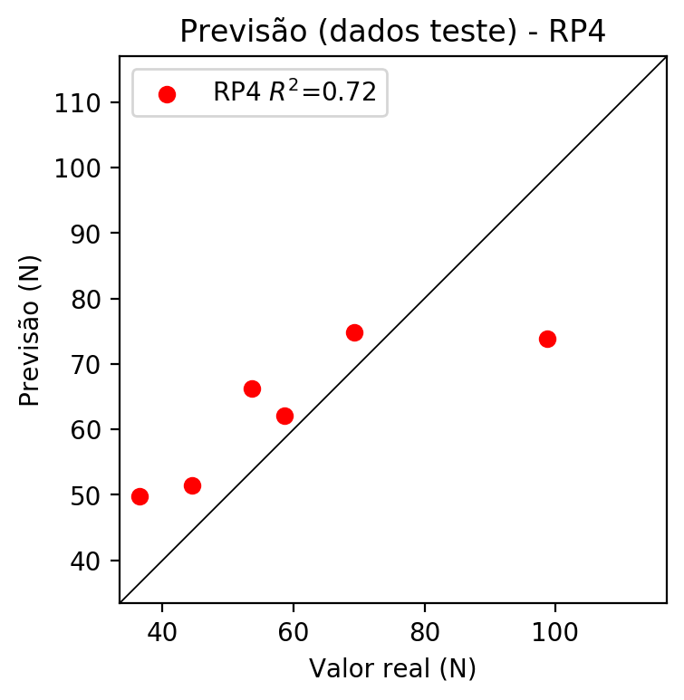

**Dados de treino**

* Erro relativo médio: 0.0
* Coeficiente de correlação: 1.0
* Coeficiente de determinação: 1.0
* MSE: 0.0
* RMSE: 0.0

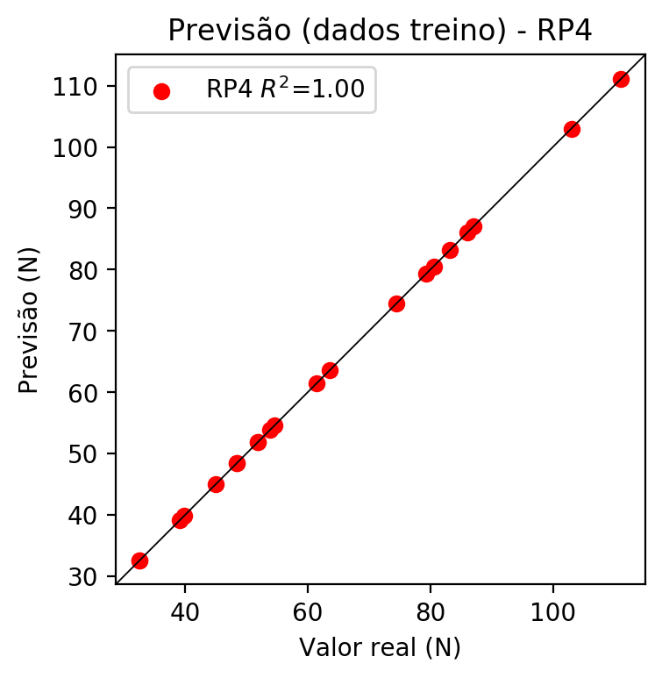

# Geral

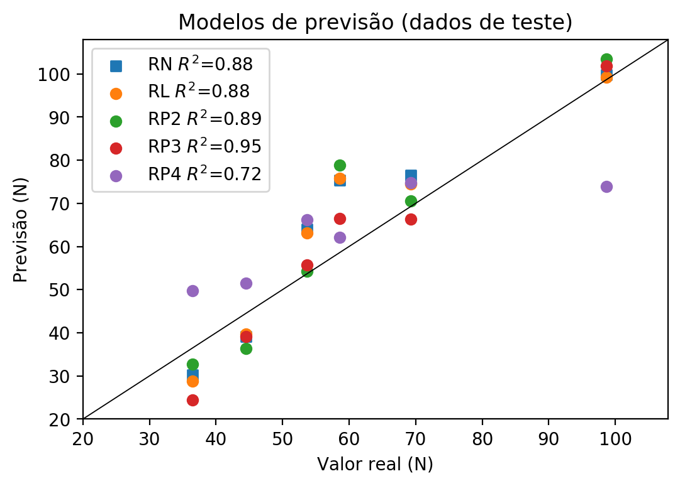

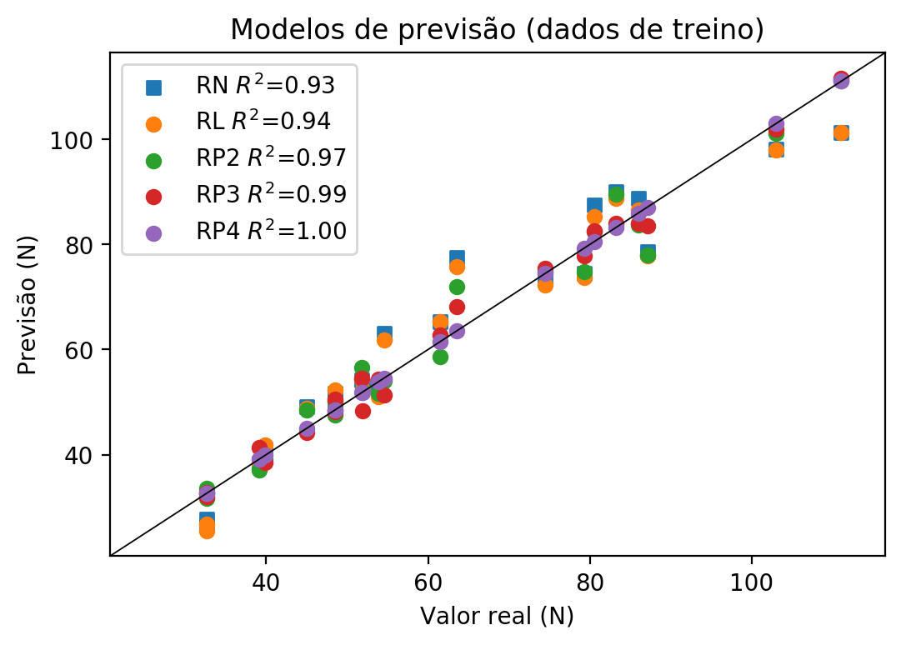

**Dados de teste**

|  |  |  |  |  |  |  |  |  |  |  |
| --- | --- | --- | --- | --- | --- | --- | --- | --- | --- | --- |
| Valor real | RN Previsto | RN Erro (%) | RL Previsto | RL Erro (%) | RP2 Previsto | RP2 Erro (%) | RP3 Previsto | RP3 Erro (%) | RP4 Previsto | RP4 Erro (%) |
| 36.5 | 30.21 | 17.23 | 28.84 | 20.99 | 32.7 | 10.41 | 24.4 | 33.15 | 49.8 | 36.44 |
| 98.7 | 99.76 | 1.07 | 99.26 | 0.57 | 103.5 | 4.86 | 101.81 | 3.15 | 73.92 | 25.11 |
| 58.6 | 75.39 | 28.65 | 75.76 | 29.28 | 78.86 | 34.57 | 66.45 | 13.4 | 62.11 | 5.99 |
| 69.3 | 76.45 | 10.32 | 74.46 | 7.45 | 70.59 | 1.86 | 66.39 | 4.2 | 74.82 | 7.97 |
| 44.5 | 39.12 | 12.09 | 39.72 | 10.74 | 36.39 | 18.22 | 39.09 | 12.16 | 51.43 | 15.57 |
| 53.7 | 63.99 | 19.16 | 63.18 | 17.65 | 54.31 | 1.14 | 55.74 | 3.8 | 66.18 | 23.24 |

**Dados de treino**

|  |  |  |  |  |  |  |  |  |  |  |
| --- | --- | --- | --- | --- | --- | --- | --- | --- | --- | --- |
| Valor real | RN Previsto | RN Erro (%) | RL Previsto | RL Erro (%) | RP2 Previsto | RP2 Erro (%) | RP3 Previsto | RP3 Erro (%) | RP4 Previsto | RP4 Erro (%) |
| 87.1 | 78.68 | 9.67 | 77.88 | 10.59 | 78.07 | 10.37 | 83.53 | 4.1 | 87.1 | 0.0 |
| 54.55 | 63.09 | 15.66 | 61.84 | 13.36 | 54.05 | 0.92 | 51.34 | 5.88 | 54.55 | 0.0 |
| 79.3 | 74.43 | 6.14 | 73.68 | 7.09 | 74.85 | 5.61 | 77.88 | 1.79 | 79.3 | 0.0 |
| 80.55 | 87.53 | 8.67 | 85.3 | 5.9 | 82.5 | 2.42 | 82.65 | 2.61 | 80.55 | 0.0 |
| 63.6 | 77.5 | 21.86 | 75.8 | 19.18 | 72.0 | 13.21 | 68.12 | 7.11 | 63.6 | 0.0 |
| 32.63 | 26.56 | 18.6 | 25.42 | 22.1 | 33.64 | 3.1 | 31.93 | 2.15 | 32.63 | 0.0 |
| 51.9 | 53.11 | 2.33 | 52.34 | 0.85 | 52.02 | 0.23 | 48.34 | 6.86 | 51.9 | 0.0 |
| 111.09 | 101.34 | 8.78 | 101.34 | 8.78 | 111.09 | 0.0 | 111.65 | 0.5 | 111.09 | 0.0 |
| 103.0 | 98.17 | 4.69 | 97.92 | 4.93 | 101.1 | 1.84 | 101.96 | 1.01 | 103.0 | 0.0 |
| 48.5 | 50.03 | 3.15 | 50.22 | 3.55 | 47.54 | 1.98 | 50.63 | 4.39 | 48.5 | 0.0 |
| 45.0 | 49.17 | 9.27 | 48.88 | 8.62 | 48.45 | 7.67 | 44.17 | 1.84 | 45.0 | 0.0 |
| 39.86 | 41.03 | 2.94 | 41.8 | 4.87 | 39.17 | 1.73 | 38.54 | 3.31 | 39.86 | 0.0 |
| 74.5 | 73.65 | 1.14 | 72.34 | 2.9 | 74.78 | 0.38 | 75.46 | 1.29 | 74.5 | 0.0 |
| 51.84 | 54.21 | 4.57 | 54.42 | 4.98 | 56.56 | 9.1 | 54.47 | 5.07 | 51.84 | 0.0 |
| 48.5 | 51.74 | 6.68 | 52.3 | 7.84 | 50.02 | 3.13 | 48.13 | 0.76 | 48.5 | 0.0 |
| 86.0 | 88.78 | 3.23 | 86.64 | 0.74 | 83.75 | 2.62 | 84.1 | 2.21 | 86.0 | 0.0 |
| 39.1 | 38.31 | 2.02 | 38.38 | 1.84 | 37.12 | 5.06 | 41.36 | 5.78 | 39.1 | 0.0 |
| 32.6 | 27.68 | 15.09 | 26.76 | 17.91 | 31.74 | 2.64 | 32.83 | 0.71 | 32.6 | 0.0 |
| 83.2 | 89.98 | 8.15 | 88.72 | 6.63 | 89.57 | 7.66 | 83.95 | 0.9 | 83.2 | 0.0 |
| 61.5 | 65.34 | 6.24 | 65.26 | 6.11 | 58.61 | 4.7 | 62.82 | 2.15 | 61.5 | 0.0 |
| 53.9 | 52.53 | 2.54 | 51.0 | 5.38 | 51.59 | 4.29 | 54.35 | 0.83 | 53.9 | 0.0 |