# Informações do estudo

Referência: Bartarya

Grandeza: Rugosidade

Tipo: Ra

Material: EN31 bearing steel (60±2 HRc)

Ferramenta: TNGA160408 S01525

Número de experimentos: 27

Observações:  
Tool holder: PTGNR 2020 K16  
Dynamometer: 5233A

# Unidades

Velocidade: m/min

Avanço: mm/rev

Profundidade de corte: mm

Rugosidade: μm

# Dados de teste

|  |  |  |  |
| --- | --- | --- | --- |
| Rugosidade | n | f | a |
| 1.3 | 204.0 | 0.11 | 0.1 |
| 3.83 | 204.0 | 0.08 | 0.2 |
| 2.26 | 204.0 | 0.11 | 0.15 |
| 2.47 | 261.1 | 0.08 | 0.15 |
| 1.43 | 261.1 | 0.15 | 0.15 |
| 1.95 | 204.0 | 0.15 | 0.2 |

# Dados de treino

|  |  |  |  |
| --- | --- | --- | --- |
| Rugosidade | n | f | a |
| 3.35 | 167.0 | 0.08 | 0.15 |
| 2.05 | 167.0 | 0.15 | 0.2 |
| 2.49 | 204.0 | 0.08 | 0.15 |
| 2.56 | 204.0 | 0.15 | 0.15 |
| 2.3 | 167.0 | 0.15 | 0.15 |
| 1.23 | 261.1 | 0.11 | 0.1 |
| 1.95 | 261.1 | 0.11 | 0.15 |
| 6.19 | 167.0 | 0.08 | 0.2 |
| 5.01 | 261.1 | 0.08 | 0.2 |
| 1.89 | 204.0 | 0.15 | 0.1 |
| 1.47 | 167.0 | 0.11 | 0.1 |
| 1.38 | 261.1 | 0.15 | 0.1 |
| 2.47 | 167.0 | 0.11 | 0.2 |
| 1.92 | 261.1 | 0.11 | 0.2 |
| 1.83 | 261.1 | 0.15 | 0.2 |
| 2.83 | 167.0 | 0.08 | 0.1 |
| 1.37 | 204.0 | 0.08 | 0.1 |
| 1.11 | 261.1 | 0.08 | 0.1 |
| 2.72 | 167.0 | 0.11 | 0.15 |
| 2.28 | 204.0 | 0.11 | 0.2 |
| 1.97 | 167.0 | 0.15 | 0.1 |

# RN

Número de neurônios: 22

Taxa de aprendizado: 1.000000e-03

Número de épocas: 543

2° camada: True

Função de ativação: relu

# Erros

**Dados de teste**

* Erro relativo médio: 17.77
* Coeficiente de correlação: 0.94
* Coeficiente de determinação: 0.87
* MSE: 0.47
* RMSE: 0.69

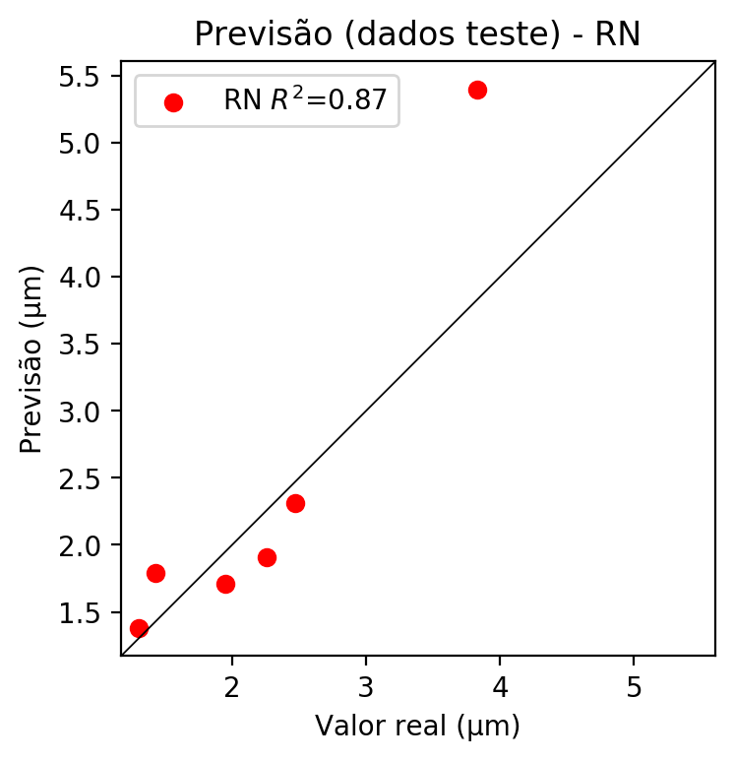

**Dados de treino**

* Erro relativo médio: 1.06
* Coeficiente de correlação: 1.0
* Coeficiente de determinação: 1.0
* MSE: 0.0
* RMSE: 0.0

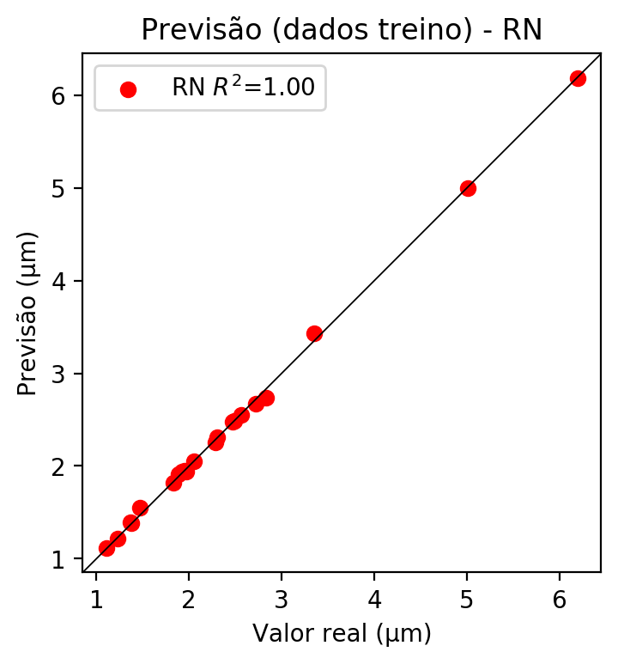

# Pesos

Pesos - camada oculta 1

[[ 0.25796074 0.07019445 -0.48187447 0.01082835 0.16354041 -0.21716523  
 0.00621394 -0.17555583 -0.2594825 0.03790346 -0.56455785 0.25733256  
 0.333726 -0.10025083 -0.06290566 -0.28070122 0.11854194 -0.11861049  
 -0.53006107 0.5243888 0.43069553 0.32659322]  
 [-0.18382101 0.3409446 -0.2172101 -0.3799081 0.5712391 0.05402754  
 0.5020875 -0.46768203 -0.21853803 -0.63461226 -0.3935326 -0.49925765  
 -0.09511831 -0.48145583 0.28117564 0.27542594 -0.36443093 -0.23859358  
 0.4532883 0.14309867 0.40479663 0.30861992]  
 [ 0.3027436 -0.06968056 0.03188991 -0.46356526 0.4789565 0.6233254  
 0.49540466 0.38304687 0.20011234 -0.03761908 -0.17981006 0.32494253  
 -0.06677318 0.0982322 -0.45096973 -0.47788587 0.467687 -0.50919914  
 -0.34545058 0.01582559 0.60577404 -0.48071083]]

Bias - camada oculta

[-0.05436347 -0.00967295 -0.30565926 0.10765462 0.17501283 0.0085706  
 0.00152019 -0.09582375 -0.04464413 0.00350011 -0.01281771 0.07290807  
 0.17402427 0.01521298 -0.07272126 0.10511683 -0.13331942 0.19261664  
 0.08137131 0.06851406 -0.00833997 -0.2192397 ]

Pesos - camada oculta 2

[[ 2.00303197e-01 1.18708462e-01 -3.74108374e-01 2.25876063e-01  
 3.79737318e-01 -2.42643282e-01 -9.24873650e-02 1.56656876e-01  
 -1.33990780e-01 1.26099765e-01 -3.03010553e-01 1.88172728e-01  
 3.39621395e-01 -1.84230685e-01 -1.75490931e-01 -3.02630126e-01  
 2.26916164e-01 -7.01901317e-02 -3.14270824e-01 4.88192886e-01  
 4.05885607e-01 3.66701901e-01]  
 [-1.22681096e-01 3.25283974e-01 -2.36212850e-01 -4.27567393e-01  
 3.25156748e-01 7.40183741e-02 3.46575558e-01 -1.45879924e-01  
 1.05696693e-02 -3.68416846e-01 -2.22357273e-01 -2.90690303e-01  
 -2.92212795e-03 -1.32522494e-01 3.99420485e-02 1.75495505e-01  
 -1.49774164e-01 -2.55969852e-01 1.78281397e-01 1.66545540e-01  
 4.22495455e-01 3.68086696e-01]  
 [ 2.22793162e-01 -3.86561938e-02 -9.62570384e-02 -1.61137402e-01  
 4.63828892e-01 2.60611326e-01 1.24571681e-01 4.31856841e-01  
 8.12908169e-03 -9.32052135e-02 -1.98576614e-01 5.65491207e-02  
 1.66634321e-01 -3.78364441e-03 -4.09737527e-01 -3.87409776e-01  
 3.95323545e-01 -3.36092800e-01 -3.37222248e-01 2.58360237e-01  
 4.84841406e-01 -2.27767348e-01]  
 [-1.35685623e-01 1.22440085e-01 -3.52524281e-01 -4.75279301e-01  
 -1.82761252e-01 1.09980129e-01 1.30268648e-01 -3.80631119e-01  
 2.50864953e-01 -2.46688813e-01 1.81445017e-01 2.33065739e-01  
 -4.80129160e-02 2.99108997e-02 3.55052859e-01 -2.16527075e-01  
 -5.48005223e-01 -2.53107786e-01 -2.73523241e-01 2.02888668e-01  
 -1.18223213e-01 -5.95442235e-01]  
 [-4.28860635e-01 5.77426672e-01 -1.52171671e-01 -4.58728760e-01  
 -5.51418424e-01 1.49933174e-01 -1.18486635e-01 -2.62449473e-01  
 -2.80496746e-01 9.70270932e-02 1.67735919e-01 -2.40683466e-01  
 4.05251943e-02 -1.34833932e-01 3.68060172e-01 -2.58090734e-01  
 -4.91777033e-01 -2.57342935e-01 -9.09246504e-02 -3.00851941e-01  
 5.83330244e-02 1.41779870e-01]  
 [ 9.98331234e-03 -3.11475396e-01 2.39145145e-01 4.31602061e-01  
 1.44307077e-01 2.97574818e-01 -1.48415416e-01 -4.39860709e-02  
 -2.72331804e-01 -2.19009936e-01 1.43216802e-02 -2.50288308e-01  
 1.07613131e-01 -4.19968724e-01 3.59037608e-01 -2.36604333e-01  
 3.98926079e-01 -5.26506174e-03 -3.27095538e-01 2.77668647e-02  
 2.67748117e-01 9.93513241e-02]  
 [ 5.01349289e-03 3.04175824e-01 5.03298998e-01 -3.86754051e-02  
 -4.86804545e-01 2.86688060e-01 -2.29477808e-01 1.40390992e-01  
 -8.97163004e-02 -3.37648690e-01 -3.63769829e-02 -8.68651271e-02  
 -2.25779444e-01 5.66699244e-02 4.86866862e-01 3.05209756e-01  
 3.32131237e-02 1.64204776e-01 3.12805206e-01 -4.67509896e-01  
 -1.30087242e-01 -4.21051443e-01]  
 [-4.34633076e-01 -6.24314070e-01 1.64437696e-01 3.70401949e-01  
 2.47784346e-01 -9.39320996e-02 -1.92196846e-01 2.68288344e-01  
 -2.06579790e-01 -4.29935753e-02 -3.01563472e-01 -3.58143270e-01  
 3.29758227e-01 2.06944775e-02 -3.34975570e-01 -4.95278463e-02  
 -5.69841079e-03 1.70701712e-01 -3.45176131e-01 3.52634937e-01  
 -2.55581141e-01 2.62757897e-01]  
 [-1.22733876e-01 2.98044771e-01 -4.63115349e-02 -2.57620692e-01  
 4.48100805e-01 1.58705220e-01 5.05637787e-02 2.71943379e-02  
 -2.23799080e-01 -1.61722928e-01 3.72207798e-02 3.03707421e-01  
 5.68189137e-02 -1.42055601e-01 -1.03143819e-01 -3.43028933e-01  
 -3.38998847e-02 -1.18727043e-01 1.31930590e-01 5.51947877e-02  
 3.57337505e-01 2.80445427e-01]  
 [-1.81261256e-01 3.92561741e-02 1.43736377e-01 -2.82225996e-01  
 4.28062320e-01 1.00463301e-01 1.38109718e-02 1.17105268e-01  
 -4.32894789e-02 -7.61982203e-02 -6.11929549e-03 2.04079062e-01  
 1.45695940e-01 -4.64064215e-06 -2.60814816e-01 2.73013562e-01  
 2.78499454e-01 -3.49827446e-02 1.25448823e-01 2.55143523e-01  
 4.04258281e-01 2.49019831e-01]  
 [ 2.50571668e-01 1.63346961e-01 -2.41822973e-01 2.36004263e-01  
 3.66354555e-01 -3.12518030e-01 2.17622146e-03 3.85981463e-02  
 1.64081872e-01 -2.89021909e-01 -5.05707681e-01 -2.31706411e-01  
 4.03502546e-02 -1.82618275e-01 3.41043532e-01 2.51334429e-01  
 -5.18983603e-02 -3.20185423e-01 3.19841921e-01 -1.49413673e-02  
 2.08178684e-01 -5.62503794e-03]  
 [ 2.76053604e-02 -3.30980718e-01 1.65826324e-02 3.55896831e-01  
 9.52222347e-02 1.73145220e-01 2.76596755e-01 -9.66773182e-02  
 3.69112581e-01 -1.93597779e-01 3.63627404e-01 -2.71641731e-01  
 2.93752313e-01 3.76316220e-01 4.68217492e-01 3.22899967e-01  
 2.76426435e-01 -2.50225782e-01 -2.72550970e-01 2.76712507e-01  
 -1.38743207e-01 -1.32608190e-01]  
 [-3.56456697e-01 -4.26528871e-01 -2.02637926e-01 -1.88977808e-01  
 -5.16936421e-01 2.23953262e-01 2.45328322e-01 -2.28485629e-01  
 -1.54557928e-01 -3.59944224e-01 -4.50393073e-02 -2.44229175e-02  
 7.75503600e-03 1.06870182e-01 1.67109689e-03 1.20259158e-01  
 -1.09763294e-01 2.97054499e-01 -2.72905588e-01 -2.88252413e-01  
 -1.50892437e-01 2.17850596e-01]  
 [ 1.12679854e-01 1.57508880e-01 -1.01626173e-01 1.40770212e-01  
 1.04915351e-01 1.96671113e-01 -1.42570004e-01 3.81461918e-01  
 3.76397282e-01 3.53402525e-01 -1.44951031e-01 -4.32227492e-01  
 -1.25858620e-01 2.66052037e-01 -1.74326852e-01 -4.40814309e-02  
 -7.82421678e-02 1.83515728e-01 2.84092486e-01 2.66290307e-01  
 9.50624496e-02 3.64667863e-01]  
 [ 2.00211316e-01 -7.84334317e-02 1.59379706e-01 -3.33209783e-01  
 3.80572155e-02 -6.36329204e-02 2.68123269e-01 1.37311161e-01  
 3.88384879e-01 -1.25663862e-01 7.89620131e-02 1.76748365e-01  
 -9.55974497e-03 -9.23514590e-02 9.43271890e-02 -1.37577280e-01  
 -3.36136252e-01 -2.66836882e-01 -3.08575958e-01 -2.86041319e-01  
 1.29890610e-02 -2.91267544e-01]  
 [-1.03858747e-01 3.03675383e-01 -1.94798291e-01 6.80016950e-02  
 2.02140838e-01 -3.97252411e-01 5.02503812e-02 3.81588966e-01  
 1.78395212e-01 -2.51402378e-01 -5.89981787e-02 -4.04631704e-01  
 7.34951198e-02 -1.56935900e-02 8.01090002e-02 3.59940618e-01  
 3.80052567e-01 -2.46487856e-01 -2.78562099e-01 -2.11181059e-01  
 2.06454232e-01 -8.39019343e-02]  
 [-3.14522862e-01 -4.28465724e-01 4.73420769e-02 4.35195416e-02  
 1.30501091e-01 2.37789482e-01 7.89256021e-02 4.99492176e-02  
 -1.34578764e-01 -5.08792400e-02 -2.31397688e-01 -3.21918689e-02  
 1.75432190e-01 3.54673266e-02 6.70993999e-02 9.95233431e-02  
 4.11363691e-01 -2.16607094e-01 2.79529005e-01 -2.85743196e-02  
 3.92464608e-01 -5.98801523e-02]  
 [ 3.09656948e-01 1.86139792e-01 2.42150128e-02 -3.46210748e-01  
 3.78819474e-04 2.95625567e-01 2.50183851e-01 6.05923645e-02  
 3.95966142e-01 -2.00777248e-01 -1.01307027e-01 2.05507368e-01  
 5.53431585e-02 4.33865219e-01 4.04748917e-01 4.60597634e-01  
 -5.10696888e-01 -3.74776512e-01 -3.12856048e-01 2.60238498e-01  
 -3.13922465e-01 -4.48851943e-01]  
 [ 1.01817310e-01 3.40335786e-01 1.46494895e-01 2.97509998e-01  
 -3.44327837e-01 -4.13442940e-01 1.79381743e-01 -7.74240941e-02  
 9.49138701e-02 -5.65887392e-02 -2.15339765e-01 4.81699314e-03  
 -1.11868765e-04 3.98490310e-01 -2.44854853e-01 -1.48026958e-01  
 3.07645053e-02 1.67345732e-01 -1.17989995e-01 -9.23901796e-02  
 1.86330065e-01 -5.22193789e-01]  
 [ 2.95184478e-02 -3.27288061e-01 -4.00915176e-01 -8.58812481e-02  
 -6.02427348e-02 -6.88091144e-02 5.55372834e-02 8.39253422e-03  
 1.03515379e-01 -2.06862390e-02 3.47487867e-01 1.63262129e-01  
 -2.76059031e-01 3.46084461e-02 4.20140833e-01 -4.42125469e-01  
 1.48299769e-01 9.42587852e-02 3.80280316e-02 3.17083418e-01  
 7.22798184e-02 1.32183045e-01]  
 [ 1.27131015e-01 3.25998664e-01 6.04937263e-02 -7.61571154e-02  
 7.89330006e-02 1.44516096e-01 -5.19565403e-01 3.68024617e-01  
 -1.75472066e-01 -2.83669144e-01 1.81265268e-02 -2.60280728e-01  
 -1.98176980e-01 -5.68950593e-01 -5.89748695e-02 -1.87571004e-01  
 2.02760875e-01 3.93386990e-01 -1.00108653e-01 -1.25723585e-01  
 1.03750169e-01 9.40042287e-02]  
 [ 2.71918893e-01 -2.88525552e-01 -3.95393044e-01 5.09327613e-02  
 8.48000795e-02 1.29954994e-01 -2.75197804e-01 2.37811774e-01  
 2.70789742e-01 -2.70389020e-02 1.82497248e-01 -2.92783201e-01  
 2.91021913e-01 4.11873385e-02 -2.52018422e-01 -1.97780102e-01  
 -1.22571766e-01 -3.45374316e-01 -1.74527913e-01 -1.13927625e-01  
 -2.70004869e-01 -3.84667926e-02]]

Bias - camada oculta 2

[-0.05458687 -0.02277536 -0.08355141 0.0205196 -0.11762239 0.08483795  
 0.11909115 -0.03725252 0.08258102 0. 0.03399358 -0.05218671  
 -0.08826264 0.1434637 0.09434582 0.11937805 0.063541 -0.0286544  
 -0.02974592 0.07163298 -0.03862904 -0.02095238]

Pesos - camada saída

[[ 0.31070095 0.20215939 -0.31641233 0.19525337 0.45270646 -0.24756484  
 -0.16258791 0.10702059 -0.2574699 0.17441213 -0.5620575 0.3022902  
 0.21596257 -0.22348464 -0.36453816 -0.44256282 0.23738645 -0.22169422  
 -0.39584982 0.5729987 0.58841777 0.5279159 ]]

# Iterações

|  |  |  |  |  |  |  |
| --- | --- | --- | --- | --- | --- | --- |
| Média | Desvio | n | ln | 2° camada | Função | Épocas |
| -1.1011 | 1.0008 | 10 | 0.1 | False | relu | 38 |
| -1.0186 | 1.2987 | 17 | 0.1 | True | relu | 716 |
| -1.2561 | 1.4302 | 7 | 0.01 | True | tanh | 130 |
| -1.2654 | 1.1321 | 19 | 0.001 | False | tanh | 282 |
| -1.0274 | 1.0896 | 29 | 0.001 | False | relu | 469 |
| -1.2416 | 1.039 | 88 | 0.1 | False | tanh | 926 |
| -0.9896 | 1.2225 | 95 | 0.0001 | True | relu | 984 |
| -1.1272 | 1.3158 | 10 | 0.01 | True | tanh | 865 |
| -0.9958 | 1.4534 | 58 | 0.001 | True | relu | 8 |
| -0.9756 | 0.9137 | 9 | 0.01 | False | tanh | 514 |
| -0.8663 | 1.0328 | 73 | 0.0001 | True | relu | 729 |
| -0.7734 | 0.9428 | 22 | 0.001 | True | relu | 543 |
| -1.261 | 1.3717 | 25 | 0.1 | True | relu | 562 |
| -0.8274 | 0.9249 | 53 | 0.001 | False | relu | 498 |
| -1.1691 | 1.1744 | 83 | 0.01 | True | relu | 337 |
| -1.2095 | 1.205 | 99 | 0.01 | False | tanh | 16 |
| -1.031 | 0.9052 | 23 | 0.01 | False | relu | 472 |
| -0.9243 | 1.0379 | 24 | 0.001 | True | relu | 778 |
| -0.9977 | 1.3555 | 58 | 0.01 | True | tanh | 382 |
| -1.2571 | 1.0393 | 35 | 0.1 | False | tanh | 596 |

# RL

# Coeficientes

[ 0. -0.27203754 -0.43657046 0.53111669]

# Erros

**Dados de teste**

* Erro relativo médio: 13.61
* Coeficiente de correlação: 0.96
* Coeficiente de determinação: 0.92
* MSE: 0.11
* RMSE: 0.33

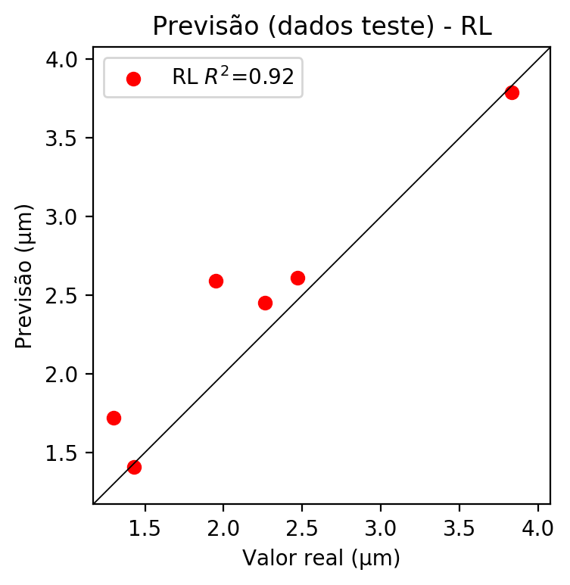

**Dados de treino**

* Erro relativo médio: 29.21
* Coeficiente de correlação: 0.72
* Coeficiente de determinação: 0.51
* MSE: 0.69
* RMSE: 0.83

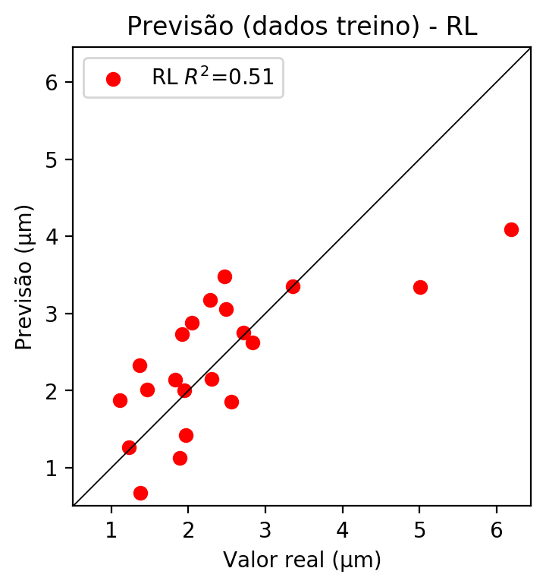

# RP2

# Coeficientes

[ 0. -0.28402377 -0.50616191 0.56555656 0.2558381 0.08435223  
 0.03143608 0.48329323 -0.52679811 -0.06632311]

# Erros

**Dados de teste**

* Erro relativo médio: 27.69
* Coeficiente de correlação: 0.93
* Coeficiente de determinação: 0.86
* MSE: 0.36
* RMSE: 0.6

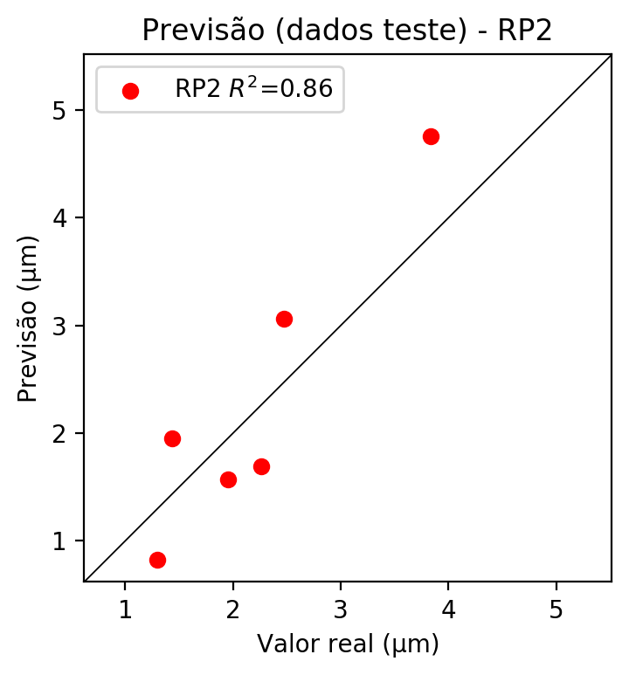

**Dados de treino**

* Erro relativo médio: 15.17
* Coeficiente de correlação: 0.93
* Coeficiente de determinação: 0.87
* MSE: 0.18
* RMSE: 0.42

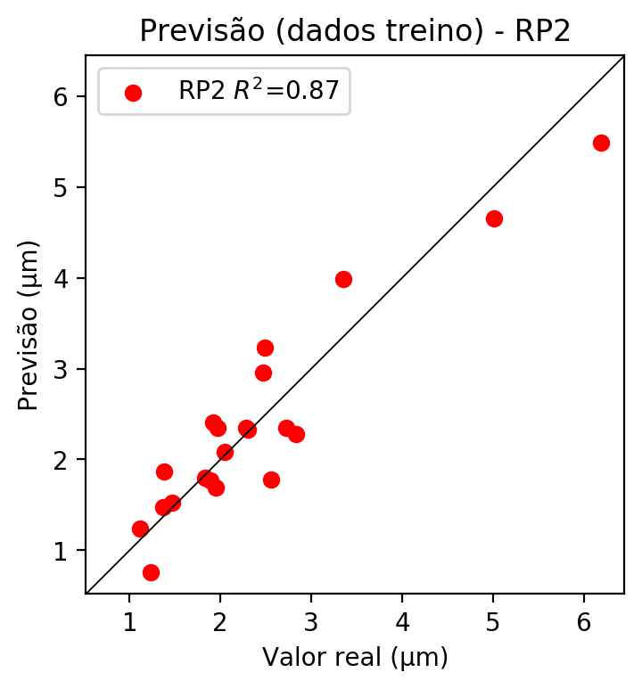

# RP3

# Coeficientes

[ 0. -0.04445255 0.03011887 0.10831882 0.16612955 0.19254769  
 0.03168424 0.47237713 -0.50951803 -0.04473663 -0.06420924 -0.22464727  
 -0.00730047 -0.04156081 -0.01035916 -0.08824733 0.04350503 0.25670445  
 -0.34352627 0.15646052]

# Erros

**Dados de teste**

* Erro relativo médio: 23.45
* Coeficiente de correlação: 0.88
* Coeficiente de determinação: 0.78
* MSE: 0.47
* RMSE: 0.69

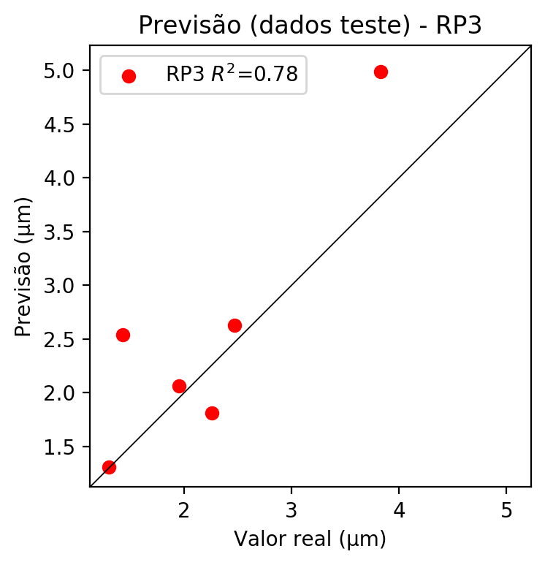

**Dados de treino**

* Erro relativo médio: 6.73
* Coeficiente de correlação: 0.99
* Coeficiente de determinação: 0.97
* MSE: 0.04
* RMSE: 0.2

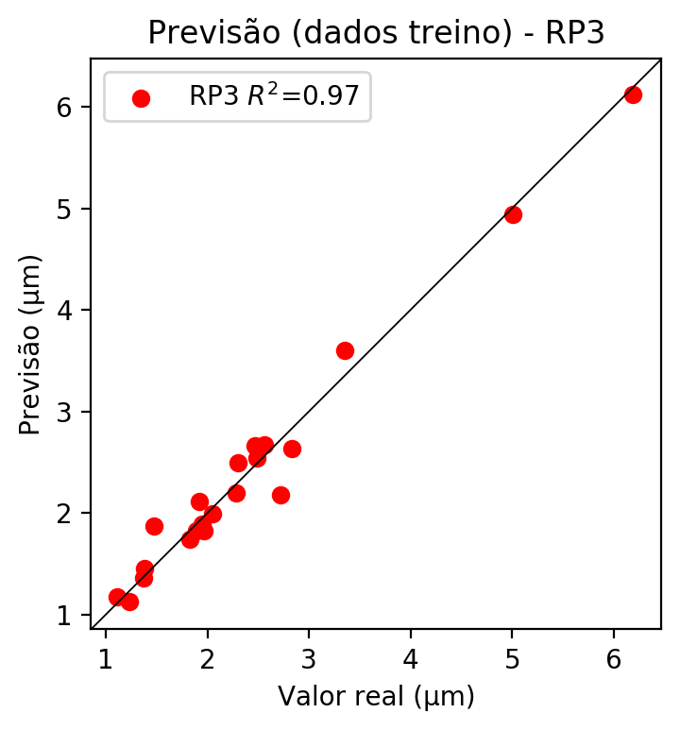

# RP4

# Coeficientes

[-3.88578059e-16 -8.30553611e-02 1.29059268e-02 1.51749247e-01  
 -1.78943633e-02 1.18185814e-02 -1.56391574e-02 -1.19082841e-02  
 -8.88772068e-02 -1.76777366e-01 -1.19968855e-01 -2.85872856e-01  
 -1.11258477e-01 -1.27006258e-01 -4.92443230e-03 6.99354801e-02  
 1.86418943e-02 2.64761724e-01 -2.52881221e-01 2.19193356e-01  
 -4.58181391e-02 2.01745243e-02 1.38983291e-02 -3.61987694e-02  
 -2.93269805e-02 1.41470716e-01 1.83527861e-02 8.05182160e-02  
 9.60521698e-02 -2.25898940e-02 -1.73999866e-02 -1.30719601e-01  
 4.91835608e-01 -1.28378188e-01 -2.55345084e-01]

# Erros

**Dados de teste**

* Erro relativo médio: 25.84
* Coeficiente de correlação: 0.95
* Coeficiente de determinação: 0.9
* MSE: 0.5
* RMSE: 0.71

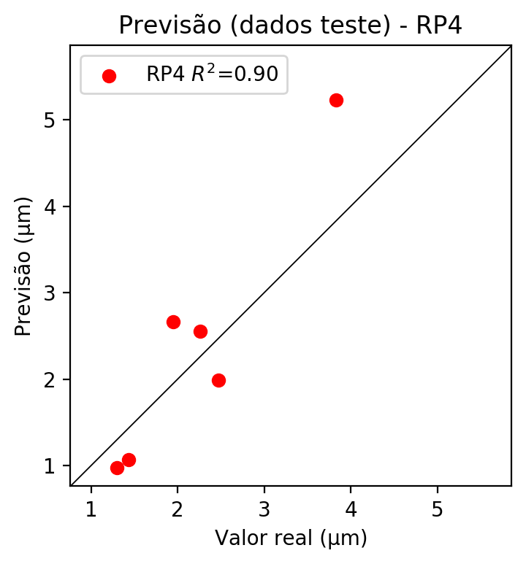

**Dados de treino**

* Erro relativo médio: 0.0
* Coeficiente de correlação: 1.0
* Coeficiente de determinação: 1.0
* MSE: 0.0
* RMSE: 0.0

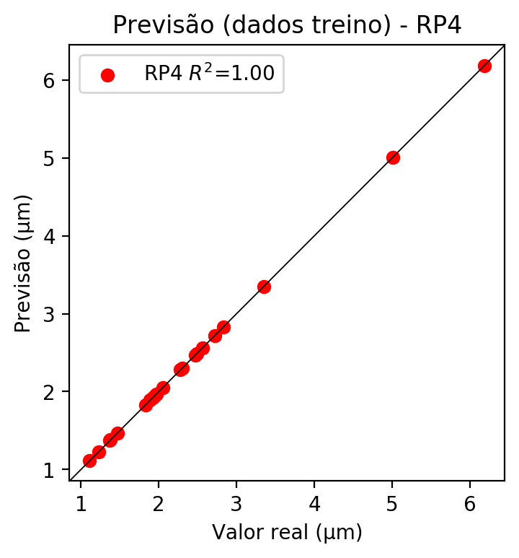

# Geral

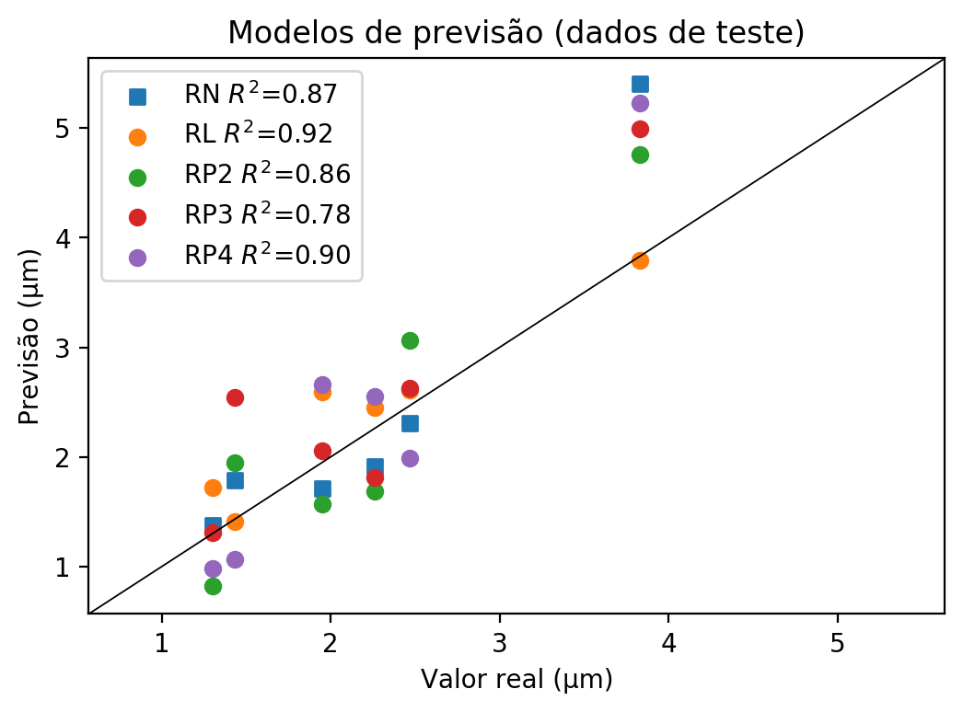

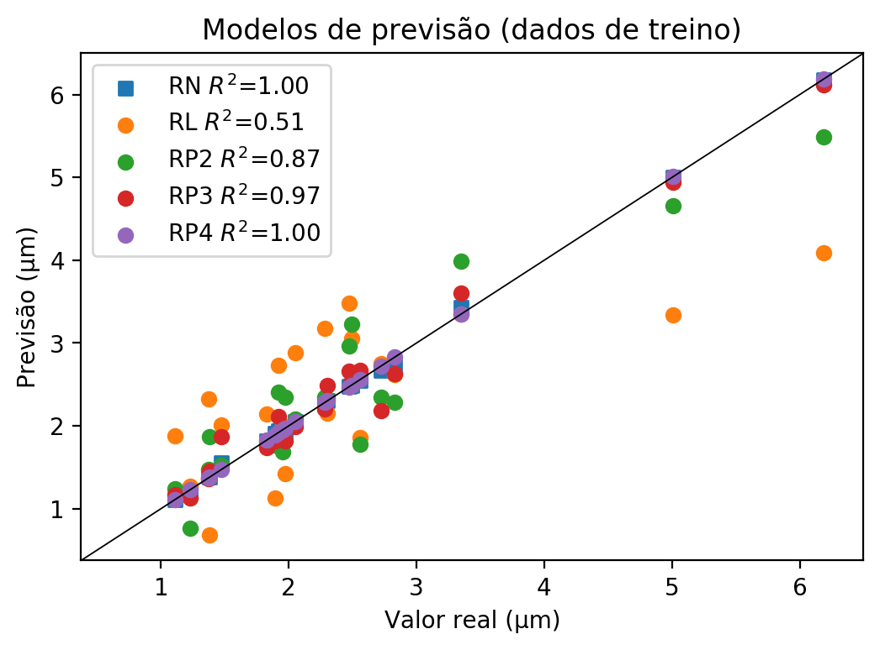

**Dados de teste**

|  |  |  |  |  |  |  |  |  |  |  |
| --- | --- | --- | --- | --- | --- | --- | --- | --- | --- | --- |
| Valor real | RN Previsto | RN Erro (%) | RL Previsto | RL Erro (%) | RP2 Previsto | RP2 Erro (%) | RP3 Previsto | RP3 Erro (%) | RP4 Previsto | RP4 Erro (%) |
| 1.3 | 1.38 | 6.15 | 1.72 | 32.31 | 0.82 | 36.92 | 1.31 | 0.77 | 0.98 | 24.62 |
| 3.83 | 5.4 | 40.99 | 3.79 | 1.04 | 4.76 | 24.28 | 4.99 | 30.29 | 5.23 | 36.55 |
| 2.26 | 1.91 | 15.49 | 2.45 | 8.41 | 1.69 | 25.22 | 1.81 | 19.91 | 2.55 | 12.83 |
| 2.47 | 2.31 | 6.48 | 2.61 | 5.67 | 3.06 | 23.89 | 2.63 | 6.48 | 1.99 | 19.43 |
| 1.43 | 1.79 | 25.17 | 1.41 | 1.4 | 1.95 | 36.36 | 2.54 | 77.62 | 1.07 | 25.17 |
| 1.95 | 1.71 | 12.31 | 2.59 | 32.82 | 1.57 | 19.49 | 2.06 | 5.64 | 2.66 | 36.41 |

**Dados de treino**

|  |  |  |  |  |  |  |  |  |  |  |
| --- | --- | --- | --- | --- | --- | --- | --- | --- | --- | --- |
| Valor real | RN Previsto | RN Erro (%) | RL Previsto | RL Erro (%) | RP2 Previsto | RP2 Erro (%) | RP3 Previsto | RP3 Erro (%) | RP4 Previsto | RP4 Erro (%) |
| 3.35 | 3.43 | 2.39 | 3.35 | 0.0 | 3.99 | 19.1 | 3.6 | 7.46 | 3.35 | 0.0 |
| 2.05 | 2.05 | 0.0 | 2.88 | 40.49 | 2.08 | 1.46 | 1.99 | 2.93 | 2.05 | 0.0 |
| 2.49 | 2.49 | 0.0 | 3.06 | 22.89 | 3.23 | 29.72 | 2.54 | 2.01 | 2.49 | 0.0 |
| 2.56 | 2.55 | 0.39 | 1.86 | 27.34 | 1.78 | 30.47 | 2.67 | 4.3 | 2.56 | 0.0 |
| 2.3 | 2.31 | 0.43 | 2.15 | 6.52 | 2.33 | 1.3 | 2.49 | 8.26 | 2.3 | 0.0 |
| 1.23 | 1.22 | 0.81 | 1.27 | 3.25 | 0.76 | 38.21 | 1.13 | 8.13 | 1.23 | 0.0 |
| 1.95 | 1.95 | 0.0 | 2.0 | 2.56 | 1.69 | 13.33 | 1.89 | 3.08 | 1.95 | 0.0 |
| 6.19 | 6.18 | 0.16 | 4.09 | 33.93 | 5.49 | 11.31 | 6.12 | 1.13 | 6.19 | 0.0 |
| 5.01 | 5.0 | 0.2 | 3.34 | 33.33 | 4.66 | 6.99 | 4.94 | 1.4 | 5.01 | 0.0 |
| 1.89 | 1.91 | 1.06 | 1.13 | 40.21 | 1.77 | 6.35 | 1.82 | 3.7 | 1.89 | 0.0 |
| 1.47 | 1.55 | 5.44 | 2.01 | 36.73 | 1.52 | 3.4 | 1.87 | 27.21 | 1.47 | 0.0 |
| 1.38 | 1.38 | 0.0 | 0.68 | 50.72 | 1.87 | 35.51 | 1.45 | 5.07 | 1.38 | 0.0 |
| 2.47 | 2.48 | 0.4 | 3.48 | 40.89 | 2.96 | 19.84 | 2.66 | 7.69 | 2.47 | 0.0 |
| 1.92 | 1.94 | 1.04 | 2.73 | 42.19 | 2.41 | 25.52 | 2.11 | 9.9 | 1.92 | 0.0 |
| 1.83 | 1.82 | 0.55 | 2.14 | 16.94 | 1.8 | 1.64 | 1.74 | 4.92 | 1.83 | 0.0 |
| 2.83 | 2.74 | 3.18 | 2.62 | 7.42 | 2.28 | 19.43 | 2.63 | 7.07 | 2.83 | 0.0 |
| 1.37 | 1.39 | 1.46 | 2.33 | 70.07 | 1.47 | 7.3 | 1.36 | 0.73 | 1.37 | 0.0 |
| 1.11 | 1.11 | 0.0 | 1.88 | 69.37 | 1.24 | 11.71 | 1.17 | 5.41 | 1.11 | 0.0 |
| 2.72 | 2.67 | 1.84 | 2.75 | 1.1 | 2.35 | 13.6 | 2.18 | 19.85 | 2.72 | 0.0 |
| 2.28 | 2.25 | 1.32 | 3.18 | 39.47 | 2.35 | 3.07 | 2.2 | 3.51 | 2.28 | 0.0 |
| 1.97 | 1.94 | 1.52 | 1.42 | 27.92 | 2.35 | 19.29 | 1.82 | 7.61 | 1.97 | 0.0 |