# Informações do estudo

Referência: Borsos

Grandeza: Força

Tipo: Fy

Material: AISI 1045

Ferramenta: CNMG 120408KM

Número de experimentos: 27

Observações:  
Workpiece size: 160mm  
Machine Tool: EU-630x300  
Tool holder: PCLNR 2525 M12  
Environment: Room temperature, dry conditions  
Insert shape: Diamond (opening angle: 80°)  
Relief angle: 0  
Cutting edge lenght: 12.7 mm  
Height of cutting edge: 4.76 mm  
Nose radius: 0.8 mm

# Unidades

Velocidade: rpm

Avanço: mm/rev

Profundidade de corte: mm

Força: N

# Dados de teste

|  |  |  |  |
| --- | --- | --- | --- |
| Força | n | f | a |
| 107.6 | 200.0 | 0.09 | 0.5 |
| 431.6 | 100.0 | 0.36 | 1.0 |
| 231.0 | 400.0 | 0.36 | 0.5 |
| 246.2 | 200.0 | 0.18 | 2.0 |
| 141.5 | 400.0 | 0.09 | 2.0 |
| 161.9 | 200.0 | 0.18 | 0.5 |

# Dados de treino

|  |  |  |  |
| --- | --- | --- | --- |
| Força | n | f | a |
| 399.3 | 200.0 | 0.36 | 1.0 |
| 217.6 | 200.0 | 0.18 | 1.0 |
| 284.6 | 200.0 | 0.36 | 0.5 |
| 289.7 | 100.0 | 0.36 | 0.5 |
| 232.7 | 100.0 | 0.18 | 1.0 |
| 90.4 | 400.0 | 0.09 | 0.5 |
| 160.0 | 100.0 | 0.18 | 0.5 |
| 571.0 | 100.0 | 0.36 | 2.0 |
| 456.1 | 200.0 | 0.36 | 2.0 |
| 154.6 | 200.0 | 0.09 | 2.0 |
| 144.8 | 200.0 | 0.09 | 1.0 |
| 135.8 | 100.0 | 0.09 | 1.0 |
| 248.4 | 100.0 | 0.18 | 2.0 |
| 157.4 | 100.0 | 0.09 | 2.0 |
| 148.7 | 400.0 | 0.18 | 0.5 |
| 363.6 | 400.0 | 0.36 | 2.0 |
| 129.7 | 400.0 | 0.09 | 1.0 |
| 77.8 | 100.0 | 0.09 | 0.5 |
| 321.9 | 400.0 | 0.36 | 1.0 |
| 231.7 | 400.0 | 0.18 | 2.0 |
| 186.0 | 400.0 | 0.18 | 1.0 |

# RN

Número de neurônios: 73

Taxa de aprendizado: 1.000000e-04

Número de épocas: 729

2° camada: True

Função de ativação: relu

# Erros

**Dados de teste**

* Erro relativo médio: 10.06
* Coeficiente de correlação: 0.98
* Coeficiente de determinação: 0.95
* MSE: 657.87
* RMSE: 25.65

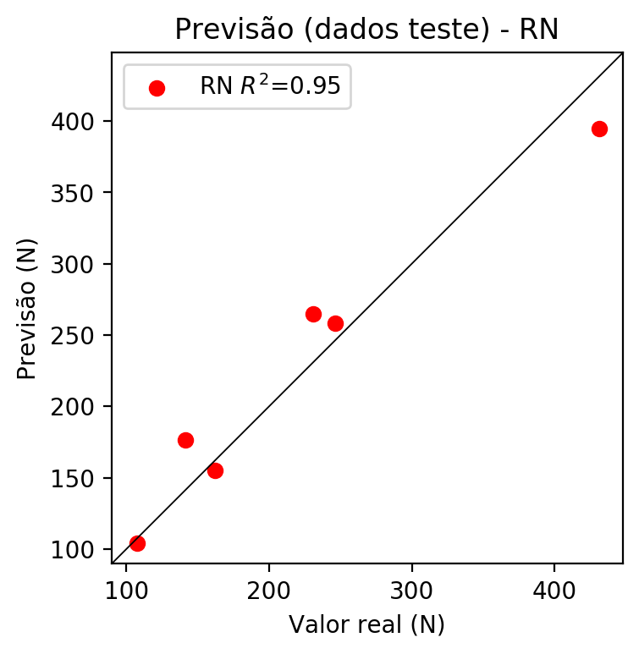

**Dados de treino**

* Erro relativo médio: 3.38
* Coeficiente de correlação: 1.0
* Coeficiente de determinação: 0.99
* MSE: 97.78
* RMSE: 9.89

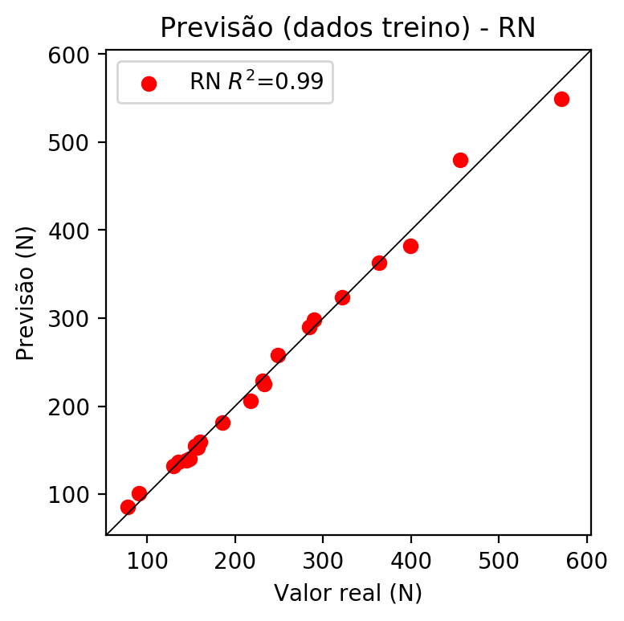

# Pesos

Pesos - camada oculta 1

[[ 0.16596785 0.03086751 -0.21076538 0.02337467 0.19504648 -0.1587588  
 -0.00775062 -0.00314783 -0.09684734 0.09929334 -0.301844 0.17184545  
 0.06268812 -0.03189762 -0.13137163 -0.11193171 0.07348247 -0.09661834  
 -0.21705337 0.21813789 0.21028514 0.21636905 -0.0266944 0.11828743  
 -0.05012301 -0.24281049 0.25436217 0.02521891 0.21080476 -0.24458234  
 -0.03889169 -0.27755183 -0.16728117 -0.22629277 0.02772844 -0.23583528  
 0.07083906 0.16031183 -0.24487998 -0.12185324 0.11680771 0.10415646  
 0.2091992 0.28173235 0.10697247 -0.02455713 -0.01204837 -0.22751787  
 0.22614537 0.3097039 0.16449754 0.1488348 0.04989446 -0.09755274  
 -0.12801291 0.08681089 -0.01028266 0.04517064 -0.2937908 -0.27853215  
 0.20164706 -0.25633818 -0.25486997 0.09209575 0.25038287 -0.28663146  
 -0.09777699 0.12407955 -0.23019114 -0.1674772 -0.09079354 -0.0038197  
 -0.00495203]  
 [-0.18374617 0.14348723 -0.17464252 0.12031988 0.20522046 0.05764001  
 -0.11035819 0.17707057 -0.29858583 -0.29190418 -0.0405035 -0.14841257  
 0.2561853 0.00970592 -0.23815653 -0.26439124 0.21275038 -0.1235549  
 -0.23019385 -0.26921457 0.10597108 -0.14910528 -0.20655255 -0.25540394  
 0.0614916 0.13354014 -0.16810894 0.17247654 -0.12738295 0.2761428  
 -0.19918883 -0.23805764 -0.22201397 -0.07358235 -0.16112034 0.08422379  
 0.1782811 -0.03620563 -0.1718017 0.26375708 0.25807112 0.09851305  
 0.30504048 -0.01128912 -0.08782534 -0.05604192 -0.1867191 0.08149274  
 -0.22651489 -0.01464433 -0.13705929 0.30055025 0.00587611 0.23424594  
 -0.03511347 -0.25853714 -0.07537602 0.12672734 0.0132596 0.06260672  
 0.06908203 0.2711384 0.16010888 -0.14619918 0.13303576 -0.22235022  
 0.24439432 -0.14494482 -0.25620875 0.05152174 -0.04297834 0.04460165  
 -0.08586255]  
 [ 0.2305764 0.16779254 0.2252775 0.10558729 0.21310228 -0.20883566  
 0.02875747 -0.21891224 -0.15599571 -0.29359603 0.2307676 0.22822493  
 0.16592574 -0.09345214 -0.18168911 0.17176297 -0.22622544 0.00927153  
 -0.2420072 -0.23035434 0.21161471 -0.1276642 -0.2738437 -0.10162597  
 -0.09391081 0.20425063 -0.23133883 0.21871594 -0.2570198 0.16443856  
 -0.24636543 0.1700293 0.08028479 -0.31015036 0.30776468 0.20762536  
 0.1678356 -0.12273728 -0.06993147 -0.09098696 0.25850663 0.2376626  
 0.00429795 -0.12957314 -0.02874827 -0.21900047 -0.08267383 0.06794732  
 0.17850585 -0.10507763 0.23760492 0.16978516 -0.11372787 -0.03740345  
 0.1877698 -0.27836064 0.29495105 0.06499775 -0.05106648 -0.06952961  
 -0.08468553 -0.02772534 -0.0012266 0.212697 0.06914375 -0.05838457  
 -0.18252283 0.19331835 0.12877627 0.04499045 0.13971938 0.16473334  
 0.19466357]]

Bias - camada oculta

[-0.02341552 0.02071544 0.01148312 0.01250714 -0.02268828 0.01337389  
 0.01423883 -0.01068255 0.01302402 0.00490236 0.02095349 -0.00237871  
 0.02279193 -0.01125456 -0.01749102 -0.00773873 0.01370342 0.02284501  
 0.03709262 -0.01432438 0.01127272 0.02141551 0.01872277 -0.01576453  
 -0.01805072 0.0324211 -0.01256099 0.03028793 0.00450881 0.03342208  
 -0.00598935 -0.01042841 0.00112061 -0.03482331 0.02674596 0.03216595  
 0.00612094 0.03248499 0.02437377 0.03248806 0.03678946 0.05289538  
 0.03594422 0.02846066 -0.01457283 0.00944892 0.00879893 0.03782127  
 0.04360548 0.03896695 0.03723497 0.02468166 -0.0102232 0.00591  
 -0.0085738 0.01133699 0.03027204 -0.01580329 0.03684024 0.03997582  
 -0.0280276 0.02885988 0.02633796 0.00903436 0.00167388 0.02066974  
 0.04041771 0.02967201 -0.01103672 -0.0119033 0.01662007 0.03741189  
 -0.01966578]

Pesos - camada oculta 2

[[ 0.10327235 0.0110561 -0.10949685 ... -0.01402294 0.00208388  
 0.01143669]  
 [-0.11797702 0.11184314 -0.16186579 ... 0.01314457 0.03452533  
 -0.08268846]  
 [ 0.22132206 0.08269925 0.1663876 ... 0.12100177 0.08590951  
 0.15384558]  
 ...  
 [ 0.22696322 0.09802863 0.11036785 ... -0.04493915 0.13287672  
 0.13658597]  
 [-0.10044759 0.14444733 0.09617019 ... -0.00841653 -0.16685852  
 -0.12848046]  
 [ 0.0389666 -0.21767478 0.0849904 ... 0.12998886 -0.04488451  
 -0.16939832]]

Bias - camada oculta 2

[ 0.05432546 0.02495413 -0.03262731 0.02868016 -0.01470861 0.01770941  
 -0.0120911 0.03447577 0. 0.01702987 0.01730265 -0.01863533  
 0.03922924 -0.00046391 0.03011873 -0.00216233 -0.01680165 0.02097213  
 -0.02526207 -0.00872796 0.01205381 -0.01461501 -0.00919151 0.03436332  
 0.01518126 -0.00130233 0.00278405 0.00613659 -0.01670982 0.02079723  
 -0.01487988 -0.00256149 0.01656057 -0.00507046 -0.00040479 0.02207752  
 -0.0019315 0.03801209 0.02332516 -0.03692452 -0.01398211 -0.01231534  
 0.05189428 0.03195633 0.00625516 0.02415263 0.02656548 0.0145797  
 0.0325711 0.03300897 -0.00546689 0.03030251 -0.01497292 0.02238716  
 0. 0.00017894 -0.00374196 -0.00184116 -0.02602131 0.01613418  
 0.02572846 0.00907242 -0.02381732 0.02582525 0.00457529 0.02459282  
 -0.02355467 -0.01019048 0.01807678 -0.03473577 0.02484795 0.00064733  
 -0.009668 ]

Pesos - camada saída

[[ 0.23551305 0.0952255 -0.17435387 0.05512175 0.14803196 -0.16687903  
 -0.07824538 0.05367776 -0.09546894 0.08360292 -0.29815853 0.16920406  
 0.13334812 -0.0711612 -0.16567294 -0.14812095 0.05073725 -0.1171569  
 -0.22336406 0.23833744 0.27977702 0.18114226 -0.05002069 0.19300252  
 -0.0909624 -0.22512706 0.31382933 0.07684851 0.19863467 -0.2471494  
 -0.02688816 -0.32921758 -0.19115779 -0.21629831 0.01733195 -0.2326256  
 0.07526048 0.17309096 -0.26727477 -0.05612636 0.11831791 0.13275737  
 0.2832914 0.3016141 0.14050421 -0.07116006 -0.03261622 -0.20961094  
 0.2870561 0.33260176 0.19010197 0.20986474 0.04892986 -0.10563676  
 -0.12295777 0.06613067 0.0181962 0.02117443 -0.24775654 -0.27604085  
 0.26599538 -0.25743413 -0.24858142 0.08060712 0.25848103 -0.30739084  
 -0.05130722 0.09265641 -0.27209967 -0.15600859 -0.10292274 0.0229419  
 -0.00883647]]

# Iterações

|  |  |  |  |  |  |  |
| --- | --- | --- | --- | --- | --- | --- |
| Média | Desvio | n | ln | 2° camada | Função | Épocas |
| -0.3652 | 0.3346 | 10 | 0.1 | False | relu | 38 |
| -0.2758 | 0.2753 | 17 | 0.1 | True | relu | 716 |
| -0.3541 | 0.4234 | 7 | 0.01 | True | tanh | 130 |
| -0.3216 | 0.3502 | 19 | 0.001 | False | tanh | 282 |
| -0.2211 | 0.2923 | 29 | 0.001 | False | relu | 469 |
| -0.1421 | 0.1344 | 88 | 0.1 | False | tanh | 926 |
| -0.1588 | 0.1366 | 95 | 0.0001 | True | relu | 984 |
| -0.2507 | 0.2818 | 10 | 0.01 | True | tanh | 865 |
| -0.7327 | 0.8333 | 58 | 0.001 | True | relu | 8 |
| -0.2169 | 0.2395 | 9 | 0.01 | False | tanh | 514 |
| -0.1126 | 0.1405 | 73 | 0.0001 | True | relu | 729 |
| -0.1602 | 0.2139 | 22 | 0.001 | True | relu | 543 |
| -0.1768 | 0.1894 | 25 | 0.1 | True | relu | 562 |
| -0.2008 | 0.2785 | 53 | 0.001 | False | relu | 498 |
| -0.1438 | 0.1557 | 83 | 0.01 | True | relu | 337 |
| -0.2417 | 0.2706 | 99 | 0.01 | False | tanh | 16 |
| -0.2471 | 0.2579 | 23 | 0.01 | False | relu | 472 |
| -0.1923 | 0.2466 | 24 | 0.001 | True | relu | 778 |
| -0.213 | 0.2206 | 58 | 0.01 | True | tanh | 382 |
| -0.278 | 0.2353 | 35 | 0.1 | False | tanh | 596 |

# RL

# Coeficientes

[ 0. -0.11974764 0.85883609 0.37481295]

# Erros

**Dados de teste**

* Erro relativo médio: 16.75
* Coeficiente de correlação: 0.92
* Coeficiente de determinação: 0.85
* MSE: 1785.23
* RMSE: 42.25

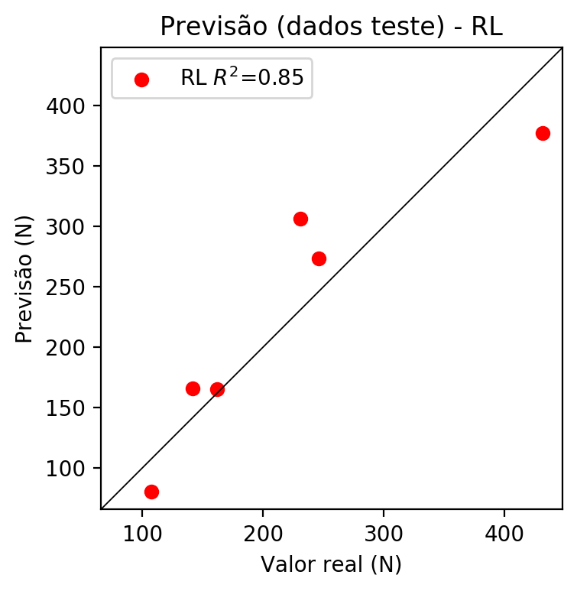

**Dados de treino**

* Erro relativo médio: 14.43
* Coeficiente de correlação: 0.95
* Coeficiente de determinação: 0.9
* MSE: 1579.04
* RMSE: 39.74

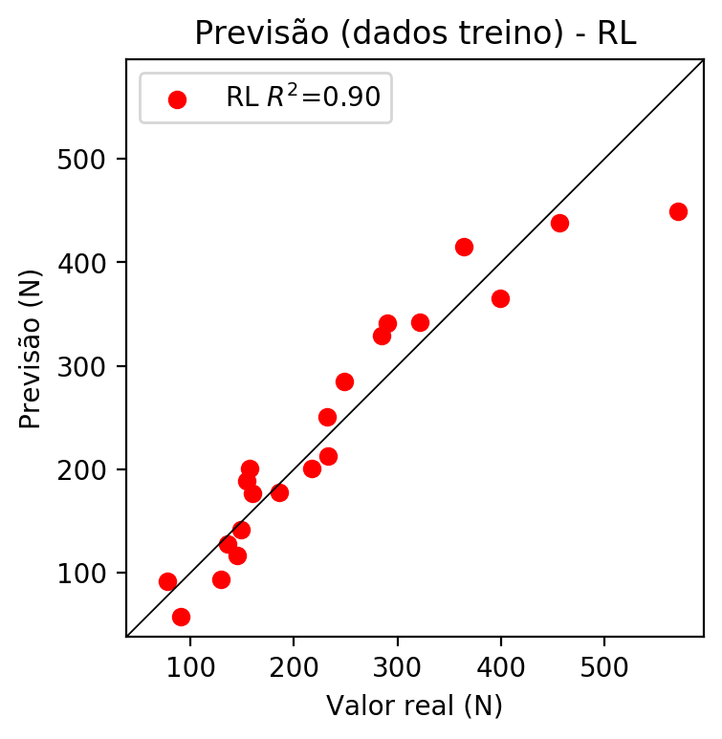

# RP2

# Coeficientes

[ 0. -0.18429398 0.85295783 0.47354135 -0.00464615 -0.17453623  
 -0.08683769 0.01746396 0.19924353 -0.24793578]

# Erros

**Dados de teste**

* Erro relativo médio: 9.85
* Coeficiente de correlação: 1.0
* Coeficiente de determinação: 0.99
* MSE: 271.89
* RMSE: 16.49

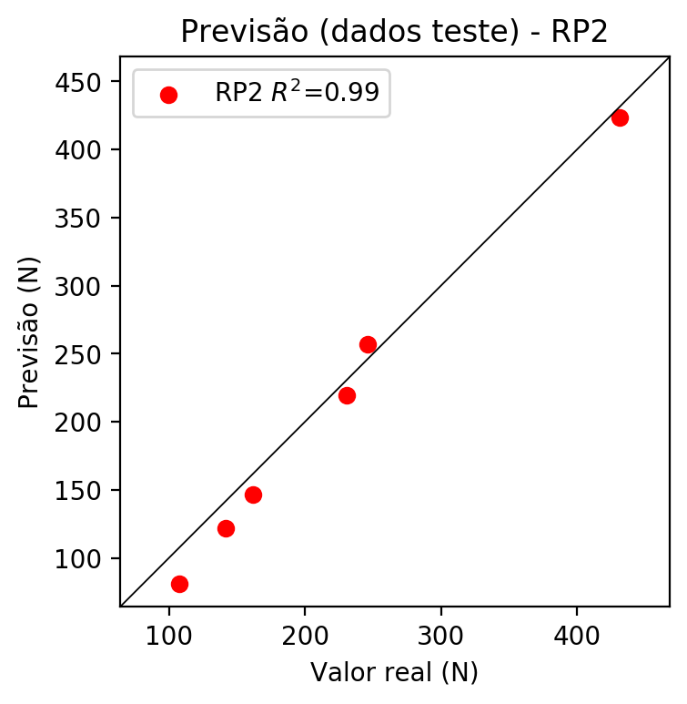

**Dados de treino**

* Erro relativo médio: 5.56
* Coeficiente de correlação: 0.99
* Coeficiente de determinação: 0.98
* MSE: 271.6
* RMSE: 16.48

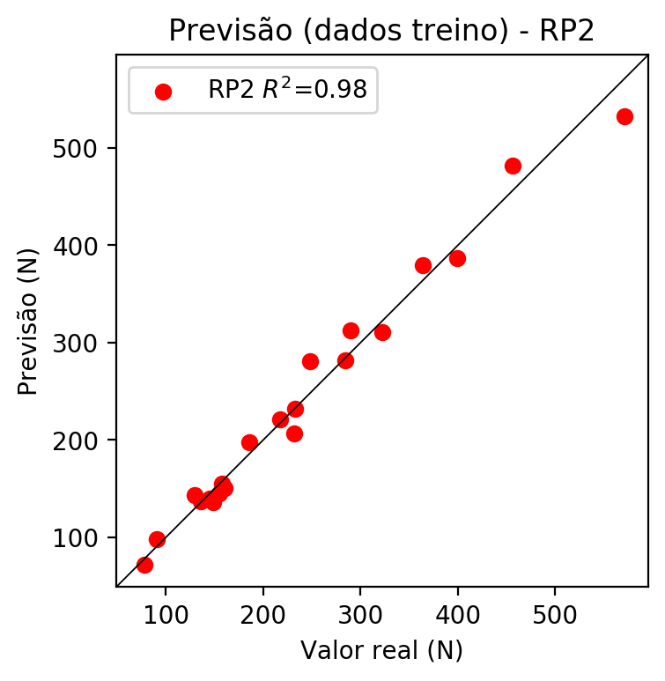

# RP3

# Coeficientes

[ 0. -0.08154451 0.27678517 0.05160716 0.03791242 -0.24123118  
 -0.11885793 0.1137654 0.13575927 -0.211608 -0.11778651 0.05320639  
 0.15371541 0.0006917 -0.14578722 0.10255065 0.3998008 0.15388401  
 -0.11255697 0.07454367]

# Erros

**Dados de teste**

* Erro relativo médio: 17.65
* Coeficiente de correlação: 0.93
* Coeficiente de determinação: 0.87
* MSE: 1896.57
* RMSE: 43.55

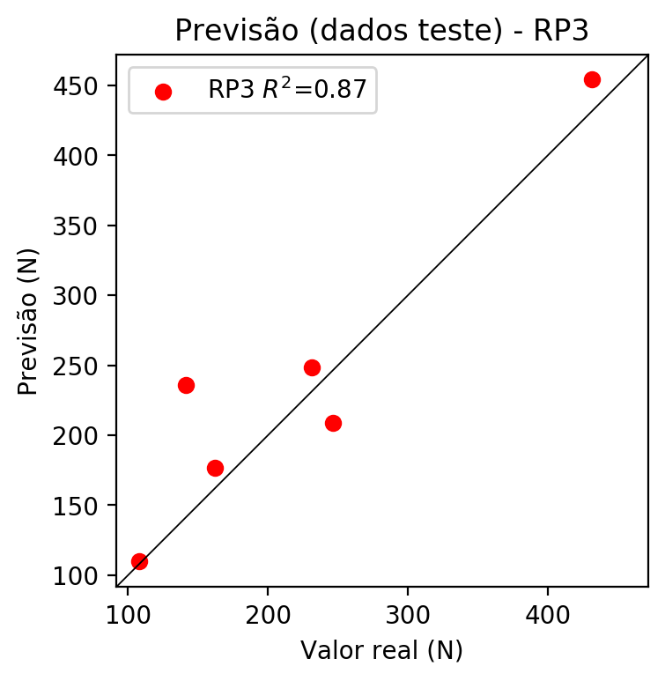

**Dados de treino**

* Erro relativo médio: 0.59
* Coeficiente de correlação: 1.0
* Coeficiente de determinação: 1.0
* MSE: 1.18
* RMSE: 1.09

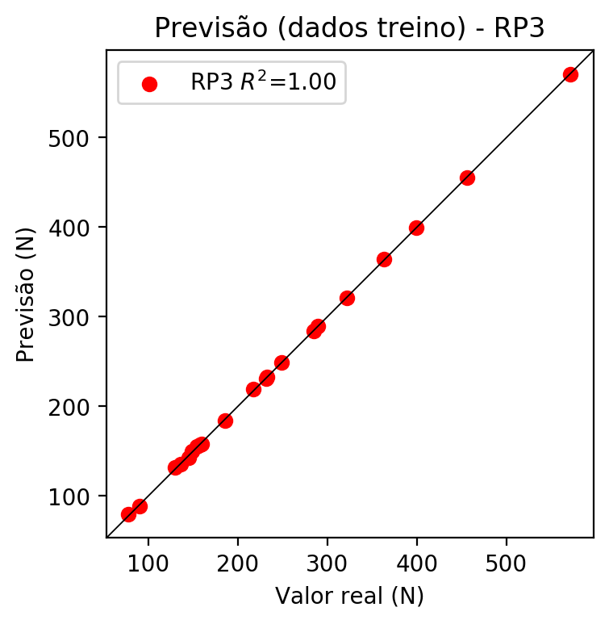

# RP4

# Coeficientes

[ 0. -0.06084247 0.25304333 0.08522046 0.02395236 -0.06632444  
 -0.01904734 -0.00360453 -0.00814539 -0.08387606 -0.08788357 0.07622453  
 0.10304485 -0.02280073 -0.12435636 0.10185968 0.36550703 0.10496747  
 -0.07545707 0.12309622 0.0126466 -0.00450693 0.0032337 -0.0118428  
 0.01893011 0.00717969 -0.11702857 -0.06079741 0.03930506 -0.04946408  
 0.08307468 0.01796597 -0.01535582 0.07952948 -0.09040778]

# Erros

**Dados de teste**

* Erro relativo médio: 12.0
* Coeficiente de correlação: 0.98
* Coeficiente de determinação: 0.95
* MSE: 802.73
* RMSE: 28.33

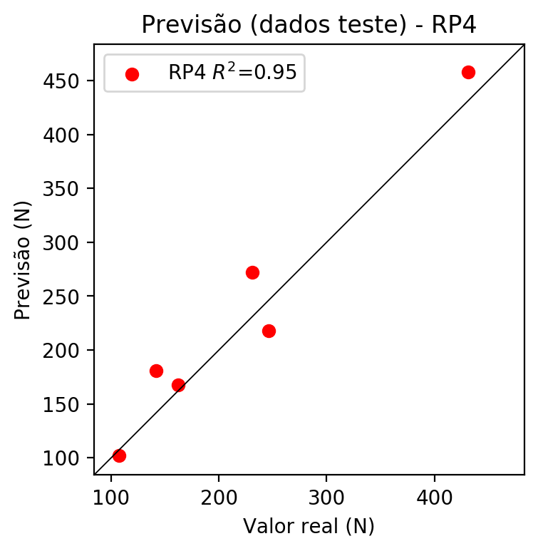

**Dados de treino**

* Erro relativo médio: 0.0
* Coeficiente de correlação: 1.0
* Coeficiente de determinação: 1.0
* MSE: 0.0
* RMSE: 0.0

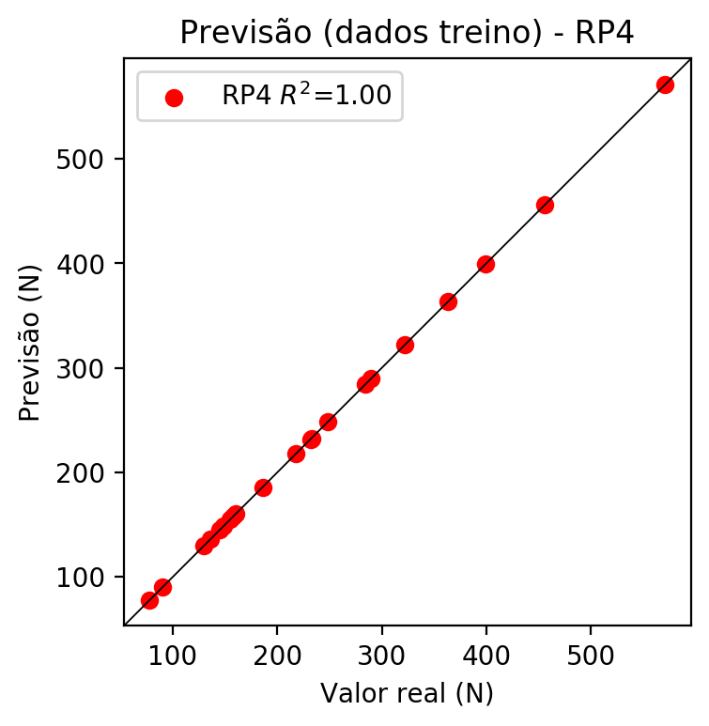

# Geral

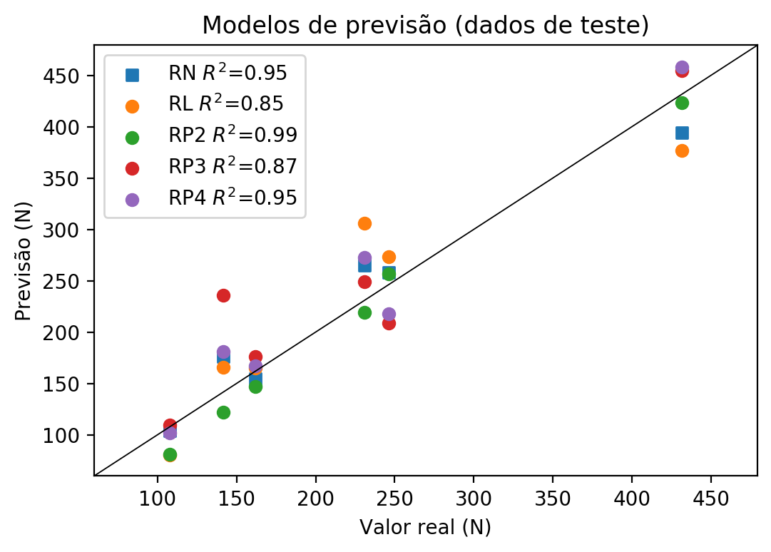

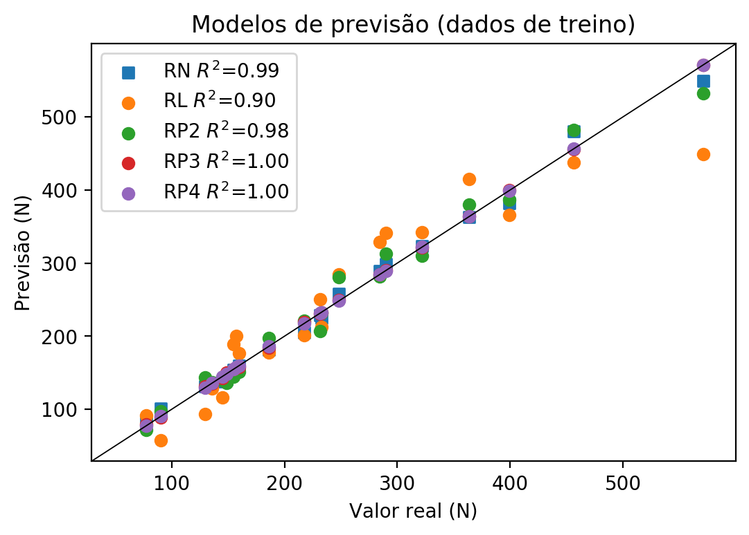

**Dados de teste**

|  |  |  |  |  |  |  |  |  |  |  |
| --- | --- | --- | --- | --- | --- | --- | --- | --- | --- | --- |
| Valor real | RN Previsto | RN Erro (%) | RL Previsto | RL Erro (%) | RP2 Previsto | RP2 Erro (%) | RP3 Previsto | RP3 Erro (%) | RP4 Previsto | RP4 Erro (%) |
| 107.6 | 104.07 | 3.28 | 80.48 | 25.2 | 81.07 | 24.66 | 109.77 | 2.02 | 101.83 | 5.36 |
| 431.6 | 394.39 | 8.62 | 376.95 | 12.66 | 423.49 | 1.88 | 454.44 | 5.29 | 458.18 | 6.16 |
| 231.0 | 264.99 | 14.71 | 306.16 | 32.54 | 219.2 | 5.11 | 248.72 | 7.67 | 272.35 | 17.9 |
| 246.2 | 258.2 | 4.87 | 273.4 | 11.05 | 256.88 | 4.34 | 208.76 | 15.21 | 218.04 | 11.44 |
| 141.5 | 176.16 | 24.49 | 165.81 | 17.18 | 122.09 | 13.72 | 235.98 | 66.77 | 180.8 | 27.77 |
| 161.9 | 154.86 | 4.35 | 164.97 | 1.9 | 146.68 | 9.4 | 176.42 | 8.97 | 167.31 | 3.34 |

**Dados de treino**

|  |  |  |  |  |  |  |  |  |  |  |
| --- | --- | --- | --- | --- | --- | --- | --- | --- | --- | --- |
| Valor real | RN Previsto | RN Erro (%) | RL Previsto | RL Erro (%) | RP2 Previsto | RP2 Erro (%) | RP3 Previsto | RP3 Erro (%) | RP4 Previsto | RP4 Erro (%) |
| 399.3 | 381.86 | 4.37 | 365.4 | 8.49 | 386.49 | 3.21 | 399.87 | 0.14 | 399.3 | 0.0 |
| 217.6 | 205.54 | 5.54 | 201.11 | 7.58 | 221.04 | 1.58 | 219.07 | 0.68 | 217.6 | 0.0 |
| 284.6 | 289.63 | 1.77 | 329.26 | 15.69 | 282.14 | 0.86 | 284.36 | 0.08 | 284.6 | 0.0 |
| 289.7 | 298.47 | 3.03 | 340.81 | 17.64 | 312.56 | 7.89 | 289.95 | 0.09 | 289.7 | 0.0 |
| 232.7 | 225.4 | 3.14 | 212.66 | 8.61 | 231.77 | 0.4 | 232.7 | 0.0 | 232.7 | 0.0 |
| 90.4 | 100.99 | 11.71 | 57.38 | 36.53 | 97.69 | 8.06 | 88.85 | 1.71 | 90.4 | 0.0 |
| 160.0 | 159.79 | 0.13 | 176.52 | 10.33 | 150.83 | 5.73 | 158.33 | 1.04 | 160.0 | 0.0 |
| 571.0 | 549.42 | 3.78 | 449.24 | 21.32 | 532.49 | 6.74 | 571.08 | 0.01 | 571.0 | 0.0 |
| 456.1 | 479.74 | 5.18 | 437.69 | 4.04 | 482.31 | 5.75 | 455.27 | 0.18 | 456.1 | 0.0 |
| 154.6 | 154.51 | 0.06 | 188.91 | 22.19 | 145.01 | 6.2 | 155.31 | 0.46 | 154.6 | 0.0 |
| 144.8 | 138.47 | 4.37 | 116.62 | 19.46 | 140.01 | 3.31 | 143.12 | 1.16 | 144.8 | 0.0 |
| 135.8 | 136.47 | 0.49 | 128.17 | 5.62 | 137.23 | 1.05 | 135.56 | 0.18 | 135.8 | 0.0 |
| 248.4 | 258.22 | 3.95 | 284.95 | 14.71 | 280.79 | 13.04 | 249.09 | 0.28 | 248.4 | 0.0 |
| 157.4 | 153.16 | 2.69 | 200.45 | 27.35 | 155.41 | 1.26 | 156.71 | 0.44 | 157.4 | 0.0 |
| 148.7 | 140.59 | 5.45 | 141.87 | 4.59 | 136.27 | 8.36 | 150.33 | 1.1 | 148.7 | 0.0 |
| 363.6 | 363.08 | 0.14 | 414.59 | 14.02 | 379.83 | 4.46 | 364.36 | 0.21 | 363.6 | 0.0 |
| 129.7 | 131.69 | 1.53 | 93.52 | 27.9 | 143.44 | 10.59 | 131.57 | 1.44 | 129.7 | 0.0 |
| 77.8 | 85.18 | 9.49 | 92.02 | 18.28 | 71.71 | 7.83 | 79.38 | 2.03 | 77.8 | 0.0 |
| 321.9 | 323.55 | 0.51 | 342.31 | 6.34 | 310.37 | 3.58 | 321.31 | 0.18 | 321.9 | 0.0 |
| 231.7 | 228.75 | 1.27 | 250.3 | 8.03 | 206.94 | 10.69 | 230.98 | 0.31 | 231.7 | 0.0 |
| 186.0 | 181.45 | 2.45 | 178.02 | 4.29 | 197.45 | 6.16 | 184.6 | 0.75 | 186.0 | 0.0 |