# Informações do estudo

Referência: Borsos

Grandeza: Força

Tipo: Fz

Material: AISI 1045

Ferramenta: CNMG 120408KM

Número de experimentos: 27

Observações:  
Workpiece size: 160mm  
Machine Tool: EU-630x300  
Tool holder: PCLNR 2525 M12  
Environment: Room temperature, dry conditions  
Insert shape: Diamond (opening angle: 80°)  
Relief angle: 0  
Cutting edge lenght: 12.7 mm  
Height of cutting edge: 4.76 mm  
Nose radius: 0.8 mm

# Unidades

Velocidade: rpm

Avanço: mm/rev

Profundidade de corte: mm

Força: N

# Dados de teste

|  |  |  |  |
| --- | --- | --- | --- |
| Força | n | f | a |
| 115.6 | 200.0 | 0.09 | 0.5 |
| 747.1 | 400.0 | 0.36 | 2.0 |
| 382.1 | 400.0 | 0.36 | 1.0 |
| 459.2 | 400.0 | 0.09 | 2.0 |
| 153.1 | 200.0 | 0.18 | 0.5 |
| 259.8 | 100.0 | 0.09 | 1.0 |

# Dados de treino

|  |  |  |  |
| --- | --- | --- | --- |
| Força | n | f | a |
| 621.0 | 200.0 | 0.18 | 2.0 |
| 336.4 | 200.0 | 0.18 | 1.0 |
| 468.9 | 200.0 | 0.36 | 1.0 |
| 543.4 | 100.0 | 0.36 | 1.0 |
| 389.1 | 100.0 | 0.09 | 2.0 |
| 106.4 | 400.0 | 0.09 | 0.5 |
| 248.0 | 200.0 | 0.09 | 1.0 |
| 1248.7 | 100.0 | 0.36 | 2.0 |
| 939.3 | 200.0 | 0.36 | 2.0 |
| 204.6 | 200.0 | 0.36 | 0.5 |
| 171.0 | 400.0 | 0.36 | 0.5 |
| 147.2 | 400.0 | 0.18 | 0.5 |
| 461.4 | 200.0 | 0.09 | 2.0 |
| 218.9 | 400.0 | 0.09 | 1.0 |
| 203.2 | 100.0 | 0.36 | 0.5 |
| 597.8 | 100.0 | 0.18 | 2.0 |
| 142.9 | 100.0 | 0.18 | 0.5 |
| 69.6 | 100.0 | 0.09 | 0.5 |
| 588.2 | 400.0 | 0.18 | 2.0 |
| 388.1 | 100.0 | 0.18 | 1.0 |
| 280.7 | 400.0 | 0.18 | 1.0 |

# RN

Número de neurônios: 58

Taxa de aprendizado: 1.000000e-02

Número de épocas: 382

2° camada: True

Função de ativação: tanh

# Erros

**Dados de teste**

* Erro relativo médio: 26.86
* Coeficiente de correlação: 0.94
* Coeficiente de determinação: 0.89
* MSE: 7903.66
* RMSE: 88.9

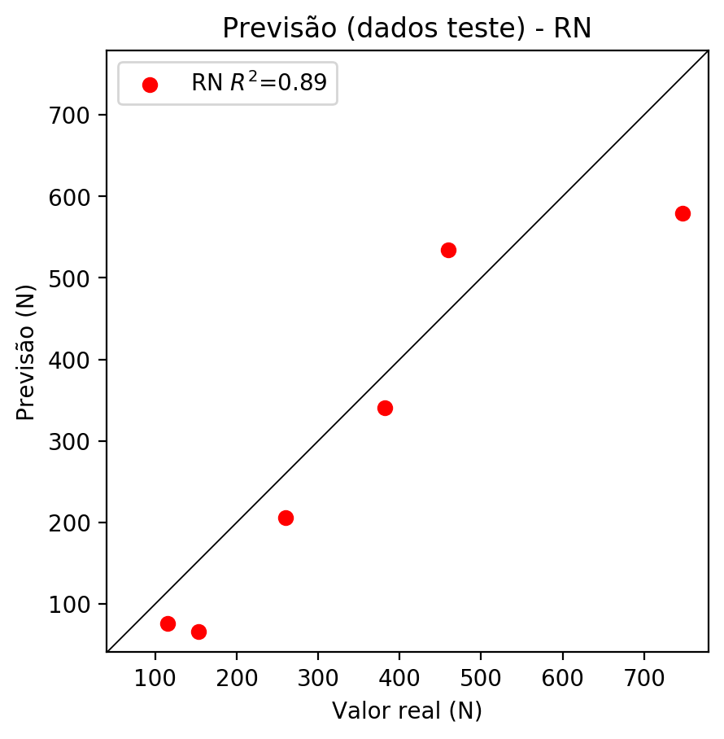

**Dados de treino**

* Erro relativo médio: 0.03
* Coeficiente de correlação: 1.0
* Coeficiente de determinação: 1.0
* MSE: 0.02
* RMSE: 0.14

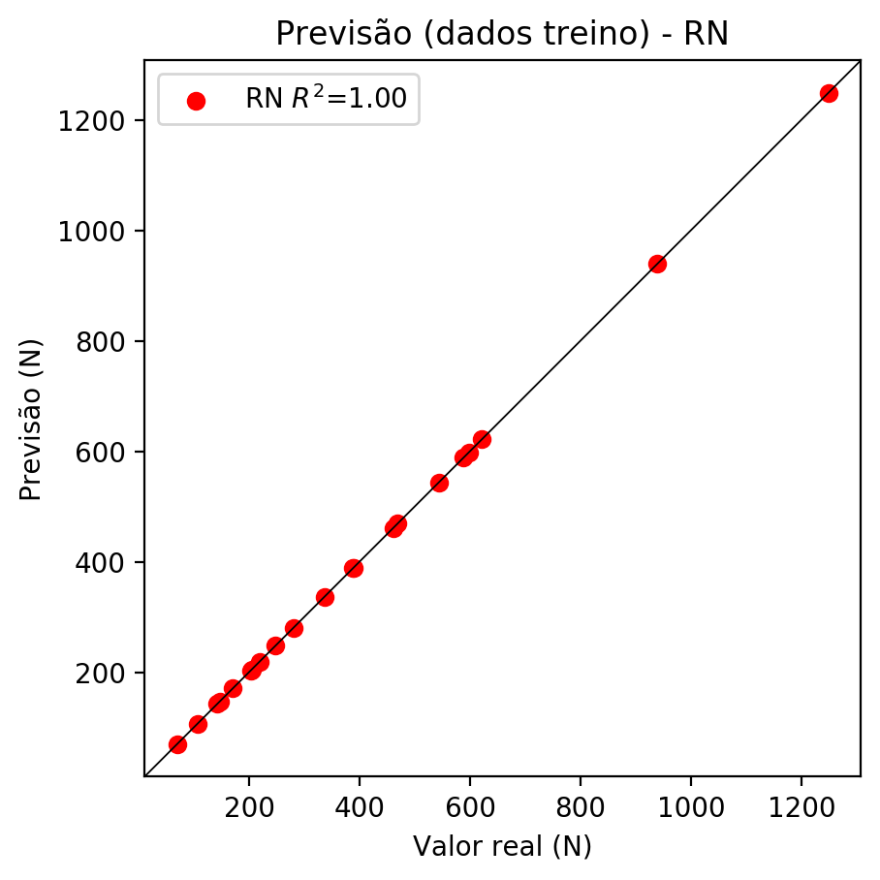

# Pesos

Pesos - camada oculta 1

[[ 0.21128057 0.07428476 -0.51030326 0.00226647 0.18823406 -0.18416066  
 -0.00179792 -0.08794244 -0.1258683 0.20495556 -0.37034374 0.21694992  
 0.1292449 -0.03834097 -0.12865682 -0.08887658 0.19399549 -0.09312296  
 -0.26248154 0.44963577 0.45189658 0.50833726 -0.08800666 0.39475048  
 -0.12914534 -0.33125523 0.32965517 -0.04944186 0.20607969 -0.21048398  
 -0.0185352 -0.28600574 -0.07580166 -0.30223864 0.07958037 -0.21263237  
 0.11747657 0.16677903 -0.24577387 -0.11299807 0.23442143 0.22350979  
 0.26459867 0.2707245 -0.09504802 0.18116848 -0.03415399 -0.19744669  
 0.2509722 0.28979284 0.36508244 0.19749694 0.02014762 -0.15724988  
 -0.13118185 0.13998963 -0.05051621 0.01357237]  
 [-0.2708705 -0.24235085 0.22452989 -0.2118989 -0.288525 0.11881097  
 0.24829516 -0.24839497 -0.12281907 0.13672398 -0.33759892 -0.16588923  
 -0.04198062 0.06829154 0.02630336 -0.39292288 0.08350248 -0.29781598  
 0.03045717 0.15474223 0.13343316 -0.18156272 0.23214416 -0.38022682  
 -0.28965804 0.01508066 -0.11283848 0.3269016 0.03365464 -0.3122514  
 -0.36362886 0.13585593 -0.18640791 -0.22714296 -0.39391255 0.10609539  
 -0.08883258 -0.19595224 -0.37460712 0.10663895 0.08466575 -0.26563177  
 0.21485336 -0.1006645 0.42143136 -0.2736873 -0.2653137 -0.29375577  
 0.0830685 -0.05339055 -0.08030935 0.23893268 0.11826304 -0.08461268  
 0.25726867 0.26428035 0.19601804 0.275822 ]  
 [ 0.01439708 -0.06023156 -0.24070035 -0.11046738 0.10311135 -0.19346103  
 -0.00121795 -0.06438363 0.3354721 -0.06025909 0.38084063 -0.0725636  
 -0.29976445 -0.10688725 0.15967998 0.1735243 -0.0537276 0.1108963  
 0.26391503 0.08732701 -0.07932646 0.09726286 -0.24055918 0.28841487  
 -0.11435349 -0.24838004 0.07993892 -0.0522167 0.03229253 -0.11336458  
 0.32609427 0.12271493 0.22051264 0.11241025 0.41853347 -0.2670046  
 -0.00739554 -0.18904781 -0.19340646 -0.29338518 0.17296478 0.256346  
 0.12979135 0.00281969 -0.27770144 0.24986103 -0.18541989 -0.03650319  
 -0.16285674 -0.2872572 0.20332527 -0.14683273 -0.22308652 -0.03192491  
 -0.11465032 0.14812118 -0.25166783 0.11987341]]

Bias - camada oculta

[-0.06320424 0.12279291 -0.42359495 -0.18722801 0.12693189 -0.3755457  
 0.00904442 -0.03352197 0.10370405 0.09882768 0.10556321 0.19313563  
 0.1794263 -0.00959363 -0.20751494 0.04231456 -0.07510489 0.18151538  
 -0.1393024 0.46637407 0.20138136 0.4798145 -0.33536834 0.46644795  
 0.0136321 -0.31463042 0.21764863 -0.35731652 -0.02195469 0.07040337  
 0.39529705 -0.12863988 0.27743748 -0.27038062 -0.16592352 -0.13044529  
 0.03698665 0.3279696 0.03615649 -0.2415757 0.22609958 0.06603126  
 0.03556002 0.20386969 -0.4669562 0.4172298 0.11980742 0.02289193  
 0.28024557 0.21880195 0.43080035 -0.03406573 -0.16348788 -0.1902561  
 0.00729623 -0.16092722 -0.23636295 -0.03768118]

Pesos - camada oculta 2

[[ 0.12704735 -0.0150005 -0.06213261 ... 0.02317087 0.04689819  
 0.01823367]  
 [-0.22618932 -0.19570442 0.24643797 ... 0.17753594 0.08802157  
 0.235374 ]  
 [ 0.09756383 -0.03555926 -0.25330496 ... 0.1614201 -0.23141527  
 0.14249475]  
 ...  
 [-0.1155586 -0.1104429 -0.1886343 ... -0.1228456 -0.19520898  
 0.18760674]  
 [ 0.24512179 0.27545863 0.00498033 ... -0.07180424 0.14942615  
 0.12820575]  
 [ 0.1360783 0.11655723 0.00164989 ... 0.11835344 0.00207592  
 -0.11402635]]

Bias - camada oculta 2

[-0.1564733 0.3255422 0.16673598 -0.03941148 -0.05471895 -0.03320071  
 -0.00043803 0.04890338 -0.03134903 -0.06009362 0.09626853 0.00372135  
 0.00735312 -0.05072 0.06808072 0.02029488 0.05370651 -0.22342652  
 -0.2250035 -0.03353771 0.11246685 -0.127828 0.03064795 0.00205977  
 -0.04921835 0.12234871 -0.19604518 0.11813427 -0.1314122 -0.09292998  
 -0.01524802 -0.09981941 0.03854566 -0.00788128 0.02767741 -0.21083243  
 0.03404623 0.00177375 -0.01042261 -0.03122332 -0.11301632 0.02675651  
 0.02841425 -0.04027723 -0.04955936 0.00304904 0.07758687 0.06444591  
 0.15619425 0.10224376 -0.05233637 -0.031215 0.02511853 0.00872713  
 0.04934955 0.05488271 -0.04293199 0.01431039]

Pesos - camada saída

[[ 0.21210444 0.15291165 -0.3022747 0.00588901 0.1904868 -0.07669637  
 -0.00114688 0.01374415 0.02028816 0.08181514 -0.2526052 0.2018844  
 0.03167748 -0.02202645 -0.07890458 -0.08391139 0.03362773 -0.1303895  
 -0.35468912 0.18531299 0.30117923 0.27962503 -0.09139618 0.06890462  
 0.01457194 -0.27211276 0.33284166 0.09063867 0.2747342 -0.1807227  
 0.01536528 -0.33460784 -0.13766102 -0.1712853 -0.00802444 -0.3081326  
 0.03013007 0.03967983 -0.17401887 0.02539138 0.16691071 0.09702737  
 0.22061764 0.28462902 0.07940266 -0.02845573 -0.01283825 -0.14720167  
 0.26015434 0.25236258 0.22994891 0.15684363 0.00315128 -0.04904023  
 -0.13462482 0.03478058 -0.06299834 0.02476121]]

# Iterações

|  |  |  |  |  |  |  |
| --- | --- | --- | --- | --- | --- | --- |
| Média | Desvio | n | ln | 2° camada | Função | Épocas |
| -0.2329 | 0.2247 | 10 | 0.1 | False | relu | 38 |
| -0.1182 | 0.0807 | 17 | 0.1 | True | relu | 716 |
| -0.3016 | 0.3831 | 7 | 0.01 | True | tanh | 130 |
| -0.4508 | 0.4348 | 19 | 0.001 | False | tanh | 282 |
| -0.1831 | 0.2836 | 29 | 0.001 | False | relu | 469 |
| -0.3836 | 0.4306 | 88 | 0.1 | False | tanh | 926 |
| -0.168 | 0.2749 | 95 | 0.0001 | True | relu | 984 |
| -0.1006 | 0.1634 | 10 | 0.01 | True | tanh | 865 |
| -0.8147 | 1.1034 | 58 | 0.001 | True | relu | 8 |
| -0.1353 | 0.1459 | 9 | 0.01 | False | tanh | 514 |
| -0.1491 | 0.2499 | 73 | 0.0001 | True | relu | 729 |
| -0.3048 | 0.5149 | 22 | 0.001 | True | relu | 543 |
| -0.2442 | 0.3081 | 25 | 0.1 | True | relu | 562 |
| -0.1453 | 0.2481 | 53 | 0.001 | False | relu | 498 |
| -0.1388 | 0.1665 | 83 | 0.01 | True | relu | 337 |
| -0.5997 | 0.4107 | 99 | 0.01 | False | tanh | 16 |
| -0.195 | 0.1407 | 23 | 0.01 | False | relu | 472 |
| -0.2764 | 0.4104 | 24 | 0.001 | True | relu | 778 |
| -0.0922 | 0.0697 | 58 | 0.01 | True | tanh | 382 |
| -0.4284 | 0.4636 | 35 | 0.1 | False | tanh | 596 |

# RL

# Coeficientes

[ 0. -0.05785176 0.49184414 0.85506613]

# Erros

**Dados de teste**

* Erro relativo médio: 33.47
* Coeficiente de correlação: 0.99
* Coeficiente de determinação: 0.98
* MSE: 7629.31
* RMSE: 87.35

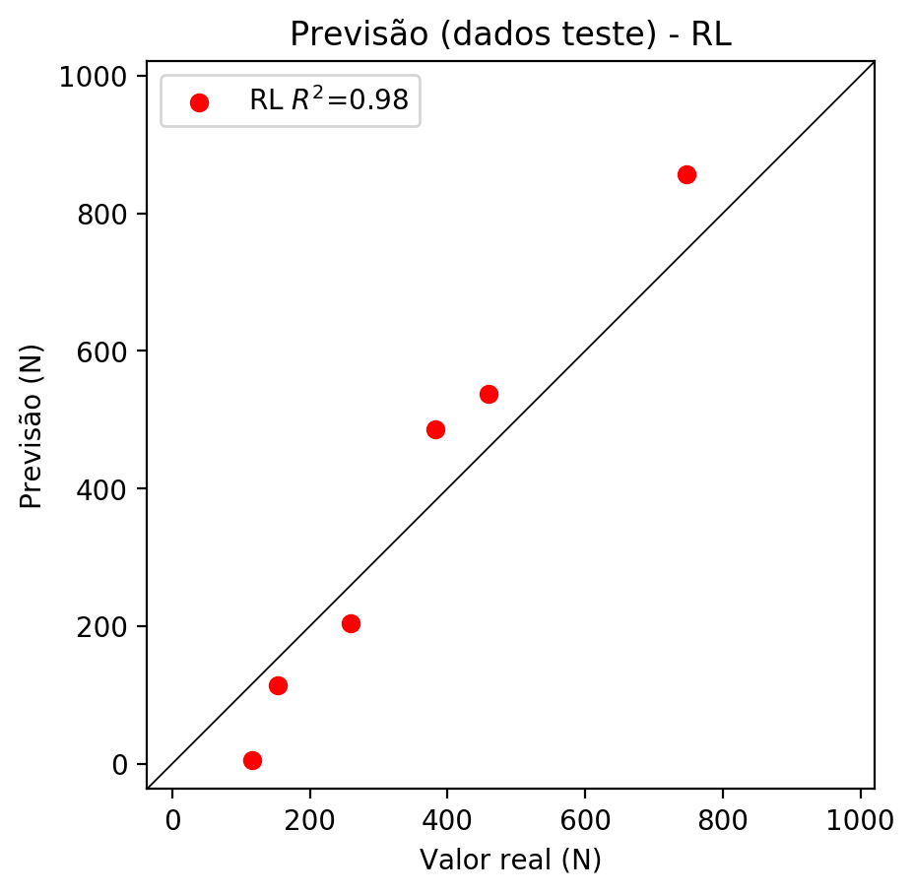

**Dados de treino**

* Erro relativo médio: 32.02
* Coeficiente de correlação: 0.92
* Coeficiente de determinação: 0.84
* MSE: 13017.02
* RMSE: 114.09

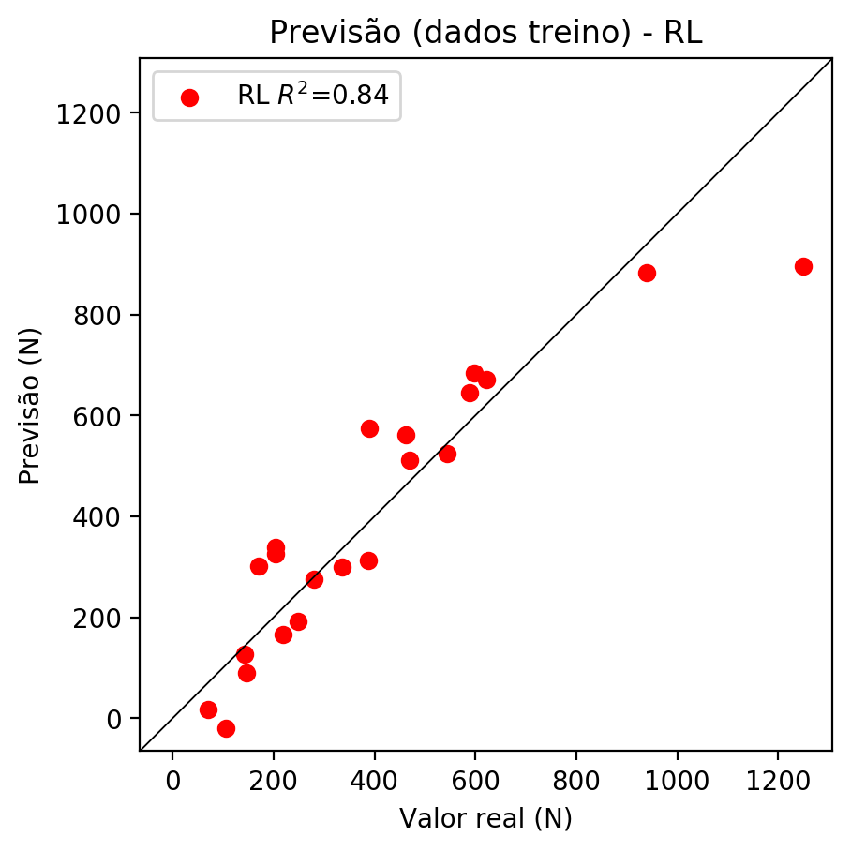

# RP2

# Coeficientes

[ 0. -0.11042845 0.50693621 0.85630848 0.04247248 -0.09378926  
 -0.07004328 -0.01616767 0.34796145 -0.08426631]

# Erros

**Dados de teste**

* Erro relativo médio: 19.06
* Coeficiente de correlação: 0.98
* Coeficiente de determinação: 0.96
* MSE: 6912.17
* RMSE: 83.14

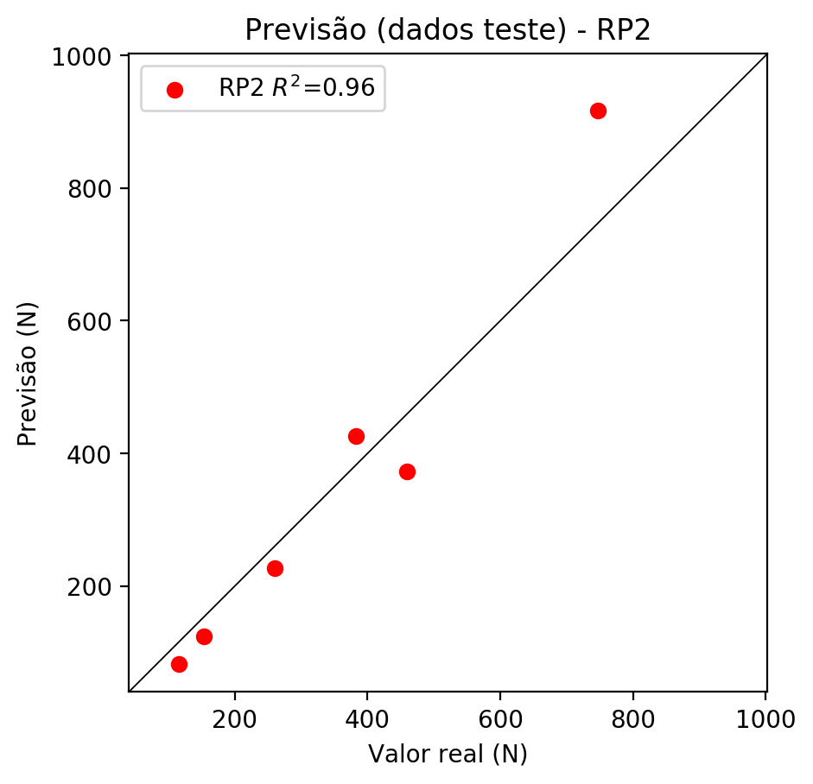

**Dados de treino**

* Erro relativo médio: 9.96
* Coeficiente de correlação: 0.99
* Coeficiente de determinação: 0.97
* MSE: 2227.49
* RMSE: 47.2

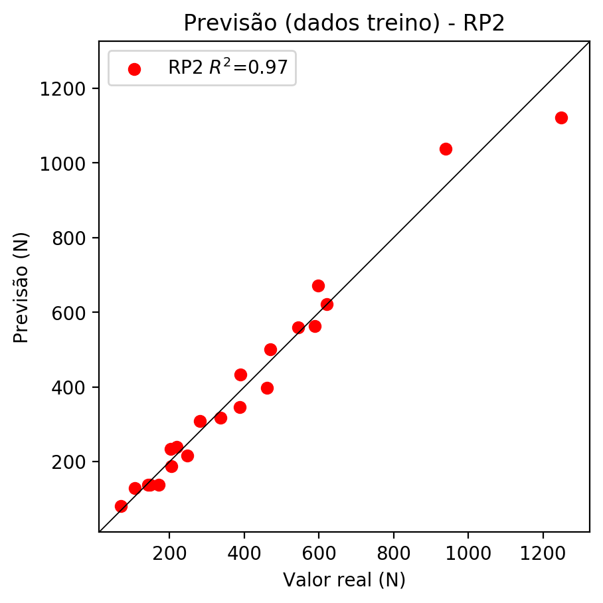

# RP3

# Coeficientes

[ 0. -0.08170813 0.09532752 0.21755644 -0.02211083 -0.30771652  
 -0.15969973 -0.03827552 0.15083188 -0.01467227 -0.11802285 0.00945162  
 0.04747244 -0.03339194 -0.27827939 0.12764695 0.1376953 0.08354757  
 0.03948084 0.31424819]

# Erros

**Dados de teste**

* Erro relativo médio: 27.23
* Coeficiente de correlação: 0.72
* Coeficiente de determinação: 0.51
* MSE: 25621.06
* RMSE: 160.07

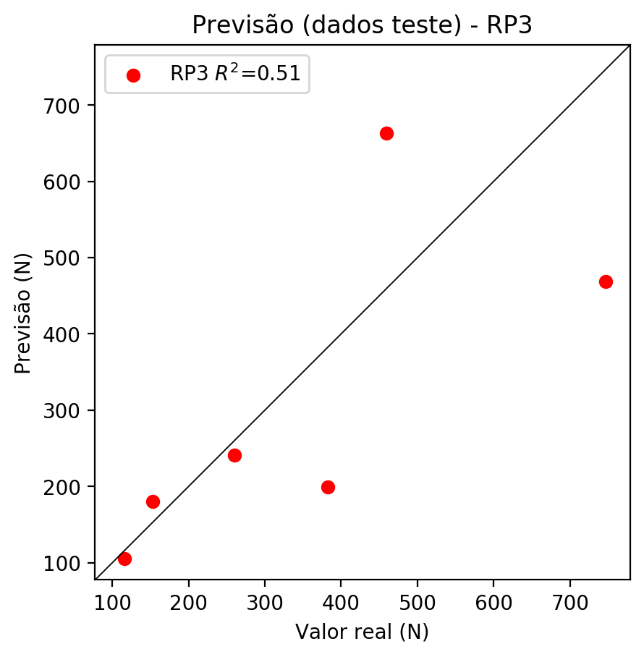

**Dados de treino**

* Erro relativo médio: 4.94
* Coeficiente de correlação: 1.0
* Coeficiente de determinação: 1.0
* MSE: 284.92
* RMSE: 16.88

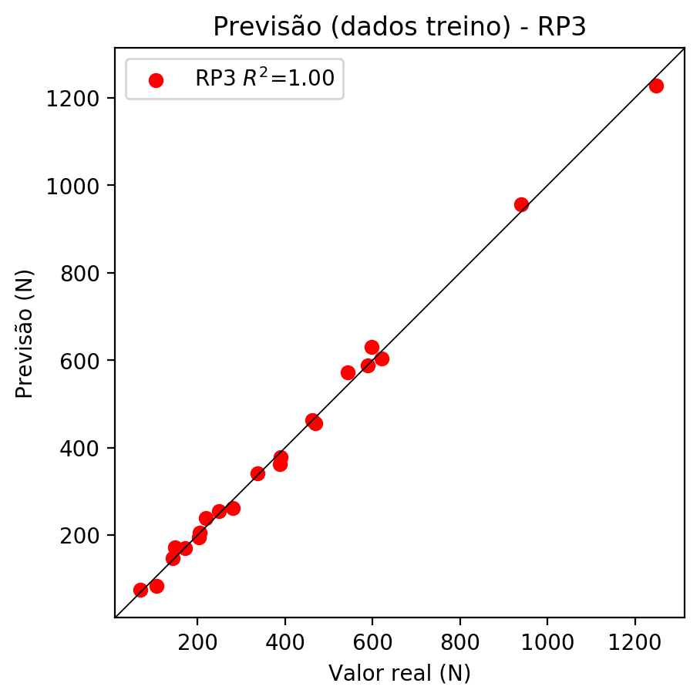

# RP4

# Coeficientes

[-1.38777878e-16 -5.08577828e-02 1.19253430e-01 2.32127737e-01  
 1.83632230e-02 -5.85433622e-04 -3.45532419e-02 -2.95337603e-02  
 -1.93910860e-02 -4.80024613e-02 -7.34612418e-02 -4.40659269e-02  
 1.15054415e-02 -7.63420386e-02 -1.83981514e-01 9.51934748e-02  
 1.72254954e-01 9.95711183e-02 4.81468701e-02 3.35295620e-01  
 8.17576782e-03 4.21796032e-02 3.38387087e-02 1.12606380e-01  
 8.48931824e-02 -6.56094799e-02 -1.85887836e-02 -5.52231107e-02  
 -2.17413737e-01 -6.82591259e-02 -1.05498798e-03 5.29748946e-02  
 -8.05061312e-02 1.50158831e-02 1.44120584e-02]

# Erros

**Dados de teste**

* Erro relativo médio: 35.6
* Coeficiente de correlação: 0.83
* Coeficiente de determinação: 0.69
* MSE: 15065.65
* RMSE: 122.74

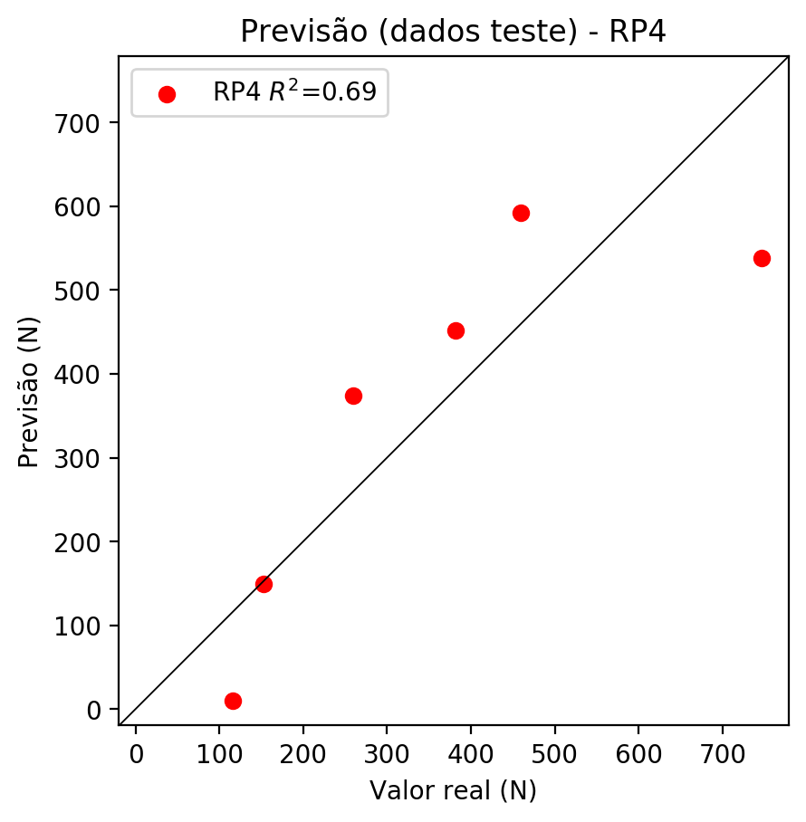

**Dados de treino**

* Erro relativo médio: 0.0
* Coeficiente de correlação: 1.0
* Coeficiente de determinação: 1.0
* MSE: 0.0
* RMSE: 0.0

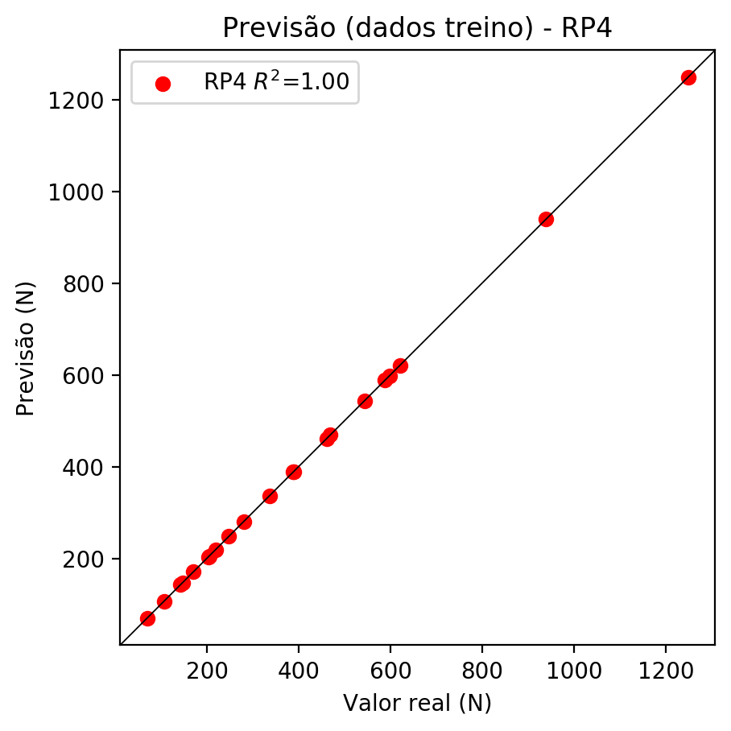

# Geral

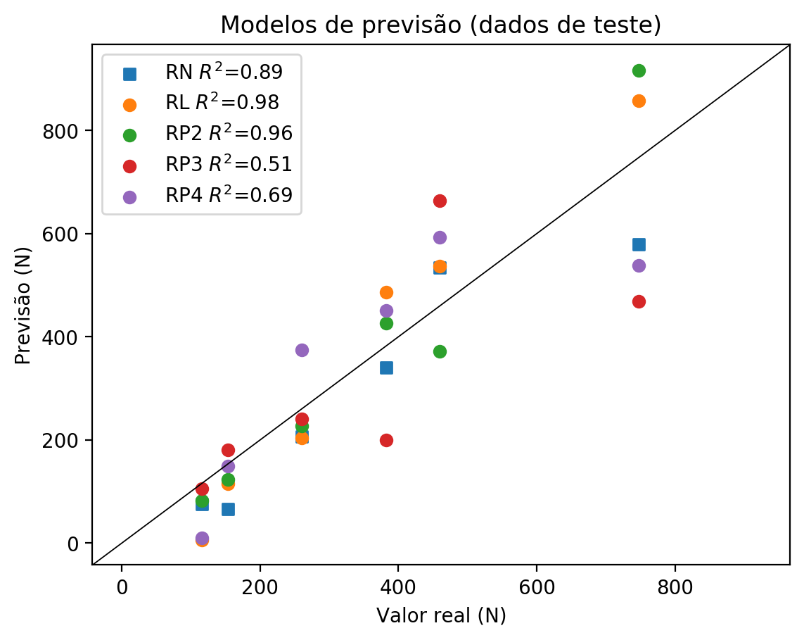

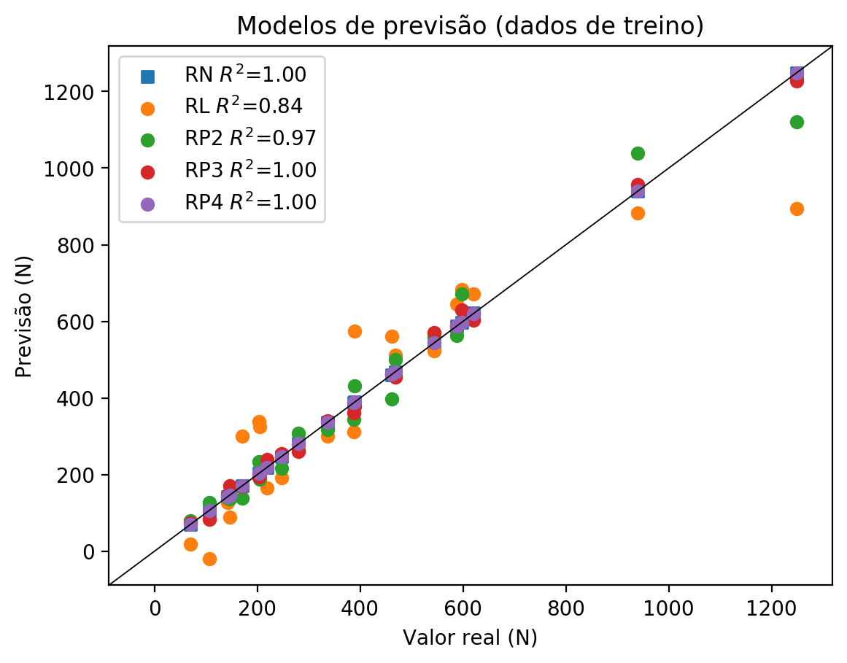

**Dados de teste**

|  |  |  |  |  |  |  |  |  |  |  |
| --- | --- | --- | --- | --- | --- | --- | --- | --- | --- | --- |
| Valor real | RN Previsto | RN Erro (%) | RL Previsto | RL Erro (%) | RP2 Previsto | RP2 Erro (%) | RP3 Previsto | RP3 Erro (%) | RP4 Previsto | RP4 Erro (%) |
| 115.6 | 75.93 | 34.32 | 5.71 | 95.06 | 82.04 | 29.03 | 105.36 | 8.86 | 9.58 | 91.71 |
| 747.1 | 579.35 | 22.45 | 857.28 | 14.75 | 916.99 | 22.74 | 468.85 | 37.24 | 538.66 | 27.9 |
| 382.1 | 341.03 | 10.75 | 486.44 | 27.31 | 426.38 | 11.59 | 199.52 | 47.78 | 451.51 | 18.17 |
| 459.2 | 534.11 | 16.31 | 536.89 | 16.92 | 372.31 | 18.92 | 663.58 | 44.51 | 592.58 | 29.05 |
| 153.1 | 66.34 | 56.67 | 114.52 | 25.2 | 123.56 | 19.29 | 180.02 | 17.58 | 148.86 | 2.77 |
| 259.8 | 206.11 | 20.67 | 203.68 | 21.6 | 226.62 | 12.77 | 240.64 | 7.37 | 374.17 | 44.02 |

**Dados de treino**

|  |  |  |  |  |  |  |  |  |  |  |
| --- | --- | --- | --- | --- | --- | --- | --- | --- | --- | --- |
| Valor real | RN Previsto | RN Erro (%) | RL Previsto | RL Erro (%) | RP2 Previsto | RP2 Erro (%) | RP3 Previsto | RP3 Erro (%) | RP4 Previsto | RP4 Erro (%) |
| 621.0 | 621.36 | 0.06 | 670.79 | 8.02 | 621.0 | 0.0 | 602.98 | 2.9 | 621.0 | 0.0 |
| 336.4 | 336.31 | 0.03 | 299.94 | 10.84 | 318.13 | 5.43 | 340.85 | 1.32 | 336.4 | 0.0 |
| 468.9 | 468.88 | 0.0 | 511.53 | 9.09 | 500.19 | 6.67 | 454.98 | 2.97 | 468.9 | 0.0 |
| 543.4 | 543.41 | 0.0 | 524.07 | 3.56 | 558.83 | 2.84 | 571.34 | 5.14 | 543.4 | 0.0 |
| 389.1 | 389.35 | 0.06 | 574.52 | 47.65 | 432.26 | 11.09 | 378.31 | 2.77 | 389.1 | 0.0 |
| 106.4 | 106.32 | 0.08 | -19.38 | 118.21 | 128.27 | 20.55 | 83.41 | 21.61 | 106.4 | 0.0 |
| 248.0 | 247.99 | 0.0 | 191.13 | 22.93 | 216.04 | 12.89 | 255.26 | 2.93 | 248.0 | 0.0 |
| 1248.7 | 1248.7 | 0.0 | 894.92 | 28.33 | 1121.16 | 10.21 | 1226.98 | 1.74 | 1248.7 | 0.0 |
| 939.3 | 939.32 | 0.0 | 882.37 | 6.06 | 1038.61 | 10.57 | 956.35 | 1.82 | 939.3 | 0.0 |
| 204.6 | 204.6 | 0.0 | 326.1 | 59.38 | 187.84 | 8.19 | 206.08 | 0.72 | 204.6 | 0.0 |
| 171.0 | 171.0 | 0.0 | 301.01 | 76.03 | 137.93 | 19.34 | 169.46 | 0.9 | 171.0 | 0.0 |
| 147.2 | 147.24 | 0.03 | 89.43 | 39.25 | 137.14 | 6.83 | 171.24 | 16.33 | 147.2 | 0.0 |
| 461.4 | 461.09 | 0.07 | 561.98 | 21.8 | 397.78 | 13.79 | 463.11 | 0.37 | 461.4 | 0.0 |
| 218.9 | 219.08 | 0.08 | 166.04 | 24.15 | 238.37 | 8.89 | 238.91 | 9.14 | 218.9 | 0.0 |
| 203.2 | 203.2 | 0.0 | 338.65 | 66.66 | 234.54 | 15.42 | 193.91 | 4.57 | 203.2 | 0.0 |
| 597.8 | 597.54 | 0.04 | 683.34 | 14.31 | 671.81 | 12.38 | 629.82 | 5.36 | 597.8 | 0.0 |
| 142.9 | 142.9 | 0.0 | 127.07 | 11.08 | 138.51 | 3.07 | 146.39 | 2.44 | 142.9 | 0.0 |
| 69.6 | 69.57 | 0.04 | 18.25 | 73.78 | 80.67 | 15.91 | 74.42 | 6.93 | 69.6 | 0.0 |
| 588.2 | 588.1 | 0.02 | 645.7 | 9.78 | 562.88 | 4.3 | 587.95 | 0.04 | 588.2 | 0.0 |
| 388.1 | 388.18 | 0.02 | 312.49 | 19.48 | 345.03 | 11.1 | 361.64 | 6.82 | 388.1 | 0.0 |
| 280.7 | 280.66 | 0.01 | 274.85 | 2.08 | 307.81 | 9.66 | 261.43 | 6.86 | 280.7 | 0.0 |