# Informações do estudo

Referência: Deshpande

Grandeza: Força

Tipo: Fz

Material: Inconel 718

Ferramenta: TNMG 160408 untreated

Número de experimentos: 20

Observações:  
Lathe machine: MTAB CNC  
Dynamometer: Kistler 9257B  
Workpiece: Ø 22 × 120 mm

# Unidades

Velocidade: m/min

Avanço: mm/rev

Profundidade de corte: mm

Força: N

# Dados de teste

|  |  |  |  |
| --- | --- | --- | --- |
| Força | n | f | a |
| 590.0 | 30.0 | 0.18 | 1.07 |
| 163.0 | 110.45 | 0.12 | 0.78 |
| 617.0 | 9.5 | 0.12 | 0.78 |
| 436.0 | 30.0 | 0.05 | 0.5 |

# Dados de treino

|  |  |  |  |
| --- | --- | --- | --- |
| Força | n | f | a |
| 447.0 | 30.0 | 0.05 | 1.07 |
| 471.0 | 60.0 | 0.12 | 0.78 |
| 300.0 | 60.0 | 0.12 | 0.3 |
| 459.0 | 60.0 | 0.12 | 0.78 |
| 231.0 | 60.0 | 0.01 | 0.78 |
| 190.0 | 90.0 | 0.05 | 1.07 |
| 279.0 | 90.0 | 0.18 | 0.5 |
| 461.0 | 60.0 | 0.12 | 0.78 |
| 444.0 | 60.0 | 0.22 | 0.78 |
| 404.0 | 60.0 | 0.12 | 1.26 |
| 464.0 | 60.0 | 0.12 | 0.78 |
| 451.0 | 60.0 | 0.12 | 0.78 |
| 200.0 | 90.0 | 0.18 | 1.07 |
| 150.0 | 90.0 | 0.05 | 0.5 |
| 463.0 | 30.0 | 0.18 | 0.5 |
| 455.0 | 60.0 | 0.12 | 0.78 |

# RN

Número de neurônios: 95

Taxa de aprendizado: 1.000000e-04

Número de épocas: 984

2° camada: True

Função de ativação: relu

# Erros

**Dados de teste**

* Erro relativo médio: 9.8
* Coeficiente de correlação: 0.97
* Coeficiente de determinação: 0.93
* MSE: 4518.88
* RMSE: 67.22

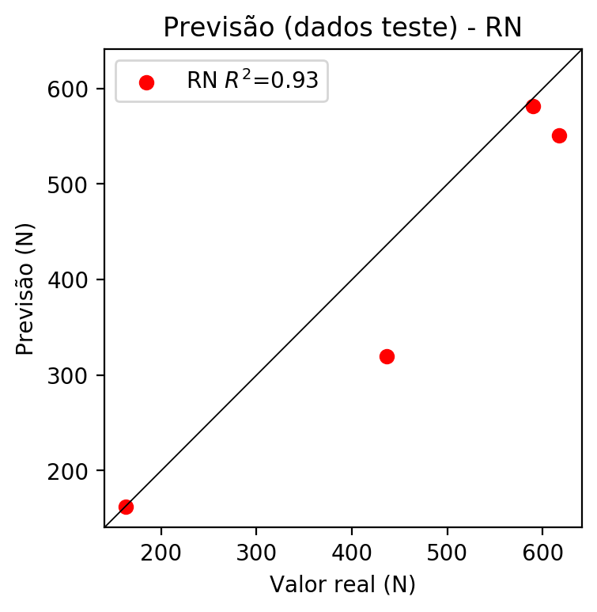

**Dados de treino**

* Erro relativo médio: 0.43
* Coeficiente de correlação: 1.0
* Coeficiente de determinação: 1.0
* MSE: 15.33
* RMSE: 3.92

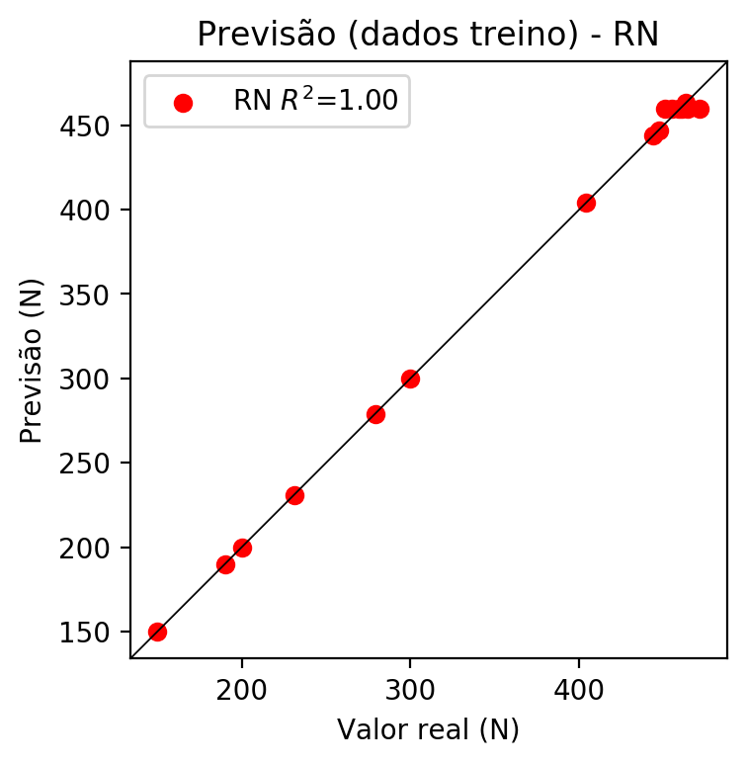

# Pesos

Pesos - camada oculta 1

[[ 0.14588782 0.072133 -0.15790044 0.04150467 0.16752976 -0.12083721  
 -0.03752819 0.00507751 -0.08118809 0.10445882 -0.24278933 0.18223654  
 0.10360423 -0.01915586 -0.1064427 -0.07111487 0.04696435 -0.06214248  
 -0.20846973 0.23360148 0.23234706 0.20263068 -0.03822891 0.1351657  
 -0.05843347 -0.17369452 0.27034968 0.0817832 0.19295633 -0.19452183  
 -0.0404129 -0.24673617 -0.10128179 -0.20367545 0.05674358 -0.17479931  
 0.09247525 0.13683285 -0.1850286 -0.05215332 0.12709893 0.11670085  
 0.2331151 0.22859788 0.09673986 -0.01535618 0.0195806 -0.14984603  
 0.23696008 0.2713762 0.13715531 0.17179868 0.05322023 -0.05613541  
 -0.09090715 0.05081591 0.04447451 0.00666818 -0.223922 -0.21550366  
 0.22754899 -0.20802249 -0.22346039 0.05441531 0.26140156 -0.2424246  
 -0.04501157 0.10508391 -0.20685253 -0.12204257 -0.04764906 0.04856715  
 -0.02819508 -0.18440005 0.1039363 -0.16524044 0.08706381 0.21819726  
 0.03028338 -0.04991153 0.16507271 -0.26850465 -0.24380852 -0.04871463  
 -0.1462768 0.21157554 0.02103242 -0.22019419 -0.22696123 0.22391386  
 -0.10769551 -0.20097037 -0.23918174 0.05279619 -0.08734676]  
 [-0.15096632 -0.2602723 0.07259898 0.11621311 -0.18257067 0.11285689  
 -0.1261882 0.18109961 -0.17010455 -0.22186944 -0.19592187 -0.08557627  
 -0.1230517 0.02245723 0.16284972 -0.04401092 -0.14443147 0.21899606  
 0.21941037 0.03587932 0.24278645 0.0054848 -0.10360058 -0.06862168  
 -0.13442807 0.05044233 -0.19154495 0.02316636 -0.10506938 0.21189377  
 0.00413532 0.18722421 -0.08080906 -0.19329667 -0.10737619 0.1521632  
 -0.02092846 -0.0031243 0.04498976 0.20722361 0.14209494 -0.10266502  
 0.07269968 -0.191255 0.17642613 -0.12108529 -0.24676298 0.04381205  
 -0.08016849 -0.02613418 -0.07259712 0.23559874 0.12774083 0.22737654  
 0.0831918 0.21437262 -0.2189766 0.00839709 -0.16414425 -0.1738422  
 -0.2544653 0.18232378 0.15571374 0.13164961 -0.04150761 -0.14073846  
 0.1597913 -0.19915646 -0.01633663 -0.20282826 -0.21392395 0.17496738  
 -0.08447877 -0.20958158 -0.10419184 -0.07720651 0.11473501 -0.23683369  
 0.17711519 -0.24533927 0.09641578 -0.22043292 0.17527318 0.02554435  
 -0.2246741 0.24274988 0.18612905 0.13302438 -0.0877497 -0.07131938  
 -0.09238543 0.16544889 0.21667969 -0.02191338 -0.10821898]  
 [ 0.00623536 -0.16998859 -0.09361638 0.0540283 0.09516095 -0.06786469  
 0.16682106 0.10095439 -0.10731151 -0.04976493 0.19900392 -0.24028744  
 0.260186 0.07593054 -0.08245869 -0.12391085 -0.08015357 -0.03517507  
 -0.00887165 0.2097086 0.06442867 -0.08557117 -0.20623286 0.11569867  
 0.09770287 0.08681102 0.10270576 0.13191646 0.17959727 0.09407013  
 0.16849187 0.08949541 -0.12389303 0.14763974 0.14362021 -0.13546427  
 -0.01869769 -0.11895771 0.10383806 -0.19708262 -0.23557982 -0.10851111  
 -0.05291396 -0.24551013 0.19179448 0.13500947 -0.11951721 -0.08784079  
 0.22368442 -0.09640826 0.07746559 -0.01136526 0.07635856 -0.02562913  
 0.09077642 0.16683209 0.00719646 -0.01024308 0.05347198 0.0082296  
 0.16475055 -0.12728326 0.20007937 -0.12755793 0.11338688 0.12611054  
 0.22350074 0.05197985 0.1280297 -0.18230695 -0.16775581 0.23498897  
 -0.01141251 -0.12975088 -0.1883579 -0.04118379 -0.07700349 -0.13727848  
 -0.20952627 0.04014718 0.05671339 0.04210898 -0.18384404 -0.25214183  
 -0.06834857 0.05330174 0.08852255 -0.06499465 -0.11090635 -0.05779869  
 -0.00709961 0.2118135 -0.1895393 -0.12048703 0.06610197]]

Bias - camada oculta

[-1.5605760e-02 -9.2573592e-04 6.4651899e-02 4.1029396e-04  
 -7.0430216e-04 -2.4400994e-03 -7.6453327e-03 6.4536393e-02  
 -5.9451821e-04 -8.1267522e-04 -7.3857512e-04 3.3450674e-02  
 -5.1978667e-04 -4.5351547e-04 6.2980562e-02 6.1964780e-02  
 -8.8630198e-03 4.7085989e-02 -3.9197356e-03 6.2675674e-05  
 8.5167668e-04 1.7472736e-05 -3.5972416e-04 -2.8841462e-04  
 -1.1838880e-02 5.4703508e-02 -7.4876356e-04 6.2277202e-02  
 -4.4080894e-04 4.7570501e-02 7.0797034e-02 7.0721023e-02  
 5.8030978e-02 5.3679615e-02 4.6436984e-02 5.9900421e-04  
 3.1176671e-02 -2.1872154e-05 5.5768792e-02 -2.8399627e-03  
 5.5625796e-04 -8.8784909e-03 2.5380423e-04 3.3678442e-02  
 -6.8318672e-03 1.8235873e-02 5.5402000e-03 6.2996052e-02  
 4.7870800e-02 -3.8018942e-04 -1.5480427e-02 8.4808352e-04  
 -3.3435619e-03 1.7045369e-02 4.4393376e-02 7.4168807e-04  
 6.7121624e-03 -1.0359577e-02 7.0528157e-02 5.5392175e-03  
 -9.8802021e-04 6.0216331e-05 4.4531062e-02 -1.1611993e-02  
 -2.0540987e-04 -5.7544205e-03 5.1500037e-02 -7.5025292e-04  
 -6.5423376e-03 -6.9299783e-04 -7.4508006e-04 8.2547991e-03  
 -1.1865152e-02 6.1281681e-02 -3.5319509e-04 -2.5806579e-04  
 4.2768783e-04 -9.5553853e-04 -5.6566992e-03 7.2603580e-03  
 -3.2607475e-03 6.7244349e-03 1.6804164e-02 1.5005998e-04  
 -2.4984705e-03 8.5513346e-04 6.6070794e-04 -1.0522974e-03  
 4.7376983e-02 -6.0551433e-04 -3.2621765e-04 6.0972907e-02  
 6.6234834e-02 -9.1275740e-03 3.6787302e-03]

Pesos - camada oculta 2

[[ 0.10058808 0.02592801 -0.10412712 ... -0.17232497 0.03208995  
 -0.04253409]  
 [-0.13770954 -0.16970621 0.06500042 ... 0.1543318 -0.03338537  
 -0.03735627]  
 [ 0.03187414 -0.06350493 -0.08362407 ... -0.1124519 -0.0201336  
 0.02979643]  
 ...  
 [ 0.05626422 0.15621571 0.02584165 ... 0.09945206 0.20519914  
 0.1169571 ]  
 [-0.19112082 -0.14510709 -0.06252494 ... -0.09415793 -0.03655161  
 0.1428345 ]  
 [-0.03787815 0.08438944 0.00365335 ... 0.0851666 0.02785033  
 0.02623572]]

Bias - camada oculta 2

[ 5.09280451e-02 5.60917929e-02 -2.19942108e-02 -1.29029024e-02  
 -7.15753669e-03 1.71389940e-04 -2.10668407e-02 -9.95589793e-03  
 -1.64232478e-02 -2.69073271e-03 -2.43159593e-03 -6.31009170e-04  
 5.61920516e-02 1.22043798e-02 1.11656059e-02 -1.87413916e-02  
 -6.21726410e-03 -2.91581266e-02 -2.76239626e-02 -1.44209415e-02  
 -1.28067862e-02 4.88208346e-02 2.01623067e-02 2.52961535e-02  
 -3.56003130e-03 -3.51800770e-03 -1.36825722e-02 -4.14034957e-03  
 -7.34097138e-03 -2.10763589e-02 8.89404491e-03 -3.23859604e-05  
 -1.84017736e-02 -9.90640838e-03 3.82543541e-02 7.14208651e-03  
 5.75001985e-02 -1.12883970e-02 4.18320764e-03 -4.39044088e-03  
 -6.19230210e-04 -1.51335727e-02 -6.87344605e-03 5.63927405e-02  
 -1.55946147e-02 2.09971033e-02 -1.14619657e-02 1.46366586e-03  
 3.48472781e-02 -1.51253305e-02 5.86014166e-02 -1.92203801e-02  
 0.00000000e+00 -4.30781255e-03 -2.03585941e-02 -1.42572001e-02  
 -1.19251367e-02 -9.83633008e-03 7.25291530e-03 -1.97942406e-02  
 2.81732082e-02 7.37361563e-03 -1.50208613e-02 -2.57902802e-03  
 -1.55159617e-02 -7.71400053e-03 1.18124308e-02 5.57263382e-02  
 2.52630049e-03 -2.67232931e-03 -1.23225460e-02 6.92565516e-02  
 -4.62260237e-03 -4.10300633e-03 -3.26807564e-03 -1.93990003e-02  
 -1.51546290e-02 5.64273186e-02 6.57266304e-02 4.64917673e-03  
 5.09826057e-02 1.83898187e-03 3.93299246e-03 1.05860177e-02  
 0.00000000e+00 9.87313315e-03 -2.17924565e-02 9.20985173e-03  
 -5.92156406e-03 -1.56482961e-02 -8.36228766e-03 -2.05226019e-02  
 -8.84213205e-03 6.64113462e-02 -9.89583880e-03]

Pesos - camada saída

[[ 0.16184822 0.11402243 -0.19156179 0.01178332 0.13650748 -0.14261389  
 -0.04632454 0.00257255 -0.10331406 0.07197315 -0.25719336 0.16196118  
 0.16060647 -0.04712753 -0.14077048 -0.14674217 0.05170923 -0.09588116  
 -0.23684767 0.20035629 0.20300397 0.22615996 -0.07843214 0.13931848  
 -0.0752569 -0.19940443 0.23631221 0.05789742 0.18056528 -0.2019848  
 -0.05908355 -0.2530013 -0.1771497 -0.22710791 0.05002803 -0.20905298  
 0.1306759 0.10720406 -0.20842217 -0.09219372 0.13595584 0.1142579  
 0.2117044 0.30384815 0.09452469 -0.05626351 -0.02919261 -0.1810602  
 0.2353588 0.24032311 0.21137552 0.14528693 0.05684704 -0.08689389  
 -0.12954015 0.04851989 0.00533128 0.01558311 -0.25161427 -0.25218725  
 0.21949922 -0.23815525 -0.2286485 0.0628074 0.22440271 -0.22700064  
 -0.08205134 0.14929363 -0.2409965 -0.16506302 -0.04939313 0.12376107  
 -0.03521753 -0.17831454 0.10416347 -0.18915468 0.07123575 0.27460852  
 0.12096592 -0.0942005 0.18537605 -0.27513975 -0.2738231 -0.0657379  
 -0.1421578 0.192599 -0.02636363 -0.24354945 -0.24703984 0.18962307  
 -0.11049435 -0.21561103 -0.25317913 0.12091074 -0.14264981]]

# Iterações

|  |  |  |  |  |  |  |
| --- | --- | --- | --- | --- | --- | --- |
| Média | Desvio | n | ln | 2° camada | Função | Épocas |
| -0.3477 | 0.2652 | 10 | 0.1 | False | relu | 38 |
| -0.51 | 0.3831 | 17 | 0.1 | True | relu | 716 |
| -0.2039 | 0.1931 | 7 | 0.01 | True | tanh | 130 |
| -1.0894 | 0.7295 | 19 | 0.001 | False | tanh | 282 |
| -0.8124 | 0.6977 | 29 | 0.001 | False | relu | 469 |
| -0.4819 | 0.319 | 88 | 0.1 | False | tanh | 926 |
| -0.1677 | 0.1087 | 95 | 0.0001 | True | relu | 984 |
| -0.3706 | 0.3132 | 10 | 0.01 | True | tanh | 865 |
| -0.7192 | 0.396 | 58 | 0.001 | True | relu | 8 |
| -0.2941 | 0.3626 | 9 | 0.01 | False | tanh | 514 |
| -0.2875 | 0.2505 | 73 | 0.0001 | True | relu | 729 |
| -0.5523 | 0.4046 | 22 | 0.001 | True | relu | 543 |
| -0.2656 | 0.1709 | 25 | 0.1 | True | relu | 562 |
| -0.7806 | 0.8901 | 53 | 0.001 | False | relu | 498 |
| -0.1924 | 0.1447 | 83 | 0.01 | True | relu | 337 |
| -1.0689 | 0.5725 | 99 | 0.01 | False | tanh | 16 |
| -0.6468 | 0.509 | 23 | 0.01 | False | relu | 472 |
| -0.2216 | 0.1523 | 24 | 0.001 | True | relu | 778 |
| -0.3495 | 0.1824 | 58 | 0.01 | True | tanh | 382 |
| -0.5275 | 0.4723 | 35 | 0.1 | False | tanh | 596 |

# RL

# Coeficientes

[ 0. -0.87668916 0.28634269 0.11252613]

# Erros

**Dados de teste**

* Erro relativo médio: 5.01
* Coeficiente de correlação: 1.0
* Coeficiente de determinação: 1.0
* MSE: 290.54
* RMSE: 17.05

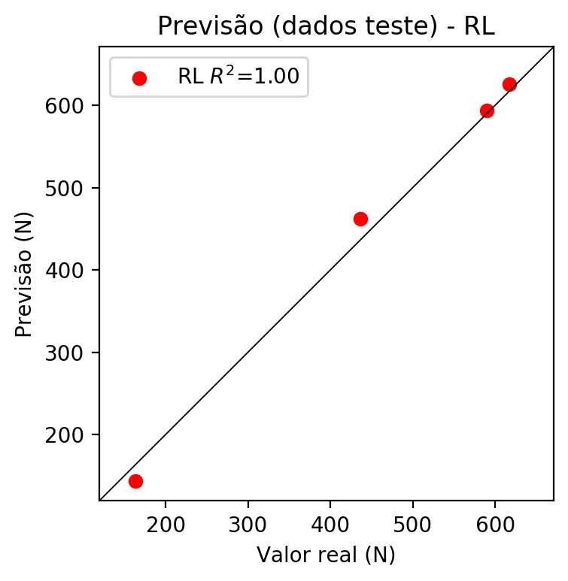

**Dados de treino**

* Erro relativo médio: 17.15
* Coeficiente de correlação: 0.82
* Coeficiente de determinação: 0.68
* MSE: 4253.61
* RMSE: 65.22

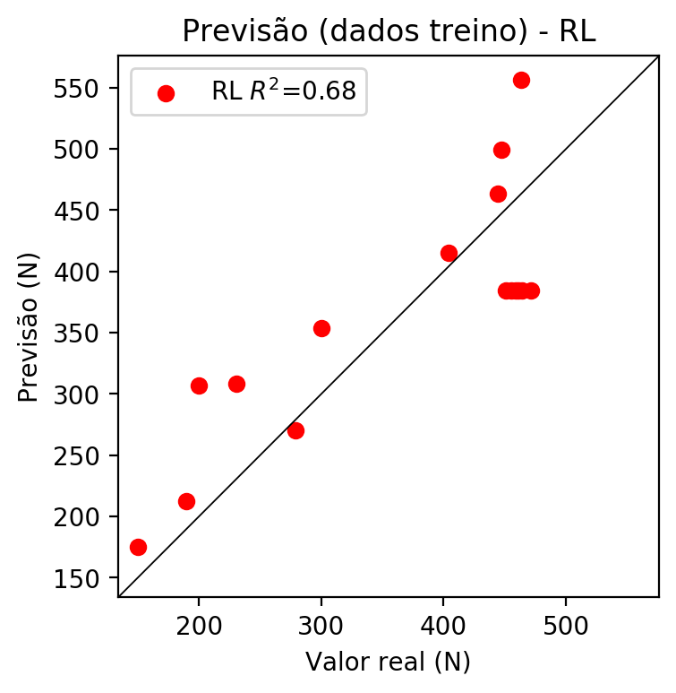

# RP2

# Coeficientes

[ 0. -0.67465811 0.38839734 0.20629223 -0.31659373 -0.14110857  
 -0.2370049 -0.23376588 -0.15291419 -0.19790559]

# Erros

**Dados de teste**

* Erro relativo médio: 28.32
* Coeficiente de correlação: 0.92
* Coeficiente de determinação: 0.85
* MSE: 17485.38
* RMSE: 132.23

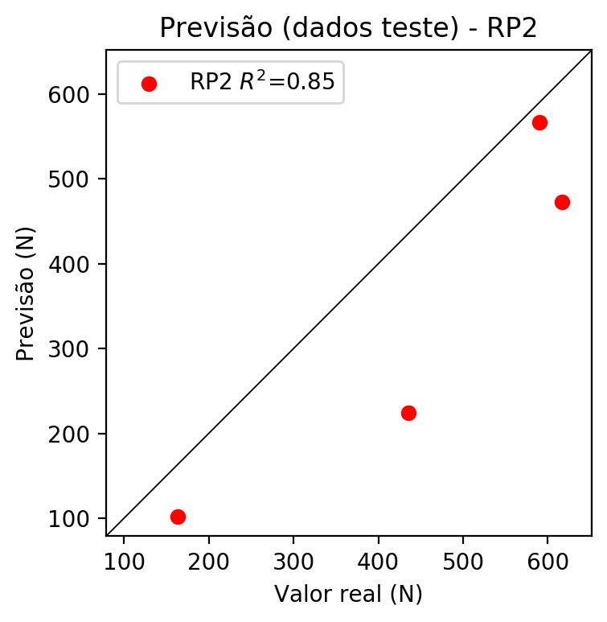

**Dados de treino**

* Erro relativo médio: 1.18
* Coeficiente de correlação: 1.0
* Coeficiente de determinação: 1.0
* MSE: 26.56
* RMSE: 5.15

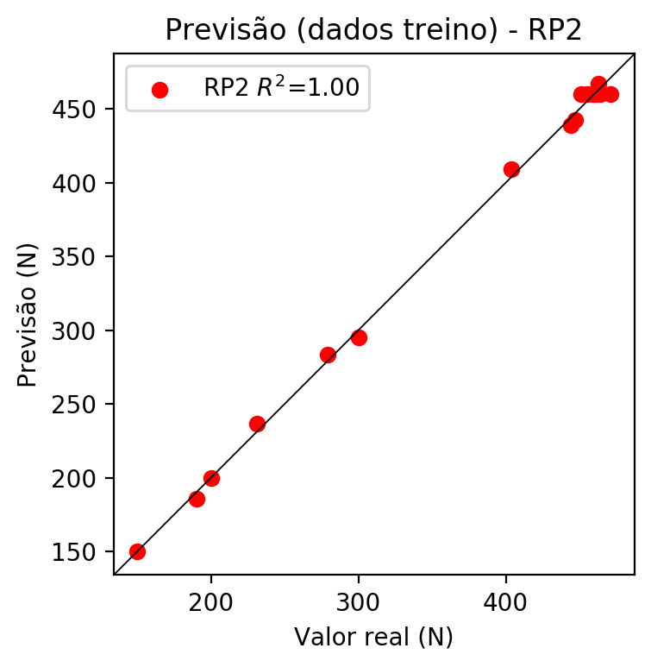

# RP3

# Coeficientes

[ 2.77555756e-17 -1.18462374e-01 2.54248015e-02 1.92389921e-03  
 -1.89574842e-01 3.71164550e-02 -5.62681555e-02 -2.40626005e-01  
 -3.48714724e-02 -1.97881554e-01 -1.64808394e-01 -1.01592660e-03  
 -2.18012646e-02 -1.67995657e-01 -1.00222713e-01 -1.64798739e-01  
 9.96510269e-02 -2.19348122e-02 -1.00719020e-03 4.73051312e-02]

# Erros

**Dados de teste**

* Erro relativo médio: 8.75
* Coeficiente de correlação: 0.98
* Coeficiente de determinação: 0.97
* MSE: 2026.87
* RMSE: 45.02

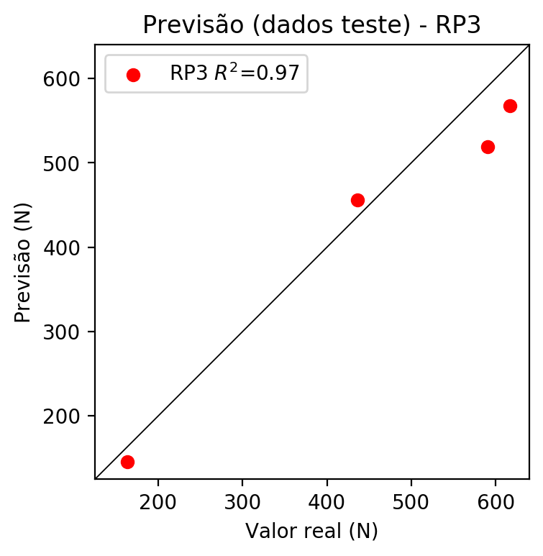

**Dados de treino**

* Erro relativo médio: 0.42
* Coeficiente de correlação: 1.0
* Coeficiente de determinação: 1.0
* MSE: 15.3
* RMSE: 3.91

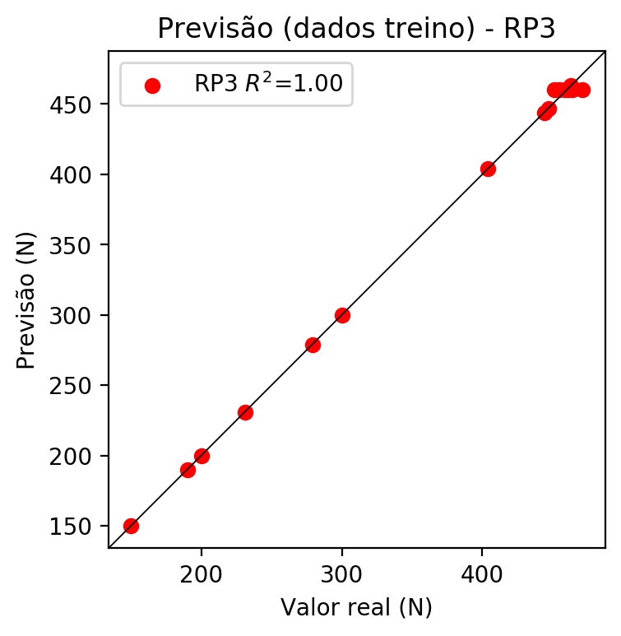

# RP4

# Coeficientes

[ 4.16333634e-17 -9.29523656e-02 2.81999085e-02 5.00910575e-03  
 -6.23884137e-02 2.43403717e-03 -1.08996821e-02 -5.43857184e-02  
 -2.65866386e-02 -4.98323192e-02 -1.29292647e-01 4.41686997e-03  
 -1.45539609e-02 -1.31610382e-01 2.49167648e-02 -1.29286412e-01  
 1.02134626e-01 -1.46157965e-02 4.35958545e-03 4.62535552e-02  
 -8.67926043e-02 3.38260476e-03 -1.51637964e-02 -8.83519742e-02  
 -3.68991556e-02 -8.67750594e-02 4.41544071e-03 -1.56146345e-02  
 3.39211447e-03 -1.52087787e-02 -4.85516131e-02 -3.74372065e-02  
 -8.83338649e-02 -3.71257168e-02 -3.76023801e-02]

# Erros

**Dados de teste**

* Erro relativo médio: 35.71
* Coeficiente de correlação: 0.99
* Coeficiente de determinação: 0.97
* MSE: 23515.0
* RMSE: 153.35

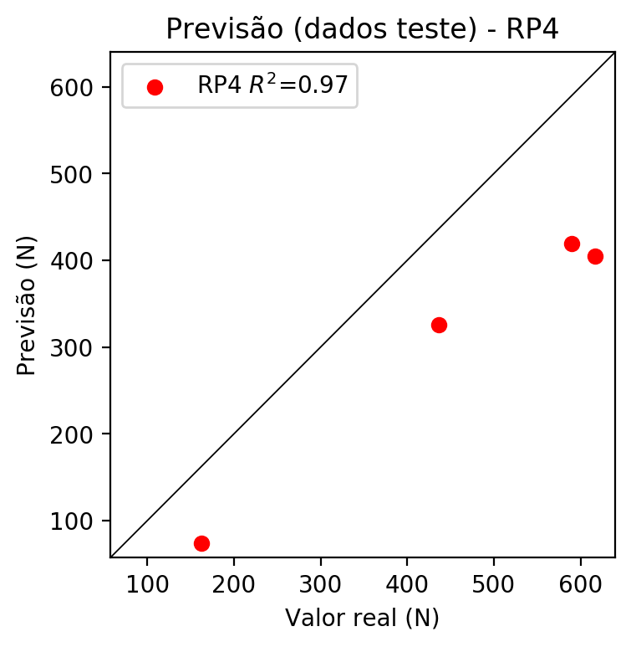

**Dados de treino**

* Erro relativo médio: 0.42
* Coeficiente de correlação: 1.0
* Coeficiente de determinação: 1.0
* MSE: 15.3
* RMSE: 3.91

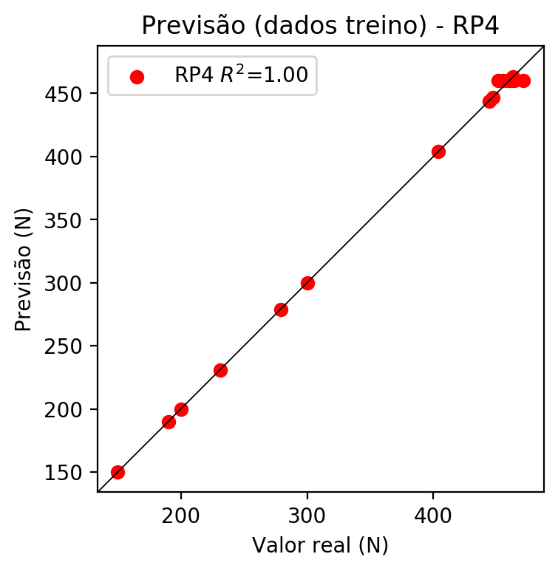

# Geral

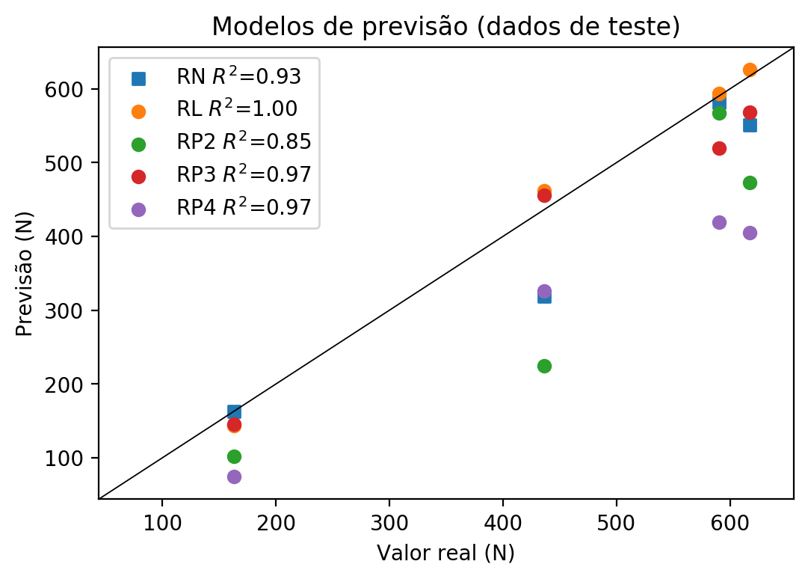

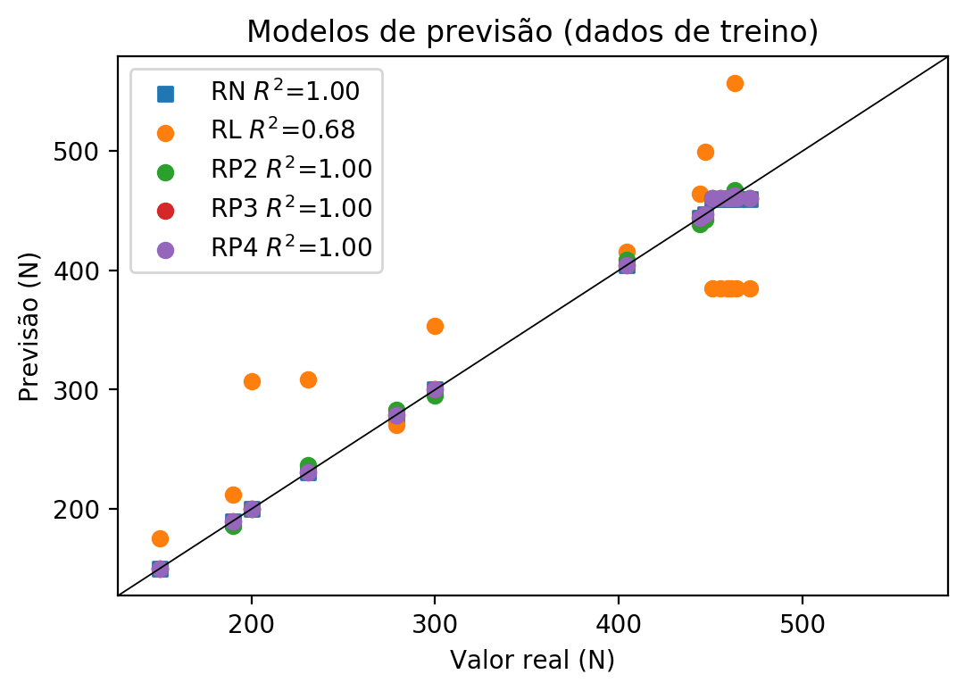

**Dados de teste**

|  |  |  |  |  |  |  |  |  |  |  |
| --- | --- | --- | --- | --- | --- | --- | --- | --- | --- | --- |
| Valor real | RN Previsto | RN Erro (%) | RL Previsto | RL Erro (%) | RP2 Previsto | RP2 Erro (%) | RP3 Previsto | RP3 Erro (%) | RP4 Previsto | RP4 Erro (%) |
| 590.0 | 581.75 | 1.4 | 593.54 | 0.6 | 566.81 | 3.93 | 519.15 | 12.01 | 419.19 | 28.95 |
| 163.0 | 162.52 | 0.29 | 143.48 | 11.98 | 102.05 | 37.39 | 145.89 | 10.5 | 74.51 | 54.29 |
| 617.0 | 550.65 | 10.75 | 625.86 | 1.44 | 472.69 | 23.39 | 567.98 | 7.94 | 405.04 | 34.35 |
| 436.0 | 319.36 | 26.75 | 462.27 | 6.03 | 224.19 | 48.58 | 455.8 | 4.54 | 325.88 | 25.26 |

**Dados de treino**

|  |  |  |  |  |  |  |  |  |  |  |
| --- | --- | --- | --- | --- | --- | --- | --- | --- | --- | --- |
| Valor real | RN Previsto | RN Erro (%) | RL Previsto | RL Erro (%) | RP2 Previsto | RP2 Erro (%) | RP3 Previsto | RP3 Erro (%) | RP4 Previsto | RP4 Erro (%) |
| 447.0 | 447.11 | 0.02 | 499.07 | 11.65 | 442.71 | 0.96 | 447.0 | 0.0 | 447.0 | 0.0 |
| 471.0 | 459.89 | 2.36 | 384.55 | 18.35 | 460.1 | 2.31 | 460.17 | 2.3 | 460.17 | 2.3 |
| 300.0 | 300.02 | 0.01 | 353.56 | 17.85 | 294.91 | 1.7 | 300.0 | 0.0 | 300.0 | 0.0 |
| 459.0 | 459.89 | 0.19 | 384.55 | 16.22 | 460.1 | 0.24 | 460.17 | 0.25 | 460.17 | 0.25 |
| 231.0 | 230.9 | 0.04 | 308.25 | 33.44 | 236.41 | 2.34 | 231.0 | 0.0 | 231.0 | 0.0 |
| 190.0 | 190.0 | 0.0 | 212.36 | 11.77 | 185.71 | 2.26 | 190.0 | 0.0 | 190.0 | 0.0 |
| 279.0 | 278.96 | 0.01 | 270.04 | 3.21 | 283.29 | 1.54 | 279.0 | 0.0 | 279.0 | 0.0 |
| 461.0 | 459.89 | 0.24 | 384.55 | 16.58 | 460.1 | 0.2 | 460.17 | 0.18 | 460.17 | 0.18 |
| 444.0 | 444.01 | 0.0 | 463.77 | 4.45 | 438.98 | 1.13 | 444.0 | 0.0 | 444.0 | 0.0 |
| 404.0 | 404.01 | 0.0 | 415.48 | 2.84 | 409.11 | 1.26 | 404.0 | 0.0 | 404.0 | 0.0 |
| 464.0 | 459.89 | 0.89 | 384.55 | 17.12 | 460.1 | 0.84 | 460.17 | 0.83 | 460.17 | 0.83 |
| 451.0 | 459.89 | 1.97 | 384.55 | 14.73 | 460.1 | 2.02 | 460.17 | 2.03 | 460.17 | 2.03 |
| 200.0 | 200.03 | 0.02 | 306.84 | 53.42 | 200.0 | 0.0 | 200.0 | 0.0 | 200.0 | 0.0 |
| 150.0 | 150.11 | 0.07 | 175.56 | 17.04 | 150.0 | 0.0 | 150.0 | 0.0 | 150.0 | 0.0 |
| 463.0 | 463.05 | 0.01 | 556.74 | 20.25 | 467.29 | 0.93 | 463.0 | 0.0 | 463.0 | 0.0 |
| 455.0 | 459.89 | 1.07 | 384.55 | 15.48 | 460.1 | 1.12 | 460.17 | 1.14 | 460.17 | 1.14 |