# Informações do estudo

Referência: Deshpande

Grandeza: Rugosidade

Tipo: Ra

Material: Inconel 718

Ferramenta: TNMG 160408 untreated

Número de experimentos: 20

Observações:  
Lathe machine: MTAB CNC  
Dynamometer: Kistler 9257B  
Workpiece: Ø 22 × 120 mm  
Surface roughness tester: Mitutoyo SURFTEST SJ-410

# Unidades

Velocidade: m/min

Avanço: mm/rev

Profundidade de corte: mm

Rugosidade: μm

# Dados de teste

|  |  |  |  |
| --- | --- | --- | --- |
| Rugosidade | n | f | a |
| 2.3 | 9.5 | 0.12 | 0.78 |
| 0.62 | 110.45 | 0.12 | 0.78 |
| 2.4 | 60.0 | 0.22 | 0.78 |
| 0.99 | 60.0 | 0.12 | 0.78 |

# Dados de treino

|  |  |  |  |
| --- | --- | --- | --- |
| Rugosidade | n | f | a |
| 1.25 | 90.0 | 0.18 | 0.5 |
| 2.2 | 30.0 | 0.18 | 1.07 |
| 0.93 | 60.0 | 0.12 | 0.78 |
| 1.6 | 30.0 | 0.05 | 1.07 |
| 0.93 | 60.0 | 0.12 | 0.78 |
| 0.72 | 90.0 | 0.05 | 0.5 |
| 0.93 | 60.0 | 0.12 | 0.78 |
| 1.78 | 90.0 | 0.18 | 1.07 |
| 0.99 | 60.0 | 0.01 | 0.78 |
| 0.99 | 60.0 | 0.12 | 0.78 |
| 2.2 | 30.0 | 0.18 | 0.5 |
| 1.3 | 60.0 | 0.12 | 0.3 |
| 0.92 | 60.0 | 0.12 | 0.78 |
| 0.52 | 90.0 | 0.05 | 1.07 |
| 1.9 | 30.0 | 0.05 | 0.5 |
| 1.49 | 60.0 | 0.12 | 1.26 |

# RN

Número de neurônios: 95

Taxa de aprendizado: 1.000000e-04

Número de épocas: 984

2° camada: True

Função de ativação: relu

# Erros

**Dados de teste**

* Erro relativo médio: 17.42
* Coeficiente de correlação: 0.97
* Coeficiente de determinação: 0.94
* MSE: 0.05
* RMSE: 0.22

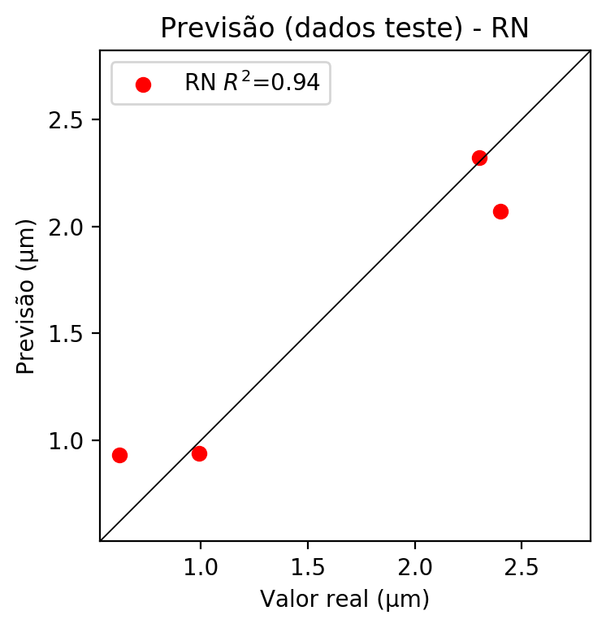

**Dados de treino**

* Erro relativo médio: 0.65
* Coeficiente de correlação: 1.0
* Coeficiente de determinação: 1.0
* MSE: 0.0
* RMSE: 0.0

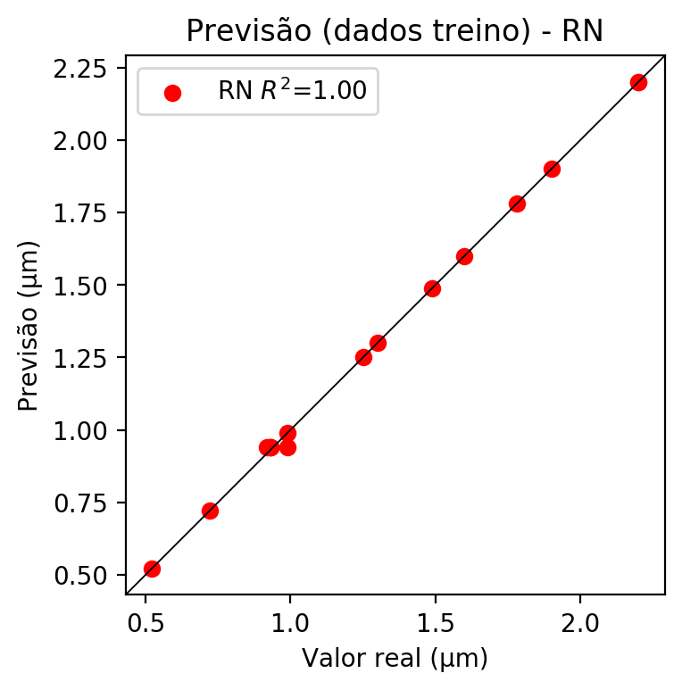

# Pesos

Pesos - camada oculta 1

[[ 0.15047939 0.06902623 -0.19271275 0.03316228 0.14959121 -0.12128069  
 -0.03757451 0.01586751 -0.09790379 0.09299402 -0.25637278 0.1761855  
 0.09088256 -0.01906552 -0.1283879 -0.12541994 0.0439325 -0.08491096  
 -0.22464265 0.21701497 0.21898375 0.18230417 -0.03306016 0.14207353  
 -0.05942688 -0.19267184 0.24663718 0.03944623 0.18534026 -0.19386151  
 -0.04907987 -0.2673054 -0.16426595 -0.21043982 0.01545451 -0.19180381  
 0.07282156 0.12517354 -0.20462818 -0.07827473 0.11011482 0.11584269  
 0.16808689 0.21728328 0.1222669 -0.02116418 0.01387533 -0.17615527  
 0.21690944 0.2515701 0.14588888 0.14153367 0.06685386 -0.04818732  
 -0.10023905 0.07059668 0.03557228 0.02167196 -0.24703161 -0.2083102  
 0.18603942 -0.22372392 -0.19280039 0.0559057 0.24409142 -0.24583617  
 -0.06755195 0.10126973 -0.20778719 -0.12852845 -0.06384109 0.02817756  
 -0.02592061 -0.19689903 0.09259669 -0.15490608 0.07579211 0.21058507  
 0.01956373 -0.05643991 0.21149588 -0.2663881 -0.261471 -0.06373849  
 -0.15355736 0.21951032 0.00410741 -0.21202937 -0.2384374 0.21206027  
 -0.10813473 -0.20325209 -0.2666855 0.04803697 -0.08646754]  
 [-0.15737782 -0.24564297 0.04743601 0.11256202 -0.17843525 0.13444197  
 -0.11679387 0.23450619 -0.16237612 -0.22563487 -0.19510047 -0.07033135  
 -0.130053 0.02463371 0.15030745 0.00185284 -0.14384465 0.20298037  
 0.22020452 0.02898978 0.22837272 0.02973377 -0.09773006 -0.06854162  
 -0.13639781 0.0559278 -0.18796627 0.000939 -0.09441279 0.25621855  
 0.0183496 0.22217119 -0.0411575 -0.21236037 -0.09584512 0.10211032  
 -0.01270971 0.00486536 0.06007785 0.2276952 0.15765405 -0.13780437  
 0.07499791 -0.1759132 0.21504119 -0.12079083 -0.23101161 0.02403616  
 -0.07692369 -0.02079162 -0.07532939 0.230794 0.13488075 0.18805991  
 0.0655565 0.22552596 -0.19126336 -0.00095619 -0.15103436 -0.17147143  
 -0.26975173 0.15764666 0.20752709 0.13012563 -0.03877576 -0.1486294  
 0.17502226 -0.19468604 -0.04158398 -0.18718131 -0.19903198 0.18825048  
 -0.09326969 -0.21496215 -0.09042987 -0.07614242 0.15843394 -0.22654153  
 0.17368323 -0.19458352 0.12199813 -0.2235449 0.14361839 0.02261516  
 -0.22629003 0.24440525 0.14174786 0.11432005 -0.06422718 -0.05791806  
 -0.12034547 0.21833819 0.21990258 -0.02420987 -0.0996788 ]  
 [-0.02852085 -0.14679486 -0.09465131 0.04641971 0.09117141 -0.06969186  
 0.17519957 0.12871598 -0.1034577 -0.04707581 0.15940498 -0.21772838  
 0.25110593 0.06880371 -0.12231173 -0.09887077 -0.10876878 -0.05812444  
 -0.02790335 0.18672659 0.02459379 -0.09495812 -0.16561212 0.12245868  
 0.09705784 0.06178495 0.08939927 0.13100933 0.18726157 0.10334429  
 0.17663512 0.08473998 -0.08282249 0.12242213 0.14010705 -0.16096461  
 -0.04963868 -0.11890061 0.05531019 -0.19837771 -0.19811161 -0.13463916  
 -0.07268395 -0.22634912 0.22807214 0.13447295 -0.07696587 -0.07344047  
 0.22252099 -0.1276378 0.08297351 -0.05734942 0.11313755 -0.02521077  
 0.08972422 0.1757179 0.04407298 -0.03015539 0.03749882 0.03807528  
 0.13929887 -0.14998467 0.23465407 -0.12179022 0.13574544 0.1048421  
 0.19939464 0.07924726 0.10015942 -0.18266834 -0.17741604 0.21714991  
 -0.00490812 -0.1688258 -0.17777991 -0.01575873 -0.04365254 -0.09505492  
 -0.23894511 0.0784146 0.05724865 0.0284467 -0.19978881 -0.2777708  
 -0.06306227 0.04628298 0.06560984 -0.04916533 -0.09959551 -0.03886555  
 -0.02376919 0.21696603 -0.16983424 -0.15397868 0.06144379]]

Bias - camada oculta

[-7.7416897e-03 3.5182789e-02 2.1216541e-04 3.9846686e-04  
 3.8187742e-02 5.6235284e-02 4.5023169e-02 8.3015190e-04  
 3.7046913e-02 4.3737024e-02 1.1523024e-02 4.3000557e-02  
 4.8192345e-02 -1.0089856e-02 5.8794610e-04 3.9495586e-05  
 -6.7873010e-03 -4.7929911e-03 2.1883197e-02 1.6123293e-02  
 -1.7773626e-02 9.3740914e-03 5.3689510e-02 3.2593857e-04  
 -5.1359035e-04 9.8884394e-03 4.1762155e-02 5.4697495e-02  
 -5.6739938e-03 9.3566178e-04 3.5139641e-05 1.8716587e-02  
 5.2032605e-02 -7.8223681e-04 5.1501077e-02 4.2565365e-04  
 4.5595217e-02 5.2337673e-02 2.2860683e-04 5.1461793e-02  
 4.9530059e-02 1.4935465e-02 4.7982357e-02 -1.0884130e-02  
 7.2793273e-04 4.6934444e-02 4.1177686e-02 1.1776139e-02  
 4.6043854e-02 4.3018449e-02 -5.4370295e-03 4.3357126e-02  
 4.6356191e-04 -1.1099484e-03 -5.4918071e-03 7.8215502e-04  
 4.0026661e-02 -1.9267619e-03 2.8241843e-02 -8.6470768e-03  
 -1.0195665e-02 6.3000945e-04 7.3007366e-04 4.9598981e-04  
 3.6629993e-02 1.4462171e-02 6.0615235e-04 4.3455526e-02  
 -4.6359799e-03 5.2082065e-02 -6.8574271e-04 1.0713299e-02  
 -4.8195217e-03 -7.3292223e-04 -6.1040348e-03 -9.6818078e-03  
 1.5831996e-02 3.6643118e-02 6.8318576e-04 5.5110186e-02  
 4.1404433e-04 -7.9823943e-04 5.9195649e-04 1.4603710e-04  
 -8.0027821e-04 8.6300925e-04 -1.3937650e-02 -9.0833763e-03  
 -5.1933862e-03 3.5616305e-02 -4.2508784e-04 7.7441958e-04  
 5.3796510e-04 -6.1724189e-05 5.3163335e-02]

Pesos - camada oculta 2

[[ 0.10556842 0.03106603 -0.10964835 ... -0.18605338 0.02971298  
 -0.05974803]  
 [-0.1334394 -0.17958444 0.06054202 ... 0.17093028 -0.02844873  
 -0.05203209]  
 [ 0.00979102 -0.09569441 -0.08503912 ... -0.1389762 -0.07620829  
 0.0225246 ]  
 ...  
 [ 0.04081308 0.13112068 0.03097472 ... 0.07997233 0.15549855  
 0.11507341]  
 [-0.1804899 -0.11665057 -0.0729589 ... -0.09755804 -0.00479107  
 0.1340632 ]  
 [-0.05179006 0.08153308 0.02244781 ... 0.17390051 0.03398157  
 0.01811216]]

Bias - camada oculta 2

[-4.31319512e-02 -4.42479178e-03 4.03027013e-02 -2.62012463e-02  
 3.72009259e-03 3.29052657e-02 4.55290154e-02 -9.51291155e-03  
 3.60789374e-02 -1.80731132e-03 3.75503674e-02 1.68388477e-03  
 1.44045036e-02 3.88654284e-02 4.06439789e-02 4.68799658e-02  
 2.12798882e-02 4.25067768e-02 3.90525199e-02 -3.71898264e-02  
 5.02876472e-03 3.10799060e-03 4.06664051e-02 -1.76562648e-02  
 4.67246883e-02 3.63140069e-02 1.17178643e-02 -3.80991725e-03  
 -6.57314807e-03 3.92501317e-02 5.52973822e-02 -1.17956446e-02  
 3.80398221e-02 5.16519137e-02 9.43700224e-03 4.50748950e-02  
 3.64896539e-03 -7.56325573e-03 -1.24090053e-02 -1.04805557e-02  
 6.79314323e-03 1.68436277e-03 3.19272326e-03 1.19740493e-03  
 -2.00320594e-02 4.08166908e-02 6.47381470e-02 3.32033709e-02  
 -5.77209808e-04 -2.44259443e-02 -1.45846643e-02 -1.05968385e-03  
 -2.66122073e-03 3.53646800e-02 3.52615677e-02 -1.38094584e-02  
 1.87611710e-02 6.02545170e-03 4.31515202e-02 -1.00810872e-02  
 -6.10656943e-03 -1.27334129e-02 3.58616635e-02 -2.77924025e-03  
 -1.85621902e-02 7.79150942e-05 4.24482226e-02 -1.92769896e-02  
 4.37668487e-02 3.97354476e-02 5.06180115e-02 0.00000000e+00  
 5.10944054e-02 -4.28526057e-03 1.08351372e-02 3.71552259e-02  
 -2.30590422e-02 -2.54353192e-02 -1.21822525e-02 4.02188711e-02  
 -3.55721079e-02 -8.86198878e-03 3.72628458e-02 -9.09994729e-03  
 0.00000000e+00 -9.92897060e-03 5.26552722e-02 3.65300253e-02  
 -7.89056625e-03 7.98910204e-03 3.72593924e-02 4.06750068e-02  
 4.10493873e-02 -1.94676835e-02 -8.67240317e-03]

Pesos - camada saída

[[ 0.19442405 0.0728583 -0.19946733 0.05664661 0.17334943 -0.15368403  
 -0.04533233 0.01394158 -0.10520989 0.10522428 -0.29590133 0.17603904  
 0.10477603 -0.04573295 -0.15731555 -0.10506509 0.08983755 -0.1010856  
 -0.2504456 0.21088573 0.24082603 0.19054219 -0.08595491 0.1548747  
 -0.08450039 -0.20808502 0.2694525 0.05786173 0.18118697 -0.20519656  
 -0.08726224 -0.24189259 -0.18289341 -0.21110201 0.04972966 -0.25477597  
 0.09309031 0.10892515 -0.19892544 -0.05240541 0.1417862 0.12345547  
 0.22723502 0.25582993 0.13408507 -0.05415425 -0.03814321 -0.1842212  
 0.21525355 0.27804595 0.17436449 0.17922491 0.05614374 -0.10079703  
 -0.13701984 0.07979215 0.03700205 0.04921662 -0.2628759 -0.21287297  
 0.2212755 -0.1967516 -0.23935094 0.06268626 0.23524207 -0.26195237  
 -0.09684855 0.10845283 -0.25731847 -0.18428133 -0.06754796 0.02674651  
 -0.0439577 -0.17822942 0.11976525 -0.19022514 0.08110772 0.22727758  
 0.06119481 -0.09792797 0.20031105 -0.23931915 -0.29543266 -0.06832716  
 -0.1421578 0.20600393 -0.03410081 -0.25799218 -0.23250376 0.20399033  
 -0.11761985 -0.18715389 -0.31633824 0.08117095 -0.09491896]]

# Iterações

|  |  |  |  |  |  |  |
| --- | --- | --- | --- | --- | --- | --- |
| Média | Desvio | n | ln | 2° camada | Função | Épocas |
| -0.8134 | 0.6153 | 10 | 0.1 | False | relu | 38 |
| -0.291 | 0.2484 | 17 | 0.1 | True | relu | 716 |
| -0.4829 | 0.3586 | 7 | 0.01 | True | tanh | 130 |
| -0.8617 | 0.5684 | 19 | 0.001 | False | tanh | 282 |
| -0.7424 | 0.9308 | 29 | 0.001 | False | relu | 469 |
| -0.7389 | 0.6891 | 88 | 0.1 | False | tanh | 926 |
| -0.264 | 0.3699 | 95 | 0.0001 | True | relu | 984 |
| -0.3841 | 0.2845 | 10 | 0.01 | True | tanh | 865 |
| -0.7425 | 0.341 | 58 | 0.001 | True | relu | 8 |
| -0.7399 | 0.6371 | 9 | 0.01 | False | tanh | 514 |
| -0.5527 | 0.8479 | 73 | 0.0001 | True | relu | 729 |
| -0.3212 | 0.3962 | 22 | 0.001 | True | relu | 543 |
| -0.2754 | 0.4044 | 25 | 0.1 | True | relu | 562 |
| -0.9391 | 1.4745 | 53 | 0.001 | False | relu | 498 |
| -0.285 | 0.3911 | 83 | 0.01 | True | relu | 337 |
| -0.9272 | 0.4839 | 99 | 0.01 | False | tanh | 16 |
| -0.3617 | 0.4058 | 23 | 0.01 | False | relu | 472 |
| -0.5705 | 0.8833 | 24 | 0.001 | True | relu | 778 |
| -0.5373 | 0.522 | 58 | 0.01 | True | tanh | 382 |
| -0.7778 | 0.5296 | 35 | 0.1 | False | tanh | 596 |

# RL

# Coeficientes

[ 0. -0.64536074 0.42854635 0.03637655]

# Erros

**Dados de teste**

* Erro relativo médio: 18.97
* Coeficiente de correlação: 0.93
* Coeficiente de determinação: 0.87
* MSE: 0.12
* RMSE: 0.35

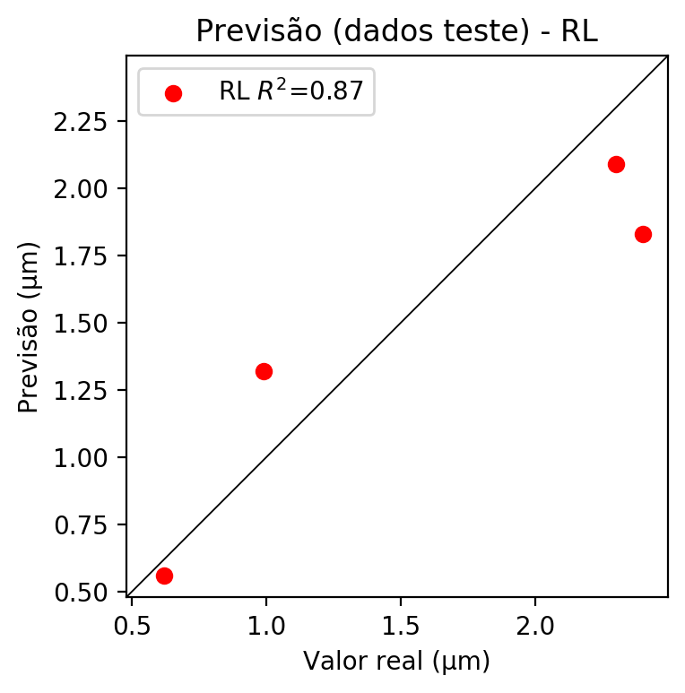

**Dados de treino**

* Erro relativo médio: 21.84
* Coeficiente de correlação: 0.81
* Coeficiente de determinação: 0.65
* MSE: 0.09
* RMSE: 0.3

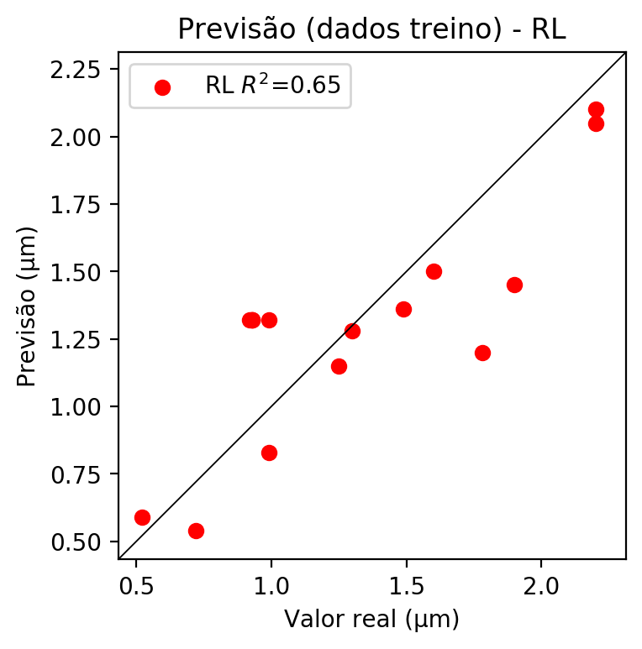

# RP2

# Coeficientes

[ 0. -0.64493933 0.47594545 0.03720969 0.23301278 0.13298639  
 0.09497429 0.26930955 0.15390396 0.19380779]

# Erros

**Dados de teste**

* Erro relativo médio: 8.55
* Coeficiente de correlação: 0.99
* Coeficiente de determinação: 0.99
* MSE: 0.02
* RMSE: 0.14

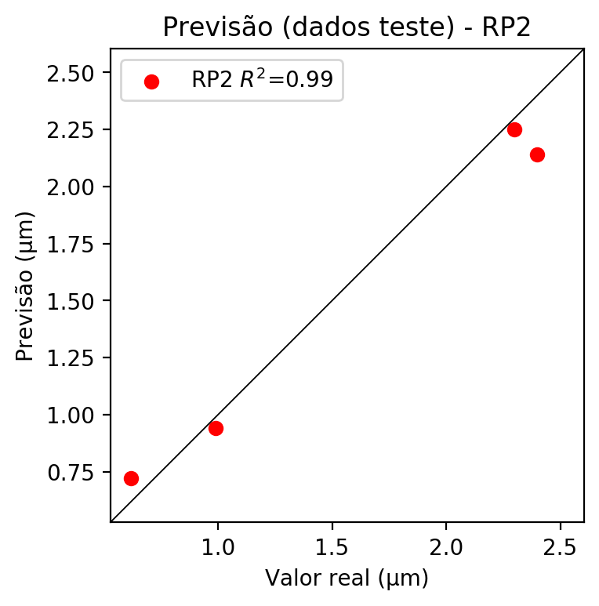

**Dados de treino**

* Erro relativo médio: 3.68
* Coeficiente de correlação: 1.0
* Coeficiente de determinação: 0.99
* MSE: 0.0
* RMSE: 0.0

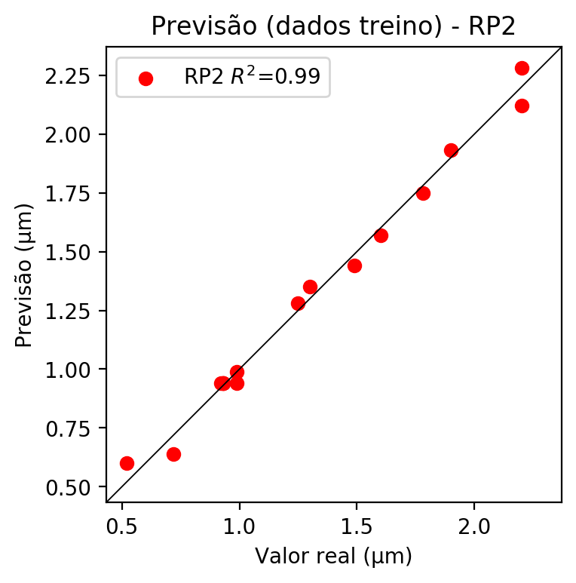

# RP3

# Coeficientes

[ 2.08166817e-17 -9.36763974e-02 7.02707829e-02 1.38991521e-03  
 2.51577151e-01 1.31978665e-01 9.52291794e-02 2.52451025e-01  
 1.53792316e-01 1.94327974e-01 -1.30207034e-01 9.45667625e-02  
 -7.87197938e-03 -1.33553683e-01 5.44822755e-02 -1.30225476e-01  
 1.00418936e-01 -9.15867646e-03 9.48161475e-02 2.03702397e-02]

# Erros

**Dados de teste**

* Erro relativo médio: 12.7
* Coeficiente de correlação: 0.99
* Coeficiente de determinação: 0.97
* MSE: 0.03
* RMSE: 0.17

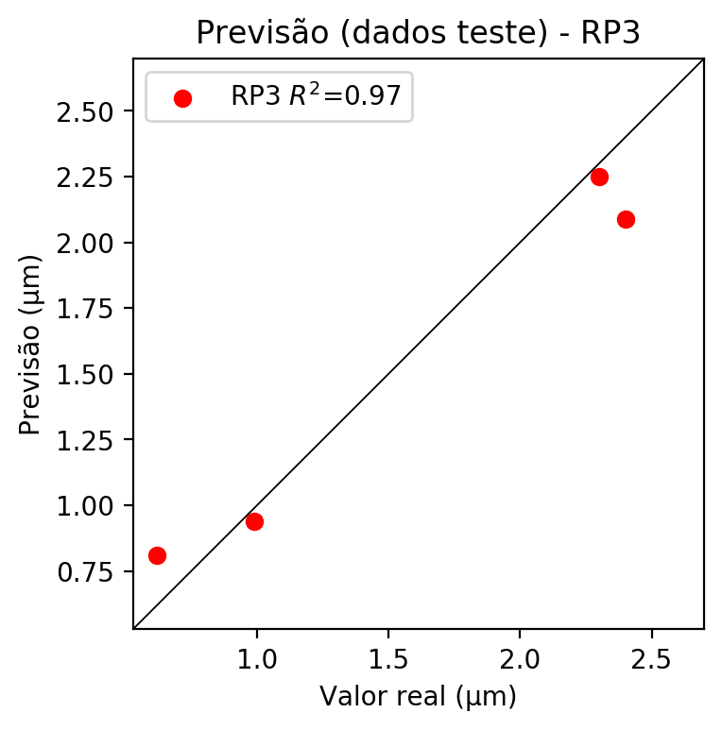

**Dados de treino**

* Erro relativo médio: 0.65
* Coeficiente de correlação: 1.0
* Coeficiente de determinação: 1.0
* MSE: 0.0
* RMSE: 0.0

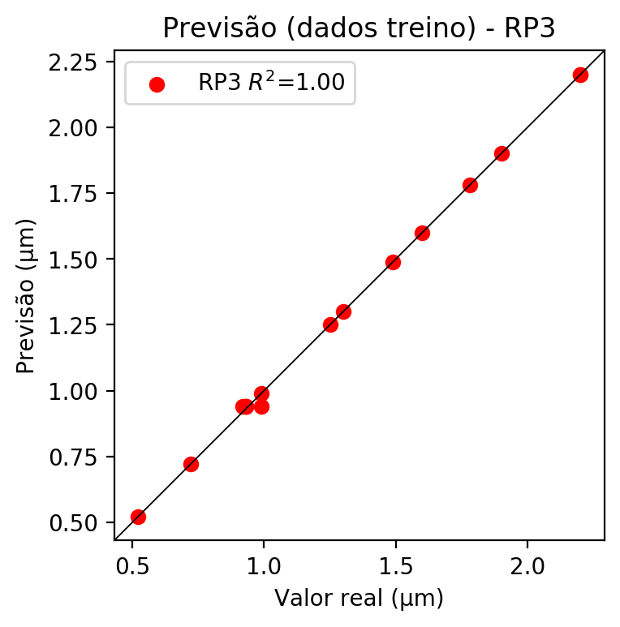

# RP4

# Coeficientes

[ 5.55111512e-17 -9.37869470e-02 6.98378730e-02 1.32029627e-03  
 5.35917747e-02 1.89956072e-02 1.39501511e-02 4.89559528e-02  
 2.23537776e-02 4.43731868e-02 -1.30419153e-01 9.32428130e-02  
 -8.32060215e-03 -1.32902927e-01 5.46068760e-02 -1.30427596e-01  
 1.04374774e-01 -8.63709198e-03 9.32841348e-02 2.05213743e-02  
 7.45075609e-02 2.64362393e-02 1.93986517e-02 7.51840292e-02  
 3.11358600e-02 7.45313370e-02 2.78646539e-02 1.93475703e-02  
 2.64410736e-02 1.93495623e-02 5.68701627e-02 3.17472926e-02  
 7.52080533e-02 3.10588566e-02 3.80883571e-02]

# Erros

**Dados de teste**

* Erro relativo médio: 22.14
* Coeficiente de correlação: 0.96
* Coeficiente de determinação: 0.91
* MSE: 0.06
* RMSE: 0.24

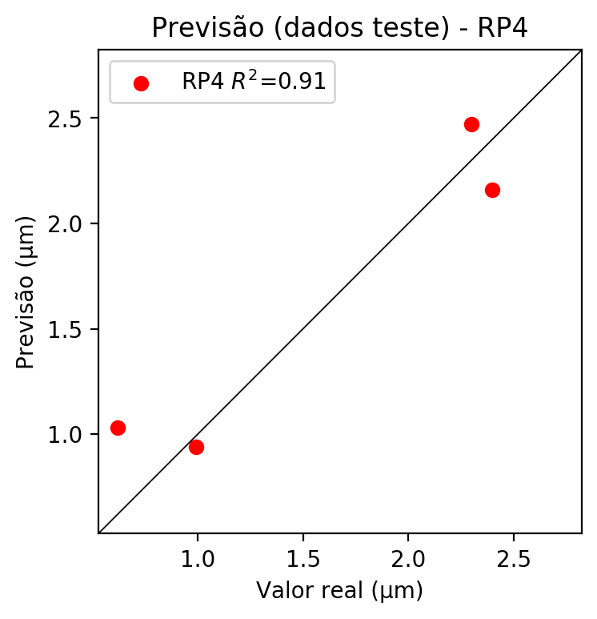

**Dados de treino**

* Erro relativo médio: 0.65
* Coeficiente de correlação: 1.0
* Coeficiente de determinação: 1.0
* MSE: 0.0
* RMSE: 0.0

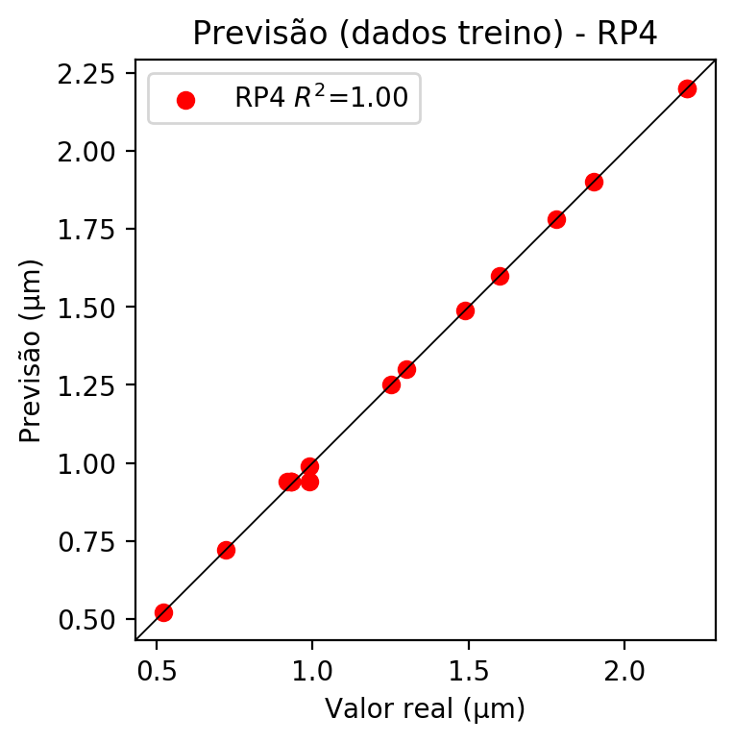

# Geral

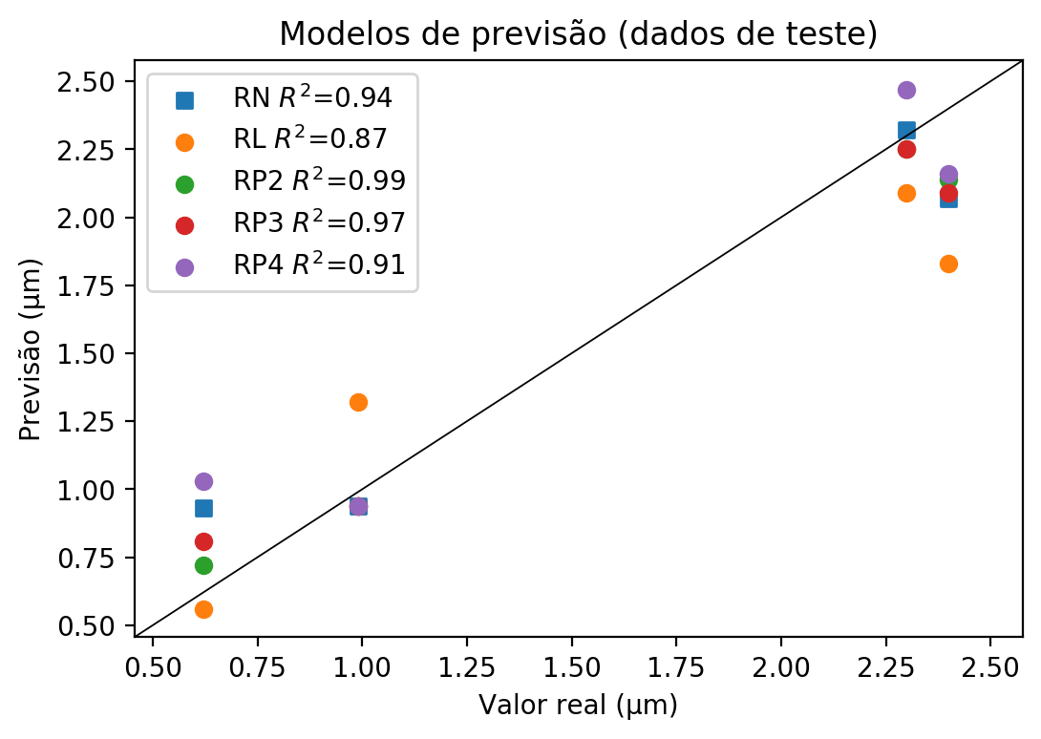

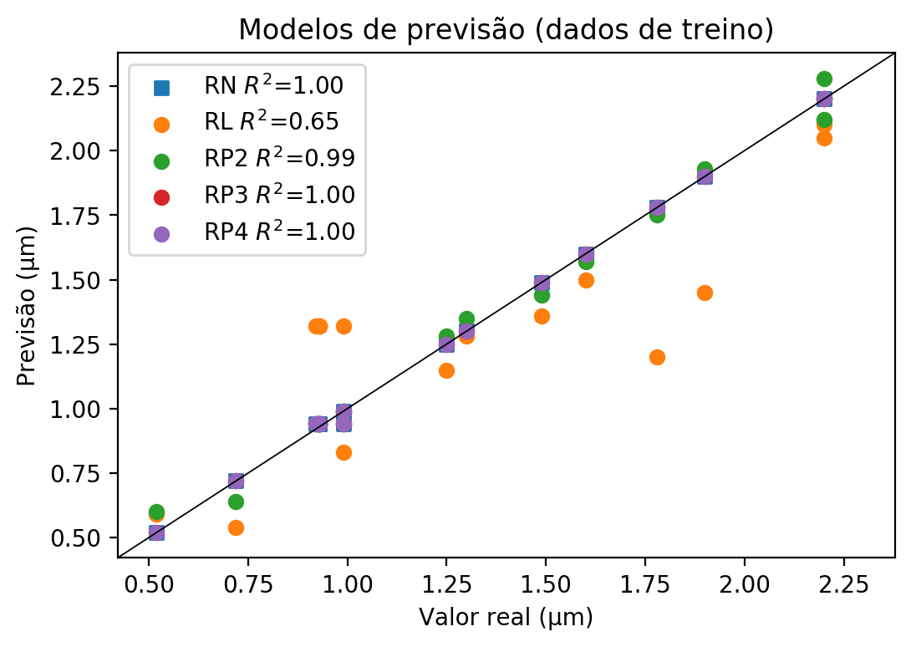

**Dados de teste**

|  |  |  |  |  |  |  |  |  |  |  |
| --- | --- | --- | --- | --- | --- | --- | --- | --- | --- | --- |
| Valor real | RN Previsto | RN Erro (%) | RL Previsto | RL Erro (%) | RP2 Previsto | RP2 Erro (%) | RP3 Previsto | RP3 Erro (%) | RP4 Previsto | RP4 Erro (%) |
| 2.3 | 2.32 | 0.87 | 2.09 | 9.13 | 2.25 | 2.17 | 2.25 | 2.17 | 2.47 | 7.39 |
| 0.62 | 0.93 | 50.0 | 0.56 | 9.68 | 0.72 | 16.13 | 0.81 | 30.65 | 1.03 | 66.13 |
| 2.4 | 2.07 | 13.75 | 1.83 | 23.75 | 2.14 | 10.83 | 2.09 | 12.92 | 2.16 | 10.0 |
| 0.99 | 0.94 | 5.05 | 1.32 | 33.33 | 0.94 | 5.05 | 0.94 | 5.05 | 0.94 | 5.05 |

**Dados de treino**

|  |  |  |  |  |  |  |  |  |  |  |
| --- | --- | --- | --- | --- | --- | --- | --- | --- | --- | --- |
| Valor real | RN Previsto | RN Erro (%) | RL Previsto | RL Erro (%) | RP2 Previsto | RP2 Erro (%) | RP3 Previsto | RP3 Erro (%) | RP4 Previsto | RP4 Erro (%) |
| 1.25 | 1.25 | 0.0 | 1.15 | 8.0 | 1.28 | 2.4 | 1.25 | 0.0 | 1.25 | 0.0 |
| 2.2 | 2.2 | 0.0 | 2.1 | 4.55 | 2.28 | 3.64 | 2.2 | 0.0 | 2.2 | 0.0 |
| 0.93 | 0.94 | 1.08 | 1.32 | 41.94 | 0.94 | 1.08 | 0.94 | 1.08 | 0.94 | 1.08 |
| 1.6 | 1.6 | 0.0 | 1.5 | 6.25 | 1.57 | 1.88 | 1.6 | 0.0 | 1.6 | 0.0 |
| 0.93 | 0.94 | 1.08 | 1.32 | 41.94 | 0.94 | 1.08 | 0.94 | 1.08 | 0.94 | 1.08 |
| 0.72 | 0.72 | 0.0 | 0.54 | 25.0 | 0.64 | 11.11 | 0.72 | 0.0 | 0.72 | 0.0 |
| 0.93 | 0.94 | 1.08 | 1.32 | 41.94 | 0.94 | 1.08 | 0.94 | 1.08 | 0.94 | 1.08 |
| 1.78 | 1.78 | 0.0 | 1.2 | 32.58 | 1.75 | 1.69 | 1.78 | 0.0 | 1.78 | 0.0 |
| 0.99 | 0.99 | 0.0 | 0.83 | 16.16 | 0.99 | 0.0 | 0.99 | 0.0 | 0.99 | 0.0 |
| 0.99 | 0.94 | 5.05 | 1.32 | 33.33 | 0.94 | 5.05 | 0.94 | 5.05 | 0.94 | 5.05 |
| 2.2 | 2.2 | 0.0 | 2.05 | 6.82 | 2.12 | 3.64 | 2.2 | 0.0 | 2.2 | 0.0 |
| 1.3 | 1.3 | 0.0 | 1.28 | 1.54 | 1.35 | 3.85 | 1.3 | 0.0 | 1.3 | 0.0 |
| 0.92 | 0.94 | 2.17 | 1.32 | 43.48 | 0.94 | 2.17 | 0.94 | 2.17 | 0.94 | 2.17 |
| 0.52 | 0.52 | 0.0 | 0.59 | 13.46 | 0.6 | 15.38 | 0.52 | 0.0 | 0.52 | 0.0 |
| 1.9 | 1.9 | 0.0 | 1.45 | 23.68 | 1.93 | 1.58 | 1.9 | 0.0 | 1.9 | 0.0 |
| 1.49 | 1.49 | 0.0 | 1.36 | 8.72 | 1.44 | 3.36 | 1.49 | 0.0 | 1.49 | 0.0 |