# Informações do estudo

Referência: Fnides

Grandeza: Força

Tipo: Fx

Material: AISI H11 hot work tool steel (50 HRC)

Ferramenta: CC650

Número de experimentos: 27

Observações:  
Toolholder: PSBNR2525M12  
Lathe: SN40C 6,6 kW  
Dynamometer: 9257 B  
Diameter: 72 mm  
Dry conditions

# Unidades

Velocidade: m/min

Avanço: mm/rev

Profundidade de corte: mm

Força: N

# Dados de teste

|  |  |  |  |
| --- | --- | --- | --- |
| Força | n | f | a |
| 29.34 | 120.0 | 0.08 | 0.15 |
| 132.6 | 120.0 | 0.16 | 0.45 |
| 74.64 | 120.0 | 0.12 | 0.3 |
| 90.32 | 90.0 | 0.16 | 0.3 |
| 32.71 | 90.0 | 0.12 | 0.15 |
| 66.33 | 180.0 | 0.12 | 0.3 |

# Dados de treino

|  |  |  |  |
| --- | --- | --- | --- |
| Força | n | f | a |
| 130.72 | 90.0 | 0.08 | 0.45 |
| 70.27 | 180.0 | 0.16 | 0.3 |
| 106.26 | 120.0 | 0.08 | 0.45 |
| 117.09 | 180.0 | 0.12 | 0.45 |
| 85.64 | 90.0 | 0.12 | 0.3 |
| 29.24 | 180.0 | 0.12 | 0.15 |
| 66.27 | 120.0 | 0.08 | 0.3 |
| 142.63 | 90.0 | 0.16 | 0.45 |
| 138.19 | 90.0 | 0.12 | 0.45 |
| 35.03 | 90.0 | 0.16 | 0.15 |
| 33.26 | 180.0 | 0.16 | 0.15 |
| 32.69 | 120.0 | 0.12 | 0.15 |
| 101.46 | 180.0 | 0.08 | 0.45 |
| 64.05 | 180.0 | 0.08 | 0.3 |
| 34.13 | 120.0 | 0.16 | 0.15 |
| 122.67 | 120.0 | 0.12 | 0.45 |
| 30.25 | 90.0 | 0.08 | 0.15 |
| 27.68 | 180.0 | 0.08 | 0.15 |
| 117.09 | 180.0 | 0.16 | 0.45 |
| 76.13 | 120.0 | 0.16 | 0.3 |
| 66.75 | 90.0 | 0.08 | 0.3 |

# RN

Número de neurônios: 23

Taxa de aprendizado: 1.000000e-02

Número de épocas: 472

2° camada: False

Função de ativação: relu

# Erros

**Dados de teste**

* Erro relativo médio: 3.34
* Coeficiente de correlação: 1.0
* Coeficiente de determinação: 1.0
* MSE: 6.94
* RMSE: 2.63

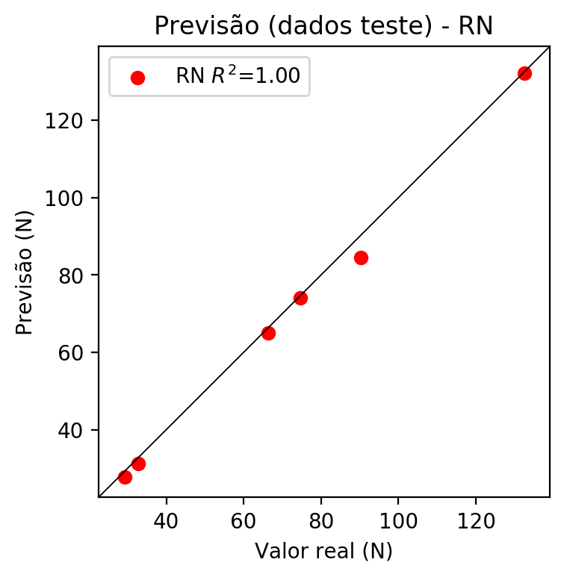

**Dados de treino**

* Erro relativo médio: 1.33
* Coeficiente de correlação: 1.0
* Coeficiente de determinação: 1.0
* MSE: 3.68
* RMSE: 1.92

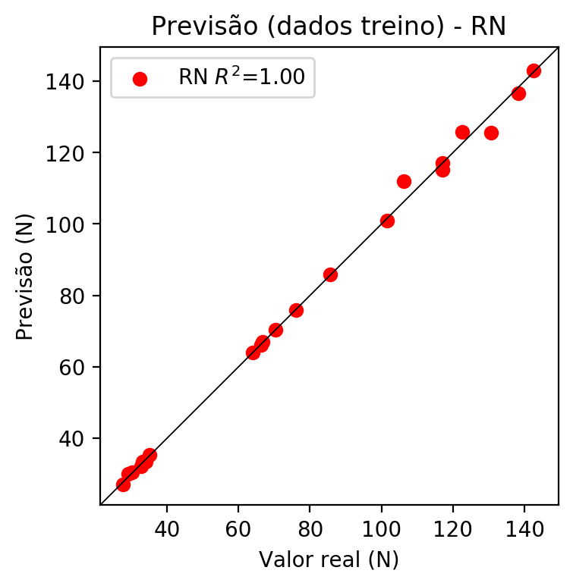

# Pesos

Pesos - camada oculta 1

[[ 2.79378504e-01 -1.17008351e-01 -2.28637569e-02 -5.42241096e-01  
 -9.40730050e-02 8.50324752e-04 -7.83744380e-02 1.57656252e-01  
 2.41624147e-01 -2.33465359e-01 -2.73736626e-01 1.00941464e-01  
 -4.20677885e-02 1.89616412e-01 2.46502943e-02 -1.58878177e-01  
 -1.37472928e-01 6.13367036e-02 -1.14012964e-01 1.85146645e-01  
 3.33915174e-01 1.22940764e-02 8.72071013e-02]  
 [ 6.97051728e-05 -2.08221853e-01 -3.01350385e-01 5.68106174e-01  
 1.52408406e-01 5.21268249e-01 -8.23614281e-03 -3.57577115e-01  
 -4.74955171e-01 -2.60659695e-01 -1.28146052e-01 -1.98746338e-01  
 -3.60542327e-01 5.82384884e-01 3.80737364e-01 -1.25430554e-01  
 -2.68037379e-01 4.04264659e-01 3.89749914e-01 1.92603409e-01  
 1.36301473e-01 1.69945702e-01 3.76093864e-01]  
 [ 2.04285622e-01 -1.42843172e-01 1.95562467e-01 7.43782759e-01  
 5.74405849e-01 7.79550299e-02 2.07738932e-02 1.44295478e-02  
 -3.80432695e-01 4.10934895e-01 -1.95081756e-01 1.99156299e-01  
 -2.62008190e-01 -5.43597162e-01 1.72943562e-01 -5.76226890e-01  
 -1.77223995e-01 -6.61912337e-02 2.47681424e-01 -2.55200654e-01  
 1.92839697e-01 4.05142307e-01 -5.51488936e-01]]

Bias - camada oculta

[-0.1722067 -0.20410223 -0.19622977 0.0066813 0.10865634 -0.20379648  
 -0.22229469 0.14817706 0.14040071 0.12818079 -0.20704535 -0.21284983  
 -0.19339219 0.32170874 -0.2013991 0.35171968 -0.25345045 -0.16007811  
 -0.19818738 -0.18305284 -0.14430678 -0.06722268 0.29248047]

Pesos - camada saída

[[ 0.27247372 -0.10973318 -0.11195182 0.38705978 0.5508456 0.00692994  
 0.06890174 -0.09126824 -0.3414753 0.42521307 -0.3154926 0.13329871  
 -0.04679904 -0.27361837 0.01418259 -0.43247405 -0.10384465 0.03735854  
 -0.16626443 0.21231443 0.28736216 0.14096399 -0.2980956 ]]

# Iterações

|  |  |  |  |  |  |  |
| --- | --- | --- | --- | --- | --- | --- |
| Média | Desvio | n | ln | 2° camada | Função | Épocas |
| -0.0601 | 0.036 | 10 | 0.1 | False | relu | 38 |
| -0.0475 | 0.0226 | 17 | 0.1 | True | relu | 716 |
| -0.0509 | 0.024 | 7 | 0.01 | True | tanh | 130 |
| -0.1668 | 0.1472 | 19 | 0.001 | False | tanh | 282 |
| -0.0332 | 0.0252 | 29 | 0.001 | False | relu | 469 |
| -0.044 | 0.0125 | 88 | 0.1 | False | tanh | 926 |
| -0.0276 | 0.0305 | 95 | 0.0001 | True | relu | 984 |
| -0.0374 | 0.0131 | 10 | 0.01 | True | tanh | 865 |
| -0.6505 | 0.2874 | 58 | 0.001 | True | relu | 8 |
| -0.0216 | 0.0125 | 9 | 0.01 | False | tanh | 514 |
| -0.032 | 0.0237 | 73 | 0.0001 | True | relu | 729 |
| -0.058 | 0.0271 | 22 | 0.001 | True | relu | 543 |
| -0.0313 | 0.0168 | 25 | 0.1 | True | relu | 562 |
| -0.0367 | 0.0357 | 53 | 0.001 | False | relu | 498 |
| -0.0205 | 0.0068 | 83 | 0.01 | True | relu | 337 |
| -0.1402 | 0.1358 | 99 | 0.01 | False | tanh | 16 |
| -0.0201 | 0.0085 | 23 | 0.01 | False | relu | 472 |
| -0.0427 | 0.0419 | 24 | 0.001 | True | relu | 778 |
| -0.0598 | 0.0294 | 58 | 0.01 | True | tanh | 382 |
| -0.0992 | 0.0642 | 35 | 0.1 | False | tanh | 596 |

# RL

# Coeficientes

[ 0. -0.13771519 0.12414803 0.96505494]

# Erros

**Dados de teste**

* Erro relativo médio: 5.89
* Coeficiente de correlação: 1.0
* Coeficiente de determinação: 0.99
* MSE: 9.78
* RMSE: 3.13

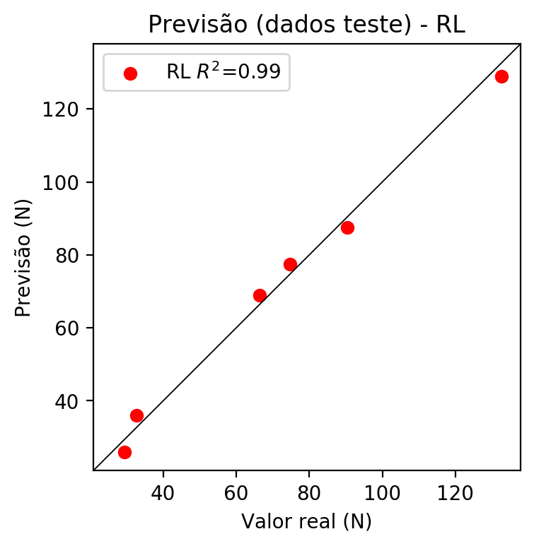

**Dados de treino**

* Erro relativo médio: 9.06
* Coeficiente de correlação: 0.99
* Coeficiente de determinação: 0.97
* MSE: 42.85
* RMSE: 6.55

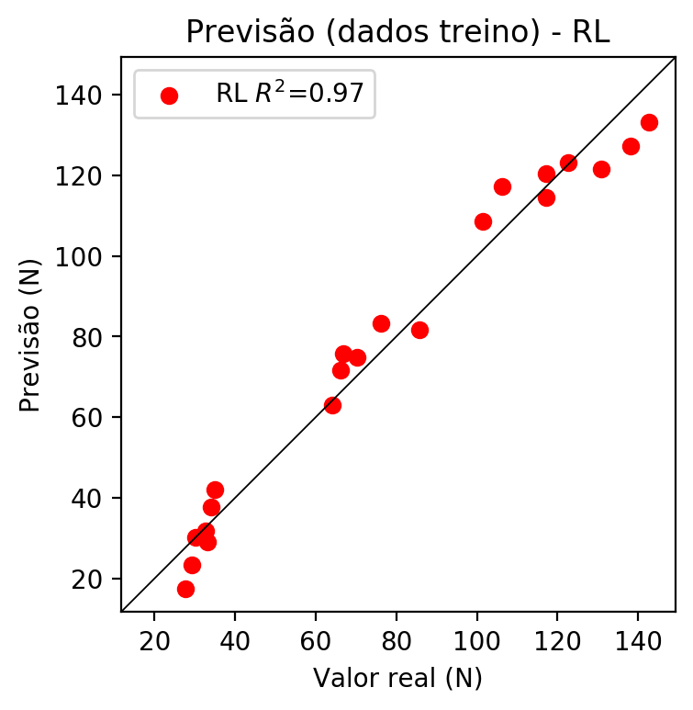

# RP2

# Coeficientes

[ 0. -0.17624466 0.12658694 0.96667421 0.10962663 -0.01691901  
 -0.08804829 -0.07257458 0.04268609 0.06677546]

# Erros

**Dados de teste**

* Erro relativo médio: 8.27
* Coeficiente de correlação: 0.99
* Coeficiente de determinação: 0.99
* MSE: 17.37
* RMSE: 4.17

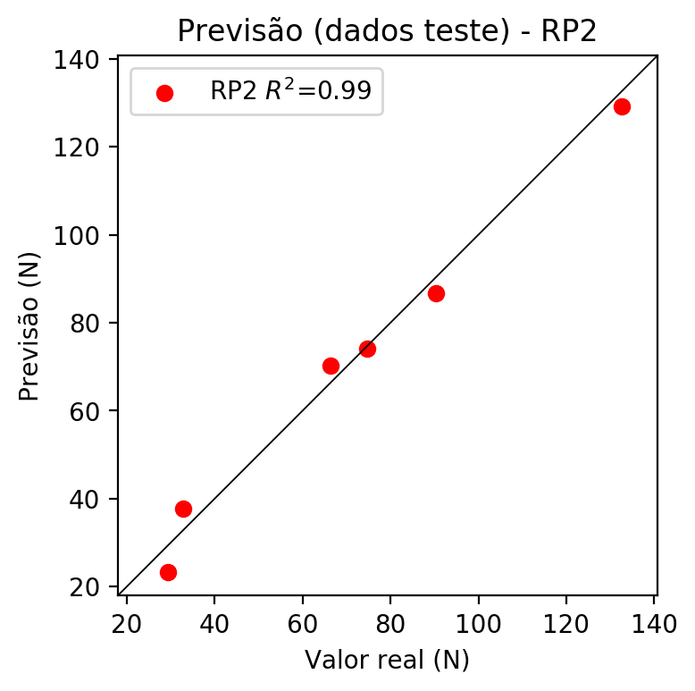

**Dados de treino**

* Erro relativo médio: 4.01
* Coeficiente de correlação: 1.0
* Coeficiente de determinação: 0.99
* MSE: 8.99
* RMSE: 3.0

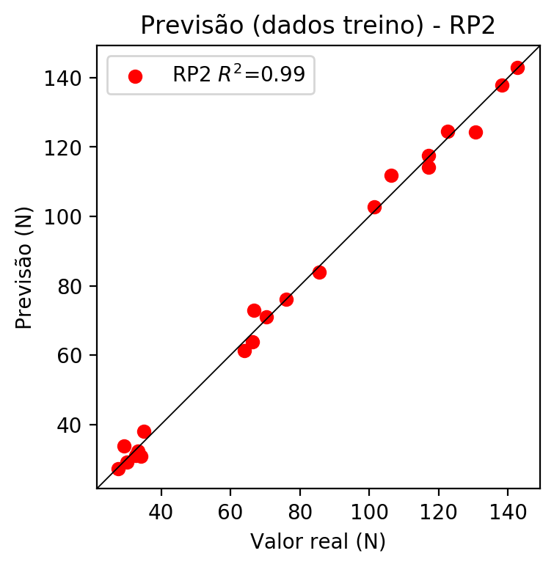

# RP3

# Coeficientes

[ 0. -0.0474261 0.03686447 0.29117468 0.10044034 -0.01209715  
 -0.12798293 -0.06641162 0.04314159 0.06593053 -0.06850437 0.00593792  
 0.10283345 0.00371174 0.00380393 -0.02296527 0.05324869 -0.04332839  
 -0.01179221 0.42058564]

# Erros

**Dados de teste**

* Erro relativo médio: 4.48
* Coeficiente de correlação: 1.0
* Coeficiente de determinação: 0.99
* MSE: 26.83
* RMSE: 5.18

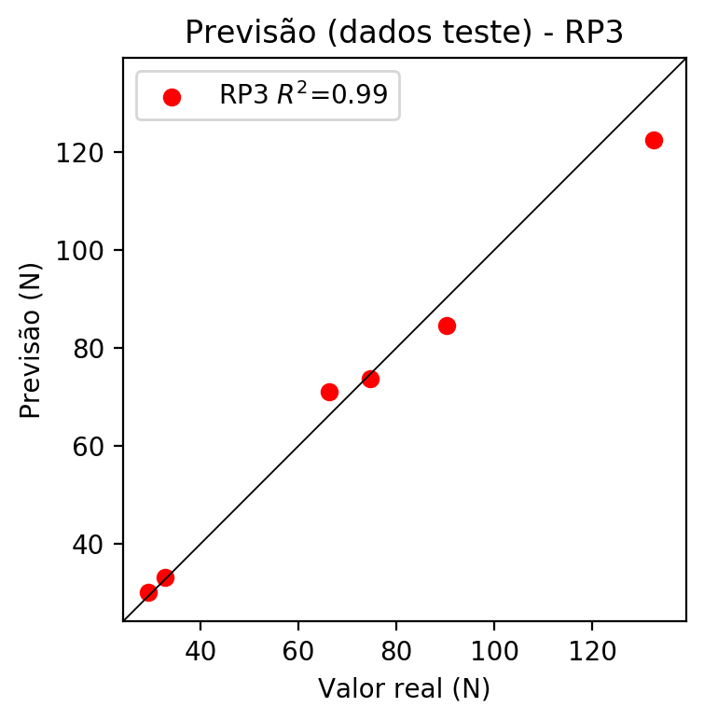

**Dados de treino**

* Erro relativo médio: 2.51
* Coeficiente de correlação: 1.0
* Coeficiente de determinação: 1.0
* MSE: 4.4
* RMSE: 2.1

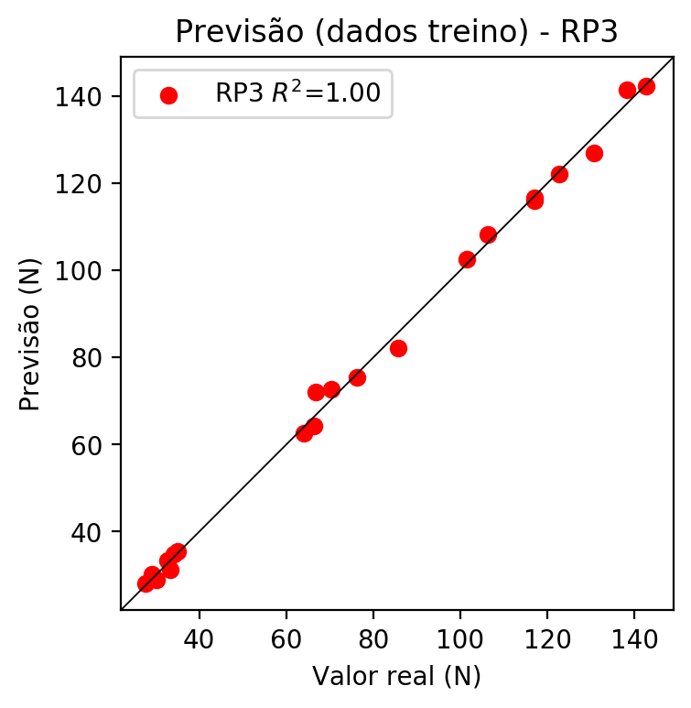

# RP4

# Coeficientes

[-1.94289029e-16 -1.01240810e-03 3.28088953e-02 2.92060960e-01  
 7.81646299e-03 -5.13671902e-03 -5.42504128e-02 -7.86183757e-02  
 3.66381552e-02 -4.74531561e-02 -1.46236726e-03 -1.43068688e-02  
 1.08762336e-01 -2.70276033e-02 3.45044026e-02 -8.28143245e-02  
 4.73906265e-02 -5.42646261e-02 1.09234216e-02 4.21865831e-01  
 1.09251816e-02 4.41735683e-03 2.70104389e-02 -3.42153164e-02  
 -1.10793786e-01 1.38946192e-02 -7.41970525e-03 -9.15889199e-03  
 1.61718278e-02 -7.83617074e-02 -1.13559876e-01 5.29217797e-02  
 1.93110931e-01 5.29217797e-02 -6.85434476e-02]

# Erros

**Dados de teste**

* Erro relativo médio: 20.55
* Coeficiente de correlação: 0.95
* Coeficiente de determinação: 0.89
* MSE: 155.27
* RMSE: 12.46

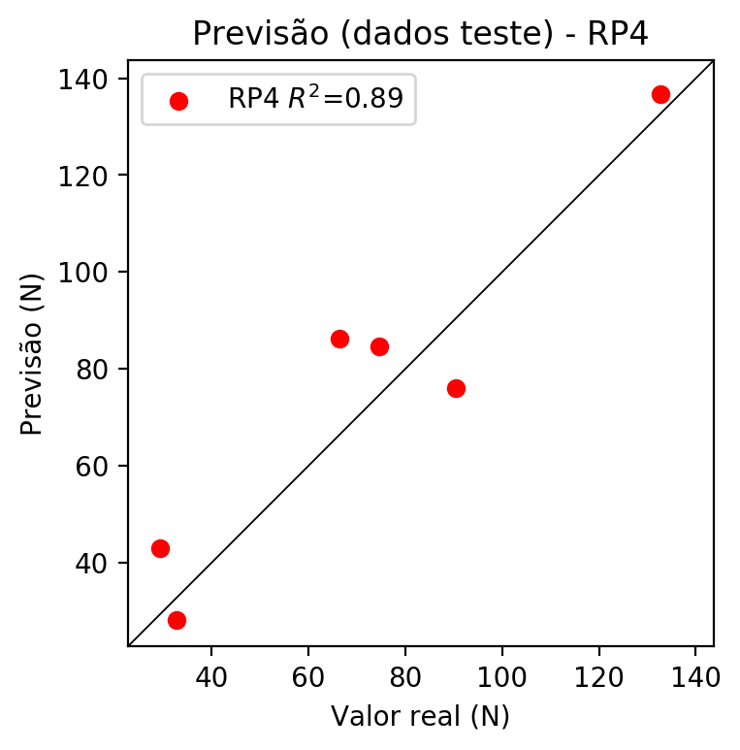

**Dados de treino**

* Erro relativo médio: 0.0
* Coeficiente de correlação: 1.0
* Coeficiente de determinação: 1.0
* MSE: 0.0
* RMSE: 0.0

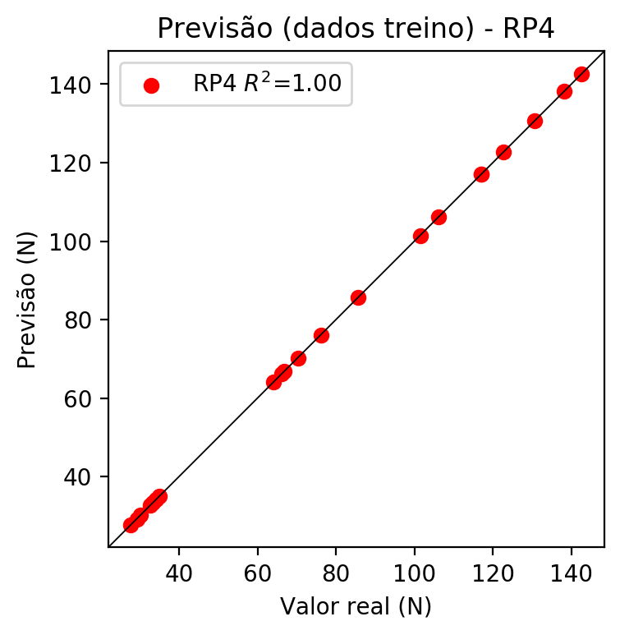

# Geral

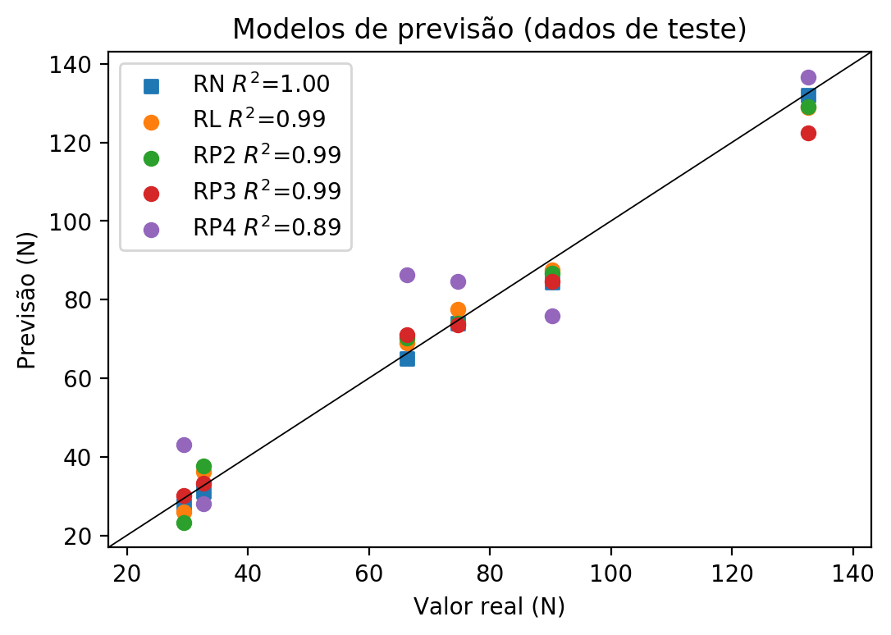

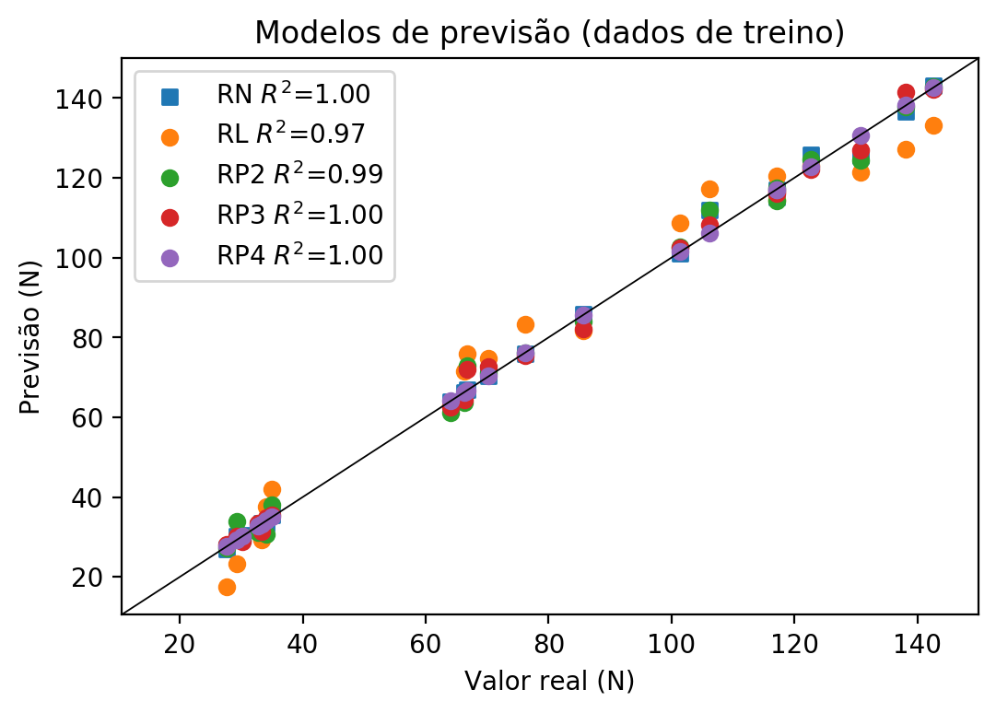

**Dados de teste**

|  |  |  |  |  |  |  |  |  |  |  |
| --- | --- | --- | --- | --- | --- | --- | --- | --- | --- | --- |
| Valor real | RN Previsto | RN Erro (%) | RL Previsto | RL Erro (%) | RP2 Previsto | RP2 Erro (%) | RP3 Previsto | RP3 Erro (%) | RP4 Previsto | RP4 Erro (%) |
| 29.34 | 27.69 | 5.62 | 25.98 | 11.45 | 23.2 | 20.93 | 30.14 | 2.73 | 42.99 | 46.52 |
| 132.6 | 132.1 | 0.38 | 128.89 | 2.8 | 129.1 | 2.64 | 122.46 | 7.65 | 136.66 | 3.06 |
| 74.64 | 73.99 | 0.87 | 77.43 | 3.74 | 74.05 | 0.79 | 73.65 | 1.33 | 84.71 | 13.49 |
| 90.32 | 84.48 | 6.47 | 87.56 | 3.06 | 86.65 | 4.06 | 84.54 | 6.4 | 75.92 | 15.94 |
| 32.71 | 31.17 | 4.71 | 36.1 | 10.36 | 37.71 | 15.29 | 33.22 | 1.56 | 28.06 | 14.22 |
| 66.33 | 65.01 | 1.99 | 68.92 | 3.9 | 70.26 | 5.92 | 71.11 | 7.21 | 86.29 | 30.09 |

**Dados de treino**

|  |  |  |  |  |  |  |  |  |  |  |
| --- | --- | --- | --- | --- | --- | --- | --- | --- | --- | --- |
| Valor real | RN Previsto | RN Erro (%) | RL Previsto | RL Erro (%) | RP2 Previsto | RP2 Erro (%) | RP3 Previsto | RP3 Erro (%) | RP4 Previsto | RP4 Erro (%) |
| 130.72 | 125.57 | 3.94 | 121.42 | 7.11 | 124.41 | 4.83 | 126.86 | 2.95 | 130.72 | 0.0 |
| 70.27 | 70.39 | 0.17 | 74.78 | 6.42 | 71.08 | 1.15 | 72.73 | 3.5 | 70.27 | 0.0 |
| 106.26 | 111.96 | 5.36 | 117.16 | 10.26 | 111.87 | 5.28 | 108.2 | 1.83 | 106.26 | 0.0 |
| 117.09 | 115.19 | 1.62 | 114.51 | 2.2 | 114.27 | 2.41 | 116.03 | 0.91 | 117.09 | 0.0 |
| 85.64 | 85.86 | 0.26 | 81.69 | 4.61 | 83.95 | 1.97 | 82.25 | 3.96 | 85.64 | 0.0 |
| 29.24 | 30.11 | 2.98 | 23.32 | 20.25 | 33.84 | 15.73 | 30.27 | 3.52 | 29.24 | 0.0 |
| 66.27 | 66.18 | 0.14 | 71.57 | 8.0 | 63.74 | 3.82 | 64.28 | 3.0 | 66.27 | 0.0 |
| 142.63 | 142.99 | 0.25 | 133.15 | 6.65 | 142.89 | 0.18 | 142.26 | 0.26 | 142.63 | 0.0 |
| 138.19 | 136.69 | 1.09 | 127.28 | 7.89 | 137.77 | 0.3 | 141.51 | 2.4 | 138.19 | 0.0 |
| 35.03 | 35.44 | 1.17 | 41.97 | 19.81 | 37.98 | 8.42 | 35.44 | 1.17 | 35.03 | 0.0 |
| 33.26 | 33.47 | 0.63 | 29.19 | 12.24 | 32.23 | 3.1 | 31.3 | 5.89 | 33.26 | 0.0 |
| 32.69 | 32.18 | 1.56 | 31.84 | 2.6 | 31.09 | 4.89 | 33.36 | 2.05 | 32.69 | 0.0 |
| 101.46 | 101.03 | 0.42 | 108.64 | 7.08 | 102.79 | 1.31 | 102.54 | 1.06 | 101.46 | 0.0 |
| 64.05 | 63.94 | 0.17 | 63.05 | 1.56 | 61.21 | 4.43 | 62.51 | 2.4 | 64.05 | 0.0 |
| 34.13 | 33.49 | 1.88 | 37.71 | 10.49 | 30.73 | 9.96 | 34.84 | 2.08 | 34.13 | 0.0 |
| 122.67 | 125.8 | 2.55 | 123.02 | 0.29 | 124.6 | 1.57 | 122.11 | 0.46 | 122.67 | 0.0 |
| 30.25 | 30.47 | 0.73 | 30.24 | 0.03 | 29.19 | 3.5 | 28.93 | 4.36 | 30.25 | 0.0 |
| 27.68 | 27.05 | 2.28 | 17.46 | 36.92 | 27.21 | 1.7 | 28.16 | 1.73 | 27.68 | 0.0 |
| 117.09 | 117.04 | 0.04 | 120.37 | 2.8 | 117.5 | 0.35 | 116.61 | 0.41 | 117.09 | 0.0 |
| 76.13 | 75.82 | 0.41 | 83.3 | 9.42 | 76.12 | 0.01 | 75.37 | 1.0 | 76.13 | 0.0 |
| 66.75 | 67.0 | 0.37 | 75.83 | 13.6 | 73.01 | 9.38 | 71.97 | 7.82 | 66.75 | 0.0 |