# Informações do estudo

Referência: Fnides

Grandeza: Força

Tipo: Fy

Material: AISI H11 hot work tool steel (50 HRC)

Ferramenta: CC650

Número de experimentos: 27

Observações:  
Toolholder: PSBNR2525M12  
Lathe: SN40C 6,6 kW  
Dynamometer: 9257 B  
Diameter: 72 mm  
Dry conditions

# Unidades

Velocidade: m/min

Avanço: mm/rev

Profundidade de corte: mm

Força: N

# Dados de teste

|  |  |  |  |
| --- | --- | --- | --- |
| Força | n | f | a |
| 89.67 | 90.0 | 0.08 | 0.15 |
| 197.73 | 90.0 | 0.12 | 0.45 |
| 143.15 | 180.0 | 0.08 | 0.45 |
| 161.92 | 120.0 | 0.16 | 0.3 |
| 100.45 | 90.0 | 0.12 | 0.15 |
| 134.47 | 120.0 | 0.08 | 0.3 |

# Dados de treino

|  |  |  |  |
| --- | --- | --- | --- |
| Força | n | f | a |
| 182.79 | 90.0 | 0.08 | 0.45 |
| 142.64 | 120.0 | 0.12 | 0.3 |
| 169.37 | 180.0 | 0.12 | 0.45 |
| 174.44 | 90.0 | 0.16 | 0.3 |
| 157.54 | 90.0 | 0.12 | 0.3 |
| 83.21 | 120.0 | 0.08 | 0.15 |
| 127.26 | 180.0 | 0.12 | 0.3 |
| 217.7 | 90.0 | 0.16 | 0.45 |
| 211.49 | 120.0 | 0.16 | 0.45 |
| 115.96 | 90.0 | 0.16 | 0.15 |
| 101.77 | 180.0 | 0.16 | 0.15 |
| 93.22 | 120.0 | 0.12 | 0.15 |
| 162.77 | 120.0 | 0.08 | 0.45 |
| 120.92 | 180.0 | 0.08 | 0.3 |
| 104.96 | 120.0 | 0.16 | 0.15 |
| 180.75 | 120.0 | 0.12 | 0.45 |
| 92.3 | 180.0 | 0.12 | 0.15 |
| 70.57 | 180.0 | 0.08 | 0.15 |
| 179.62 | 180.0 | 0.16 | 0.45 |
| 147.58 | 180.0 | 0.16 | 0.3 |
| 139.24 | 90.0 | 0.08 | 0.3 |

# RN

Número de neurônios: 58

Taxa de aprendizado: 1.000000e-02

Número de épocas: 382

2° camada: True

Função de ativação: tanh

# Erros

**Dados de teste**

* Erro relativo médio: 7.6
* Coeficiente de correlação: 0.96
* Coeficiente de determinação: 0.92
* MSE: 119.08
* RMSE: 10.91

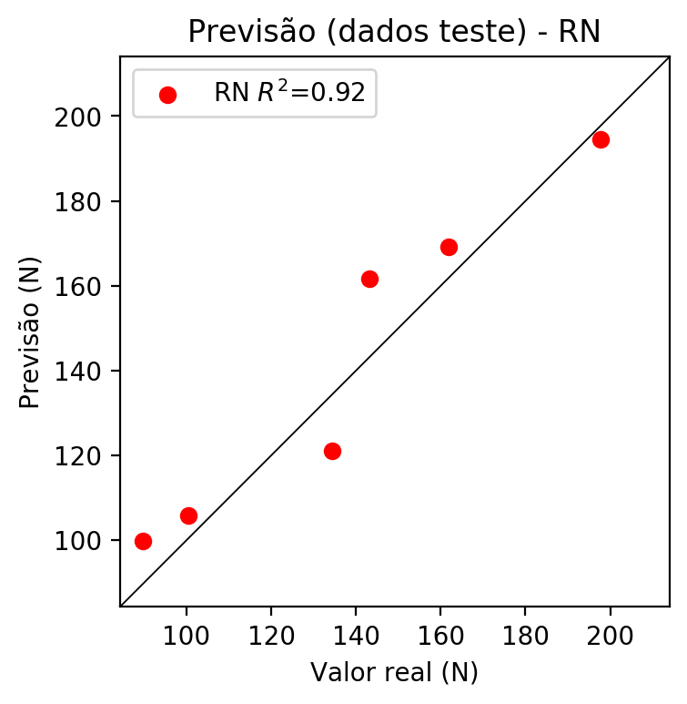

**Dados de treino**

* Erro relativo médio: 0.23
* Coeficiente de correlação: 1.0
* Coeficiente de determinação: 1.0
* MSE: 0.19
* RMSE: 0.44

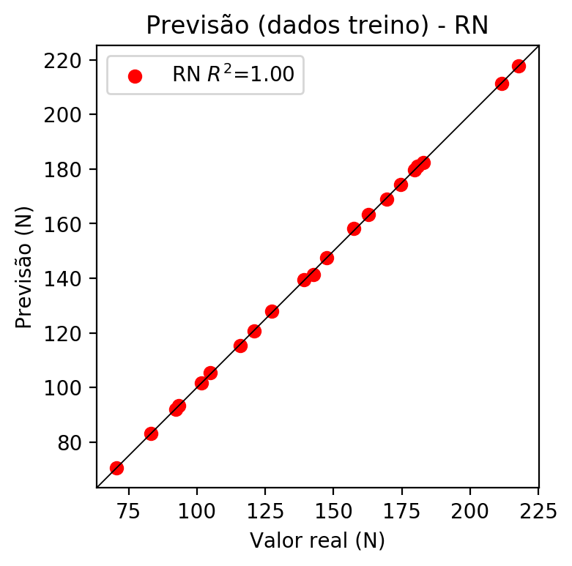

# Pesos

Pesos - camada oculta 1

[[ 0.17423981 0.00761824 -0.2360579 -0.04016028 0.19392927 -0.12492029  
 -0.00886958 -0.08194672 -0.12047418 0.16513237 -0.2783309 0.23951429  
 0.10935549 -0.03246601 -0.06882432 -0.18152721 0.16218786 -0.11599983  
 -0.2705992 0.3951125 0.28993112 0.18039335 -0.06889205 0.19931626  
 -0.09547056 -0.26243713 0.33184427 0.09171984 0.19736013 -0.24093954  
 -0.02525467 -0.35986653 -0.13318434 -0.21264933 0.06772207 -0.17769691  
 0.09697191 0.18044935 -0.32287684 -0.12944469 0.21134266 0.19057578  
 0.28051832 0.24792868 0.11175495 -0.00292555 -0.0228814 -0.23336427  
 0.21616188 0.36369103 0.20601252 0.18181275 0.0056055 -0.14289057  
 -0.1596227 0.20630595 0.00637573 0.05756362]  
 [-0.27541703 -0.22613849 0.10477367 -0.22064012 -0.24402495 0.08703844  
 0.2722868 -0.18347953 -0.07042611 0.07413501 -0.25695866 -0.15843023  
 -0.05887491 0.03655735 -0.10135265 -0.20071064 0.09521563 -0.17414036  
 0.11268805 0.20807084 0.11089622 -0.01246498 0.22635405 -0.24643184  
 -0.25828376 -0.0350077 -0.12879439 0.2737781 0.03308238 -0.30356804  
 -0.29607034 0.21824896 -0.18877462 -0.28265646 -0.37897313 0.06060915  
 -0.12429637 -0.16465034 -0.23670596 0.10728016 0.06932814 -0.21151802  
 0.16875277 -0.05630663 0.32098067 -0.24333373 -0.22203557 -0.25904995  
 -0.00993281 -0.18593645 0.09129822 0.18187542 0.02256716 -0.14066114  
 0.26518017 0.1423285 0.08832359 0.27887684]  
 [ 0.03970267 0.00597583 -0.15487349 -0.13977535 0.08986744 -0.2591383  
 0.01363873 -0.05402206 0.31913713 0.0294368 0.26497322 -0.09586308  
 -0.2849748 -0.11048581 0.12694634 0.10646614 0.03289432 0.11168873  
 0.2732442 0.20584992 -0.01005216 0.23174989 -0.25614068 0.33993936  
 -0.11697003 -0.33036175 0.06766134 -0.07264043 0.05747431 -0.11051477  
 0.28075472 0.15052295 0.1913518 0.00148114 0.33534765 -0.29469454  
 0.01320342 -0.19881795 -0.16222563 -0.26775455 0.22045651 0.25558263  
 0.15500695 0.07513755 -0.19714059 0.18520138 -0.2141062 -0.04544463  
 -0.17105217 -0.28303242 0.27925178 -0.1266893 -0.23222095 -0.10092335  
 -0.12374678 0.10103389 -0.22261184 0.14727972]]

Bias - camada oculta

[-0.01007434 -0.07054842 -0.09517699 -0.01795373 -0.02270212 -0.03213957  
 -0.0729821 -0.10314451 0.09294278 0.09075046 0.06250449 0.07885913  
 0.08095678 -0.03807513 0.06847242 0.06873408 0.09053913 0.21404457  
 -0.06014416 -0.08387233 0.1763207 0.2110781 -0.00625236 -0.12113763  
 0.03209958 -0.12159771 0.02434556 -0.19549574 -0.12818862 0.06629509  
 0.04096752 -0.11211456 0.04768568 -0.12682174 -0.07272448 0.00989397  
 0.06348591 0.12354665 0.06026047 -0.00661455 -0.06869202 -0.09811576  
 0.03273331 -0.0313528 -0.1175882 0.0964551 -0.01469319 0.04919972  
 0.16036393 0.19832349 0.22013423 0.00854063 0.06632284 -0.173556  
 0.05863708 -0.08357155 -0.26383004 0.07540382]

Pesos - camada oculta 2

[[ 0.1240781 -0.02624703 -0.09842403 ... 0.03608324 -0.08202546  
 0.02842711]  
 [-0.2177382 -0.21335374 0.20259838 ... 0.18590353 -0.02218155  
 0.23955953]  
 [ 0.03072249 0.01063145 -0.10470845 ... 0.14583443 -0.06341108  
 0.12483833]  
 ...  
 [-0.12681691 -0.10347376 -0.13917805 ... -0.12490922 -0.07206949  
 0.19231988]  
 [ 0.16802818 0.32853815 0.05032356 ... -0.08097993 0.14624412  
 0.11567602]  
 [ 0.150148 0.0935908 0.02871924 ... 0.10944646 0.14992586  
 -0.11005189]]

Bias - camada oculta 2

[-0.06390347 0.05683123 -0.07227011 -0.00832003 -0.05252067 -0.05077349  
 -0.01446573 0.03900034 -0.00480968 -0.01199015 0.00274916 0.08062819  
 0.00938155 -0.01028111 0.00704759 -0.01991577 0.02327799 -0.05914529  
 -0.09365417 0.00409784 0.07883961 0.14823432 0.0730698 0.01213864  
 -0.00935083 0.16266564 -0.06173775 0.05082934 -0.02795719 -0.02954027  
 0.00972907 -0.08526571 -0.02853456 -0.01109914 -0.01424545 -0.06030914  
 0.03372333 0.0057305 -0.02266783 -0.00281115 -0.01735025 0.01386067  
 0.04597667 0.0013458 -0.00858734 -0.00330992 0.01869461 0.06956036  
 -0.05676744 0.03005869 -0.20987962 0.0142623 0.00334663 -0.00519293  
 -0.04055575 0.03146692 -0.1981753 0.0337404 ]

Pesos - camada saída

[[ 0.18911609 0.20195916 -0.20973586 -0.0133967 0.15107988 -0.0439188  
 0.00311641 0.01075764 0.03837611 0.0758096 -0.25959393 0.19068377  
 0.0188714 0.01492804 -0.10450763 -0.06140159 -0.01734515 -0.05014779  
 -0.24665424 0.1455993 0.27546912 0.2344168 -0.05671518 0.08922186  
 -0.01695545 -0.2525547 0.29449752 0.07485175 0.21660908 -0.14645816  
 0.020222 -0.31907192 -0.14928503 -0.18111457 -0.00249899 -0.2025147  
 0.0506403 0.04381705 -0.10723462 -0.00197103 0.14001507 0.00475153  
 0.14283083 0.1685451 0.07984697 -0.03257203 -0.00115018 -0.1856318  
 0.2607047 0.2399611 0.22958563 0.12813401 0.01097795 -0.04239732  
 -0.11347675 0.01090121 0.10775458 0.02183842]]

# Iterações

|  |  |  |  |  |  |  |
| --- | --- | --- | --- | --- | --- | --- |
| Média | Desvio | n | ln | 2° camada | Função | Épocas |
| -0.0645 | 0.0416 | 10 | 0.1 | False | relu | 38 |
| -0.0641 | 0.0564 | 17 | 0.1 | True | relu | 716 |
| -0.0862 | 0.0612 | 7 | 0.01 | True | tanh | 130 |
| -0.2029 | 0.1358 | 19 | 0.001 | False | tanh | 282 |
| -0.08 | 0.0655 | 29 | 0.001 | False | relu | 469 |
| -0.0778 | 0.0276 | 88 | 0.1 | False | tanh | 926 |
| -0.0515 | 0.0356 | 95 | 0.0001 | True | relu | 984 |
| -0.0687 | 0.0214 | 10 | 0.01 | True | tanh | 865 |
| -0.6591 | 0.382 | 58 | 0.001 | True | relu | 8 |
| -0.0491 | 0.0206 | 9 | 0.01 | False | tanh | 514 |
| -0.0656 | 0.0518 | 73 | 0.0001 | True | relu | 729 |
| -0.0932 | 0.0746 | 22 | 0.001 | True | relu | 543 |
| -0.0609 | 0.0349 | 25 | 0.1 | True | relu | 562 |
| -0.0643 | 0.0541 | 53 | 0.001 | False | relu | 498 |
| -0.0486 | 0.021 | 83 | 0.01 | True | relu | 337 |
| -0.1458 | 0.0975 | 99 | 0.01 | False | tanh | 16 |
| -0.0572 | 0.04 | 23 | 0.01 | False | relu | 472 |
| -0.0648 | 0.0397 | 24 | 0.001 | True | relu | 778 |
| -0.0469 | 0.015 | 58 | 0.01 | True | tanh | 382 |
| -0.1211 | 0.0594 | 35 | 0.1 | False | tanh | 596 |

# RL

# Coeficientes

[ 0. -0.23781363 0.31115014 0.90144759]

# Erros

**Dados de teste**

* Erro relativo médio: 4.42
* Coeficiente de correlação: 0.98
* Coeficiente de determinação: 0.97
* MSE: 51.07
* RMSE: 7.15

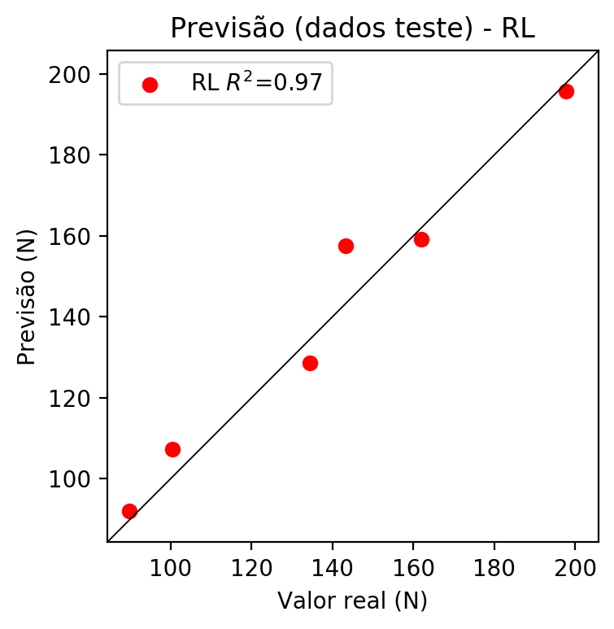

**Dados de treino**

* Erro relativo médio: 3.93
* Coeficiente de correlação: 0.99
* Coeficiente de determinação: 0.98
* MSE: 37.56
* RMSE: 6.13

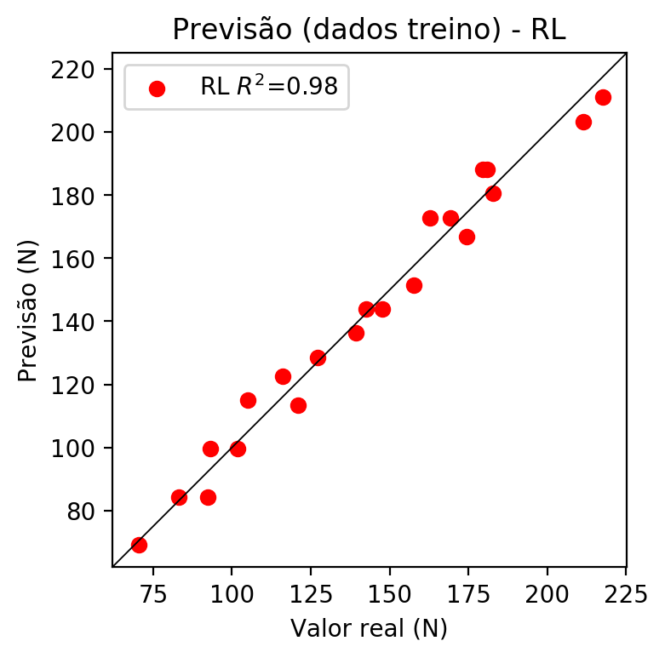

# RP2

# Coeficientes

[ 0. -0.2779592 0.32872089 0.90390754 0.08175809 -0.01244543  
 -0.08940471 0.00612713 0.0508959 -0.08616469]

# Erros

**Dados de teste**

* Erro relativo médio: 2.06
* Coeficiente de correlação: 1.0
* Coeficiente de determinação: 0.99
* MSE: 11.6
* RMSE: 3.41

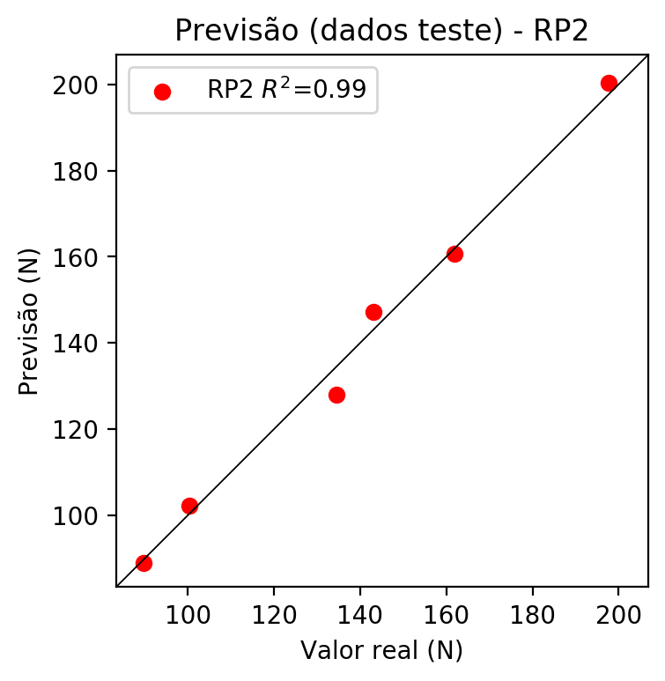

**Dados de treino**

* Erro relativo médio: 2.08
* Coeficiente de correlação: 1.0
* Coeficiente de determinação: 0.99
* MSE: 10.76
* RMSE: 3.28

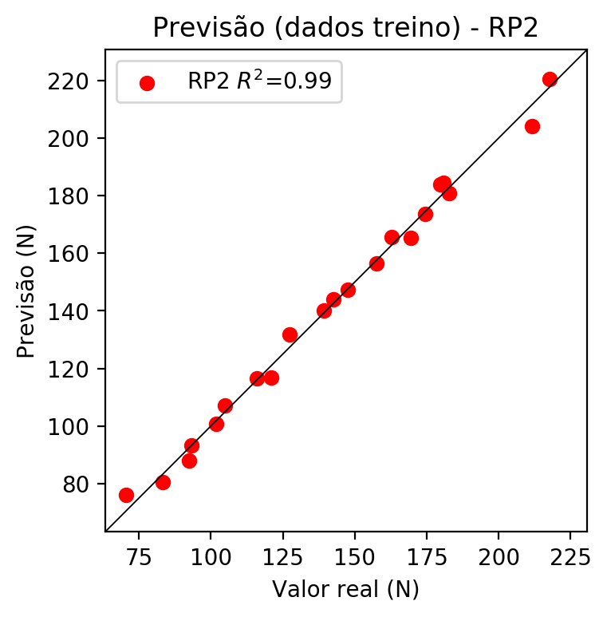

# RP3

# Coeficientes

[ 0. -0.104716 0.16507801 0.28482238 0.17164471 0.02710541  
 0.04107748 0.03096279 0.05107826 -0.01253864 -0.15125644 -0.1404501  
 -0.06981601 0.01422772 -0.1143304 -0.0047691 0.23844602 0.06792088  
 -0.09268144 0.41141011]

# Erros

**Dados de teste**

* Erro relativo médio: 14.55
* Coeficiente de correlação: 0.88
* Coeficiente de determinação: 0.77
* MSE: 395.1
* RMSE: 19.88

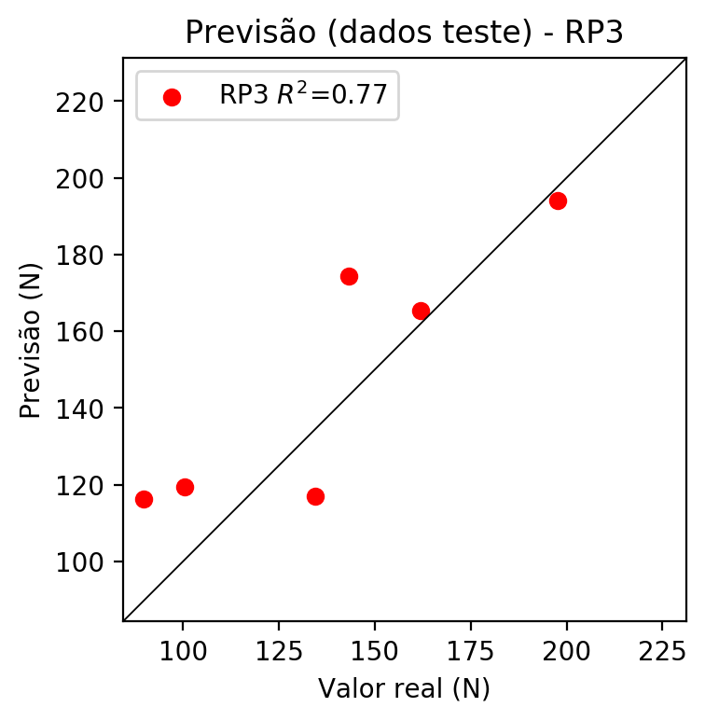

**Dados de treino**

* Erro relativo médio: 1.45
* Coeficiente de correlação: 1.0
* Coeficiente de determinação: 1.0
* MSE: 4.24
* RMSE: 2.06

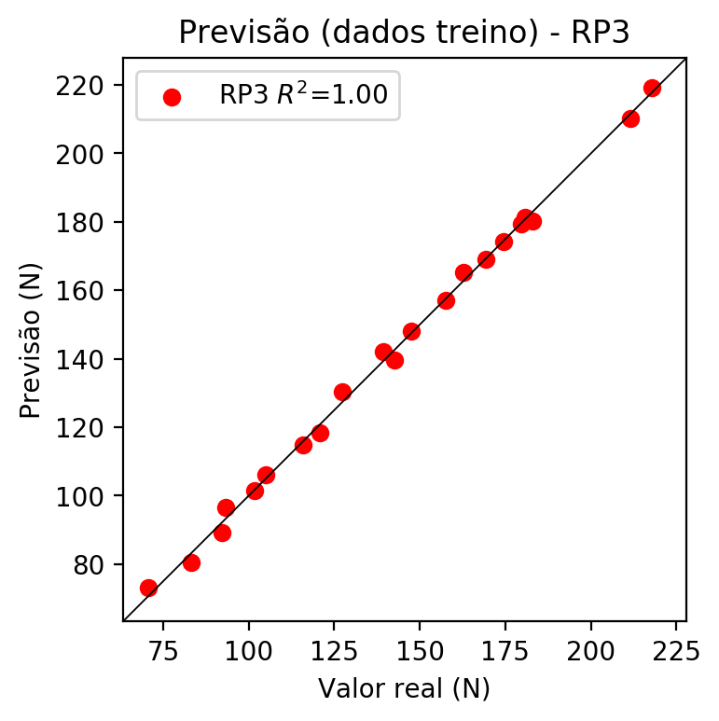

# RP4

# Coeficientes

[-4.16333634e-17 -1.13477662e-01 1.16243780e-01 2.72429808e-01  
 4.99543606e-02 -1.71717660e-02 -5.63161315e-02 5.22875999e-02  
 2.39497987e-02 -2.74926104e-02 -1.63912179e-01 -3.27951517e-02  
 7.78227848e-02 7.72019915e-02 -3.21706717e-03 5.34030289e-02  
 1.67907682e-01 5.29828605e-02 -2.08191630e-02 3.93509722e-01  
 3.12148977e-02 1.71357215e-02 1.69439351e-02 -8.38285139e-02  
 -1.52042961e-01 4.38568788e-02 -2.48036620e-02 5.37507000e-02  
 -4.96729288e-02 -8.13455233e-02 7.55265332e-02 3.45941537e-02  
 -5.12118847e-02 3.45941537e-02 -3.97115484e-02]

# Erros

**Dados de teste**

* Erro relativo médio: 9.79
* Coeficiente de correlação: 0.95
* Coeficiente de determinação: 0.9
* MSE: 323.81
* RMSE: 17.99

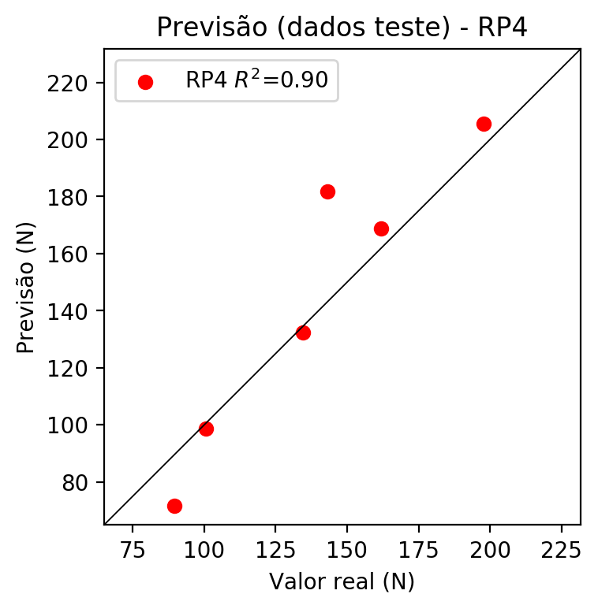

**Dados de treino**

* Erro relativo médio: 0.0
* Coeficiente de correlação: 1.0
* Coeficiente de determinação: 1.0
* MSE: 0.0
* RMSE: 0.0

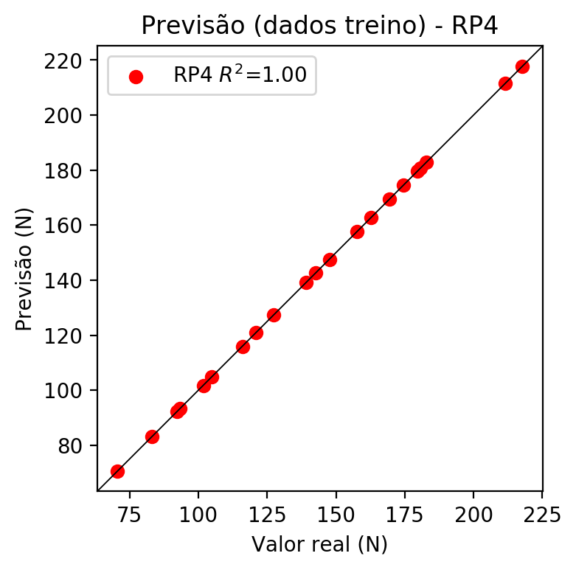

# Geral

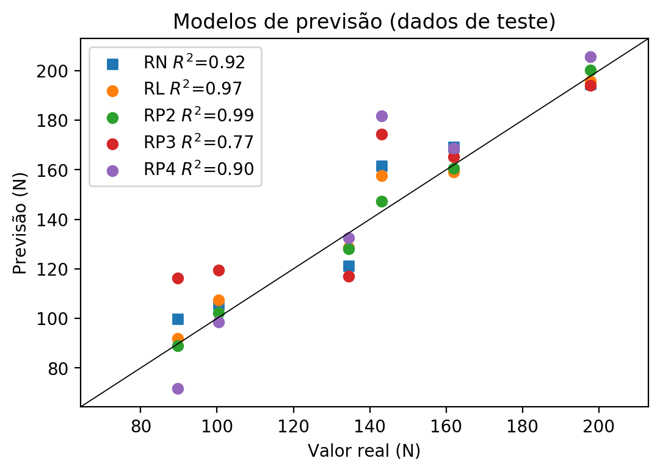

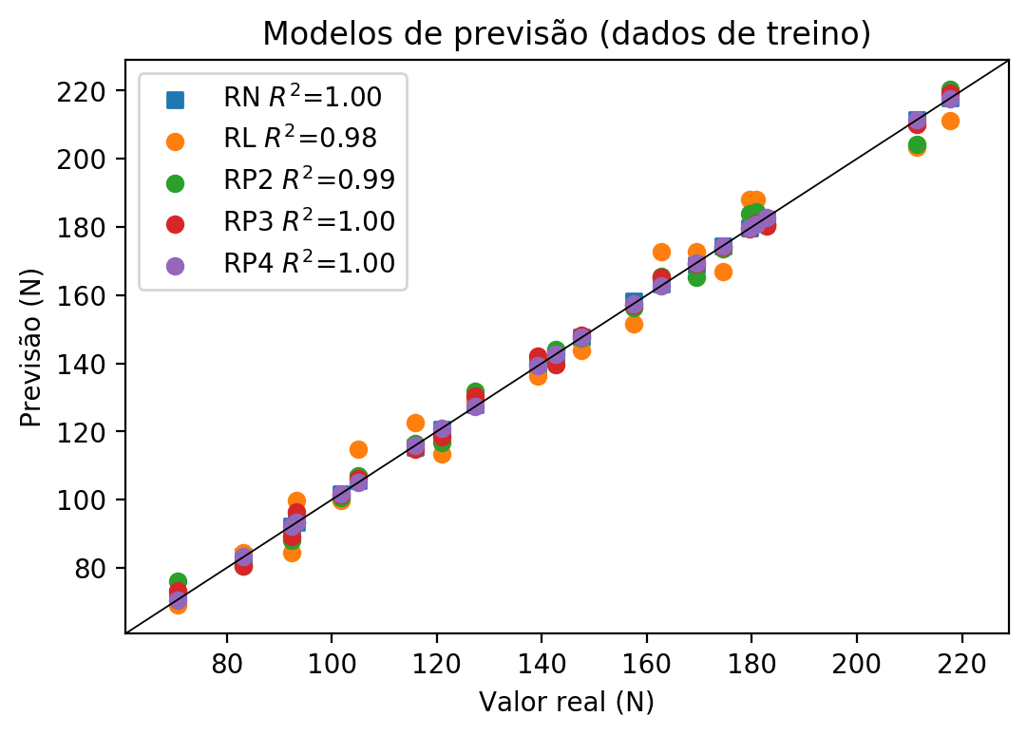

**Dados de teste**

|  |  |  |  |  |  |  |  |  |  |  |
| --- | --- | --- | --- | --- | --- | --- | --- | --- | --- | --- |
| Valor real | RN Previsto | RN Erro (%) | RL Previsto | RL Erro (%) | RP2 Previsto | RP2 Erro (%) | RP3 Previsto | RP3 Erro (%) | RP4 Previsto | RP4 Erro (%) |
| 89.67 | 99.84 | 11.34 | 92.02 | 2.62 | 88.91 | 0.85 | 116.19 | 29.58 | 71.59 | 20.16 |
| 197.73 | 194.59 | 1.59 | 195.8 | 0.98 | 200.29 | 1.29 | 193.96 | 1.91 | 205.55 | 3.95 |
| 143.15 | 161.63 | 12.91 | 157.6 | 10.09 | 147.22 | 2.84 | 174.36 | 21.8 | 181.88 | 27.06 |
| 161.92 | 169.29 | 4.55 | 159.18 | 1.69 | 160.67 | 0.77 | 165.31 | 2.09 | 168.8 | 4.25 |
| 100.45 | 105.81 | 5.34 | 107.29 | 6.81 | 102.33 | 1.87 | 119.42 | 18.89 | 98.6 | 1.84 |
| 134.47 | 121.18 | 9.88 | 128.63 | 4.34 | 128.08 | 4.75 | 116.93 | 13.04 | 132.46 | 1.49 |

**Dados de treino**

|  |  |  |  |  |  |  |  |  |  |  |
| --- | --- | --- | --- | --- | --- | --- | --- | --- | --- | --- |
| Valor real | RN Previsto | RN Erro (%) | RL Previsto | RL Erro (%) | RP2 Previsto | RP2 Erro (%) | RP3 Previsto | RP3 Erro (%) | RP4 Previsto | RP4 Erro (%) |
| 182.79 | 182.3 | 0.27 | 180.53 | 1.24 | 180.87 | 1.05 | 180.18 | 1.43 | 182.79 | 0.0 |
| 142.64 | 141.48 | 0.81 | 143.9 | 0.88 | 144.01 | 0.96 | 139.52 | 2.19 | 142.64 | 0.0 |
| 169.37 | 168.95 | 0.25 | 172.87 | 2.07 | 165.2 | 2.46 | 169.11 | 0.15 | 169.37 | 0.0 |
| 174.44 | 174.29 | 0.09 | 166.82 | 4.37 | 173.53 | 0.52 | 174.11 | 0.19 | 174.44 | 0.0 |
| 157.54 | 158.38 | 0.53 | 151.55 | 3.8 | 156.39 | 0.73 | 157.14 | 0.25 | 157.54 | 0.0 |
| 83.21 | 83.22 | 0.01 | 84.37 | 1.39 | 80.47 | 3.29 | 80.41 | 3.36 | 83.21 | 0.0 |
| 127.26 | 127.88 | 0.49 | 128.62 | 1.07 | 131.66 | 3.46 | 130.32 | 2.4 | 127.26 | 0.0 |
| 217.7 | 217.79 | 0.04 | 211.08 | 3.04 | 220.43 | 1.25 | 219.27 | 0.72 | 217.7 | 0.0 |
| 211.49 | 211.41 | 0.04 | 203.43 | 3.81 | 204.12 | 3.48 | 210.07 | 0.67 | 211.49 | 0.0 |
| 115.96 | 115.47 | 0.42 | 122.57 | 5.7 | 116.47 | 0.44 | 114.92 | 0.9 | 115.96 | 0.0 |
| 101.77 | 101.68 | 0.09 | 99.64 | 2.09 | 100.65 | 1.1 | 101.57 | 0.2 | 101.77 | 0.0 |
| 93.22 | 93.29 | 0.08 | 99.65 | 6.9 | 93.4 | 0.19 | 96.46 | 3.48 | 93.22 | 0.0 |
| 162.77 | 163.29 | 0.32 | 172.88 | 6.21 | 165.52 | 1.69 | 165.26 | 1.53 | 162.77 | 0.0 |
| 120.92 | 120.64 | 0.23 | 113.34 | 6.27 | 116.69 | 3.5 | 118.34 | 2.13 | 120.92 | 0.0 |
| 104.96 | 105.49 | 0.5 | 114.92 | 9.49 | 107.06 | 2.0 | 106.08 | 1.07 | 104.96 | 0.0 |
| 180.75 | 180.99 | 0.13 | 188.16 | 4.1 | 184.46 | 2.05 | 181.24 | 0.27 | 180.75 | 0.0 |
| 92.3 | 92.15 | 0.16 | 84.36 | 8.6 | 87.96 | 4.7 | 89.3 | 3.25 | 92.3 | 0.0 |
| 70.57 | 70.67 | 0.14 | 69.09 | 2.1 | 75.98 | 7.67 | 73.25 | 3.8 | 70.57 | 0.0 |
| 179.62 | 179.71 | 0.05 | 188.15 | 4.75 | 183.9 | 2.38 | 179.36 | 0.14 | 179.62 | 0.0 |
| 147.58 | 147.65 | 0.05 | 143.89 | 2.5 | 147.36 | 0.15 | 148.14 | 0.38 | 147.58 | 0.0 |
| 139.24 | 139.36 | 0.09 | 136.27 | 2.13 | 139.98 | 0.53 | 142.05 | 2.02 | 139.24 | 0.0 |