# Informações do estudo

Referência: Galanis

Grandeza: Rugosidade

Tipo: Ra

Material: AISI 316L

Ferramenta: DNMG 110402-M3

Número de experimentos: 27

Observações:  
Lathe: OKUMA Lb 10II

# Unidades

Velocidade: m/min

Avanço: mm/rev

Profundidade de corte: mm

Rugosidade: μm

# Dados de teste

|  |  |  |  |
| --- | --- | --- | --- |
| Rugosidade | n | f | a |
| 0.24 | 440.0 | 0.12 | 0.1 |
| 0.41 | 265.0 | 0.06 | 0.2 |
| 0.32 | 356.0 | 0.08 | 0.15 |
| 0.34 | 356.0 | 0.06 | 0.2 |
| 0.28 | 356.0 | 0.08 | 0.1 |
| 0.31 | 265.0 | 0.08 | 0.15 |

# Dados de treino

|  |  |  |  |
| --- | --- | --- | --- |
| Rugosidade | n | f | a |
| 0.4 | 356.0 | 0.12 | 0.2 |
| 0.32 | 440.0 | 0.12 | 0.15 |
| 0.35 | 440.0 | 0.08 | 0.2 |
| 0.35 | 265.0 | 0.12 | 0.15 |
| 0.33 | 356.0 | 0.12 | 0.15 |
| 0.22 | 440.0 | 0.08 | 0.1 |
| 0.31 | 265.0 | 0.06 | 0.15 |
| 0.46 | 265.0 | 0.12 | 0.2 |
| 0.41 | 265.0 | 0.08 | 0.2 |
| 0.3 | 356.0 | 0.12 | 0.1 |
| 0.29 | 265.0 | 0.06 | 0.1 |
| 0.27 | 356.0 | 0.06 | 0.1 |
| 0.34 | 440.0 | 0.06 | 0.2 |
| 0.3 | 356.0 | 0.06 | 0.15 |
| 0.29 | 265.0 | 0.08 | 0.1 |
| 0.39 | 440.0 | 0.12 | 0.2 |
| 0.25 | 440.0 | 0.06 | 0.15 |
| 0.18 | 440.0 | 0.06 | 0.1 |
| 0.37 | 356.0 | 0.08 | 0.2 |
| 0.32 | 265.0 | 0.12 | 0.1 |
| 0.32 | 440.0 | 0.08 | 0.15 |

# RN

Número de neurônios: 17

Taxa de aprendizado: 1.000000e-01

Número de épocas: 716

2° camada: True

Função de ativação: relu

# Erros

**Dados de teste**

* Erro relativo médio: 7.51
* Coeficiente de correlação: 0.85
* Coeficiente de determinação: 0.73
* MSE: 0.0
* RMSE: 0.0

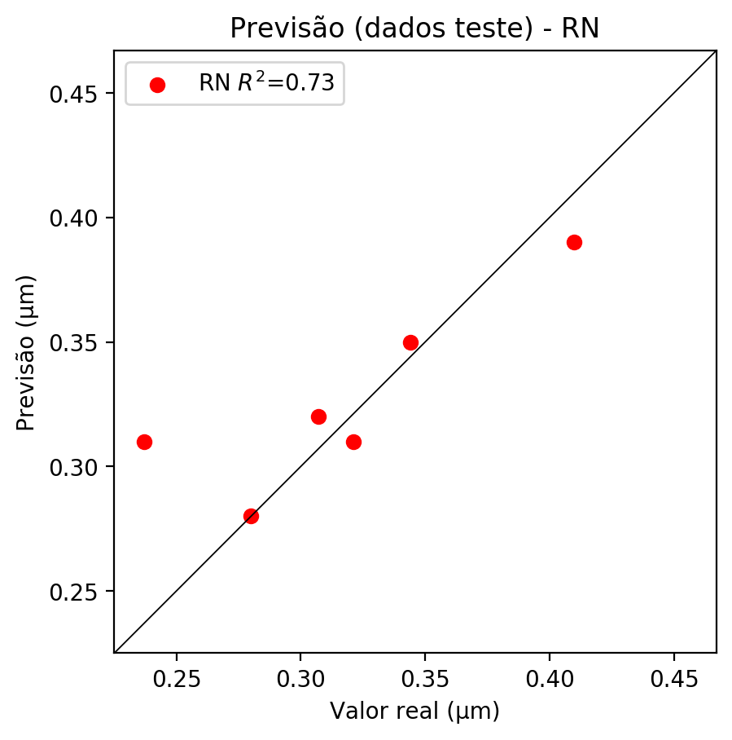

**Dados de treino**

* Erro relativo médio: 0.87
* Coeficiente de correlação: 1.0
* Coeficiente de determinação: 1.0
* MSE: 0.0
* RMSE: 0.0

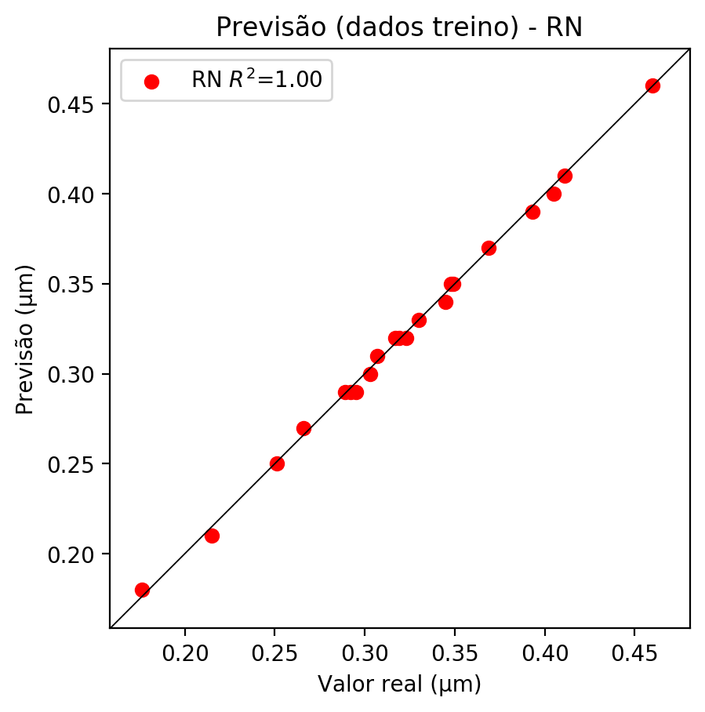

# Pesos

Pesos - camada oculta 1

[[-0.12089255 0.4350436 0.31972423 -0.7628724 1.0337569 -0.6761461  
 0.2326164 -0.58657455 0.4337424 0.97991467 -0.5358545 -0.18008842  
 -0.12751457 0.26155043 -0.15832599 0.12270061 -0.17773992]  
 [ 0.5274036 -0.5275911 -0.39380813 0.6428953 0.0402372 0.21272776  
 -0.19439474 0.08189721 -0.5896762 0.48105806 0.16034707 0.54523265  
 0.18918087 -0.6911395 0.11814546 -0.00625031 -0.132396 ]  
 [ 0.77537215 -0.43729872 -0.40245348 0.7743732 -0.73771 -0.25515294  
 -0.01160315 0.49630564 0.18057857 0.59195286 0.33228338 0.11204865  
 0.02844363 -0.63398284 1.1523536 0.94237304 0.13327791]]

Bias - camada oculta

[-0.9651722 -0.65572727 -0.9628198 0.06864887 -0.418402 0.53601617  
 -0.59409785 -0.7098766 -0.6580655 -0.53037256 -0.60573524 -0.34320542  
 -0.75755453 -0.05388444 -0.530842 -0.0451847 -0.58904773]

Pesos - camada oculta 2

[[ 6.16512895e-01 2.31371164e-01 -4.90998439e-02 -1.01219308e+00  
 -4.23421621e-01 -2.04533741e-01 5.97092271e-01 -3.69103521e-01  
 -7.40993142e-01 -5.08207202e-01 3.08399796e-01 -3.86806339e-01  
 6.96747452e-02 4.37676936e-01 5.74435711e-01 -2.82479703e-01  
 1.42620459e-01]  
 [-8.22905660e-01 -8.48641992e-01 9.37050998e-01 -4.83954191e-01  
 -3.07580203e-01 -8.31244290e-02 4.64583188e-01 -6.82626426e-01  
 -2.98601627e-01 -1.89529046e-01 7.98187137e-01 -3.28835249e-01  
 -1.10051835e+00 1.60935879e-01 -6.38391972e-02 -3.97115320e-01  
 -1.46917474e+00]  
 [ 6.15080237e-01 9.48180631e-02 5.89821279e-01 8.81777942e-01  
 2.78656900e-01 -7.10235059e-01 -4.45185363e-01 6.81301773e-01  
 -2.47781098e-01 8.25817883e-01 -4.19033945e-01 5.27290583e-01  
 5.37633419e-01 -8.74088764e-01 -2.46957079e-01 -1.68081731e-01  
 7.75322855e-01]  
 [ 6.77937448e-01 1.20391801e-01 -3.42550188e-01 -1.90445930e-01  
 9.91035402e-02 -5.69121301e-01 -3.93832177e-01 -3.53701174e-01  
 -9.71866310e-01 3.97631198e-01 -9.99687433e-01 1.38477638e-01  
 2.45557487e-01 -6.49171948e-01 -9.89758015e-01 -5.77781916e-01  
 2.83297360e-01]  
 [-4.03101206e-01 -1.13897169e+00 4.37238604e-01 -8.22343409e-01  
 -6.64519727e-01 -9.02905345e-01 4.16514814e-01 -7.53930151e-01  
 -4.57292467e-01 -3.50718498e-01 7.31847227e-01 -7.25712538e-01  
 -3.88549030e-01 -1.12832522e+00 -1.06909943e+00 -6.44462481e-02  
 3.81314278e-01]  
 [-1.38355345e-01 -4.01177794e-01 1.89414337e-01 -1.07175970e+00  
 -4.24674839e-01 -1.50587797e-01 -9.05183434e-01 -6.90711260e-01  
 -4.96389985e-01 -1.11282265e+00 -1.56247342e+00 -1.25282776e+00  
 -2.12913696e-02 -3.60909291e-02 -1.61902726e-01 -6.82322800e-01  
 -5.36134183e-01]  
 [ 8.92162144e-01 -6.74510598e-02 -6.75647110e-02 1.26762301e-01  
 4.40497369e-01 -7.91220307e-01 -4.97683793e-01 6.10675335e-01  
 -6.08159781e-01 3.66169691e-01 -2.43136138e-01 9.56344128e-01  
 5.59219360e-01 -1.84362367e-01 -5.75052261e-01 -9.50018108e-01  
 3.27537209e-01]  
 [ 2.28465199e-01 3.07761319e-02 -2.62445182e-01 -1.52287081e-01  
 -3.79414670e-02 -1.94337308e-01 -2.21894205e-01 2.28813618e-01  
 -6.94938779e-01 1.07142560e-01 -7.30483890e-01 1.99195638e-01  
 3.48038286e-01 -7.01057076e-01 -2.42570907e-01 3.23434509e-02  
 7.08734632e-01]  
 [-4.22892980e-02 2.46117920e-01 6.30727530e-01 3.53299588e-01  
 -9.92963552e-01 -9.83270824e-01 7.42807761e-02 -5.07269762e-02  
 -6.01594865e-01 -7.50056148e-01 2.08874032e-01 3.69873434e-01  
 5.15043318e-01 -1.18192565e+00 -1.45489782e-01 -8.69167268e-01  
 -3.74204844e-01]  
 [ 1.24814615e-01 -8.39091763e-02 -1.42125845e+00 5.62374055e-01  
 5.79856455e-01 -4.06971365e-01 -8.03959608e-01 -3.07593029e-02  
 -3.39952260e-01 9.81613621e-02 -6.63911700e-01 2.35528365e-01  
 -5.91846168e-01 -4.95888889e-01 -7.92615056e-01 -9.38596487e-01  
 2.25158706e-01]  
 [ 4.73995060e-01 3.17676574e-01 1.18077822e-01 7.01238275e-01  
 -9.94580507e-01 -4.25095737e-01 -9.62558389e-01 5.42055428e-01  
 -5.36990464e-01 9.79453772e-02 -2.00664505e-01 6.85355365e-01  
 7.63118505e-01 -7.43635416e-01 -6.43871903e-01 -9.37394857e-01  
 8.90752852e-01]  
 [ 2.52267867e-01 -2.25112587e-01 -8.52740780e-02 -5.32807231e-01  
 -6.93398058e-01 -7.65475392e-01 -1.40639260e-01 -2.96601087e-01  
 -7.10244596e-01 -7.12130249e-01 5.40878884e-02 -8.33286703e-01  
 -7.44923472e-01 -8.97280037e-01 -6.02418363e-01 4.31710780e-01  
 -6.53837696e-02]  
 [-2.53552496e-01 -9.00996700e-02 2.50249803e-01 -7.30318964e-01  
 -6.18962944e-01 3.00033420e-01 2.52874941e-01 -2.23417044e-01  
 -3.18493247e-01 -4.08668369e-01 8.66856098e-01 -5.62734365e-01  
 -2.57804006e-01 7.19240427e-01 1.01086879e+00 -3.62241745e-01  
 4.82999571e-02]  
 [ 2.30137542e-01 -6.67981863e-01 5.07230699e-01 -5.29792845e-01  
 -8.35583568e-01 -4.66912389e-02 -1.77697673e-01 -4.20922756e-01  
 2.70795017e-01 -1.00671697e+00 4.25005168e-01 -7.87846148e-01  
 -1.02064705e+00 -3.53756323e-02 -1.20753713e-01 -3.45484674e-01  
 5.25199585e-02]  
 [ 5.56272686e-01 -1.53939456e-01 4.96895239e-02 -2.27056742e-01  
 -5.99022329e-01 -5.45226336e-02 -2.82707065e-01 2.88672626e-01  
 -5.51536918e-01 -7.84991503e-01 -5.67140460e-01 4.63356152e-02  
 4.93133098e-01 -1.24692678e+00 2.06078665e-04 -8.06037009e-01  
 3.07220936e-01]  
 [ 5.23868799e-01 4.12550837e-01 -7.82717615e-02 3.27279449e-01  
 -4.15571928e-01 -8.84491920e-01 -1.99221507e-01 5.91606684e-02  
 -8.32811892e-01 -8.01476359e-01 -6.44267023e-01 1.65104121e-01  
 9.49939489e-02 -1.13777721e+00 -4.20682967e-01 -4.45170403e-01  
 2.95990795e-01]  
 [-1.08187802e-01 -1.40452102e-01 -2.35762075e-01 -1.24767445e-01  
 -5.08526444e-01 -7.48666823e-02 -4.43579704e-01 2.02833563e-01  
 -6.33641481e-01 -2.64455438e-01 -8.82280350e-01 -1.04791915e+00  
 1.27609283e-01 7.65891910e-01 -4.81221154e-02 -3.27874899e-01  
 1.18580014e-01]]

Bias - camada oculta 2

[ 0.1527794 -0.311964 0.10079969 -0.64801663 -0.70504445 -0.60049987  
 -0.3005986 -0.29238844 -0.60053474 -0.7120516 -0.4601366 -0.7696818  
 -0.31252366 -0.91514546 -0.49890482 -0.65471256 0.02296232]

Pesos - camada saída

[[ 0.41714734 -0.03813893 -0.44606376 -0.21642545 -0.37693375 0.3192124  
 -0.01871447 -0.07731579 0.4069647 -0.48761645 -0.3679694 -0.28997046  
 0.22021616 0.12992178 0.46374565 0.2190339 0.18240012]]

# Iterações

|  |  |  |  |  |  |  |
| --- | --- | --- | --- | --- | --- | --- |
| Média | Desvio | n | ln | 2° camada | Função | Épocas |
| -0.3152 | 0.1605 | 10 | 0.1 | False | relu | 38 |
| -0.1791 | 0.0721 | 17 | 0.1 | True | relu | 716 |
| -0.3958 | 0.1451 | 7 | 0.01 | True | tanh | 130 |
| -0.421 | 0.1461 | 19 | 0.001 | False | tanh | 282 |
| -0.2814 | 0.1289 | 29 | 0.001 | False | relu | 469 |
| -0.2913 | 0.1916 | 88 | 0.1 | False | tanh | 926 |
| -0.2177 | 0.097 | 95 | 0.0001 | True | relu | 984 |
| -0.4144 | 0.2664 | 10 | 0.01 | True | tanh | 865 |
| -0.7031 | 0.6155 | 58 | 0.001 | True | relu | 8 |
| -0.3771 | 0.1029 | 9 | 0.01 | False | tanh | 514 |
| -0.2085 | 0.1303 | 73 | 0.0001 | True | relu | 729 |
| -0.2313 | 0.1056 | 22 | 0.001 | True | relu | 543 |
| -0.2536 | 0.0942 | 25 | 0.1 | True | relu | 562 |
| -0.3133 | 0.1946 | 53 | 0.001 | False | relu | 498 |
| -0.2146 | 0.0654 | 83 | 0.01 | True | relu | 337 |
| -0.5995 | 0.4022 | 99 | 0.01 | False | tanh | 16 |
| -0.2663 | 0.1284 | 23 | 0.01 | False | relu | 472 |
| -0.2861 | 0.1056 | 24 | 0.001 | True | relu | 778 |
| -0.3715 | 0.226 | 58 | 0.01 | True | tanh | 382 |
| -0.3704 | 0.2159 | 35 | 0.1 | False | tanh | 596 |

# RL

# Coeficientes

[ 0. -0.40251228 0.31885916 0.81698993]

# Erros

**Dados de teste**

* Erro relativo médio: 7.38
* Coeficiente de correlação: 0.89
* Coeficiente de determinação: 0.79
* MSE: 0.0
* RMSE: 0.0

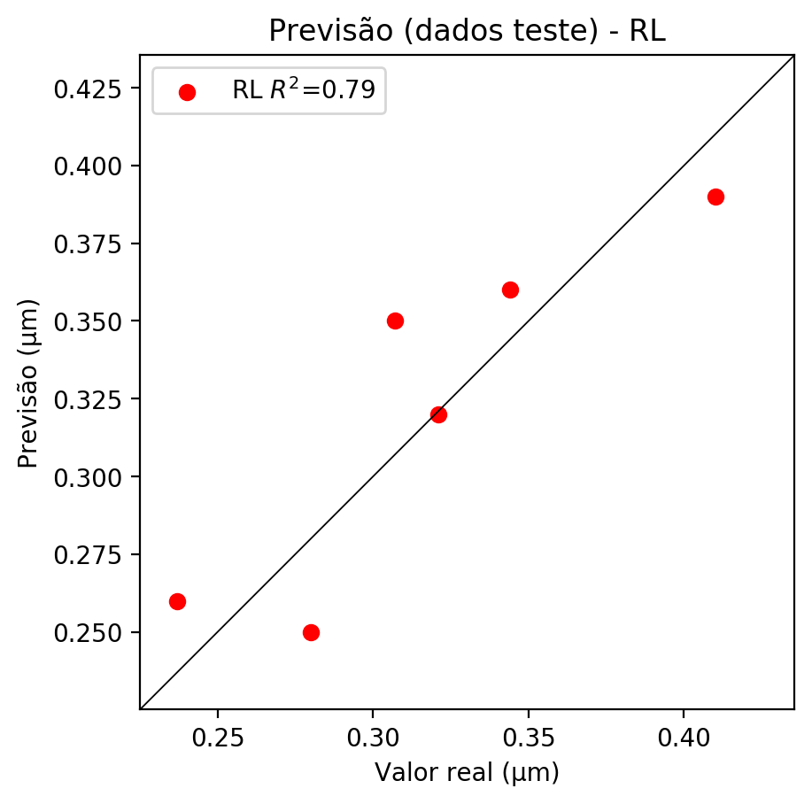

**Dados de treino**

* Erro relativo médio: 4.67
* Coeficiente de correlação: 0.96
* Coeficiente de determinação: 0.93
* MSE: 0.0
* RMSE: 0.0

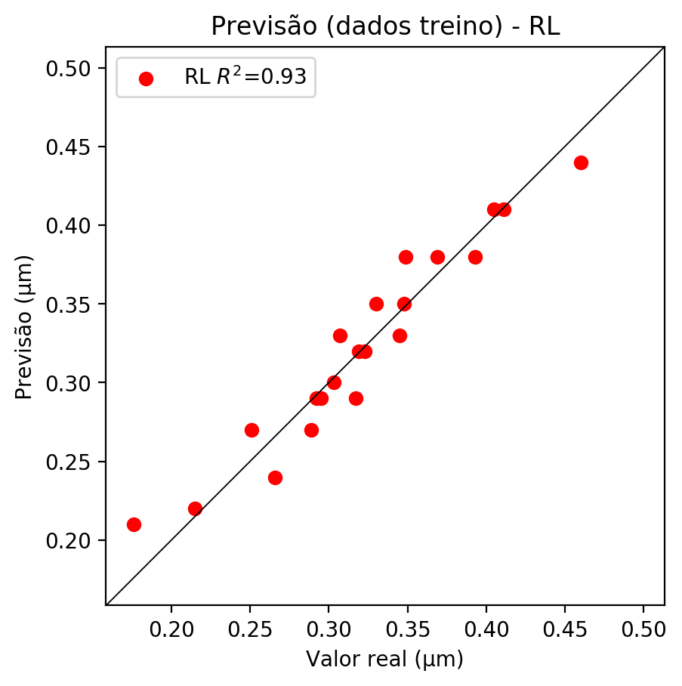

# RP2

# Coeficientes

[ 0. -0.39733582 0.33956992 0.80854127 -0.03744629 0.0301152  
 0.08072307 -0.0532612 0.02670544 0.1128982 ]

# Erros

**Dados de teste**

* Erro relativo médio: 6.06
* Coeficiente de correlação: 0.93
* Coeficiente de determinação: 0.86
* MSE: 0.0
* RMSE: 0.0

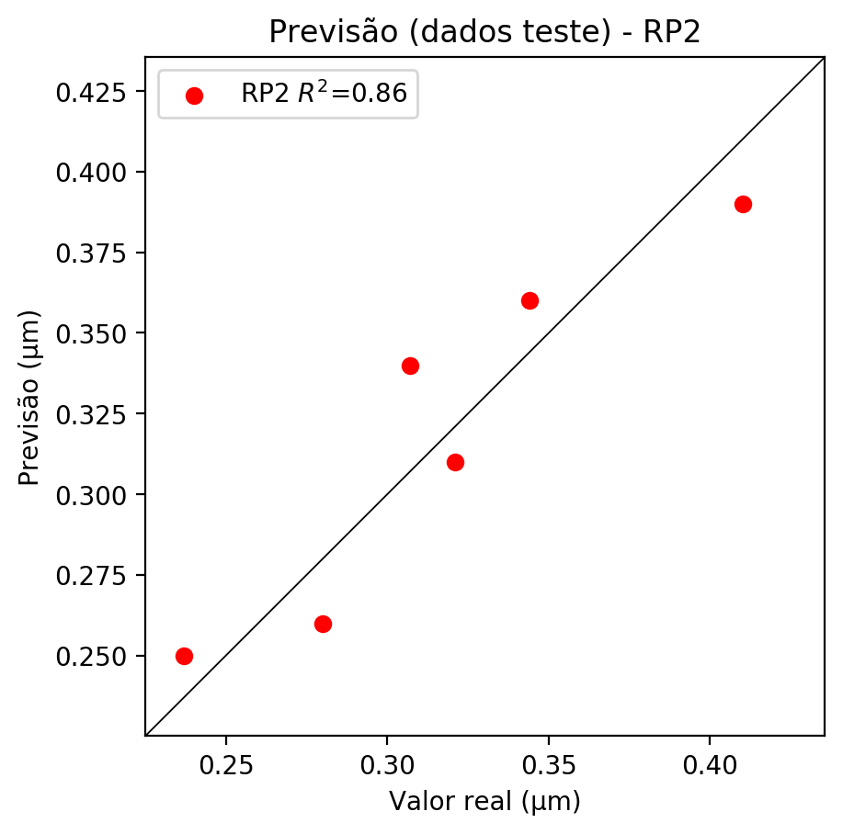

**Dados de treino**

* Erro relativo médio: 4.37
* Coeficiente de correlação: 0.97
* Coeficiente de determinação: 0.94
* MSE: 0.0
* RMSE: 0.0

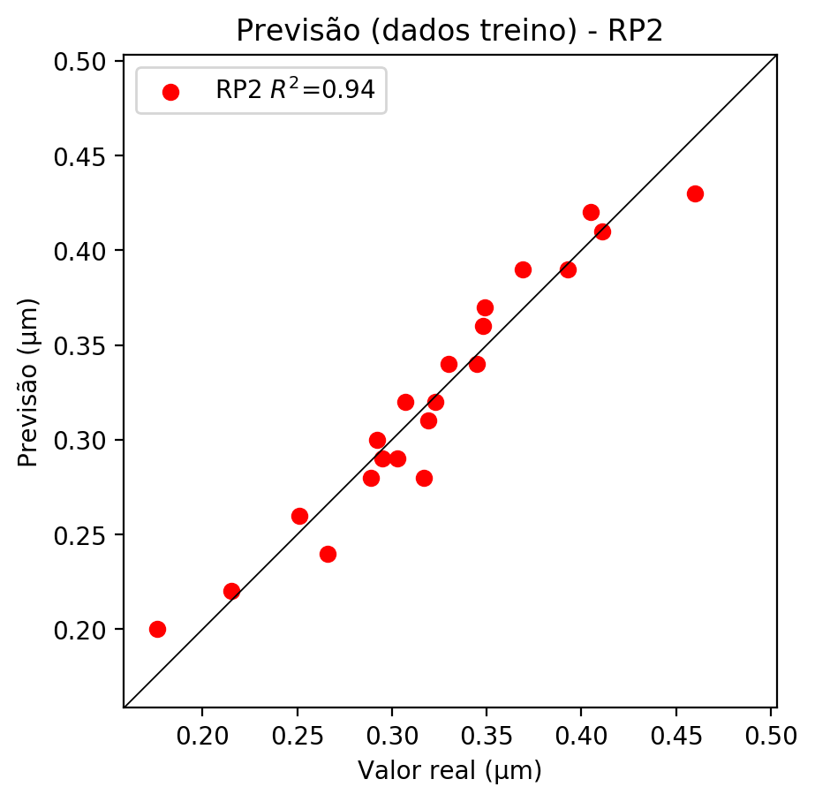

# RP3

# Coeficientes

[ 0. 0.03927157 0.07340856 0.14509232 -0.12042047 0.13288344  
 0.06749753 0.0531299 -0.08438852 0.23033221 0.0567256 0.05526899  
 0.23674659 -0.26663569 0.07208419 -0.33396629 0.10603458 0.23167966  
 -0.0868976 0.20957779]

# Erros

**Dados de teste**

* Erro relativo médio: 8.95
* Coeficiente de correlação: 0.98
* Coeficiente de determinação: 0.95
* MSE: 0.0
* RMSE: 0.0

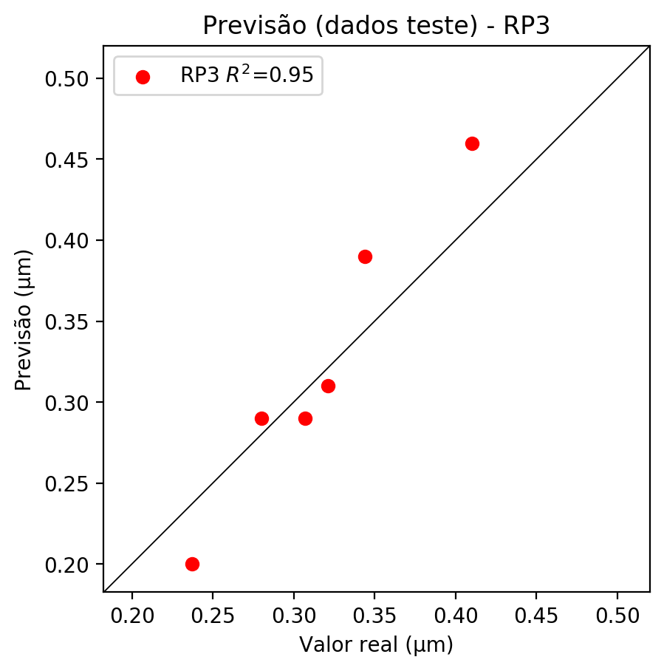

**Dados de treino**

* Erro relativo médio: 1.62
* Coeficiente de correlação: 1.0
* Coeficiente de determinação: 0.99
* MSE: 0.0
* RMSE: 0.0

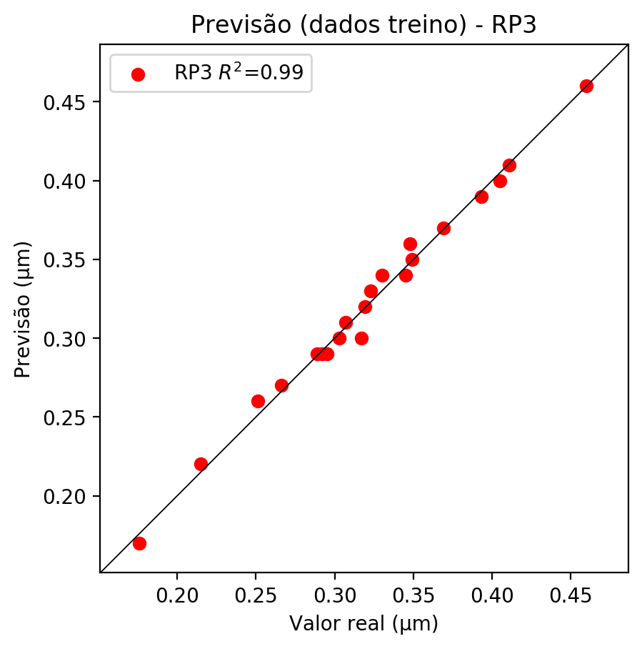

# RP4

# Coeficientes

[ 2.22044605e-16 -5.88716792e-02 9.11093951e-02 2.06339946e-01  
 1.91989558e-02 2.62544918e-02 7.76573071e-03 -9.49628750e-02  
 -3.70557099e-02 -6.65077749e-02 -8.50368700e-02 1.70019657e-01  
 1.18276598e-01 -8.62088795e-02 -4.22656246e-02 -1.82092043e-01  
 1.31602460e-01 1.07201408e-01 -1.28356150e-01 2.98046589e-01  
 3.04545381e-02 3.37095034e-02 1.67430221e-03 -1.44793487e-01  
 4.80223335e-02 -2.40055838e-02 1.66829480e-02 5.95006680e-02  
 -3.25799359e-02 1.12171666e-02 -1.04297403e-01 2.09201022e-02  
 3.48293695e-01 -5.35249144e-02 -9.60667860e-02]

# Erros

**Dados de teste**

* Erro relativo médio: 6.6
* Coeficiente de correlação: 0.93
* Coeficiente de determinação: 0.86
* MSE: 0.0
* RMSE: 0.0

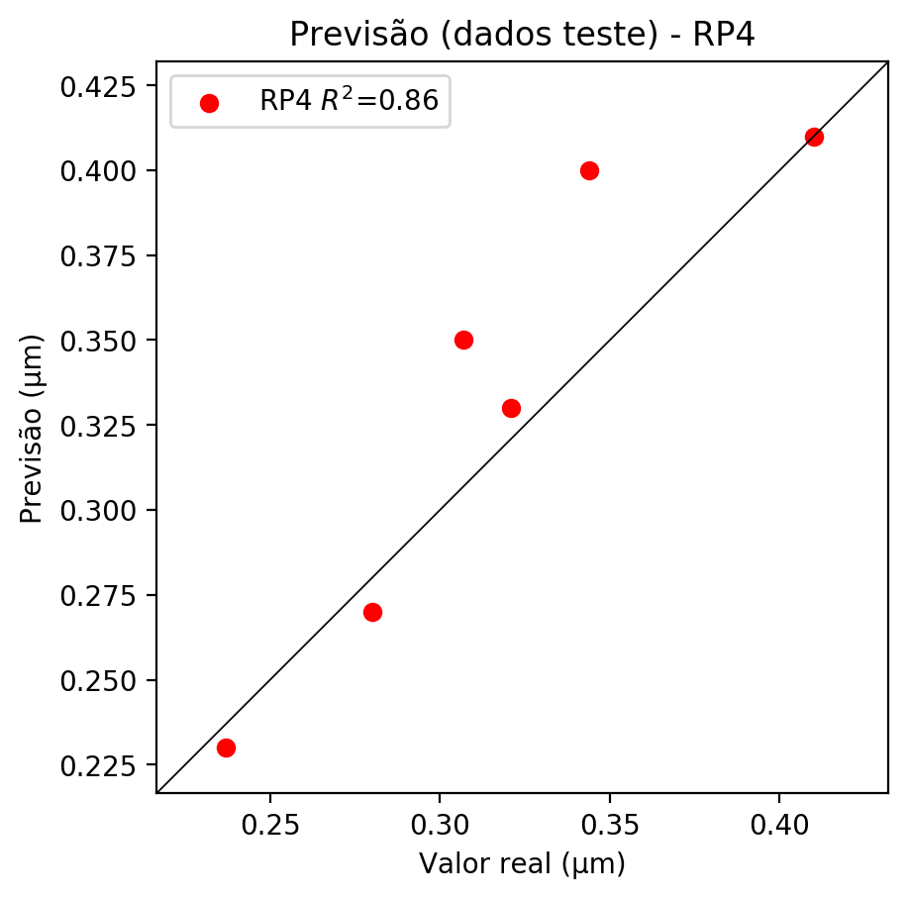

**Dados de treino**

* Erro relativo médio: 0.87
* Coeficiente de correlação: 1.0
* Coeficiente de determinação: 1.0
* MSE: 0.0
* RMSE: 0.0

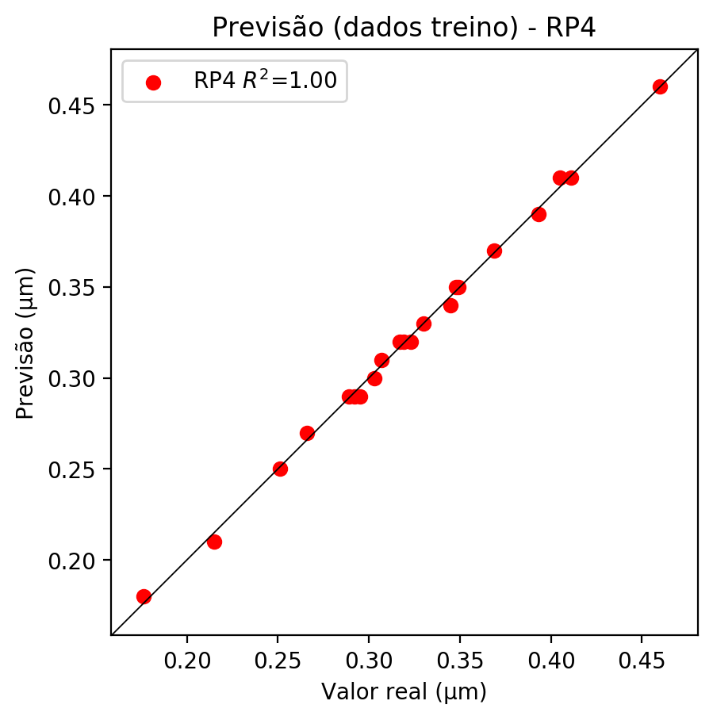

# Geral

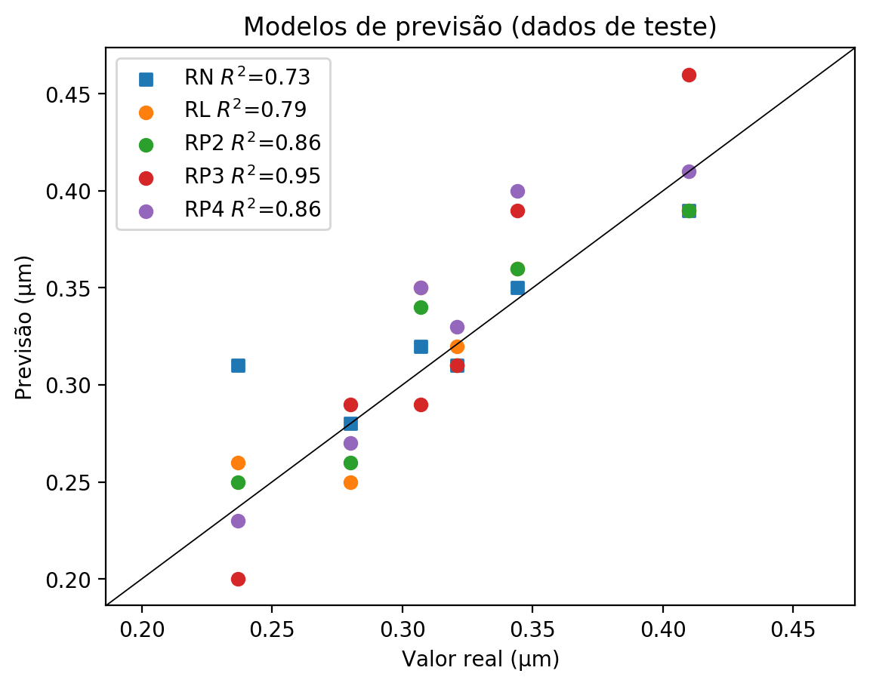

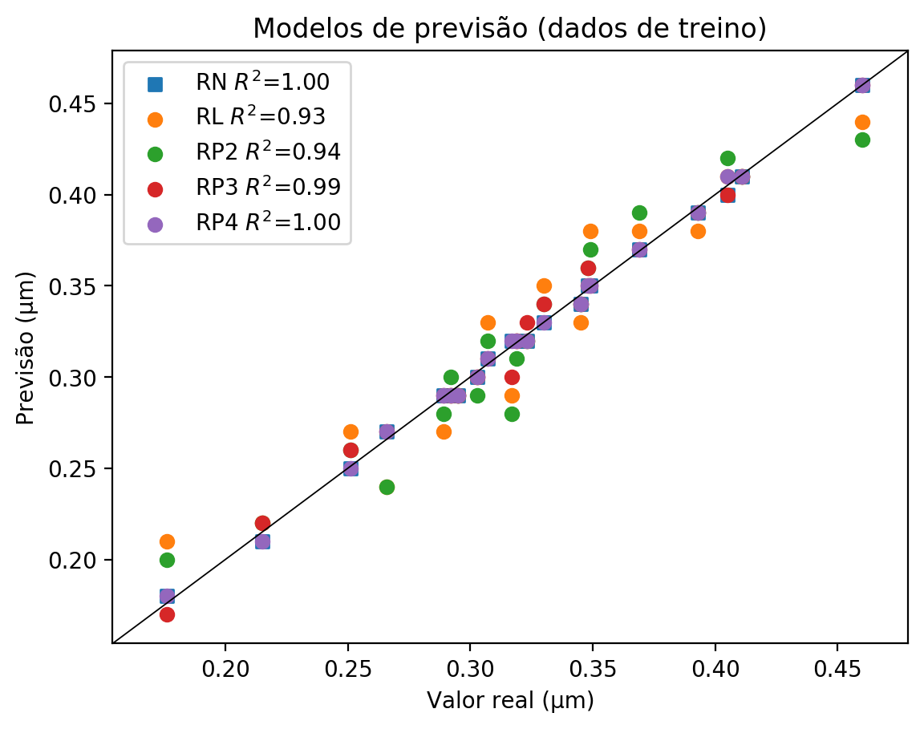

**Dados de teste**

|  |  |  |  |  |  |  |  |  |  |  |
| --- | --- | --- | --- | --- | --- | --- | --- | --- | --- | --- |
| Valor real | RN Previsto | RN Erro (%) | RL Previsto | RL Erro (%) | RP2 Previsto | RP2 Erro (%) | RP3 Previsto | RP3 Erro (%) | RP4 Previsto | RP4 Erro (%) |
| 0.24 | 0.31 | 30.8 | 0.26 | 9.7 | 0.25 | 5.49 | 0.2 | 15.61 | 0.23 | 2.95 |
| 0.41 | 0.39 | 4.88 | 0.39 | 4.88 | 0.39 | 4.88 | 0.46 | 12.2 | 0.41 | 0.0 |
| 0.32 | 0.31 | 3.43 | 0.32 | 0.31 | 0.31 | 3.43 | 0.31 | 3.43 | 0.33 | 2.8 |
| 0.34 | 0.35 | 1.74 | 0.36 | 4.65 | 0.36 | 4.65 | 0.39 | 13.37 | 0.4 | 16.28 |
| 0.28 | 0.28 | 0.0 | 0.25 | 10.71 | 0.26 | 7.14 | 0.29 | 3.57 | 0.27 | 3.57 |
| 0.31 | 0.32 | 4.23 | 0.35 | 14.01 | 0.34 | 10.75 | 0.29 | 5.54 | 0.35 | 14.01 |

**Dados de treino**

|  |  |  |  |  |  |  |  |  |  |  |
| --- | --- | --- | --- | --- | --- | --- | --- | --- | --- | --- |
| Valor real | RN Previsto | RN Erro (%) | RL Previsto | RL Erro (%) | RP2 Previsto | RP2 Erro (%) | RP3 Previsto | RP3 Erro (%) | RP4 Previsto | RP4 Erro (%) |
| 0.4 | 0.4 | 1.23 | 0.41 | 1.23 | 0.42 | 3.7 | 0.4 | 1.23 | 0.41 | 1.23 |
| 0.32 | 0.32 | 0.31 | 0.32 | 0.31 | 0.31 | 2.82 | 0.32 | 0.31 | 0.32 | 0.31 |
| 0.35 | 0.35 | 0.57 | 0.35 | 0.57 | 0.36 | 3.45 | 0.36 | 3.45 | 0.35 | 0.57 |
| 0.35 | 0.35 | 0.29 | 0.38 | 8.88 | 0.37 | 6.02 | 0.35 | 0.29 | 0.35 | 0.29 |
| 0.33 | 0.33 | 0.0 | 0.35 | 6.06 | 0.34 | 3.03 | 0.34 | 3.03 | 0.33 | 0.0 |
| 0.22 | 0.21 | 2.33 | 0.22 | 2.33 | 0.22 | 2.33 | 0.22 | 2.33 | 0.21 | 2.33 |
| 0.31 | 0.31 | 0.98 | 0.33 | 7.49 | 0.32 | 4.23 | 0.31 | 0.98 | 0.31 | 0.98 |
| 0.46 | 0.46 | 0.0 | 0.44 | 4.35 | 0.43 | 6.52 | 0.46 | 0.0 | 0.46 | 0.0 |
| 0.41 | 0.41 | 0.24 | 0.41 | 0.24 | 0.41 | 0.24 | 0.41 | 0.24 | 0.41 | 0.24 |
| 0.3 | 0.29 | 1.69 | 0.29 | 1.69 | 0.29 | 1.69 | 0.29 | 1.69 | 0.29 | 1.69 |
| 0.29 | 0.29 | 0.35 | 0.27 | 6.57 | 0.28 | 3.11 | 0.29 | 0.35 | 0.29 | 0.35 |
| 0.27 | 0.27 | 1.5 | 0.24 | 9.77 | 0.24 | 9.77 | 0.27 | 1.5 | 0.27 | 1.5 |
| 0.34 | 0.34 | 1.45 | 0.33 | 4.35 | 0.34 | 1.45 | 0.34 | 1.45 | 0.34 | 1.45 |
| 0.3 | 0.3 | 0.99 | 0.3 | 0.99 | 0.29 | 4.29 | 0.3 | 0.99 | 0.3 | 0.99 |
| 0.29 | 0.29 | 0.68 | 0.29 | 0.68 | 0.3 | 2.74 | 0.29 | 0.68 | 0.29 | 0.68 |
| 0.39 | 0.39 | 0.76 | 0.38 | 3.31 | 0.39 | 0.76 | 0.39 | 0.76 | 0.39 | 0.76 |
| 0.25 | 0.25 | 0.4 | 0.27 | 7.57 | 0.26 | 3.59 | 0.26 | 3.59 | 0.25 | 0.4 |
| 0.18 | 0.18 | 2.27 | 0.21 | 19.32 | 0.2 | 13.64 | 0.17 | 3.41 | 0.18 | 2.27 |
| 0.37 | 0.37 | 0.27 | 0.38 | 2.98 | 0.39 | 5.69 | 0.37 | 0.27 | 0.37 | 0.27 |
| 0.32 | 0.32 | 0.93 | 0.32 | 0.93 | 0.32 | 0.93 | 0.33 | 2.17 | 0.32 | 0.93 |
| 0.32 | 0.32 | 0.95 | 0.29 | 8.52 | 0.28 | 11.67 | 0.3 | 5.36 | 0.32 | 0.95 |