# Informações do estudo

Referência: Jadhav

Grandeza: Força

Tipo: Fx

Material: Mild Steel

Ferramenta: HSS

Número de experimentos: 27

Observações:  
Work piece diameter: 40 mm  
Work piece length: 300 mm  
Lathe Tool Dynamometer: IEICOS multi-component force indicator

# Unidades

Velocidade: m/min

Avanço: mm/rev

Profundidade de corte: mm

Força: Kgf

# Dados de teste

|  |  |  |  |
| --- | --- | --- | --- |
| Força | n | f | a |
| 2.5 | 65.37 | 0.18 | 0.25 |
| 19.1 | 65.37 | 0.25 | 0.75 |
| 9.1 | 44.13 | 0.18 | 0.5 |
| 10.2 | 65.37 | 0.1 | 0.25 |
| 4.3 | 28.91 | 0.18 | 0.5 |
| 8.0 | 65.37 | 0.25 | 0.25 |

# Dados de treino

|  |  |  |  |
| --- | --- | --- | --- |
| Força | n | f | a |
| 12.4 | 28.91 | 0.1 | 0.25 |
| 8.3 | 44.13 | 0.1 | 0.75 |
| 10.3 | 65.37 | 0.18 | 0.75 |
| 10.4 | 44.13 | 0.25 | 0.5 |
| 10.1 | 65.37 | 0.25 | 0.5 |
| 2.3 | 65.37 | 0.18 | 0.5 |
| 7.1 | 44.13 | 0.25 | 0.25 |
| 24.2 | 44.13 | 0.25 | 0.75 |
| 21.8 | 44.13 | 0.18 | 0.25 |
| 5.2 | 28.91 | 0.1 | 0.5 |
| 5.0 | 28.91 | 0.18 | 0.25 |
| 4.2 | 44.13 | 0.1 | 0.5 |
| 10.3 | 28.91 | 0.25 | 0.5 |
| 5.5 | 65.37 | 0.1 | 0.5 |
| 5.0 | 44.13 | 0.1 | 0.25 |
| 11.5 | 28.91 | 0.18 | 0.75 |
| 2.8 | 28.91 | 0.25 | 0.25 |
| 1.6 | 44.13 | 0.18 | 0.75 |
| 11.4 | 28.91 | 0.25 | 0.75 |
| 9.6 | 28.91 | 0.1 | 0.75 |
| 8.3 | 65.37 | 0.1 | 0.75 |

# RN

Número de neurônios: 58

Taxa de aprendizado: 1.000000e-03

Número de épocas: 8

2° camada: True

Função de ativação: relu

# Erros

**Dados de teste**

* Erro relativo médio: 69.45
* Coeficiente de correlação: 0.79
* Coeficiente de determinação: 0.2
* MSE: 22.53
* RMSE: 4.75

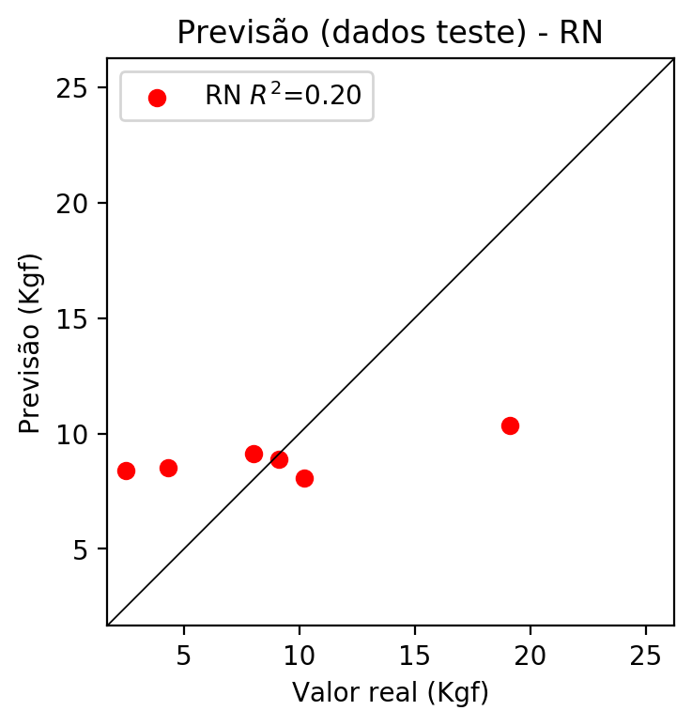

**Dados de treino**

* Erro relativo médio: 71.25
* Coeficiente de correlação: 0.53
* Coeficiente de determinação: 0.15
* MSE: 26.19
* RMSE: 5.12

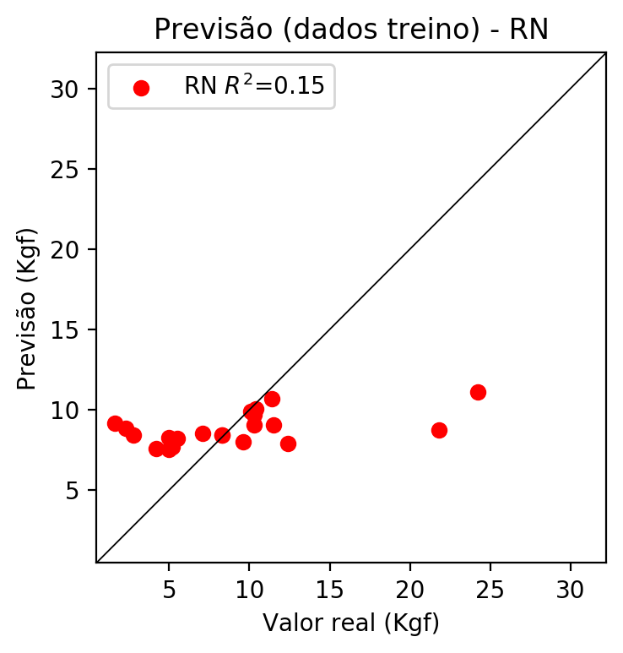

# Pesos

Pesos - camada oculta 1

[[ 0.19848542 0.07433353 -0.2219235 0.01953388 0.18715793 -0.15885226  
 -0.03567608 0.01376974 -0.09982134 0.10062958 -0.30783466 0.21244663  
 0.11264199 -0.02724322 -0.14856316 -0.12028991 0.06373119 -0.08420927  
 -0.25619313 0.27587748 0.26329595 0.2266423 -0.0592812 0.16939346  
 -0.06555557 -0.22925283 0.29969007 0.08293476 0.22539683 -0.22553967  
 -0.05174208 -0.30501664 -0.17762713 -0.24970813 0.04009645 -0.22670196  
 0.0978097 0.1527723 -0.2256408 -0.08998251 0.15914309 0.15054628  
 0.2555009 0.27767205 0.13362026 -0.03170533 0.00309528 -0.19294964  
 0.256197 0.3185982 0.18569979 0.19166133 0.0769513 -0.08675271  
 -0.13206145 0.06688106 0.01915265 0.02573286]  
 [-0.28194693 -0.2850888 0.24474682 -0.25147757 -0.26282468 0.08938367  
 0.3059961 -0.28268898 -0.0645606 0.10273471 -0.27263355 -0.18226197  
 -0.06137421 0.02641782 -0.01109093 -0.22027335 0.13222179 -0.21701999  
 0.11357921 0.2412409 0.04950839 -0.10114983 0.20691332 -0.30063  
 -0.31131318 -0.06945536 -0.17608857 0.24851382 0.00171909 -0.28755152  
 -0.2964971 0.26053143 -0.1203922 -0.2310264 -0.3194471 0.07855445  
 -0.1302925 -0.21910328 -0.31065762 0.09023453 0.12937164 -0.21221018  
 0.15828018 -0.15070432 0.27849165 -0.21520069 -0.28244615 -0.25944173  
 -0.06961995 -0.15038513 0.05504744 0.2007692 0.00193608 -0.18697286  
 0.27120247 0.2579754 0.05755693 0.2993099 ]  
 [ 0.0118791 -0.12262084 -0.10467142 -0.19298223 0.06840359 -0.22045419  
 0.02123156 -0.11321811 0.295358 0.0064466 0.25848317 -0.06254141  
 -0.27279782 -0.10016721 0.1686927 0.01288203 0.03268374 0.0870899  
 0.27412692 0.19029245 -0.15497398 0.11704293 -0.23191212 0.24536952  
 -0.14521971 -0.29355115 0.02360648 -0.08169138 -0.00565004 -0.10463595  
 0.27107877 0.15296103 0.23419707 0.08665077 0.26135635 -0.24734654  
 -0.00729621 -0.21299022 -0.19895649 -0.31291136 0.23145035 0.24276976  
 0.14867625 -0.03514772 -0.19175366 0.20187575 -0.22654802 -0.0287934  
 -0.23930535 -0.25447068 0.21982783 -0.11492662 -0.26579016 -0.11630918  
 -0.07936583 0.18729918 -0.2781066 0.20443594]]

Bias - camada oculta

[-0.00774627 0.00796492 -0.00688756 -0.00769695 0.00797907 0.00765236  
 0.00779678 -0.00780048 -0.00768688 -0.00752049 0.00790652 0.00795863  
 0.00793559 -0.00789946 0.00202027 -0.00778462 0.00797855 0.00773124  
 0.00805727 0.00780925 0.00784472 0.00801186 -0.00716861 -0.00783146  
 0.00805765 0.00647709 -0.00222679 0.00775372 -0.00772277 0.00169513  
 -0.00772431 0.00468394 -0.00794989 -0.00775061 0.00801268 0.007754  
 0.00804737 0.00786065 -0.0007865 0.00342919 0.00793231 0.00774484  
 -0.00767602 -0.00768724 0.00759953 -0.00742062 0.00792013 0.00629627  
 -0.00682732 0.00778802 -0.00651679 -0.00773382 -0.00800575 -0.00780385  
 -0.00582859 -0.00786632 -0.00234899 -0.00729565]

Pesos - camada oculta 2

[[ 0.14265816 0.04093823 -0.14744866 ... 0.0456507 0.00904883  
 0.01028606]  
 [-0.2179447 -0.19301853 0.19064704 ... 0.19269903 0.04091722  
 0.21463828]  
 [ 0.02168787 -0.07630365 -0.07872666 ... 0.13769765 -0.19049153  
 0.16196209]  
 ...  
 [-0.12882356 -0.07129491 -0.1313269 ... -0.13348624 -0.14472263  
 0.2010117 ]  
 [ 0.17862895 0.2259444 0.05754621 ... -0.06131526 0.14577487  
 0.12247211]  
 [ 0.13825753 0.10516877 0.05595064 ... 0.10111099 0.06077808  
 -0.1035646 ]]

Bias - camada oculta 2

[ 0.00681845 0.00791339 0.0077794 -0.00687327 -0.00147989 0.007256  
 0.00660577 -0.00687253 0.00639617 0.00741249 -0.00798897 -0.00612162  
 0.00788892 0.007613 0.00801943 -0.00611645 -0.0065977 -0.00725961  
 -0.00788809 0.00496362 -0.00734488 -0.00807509 0.00746897 -0.00642988  
 0.00658543 0.00624831 -0.007977 -0.00696458 0. -0.00799086  
 -0.00792193 -0.00782287 0.00741017 -0.00801253 0.00775504 -0.00790435  
 -0.00489073 0.0080273 0.00788281 -0.00748219 -0.0079253 -0.00441457  
 -0.00759218 0.00769407 -0.00781349 -0.00793343 -0.00609423 0.00729733  
 0.00471591 -0.00749262 -0.00747352 -0.00787404 0.00308047 0.00803067  
 -0.00802073 0.00781937 0.00804266 -0.00772764]

Pesos - camada saída

[[ 0.21795535 0.07652989 -0.2255883 0.02059927 0.19020718 -0.16316818  
 -0.04054568 0.02910944 -0.09887774 0.1163704 -0.29765362 0.20079543  
 0.09987159 -0.04334913 -0.15103391 -0.13805819 0.0666564 -0.09289679  
 -0.2765426 0.28103405 0.2826454 0.21453735 -0.07088829 0.16035633  
 -0.05045216 -0.23458678 0.31998911 0.07113338 0.2370379 -0.2235304  
 -0.03827154 -0.31105128 -0.19656928 -0.23839082 0.02479769 -0.21476802  
 0.0921248 0.15163803 -0.24541934 -0.07571255 0.16198628 0.16796161  
 0.2607548 0.2978794 0.12689717 -0.03208368 0.00306242 -0.21215211  
 0.2608925 0.30889463 0.1891526 0.19493632 0.06839425 -0.08856355  
 -0.12976135 0.08314747 0.03189857 0.03345068]]

# Iterações

|  |  |  |  |  |  |  |
| --- | --- | --- | --- | --- | --- | --- |
| Média | Desvio | n | ln | 2° camada | Função | Épocas |
| -2.3291 | 1.6657 | 10 | 0.1 | False | relu | 38 |
| -2.7783 | 1.322 | 17 | 0.1 | True | relu | 716 |
| -1.702 | 1.5117 | 7 | 0.01 | True | tanh | 130 |
| -1.2046 | 1.3163 | 19 | 0.001 | False | tanh | 282 |
| -1.8122 | 1.4177 | 29 | 0.001 | False | relu | 469 |
| -2.2988 | 1.1347 | 88 | 0.1 | False | tanh | 926 |
| -2.4199 | 1.446 | 95 | 0.0001 | True | relu | 984 |
| -2.6785 | 2.0843 | 10 | 0.01 | True | tanh | 865 |
| -1.1192 | 1.3346 | 58 | 0.001 | True | relu | 8 |
| -3.3649 | 1.9815 | 9 | 0.01 | False | tanh | 514 |
| -2.0597 | 1.4945 | 73 | 0.0001 | True | relu | 729 |
| -2.5993 | 1.3612 | 22 | 0.001 | True | relu | 543 |
| -5.0249 | 3.8397 | 25 | 0.1 | True | relu | 562 |
| -1.7929 | 1.3717 | 53 | 0.001 | False | relu | 498 |
| -3.2144 | 1.4446 | 83 | 0.01 | True | relu | 337 |
| -1.2283 | 1.3321 | 99 | 0.01 | False | tanh | 16 |
| -5.0928 | 2.7333 | 23 | 0.01 | False | relu | 472 |
| -2.4024 | 1.4448 | 24 | 0.001 | True | relu | 778 |
| -2.395 | 1.3586 | 58 | 0.01 | True | tanh | 382 |
| -2.0408 | 1.5814 | 35 | 0.1 | False | tanh | 596 |

# RL

# Coeficientes

[ 0. -0.09172906 0.26680523 0.1752904 ]

# Erros

**Dados de teste**

* Erro relativo médio: 67.42
* Coeficiente de correlação: 0.45
* Coeficiente de determinação: 0.18
* MSE: 22.93
* RMSE: 4.79

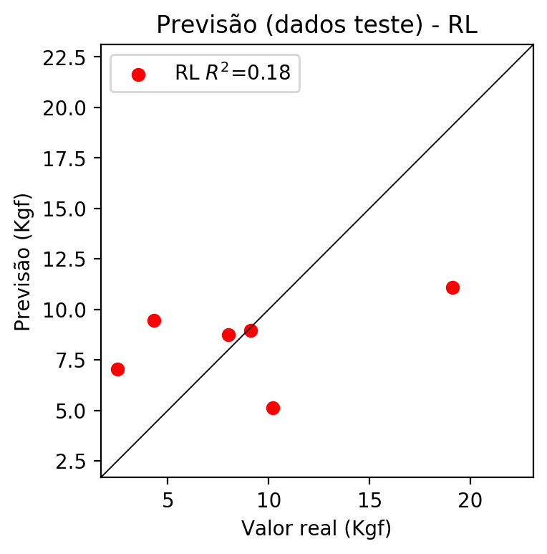

**Dados de treino**

* Erro relativo médio: 71.94
* Coeficiente de correlação: 0.32
* Coeficiente de determinação: 0.1
* MSE: 27.71
* RMSE: 5.26

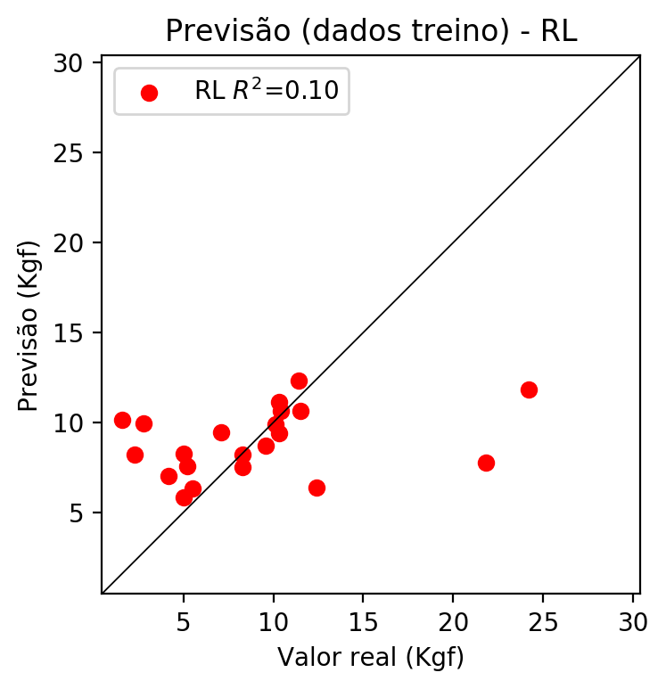

# RP2

# Coeficientes

[ 0. 0.12768889 0.32190483 0.15043009 -0.15420059 0.16937994  
 -0.05702888 0.23082412 0.32810386 0.49163976]

# Erros

**Dados de teste**

* Erro relativo médio: 59.01
* Coeficiente de correlação: 0.8
* Coeficiente de determinação: 0.6
* MSE: 11.33
* RMSE: 3.37

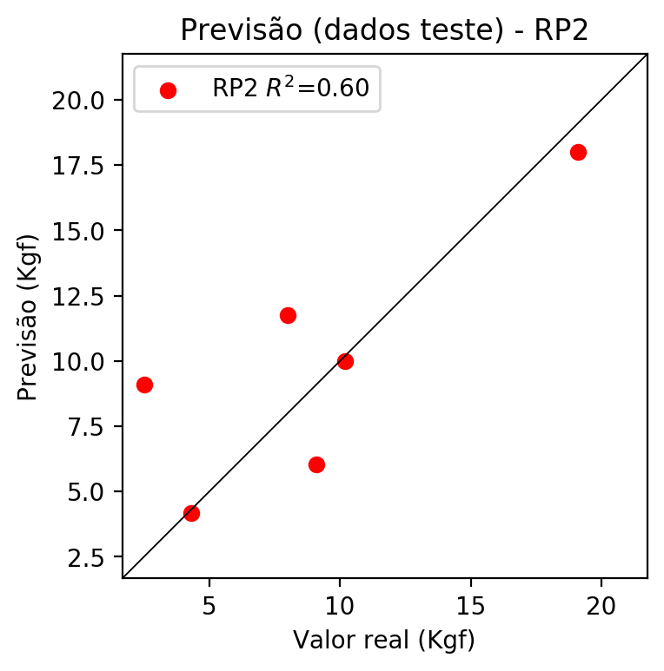

**Dados de treino**

* Erro relativo médio: 67.25
* Coeficiente de correlação: 0.57
* Coeficiente de determinação: 0.33
* MSE: 20.72
* RMSE: 4.55

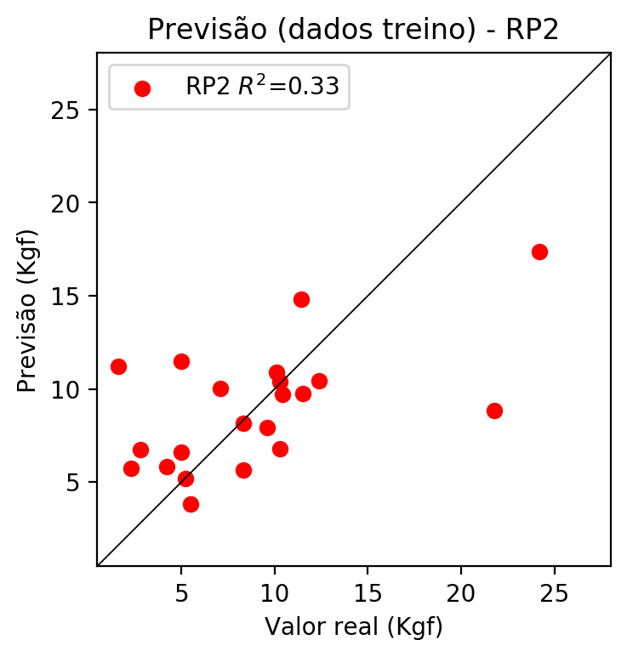

# RP3

# Coeficientes

[ 0. -0.08716369 0.24195884 -0.21310526 -0.00368155 0.22129876  
 -0.14813237 0.15157985 0.56116657 0.58211025 -0.12590311 -0.36214783  
 0.1198581 0.14011031 0.18550357 0.40464844 0.3494961 0.66574586  
 -0.10655215 -0.30781871]

# Erros

**Dados de teste**

* Erro relativo médio: 138.17
* Coeficiente de correlação: 0.62
* Coeficiente de determinação: -1.03
* MSE: 57.03
* RMSE: 7.55

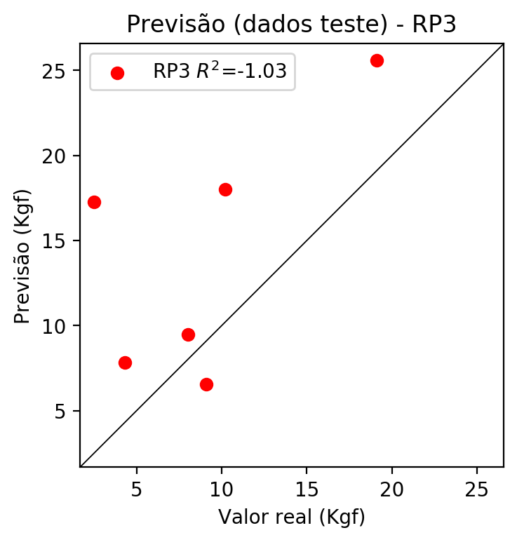

**Dados de treino**

* Erro relativo médio: 51.62
* Coeficiente de correlação: 0.8
* Coeficiente de determinação: 0.64
* MSE: 11.18
* RMSE: 3.34

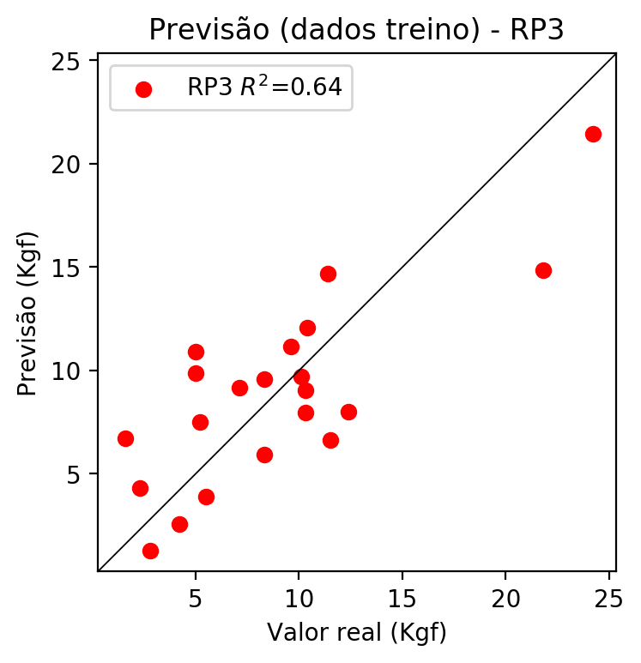

# RP4

# Coeficientes

[-4.44089210e-16 1.08723694e-02 1.66005085e-01 -5.14773518e-01  
 -1.52620417e-02 -9.95343087e-03 -1.45563106e-01 2.06653223e-01  
 1.16292376e-01 3.85941240e-01 1.57045336e-02 -6.59517277e-02  
 8.74158749e-01 -2.45218634e-02 1.23222762e+00 4.58798421e-01  
 2.39785122e-01 1.82576817e+00 1.99582561e-01 -7.43561748e-01  
 -2.00017715e-02 1.68225306e-02 -3.07006565e-01 7.11500077e-02  
 8.42923708e-01 1.01068080e-01 -1.52137706e-02 1.76198378e+00  
 6.06915693e-01 -2.10257819e-01 2.85725562e-01 2.07587985e-01  
 -4.53368302e-01 1.67977876e-01 5.57470679e-01]

# Erros

**Dados de teste**

* Erro relativo médio: 321.79
* Coeficiente de correlação: 0.66
* Coeficiente de determinação: -36.75
* MSE: 1061.5
* RMSE: 32.58

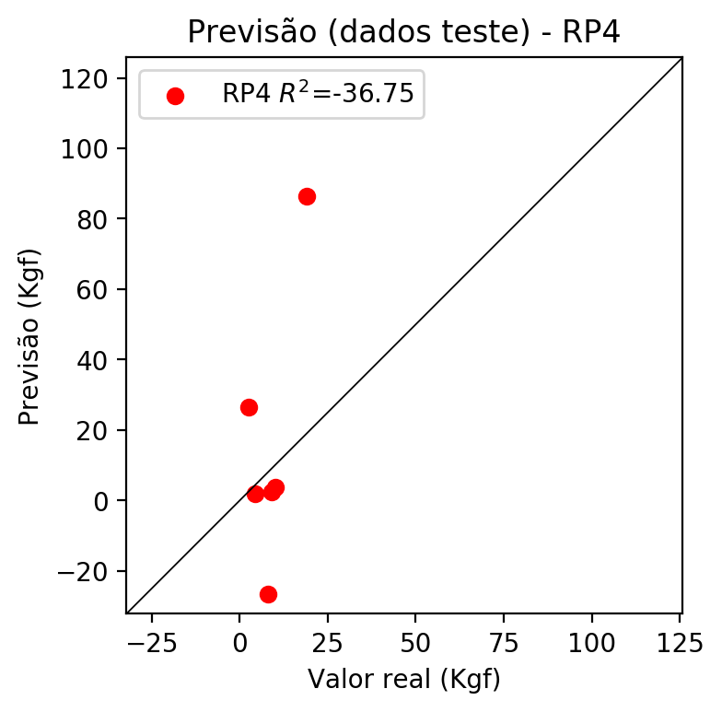

**Dados de treino**

* Erro relativo médio: 0.0
* Coeficiente de correlação: 1.0
* Coeficiente de determinação: 1.0
* MSE: 0.0
* RMSE: 0.0

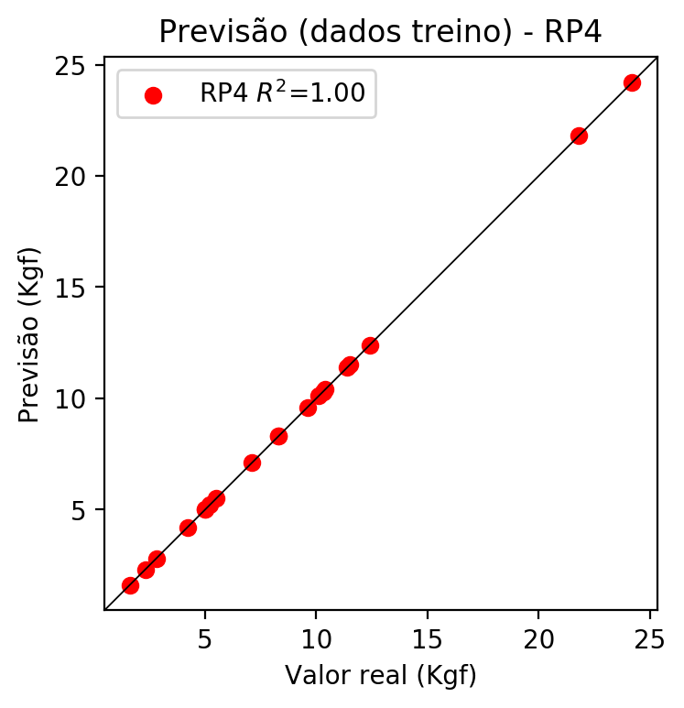

# Geral

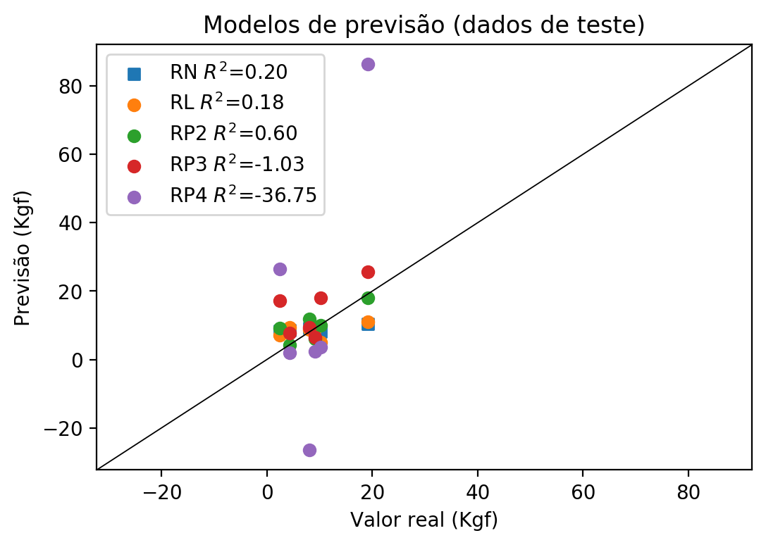

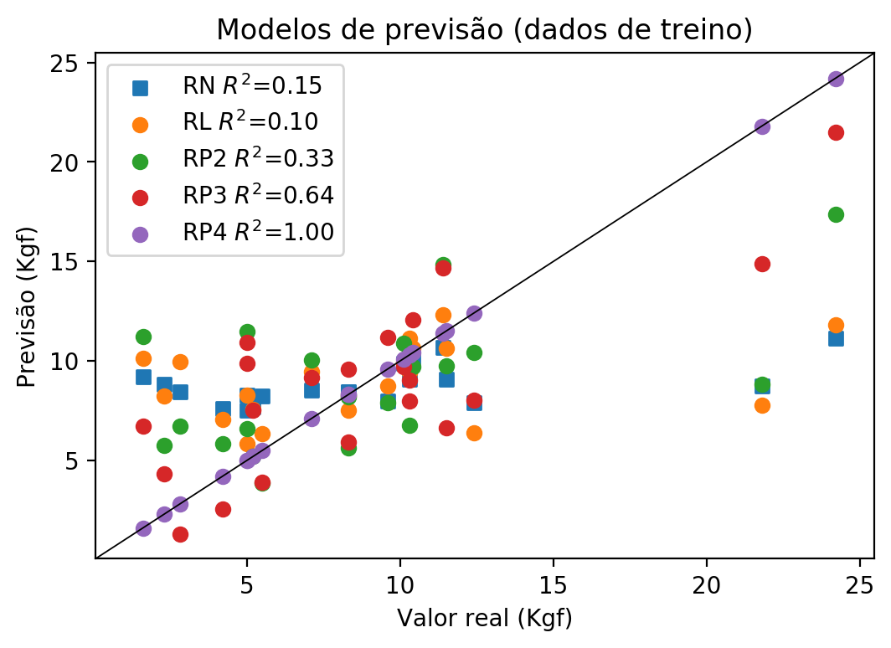

**Dados de teste**

|  |  |  |  |  |  |  |  |  |  |  |
| --- | --- | --- | --- | --- | --- | --- | --- | --- | --- | --- |
| Valor real | RN Previsto | RN Erro (%) | RL Previsto | RL Erro (%) | RP2 Previsto | RP2 Erro (%) | RP3 Previsto | RP3 Erro (%) | RP4 Previsto | RP4 Erro (%) |
| 2.5 | 8.4 | 236.0 | 7.05 | 182.0 | 9.08 | 263.2 | 17.25 | 590.0 | 26.42 | 956.8 |
| 19.1 | 10.33 | 45.92 | 11.1 | 41.88 | 18.01 | 5.71 | 25.61 | 34.08 | 86.28 | 351.73 |
| 9.1 | 8.89 | 2.31 | 8.95 | 1.65 | 6.04 | 33.63 | 6.54 | 28.13 | 2.48 | 72.75 |
| 10.2 | 8.08 | 20.78 | 5.14 | 49.61 | 10.01 | 1.86 | 18.02 | 76.67 | 3.71 | 63.63 |
| 4.3 | 8.5 | 97.67 | 9.47 | 120.23 | 4.18 | 2.79 | 7.82 | 81.86 | 1.97 | 54.19 |
| 8.0 | 9.12 | 14.0 | 8.73 | 9.13 | 11.75 | 46.88 | 9.46 | 18.25 | -26.53 | 431.62 |

**Dados de treino**

|  |  |  |  |  |  |  |  |  |  |  |
| --- | --- | --- | --- | --- | --- | --- | --- | --- | --- | --- |
| Valor real | RN Previsto | RN Erro (%) | RL Previsto | RL Erro (%) | RP2 Previsto | RP2 Erro (%) | RP3 Previsto | RP3 Erro (%) | RP4 Previsto | RP4 Erro (%) |
| 12.4 | 7.89 | 36.37 | 6.37 | 48.63 | 10.44 | 15.81 | 8.01 | 35.4 | 12.4 | 0.0 |
| 8.3 | 8.44 | 1.69 | 8.22 | 0.96 | 8.17 | 1.57 | 5.93 | 28.55 | 8.3 | 0.0 |
| 10.3 | 9.08 | 11.84 | 9.42 | 8.54 | 10.38 | 0.78 | 9.03 | 12.33 | 10.3 | 0.0 |
| 10.4 | 10.03 | 3.56 | 10.63 | 2.21 | 9.71 | 6.63 | 12.05 | 15.87 | 10.4 | 0.0 |
| 10.1 | 9.88 | 2.18 | 9.91 | 1.88 | 10.9 | 7.92 | 9.69 | 4.06 | 10.1 | 0.0 |
| 2.3 | 8.84 | 284.35 | 8.24 | 258.26 | 5.75 | 150.0 | 4.33 | 88.26 | 2.3 | 0.0 |
| 7.1 | 8.51 | 19.86 | 9.45 | 33.1 | 10.03 | 41.27 | 9.17 | 29.15 | 7.1 | 0.0 |
| 24.2 | 11.12 | 54.05 | 11.81 | 51.2 | 17.35 | 28.31 | 21.47 | 11.28 | 24.2 | 0.0 |
| 21.8 | 8.73 | 59.95 | 7.77 | 64.36 | 8.84 | 59.45 | 14.87 | 31.79 | 21.8 | 0.0 |
| 5.2 | 7.7 | 48.08 | 7.55 | 45.19 | 5.19 | 0.19 | 7.52 | 44.62 | 5.2 | 0.0 |
| 5.0 | 8.28 | 65.6 | 8.28 | 65.6 | 6.6 | 32.0 | 10.92 | 118.4 | 5.0 | 0.0 |
| 4.2 | 7.6 | 80.95 | 7.04 | 67.62 | 5.83 | 38.81 | 2.55 | 39.29 | 4.2 | 0.0 |
| 10.3 | 9.71 | 5.73 | 11.14 | 8.16 | 6.78 | 34.17 | 7.98 | 22.52 | 10.3 | 0.0 |
| 5.5 | 8.24 | 49.82 | 6.32 | 14.91 | 3.84 | 30.18 | 3.88 | 29.45 | 5.5 | 0.0 |
| 5.0 | 7.53 | 50.6 | 5.85 | 17.0 | 11.47 | 129.4 | 9.87 | 97.4 | 5.0 | 0.0 |
| 11.5 | 9.07 | 21.13 | 10.65 | 7.39 | 9.73 | 15.39 | 6.65 | 42.17 | 11.5 | 0.0 |
| 2.8 | 8.45 | 201.79 | 9.96 | 255.71 | 6.72 | 140.0 | 1.28 | 54.29 | 2.8 | 0.0 |
| 1.6 | 9.18 | 473.75 | 10.13 | 533.13 | 11.21 | 600.63 | 6.7 | 318.75 | 1.6 | 0.0 |
| 11.4 | 10.68 | 6.32 | 12.33 | 8.16 | 14.82 | 30.0 | 14.68 | 28.77 | 11.4 | 0.0 |
| 9.6 | 7.99 | 16.77 | 8.73 | 9.06 | 7.91 | 17.6 | 11.17 | 16.35 | 9.6 | 0.0 |
| 8.3 | 8.45 | 1.81 | 7.5 | 9.64 | 5.64 | 32.05 | 9.57 | 15.3 | 8.3 | 0.0 |