# Informações do estudo

Referência: Jadhav

Grandeza: Força

Tipo: Fz

Material: Mild Steel

Ferramenta: HSS

Número de experimentos: 27

Observações:  
Work piece diameter: 40 mm  
Work piece length: 300 mm  
Lathe Tool Dynamometer: IEICOS multi-component force indicator

# Unidades

Velocidade: m/min

Avanço: mm/rev

Profundidade de corte: mm

Força: Kgf

# Dados de teste

|  |  |  |  |
| --- | --- | --- | --- |
| Força | n | f | a |
| 13.6 | 28.91 | 0.18 | 0.25 |
| 33.1 | 65.37 | 0.25 | 0.75 |
| 21.3 | 28.91 | 0.1 | 0.75 |
| 24.1 | 65.37 | 0.25 | 0.5 |
| 16.3 | 65.37 | 0.18 | 0.5 |
| 19.2 | 28.91 | 0.1 | 0.5 |

# Dados de treino

|  |  |  |  |
| --- | --- | --- | --- |
| Força | n | f | a |
| 26.4 | 28.91 | 0.1 | 0.25 |
| 21.1 | 44.13 | 0.25 | 0.25 |
| 24.3 | 28.91 | 0.25 | 0.5 |
| 24.4 | 44.13 | 0.25 | 0.5 |
| 22.3 | 44.13 | 0.1 | 0.75 |
| 9.6 | 44.13 | 0.1 | 0.25 |
| 18.3 | 28.91 | 0.18 | 0.5 |
| 38.2 | 44.13 | 0.25 | 0.75 |
| 35.8 | 44.13 | 0.18 | 0.25 |
| 16.9 | 65.37 | 0.25 | 0.25 |
| 16.5 | 65.37 | 0.18 | 0.25 |
| 15.6 | 44.13 | 0.18 | 0.75 |
| 24.3 | 65.37 | 0.18 | 0.75 |
| 18.2 | 44.13 | 0.1 | 0.5 |
| 16.8 | 28.91 | 0.25 | 0.25 |
| 25.5 | 28.91 | 0.18 | 0.75 |
| 15.0 | 44.13 | 0.18 | 0.5 |
| 9.3 | 65.37 | 0.1 | 0.25 |
| 25.4 | 28.91 | 0.25 | 0.75 |
| 22.3 | 65.37 | 0.1 | 0.75 |
| 19.5 | 65.37 | 0.1 | 0.5 |

# RN

Número de neurônios: 58

Taxa de aprendizado: 1.000000e-03

Número de épocas: 8

2° camada: True

Função de ativação: relu

# Erros

**Dados de teste**

* Erro relativo médio: 21.47
* Coeficiente de correlação: 0.9
* Coeficiente de determinação: 0.24
* MSE: 29.82
* RMSE: 5.46

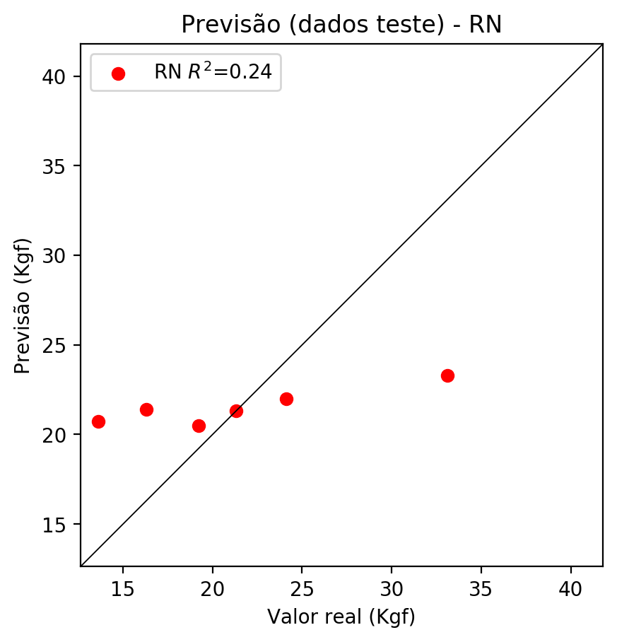

**Dados de treino**

* Erro relativo médio: 24.9
* Coeficiente de correlação: 0.6
* Coeficiente de determinação: 0.21
* MSE: 38.34
* RMSE: 6.19

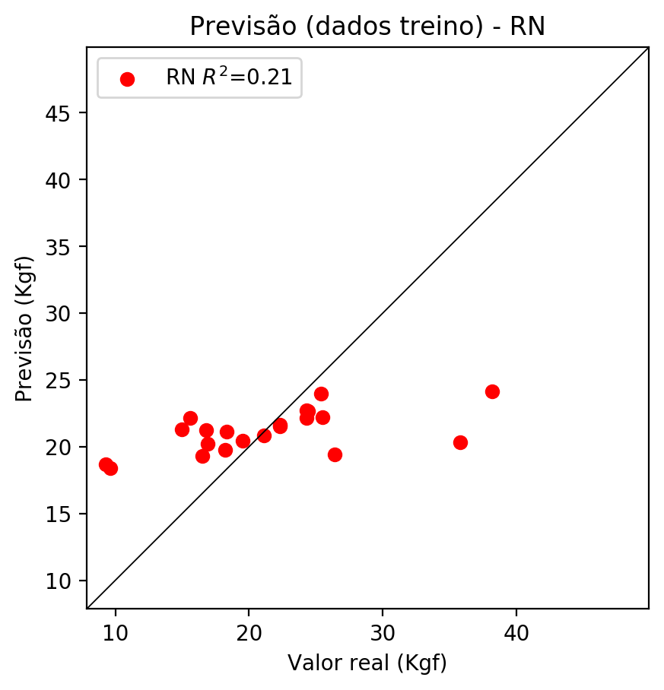

# Pesos

Pesos - camada oculta 1

[[ 0.1986093 0.07509375 -0.21746211 0.01957507 0.18710268 -0.16069044  
 -0.03949814 0.01404815 -0.09767088 0.11486944 -0.30798683 0.2122994  
 0.11237059 -0.02708833 -0.14821562 -0.12927973 0.06378679 -0.08435333  
 -0.2700995 0.27286857 0.2629458 0.2261682 -0.05479857 0.16361752  
 -0.05283948 -0.21518166 0.30616325 0.0689791 0.22720796 -0.22005498  
 -0.05212038 -0.3204563 -0.17764336 -0.2501666 0.03999771 -0.22220165  
 0.09906755 0.15334104 -0.22546794 -0.07398789 0.14359426 0.16438618  
 0.25558946 0.2795078 0.14002761 -0.03466373 0.00325538 -0.19300614  
 0.25625286 0.31859574 0.18590176 0.1911779 0.07926673 -0.0868517  
 -0.1432194 0.06619253 0.01759965 0.03183428]  
 [-0.28189752 -0.28483227 0.24430479 -0.2516031 -0.26174146 0.08776901  
 0.30601436 -0.28575832 -0.07797075 0.10314333 -0.27247503 -0.18206313  
 -0.0750528 0.02597796 -0.01094727 -0.22363503 0.13226153 -0.21657369  
 0.11357699 0.24119154 0.04973764 -0.10090023 0.2063954 -0.30068538  
 -0.31009248 -0.06940258 -0.1743489 0.24353269 -0.00556631 -0.28739876  
 -0.30150083 0.2605905 -0.12027281 -0.24595335 -0.3195597 0.07411863  
 -0.13513312 -0.21895088 -0.31137192 0.09011314 0.13196862 -0.20719697  
 0.15825832 -0.15939656 0.27784103 -0.21481098 -0.28252512 -0.25955856  
 -0.06939815 -0.14975181 0.05509957 0.2019689 -0.01344422 -0.18677099  
 0.25884512 0.26287165 0.05762164 0.29917267]  
 [ 0.0268496 -0.12233535 -0.10472813 -0.17837468 0.05822948 -0.22036085  
 0.0211933 -0.11396342 0.29547662 0.00636788 0.25949505 -0.07768048  
 -0.27247906 -0.11544802 0.16864187 0.00864242 0.03270463 0.0818031  
 0.274089 0.18700981 -0.14092834 0.11356696 -0.24245508 0.249759  
 -0.1449548 -0.2945107 0.0260603 -0.08163092 0.00602556 -0.10451322  
 0.27012718 0.15302163 0.23432115 0.0860689 0.25771338 -0.24542272  
 -0.01449071 -0.21270448 -0.2143991 -0.30688035 0.23147549 0.23659812  
 0.15244804 -0.02231422 -0.19180515 0.20189768 -0.23897505 -0.04441478  
 -0.22355567 -0.26900393 0.21987893 -0.11462352 -0.26966077 -0.11644375  
 -0.07933716 0.18753427 -0.2807167 0.2045367 ]]

Bias - camada oculta

[-0.00763614 0.00762419 -0.00773566 -0.00752075 0.00772234 0.00775133  
 0.00764702 -0.00713323 -0.00762532 -0.00565698 0.00792443 0.00717709  
 0.00764748 0.00743731 0.00801225 -0.00298368 0.00795237 0.00780084  
 0.00786267 -0.00521917 -0.00547329 0.00770522 0.00794583 -0.00789622  
 0.00784703 0.00772717 0.0041541 -0.00449732 -0.00591164 0.00763923  
 -0.00454618 0.00792557 -0.00787484 0.00255457 0.00798567 0.00668282  
 0.00583955 0.00767668 0.00795552 -0.00352896 0.00784965 0.00760479  
 0.00787274 -0.00648883 0.00773451 -0.00773877 0.00788883 0.0076823  
 -0.00768607 0.00612178 0.0078375 -0.00789388 0.00484056 -0.00778482  
 -0.00772446 -0.00545551 0.00767746 -0.00791865]

Pesos - camada oculta 2

[[ 0.1576997 0.04162156 -0.1474247 ... 0.04566846 0.00926616  
 0.01096511]  
 [-0.20999411 -0.19297019 0.19071417 ... 0.18475568 0.03973889  
 0.2150662 ]  
 [ 0.02158952 -0.07541382 -0.07872699 ... 0.13805212 -0.19018844  
 0.16195205]  
 ...  
 [-0.12890272 -0.07133263 -0.1469868 ... -0.13349265 -0.14490522  
 0.2010051 ]  
 [ 0.18636343 0.22618107 0.07289745 ... -0.07710069 0.13011086  
 0.12307706]  
 [ 0.13816428 0.10512645 0.04139203 ... 0.10109922 0.06058098  
 -0.10357662]]

Bias - camada oculta 2

[ 0.00616274 0.00784315 0.00778485 -0.00718886 0.00737013 0.00783756  
 0.00773652 0.00806144 0.00669826 0.00763203 -0.00794003 0.0078078  
 0.00033163 0.00735779 0.0080693 -0.00315298 -0.00623527 -0.00761067  
 -0.00802035 0.00788237 -0.00661127 -0.00798998 0.0078524 -0.0078577  
 0.00667493 0.00746064 -0.00010815 -0.00735191 0. -0.00799573  
 -0.00790576 0.00761337 0.00022852 -0.00794951 0.00800402 -0.00799101  
 0.00168908 -0.00368961 0.00751558 -0.00679602 0.00752702 -0.00678086  
 -0.00780944 -0.00674624 -0.00790961 -0.00796912 -0.00613054 -0.00615621  
 0.00444789 -0.00762476 -0.00476571 -0.00748228 0.00290778 0.00685491  
 -0.00793061 0.00804411 0.00707917 0.00052428]

Pesos - camada saída

[[ 0.21795012 0.07655174 -0.22560549 0.02039265 0.1901845 -0.1633386  
 -0.04063668 0.02905221 -0.09935828 0.11663378 -0.29767117 0.21571489  
 0.09882942 -0.04347617 -0.15087198 -0.13730097 0.06626283 -0.08562539  
 -0.26210797 0.28108138 0.2827814 0.22705805 -0.07094618 0.15994388  
 -0.05068595 -0.23457654 0.32002753 0.07375889 0.2370379 -0.22366288  
 -0.03791885 -0.32614338 -0.18413922 -0.23844868 0.04080252 -0.23048809  
 0.10055166 0.15556325 -0.24547482 -0.07577703 0.16195367 0.16765831  
 0.26028615 0.28387704 0.12681907 -0.03289755 0.00299652 -0.19638267  
 0.26114577 0.30849883 0.2047049 0.19532146 0.06496322 -0.08849414  
 -0.14576185 0.08318544 0.01666316 0.03346739]]

# Iterações

|  |  |  |  |  |  |  |
| --- | --- | --- | --- | --- | --- | --- |
| Média | Desvio | n | ln | 2° camada | Função | Épocas |
| -1.3446 | 0.8536 | 10 | 0.1 | False | relu | 38 |
| -1.3778 | 0.8654 | 17 | 0.1 | True | relu | 716 |
| -1.7335 | 0.8901 | 7 | 0.01 | True | tanh | 130 |
| -1.2231 | 0.9306 | 19 | 0.001 | False | tanh | 282 |
| -1.6888 | 1.0424 | 29 | 0.001 | False | relu | 469 |
| -2.4313 | 1.0709 | 88 | 0.1 | False | tanh | 926 |
| -1.6397 | 1.1452 | 95 | 0.0001 | True | relu | 984 |
| -2.5545 | 1.1688 | 10 | 0.01 | True | tanh | 865 |
| -1.0086 | 1.0581 | 58 | 0.001 | True | relu | 8 |
| -2.079 | 0.9623 | 9 | 0.01 | False | tanh | 514 |
| -1.5736 | 1.1217 | 73 | 0.0001 | True | relu | 729 |
| -2.2032 | 1.2127 | 22 | 0.001 | True | relu | 543 |
| -1.6044 | 1.0915 | 25 | 0.1 | True | relu | 562 |
| -1.6065 | 1.0572 | 53 | 0.001 | False | relu | 498 |
| -2.3777 | 1.1357 | 83 | 0.01 | True | relu | 337 |
| -1.1823 | 0.8124 | 99 | 0.01 | False | tanh | 16 |
| -3.8059 | 2.2987 | 23 | 0.01 | False | relu | 472 |
| -1.928 | 1.0316 | 24 | 0.001 | True | relu | 778 |
| -2.444 | 0.8926 | 58 | 0.01 | True | tanh | 382 |
| -3.4344 | 2.0478 | 35 | 0.1 | False | tanh | 596 |

# RL

# Coeficientes

[ 0. -0.16656589 0.28906067 0.32563394]

# Erros

**Dados de teste**

* Erro relativo médio: 19.13
* Coeficiente de correlação: 0.93
* Coeficiente de determinação: 0.46
* MSE: 21.38
* RMSE: 4.62

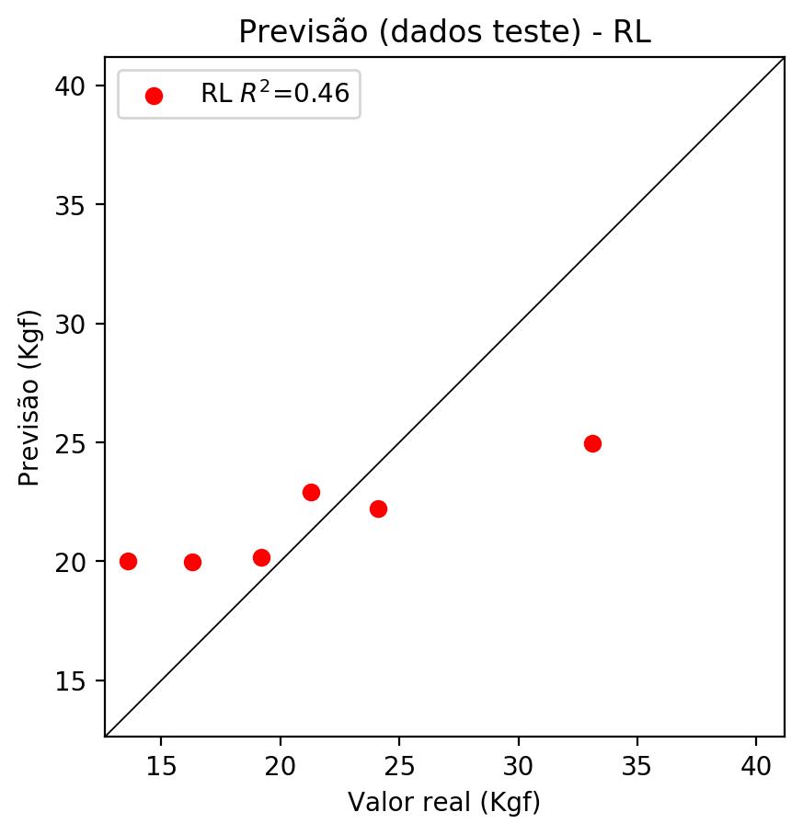

**Dados de treino**

* Erro relativo médio: 22.12
* Coeficiente de correlação: 0.5
* Coeficiente de determinação: 0.25
* MSE: 36.73
* RMSE: 6.06

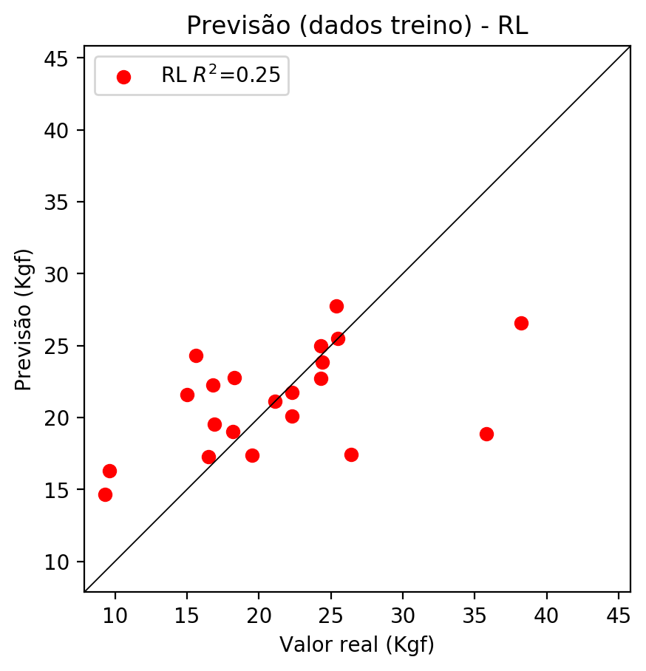

# RP2

# Coeficientes

[ 0. -0.0496002 0.40825349 0.35472491 -0.0827668 0.17472803  
 0.28774409 0.06896127 0.19240136 0.20002591]

# Erros

**Dados de teste**

* Erro relativo médio: 16.27
* Coeficiente de correlação: 0.86
* Coeficiente de determinação: 0.64
* MSE: 14.01
* RMSE: 3.74

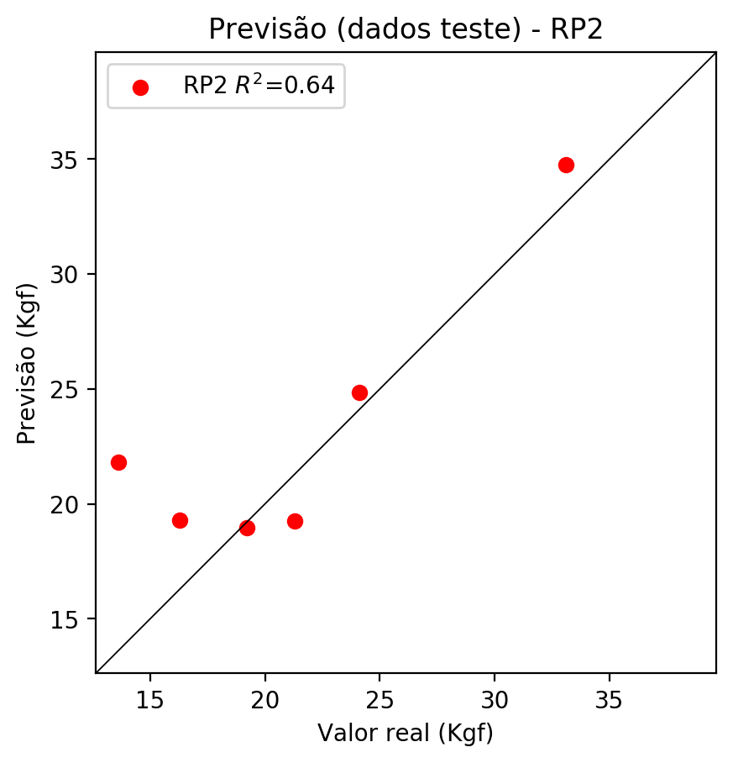

**Dados de treino**

* Erro relativo médio: 21.83
* Coeficiente de correlação: 0.61
* Coeficiente de determinação: 0.37
* MSE: 30.79
* RMSE: 5.55

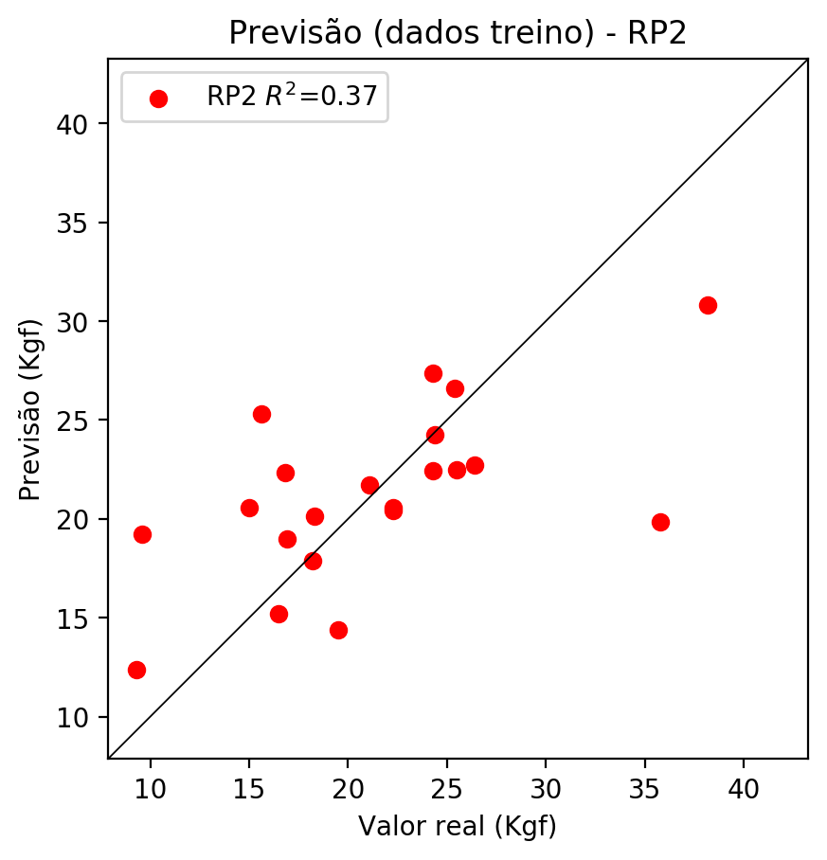

# RP3

# Coeficientes

[ 0. -0.03545152 0.26708384 -0.29010938 0.52761364 0.99426892  
 0.34246251 0.35730995 0.27501676 0.23991431 -0.05120775 -0.37932663  
 0.44194933 0.30293704 0.50489414 -0.34749707 0.38578777 1.16736849  
 0.00742926 -0.41904688]

# Erros

**Dados de teste**

* Erro relativo médio: 93.85
* Coeficiente de correlação: 0.86
* Coeficiente de determinação: -10.55
* MSE: 454.02
* RMSE: 21.31

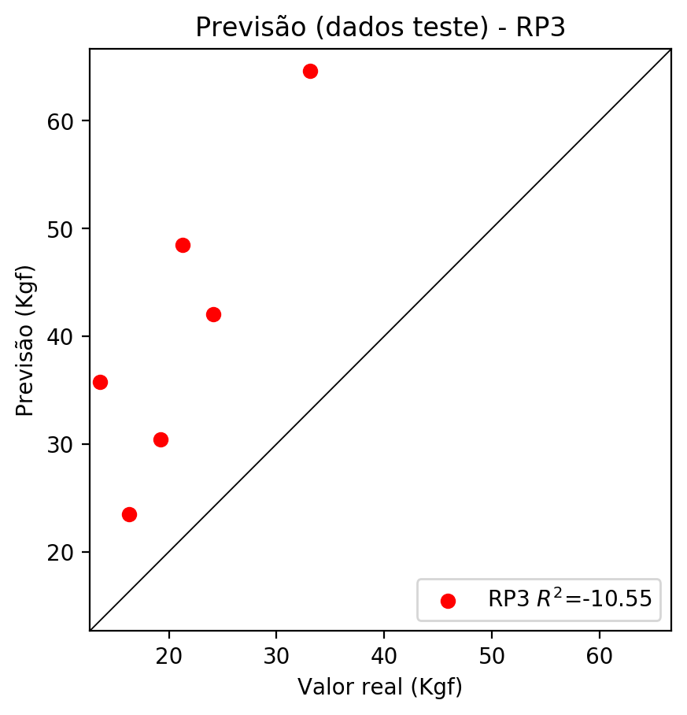

**Dados de treino**

* Erro relativo médio: 12.84
* Coeficiente de correlação: 0.9
* Coeficiente de determinação: 0.81
* MSE: 9.46
* RMSE: 3.08

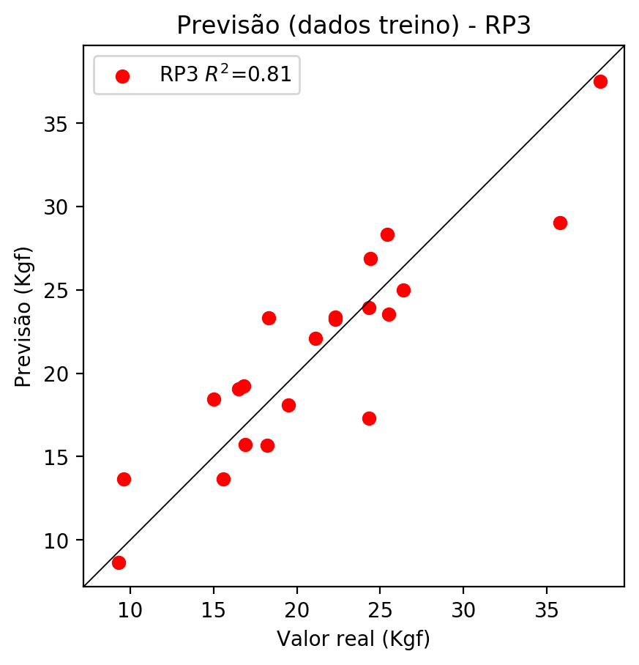

# RP4

# Coeficientes

[ 5.27355937e-16 -3.95053183e-01 1.54710540e-01 -3.88032085e-01  
 -1.57609109e-01 7.71921432e-02 7.22857359e-02 2.27622879e-01  
 5.30654974e-02 3.56084892e-01 -5.70632376e-01 -5.74848205e-01  
 7.78853794e-01 3.63460535e-01 9.83479364e-01 4.21583411e-01  
 2.23470780e-01 1.47172981e+00 3.89026198e-01 -5.60490789e-01  
 -3.01905593e-01 1.40576726e-01 3.14843135e-02 7.87720488e-01  
 -1.56637375e-02 4.54872609e-01 1.41897790e-01 3.27484851e-02  
 8.46603073e-01 1.04412730e-01 3.16884142e-01 1.06507941e-01  
 -6.20066244e-01 7.66501629e-02 5.14344845e-01]

# Erros

**Dados de teste**

* Erro relativo médio: 132.84
* Coeficiente de correlação: 0.68
* Coeficiente de determinação: -27.65
* MSE: 1125.76
* RMSE: 33.55

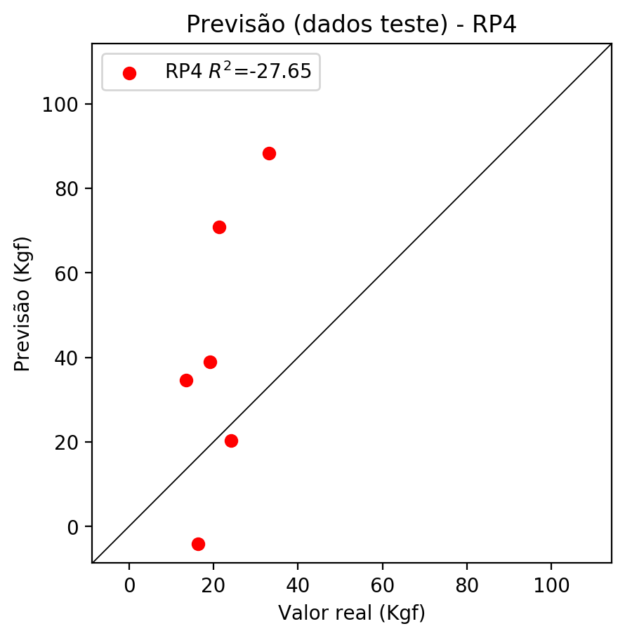

**Dados de treino**

* Erro relativo médio: 0.0
* Coeficiente de correlação: 1.0
* Coeficiente de determinação: 1.0
* MSE: 0.0
* RMSE: 0.0

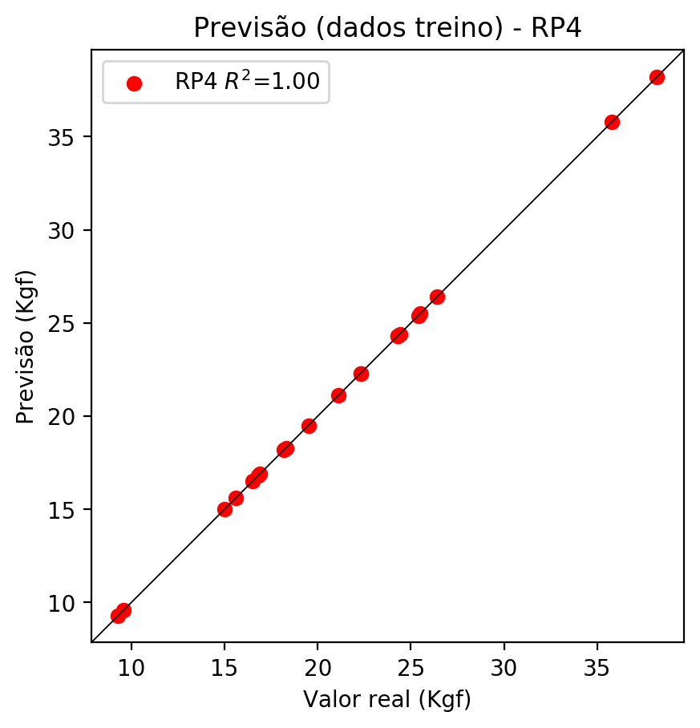

# Geral

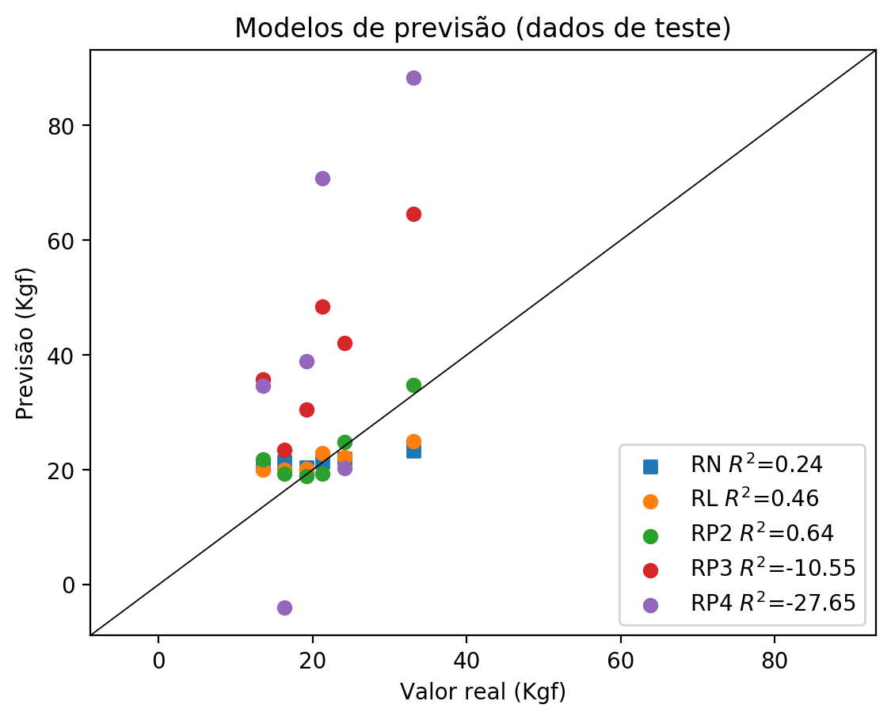

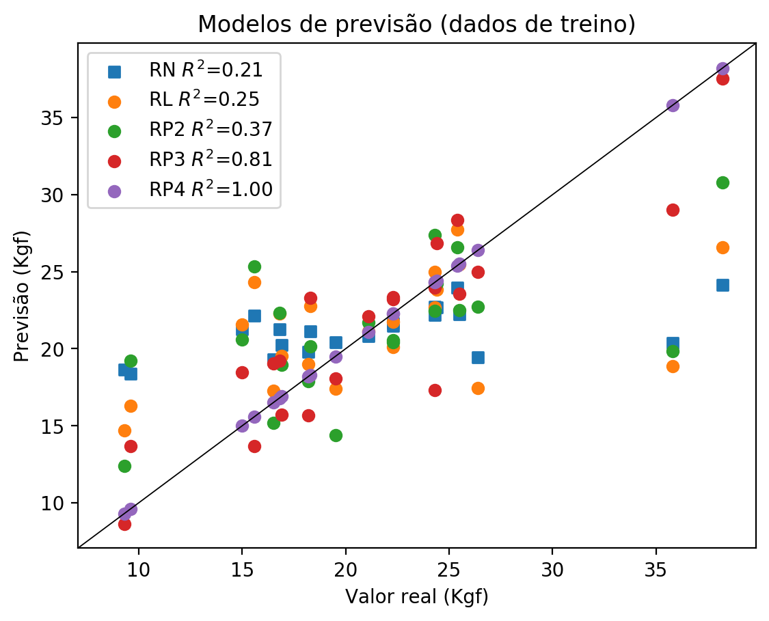

**Dados de teste**

|  |  |  |  |  |  |  |  |  |  |  |
| --- | --- | --- | --- | --- | --- | --- | --- | --- | --- | --- |
| Valor real | RN Previsto | RN Erro (%) | RL Previsto | RL Erro (%) | RP2 Previsto | RP2 Erro (%) | RP3 Previsto | RP3 Erro (%) | RP4 Previsto | RP4 Erro (%) |
| 13.6 | 20.72 | 52.35 | 20.03 | 47.28 | 21.82 | 60.44 | 35.77 | 163.01 | 34.66 | 154.85 |
| 33.1 | 23.29 | 29.64 | 24.95 | 24.62 | 34.76 | 5.02 | 64.61 | 95.2 | 88.29 | 166.74 |
| 21.3 | 21.34 | 0.19 | 22.9 | 7.51 | 19.26 | 9.58 | 48.47 | 127.56 | 70.79 | 232.35 |
| 24.1 | 21.99 | 8.76 | 22.23 | 7.76 | 24.85 | 3.11 | 42.08 | 74.61 | 20.3 | 15.77 |
| 16.3 | 21.39 | 31.23 | 19.98 | 22.58 | 19.29 | 18.34 | 23.49 | 44.11 | -4.05 | 124.85 |
| 19.2 | 20.48 | 6.67 | 20.17 | 5.05 | 18.98 | 1.15 | 30.45 | 58.59 | 38.88 | 102.5 |

**Dados de treino**

|  |  |  |  |  |  |  |  |  |  |  |
| --- | --- | --- | --- | --- | --- | --- | --- | --- | --- | --- |
| Valor real | RN Previsto | RN Erro (%) | RL Previsto | RL Erro (%) | RP2 Previsto | RP2 Erro (%) | RP3 Previsto | RP3 Erro (%) | RP4 Previsto | RP4 Erro (%) |
| 26.4 | 19.44 | 26.36 | 17.45 | 33.9 | 22.72 | 13.94 | 24.97 | 5.42 | 26.4 | 0.0 |
| 21.1 | 20.83 | 1.28 | 21.12 | 0.09 | 21.72 | 2.94 | 22.11 | 4.79 | 21.1 | 0.0 |
| 24.3 | 22.72 | 6.5 | 25.0 | 2.88 | 22.44 | 7.65 | 17.32 | 28.72 | 24.3 | 0.0 |
| 24.4 | 22.68 | 7.05 | 23.85 | 2.25 | 24.25 | 0.61 | 26.86 | 10.08 | 24.4 | 0.0 |
| 22.3 | 21.66 | 2.87 | 21.74 | 2.51 | 20.56 | 7.8 | 23.22 | 4.13 | 22.3 | 0.0 |
| 9.6 | 18.39 | 91.56 | 16.29 | 69.69 | 19.21 | 100.1 | 13.67 | 42.4 | 9.6 | 0.0 |
| 18.3 | 21.12 | 15.41 | 22.75 | 24.32 | 20.14 | 10.05 | 23.3 | 27.32 | 18.3 | 0.0 |
| 38.2 | 24.16 | 36.75 | 26.57 | 30.45 | 30.8 | 19.37 | 37.53 | 1.75 | 38.2 | 0.0 |
| 35.8 | 20.36 | 43.13 | 18.87 | 47.29 | 19.86 | 44.53 | 29.02 | 18.94 | 35.8 | 0.0 |
| 16.9 | 20.22 | 19.64 | 19.51 | 15.44 | 18.97 | 12.25 | 15.73 | 6.92 | 16.9 | 0.0 |
| 16.5 | 19.33 | 17.15 | 17.25 | 4.55 | 15.21 | 7.82 | 19.05 | 15.45 | 16.5 | 0.0 |
| 15.6 | 22.15 | 41.99 | 24.32 | 55.9 | 25.33 | 62.37 | 13.66 | 12.44 | 15.6 | 0.0 |
| 24.3 | 22.18 | 8.72 | 22.7 | 6.58 | 27.39 | 12.72 | 23.95 | 1.44 | 24.3 | 0.0 |
| 18.2 | 19.79 | 8.74 | 19.01 | 4.45 | 17.87 | 1.81 | 15.66 | 13.96 | 18.2 | 0.0 |
| 16.8 | 21.24 | 26.43 | 22.28 | 32.62 | 22.32 | 32.86 | 19.22 | 14.4 | 16.8 | 0.0 |
| 25.5 | 22.22 | 12.86 | 25.47 | 0.12 | 22.48 | 11.84 | 23.56 | 7.61 | 25.5 | 0.0 |
| 15.0 | 21.28 | 41.87 | 21.59 | 43.93 | 20.59 | 37.27 | 18.46 | 23.07 | 15.0 | 0.0 |
| 9.3 | 18.66 | 100.65 | 14.68 | 57.85 | 12.39 | 33.23 | 8.63 | 7.2 | 9.3 | 0.0 |
| 25.4 | 23.96 | 5.67 | 27.73 | 9.17 | 26.59 | 4.69 | 28.33 | 11.54 | 25.4 | 0.0 |
| 22.3 | 21.5 | 3.59 | 20.12 | 9.78 | 20.44 | 8.34 | 23.36 | 4.75 | 22.3 | 0.0 |
| 19.5 | 20.43 | 4.77 | 17.4 | 10.77 | 14.4 | 26.15 | 18.08 | 7.28 | 19.5 | 0.0 |