# Informações do estudo

Referência: Lalwani

Grandeza: Força

Tipo: Fy

Material: MDN250

Ferramenta: TNMA160408S01525

Número de experimentos: 20

Observações:  
Tool holder: MTJNR 2525M16  
Lathe Machine: HMT NH22  
Piezoelectric dynamometer: 9257B

# Unidades

Velocidade: m/min

Avanço: mm/rev

Profundidade de corte: mm

Força: N

# Dados de teste

|  |  |  |  |
| --- | --- | --- | --- |
| Força | n | f | a |
| 125.1 | 93.0 | 0.12 | 0.2 |
| 52.56 | 93.0 | 0.04 | 0.1 |
| 126.76 | 55.0 | 0.12 | 0.2 |
| 83.86 | 74.0 | 0.08 | 0.15 |

# Dados de treino

|  |  |  |  |
| --- | --- | --- | --- |
| Força | n | f | a |
| 85.23 | 55.0 | 0.12 | 0.1 |
| 118.2 | 93.0 | 0.12 | 0.2 |
| 79.32 | 55.0 | 0.04 | 0.2 |
| 87.63 | 55.0 | 0.04 | 0.2 |
| 77.32 | 74.0 | 0.08 | 0.15 |
| 54.59 | 55.0 | 0.04 | 0.1 |
| 78.49 | 93.0 | 0.12 | 0.1 |
| 88.51 | 93.0 | 0.04 | 0.2 |
| 84.2 | 93.0 | 0.12 | 0.1 |
| 82.48 | 93.0 | 0.04 | 0.2 |
| 116.4 | 55.0 | 0.12 | 0.2 |
| 85.94 | 55.0 | 0.12 | 0.1 |
| 56.88 | 55.0 | 0.04 | 0.1 |
| 49.72 | 93.0 | 0.04 | 0.1 |
| 91.62 | 74.0 | 0.08 | 0.15 |
| 87.13 | 74.0 | 0.08 | 0.15 |

# RN

Número de neurônios: 99

Taxa de aprendizado: 1.000000e-02

Número de épocas: 16

2° camada: False

Função de ativação: tanh

# Erros

**Dados de teste**

* Erro relativo médio: 3.97
* Coeficiente de correlação: 1.0
* Coeficiente de determinação: 0.99
* MSE: 43.61
* RMSE: 6.6

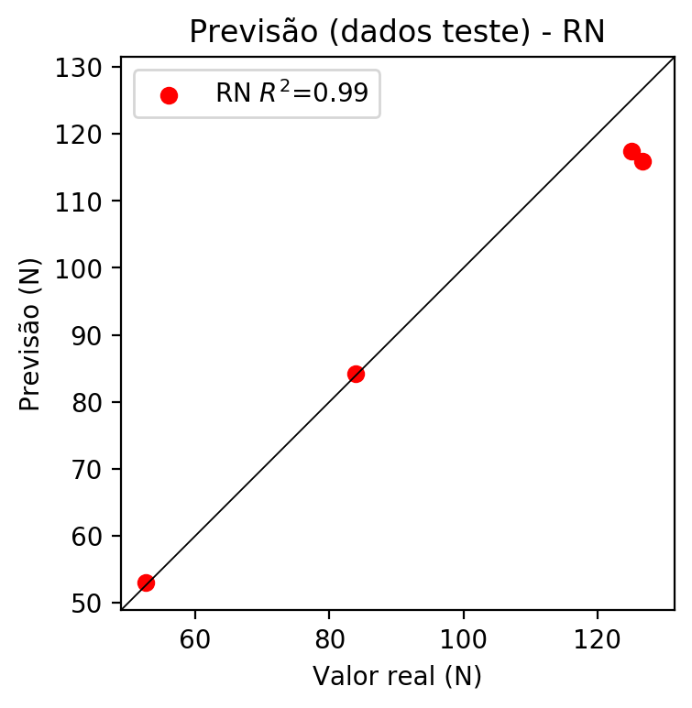

**Dados de treino**

* Erro relativo médio: 4.49
* Coeficiente de correlação: 0.98
* Coeficiente de determinação: 0.95
* MSE: 15.85
* RMSE: 3.98

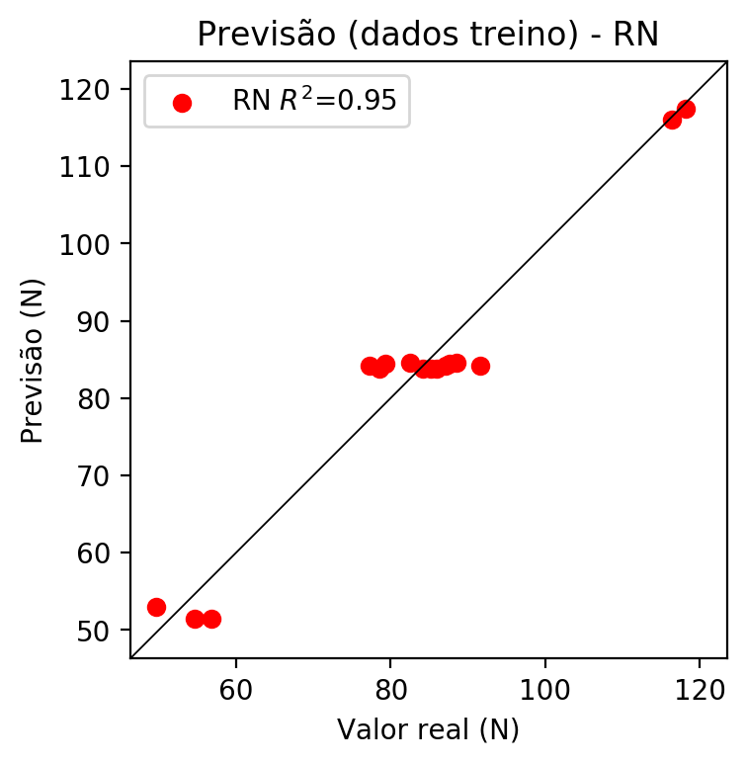

# Pesos

Pesos - camada oculta 1

[[ 3.49334106e-02 -5.84668294e-02 -4.26080376e-02 -1.35736242e-01  
 1.64184589e-02 -1.43497530e-03 1.31095201e-01 7.04077929e-02  
 2.79269144e-02 -2.51601301e-02 -1.02970608e-01 3.45651619e-02  
 -2.68206187e-02 -2.17921399e-02 8.57744366e-03 1.47449179e-02  
 -9.56040323e-02 3.06700841e-02 -7.80813470e-02 8.01340044e-02  
 8.12590569e-02 4.48040068e-02 1.00995429e-01 7.32853077e-03  
 8.60893354e-02 -4.64279391e-02 1.08942136e-01 -8.83944333e-02  
 5.43222949e-02 -5.20418771e-02 9.56918970e-02 -1.12850323e-01  
 -2.14026198e-02 -6.13580495e-02 -1.22174218e-01 -4.38267291e-02  
 -4.63328287e-02 -5.28259808e-03 -5.46004437e-02 7.33600780e-02  
 -6.70938753e-04 2.35518534e-03 7.55268261e-02 9.26080346e-02  
 -1.28602348e-02 4.18942943e-02 1.51990876e-01 -3.12867016e-02  
 7.77020156e-02 1.12801455e-01 2.71252189e-02 3.17198560e-02  
 -3.37178707e-02 3.83538753e-02 8.65468197e-03 -2.98487134e-02  
 6.42727613e-02 -1.37441576e-01 -9.57031101e-02 -8.60067979e-02  
 6.85030371e-02 -7.45774060e-02 -7.33495206e-02 -3.45422216e-02  
 1.01790026e-01 -9.78484005e-02 9.65256840e-02 -2.36555301e-02  
 -7.93540478e-02 -1.50043368e-02 7.12127313e-02 6.28593750e-03  
 -8.11343044e-02 -5.21477126e-02 -1.48119954e-02 -3.92911732e-02  
 -2.55914424e-02 6.46876693e-02 -1.22062698e-01 3.11984196e-02  
 3.98398079e-02 -1.08642370e-01 -1.07973769e-01 2.30477117e-02  
 -1.69545356e-02 6.79071471e-02 1.51488841e-01 -8.86634588e-02  
 -1.05393670e-01 6.85700402e-02 2.29018349e-02 -5.86546883e-02  
 -1.13077641e-01 -3.63413952e-02 1.56976208e-02 -3.91592458e-02  
 -1.07359521e-01 -7.37960637e-02 -1.64785553e-02]  
 [-6.40531927e-02 2.01575845e-01 -2.23951250e-01 2.87848473e-01  
 -7.85159171e-02 -3.10962468e-01 -2.74786025e-01 -1.73507184e-02  
 -2.04017490e-01 1.31369099e-01 6.18815832e-02 9.14158151e-02  
 -5.55553511e-02 1.32345647e-01 1.10654570e-01 -4.53085639e-02  
 3.27189654e-01 -7.92702660e-02 -1.92026019e-01 1.83498729e-02  
 -5.48555218e-02 1.44641668e-01 -2.46060625e-01 1.06429696e-01  
 -1.71618342e-01 1.43908322e-01 1.08548597e-01 2.90838331e-01  
 4.20723632e-02 -3.05559188e-01 -1.53609321e-01 3.67616713e-02  
 -9.04516876e-02 -7.70762488e-02 1.22321360e-01 1.15488991e-01  
 2.30458543e-01 -1.87935159e-02 -2.73850979e-04 -2.66962975e-01  
 2.82792360e-01 -1.02383019e-02 -1.38110116e-01 1.25480562e-01  
 3.82998027e-02 -7.11326152e-02 -1.52760476e-01 1.21777937e-01  
 2.13882551e-01 2.94438928e-01 1.70743719e-01 3.05803686e-01  
 -9.34580490e-02 -9.80975479e-02 -2.56238073e-01 -6.69577643e-02  
 -1.91719890e-01 2.51473367e-01 8.78332481e-02 1.71151869e-02  
 7.38922581e-02 -2.54792303e-01 6.09929785e-02 -8.55581909e-02  
 6.99933022e-02 -2.81501889e-01 -2.92760521e-01 2.59111822e-01  
 -1.95531577e-01 -3.09772640e-01 -1.79172903e-01 1.55441696e-04  
 1.04951039e-01 -3.14181328e-01 2.61277825e-01 -3.10946316e-01  
 1.96242049e-01 -1.39130726e-01 2.33468607e-01 -5.70714399e-02  
 -1.33241445e-01 1.55777410e-01 6.60007969e-02 3.39711830e-02  
 -1.74102768e-01 5.46074323e-02 -1.73140630e-01 9.62437838e-02  
 1.17905602e-01 6.65106550e-02 -1.87753484e-01 -1.07445635e-01  
 -2.56513953e-01 -3.53216100e-03 -6.62182942e-02 7.73676066e-03  
 -1.67649209e-01 2.50800401e-01 2.00694069e-01]  
 [-8.12873337e-03 8.76657739e-02 2.39413530e-01 -7.59265795e-02  
 3.51129562e-01 -2.00551525e-02 -2.18450323e-01 -1.50117159e-01  
 -2.10031286e-01 7.30979145e-02 -1.45882055e-01 3.00596774e-01  
 1.58940837e-01 -8.97077546e-02 -3.00640255e-01 2.40316186e-02  
 2.43854061e-01 -5.48863634e-02 1.74510032e-01 2.46052235e-01  
 3.19803953e-01 2.27721944e-01 1.20778438e-02 2.25666493e-01  
 -2.24535078e-01 1.08063929e-01 2.69186556e-01 4.90035955e-03  
 1.09022394e-01 -2.46805280e-01 -5.64633310e-02 -3.19323450e-01  
 -3.43971461e-01 -2.48571530e-01 8.29212517e-02 -3.39475036e-01  
 3.25043917e-01 2.40737662e-01 -2.25853011e-01 -2.19962746e-01  
 3.64934146e-01 -2.75200419e-02 1.94335699e-01 4.02246490e-02  
 2.02237859e-01 -9.31009054e-02 -4.43227664e-02 1.79302856e-01  
 1.67195395e-01 -1.04647437e-02 1.66690126e-01 1.58461660e-01  
 2.57457107e-01 -2.37148747e-01 1.48921236e-01 -8.94343033e-02  
 8.16403106e-02 2.55370587e-01 3.04601848e-01 -2.38279738e-02  
 2.50042617e-01 -2.96517819e-01 -2.91676015e-01 3.01299810e-01  
 1.14014983e-01 -2.73577780e-01 -3.01693290e-01 9.54917669e-02  
 -2.02046722e-01 -2.48326093e-01 -3.41025054e-01 5.79680353e-02  
 1.10006846e-01 4.77650575e-03 -1.01908363e-01 -3.72279584e-01  
 5.00151813e-02 1.54369786e-01 2.18364596e-01 -1.60105094e-01  
 -1.18501540e-02 -1.72127888e-01 -1.55406162e-01 2.09033281e-01  
 -3.07557851e-01 -1.89015538e-01 -8.76604393e-02 3.47707242e-01  
 -5.81117757e-02 1.54466987e-01 -1.19733319e-01 -5.57891503e-02  
 -1.09096326e-01 2.87429124e-01 -2.96417445e-01 1.45156026e-01  
 2.94028640e-01 3.74734551e-01 7.40630478e-02]]

Bias - camada oculta

[ 3.1161583e-03 -1.8919172e-02 -2.1034107e-02 1.1053092e-02  
 5.8058073e-04 -3.8584592e-03 1.7262558e-02 -1.2257789e-02  
 1.0815605e-02 8.9006033e-04 2.6131270e-04 -1.9736385e-02  
 2.3401892e-03 1.6379554e-02 -7.4270270e-03 -3.1626872e-03  
 -2.6483681e-02 -1.5211443e-03 -1.3906707e-02 -1.4576987e-02  
 -1.2070963e-02 -1.8718347e-02 9.5170015e-04 -1.1028026e-02  
 3.3647269e-02 -9.9261082e-04 -2.9785985e-02 1.4616358e-03  
 -1.7064546e-03 3.1109916e-02 3.0891104e-02 1.9721188e-02  
 2.0320533e-02 1.7902549e-02 -1.8720046e-02 -1.5171845e-03  
 -3.0630531e-02 -1.3255766e-03 8.4415451e-03 3.0470034e-02  
 -3.2802593e-02 2.2651902e-03 3.3359416e-03 1.3310290e-03  
 -3.2981148e-03 4.0971223e-02 3.5045284e-03 5.6583475e-04  
 -1.8232426e-02 -5.5737724e-03 -1.1337649e-02 -1.6292894e-02  
 3.8165250e-03 8.4046833e-03 -1.8926946e-02 9.7081298e-05  
 -1.9554369e-02 -1.8082734e-02 -1.3643092e-02 -6.3773626e-03  
 -1.8715767e-02 3.8845327e-02 8.3906585e-03 5.4275542e-03  
 -3.9806780e-03 4.0792678e-02 3.0569259e-02 -1.6015476e-03  
 2.2749813e-02 2.5164193e-02 3.7368331e-02 -2.4561379e-02  
 7.5611575e-03 5.0297880e-05 1.6034616e-02 6.6768780e-02  
 2.4124256e-03 4.2531742e-03 -1.6339986e-02 1.4782143e-03  
 1.7985472e-03 -4.2122011e-03 9.0741238e-04 -1.0240886e-03  
 2.4126763e-02 1.2914621e-02 4.4049099e-03 -1.1894142e-02  
 -7.4774781e-03 -7.7296612e-03 2.8804834e-03 -7.4183824e-04  
 1.4953531e-02 -1.7459245e-03 8.5934596e-03 -6.8421671e-03  
 -2.8957138e-02 -4.2855565e-02 2.9266390e-04]

Pesos - camada saída

[[ 0.04138035 0.03236504 -0.03619446 0.15870744 0.02887333 0.01647101  
 -0.16625707 -0.07551087 0.01804494 -0.02425561 -0.11031501 0.0396295  
 -0.01797785 0.04644996 -0.00526676 0.01356881 0.18923402 0.02826743  
 -0.07579201 0.08623581 0.08996987 0.04651833 -0.14677642 0.01152949  
 -0.09291518 -0.0543211 0.11255661 0.14164583 0.05861469 -0.0455292  
 -0.09414304 -0.12061549 -0.02795235 -0.06580489 0.11907838 -0.05555148  
 0.03039963 0.00467143 -0.06137225 -0.10627619 -0.00236806 0.00645055  
 0.08537441 0.09402791 -0.00501274 -0.02562436 -0.15611298 -0.0380552  
 0.07640965 0.10847873 0.02667876 0.02228432 -0.02536849 0.01150959  
 0.02579731 -0.03892078 -0.06329026 0.16291943 -0.10152889 -0.09144772  
 0.07302206 -0.07251582 -0.08213712 -0.02035399 0.10549613 -0.09514987  
 -0.1921649 -0.03196382 -0.07914519 -0.00525025 -0.07728676 -0.01710973  
 0.08352982 -0.04244066 -0.03381184 -0.03369948 -0.02966832 0.07441474  
 0.1798576 0.02210371 0.04815663 -0.11820157 -0.11544839 0.04739248  
 -0.01914058 0.07011375 -0.15454571 -0.09431325 -0.11346683 0.07248572  
 0.02306897 -0.06020284 -0.11082001 -0.01702907 0.00459504 -0.04295631  
 -0.10646772 0.11780491 -0.02128148]]

# Iterações

|  |  |  |  |  |  |  |
| --- | --- | --- | --- | --- | --- | --- |
| Média | Desvio | n | ln | 2° camada | Função | Épocas |
| -0.1189 | 0.066 | 10 | 0.1 | False | relu | 38 |
| -0.1384 | 0.1496 | 17 | 0.1 | True | relu | 716 |
| -0.0958 | 0.0926 | 7 | 0.01 | True | tanh | 130 |
| -0.1153 | 0.059 | 19 | 0.001 | False | tanh | 282 |
| -0.1095 | 0.0914 | 29 | 0.001 | False | relu | 469 |
| -0.0869 | 0.0731 | 88 | 0.1 | False | tanh | 926 |
| -0.1813 | 0.1788 | 95 | 0.0001 | True | relu | 984 |
| -0.1119 | 0.0783 | 10 | 0.01 | True | tanh | 865 |
| -0.4231 | 0.2391 | 58 | 0.001 | True | relu | 8 |
| -0.1177 | 0.1155 | 9 | 0.01 | False | tanh | 514 |
| -0.2496 | 0.1201 | 73 | 0.0001 | True | relu | 729 |
| -0.2523 | 0.1689 | 22 | 0.001 | True | relu | 543 |
| -0.2246 | 0.0886 | 25 | 0.1 | True | relu | 562 |
| -0.1691 | 0.0385 | 53 | 0.001 | False | relu | 498 |
| -0.1475 | 0.0854 | 83 | 0.01 | True | relu | 337 |
| -0.0842 | 0.0258 | 99 | 0.01 | False | tanh | 16 |
| -0.09 | 0.0685 | 23 | 0.01 | False | relu | 472 |
| -0.1393 | 0.1158 | 24 | 0.001 | True | relu | 778 |
| -0.0856 | 0.0755 | 58 | 0.01 | True | tanh | 382 |
| -0.1385 | 0.1791 | 35 | 0.1 | False | tanh | 596 |

# RL

# Coeficientes

[ 0. -0.0360752 0.63667399 0.65743423]

# Erros

**Dados de teste**

* Erro relativo médio: 4.28
* Coeficiente de correlação: 1.0
* Coeficiente de determinação: 0.99
* MSE: 45.13
* RMSE: 6.72

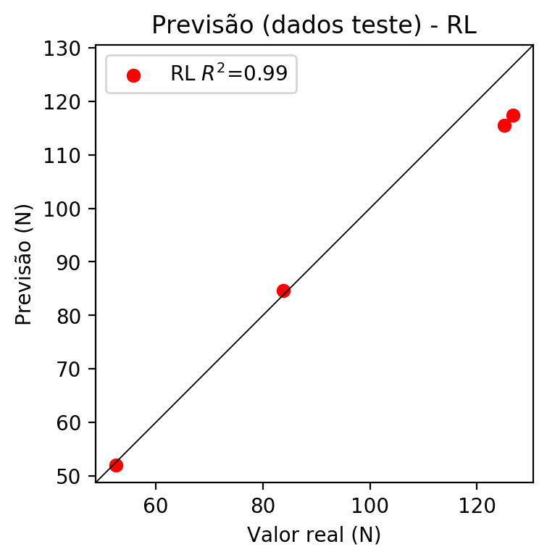

**Dados de treino**

* Erro relativo médio: 3.76
* Coeficiente de correlação: 0.98
* Coeficiente de determinação: 0.96
* MSE: 14.08
* RMSE: 3.75

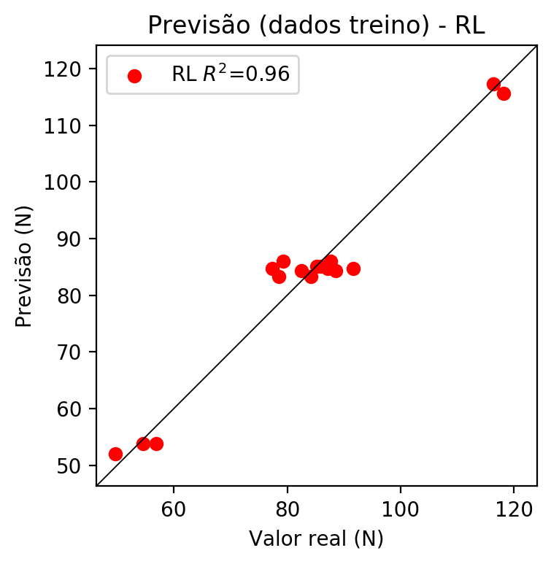

# RP2

# Coeficientes

[ 0. -0.02997468 0.64582477 0.66658501 -0.0104546 0.00810767  
 0.06656779 -0.0104546 0.02024795 -0.0104546 ]

# Erros

**Dados de teste**

* Erro relativo médio: 5.05
* Coeficiente de correlação: 0.99
* Coeficiente de determinação: 0.99
* MSE: 41.52
* RMSE: 6.44

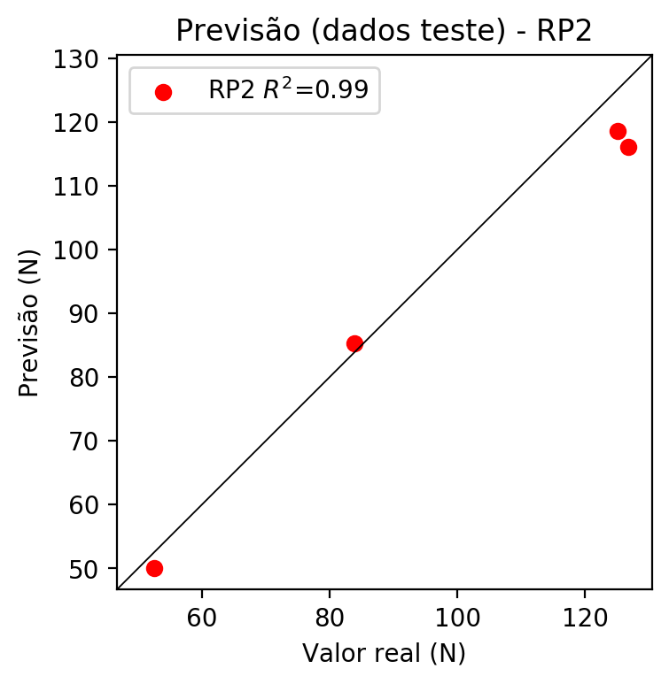

**Dados de treino**

* Erro relativo médio: 3.1
* Coeficiente de correlação: 0.98
* Coeficiente de determinação: 0.97
* MSE: 11.22
* RMSE: 3.35

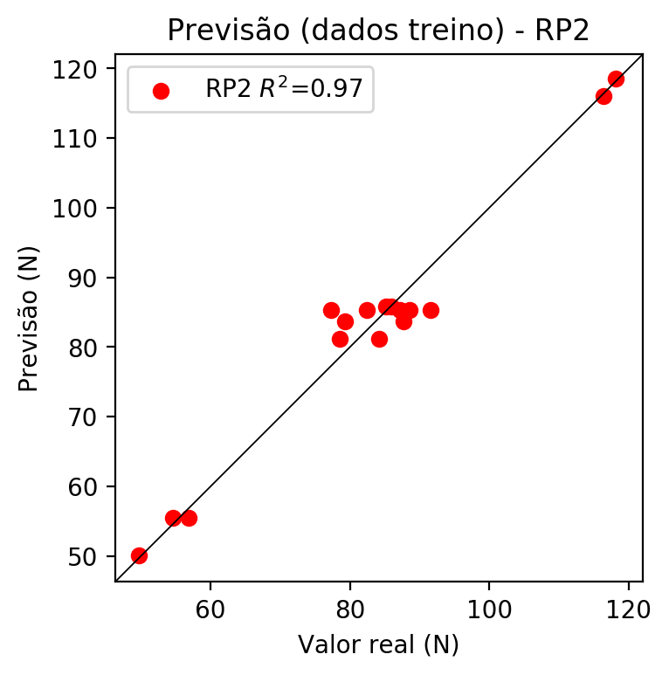

# RP3

# Coeficientes

[-1.38777878e-17 -6.26008361e-03 1.23650027e-01 1.27619125e-01  
 -1.07368851e-02 7.26082180e-03 6.57209433e-02 -1.07368851e-02  
 1.94011026e-02 -1.07368851e-02 -7.43384928e-03 1.46834408e-01  
 1.51547711e-01 -7.43384928e-03 -8.54833386e-03 -7.43384928e-03  
 1.46834408e-01 1.51547711e-01 1.46834408e-01 1.51547711e-01]

# Erros

**Dados de teste**

* Erro relativo médio: 5.22
* Coeficiente de correlação: 0.99
* Coeficiente de determinação: 0.99
* MSE: 41.31
* RMSE: 6.43

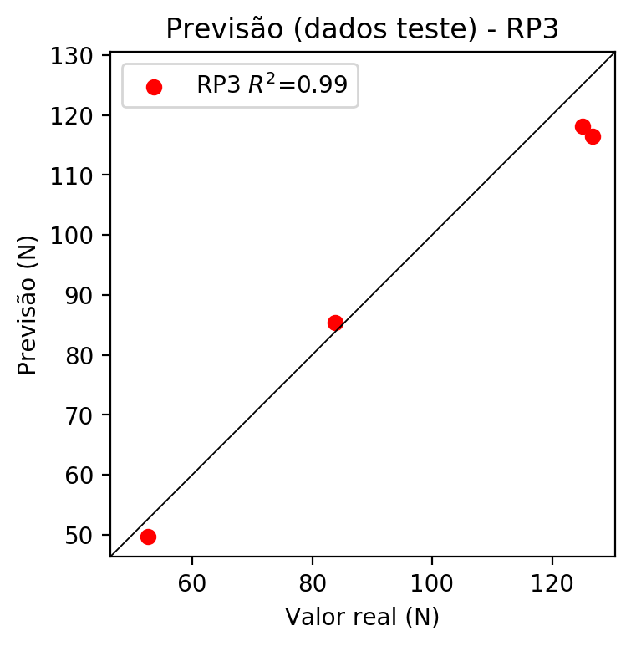

**Dados de treino**

* Erro relativo médio: 3.02
* Coeficiente de correlação: 0.98
* Coeficiente de determinação: 0.97
* MSE: 11.18
* RMSE: 3.34

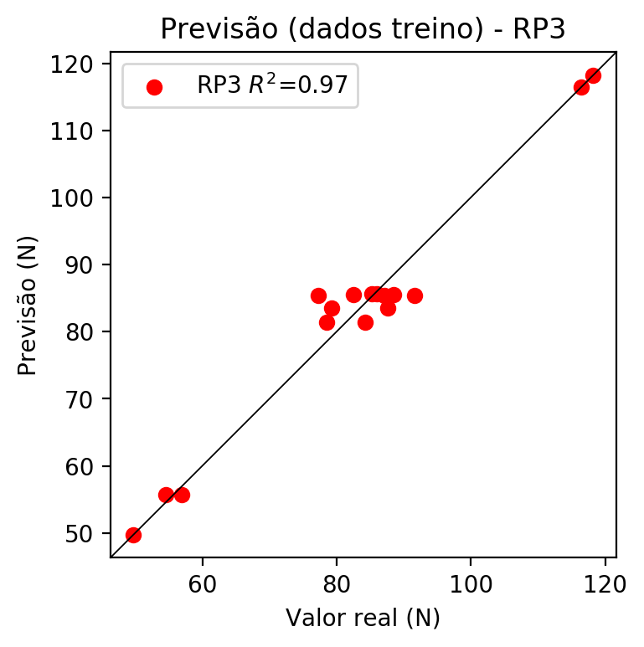

# RP4

# Coeficientes

[-1.38777878e-17 -6.26008361e-03 1.23650027e-01 1.27619125e-01  
 -2.81047299e-03 1.38817803e-03 1.25650198e-02 -2.81047299e-03  
 3.70924740e-03 -2.81047299e-03 -7.43384928e-03 1.46834408e-01  
 1.51547711e-01 -7.43384928e-03 -8.54833386e-03 -7.43384928e-03  
 1.46834408e-01 1.51547711e-01 1.46834408e-01 1.51547711e-01  
 -3.33743668e-03 1.64846141e-03 1.49209610e-02 -3.33743668e-03  
 4.40473129e-03 -3.33743668e-03 1.64846141e-03 1.49209610e-02  
 1.64846141e-03 1.49209610e-02 -3.33743668e-03 4.40473129e-03  
 -3.33743668e-03 4.40473129e-03 -3.33743668e-03]

# Erros

**Dados de teste**

* Erro relativo médio: 5.22
* Coeficiente de correlação: 0.99
* Coeficiente de determinação: 0.99
* MSE: 41.31
* RMSE: 6.43

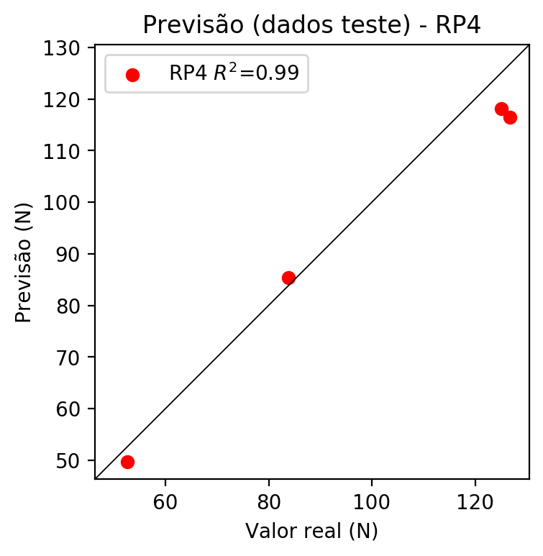

**Dados de treino**

* Erro relativo médio: 3.02
* Coeficiente de correlação: 0.98
* Coeficiente de determinação: 0.97
* MSE: 11.18
* RMSE: 3.34

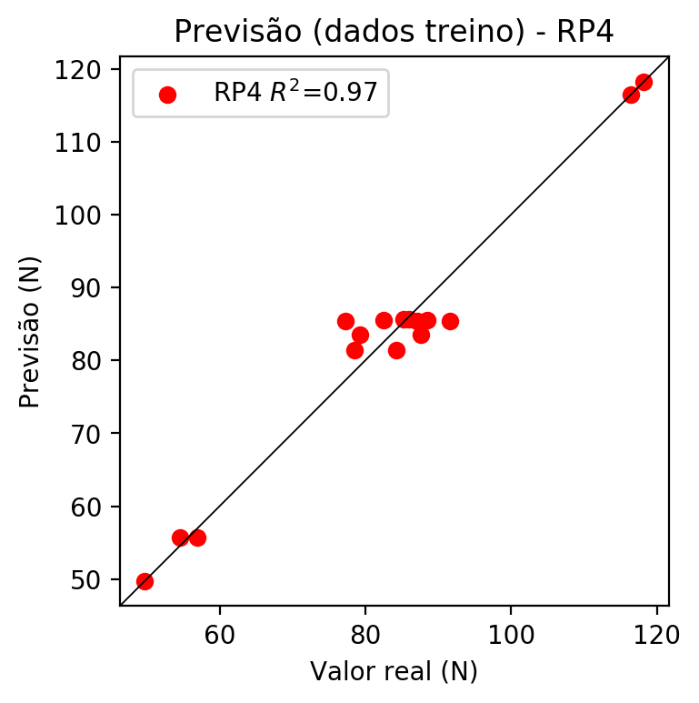

# Geral

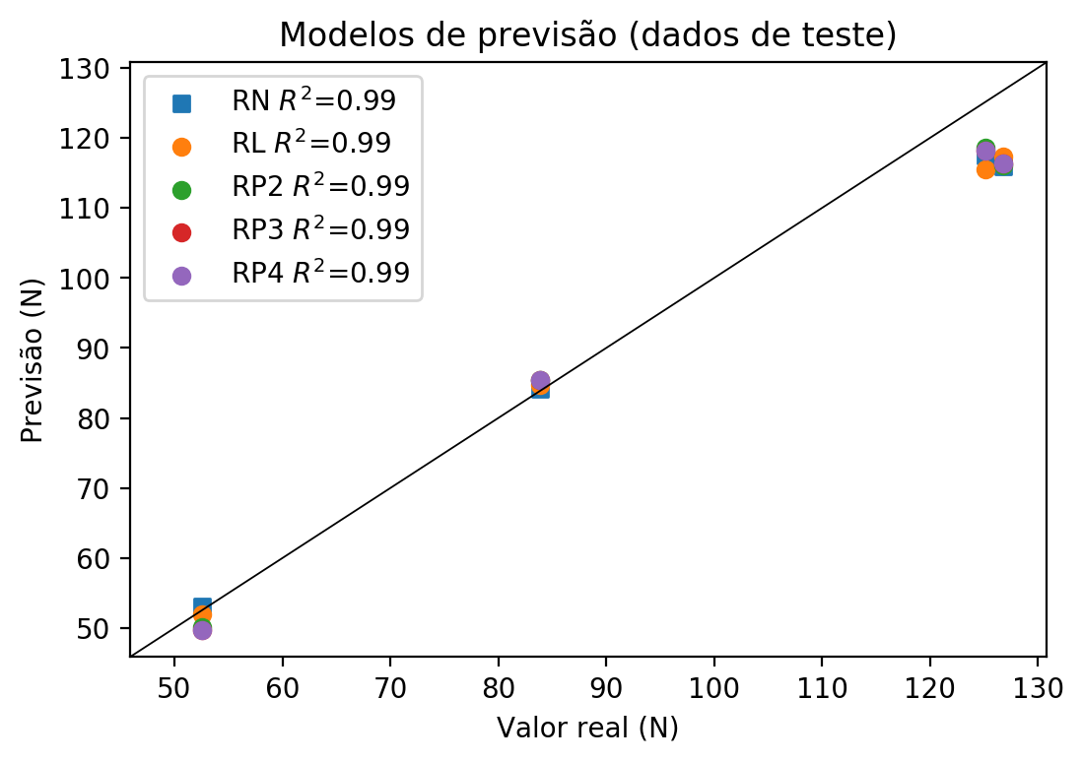

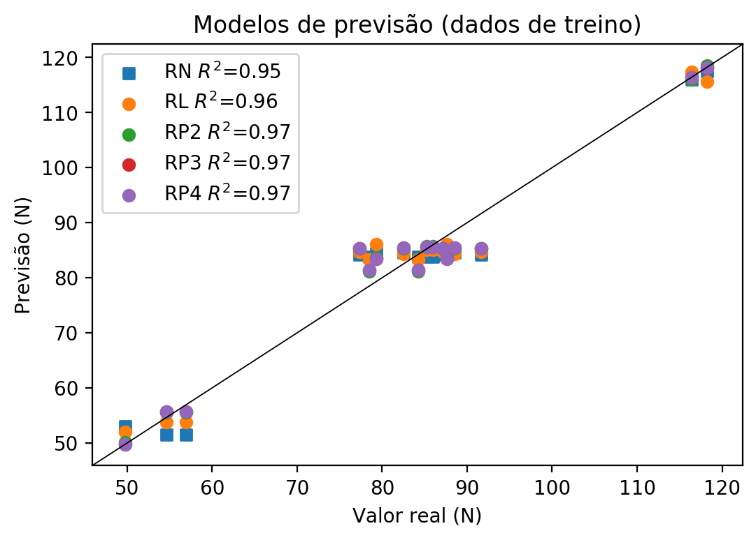

**Dados de teste**

|  |  |  |  |  |  |  |  |  |  |  |
| --- | --- | --- | --- | --- | --- | --- | --- | --- | --- | --- |
| Valor real | RN Previsto | RN Erro (%) | RL Previsto | RL Erro (%) | RP2 Previsto | RP2 Erro (%) | RP3 Previsto | RP3 Erro (%) | RP4 Previsto | RP4 Erro (%) |
| 125.1 | 117.49 | 6.08 | 115.57 | 7.62 | 118.56 | 5.23 | 118.2 | 5.52 | 118.2 | 5.52 |
| 52.56 | 53.05 | 0.93 | 51.98 | 1.1 | 50.08 | 4.72 | 49.72 | 5.4 | 49.72 | 5.4 |
| 126.76 | 115.98 | 8.5 | 117.34 | 7.43 | 116.04 | 8.46 | 116.4 | 8.17 | 116.4 | 8.17 |
| 83.86 | 84.16 | 0.36 | 84.66 | 0.95 | 85.36 | 1.79 | 85.36 | 1.79 | 85.36 | 1.79 |

**Dados de treino**

|  |  |  |  |  |  |  |  |  |  |  |
| --- | --- | --- | --- | --- | --- | --- | --- | --- | --- | --- |
| Valor real | RN Previsto | RN Erro (%) | RL Previsto | RL Erro (%) | RP2 Previsto | RP2 Erro (%) | RP3 Previsto | RP3 Erro (%) | RP4 Previsto | RP4 Erro (%) |
| 85.23 | 83.76 | 1.72 | 85.04 | 0.22 | 85.77 | 0.63 | 85.59 | 0.42 | 85.58 | 0.41 |
| 118.2 | 117.49 | 0.6 | 115.57 | 2.23 | 118.56 | 0.3 | 118.2 | 0.0 | 118.2 | 0.0 |
| 79.32 | 84.49 | 6.52 | 86.06 | 8.5 | 83.66 | 5.47 | 83.47 | 5.23 | 83.47 | 5.23 |
| 87.63 | 84.49 | 3.58 | 86.06 | 1.79 | 83.66 | 4.53 | 83.47 | 4.75 | 83.47 | 4.75 |
| 77.32 | 84.16 | 8.85 | 84.66 | 9.49 | 85.36 | 10.4 | 85.36 | 10.4 | 85.36 | 10.4 |
| 54.59 | 51.48 | 5.7 | 53.76 | 1.52 | 55.55 | 1.76 | 55.73 | 2.09 | 55.73 | 2.09 |
| 78.49 | 83.81 | 6.78 | 83.26 | 6.08 | 81.16 | 3.4 | 81.34 | 3.63 | 81.34 | 3.63 |
| 88.51 | 84.6 | 4.42 | 84.28 | 4.78 | 85.31 | 3.62 | 85.5 | 3.4 | 85.5 | 3.4 |
| 84.2 | 83.81 | 0.46 | 83.26 | 1.12 | 81.16 | 3.61 | 81.34 | 3.4 | 81.34 | 3.4 |
| 82.48 | 84.6 | 2.57 | 84.28 | 2.18 | 85.31 | 3.43 | 85.5 | 3.66 | 85.5 | 3.66 |
| 116.4 | 115.98 | 0.36 | 117.34 | 0.81 | 116.04 | 0.31 | 116.4 | 0.0 | 116.4 | 0.0 |
| 85.94 | 83.76 | 2.54 | 85.04 | 1.05 | 85.77 | 0.2 | 85.59 | 0.41 | 85.58 | 0.42 |
| 56.88 | 51.48 | 9.49 | 53.76 | 5.49 | 55.55 | 2.34 | 55.73 | 2.02 | 55.73 | 2.02 |
| 49.72 | 53.05 | 6.7 | 51.98 | 4.55 | 50.08 | 0.72 | 49.72 | 0.0 | 49.72 | 0.0 |
| 91.62 | 84.16 | 8.14 | 84.66 | 7.6 | 85.36 | 6.83 | 85.36 | 6.83 | 85.36 | 6.83 |
| 87.13 | 84.16 | 3.41 | 84.66 | 2.83 | 85.36 | 2.03 | 85.36 | 2.03 | 85.36 | 2.03 |