# Informações do estudo

Referência: Lee

Grandeza: Rugosidade

Tipo: Ra

Material: S45C

Ferramenta: Tungsten carbide P-10

Número de experimentos: 27

Observações:  
Dynamometer: Kistler 525PA  
Profile meter: 3D-Hommelewerk

# Unidades

Velocidade: m/min

Avanço: mm/rev

Profundidade de corte: mm

Rugosidade: μm

# Dados de teste

|  |  |  |  |
| --- | --- | --- | --- |
| Rugosidade | n | f | a |
| 1.01 | 210.0 | 0.08 | 1.1 |
| 10.17 | 285.0 | 0.32 | 1.6 |
| 4.12 | 135.0 | 0.2 | 1.6 |
| 5.34 | 135.0 | 0.2 | 0.6 |
| 1.68 | 135.0 | 0.08 | 1.1 |
| 2.75 | 210.0 | 0.2 | 1.1 |

# Dados de treino

|  |  |  |  |
| --- | --- | --- | --- |
| Rugosidade | n | f | a |
| 9.7 | 285.0 | 0.32 | 0.6 |
| 4.06 | 135.0 | 0.32 | 1.1 |
| 6.12 | 285.0 | 0.32 | 1.1 |
| 7.49 | 210.0 | 0.32 | 1.1 |
| 4.51 | 210.0 | 0.2 | 0.6 |
| 0.91 | 285.0 | 0.08 | 1.1 |
| 2.74 | 285.0 | 0.2 | 1.1 |
| 14.37 | 210.0 | 0.32 | 1.6 |
| 11.05 | 210.0 | 0.32 | 0.6 |
| 2.61 | 210.0 | 0.08 | 0.6 |
| 1.86 | 135.0 | 0.08 | 1.6 |
| 1.25 | 285.0 | 0.08 | 1.6 |
| 6.06 | 210.0 | 0.2 | 1.6 |
| 2.64 | 210.0 | 0.08 | 1.6 |
| 1.92 | 135.0 | 0.2 | 1.1 |
| 9.49 | 135.0 | 0.32 | 0.6 |
| 1.24 | 135.0 | 0.08 | 0.6 |
| 0.56 | 285.0 | 0.08 | 0.6 |
| 9.44 | 135.0 | 0.32 | 1.6 |
| 4.18 | 285.0 | 0.2 | 1.6 |
| 2.84 | 285.0 | 0.2 | 0.6 |

# RN

Número de neurônios: 83

Taxa de aprendizado: 1.000000e-02

Número de épocas: 337

2° camada: True

Função de ativação: relu

# Erros

**Dados de teste**

* Erro relativo médio: 41.59
* Coeficiente de correlação: 0.94
* Coeficiente de determinação: 0.89
* MSE: 1.15
* RMSE: 1.07

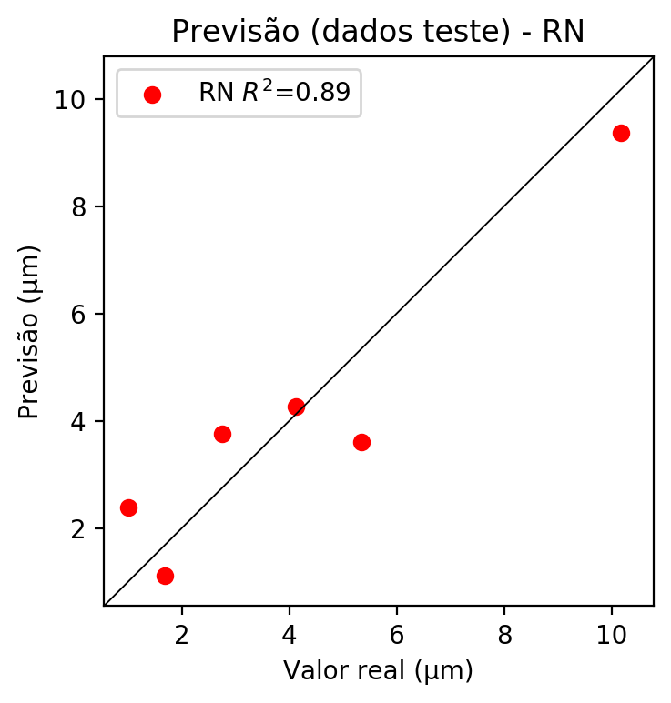

**Dados de treino**

* Erro relativo médio: 0.0
* Coeficiente de correlação: 1.0
* Coeficiente de determinação: 1.0
* MSE: 0.0
* RMSE: 0.0

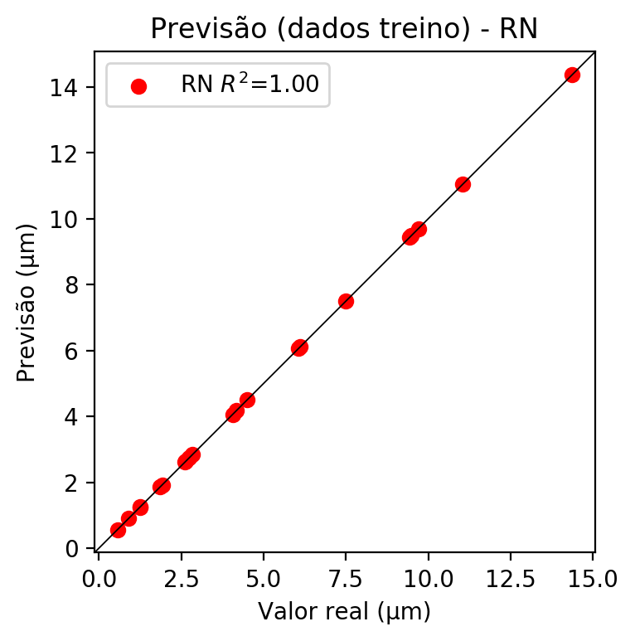

# Pesos

Pesos - camada oculta 1

[[ 0.0429965 -0.01872586 -0.13851745 -0.02900254 0.19947942 -0.016382  
 0.03250792 0.08275171 0.07263736 0.22062783 -0.10409667 0.21903504  
 0.04958503 0.0674844 -0.04668761 0.00110859 0.1347248 0.02802  
 -0.33138198 0.01855186 0.2677586 0.28560498 -0.05237568 0.10269086  
 -0.02455674 -0.11374576 0.33878198 0.11156513 0.20880926 -0.04891022  
 -0.17961146 -0.12511301 -0.07093862 -0.18414585 0.11146687 -0.13390051  
 0.02139082 0.15976197 -0.2307535 0.02452208 0.258029 0.12690409  
 0.23258139 0.29901394 0.00747541 0.00084293 0.03912532 -0.07852326  
 0.14274167 0.31900322 0.10096532 0.26858252 -0.04465803 0.04900803  
 -0.04806365 -0.01103342 -0.05746874 0.13065626 -0.2094398 -0.10084382  
 0.31593713 -0.2723787 -0.32178715 0.08829761 0.30365583 -0.18868914  
 0.09123122 -0.00967767 -0.35222197 -0.2227633 0.01827245 0.0276411  
 0.0336588 -0.06303928 0.11800963 -0.07908578 0.02190686 0.15287712  
 0.05233746 -0.09920376 0.09438884 -0.34967414 -0.31471065]  
 [ 0.01880854 -0.16853453 0.26067764 -0.05114536 -0.24169788 -0.24018848  
 0.0869983 -0.11287661 -0.2604205 -0.25775075 0.13535297 -0.01745845  
 -0.07776814 -0.16587576 0.03709861 0.04613668 -0.19424373 0.1725957  
 -0.10948835 0.1878396 -0.11512472 -0.22759722 -0.16016251 -0.08798986  
 -0.09793787 0.11153438 0.08796812 -0.0021542 -0.04331086 0.2822209  
 0.14472131 0.08197617 0.15033662 -0.02625647 -0.14920132 -0.06480928  
 -0.07232891 -0.02454462 -0.1449962 0.01986867 -0.10093655 0.1998673  
 0.09602439 0.25233817 0.02138539 -0.198243 0.02590061 0.13695617  
 0.1287344 0.0419907 0.21294954 0.23967907 0.04150312 -0.06609192  
 0.04924916 -0.10079565 0.18841045 -0.1201257 -0.22359744 -0.05195527  
 0.02680961 -0.01840817 -0.09551792 0.22866757 0.14725082 0.27229276  
 0.1365414 0.24276769 -0.15640096 -0.00211164 -0.27057546 -0.07937107  
 -0.29233882 0.16342789 0.12388369 0.17746842 0.00803829 -0.10147121  
 0.19079153 -0.1859788 -0.02382947 -0.1727806 -0.12290445]  
 [ 0.3339836 -0.22678424 -0.1072117 0.00209715 -0.1369046 0.17776051  
 -0.35932776 0.0690258 -0.1625906 0.1736196 -0.39450836 0.20800473  
 0.18945709 -0.23849548 0.39791802 0.25395828 0.15822549 0.04255449  
 -0.1105695 -0.24129212 0.20465966 0.23413451 -0.0844856 -0.0799193  
 0.01502694 -0.16854028 -0.07798094 0.03773229 0.06597738 -0.09224162  
 0.16763783 0.24263752 -0.25921437 0.10330702 0.085729 -0.20968047  
 0.35443467 -0.0404708 -0.13078678 -0.22462036 -0.09607899 -0.03056413  
 -0.01919108 0.2773609 -0.06486875 -0.21331853 -0.31754023 0.22659755  
 0.30552387 0.10924968 0.28682473 0.27561298 0.31367013 0.20842783  
 0.27640206 0.25152254 -0.03050857 0.08288115 0.15865235 -0.06122855  
 -0.02249393 -0.03457928 0.11068504 -0.2632265 -0.21392266 -0.09970593  
 -0.00828634 -0.3503626 0.23499463 0.13505125 -0.1713017 -0.2049826  
 0.24538375 -0.0658149 0.06461005 0.03370497 0.24994299 0.06543925  
 0.23359123 0.19952133 0.16415477 0.00530685 0.12112566]]

Bias - camada oculta

[ 0.01749855 -0.04946028 -0.02445154 -0.11144447 -0.00342175 -0.05082452  
 -0.16733839 -0.1290982 -0.01865233 0.04100601 0.00683154 0.08734659  
 -0.09105488 -0.05713591 -0.10152963 -0.11610965 0.00830536 -0.00700472  
 0.09932364 -0.10851714 0.01745297 0.03689367 0.1348159 -0.09194965  
 -0.04838199 0.06440531 -0.0807704 -0.0827561 -0.0772304 0.01047262  
 -0.07262901 -0.12034339 -0.15752032 -0.03727213 -0.11365017 0.02754431  
 0.02000585 -0.13311554 0.01840872 -0.08753893 0.09539453 -0.06487647  
 0.1227011 0.00083236 -0.1310061 0.08400794 -0.01418122 -0.05065457  
 0.07866054 0.10366294 0.08049526 -0.00976374 -0.15513793 -0.02680874  
 -0.11430775 -0.07088247 -0.05500752 -0.07030063 -0.00089259 -0.08654414  
 0.12876797 -0.02510805 0.02151273 0.05353143 0.1205646 0.01868194  
 -0.0123893 -0.05198101 0.10594538 0.01743938 0.06087223 -0.05019863  
 -0.08747284 -0.06990995 -0.09635597 0.04024385 -0.01234996 -0.07506354  
 0.00365585 0.02630347 -0.07039157 0.15995447 0.03108811]

Pesos - camada oculta 2

[[ 0.27233362 0.03531956 -0.24568084 ... 0.2193081 -0.17377998  
 -0.30576658]  
 [-0.21294044 -0.19482045 0.1808211 ... -0.06248506 -0.10197743  
 -0.15204525]  
 [ 0.17527106 -0.08061044 -0.24385658 ... 0.0547339 0.07537818  
 -0.03824396]  
 ...  
 [-0.0519577 -0.03282584 0.21806546 ... -0.0170807 -0.02884282  
 0.06900738]  
 [-0.22879578 -0.17412835 0.06475154 ... 0.00746725 0.21419945  
 0.02160906]  
 [ 0.0927197 -0.1024809 -0.04588735 ... 0.01646744 0.17942396  
 -0.09069153]]

Bias - camada oculta 2

[ 0.04512368 -0.02807884 -0.10478974 -0.02705297 -0.05517368 -0.00938181  
 -0.03092127 -0.00205903 0.04377388 -0.05214155 0.0380808 0.00875584  
 0.01414315 -0.07122178 -0.07323805 -0.04921014 0.00481323 -0.10867887  
 0.07202228 -0.04606483 -0.06045044 -0.00927163 -0.04744248 0.00291804  
 -0.1287734 0.11753274 -0.05155263 -0.09178898 0.02344018 -0.0938732  
 0.08828706 0.04176131 -0.0036849 -0.08919015 -0.01604495 0.10582328  
 -0.10609504 -0.00169051 0.11718068 0.02166418 -0.02254049 0.04716647  
 0.02385552 -0.06156715 0.0022154 -0.05859269 -0.02304014 -0.0786758  
 0.00373757 -0.06925713 -0.08627855 -0.07515078 -0.0089034 -0.01706575  
 -0.06909703 -0.09491158 -0.01587564 -0.13181219 -0.08193468 -0.08022193  
 0.02570435 -0.13189214 0.08957761 -0.06004788 0.01581859 -0.07200971  
 -0.06156446 -0.01679343 0.07335758 -0.09645538 0.08039957 -0.12114456  
 -0.07974472 0. 0.0190119 -0.06985363 0.03520076 -0.04949943  
 -0.01724393 -0.09768016 0.03229871 0.09915474 -0.08500733]

Pesos - camada saída

[[ 0.23678584 0.11489654 -0.06738417 0.09231699 0.19572712 -0.08143723  
 0.01521243 0.04482218 -0.05876342 0.1474586 -0.24346629 0.1719759  
 0.22474626 0.02019309 -0.0431158 -0.0548233 0.07877702 0.03673871  
 -0.17242773 0.30729586 0.17103939 0.23250343 -0.02548179 0.16917819  
 -0.00585767 -0.1835538 0.27540568 -0.01483133 0.12982833 -0.08388858  
 -0.01925305 -0.23964903 -0.1554713 -0.10457935 0.08314025 -0.16956578  
 0.19710664 0.2504686 -0.24301794 -0.03340898 0.25367367 0.0796136  
 0.17977816 0.18080613 0.2465921 -0.00552079 0.06870367 -0.06279455  
 0.26000765 0.20126343 0.24849193 0.10419473 0.1753375 -0.02396346  
 -0.03481497 0.10350127 0.07748188 -0.07741282 -0.13320714 -0.16174452  
 0.26862836 -0.1037934 -0.16520615 0.00926774 0.31187686 -0.13243169  
 -0.00750479 0.125744 -0.18373212 -0.06391765 -0.06424971 0.07911588  
 0.06315248 -0.19389391 0.16839975 -0.08343422 0.09351452 0.24275155  
 0.09019601 -0.01642882 0.1333377 -0.26809198 -0.17865427]]

# Iterações

|  |  |  |  |  |  |  |
| --- | --- | --- | --- | --- | --- | --- |
| Média | Desvio | n | ln | 2° camada | Função | Épocas |
| -0.6435 | 0.6061 | 10 | 0.1 | False | relu | 38 |
| -0.4508 | 0.3275 | 17 | 0.1 | True | relu | 716 |
| -0.4355 | 0.378 | 7 | 0.01 | True | tanh | 130 |
| -0.5446 | 0.3941 | 19 | 0.001 | False | tanh | 282 |
| -0.5249 | 0.395 | 29 | 0.001 | False | relu | 469 |
| -0.4668 | 0.1948 | 88 | 0.1 | False | tanh | 926 |
| -0.3407 | 0.2425 | 95 | 0.0001 | True | relu | 984 |
| -0.6175 | 0.3683 | 10 | 0.01 | True | tanh | 865 |
| -0.8275 | 0.6981 | 58 | 0.001 | True | relu | 8 |
| -0.447 | 0.4681 | 9 | 0.01 | False | tanh | 514 |
| -0.3648 | 0.2721 | 73 | 0.0001 | True | relu | 729 |
| -0.3189 | 0.2324 | 22 | 0.001 | True | relu | 543 |
| -0.5138 | 0.4274 | 25 | 0.1 | True | relu | 562 |
| -0.3601 | 0.2662 | 53 | 0.001 | False | relu | 498 |
| -0.2915 | 0.249 | 83 | 0.01 | True | relu | 337 |
| -0.7233 | 0.5992 | 99 | 0.01 | False | tanh | 16 |
| -0.349 | 0.3973 | 23 | 0.01 | False | relu | 472 |
| -0.3202 | 0.2325 | 24 | 0.001 | True | relu | 778 |
| -0.4823 | 0.2636 | 58 | 0.01 | True | tanh | 382 |
| -0.4206 | 0.0965 | 35 | 0.1 | False | tanh | 596 |

# RL

# Coeficientes

[ 0. -0.02449169 0.83412093 0.09351796]

# Erros

**Dados de teste**

* Erro relativo médio: 28.65
* Coeficiente de correlação: 0.92
* Coeficiente de determinação: 0.85
* MSE: 1.41
* RMSE: 1.19

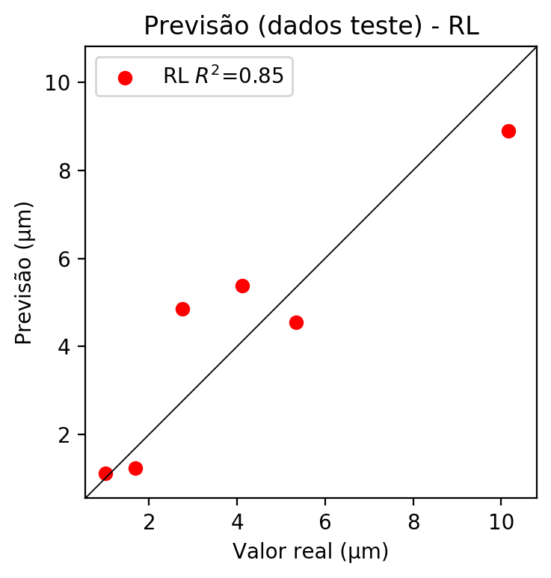

**Dados de treino**

* Erro relativo médio: 37.02
* Coeficiente de correlação: 0.83
* Coeficiente de determinação: 0.7
* MSE: 4.37
* RMSE: 2.09

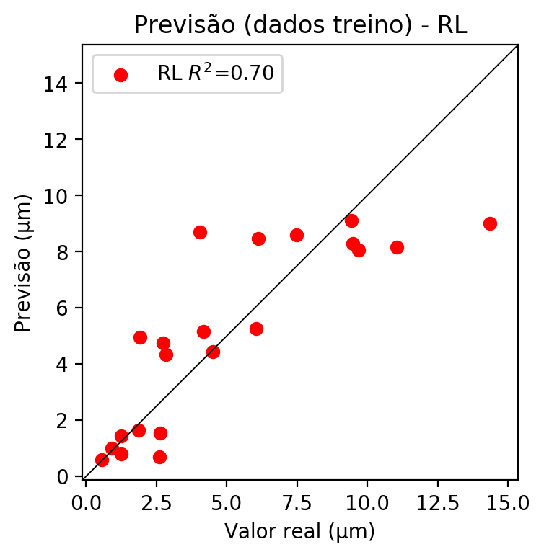

# RP2

# Coeficientes

[ 0. 0.06690171 0.90180708 0.11912825 -0.31747115 0.045877  
 0.03309288 0.28933694 0.05137932 0.51374314]

# Erros

**Dados de teste**

* Erro relativo médio: 48.69
* Coeficiente de correlação: 0.95
* Coeficiente de determinação: 0.91
* MSE: 2.41
* RMSE: 1.55

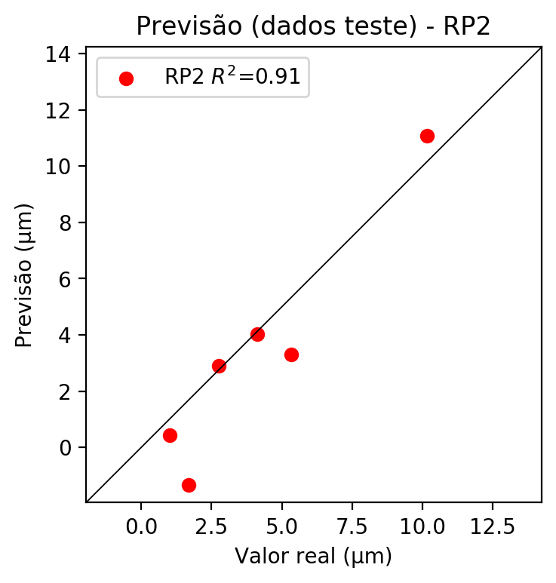

**Dados de treino**

* Erro relativo médio: 35.56
* Coeficiente de correlação: 0.96
* Coeficiente de determinação: 0.92
* MSE: 1.19
* RMSE: 1.09

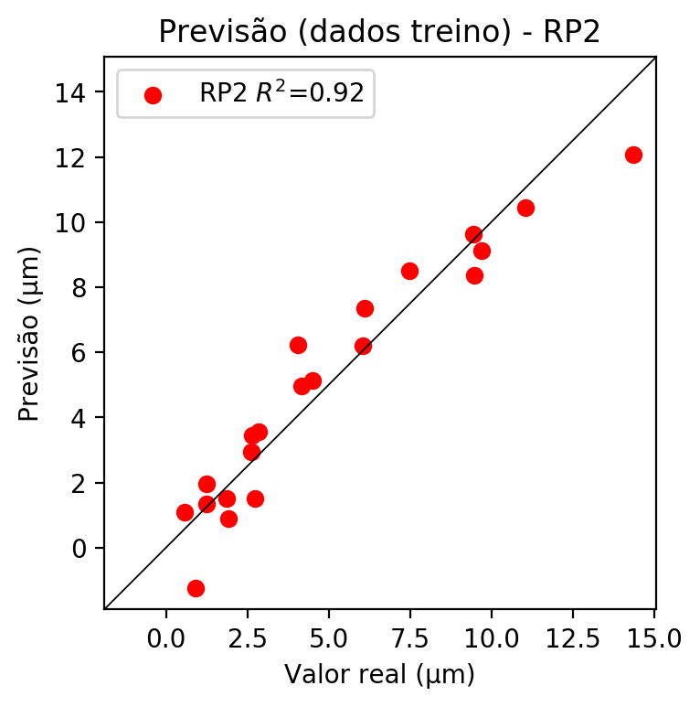

# RP3

# Coeficientes

[ 0. 0.00426894 0.15078928 0.04651508 -0.32207367 0.14233108  
 0.08563759 0.36773136 0.08923997 0.39195377 0.00616625 -0.0588931  
 -0.04650522 0.03826593 0.0736717 -0.0027609 0.21780674 0.04041262  
 0.45726995 0.06718845]

# Erros

**Dados de teste**

* Erro relativo médio: 62.13
* Coeficiente de correlação: 0.91
* Coeficiente de determinação: 0.84
* MSE: 3.35
* RMSE: 1.83

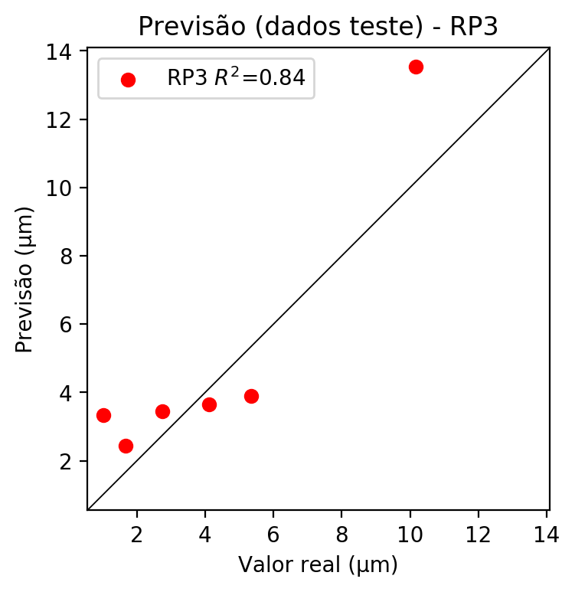

**Dados de treino**

* Erro relativo médio: 12.59
* Coeficiente de correlação: 0.99
* Coeficiente de determinação: 0.99
* MSE: 0.14
* RMSE: 0.37

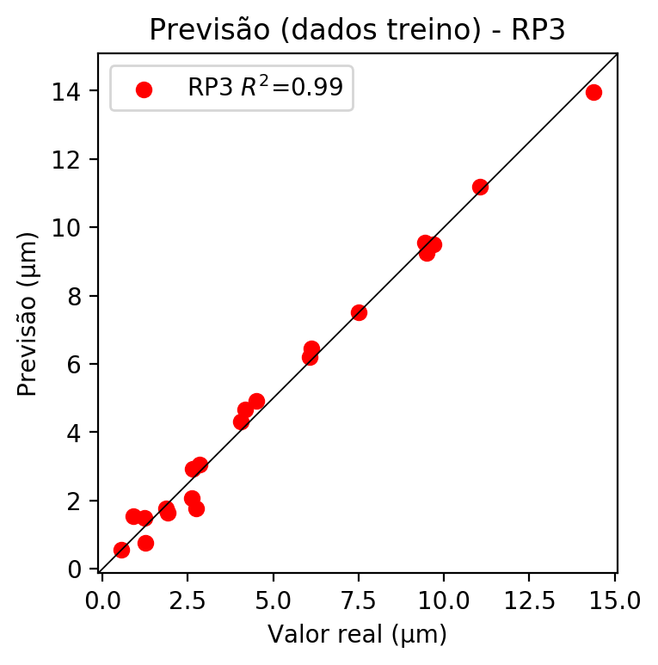

# RP4

# Coeficientes

[ 2.77555756e-17 2.96825687e-02 1.97901410e-01 5.61072946e-02  
 -9.68852055e-02 1.66387146e-02 1.08369591e-02 4.92765574e-02  
 2.95616790e-02 8.11167156e-02 4.28748215e-02 -9.15040356e-02  
 -6.28857574e-02 2.42958354e-02 4.19190181e-02 -6.12704491e-02  
 2.85857593e-01 9.66833722e-03 3.57175186e-01 8.10438699e-02  
 -1.39945297e-01 2.40336989e-02 1.56533854e-02 -2.57548152e-02  
 -9.25468271e-02 -2.32374524e-02 2.40336989e-02 -1.67807763e-03  
 3.93079596e-03 1.56533854e-02 7.11772496e-02 4.27002030e-02  
 2.01366183e-01 4.27002030e-02 1.17168589e-01]

# Erros

**Dados de teste**

* Erro relativo médio: 44.72
* Coeficiente de correlação: 0.93
* Coeficiente de determinação: 0.87
* MSE: 1.73
* RMSE: 1.32

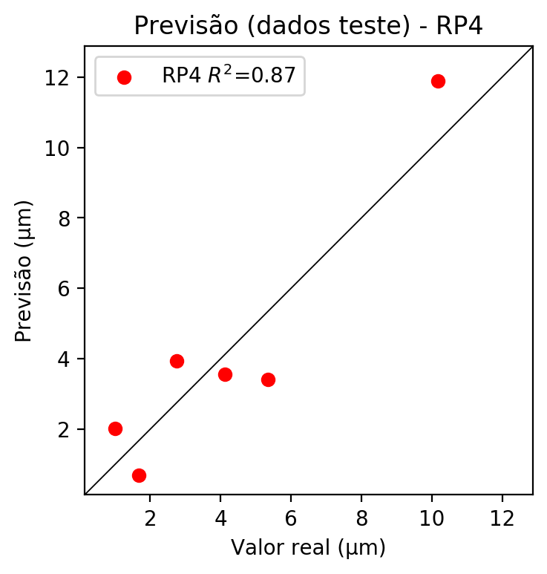

**Dados de treino**

* Erro relativo médio: 0.0
* Coeficiente de correlação: 1.0
* Coeficiente de determinação: 1.0
* MSE: 0.0
* RMSE: 0.0

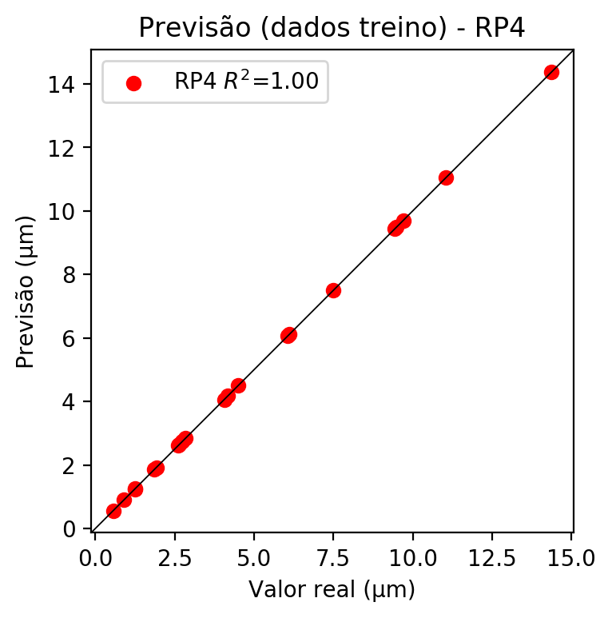

# Geral

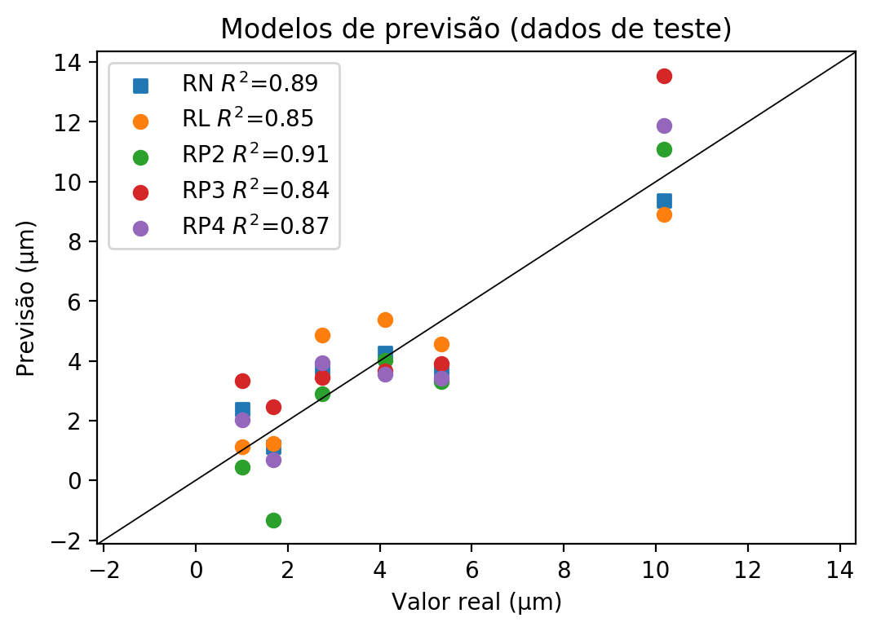

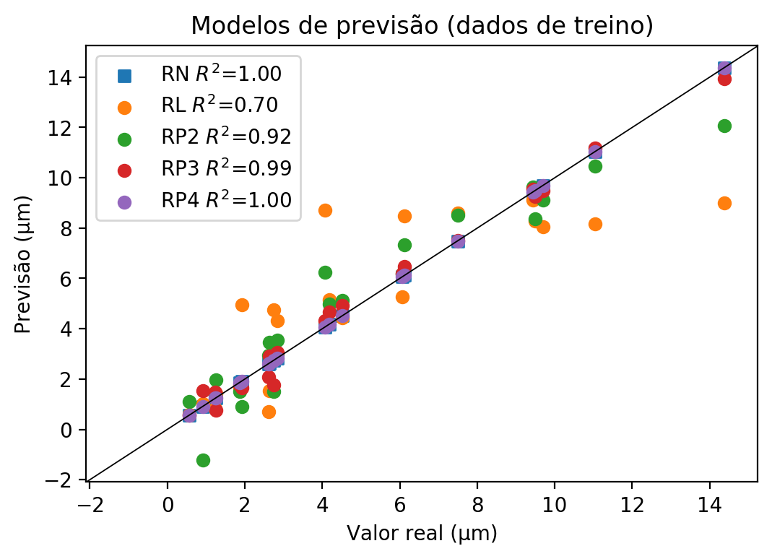

**Dados de teste**

|  |  |  |  |  |  |  |  |  |  |  |
| --- | --- | --- | --- | --- | --- | --- | --- | --- | --- | --- |
| Valor real | RN Previsto | RN Erro (%) | RL Previsto | RL Erro (%) | RP2 Previsto | RP2 Erro (%) | RP3 Previsto | RP3 Erro (%) | RP4 Previsto | RP4 Erro (%) |
| 1.01 | 2.38 | 135.64 | 1.12 | 10.89 | 0.43 | 57.43 | 3.34 | 230.69 | 2.02 | 100.0 |
| 10.17 | 9.37 | 7.87 | 8.9 | 12.49 | 11.09 | 9.05 | 13.53 | 33.04 | 11.89 | 16.91 |
| 4.12 | 4.26 | 3.4 | 5.38 | 30.58 | 4.02 | 2.43 | 3.66 | 11.17 | 3.55 | 13.83 |
| 5.34 | 3.6 | 32.58 | 4.55 | 14.79 | 3.31 | 38.01 | 3.9 | 26.97 | 3.42 | 35.96 |
| 1.68 | 1.12 | 33.33 | 1.23 | 26.79 | -1.34 | 179.76 | 2.45 | 45.83 | 0.7 | 58.33 |
| 2.75 | 3.76 | 36.73 | 4.85 | 76.36 | 2.9 | 5.45 | 3.44 | 25.09 | 3.94 | 43.27 |

**Dados de treino**

|  |  |  |  |  |  |  |  |  |  |  |
| --- | --- | --- | --- | --- | --- | --- | --- | --- | --- | --- |
| Valor real | RN Previsto | RN Erro (%) | RL Previsto | RL Erro (%) | RP2 Previsto | RP2 Erro (%) | RP3 Previsto | RP3 Erro (%) | RP4 Previsto | RP4 Erro (%) |
| 9.7 | 9.7 | 0.0 | 8.06 | 16.91 | 9.11 | 6.08 | 9.49 | 2.16 | 9.7 | 0.0 |
| 4.06 | 4.06 | 0.0 | 8.7 | 114.29 | 6.24 | 53.69 | 4.32 | 6.4 | 4.06 | 0.0 |
| 6.12 | 6.12 | 0.0 | 8.48 | 38.56 | 7.34 | 19.93 | 6.46 | 5.56 | 6.12 | 0.0 |
| 7.49 | 7.49 | 0.0 | 8.59 | 14.69 | 8.5 | 13.48 | 7.5 | 0.13 | 7.49 | 0.0 |
| 4.51 | 4.51 | 0.0 | 4.44 | 1.55 | 5.13 | 13.75 | 4.91 | 8.87 | 4.51 | 0.0 |
| 0.91 | 0.91 | 0.0 | 1.01 | 10.99 | -1.23 | 235.16 | 1.53 | 68.13 | 0.91 | 0.0 |
| 2.74 | 2.74 | 0.0 | 4.74 | 72.99 | 1.5 | 45.26 | 1.77 | 35.4 | 2.74 | 0.0 |
| 14.37 | 14.37 | 0.0 | 9.01 | 37.3 | 12.07 | 16.01 | 13.95 | 2.92 | 14.37 | 0.0 |
| 11.05 | 11.05 | 0.0 | 8.17 | 26.06 | 10.45 | 5.43 | 11.19 | 1.27 | 11.05 | 0.0 |
| 2.61 | 2.61 | 0.0 | 0.7 | 73.18 | 2.93 | 12.26 | 2.07 | 20.69 | 2.61 | 0.0 |
| 1.86 | 1.86 | 0.0 | 1.65 | 11.29 | 1.51 | 18.82 | 1.76 | 5.38 | 1.86 | 0.0 |
| 1.25 | 1.25 | 0.0 | 1.43 | 14.4 | 1.97 | 57.6 | 0.77 | 38.4 | 1.25 | 0.0 |
| 6.06 | 6.06 | 0.0 | 5.27 | 13.04 | 6.2 | 2.31 | 6.19 | 2.15 | 6.06 | 0.0 |
| 2.64 | 2.64 | 0.0 | 1.54 | 41.67 | 3.45 | 30.68 | 2.92 | 10.61 | 2.64 | 0.0 |
| 1.92 | 1.92 | 0.0 | 4.96 | 158.33 | 0.9 | 53.12 | 1.65 | 14.06 | 1.92 | 0.0 |
| 9.49 | 9.49 | 0.0 | 8.28 | 12.75 | 8.37 | 11.8 | 9.26 | 2.42 | 9.49 | 0.0 |
| 1.24 | 1.24 | 0.0 | 0.81 | 34.68 | 1.35 | 8.87 | 1.48 | 19.35 | 1.24 | 0.0 |
| 0.56 | 0.56 | 0.0 | 0.59 | 5.36 | 1.1 | 96.43 | 0.56 | 0.0 | 0.56 | 0.0 |
| 9.44 | 9.44 | 0.0 | 9.12 | 3.39 | 9.64 | 2.12 | 9.55 | 1.17 | 9.44 | 0.0 |
| 4.18 | 4.18 | 0.0 | 5.16 | 23.44 | 4.97 | 18.9 | 4.66 | 11.48 | 4.18 | 0.0 |
| 2.84 | 2.84 | 0.0 | 4.33 | 52.46 | 3.55 | 25.0 | 3.06 | 7.75 | 2.84 | 0.0 |