# Informações do estudo

Referência: Lin

Grandeza: Força

Tipo: Fr

Material: S55C high carbon steel

Ferramenta: TNMG160404L2G

Número de experimentos: 27

Observações:  
Tool holder: MTJNL2525M16  
Diameter: 64.5 mm  
Length: 250 mm

# Unidades

Velocidade: m/min

Avanço: mm/rev

Profundidade de corte: mm

Força: N

# Dados de teste

|  |  |  |  |
| --- | --- | --- | --- |
| Força | n | f | a |
| 192.4 | 202.63 | 0.08 | 0.35 |
| 1019.8 | 202.63 | 0.32 | 1.25 |
| 490.0 | 121.58 | 0.08 | 1.25 |
| 598.9 | 121.58 | 0.2 | 0.8 |
| 314.1 | 121.58 | 0.2 | 0.35 |
| 432.7 | 86.12 | 0.32 | 0.35 |

# Dados de treino

|  |  |  |  |
| --- | --- | --- | --- |
| Força | n | f | a |
| 827.1 | 121.58 | 0.32 | 0.8 |
| 481.7 | 86.12 | 0.08 | 1.25 |
| 762.2 | 202.63 | 0.32 | 0.8 |
| 782.5 | 86.12 | 0.2 | 1.25 |
| 588.4 | 86.12 | 0.2 | 0.8 |
| 188.2 | 121.58 | 0.08 | 0.35 |
| 424.7 | 121.58 | 0.32 | 0.35 |
| 1111.7 | 121.58 | 0.32 | 1.25 |
| 1076.1 | 86.12 | 0.32 | 1.25 |
| 352.2 | 121.58 | 0.08 | 0.8 |
| 316.8 | 202.63 | 0.08 | 0.8 |
| 298.8 | 86.12 | 0.2 | 0.35 |
| 737.9 | 202.63 | 0.2 | 1.25 |
| 396.2 | 202.63 | 0.32 | 0.35 |
| 339.5 | 86.12 | 0.08 | 0.8 |
| 825.6 | 121.58 | 0.2 | 1.25 |
| 283.8 | 202.63 | 0.2 | 0.35 |
| 185.9 | 86.12 | 0.08 | 0.35 |
| 801.1 | 86.12 | 0.32 | 0.8 |
| 529.7 | 202.63 | 0.2 | 0.8 |
| 452.2 | 202.63 | 0.08 | 1.25 |

# RN

Número de neurônios: 58

Taxa de aprendizado: 1.000000e-02

Número de épocas: 382

2° camada: True

Função de ativação: tanh

# Erros

**Dados de teste**

* Erro relativo médio: 2.94
* Coeficiente de correlação: 1.0
* Coeficiente de determinação: 1.0
* MSE: 197.05
* RMSE: 14.04

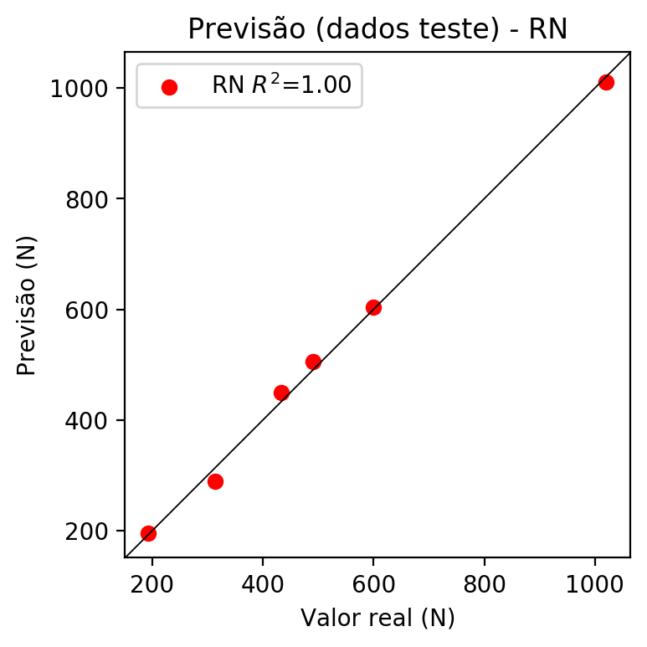

**Dados de treino**

* Erro relativo médio: 0.31
* Coeficiente de correlação: 1.0
* Coeficiente de determinação: 1.0
* MSE: 2.44
* RMSE: 1.56

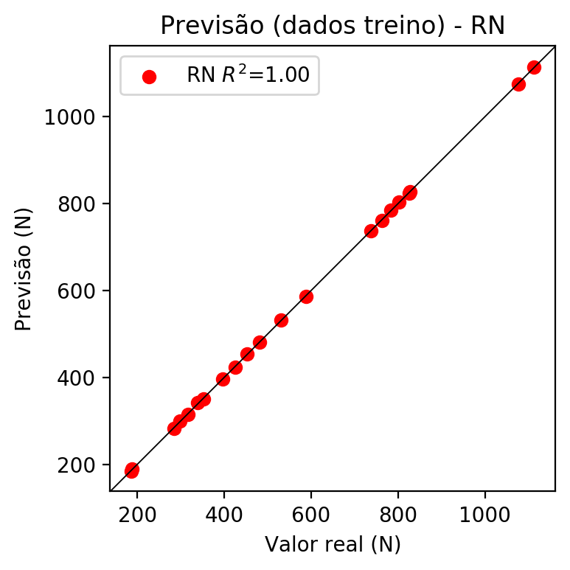

# Pesos

Pesos - camada oculta 1

[[ 0.19728094 0.04534541 -0.20197693 -0.03408533 0.1535026 -0.20023431  
 -0.02202222 -0.04646915 -0.08019754 0.11618051 -0.3545395 0.20933567  
 0.11183425 -0.03139548 -0.08347242 -0.23795384 0.11386307 -0.10876077  
 -0.27837193 0.44210938 0.1904472 0.18899795 0.00346553 0.0235313  
 -0.05772869 -0.3067703 0.30400664 0.17961892 0.1685663 -0.20547055  
 -0.12970869 -0.31754264 -0.09772676 -0.38911524 -0.04341223 -0.19444849  
 0.10430915 0.14559732 -0.2581411 -0.12895246 0.18931551 0.10748786  
 0.30145037 0.21133818 0.16303043 -0.01531638 -0.0192669 -0.21067892  
 0.25017163 0.34704903 0.22913983 0.27147645 0.01700876 -0.1281545  
 -0.11386436 0.15544805 -0.03374175 0.08482707]  
 [-0.26347443 -0.20856257 0.14832076 -0.1974831 -0.24903291 0.12610039  
 0.2730284 -0.22021492 -0.09519648 0.08419447 -0.2556248 -0.18154398  
 -0.0671389 0.03643305 -0.04801203 -0.15524173 0.10017073 -0.16875525  
 0.11818153 0.14812344 0.14056852 0.01614034 0.14764288 -0.22417593  
 -0.28933832 -0.00357188 -0.12577876 0.16739179 0.04714634 -0.2874179  
 -0.21545123 0.22897014 -0.16934696 -0.15605338 -0.25932753 0.06268236  
 -0.08779648 -0.21148303 -0.27362743 0.12617314 0.07931839 -0.21143718  
 0.14853601 -0.05251222 0.22199833 -0.15289617 -0.26063883 -0.24501288  
 -0.02233984 -0.16035616 0.04193335 0.1490614 0.06586307 -0.1376502  
 0.24802375 0.17948581 0.12074659 0.2505626 ]  
 [ 0.06427472 -0.1594294 -0.23934092 -0.10976761 0.06572526 -0.2965661  
 0.00732016 -0.07796977 0.3143174 -0.03978084 0.34922305 -0.0839777  
 -0.27937415 -0.12042777 0.14451922 0.09353718 0.02352754 0.13455425  
 0.2977123 0.08221126 -0.03696318 0.12718797 -0.3214375 0.33758244  
 -0.1672476 -0.291521 0.06831601 -0.19314829 0.07088318 -0.12062331  
 0.40700355 0.16073322 0.21790113 0.11350963 0.33465847 -0.34386984  
 0.04421449 -0.23973641 -0.1709294 -0.3544677 0.21138509 0.2489515  
 0.1739365 0.00765887 -0.23051296 0.30607665 -0.24124318 -0.03630635  
 -0.09814658 -0.29296726 0.2851925 -0.12765135 -0.21626027 -0.03186954  
 -0.11167339 0.21279116 -0.26141256 0.15134327]]

Bias - camada oculta

[ 0.02093038 0.12900726 0.06022147 -0.05415009 -0.05431456 -0.2841085  
 -0.00121707 0.11256686 0.17118962 -0.49476612 0.30158073 0.0502428  
 0.02185444 0.03233712 -0.08558173 -0.17883317 -0.48709336 0.03435171  
 -0.02498906 0.10033235 -0.28710192 -0.31226313 -0.06363695 -0.09791691  
 0.13555133 -0.017868 -0.04197388 -0.24438672 -0.05649164 0.09334593  
 -0.22929828 0.03169189 0.24706946 -0.06052517 -0.22460711 -0.08050639  
 0.13240674 0.10304908 0.09788676 -0.2407938 0.00106119 -0.15814584  
 -0.0125596 -0.05848778 -0.06558446 0.06931461 0.06277716 0.04678165  
 0.17066295 0.0346869 -0.42795697 -0.12009338 -0.02397701 0.12248746  
 0.08225382 -0.1888251 -0.14391315 0.08262739]

Pesos - camada oculta 2

[[ 0.1172675 0.01181073 -0.11562793 ... 0.03476067 0.02696753  
 0.02487681]  
 [-0.234431 -0.21113935 0.21658327 ... 0.18614593 0.05313858  
 0.23233199]  
 [ 0.03285774 -0.0454347 -0.08525403 ... 0.14299652 -0.21522513  
 0.13889003]  
 ...  
 [-0.11019443 -0.07487956 -0.17515272 ... -0.13344057 -0.14370169  
 0.19275731]  
 [ 0.19624345 0.21706013 0.11495793 ... -0.05404978 0.12601745  
 0.10013595]  
 [ 0.15887626 0.14493328 0.00712891 ... 0.11166822 0.05102111  
 -0.10769433]]

Bias - camada oculta 2

[-0.0778333 0.25604364 0.00644783 -0.0045168 -0.1167423 -0.03140415  
 -0.0005616 0.00195838 -0.01818397 -0.02921806 0.05596663 -0.08931391  
 -0.0038982 -0.02089506 0.04777993 0.01780165 0.00757079 -0.07547584  
 -0.1631329 -0.00632543 -0.00378559 0.03595641 0.08137796 -0.01139251  
 0.07748908 0.01371569 -0.12560567 0.00046374 -0.02844841 -0.00348122  
 0.00773763 0.05637376 -0.01133538 -0.04401145 0.03759275 -0.11927266  
 0.01659431 0.00676558 -0.04851021 0.02247652 -0.1260697 0.03834759  
 0.09360679 -0.01964731 -0.03481017 -0.02563032 0.05377493 -0.02635144  
 0.02249048 0.07927548 0.11422946 -0.04447896 0.00634547 -0.01278376  
 0.13300191 0.07694235 -0.05726 -0.00068106]

Pesos - camada saída

[[ 2.03731164e-01 9.38712880e-02 -2.13563785e-01 1.84867662e-04  
 1.84282467e-01 -3.72870415e-02 -1.54971043e-02 -1.94064144e-03  
 1.07226772e-02 8.31632614e-02 -2.43282869e-01 1.80510715e-01  
 1.73149575e-02 -2.24820394e-02 -9.22888070e-02 -4.80051301e-02  
 1.80346519e-02 -2.38316320e-02 -2.36211330e-01 1.29345670e-01  
 2.23963603e-01 2.19258025e-01 -6.71615079e-02 5.88790476e-02  
 3.49039026e-02 -2.16021240e-01 3.13361377e-01 4.93020117e-02  
 2.26937130e-01 -1.06511064e-01 4.03979514e-03 -3.00252408e-01  
 -1.44694418e-01 -1.48722559e-01 7.26109650e-03 -1.35981947e-01  
 -1.24751637e-02 5.98538248e-03 -1.74433619e-01 3.22904289e-02  
 1.54292122e-01 9.49324965e-02 1.78041130e-01 2.32972533e-01  
 7.39871934e-02 1.64821781e-02 5.09963697e-03 -1.21853523e-01  
 1.40717968e-01 2.55433232e-01 1.94466665e-01 1.17941871e-01  
 -7.70736067e-03 -1.31097808e-02 -1.20199375e-01 4.12336253e-02  
 -2.07229611e-03 9.23121814e-03]]

# Iterações

|  |  |  |  |  |  |  |
| --- | --- | --- | --- | --- | --- | --- |
| Média | Desvio | n | ln | 2° camada | Função | Épocas |
| -0.0501 | 0.0628 | 10 | 0.1 | False | relu | 38 |
| -0.0599 | 0.0343 | 17 | 0.1 | True | relu | 716 |
| -0.1183 | 0.1113 | 7 | 0.01 | True | tanh | 130 |
| -0.1466 | 0.0782 | 19 | 0.001 | False | tanh | 282 |
| -0.0385 | 0.0272 | 29 | 0.001 | False | relu | 469 |
| -0.1341 | 0.177 | 88 | 0.1 | False | tanh | 926 |
| -0.0437 | 0.0419 | 95 | 0.0001 | True | relu | 984 |
| -0.0442 | 0.0521 | 10 | 0.01 | True | tanh | 865 |
| -0.6218 | 0.4494 | 58 | 0.001 | True | relu | 8 |
| -0.0365 | 0.0335 | 9 | 0.01 | False | tanh | 514 |
| -0.0565 | 0.0433 | 73 | 0.0001 | True | relu | 729 |
| -0.0759 | 0.0657 | 22 | 0.001 | True | relu | 543 |
| -0.0233 | 0.0113 | 25 | 0.1 | True | relu | 562 |
| -0.0337 | 0.0225 | 53 | 0.001 | False | relu | 498 |
| -0.0246 | 0.0143 | 83 | 0.01 | True | relu | 337 |
| -0.1079 | 0.067 | 99 | 0.01 | False | tanh | 16 |
| -0.0384 | 0.0271 | 23 | 0.01 | False | relu | 472 |
| -0.0599 | 0.0581 | 24 | 0.001 | True | relu | 778 |
| -0.0152 | 0.0123 | 58 | 0.01 | True | tanh | 382 |
| -0.1264 | 0.1519 | 35 | 0.1 | False | tanh | 596 |

# RL

# Coeficientes

[ 0. -0.11992696 0.67284015 0.72526795]

# Erros

**Dados de teste**

* Erro relativo médio: 23.16
* Coeficiente de correlação: 0.94
* Coeficiente de determinação: 0.89
* MSE: 8577.36
* RMSE: 92.61

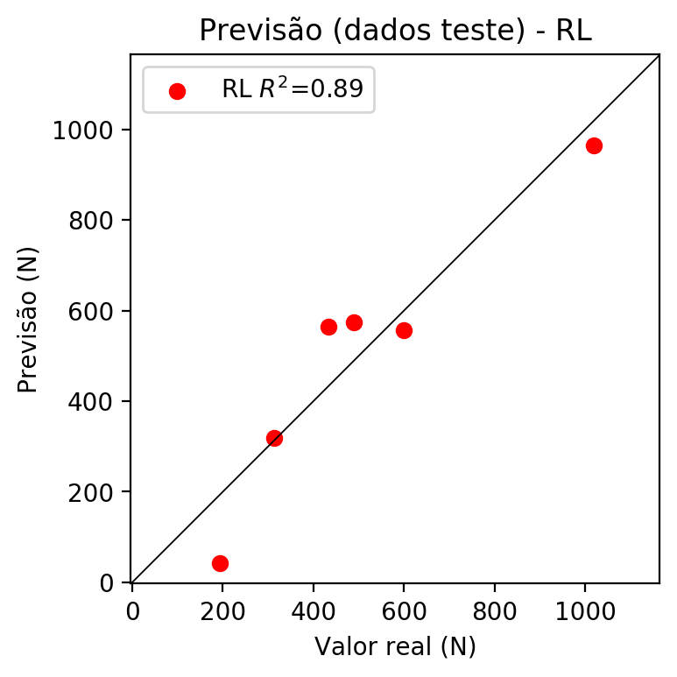

**Dados de treino**

* Erro relativo médio: 12.07
* Coeficiente de correlação: 0.98
* Coeficiente de determinação: 0.95
* MSE: 3483.62
* RMSE: 59.02

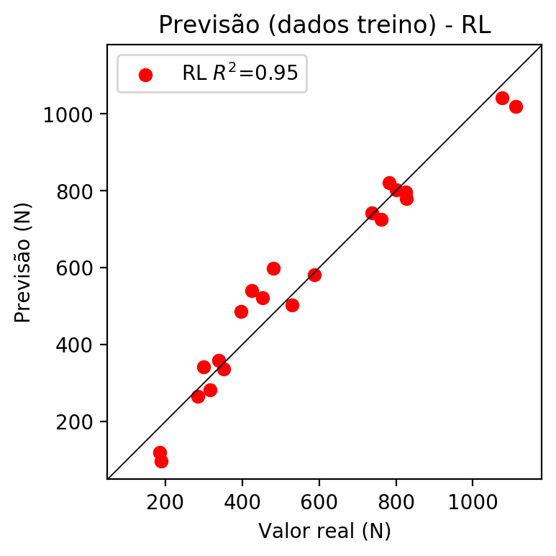

# RP2

# Coeficientes

[ 0.00000000e+00 -2.61018232e-02 6.62963106e-01 7.33152228e-01  
 -8.75180947e-02 6.70687346e-04 -3.67177632e-03 -1.35969405e-02  
 2.27893273e-01 -7.57684496e-02]

# Erros

**Dados de teste**

* Erro relativo médio: 6.12
* Coeficiente de correlação: 1.0
* Coeficiente de determinação: 1.0
* MSE: 729.49
* RMSE: 27.01

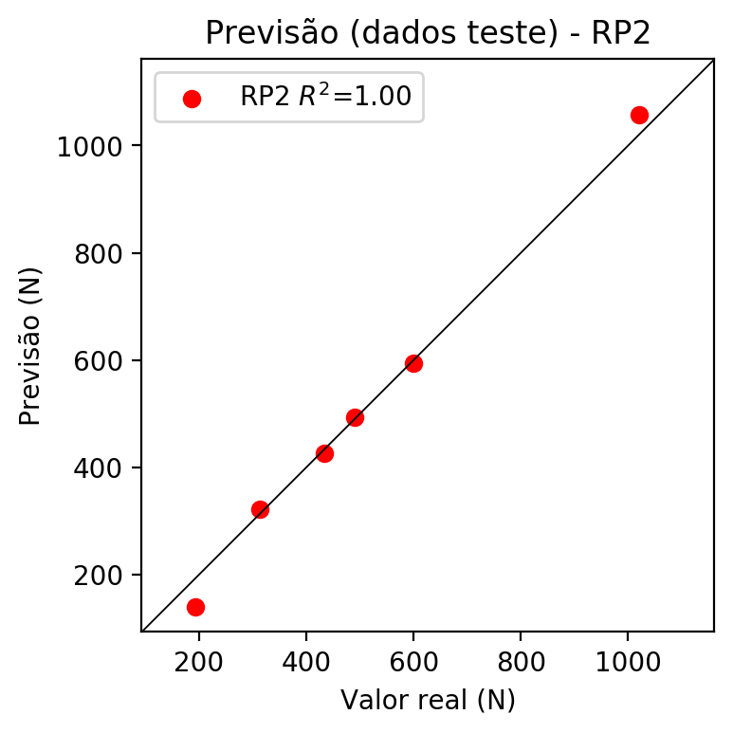

**Dados de treino**

* Erro relativo médio: 2.34
* Coeficiente de correlação: 1.0
* Coeficiente de determinação: 1.0
* MSE: 159.09
* RMSE: 12.61

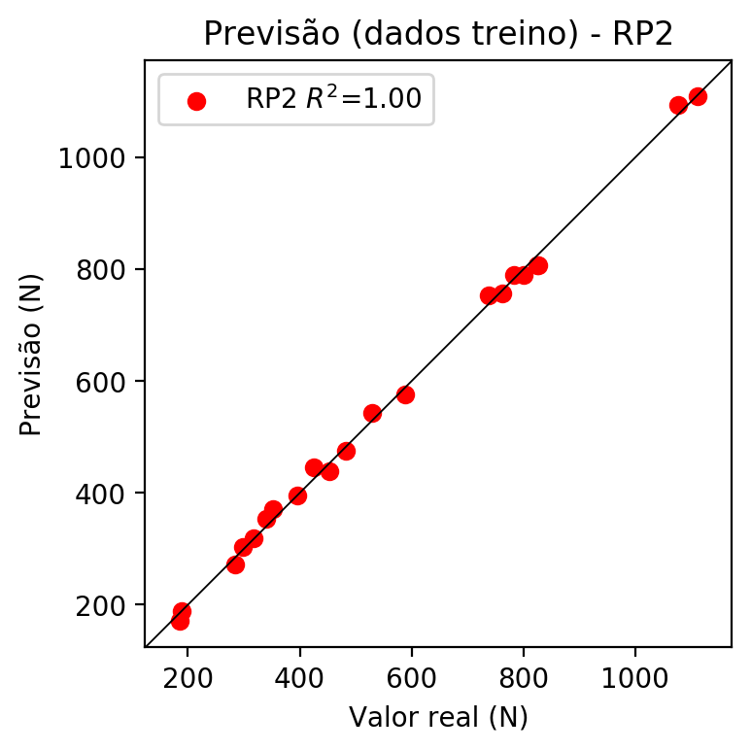

# RP3

# Coeficientes

[ 0. -0.01632915 0.23323936 0.25353431 -0.09137018 -0.0040698  
 -0.00737579 -0.00671627 0.23292783 -0.07554655 -0.02358655 -0.02221945  
 -0.04797204 0.01724874 -0.00066388 0.01677208 0.33690129 -0.00801653  
 -0.05783814 0.36621623]

# Erros

**Dados de teste**

* Erro relativo médio: 2.48
* Coeficiente de correlação: 1.0
* Coeficiente de determinação: 1.0
* MSE: 206.85
* RMSE: 14.38

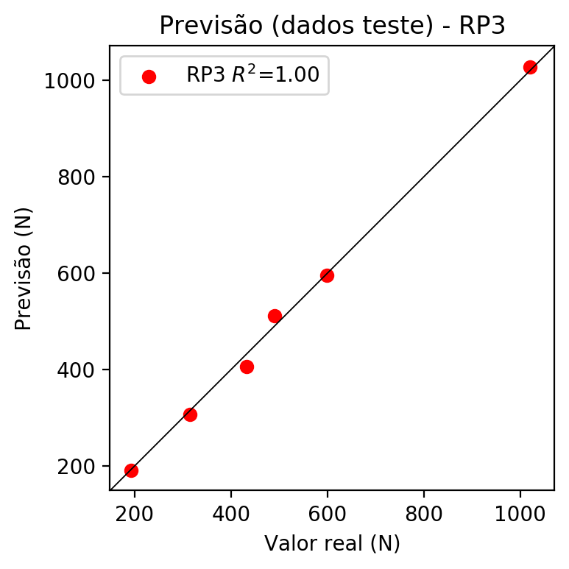

**Dados de treino**

* Erro relativo médio: 0.42
* Coeficiente de correlação: 1.0
* Coeficiente de determinação: 1.0
* MSE: 8.1
* RMSE: 2.85

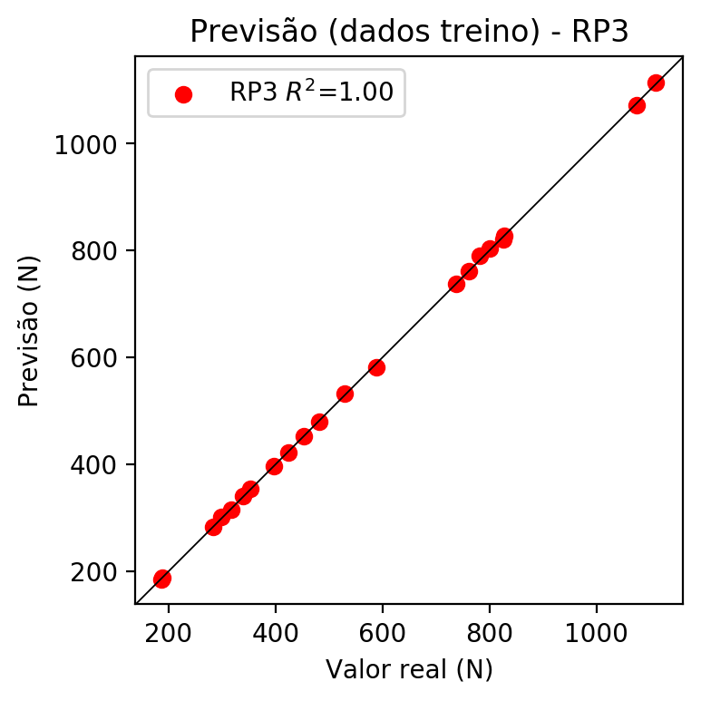

# RP4

# Coeficientes

[-5.55111512e-17 -3.91583567e-03 2.26368449e-01 2.07701530e-01  
 -5.04887816e-02 -2.67353232e-02 -3.00853426e-02 -2.55506593e-02  
 3.96147481e-02 -7.98052291e-03 -5.65620708e-03 -2.37513335e-02  
 4.10013445e-02 1.55849298e-02 -5.16637761e-02 4.56254330e-02  
 3.26976649e-01 7.47217015e-02 -4.18650774e-02 3.00013321e-01  
 -7.45459898e-02 5.49019401e-02 4.23511564e-02 4.72246597e-02  
 4.39984417e-02 -4.74876040e-02 -3.86176891e-02 1.92331554e-02  
 6.97400275e-02 -4.34566060e-02 -3.69065079e-02 5.72213028e-02  
 -2.05282809e-02 5.72213028e-02 -1.15274220e-02]

# Erros

**Dados de teste**

* Erro relativo médio: 22.33
* Coeficiente de correlação: 0.98
* Coeficiente de determinação: 0.95
* MSE: 7883.92
* RMSE: 88.79

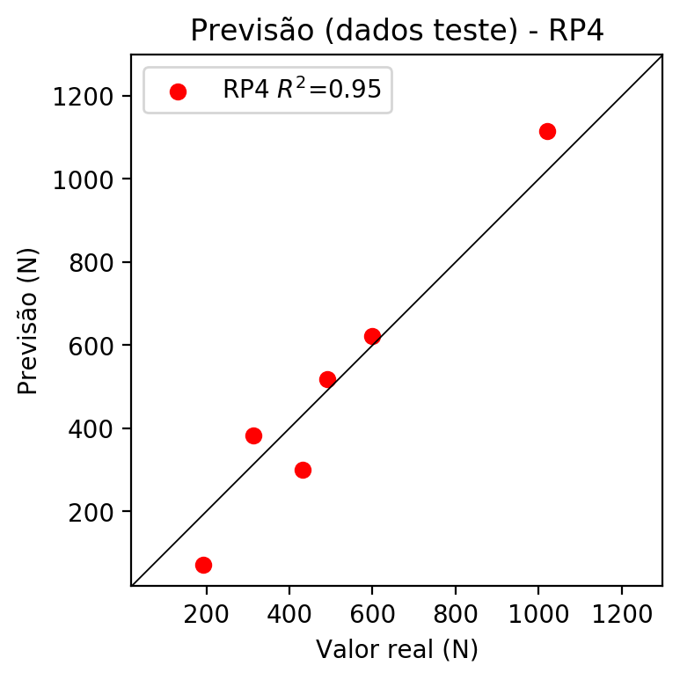

**Dados de treino**

* Erro relativo médio: 0.0
* Coeficiente de correlação: 1.0
* Coeficiente de determinação: 1.0
* MSE: 0.0
* RMSE: 0.0

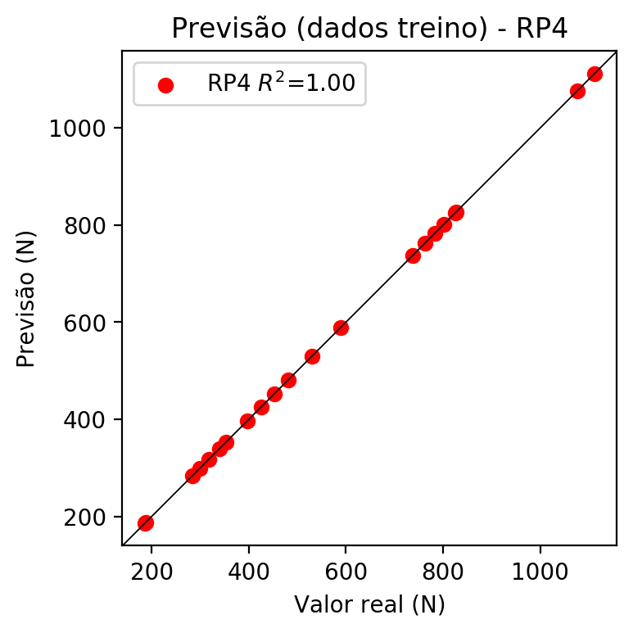

# Geral

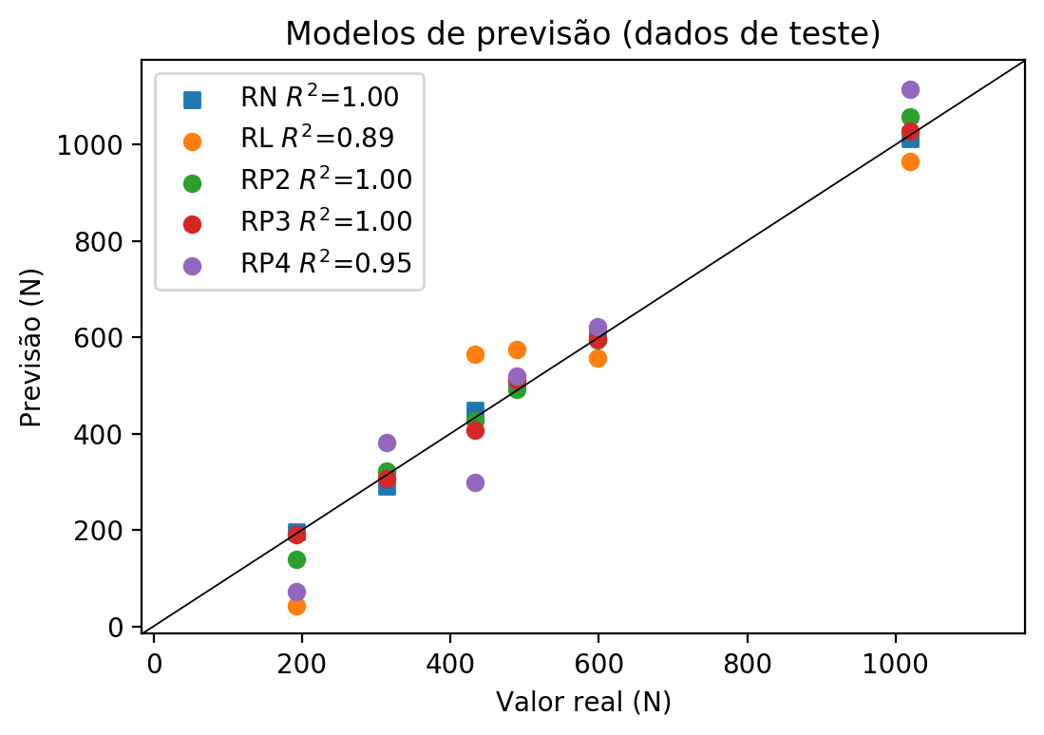

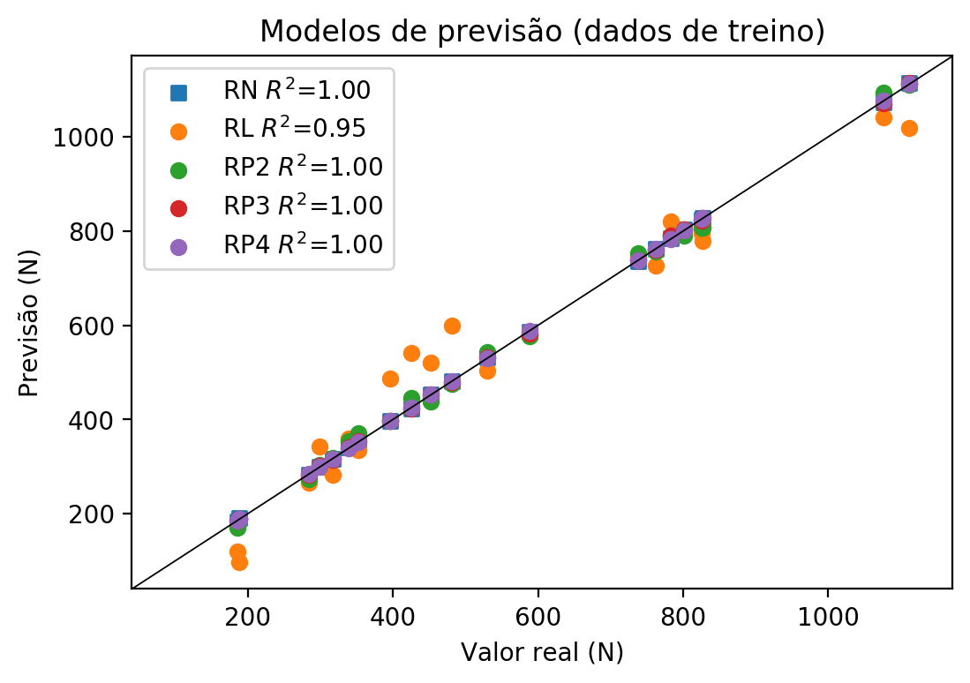

**Dados de teste**

|  |  |  |  |  |  |  |  |  |  |  |
| --- | --- | --- | --- | --- | --- | --- | --- | --- | --- | --- |
| Valor real | RN Previsto | RN Erro (%) | RL Previsto | RL Erro (%) | RP2 Previsto | RP2 Erro (%) | RP3 Previsto | RP3 Erro (%) | RP4 Previsto | RP4 Erro (%) |
| 192.4 | 195.23 | 1.47 | 42.99 | 77.66 | 138.87 | 27.82 | 190.51 | 0.98 | 72.04 | 62.56 |
| 1019.8 | 1011.17 | 0.85 | 965.01 | 5.37 | 1056.96 | 3.64 | 1027.28 | 0.73 | 1115.16 | 9.35 |
| 490.0 | 504.93 | 3.05 | 574.95 | 17.34 | 492.47 | 0.5 | 510.71 | 4.23 | 518.79 | 5.88 |
| 598.9 | 603.71 | 0.8 | 557.67 | 6.88 | 594.62 | 0.71 | 595.9 | 0.5 | 621.04 | 3.7 |
| 314.1 | 289.87 | 7.71 | 318.52 | 1.41 | 322.47 | 2.66 | 306.64 | 2.38 | 382.38 | 21.74 |
| 432.7 | 449.03 | 3.77 | 563.86 | 30.31 | 426.69 | 1.39 | 406.47 | 6.06 | 299.5 | 30.78 |

**Dados de treino**

|  |  |  |  |  |  |  |  |  |  |  |
| --- | --- | --- | --- | --- | --- | --- | --- | --- | --- | --- |
| Valor real | RN Previsto | RN Erro (%) | RL Previsto | RL Erro (%) | RP2 Previsto | RP2 Erro (%) | RP3 Previsto | RP3 Erro (%) | RP4 Previsto | RP4 Erro (%) |
| 827.1 | 826.87 | 0.03 | 779.53 | 5.75 | 807.77 | 2.34 | 828.24 | 0.14 | 827.1 | 0.0 |
| 481.7 | 480.95 | 0.16 | 598.43 | 24.23 | 475.89 | 1.21 | 479.81 | 0.39 | 481.7 | 0.0 |
| 762.2 | 761.58 | 0.08 | 725.86 | 4.77 | 756.52 | 0.75 | 760.79 | 0.18 | 762.2 | 0.0 |
| 782.5 | 785.47 | 0.38 | 820.3 | 4.83 | 789.98 | 0.96 | 789.41 | 0.88 | 782.5 | 0.0 |
| 588.4 | 586.21 | 0.37 | 581.14 | 1.23 | 577.02 | 1.93 | 582.06 | 1.08 | 588.4 | 0.0 |
| 188.2 | 189.96 | 0.94 | 96.65 | 48.65 | 188.86 | 0.35 | 188.54 | 0.18 | 188.2 | 0.0 |
| 424.7 | 423.97 | 0.17 | 540.38 | 27.24 | 445.3 | 4.85 | 422.86 | 0.43 | 424.7 | 0.0 |
| 1111.7 | 1113.72 | 0.18 | 1018.68 | 8.37 | 1110.17 | 0.14 | 1114.59 | 0.26 | 1111.7 | 0.0 |
| 1076.1 | 1073.88 | 0.21 | 1042.16 | 3.15 | 1093.28 | 1.6 | 1072.12 | 0.37 | 1076.1 | 0.0 |
| 352.2 | 351.17 | 0.29 | 335.8 | 4.66 | 370.69 | 5.25 | 354.05 | 0.53 | 352.2 | 0.0 |
| 316.8 | 315.59 | 0.38 | 282.14 | 10.94 | 318.73 | 0.61 | 315.34 | 0.46 | 316.8 | 0.0 |
| 298.8 | 299.63 | 0.28 | 341.99 | 14.45 | 304.01 | 1.74 | 301.28 | 0.83 | 298.8 | 0.0 |
| 737.9 | 736.88 | 0.14 | 743.15 | 0.71 | 753.13 | 2.06 | 737.56 | 0.05 | 737.9 | 0.0 |
| 396.2 | 396.68 | 0.12 | 486.71 | 22.84 | 396.04 | 0.04 | 396.94 | 0.19 | 396.2 | 0.0 |
| 339.5 | 341.47 | 0.58 | 359.28 | 5.83 | 353.25 | 4.05 | 341.3 | 0.53 | 339.5 | 0.0 |
| 825.6 | 823.49 | 0.26 | 796.82 | 3.49 | 806.71 | 2.29 | 821.22 | 0.53 | 825.6 | 0.0 |
| 283.8 | 283.04 | 0.27 | 264.85 | 6.68 | 272.84 | 3.86 | 283.51 | 0.1 | 283.8 | 0.0 |
| 185.9 | 184.18 | 0.93 | 120.13 | 35.38 | 170.55 | 8.26 | 184.46 | 0.77 | 185.9 | 0.0 |
| 801.1 | 802.48 | 0.17 | 803.01 | 0.24 | 790.01 | 1.38 | 803.56 | 0.31 | 801.1 | 0.0 |
| 529.7 | 531.82 | 0.4 | 504.0 | 4.85 | 543.01 | 2.51 | 531.67 | 0.37 | 529.7 | 0.0 |
| 452.2 | 453.3 | 0.24 | 521.29 | 15.28 | 438.53 | 3.02 | 453.0 | 0.18 | 452.2 | 0.0 |