# Informações do estudo

Referência: Lin

Grandeza: Rugosidade

Tipo: Ra

Material: S55C high carbon steel

Ferramenta: TNMG160404L2G

Número de experimentos: 27

Observações:  
Tool holder: MTJNL2525M16  
Diameter: 64.5 mm  
Length: 250 mm

# Unidades

Velocidade: m/min

Avanço: mm/rev

Profundidade de corte: mm

Rugosidade: μm

# Dados de teste

|  |  |  |  |
| --- | --- | --- | --- |
| Rugosidade | n | f | a |
| 0.76 | 121.58 | 0.08 | 0.35 |
| 8.5 | 121.58 | 0.32 | 0.8 |
| 3.34 | 121.58 | 0.2 | 0.35 |
| 3.79 | 121.58 | 0.2 | 1.25 |
| 0.86 | 86.12 | 0.08 | 0.8 |
| 3.11 | 202.63 | 0.2 | 1.25 |

# Dados de treino

|  |  |  |  |
| --- | --- | --- | --- |
| Rugosidade | n | f | a |
| 8.28 | 202.63 | 0.32 | 1.25 |
| 3.25 | 86.12 | 0.2 | 0.8 |
| 7.56 | 86.12 | 0.32 | 0.35 |
| 7.57 | 202.63 | 0.32 | 0.8 |
| 3.63 | 121.58 | 0.2 | 0.8 |
| 0.73 | 86.12 | 0.08 | 1.25 |
| 3.06 | 86.12 | 0.2 | 0.35 |
| 9.49 | 121.58 | 0.32 | 1.25 |
| 9.03 | 86.12 | 0.32 | 1.25 |
| 1.09 | 202.63 | 0.08 | 0.35 |
| 0.9 | 86.12 | 0.08 | 0.35 |
| 0.85 | 202.63 | 0.08 | 1.25 |
| 7.0 | 202.63 | 0.32 | 0.35 |
| 2.81 | 202.63 | 0.2 | 0.35 |
| 1.06 | 202.63 | 0.08 | 0.8 |
| 8.12 | 86.12 | 0.32 | 0.8 |
| 0.84 | 121.58 | 0.08 | 0.8 |
| 0.71 | 121.58 | 0.08 | 1.25 |
| 7.94 | 121.58 | 0.32 | 0.35 |
| 3.47 | 86.12 | 0.2 | 1.25 |
| 3.15 | 202.63 | 0.2 | 0.8 |

# RN

Número de neurônios: 83

Taxa de aprendizado: 1.000000e-02

Número de épocas: 337

2° camada: True

Função de ativação: relu

# Erros

**Dados de teste**

* Erro relativo médio: 16.61
* Coeficiente de correlação: 0.99
* Coeficiente de determinação: 0.99
* MSE: 0.12
* RMSE: 0.35

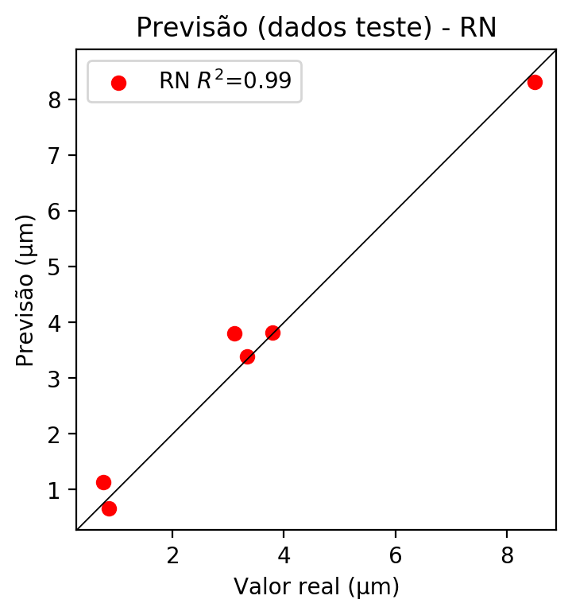

**Dados de treino**

* Erro relativo médio: 0.15
* Coeficiente de correlação: 1.0
* Coeficiente de determinação: 1.0
* MSE: 0.0
* RMSE: 0.0

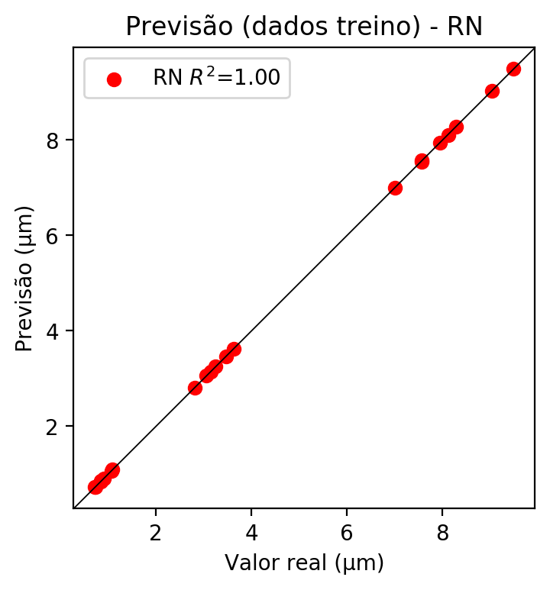

# Pesos

Pesos - camada oculta 1

[[ 0.08942638 -0.00852819 -0.11650495 0.01538772 0.23161791 -0.10287761  
 -0.03445514 0.11636567 -0.09692515 0.22154175 -0.25908893 0.20851156  
 0.04664067 -0.0665382 -0.14934488 -0.03935244 0.15958264 0.06655477  
 -0.24410169 0.07831514 0.19897448 0.23967822 0.07413182 0.05035427  
 -0.11300494 -0.22109443 0.20717363 -0.00570196 0.14174828 -0.06546797  
 0.02130605 -0.15208842 -0.17539042 -0.13947566 0.10743613 -0.1090363  
 0.0305514 0.15370825 -0.27132687 0.00765244 0.1397783 -0.0070615  
 0.28414935 0.1802819 0.05355358 0.0765437 0.07842017 -0.04502605  
 0.15030205 0.29592448 0.24765378 0.11429268 -0.02567576 0.06056527  
 -0.11039235 -0.05808234 -0.05662885 0.06254898 -0.23721853 -0.1481152  
 0.25886068 -0.05314653 -0.15802845 0.13129619 0.18371461 -0.20757605  
 0.05381881 0.07454545 -0.25513878 -0.14248002 -0.02351294 0.09389034  
 0.08260215 -0.13847454 0.0295687 -0.21240734 0.12889045 0.11426461  
 0.11998449 -0.06372973 0.04194828 -0.32148984 -0.20960237]  
 [ 0.01077112 -0.05895182 0.26527235 -0.0393818 -0.2322256 -0.21828663  
 0.1916929 -0.13084301 -0.22678958 -0.27126673 0.12790492 -0.04925548  
 -0.13003013 -0.19345689 0.11630598 0.01858799 -0.18474634 0.14524421  
 -0.16217405 0.14342403 -0.17404312 -0.25741896 -0.19914046 -0.06414251  
 -0.06867063 0.09334867 0.09011338 -0.00671945 -0.05998353 0.28720206  
 0.13678263 0.09935384 0.1706736 -0.05257813 -0.15026131 -0.09617096  
 -0.08569542 -0.00844712 -0.1819488 0.06757975 -0.1177004 0.20101053  
 0.05610238 0.25907138 0.00642086 -0.21770774 -0.00516819 0.17717014  
 -0.00041196 -0.00539884 0.01567068 0.27832788 0.10431245 -0.08498024  
 0.00579432 -0.11556666 0.19192964 -0.03990393 -0.23599201 0.03171723  
 -0.04169964 -0.00746379 -0.12600312 0.15712738 0.0512354 0.26220652  
 0.13454643 0.25938806 -0.22357291 -0.0736043 -0.20125744 -0.09179745  
 -0.28320011 0.1636854 0.1527916 0.16329165 0.03704814 -0.11132841  
 0.20054975 -0.20379755 -0.04124213 -0.22376603 -0.1460477 ]  
 [ 0.26272455 -0.19199029 -0.13665387 -0.03569513 -0.04315581 0.15145496  
 -0.17507431 0.07558687 -0.20332268 0.17215957 -0.22030224 0.20758303  
 0.15644793 -0.2616208 0.3080933 0.10298318 0.10363489 0.00583978  
 -0.02744712 -0.17639135 0.08692933 0.24690107 -0.11528113 -0.12244962  
 0.02370802 -0.10696453 -0.01228381 0.01063651 0.0113139 -0.01895669  
 0.08735256 0.06166855 -0.1908417 0.02755265 0.06179159 -0.24882346  
 0.24600971 0.02251667 -0.09155352 -0.04932198 -0.105019 -0.03529258  
 0.05937845 0.22620696 0.04935262 -0.18997899 -0.17481068 0.12922561  
 0.10496763 0.17307809 0.14405712 0.17329273 0.17639783 0.17687927  
 0.06540701 0.17845474 -0.03045844 0.10760625 0.14675084 -0.112482  
 0.015551 -0.03731666 0.02656335 -0.28255802 -0.27842435 -0.06249487  
 -0.00065065 -0.24508289 0.1300975 0.03025169 -0.14824907 -0.14039199  
 0.24185432 -0.09431332 0.08672278 0.02513306 0.16058044 0.0603282  
 0.16440493 0.21573487 0.12206367 -0.03702354 -0.01671854]]

Bias - camada oculta

[-0.02412954 -0.06758881 0.02960884 -0.09497447 0.00699415 -0.03155222  
 -0.04917997 -0.08165528 0.0307791 0.05920386 0.0424044 0.05744243  
 0.00628696 -0.03842925 0.02945128 -0.09237356 -0.00938661 -0.01900822  
 0.05228715 -0.11147155 -0.05113932 0.0790343 0.05302064 0.00659343  
 -0.0579841 0.03562153 -0.10360334 -0.0956016 -0.08894785 0.01456403  
 -0.08983064 -0.10038 -0.09241135 -0.04677785 -0.04701068 0.06837301  
 -0.07508581 -0.07521999 0.02968508 -0.05379557 0.0188843 -0.06852551  
 0.03161332 -0.0040175 -0.0703723 0.05896347 -0.11308846 -0.04684571  
 -0.05227692 0.05756809 0.02901097 0.02874549 -0.06786212 -0.02852901  
 -0.10146381 -0.06504812 -0.02913783 -0.12408209 0.04369712 -0.09408019  
 0.1098199 -0.16224593 -0.01845558 -0.04231432 -0.08959037 0.03141546  
 -0.034441 -0.00856753 0.05073269 0.0904014 0.06496333 -0.04567352  
 0.04456866 -0.03842287 -0.07728168 0.05417157 0.03849644 -0.06568934  
 -0.00158646 0.01677983 -0.12332813 0.12014095 -0.00933474]

Pesos - camada oculta 2

[[ 0.11925656 -0.0031113 -0.2320674 ... 0.05874335 -0.12139371  
 -0.28473756]  
 [-0.14447261 -0.1742649 0.17736436 ... -0.05758654 -0.10860635  
 -0.20351698]  
 [ 0.18583106 -0.05329505 -0.23090005 ... 0.06604319 0.03619345  
 -0.04703615]  
 ...  
 [ 0.04497039 -0.02149101 0.06489692 ... -0.02117132 -0.03040054  
 0.07475042]  
 [-0.14654098 -0.16328204 0.10626041 ... 0.00417059 0.21628246  
 -0.02545885]  
 [ 0.12312108 -0.09367752 -0.01558274 ... 0.01580203 0.17873551  
 -0.11611389]]

Bias - camada oculta 2

[ 4.09975089e-02 7.40508689e-03 -9.26549807e-02 1.38043137e-02  
 -1.12070797e-04 -8.70024487e-02 -1.15365500e-03 1.46301901e-02  
 -1.17863752e-01 1.55304251e-02 -3.26116420e-02 4.73560542e-02  
 1.76695120e-02 -6.06787987e-02 -7.49158934e-02 -7.53773898e-02  
 2.23642085e-02 -1.05983019e-01 6.47794157e-02 -8.97186995e-02  
 -6.58966452e-02 1.44022247e-02 2.64502056e-02 1.84616111e-02  
 8.24053679e-03 8.62400904e-02 -5.67314699e-02 -9.72072184e-02  
 3.89842317e-02 -1.23250104e-01 7.14446884e-03 4.98254895e-02  
 2.54127495e-02 -7.26609752e-02 1.69654414e-02 6.46044835e-02  
 2.50853542e-02 1.15938243e-02 5.58369532e-02 3.46963247e-03  
 6.48486381e-03 3.44257094e-02 4.66696881e-02 -7.37730414e-02  
 9.38053802e-03 -2.06180308e-02 -8.52956548e-02 -3.19769643e-02  
 4.12994102e-02 -7.39213452e-02 -3.36896256e-02 -6.16561696e-02  
 -1.17036523e-02 2.54809950e-03 -4.99093682e-02 -5.45115955e-03  
 7.07999431e-03 9.65180546e-02 -6.00528605e-02 -8.27789009e-02  
 3.48149203e-02 -1.20111950e-01 6.19310625e-02 -6.00484274e-02  
 4.78201024e-02 -1.30462855e-01 -4.29761633e-02 1.19813243e-02  
 7.72041157e-02 -8.53661597e-02 8.39694589e-02 -6.46057501e-02  
 -8.00089985e-02 0.00000000e+00 5.42677827e-02 -9.66902003e-02  
 3.04124225e-02 -2.72790063e-02 2.23304820e-03 -8.07654411e-02  
 -2.83748787e-02 8.41170177e-02 -8.77113268e-02]

Pesos - camada saída

[[ 2.0257343e-01 8.4067181e-02 -6.6803105e-02 6.7058317e-02  
 1.0676716e-01 -2.6046218e-02 1.2386680e-02 2.4456270e-02  
 4.6443315e-03 9.6495129e-02 -2.5596809e-01 1.3990736e-01  
 1.0242390e-01 2.6227858e-02 -5.1092140e-02 -3.4882993e-02  
 2.3409680e-02 1.0164281e-02 -1.8732262e-01 1.4121877e-01  
 1.6705240e-01 2.0540440e-01 -4.3197025e-02 1.5016653e-01  
 -2.0153210e-02 -1.8396099e-01 1.6989140e-01 -6.8860846e-03  
 1.5845877e-01 -9.7605340e-02 -2.3545081e-02 -2.1995789e-01  
 -1.6899909e-01 -1.0158393e-01 5.3976234e-02 -1.9698884e-01  
 8.1575394e-02 1.2598549e-01 -1.4167883e-01 -6.2238611e-02  
 1.0967525e-01 9.5986538e-02 1.5702341e-01 1.6002850e-01  
 1.4084938e-01 -2.3889994e-02 1.7141141e-02 -5.0565105e-02  
 2.5126848e-01 1.9867337e-01 1.8201570e-01 7.8252040e-02  
 6.5411717e-02 -2.8529109e-02 -8.6729206e-02 4.0728185e-02  
 5.4493077e-02 -3.5054938e-05 -1.8672784e-01 -1.6294491e-01  
 2.4753512e-01 -1.1931497e-01 -1.9389442e-01 9.2672035e-03  
 2.8557682e-01 -1.1985792e-01 4.0221061e-03 1.0679619e-01  
 -2.0152724e-01 -3.7053611e-02 -7.6180026e-02 -3.5723373e-02  
 5.6244250e-02 -1.9389391e-01 1.3213266e-01 -7.6074287e-02  
 8.3147481e-02 1.4835250e-01 2.4651019e-02 -3.5923894e-02  
 1.8809915e-01 -2.6884249e-01 -1.8527283e-01]]

# Iterações

|  |  |  |  |  |  |  |
| --- | --- | --- | --- | --- | --- | --- |
| Média | Desvio | n | ln | 2° camada | Função | Épocas |
| -0.0278 | 0.0251 | 10 | 0.1 | False | relu | 38 |
| -0.034 | 0.0469 | 17 | 0.1 | True | relu | 716 |
| -0.0582 | 0.0604 | 7 | 0.01 | True | tanh | 130 |
| -0.1245 | 0.0723 | 19 | 0.001 | False | tanh | 282 |
| -0.0875 | 0.0475 | 29 | 0.001 | False | relu | 469 |
| -0.059 | 0.0645 | 88 | 0.1 | False | tanh | 926 |
| -0.0608 | 0.0454 | 95 | 0.0001 | True | relu | 984 |
| -0.0251 | 0.0207 | 10 | 0.01 | True | tanh | 865 |
| -0.7219 | 0.2098 | 58 | 0.001 | True | relu | 8 |
| -0.0534 | 0.0487 | 9 | 0.01 | False | tanh | 514 |
| -0.0739 | 0.054 | 73 | 0.0001 | True | relu | 729 |
| -0.0901 | 0.1452 | 22 | 0.001 | True | relu | 543 |
| -0.0254 | 0.0163 | 25 | 0.1 | True | relu | 562 |
| -0.0686 | 0.0312 | 53 | 0.001 | False | relu | 498 |
| -0.0177 | 0.0101 | 83 | 0.01 | True | relu | 337 |
| -0.1458 | 0.0943 | 99 | 0.01 | False | tanh | 16 |
| -0.0474 | 0.0367 | 23 | 0.01 | False | relu | 472 |
| -0.0782 | 0.0647 | 24 | 0.001 | True | relu | 778 |
| -0.0268 | 0.0064 | 58 | 0.01 | True | tanh | 382 |
| -0.11 | 0.1095 | 35 | 0.1 | False | tanh | 596 |

# RL

# Coeficientes

[ 0. -0.01297492 0.975991 0.11021643]

# Erros

**Dados de teste**

* Erro relativo médio: 36.02
* Coeficiente de correlação: 0.96
* Coeficiente de determinação: 0.91
* MSE: 0.62
* RMSE: 0.79

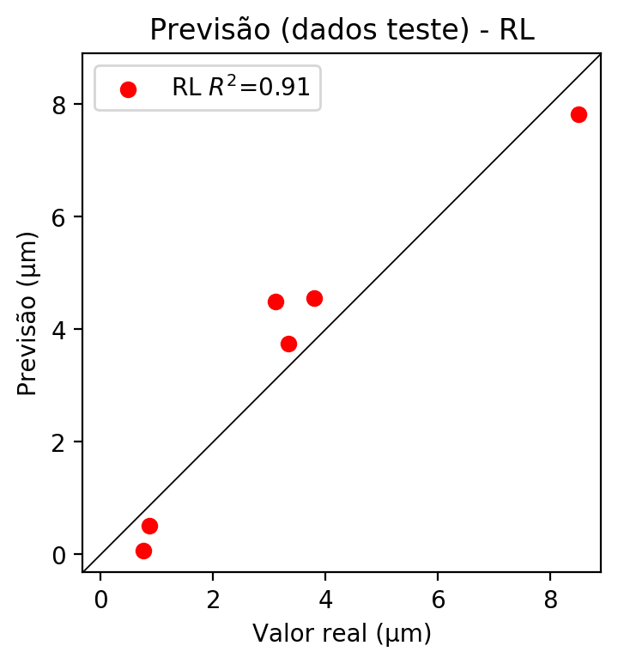

**Dados de treino**

* Erro relativo médio: 26.1
* Coeficiente de correlação: 0.98
* Coeficiente de determinação: 0.95
* MSE: 0.46
* RMSE: 0.68

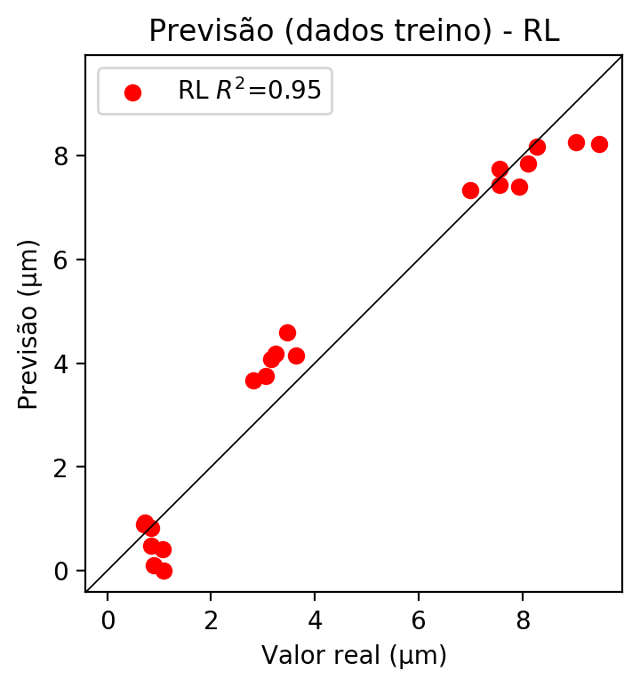

# RP2

# Coeficientes

[ 0.00000000e+00 1.08583000e-02 9.66106631e-01 7.18637154e-02  
 -1.04814549e-01 -5.65858760e-02 -1.97945795e-04 2.61371087e-01  
 9.77573670e-02 2.15127745e-02]

# Erros

**Dados de teste**

* Erro relativo médio: 20.83
* Coeficiente de correlação: 0.99
* Coeficiente de determinação: 0.99
* MSE: 0.09
* RMSE: 0.3

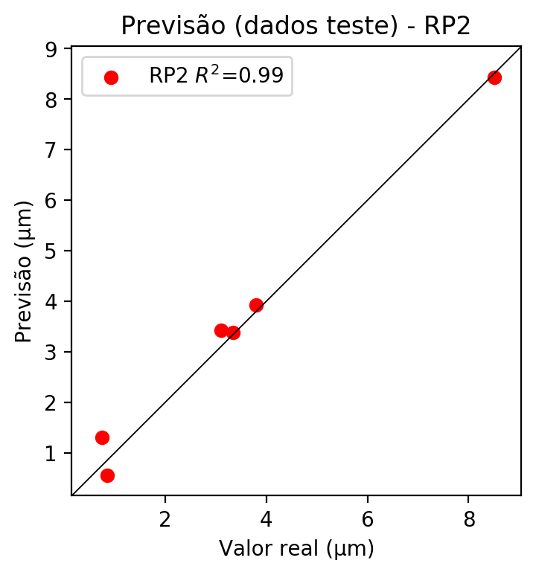

**Dados de treino**

* Erro relativo médio: 7.08
* Coeficiente de correlação: 1.0
* Coeficiente de determinação: 1.0
* MSE: 0.02
* RMSE: 0.14

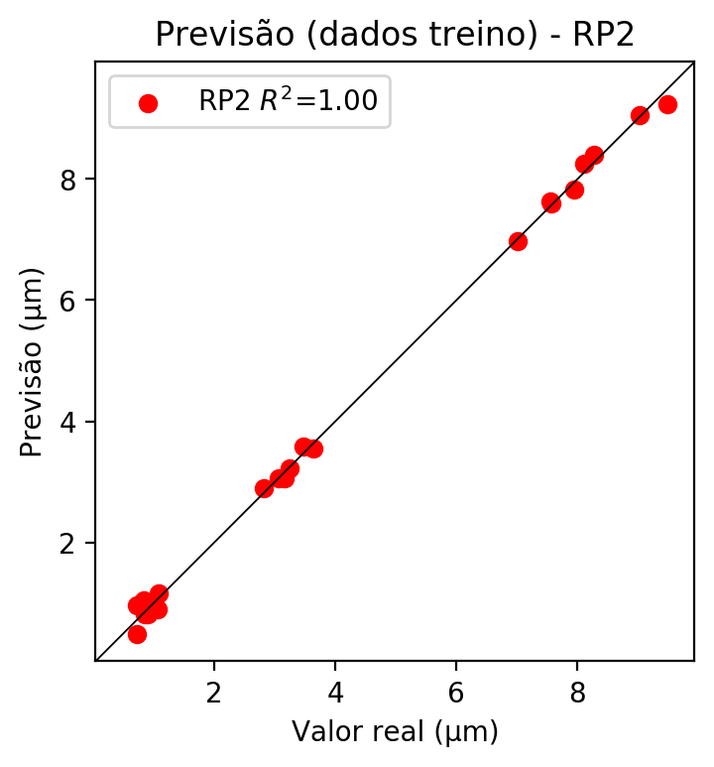

# RP3

# Coeficientes

[ 0.00000000e+00 2.38258683e-03 3.36089744e-01 2.45243235e-02  
 -8.48692445e-02 -1.91063076e-02 -2.69159053e-04 2.72037865e-01  
 8.90630614e-02 -2.22903851e-03 3.44151431e-03 -8.38372254e-02  
 -1.29806463e-02 -2.31866746e-03 -3.52640188e-03 -7.74907169e-03  
 4.85462963e-01 1.40265896e-02 1.58571710e-02 3.54240229e-02]

# Erros

**Dados de teste**

* Erro relativo médio: 3.58
* Coeficiente de correlação: 1.0
* Coeficiente de determinação: 1.0
* MSE: 0.01
* RMSE: 0.1

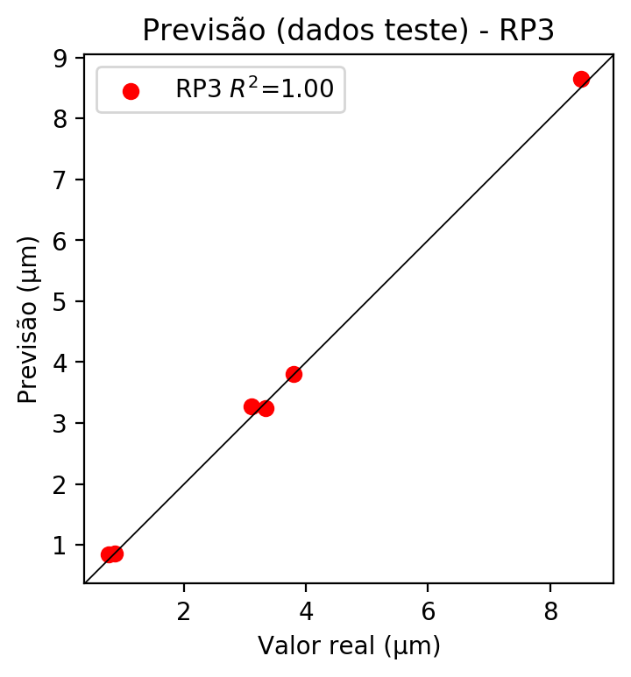

**Dados de treino**

* Erro relativo médio: 1.33
* Coeficiente de correlação: 1.0
* Coeficiente de determinação: 1.0
* MSE: 0.0
* RMSE: 0.0

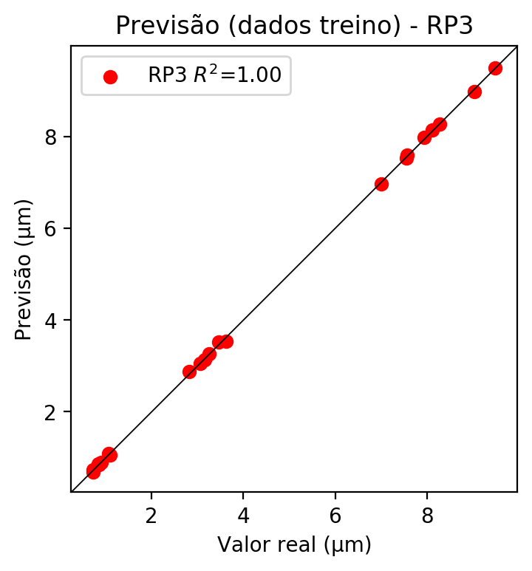

# RP4

# Coeficientes

[ 1.24900090e-16 1.39130369e-02 2.99309596e-01 -5.79267688e-03  
 -3.92930821e-02 -4.34459419e-02 -2.52409937e-03 5.49794653e-02  
 3.24371846e-02 3.80803908e-02 2.00966089e-02 -1.30717768e-02  
 5.60065978e-02 -2.13210136e-02 1.48792273e-02 1.55037701e-02  
 4.32336084e-01 1.63660586e-02 1.16762734e-02 -8.36719993e-03  
 -5.10087792e-02 6.08985663e-02 -6.03905072e-03 6.59648345e-02  
 -5.90720713e-02 -9.50172906e-02 -6.27552494e-02 -5.66770273e-03  
 3.06993759e-03 -3.64592131e-03 7.94147832e-02 4.68537111e-02  
 1.80933126e-02 4.68537111e-02 5.50050089e-02]

# Erros

**Dados de teste**

* Erro relativo médio: 37.05
* Coeficiente de correlação: 0.98
* Coeficiente de determinação: 0.96
* MSE: 0.42
* RMSE: 0.65

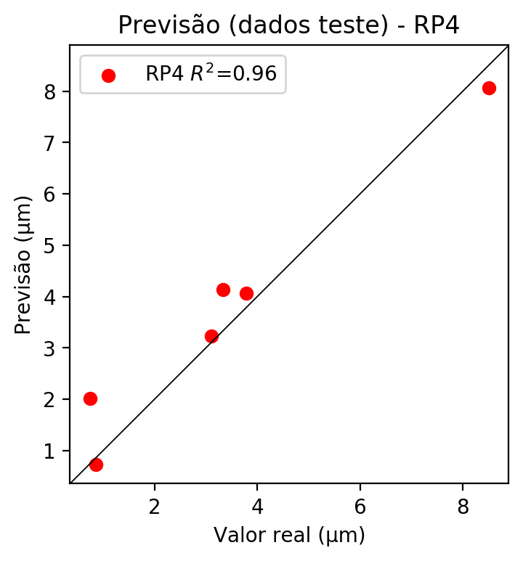

**Dados de treino**

* Erro relativo médio: 0.15
* Coeficiente de correlação: 1.0
* Coeficiente de determinação: 1.0
* MSE: 0.0
* RMSE: 0.0

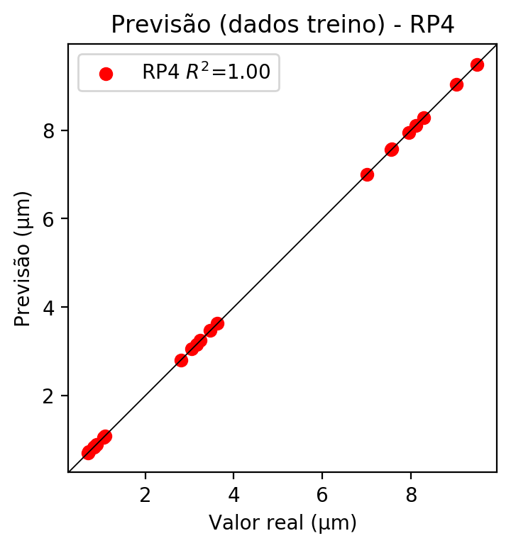

# Geral

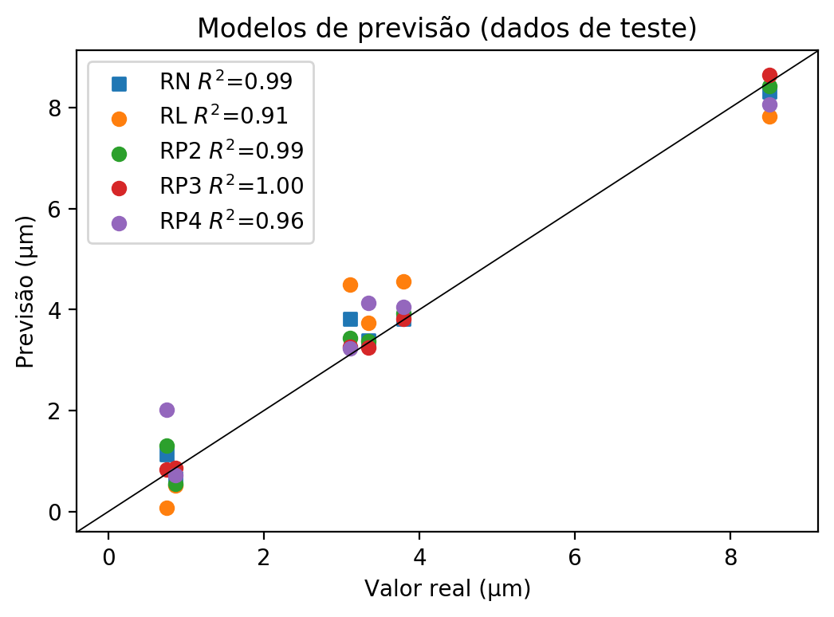

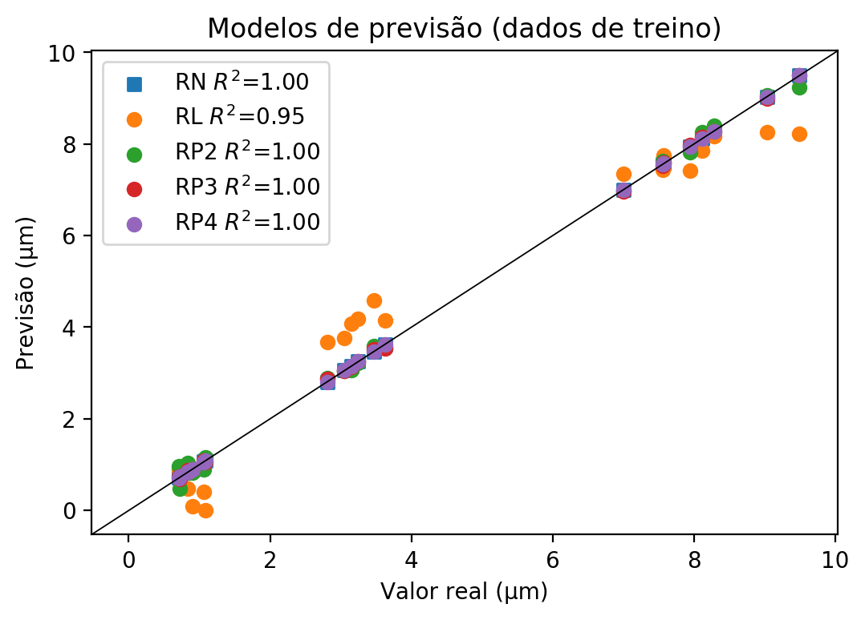

**Dados de teste**

|  |  |  |  |  |  |  |  |  |  |  |
| --- | --- | --- | --- | --- | --- | --- | --- | --- | --- | --- |
| Valor real | RN Previsto | RN Erro (%) | RL Previsto | RL Erro (%) | RP2 Previsto | RP2 Erro (%) | RP3 Previsto | RP3 Erro (%) | RP4 Previsto | RP4 Erro (%) |
| 0.76 | 1.13 | 49.67 | 0.07 | 90.73 | 1.31 | 73.51 | 0.84 | 11.26 | 2.02 | 167.55 |
| 8.5 | 8.31 | 2.27 | 7.82 | 8.03 | 8.43 | 0.86 | 8.65 | 1.73 | 8.07 | 5.09 |
| 3.34 | 3.39 | 1.47 | 3.74 | 11.94 | 3.38 | 1.17 | 3.25 | 2.72 | 4.14 | 23.91 |
| 3.79 | 3.82 | 0.69 | 4.56 | 20.19 | 3.92 | 3.32 | 3.81 | 0.42 | 4.06 | 7.01 |
| 0.86 | 0.66 | 23.08 | 0.51 | 40.56 | 0.55 | 35.9 | 0.86 | 0.23 | 0.73 | 14.92 |
| 3.11 | 3.81 | 22.47 | 4.5 | 44.65 | 3.43 | 10.25 | 3.27 | 5.11 | 3.23 | 3.83 |

**Dados de treino**

|  |  |  |  |  |  |  |  |  |  |  |
| --- | --- | --- | --- | --- | --- | --- | --- | --- | --- | --- |
| Valor real | RN Previsto | RN Erro (%) | RL Previsto | RL Erro (%) | RP2 Previsto | RP2 Erro (%) | RP3 Previsto | RP3 Erro (%) | RP4 Previsto | RP4 Erro (%) |
| 8.28 | 8.28 | 0.01 | 8.17 | 1.32 | 8.4 | 1.46 | 8.28 | 0.01 | 8.28 | 0.01 |
| 3.25 | 3.25 | 0.09 | 4.18 | 28.73 | 3.22 | 0.83 | 3.26 | 0.4 | 3.25 | 0.09 |
| 7.56 | 7.55 | 0.07 | 7.43 | 1.65 | 7.63 | 0.99 | 7.53 | 0.33 | 7.56 | 0.07 |
| 7.57 | 7.57 | 0.03 | 7.75 | 2.4 | 7.6 | 0.42 | 7.59 | 0.29 | 7.57 | 0.03 |
| 3.63 | 3.63 | 0.0 | 4.15 | 14.33 | 3.55 | 2.2 | 3.53 | 2.75 | 3.63 | 0.0 |
| 0.73 | 0.73 | 0.41 | 0.92 | 26.55 | 0.48 | 33.98 | 0.69 | 5.09 | 0.73 | 0.41 |
| 3.06 | 3.06 | 0.16 | 3.76 | 23.08 | 3.05 | 0.16 | 3.05 | 0.16 | 3.06 | 0.16 |
| 9.49 | 9.49 | 0.01 | 8.23 | 13.27 | 9.24 | 2.62 | 9.5 | 0.12 | 9.49 | 0.01 |
| 9.03 | 9.03 | 0.01 | 8.26 | 8.54 | 9.06 | 0.32 | 8.99 | 0.45 | 9.03 | 0.01 |
| 1.09 | 1.09 | 0.28 | 0.0 | 100.0 | 1.16 | 6.72 | 1.05 | 3.4 | 1.09 | 0.28 |
| 0.9 | 0.9 | 0.0 | 0.1 | 88.89 | 0.82 | 8.89 | 0.9 | 0.0 | 0.9 | 0.0 |
| 0.85 | 0.85 | 0.24 | 0.83 | 2.12 | 0.82 | 3.3 | 0.84 | 0.94 | 0.85 | 0.24 |
| 7.0 | 7.0 | 0.06 | 7.34 | 4.8 | 6.98 | 0.34 | 6.97 | 0.49 | 7.0 | 0.06 |
| 2.81 | 2.81 | 0.11 | 3.67 | 30.47 | 2.89 | 2.74 | 2.87 | 2.03 | 2.81 | 0.11 |
| 1.06 | 1.07 | 0.47 | 0.41 | 61.5 | 0.9 | 15.49 | 1.09 | 2.35 | 1.06 | 0.47 |
| 8.12 | 8.11 | 0.06 | 7.85 | 3.27 | 8.25 | 1.66 | 8.15 | 0.43 | 8.11 | 0.06 |
| 0.84 | 0.84 | 0.24 | 0.48 | 42.72 | 1.04 | 24.11 | 0.87 | 3.82 | 0.84 | 0.24 |
| 0.71 | 0.72 | 0.7 | 0.9 | 25.87 | 0.96 | 34.27 | 0.73 | 2.1 | 0.71 | 0.7 |
| 7.94 | 7.94 | 0.04 | 7.41 | 6.71 | 7.82 | 1.55 | 7.98 | 0.47 | 7.94 | 0.04 |
| 3.47 | 3.47 | 0.12 | 4.59 | 32.43 | 3.59 | 3.58 | 3.52 | 1.56 | 3.47 | 0.12 |
| 3.15 | 3.15 | 0.13 | 4.08 | 29.36 | 3.06 | 2.98 | 3.13 | 0.76 | 3.15 | 0.13 |