# Informações do estudo

Referência: Mata

Grandeza: Força

Tipo: Fy

Material: PEEK CF30

Ferramenta: TiN coated

Número de experimentos: 27

Observações:  
Workpiece: 50mm in diameter and a length of 100 mm  
CNC: GORATU G CRONO 4S

# Unidades

Velocidade: m/min

Avanço: mm/rev

Profundidade de corte: mm

Força: N

# Dados de teste

|  |  |  |  |
| --- | --- | --- | --- |
| Força | n | f | a |
| 64.31 | 300.0 | 0.15 | 1.5 |
| 111.39 | 200.0 | 0.2 | 0.75 |
| 86.74 | 300.0 | 0.15 | 0.75 |
| 98.43 | 100.0 | 0.2 | 0.75 |
| 72.74 | 300.0 | 0.2 | 0.25 |
| 85.42 | 200.0 | 0.2 | 0.25 |

# Dados de treino

|  |  |  |  |
| --- | --- | --- | --- |
| Força | n | f | a |
| 111.18 | 200.0 | 0.2 | 1.5 |
| 86.6 | 100.0 | 0.15 | 0.25 |
| 100.93 | 200.0 | 0.15 | 0.75 |
| 101.55 | 200.0 | 0.15 | 1.5 |
| 91.84 | 100.0 | 0.2 | 0.25 |
| 62.47 | 300.0 | 0.1 | 0.25 |
| 78.08 | 200.0 | 0.15 | 0.25 |
| 121.14 | 100.0 | 0.2 | 1.5 |
| 112.73 | 100.0 | 0.15 | 1.5 |
| 76.86 | 100.0 | 0.1 | 0.25 |
| 74.97 | 300.0 | 0.2 | 1.5 |
| 70.33 | 300.0 | 0.15 | 0.25 |
| 98.94 | 100.0 | 0.1 | 1.5 |
| 77.8 | 300.0 | 0.2 | 0.75 |
| 76.44 | 300.0 | 0.1 | 0.75 |
| 102.63 | 100.0 | 0.15 | 0.75 |
| 67.52 | 200.0 | 0.1 | 0.25 |
| 57.87 | 300.0 | 0.1 | 1.5 |
| 102.39 | 100.0 | 0.1 | 0.75 |
| 89.62 | 200.0 | 0.1 | 1.5 |
| 86.58 | 200.0 | 0.1 | 0.75 |

# RN

Número de neurônios: 23

Taxa de aprendizado: 1.000000e-02

Número de épocas: 472

2° camada: False

Função de ativação: relu

# Erros

**Dados de teste**

* Erro relativo médio: 6.24
* Coeficiente de correlação: 0.92
* Coeficiente de determinação: 0.84
* MSE: 40.0
* RMSE: 6.32

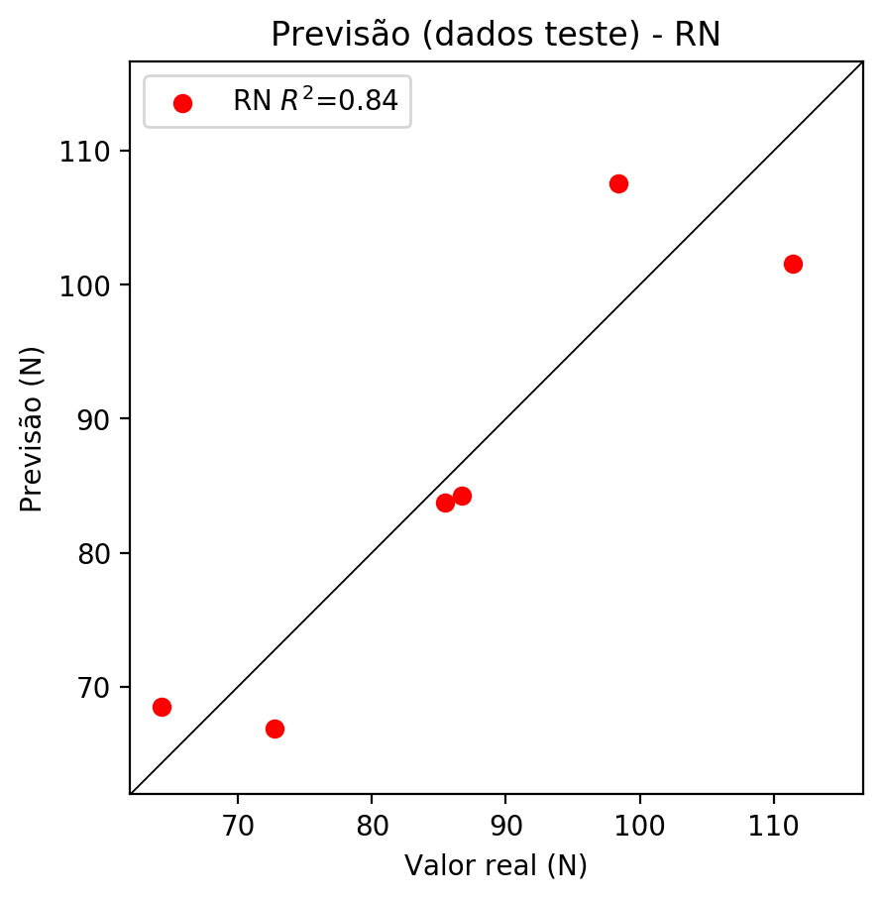

**Dados de treino**

* Erro relativo médio: 0.26
* Coeficiente de correlação: 1.0
* Coeficiente de determinação: 1.0
* MSE: 0.11
* RMSE: 0.33

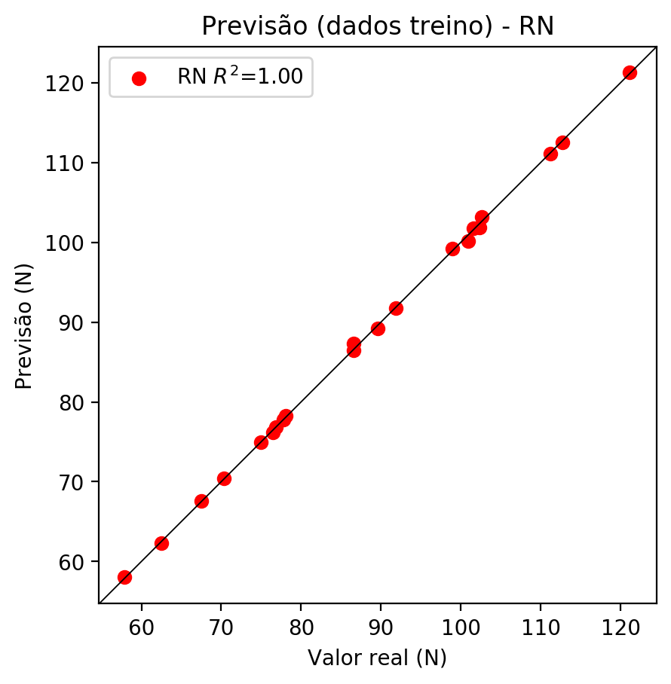

# Pesos

Pesos - camada oculta 1

[[ 8.35911371e-03 -4.89749551e-01 1.05445972e-02 -6.56904757e-01  
 -3.71066034e-02 7.26018921e-02 3.70637119e-01 9.67518806e-01  
 3.75076890e-01 -7.26345703e-02 -1.77331135e-01 -6.29198737e-03  
 3.28020640e-02 4.08134729e-01 4.01164591e-02 9.49397832e-02  
 -2.40606263e-01 1.16963878e-01 -4.07406874e-02 1.54416576e-01  
 1.06063321e-01 1.53155401e-02 1.29889429e-01]  
 [ 2.17173010e-01 -1.32888272e-01 -4.79031205e-01 4.18724179e-01  
 8.78731608e-02 5.20028293e-01 -7.30309963e-01 3.00418526e-01  
 -7.70601332e-01 -7.20924199e-01 1.11979321e-01 1.56371132e-01  
 -1.28691390e-01 5.42309880e-01 2.37332910e-01 -1.48151666e-01  
 1.35668680e-01 1.70357391e-01 1.61239326e-01 1.16179414e-01  
 -9.43751889e-04 4.00349796e-01 -2.13226333e-01]  
 [ 2.50331521e-01 -3.43536884e-01 2.40675256e-01 4.05295670e-01  
 5.31319022e-01 6.76745474e-02 8.97815883e-01 4.25464213e-01  
 -3.15549791e-01 3.15271378e-01 -1.74151823e-01 1.59371331e-01  
 -2.27525517e-01 -5.83415866e-01 1.60987034e-01 -8.25113058e-01  
 -5.06212592e-01 -7.65123516e-02 1.84567139e-01 -3.60164881e-01  
 -4.14711572e-02 3.95160079e-01 -9.59840953e-01]]

Bias - camada oculta

[-0.1573008 0.27775514 -0.2374467 0.7767864 0.23476051 -0.20645937  
 -0.2896096 -0.6403021 -0.5231196 -0.03774611 -0.27430093 -0.23174188  
 -0.26821324 -0.14089002 -0.21498999 -0.6085874 0.3651501 -0.15148298  
 -0.262489 -0.25533283 -0.32101992 -0.20785446 -0.2517179 ]

Pesos - camada saída

[[ 0.0598429 -0.3508477 -0.09700201 0.58554995 -0.06047773 -0.01070273  
 -0.6833231 -1.0955712 -0.59999454 0.29762882 -0.22584508 0.04530262  
 -0.06616914 -0.39246303 0.01113097 -0.8195767 -0.2624927 -0.09846152  
 -0.10678064 0.19078021 0.13131122 0.13468273 -0.48582408]]

# Iterações

|  |  |  |  |  |  |  |
| --- | --- | --- | --- | --- | --- | --- |
| Média | Desvio | n | ln | 2° camada | Função | Épocas |
| -0.547 | 0.4828 | 10 | 0.1 | False | relu | 38 |
| -0.3891 | 0.3716 | 17 | 0.1 | True | relu | 716 |
| -0.4604 | 0.289 | 7 | 0.01 | True | tanh | 130 |
| -1.0772 | 0.5388 | 19 | 0.001 | False | tanh | 282 |
| -0.4357 | 0.4113 | 29 | 0.001 | False | relu | 469 |
| -0.3635 | 0.2178 | 88 | 0.1 | False | tanh | 926 |
| -0.3903 | 0.2503 | 95 | 0.0001 | True | relu | 984 |
| -0.4267 | 0.2134 | 10 | 0.01 | True | tanh | 865 |
| -0.8385 | 0.4106 | 58 | 0.001 | True | relu | 8 |
| -0.6065 | 0.5915 | 9 | 0.01 | False | tanh | 514 |
| -0.3318 | 0.2698 | 73 | 0.0001 | True | relu | 729 |
| -0.3279 | 0.2267 | 22 | 0.001 | True | relu | 543 |
| -0.3582 | 0.2989 | 25 | 0.1 | True | relu | 562 |
| -0.4412 | 0.4213 | 53 | 0.001 | False | relu | 498 |
| -0.2855 | 0.271 | 83 | 0.01 | True | relu | 337 |
| -1.261 | 0.5437 | 99 | 0.01 | False | tanh | 16 |
| -0.2154 | 0.1245 | 23 | 0.01 | False | relu | 472 |
| -0.2864 | 0.2004 | 24 | 0.001 | True | relu | 778 |
| -0.4416 | 0.2344 | 58 | 0.01 | True | tanh | 382 |
| -0.5828 | 0.6726 | 35 | 0.1 | False | tanh | 596 |

# RL

# Coeficientes

[ 0. -0.68863662 0.31476847 0.41023056]

# Erros

**Dados de teste**

* Erro relativo médio: 11.95
* Coeficiente de correlação: 0.61
* Coeficiente de determinação: 0.38
* MSE: 158.44
* RMSE: 12.59

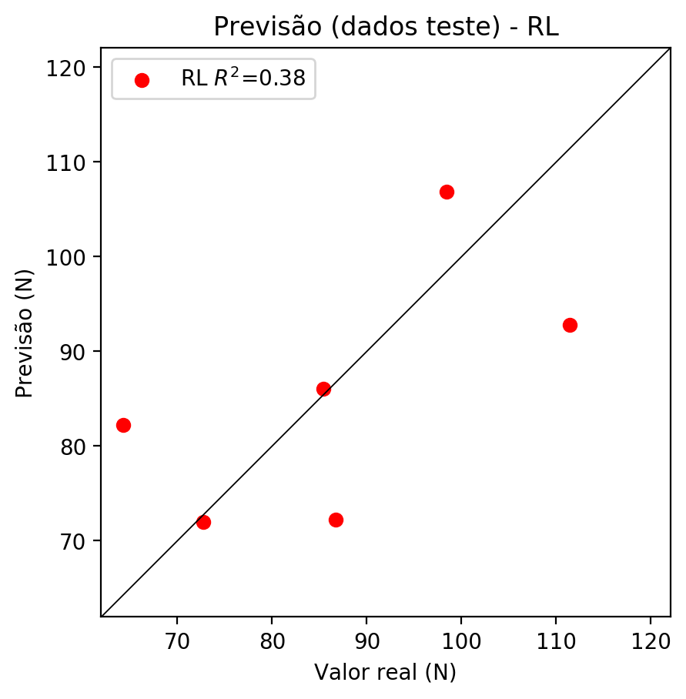

**Dados de treino**

* Erro relativo médio: 8.29
* Coeficiente de correlação: 0.88
* Coeficiente de determinação: 0.77
* MSE: 66.8
* RMSE: 8.17

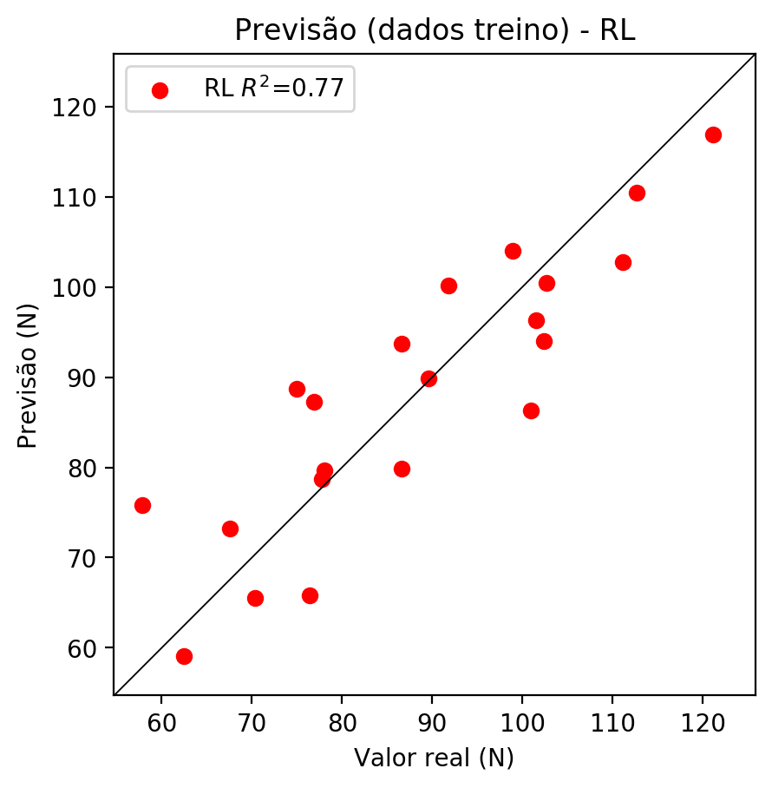

# RP2

# Coeficientes

[ 0. -0.7323256 0.3425178 0.49873593 -0.2267878 -0.0889572  
 -0.24693564 -0.09962464 0.09374616 -0.46350397]

# Erros

**Dados de teste**

* Erro relativo médio: 8.9
* Coeficiente de correlação: 0.86
* Coeficiente de determinação: 0.74
* MSE: 76.6
* RMSE: 8.75

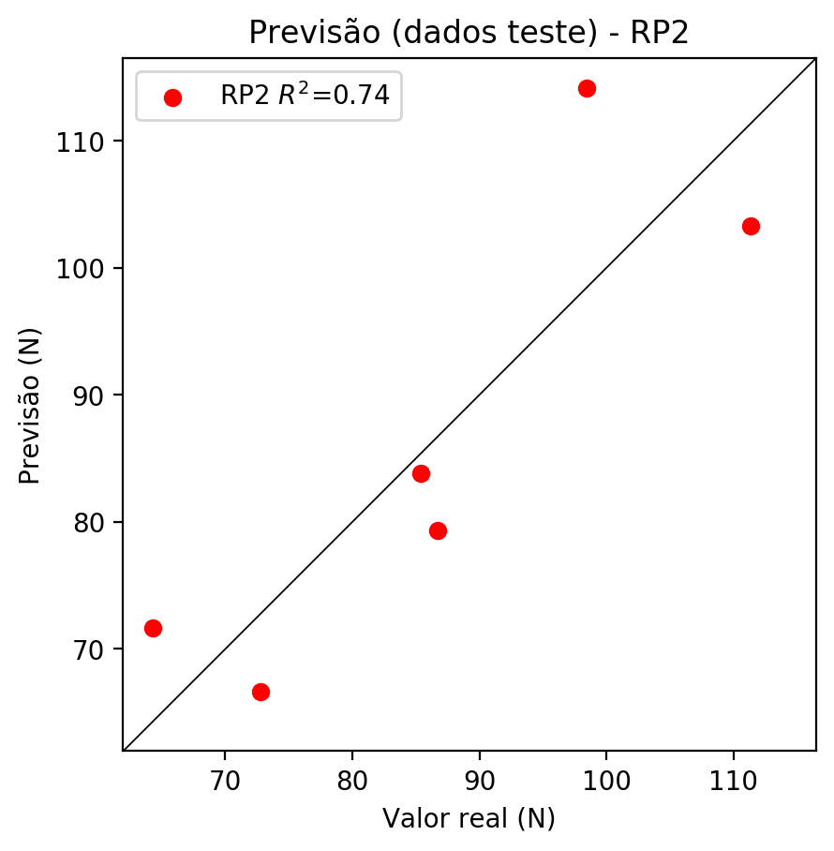

**Dados de treino**

* Erro relativo médio: 3.74
* Coeficiente de correlação: 0.98
* Coeficiente de determinação: 0.96
* MSE: 12.47
* RMSE: 3.53

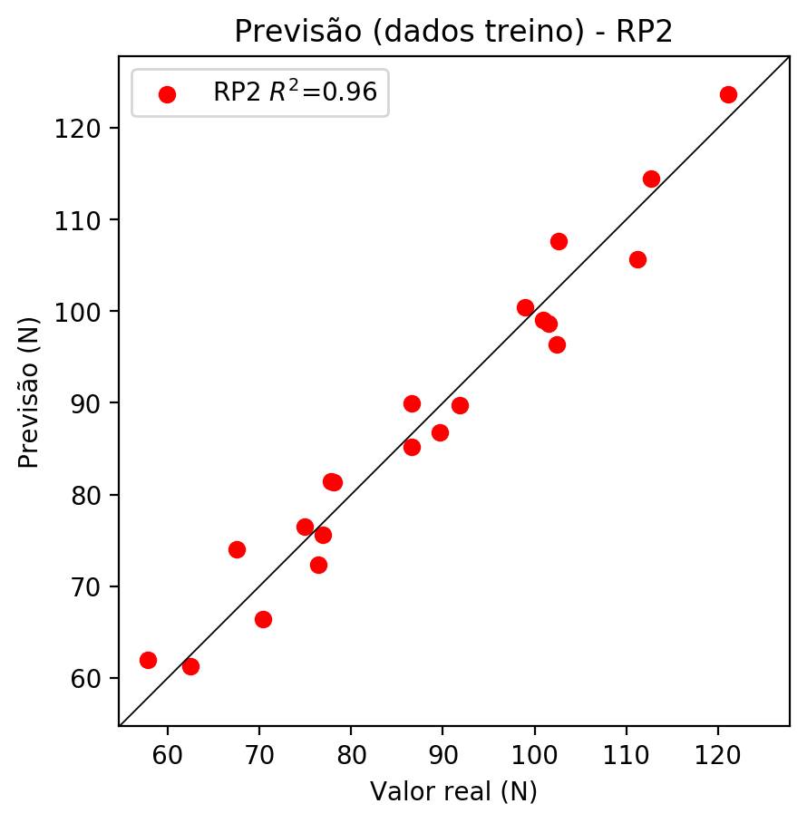

# RP3

# Coeficientes

[ 0. -0.18855971 0.08688047 0.21770658 -0.20992358 -0.06464923  
 -0.24303441 -0.13674201 0.06294624 -0.43620656 -0.27236402 -0.09552377  
 -0.18974525 -0.0791866 0.01706534 -0.04613673 0.12549402 0.00609698  
 0.14759729 0.31446505]

# Erros

**Dados de teste**

* Erro relativo médio: 7.72
* Coeficiente de correlação: 0.88
* Coeficiente de determinação: 0.78
* MSE: 54.01
* RMSE: 7.35

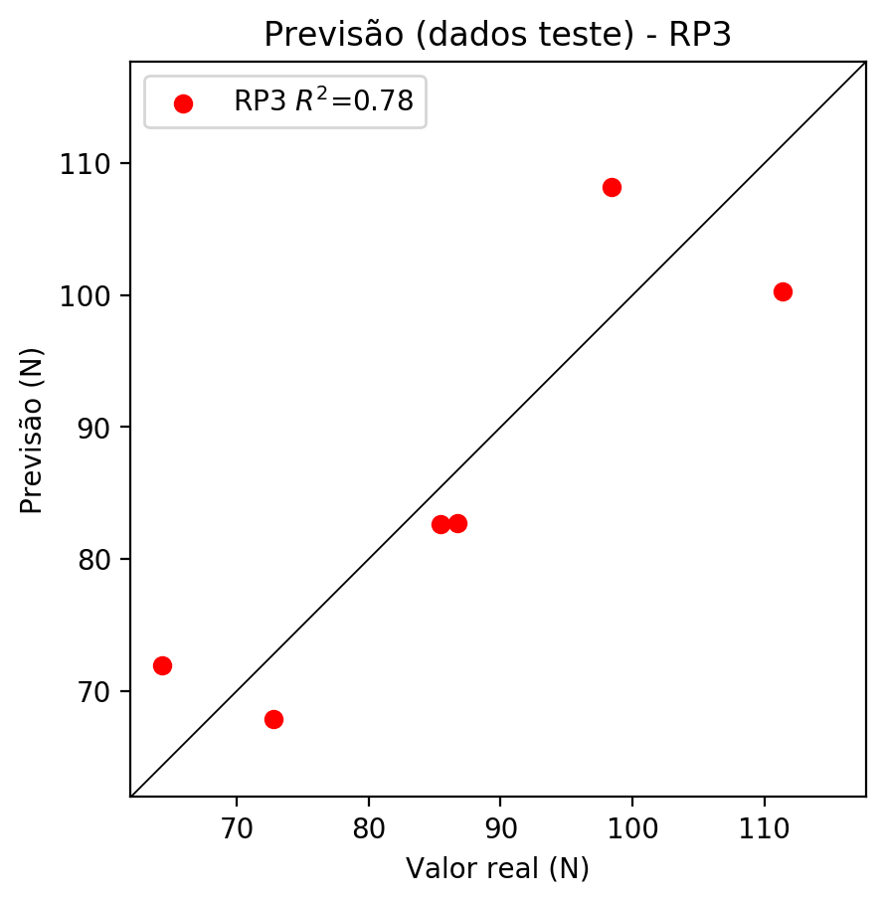

**Dados de treino**

* Erro relativo médio: 1.13
* Coeficiente de correlação: 1.0
* Coeficiente de determinação: 0.99
* MSE: 1.92
* RMSE: 1.39

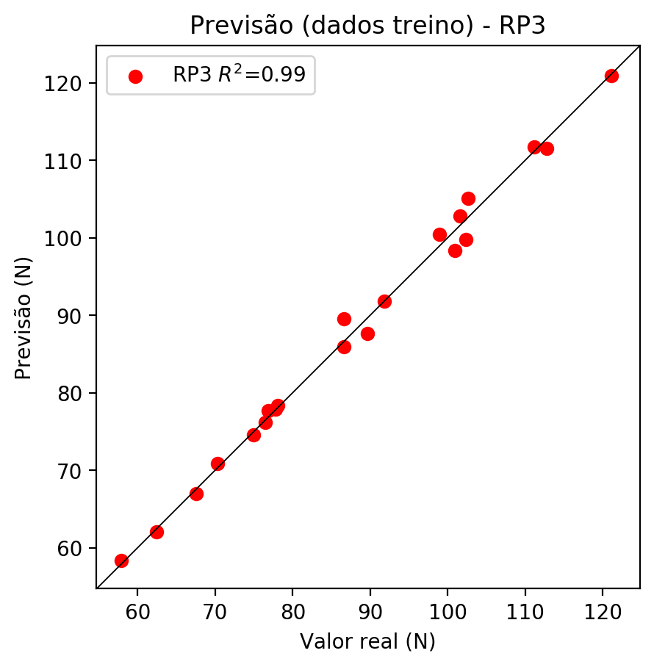

# RP4

# Coeficientes

[-0.00104179 0.03678179 0.0108798 0.22963065 0.07767752 0.03286219  
 -0.0383287 -0.14318081 0.03727418 -0.26255022 0.02006227 -0.12360109  
 -0.1128107 -0.30128772 0.30612228 -0.49704915 0.00442767 0.15932008  
 0.11718842 0.33850705 0.02416708 0.07464504 -0.03890781 -0.11976039  
 0.07168407 -0.1792988 0.07598829 0.16447163 -0.42676324 -0.03508051  
 -0.29136175 0.06609806 0.19384188 0.0728304 -0.21825442]

# Erros

**Dados de teste**

* Erro relativo médio: 29.33
* Coeficiente de correlação: 0.48
* Coeficiente de determinação: 0.23
* MSE: 814.36
* RMSE: 28.54

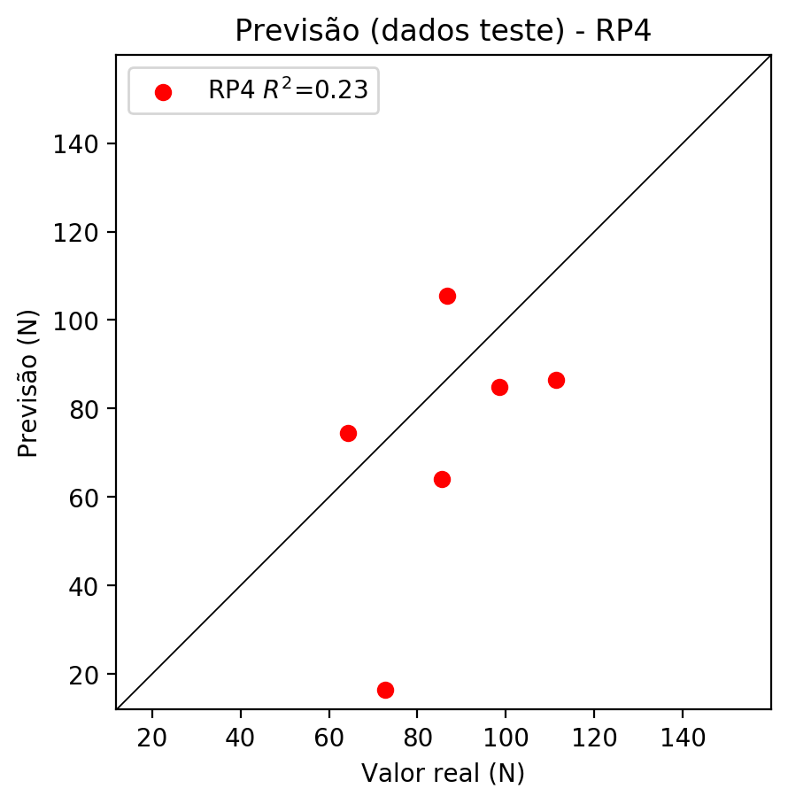

**Dados de treino**

* Erro relativo médio: 0.0
* Coeficiente de correlação: 1.0
* Coeficiente de determinação: 1.0
* MSE: 0.0
* RMSE: 0.0

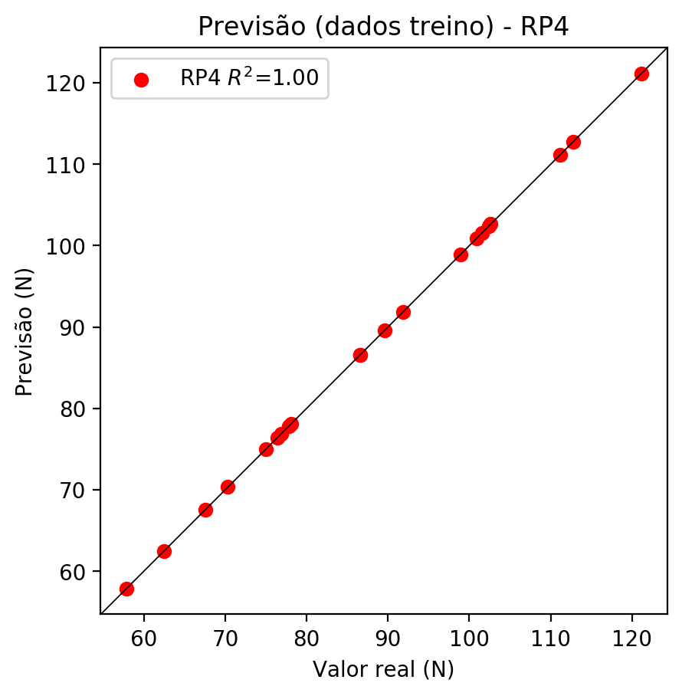

# Geral

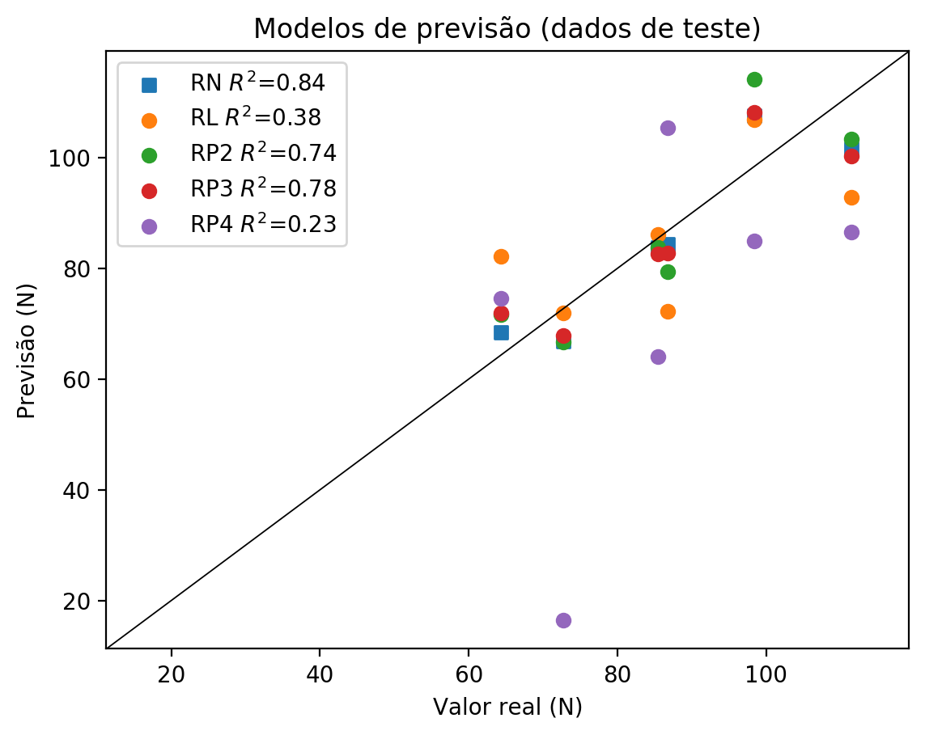

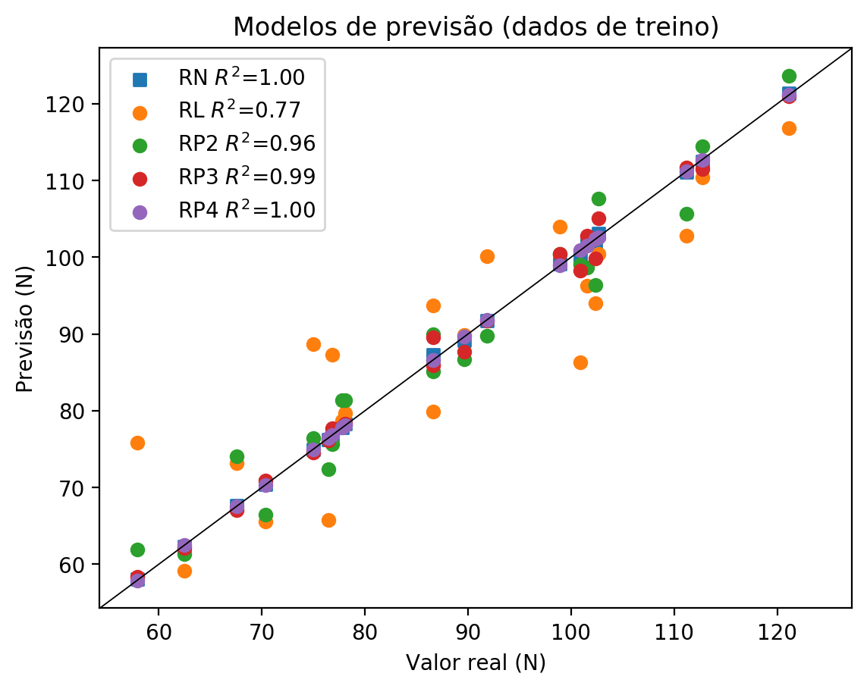

**Dados de teste**

|  |  |  |  |  |  |  |  |  |  |  |
| --- | --- | --- | --- | --- | --- | --- | --- | --- | --- | --- |
| Valor real | RN Previsto | RN Erro (%) | RL Previsto | RL Erro (%) | RP2 Previsto | RP2 Erro (%) | RP3 Previsto | RP3 Erro (%) | RP4 Previsto | RP4 Erro (%) |
| 64.31 | 68.49 | 6.5 | 82.23 | 27.87 | 71.65 | 11.41 | 71.97 | 11.91 | 74.54 | 15.91 |
| 111.39 | 101.6 | 8.79 | 92.76 | 16.73 | 103.33 | 7.24 | 100.29 | 9.96 | 86.53 | 22.32 |
| 86.74 | 84.29 | 2.82 | 72.23 | 16.73 | 79.32 | 8.55 | 82.75 | 4.6 | 105.43 | 21.55 |
| 98.43 | 107.57 | 9.29 | 106.85 | 8.55 | 114.12 | 15.94 | 108.18 | 9.91 | 84.97 | 13.67 |
| 72.74 | 66.89 | 8.04 | 72.0 | 1.02 | 66.67 | 8.34 | 67.9 | 6.65 | 16.4 | 77.45 |
| 85.42 | 83.72 | 1.99 | 86.09 | 0.78 | 83.79 | 1.91 | 82.63 | 3.27 | 64.0 | 25.08 |

**Dados de treino**

|  |  |  |  |  |  |  |  |  |  |  |
| --- | --- | --- | --- | --- | --- | --- | --- | --- | --- | --- |
| Valor real | RN Previsto | RN Erro (%) | RL Previsto | RL Erro (%) | RP2 Previsto | RP2 Erro (%) | RP3 Previsto | RP3 Erro (%) | RP4 Previsto | RP4 Erro (%) |
| 111.18 | 111.12 | 0.05 | 102.77 | 7.56 | 105.65 | 4.97 | 111.7 | 0.47 | 111.18 | 0.0 |
| 86.6 | 86.51 | 0.1 | 93.74 | 8.24 | 85.15 | 1.67 | 85.93 | 0.77 | 86.6 | 0.0 |
| 100.93 | 100.13 | 0.79 | 86.32 | 14.48 | 99.08 | 1.83 | 98.31 | 2.6 | 100.93 | 0.0 |
| 101.55 | 101.75 | 0.2 | 96.33 | 5.14 | 98.65 | 2.86 | 102.85 | 1.28 | 101.55 | 0.0 |
| 91.84 | 91.77 | 0.08 | 100.18 | 9.08 | 89.76 | 2.26 | 91.78 | 0.07 | 91.84 | 0.0 |
| 62.47 | 62.29 | 0.29 | 59.12 | 5.36 | 61.3 | 1.87 | 62.06 | 0.66 | 62.47 | 0.0 |
| 78.08 | 78.28 | 0.26 | 79.65 | 2.01 | 81.37 | 4.21 | 78.35 | 0.35 | 78.08 | 0.0 |
| 121.14 | 121.33 | 0.16 | 116.86 | 3.53 | 123.68 | 2.1 | 120.94 | 0.17 | 121.14 | 0.0 |
| 112.73 | 112.53 | 0.18 | 110.42 | 2.05 | 114.49 | 1.56 | 111.52 | 1.07 | 112.73 | 0.0 |
| 76.86 | 76.85 | 0.01 | 87.3 | 13.58 | 75.64 | 1.59 | 77.7 | 1.09 | 76.86 | 0.0 |
| 74.97 | 74.94 | 0.04 | 88.68 | 18.29 | 76.46 | 1.99 | 74.6 | 0.49 | 74.97 | 0.0 |
| 70.33 | 70.38 | 0.07 | 65.56 | 6.78 | 66.44 | 5.53 | 70.85 | 0.74 | 70.33 | 0.0 |
| 98.94 | 99.19 | 0.25 | 103.98 | 5.09 | 100.4 | 1.48 | 100.43 | 1.51 | 98.94 | 0.0 |
| 77.8 | 77.83 | 0.04 | 78.67 | 1.12 | 81.39 | 4.61 | 77.9 | 0.13 | 77.8 | 0.0 |
| 76.44 | 76.21 | 0.3 | 65.79 | 13.93 | 72.36 | 5.34 | 76.15 | 0.38 | 76.44 | 0.0 |
| 102.63 | 103.15 | 0.51 | 100.41 | 2.16 | 107.68 | 4.92 | 105.04 | 2.35 | 102.63 | 0.0 |
| 67.52 | 67.59 | 0.1 | 73.21 | 8.43 | 74.05 | 9.67 | 67.02 | 0.74 | 67.52 | 0.0 |
| 57.87 | 58.03 | 0.28 | 75.79 | 30.97 | 61.93 | 7.02 | 58.31 | 0.76 | 57.87 | 0.0 |
| 102.39 | 101.89 | 0.49 | 93.97 | 8.22 | 96.34 | 5.91 | 99.8 | 2.53 | 102.39 | 0.0 |
| 89.62 | 89.22 | 0.45 | 89.88 | 0.29 | 86.74 | 3.21 | 87.65 | 2.2 | 89.62 | 0.0 |
| 86.58 | 87.34 | 0.88 | 79.88 | 7.74 | 89.93 | 3.87 | 89.57 | 3.45 | 86.58 | 0.0 |