# Informações do estudo

Referência: Shankar

Grandeza: Força

Tipo: Fz

Material: 77 BHN

Ferramenta: CNMG 120408

Número de experimentos: 27

Observações:  
Tool holder: PCLNR2525M12  
Workpiece: 70mm diameter and 200mm length

# Unidades

Velocidade: m/min

Avanço: mm/rev

Profundidade de corte: mm

Força: N

# Dados de teste

|  |  |  |  |
| --- | --- | --- | --- |
| Força | n | f | a |
| 739.15 | 90.0 | 0.04 | 1.0 |
| 866.89 | 540.0 | 0.29 | 0.2 |
| 818.69 | 270.0 | 0.14 | 1.0 |
| 823.34 | 540.0 | 0.04 | 0.2 |
| 744.79 | 90.0 | 0.29 | 0.2 |
| 800.97 | 270.0 | 0.04 | 0.2 |

# Dados de treino

|  |  |  |  |
| --- | --- | --- | --- |
| Força | n | f | a |
| 848.8 | 540.0 | 0.14 | 0.75 |
| 814.51 | 270.0 | 0.14 | 0.75 |
| 838.66 | 540.0 | 0.04 | 0.75 |
| 840.39 | 540.0 | 0.04 | 1.0 |
| 822.52 | 270.0 | 0.29 | 0.75 |
| 731.63 | 90.0 | 0.04 | 0.75 |
| 800.67 | 270.0 | 0.14 | 0.2 |
| 879.28 | 540.0 | 0.29 | 1.0 |
| 877.48 | 540.0 | 0.29 | 0.75 |
| 774.39 | 90.0 | 0.29 | 1.0 |
| 745.56 | 90.0 | 0.29 | 0.75 |
| 744.79 | 90.0 | 0.14 | 0.75 |
| 823.72 | 270.0 | 0.29 | 0.2 |
| 797.36 | 270.0 | 0.04 | 0.75 |
| 750.43 | 90.0 | 0.14 | 1.0 |
| 844.82 | 540.0 | 0.14 | 1.0 |
| 742.91 | 90.0 | 0.14 | 0.2 |
| 725.98 | 90.0 | 0.04 | 0.2 |
| 842.59 | 540.0 | 0.14 | 0.2 |
| 820.49 | 270.0 | 0.29 | 1.0 |
| 805.17 | 270.0 | 0.04 | 1.0 |

# RN

Número de neurônios: 83

Taxa de aprendizado: 1.000000e-02

Número de épocas: 337

2° camada: True

Função de ativação: relu

# Erros

**Dados de teste**

* Erro relativo médio: 0.94
* Coeficiente de correlação: 0.98
* Coeficiente de determinação: 0.96
* MSE: 92.83
* RMSE: 9.63

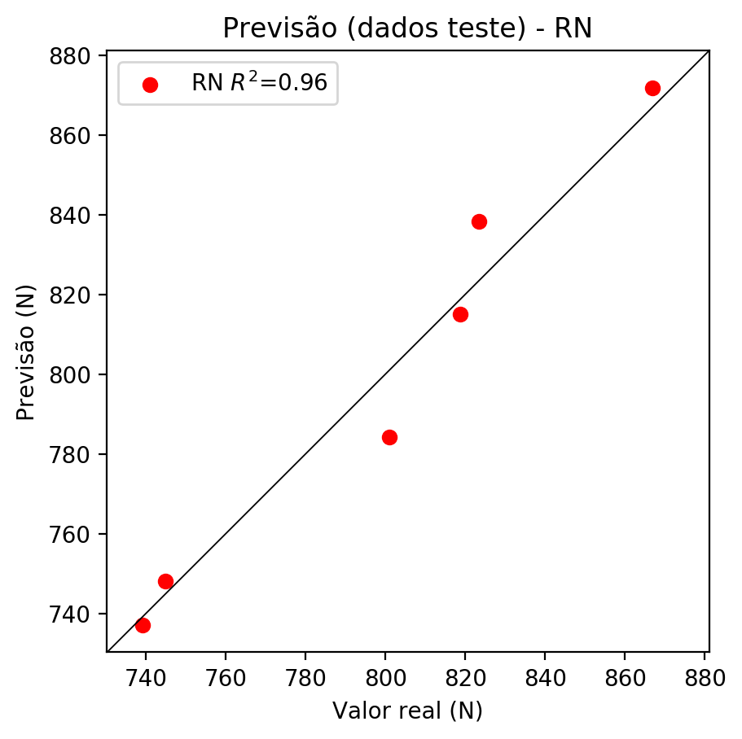

**Dados de treino**

* Erro relativo médio: 0.0
* Coeficiente de correlação: 1.0
* Coeficiente de determinação: 1.0
* MSE: 0.0
* RMSE: 0.0

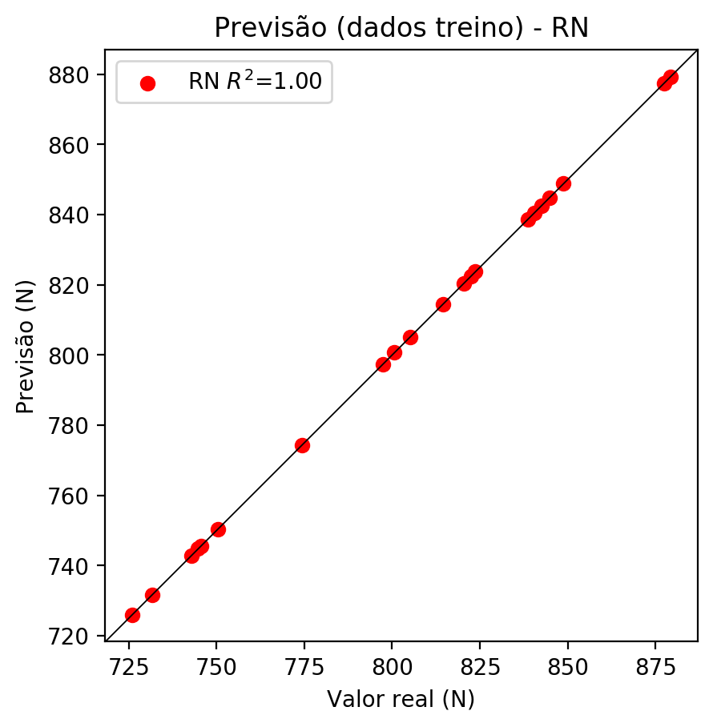

# Pesos

Pesos - camada oculta 1

[[ 0.19339722 0.02070527 -0.10246815 0.04045324 0.03537869 -0.05803845  
 -0.02438928 -0.03377798 -0.09980854 0.04786979 -0.17364508 0.21276702  
 0.05258232 0.00147032 -0.06551842 -0.15634604 0.01315597 -0.01145314  
 -0.2939755 0.16263263 0.20040466 0.10507536 -0.05254928 0.0778133  
 -0.07748652 -0.12001688 0.18788613 -0.05296439 0.18505467 -0.13015828  
 -0.11821733 -0.22665918 -0.22772945 -0.20590143 -0.06449971 -0.17247295  
 0.05806199 0.02416789 -0.24595365 -0.07995861 0.06456935 0.09611148  
 0.22271188 0.26762003 0.10057912 -0.08474738 0.04852651 -0.10880475  
 0.1158974 0.2704372 0.07452018 0.17529233 -0.03234208 0.01301743  
 -0.18258636 0.07483483 -0.05847977 0.0305266 -0.26970047 -0.2860991  
 0.19939329 -0.27803132 -0.28220105 0.003435 0.19270656 -0.19066824  
 0.01485443 0.19376682 -0.25737166 -0.20718014 -0.12156411 0.06715237  
 0.0017444 -0.25690433 0.04166439 -0.1018859 0.11389396 0.22620463  
 0.09537469 -0.09842741 0.14749 -0.32618973 -0.23036319]  
 [ 0.06694693 -0.14203101 0.28494552 -0.05793414 -0.22636157 -0.26361567  
 0.2636284 -0.20214365 -0.21563032 -0.23696876 0.17104891 -0.08549383  
 -0.21389513 -0.18120156 0.15252157 0.07915996 -0.08172914 0.1636894  
 -0.10309088 0.18174335 -0.26178047 -0.24542338 -0.20524766 -0.076547  
 -0.1093668 0.04496694 0.11595237 0.03111289 -0.10616193 0.289793  
 0.13735333 0.13695864 0.17839673 -0.04881193 -0.07258438 -0.12212501  
 -0.0366958 0.03788742 -0.20276918 0.03261427 -0.11716814 0.15832028  
 0.09216717 0.26970837 -0.02174314 -0.22895482 -0.0180381 0.15379354  
 0.0651245 0.09045541 0.10494059 0.32816762 0.14519717 -0.0814556  
 0.07294253 -0.0947481 0.13273074 -0.06834309 -0.1711559 -0.04782207  
 -0.01049899 0.0183491 -0.05170368 0.08442219 0.06392188 0.16733615  
 0.13250151 0.20753492 -0.20017621 0.02474643 -0.15672606 -0.2639108  
 -0.23380928 0.22066467 0.1164039 0.2095569 0.08207262 -0.1431441  
 0.13742653 -0.22336575 -0.07657509 -0.17158188 -0.20291689]  
 [ 0.24777545 -0.08871979 -0.1324204 0.01734219 -0.08618783 0.23109214  
 -0.11862757 0.17438261 -0.2221055 0.10516807 -0.33196184 0.1225955  
 -0.05484941 -0.1431058 0.2304048 0.07829295 0.16832103 -0.01035709  
 -0.08013631 -0.19405359 0.15822418 0.13916962 0.04380196 -0.17945893  
 -0.10100683 -0.11163408 -0.08436712 -0.09396779 0.10007782 0.01374356  
 0.14671464 0.17034474 -0.12775269 -0.00792223 0.18781601 -0.13198823  
 0.26578614 -0.02482034 -0.11693373 -0.12791297 -0.10502739 -0.11486349  
 -0.05624812 0.14183111 0.01144981 -0.1228009 -0.05374533 0.1329971  
 -0.00103055 0.09943838 -0.02989715 0.13542815 0.10873806 0.16905083  
 0.12599349 -0.00157123 -0.07477964 0.09529582 0.14481278 -0.16667244  
 -0.0972958 -0.03232215 0.03677207 -0.25978193 -0.27753857 -0.16895343  
 -0.00686073 -0.24603623 0.09632515 0.08664545 -0.09527031 -0.07932737  
 0.3267805 -0.05624272 -0.04021238 0.0329654 0.15451229 -0.01754211  
 -0.01406301 0.14513557 0.05787136 -0.10014945 0.0312389 ]]

Bias - camada oculta

[ 0.10753442 0.0461358 -0.08711133 -0.11655066 -0.08141634 -0.01074975  
 0.02922425 -0.0231023 -0.01011703 -0.07611573 -0.06435905 0.06244881  
 0.09921665 -0.10301929 -0.01309859 -0.08935098 -0.09196351 -0.01454943  
 0.01651033 0.00091894 -0.02880925 -0.07210972 -0.05785974 0.04548843  
 -0.0104921 -0.0658139 -0.06849234 -0.09987065 0.05976076 -0.07852615  
 -0.09051741 -0.07906988 -0.06956231 -0.05171955 0.01224096 -0.07952369  
 0.02899251 -0.10049343 -0.01689905 -0.00169376 -0.04756624 -0.08194184  
 0.01656648 0.00394766 0.04173505 -0.02605193 -0.15696248 -0.07809243  
 -0.10167001 0.048613 -0.08896057 0.00165444 -0.08603141 -0.08460816  
 -0.06196041 -0.1044731 -0.06849236 -0.09264271 -0.05152361 -0.00350616  
 0.02007838 0.00975835 0.02767232 -0.065043 -0.03640996 -0.04951018  
 -0.07806841 0.00215699 0.01258697 -0.00316988 -0.0530531 0.0860016  
 -0.0429915 0.00235544 -0.1101855 -0.06119773 0.09260803 0.11314889  
 -0.14335807 -0.01836406 0.05128031 0.00795212 -0.05443002]

Pesos - camada oculta 2

[[ 0.12165219 0.04201274 -0.21627988 ... 0.15583439 -0.20944484  
 -0.28429985]  
 [-0.04475182 -0.16513285 0.1815821 ... -0.0990922 -0.08121625  
 -0.19373202]  
 [ 0.21360473 -0.08025775 -0.10025804 ... -0.04361492 0.05886319  
 0.07427132]  
 ...  
 [ 0.03536693 0.06900384 0.09366219 ... 0.04715706 -0.1091298  
 0.07472146]  
 [-0.05927183 -0.07518399 0.17893334 ... -0.01427626 0.23678854  
 0.03082511]  
 [ 0.27486795 -0.00447998 0.05270994 ... -0.01156349 0.21068531  
 -0.07279263]]

Bias - camada oculta 2

[ 0.05521886 0.02868258 -0.0396961 0.05079975 0.06755676 0.0288009  
 -0.07792987 0.01920395 -0.07210158 -0.10800864 0.01348097 -0.07920006  
 -0.03080779 -0.05929887 -0.00667932 -0.02970584 0.00521241 -0.09042031  
 -0.03596889 -0.0692253 -0.12093924 0.00623197 -0.0369452 0.06994727  
 -0.07404365 -0.03897483 0.09915732 0.05618778 -0.0833834 -0.06681097  
 0.00509041 0.02669182 -0.08380781 -0.06379096 -0.0116991 -0.00533519  
 0.05372961 -0.04898394 0.02376196 -0.04984327 -0.07072866 0.08613749  
 0.10314001 0.03457841 0.07873452 -0.02442649 -0.17592034 0.02008839  
 -0.11490123 0.08862034 -0.0816813 0.09371676 -0.0683575 -0.06164502  
 0.01605588 0.09518224 0.00282409 -0.0719262 -0.06005342 -0.08341544  
 0.0222315 -0.07269977 -0.06288128 -0.13069789 -0.12513426 -0.00683989  
 -0.05998215 -0.12149996 0.03054724 -0.04357781 0.02456276 -0.14388216  
 -0.07406897 0. 0.03157004 -0.06005193 0.08185187 -0.09734877  
 -0.08225787 0.03056835 -0.06807272 0.0359899 -0.08126488]

Pesos - camada saída

[[ 1.79602101e-01 7.52651915e-02 -1.08289056e-01 3.29392776e-02  
 1.54608428e-01 -1.66109249e-01 2.47112084e-02 -9.33164824e-03  
 -2.13672463e-02 -1.41139310e-02 -2.86670119e-01 5.49430102e-02  
 9.98725444e-02 1.18627213e-02 -1.54519677e-01 -9.85264480e-02  
 7.02375025e-02 -1.50044379e-03 -1.86433047e-01 1.42702848e-01  
 1.18772067e-01 1.92512244e-01 -4.85266224e-02 6.78364486e-02  
 -1.43774571e-02 -2.34235585e-01 2.65905768e-01 4.45166156e-02  
 8.90942961e-02 -1.24898702e-01 -8.64595249e-02 -2.62821823e-01  
 -1.03136070e-01 -1.89688787e-01 5.64831086e-02 -2.20868871e-01  
 5.98476604e-02 7.15682283e-02 -1.78268254e-01 -1.52416257e-02  
 6.40017465e-02 1.34883836e-01 1.61947742e-01 1.69433236e-01  
 9.78351235e-02 -1.40022058e-02 4.41528969e-02 -1.75060302e-01  
 1.33912176e-01 2.13250637e-01 2.91505344e-02 1.58890128e-01  
 -4.84671723e-03 -3.05931736e-03 -1.26596019e-01 5.67966700e-02  
 6.41914010e-02 -4.53207009e-02 -1.86724305e-01 -1.60798639e-01  
 2.10610941e-01 -1.38025373e-01 -2.22353786e-01 -4.93469015e-02  
 1.65138170e-01 -2.17626035e-01 1.18040798e-05 -1.23102320e-02  
 -2.48692840e-01 -2.00549483e-01 -3.31771672e-02 -2.18422916e-02  
 4.02400456e-02 -1.93893909e-01 1.08839251e-01 -1.18515044e-01  
 1.00119911e-01 1.16157018e-01 -4.34061326e-02 -1.26428813e-01  
 1.06423259e-01 -2.97854424e-01 -2.19379500e-01]]

# Iterações

|  |  |  |  |  |  |  |
| --- | --- | --- | --- | --- | --- | --- |
| Média | Desvio | n | ln | 2° camada | Função | Épocas |
| -0.0573 | 0.0373 | 10 | 0.1 | False | relu | 38 |
| -0.0809 | 0.0605 | 17 | 0.1 | True | relu | 716 |
| -0.0558 | 0.0309 | 7 | 0.01 | True | tanh | 130 |
| -0.0848 | 0.0405 | 19 | 0.001 | False | tanh | 282 |
| -0.0559 | 0.0318 | 29 | 0.001 | False | relu | 469 |
| -0.0958 | 0.0759 | 88 | 0.1 | False | tanh | 926 |
| -0.0749 | 0.0378 | 95 | 0.0001 | True | relu | 984 |
| -0.082 | 0.0518 | 10 | 0.01 | True | tanh | 865 |
| -0.6158 | 0.3846 | 58 | 0.001 | True | relu | 8 |
| -0.0552 | 0.0293 | 9 | 0.01 | False | tanh | 514 |
| -0.0816 | 0.0639 | 73 | 0.0001 | True | relu | 729 |
| -0.0838 | 0.0647 | 22 | 0.001 | True | relu | 543 |
| -0.0745 | 0.0561 | 25 | 0.1 | True | relu | 562 |
| -0.0581 | 0.0249 | 53 | 0.001 | False | relu | 498 |
| -0.0545 | 0.0333 | 83 | 0.01 | True | relu | 337 |
| -0.3184 | 0.2543 | 99 | 0.01 | False | tanh | 16 |
| -0.0647 | 0.0277 | 23 | 0.01 | False | relu | 472 |
| -0.0914 | 0.0518 | 24 | 0.001 | True | relu | 778 |
| -0.0572 | 0.0112 | 58 | 0.01 | True | tanh | 382 |
| -0.0779 | 0.0426 | 35 | 0.1 | False | tanh | 596 |

# RL

# Coeficientes

[0. 0.92592088 0.28433935 0.05967076]

# Erros

**Dados de teste**

* Erro relativo médio: 1.93
* Coeficiente de correlação: 0.92
* Coeficiente de determinação: 0.85
* MSE: 311.83
* RMSE: 17.66

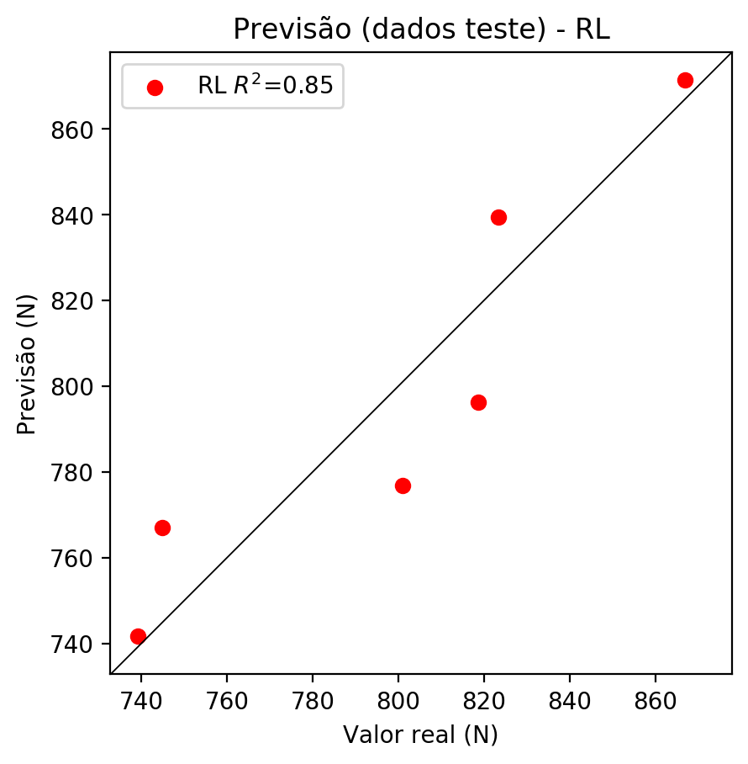

**Dados de treino**

* Erro relativo médio: 1.22
* Coeficiente de correlação: 0.97
* Coeficiente de determinação: 0.94
* MSE: 139.95
* RMSE: 11.83

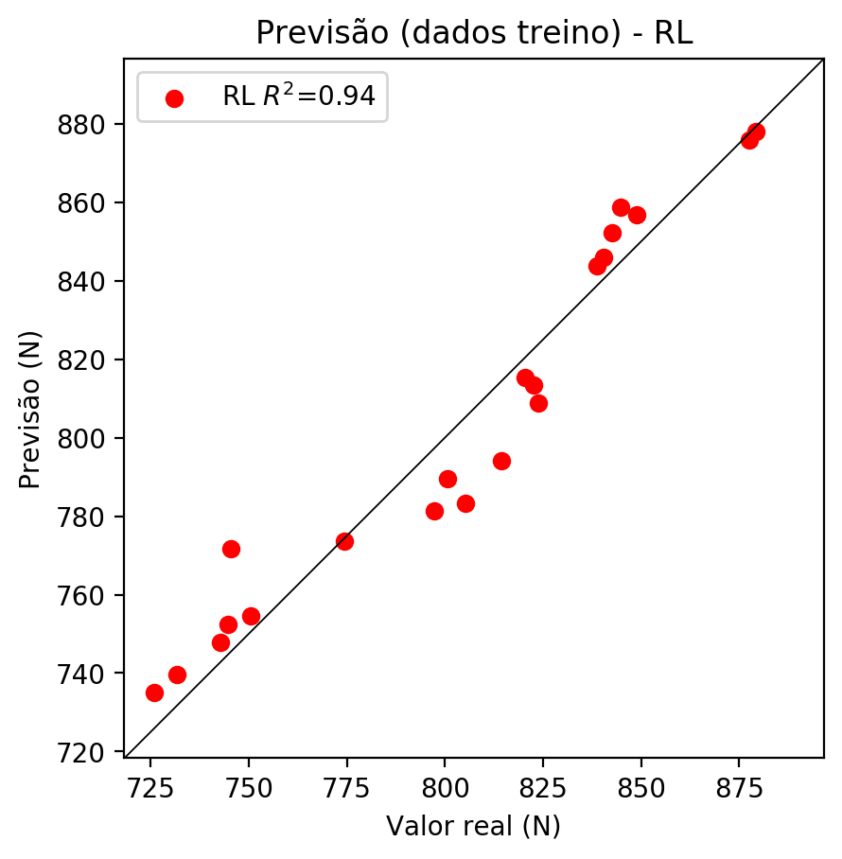

# RP2

# Coeficientes

[ 0. 1.00019591 0.26218909 0.10418067 -0.32460538 0.07085502  
 -0.02302986 0.01276745 -0.02991489 0.04527736]

# Erros

**Dados de teste**

* Erro relativo médio: 0.92
* Coeficiente de correlação: 0.99
* Coeficiente de determinação: 0.97
* MSE: 58.52
* RMSE: 7.65

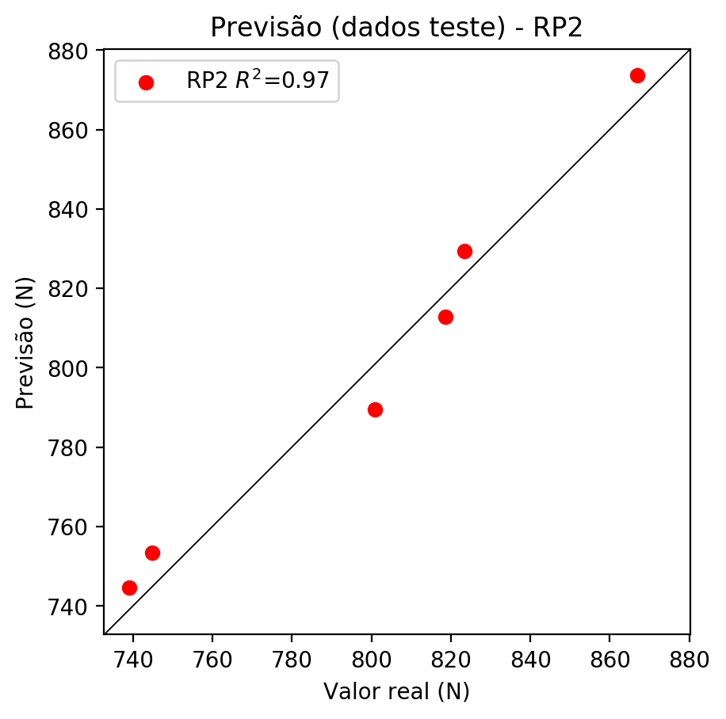

**Dados de treino**

* Erro relativo médio: 0.51
* Coeficiente de correlação: 0.99
* Coeficiente de determinação: 0.99
* MSE: 29.43
* RMSE: 5.42

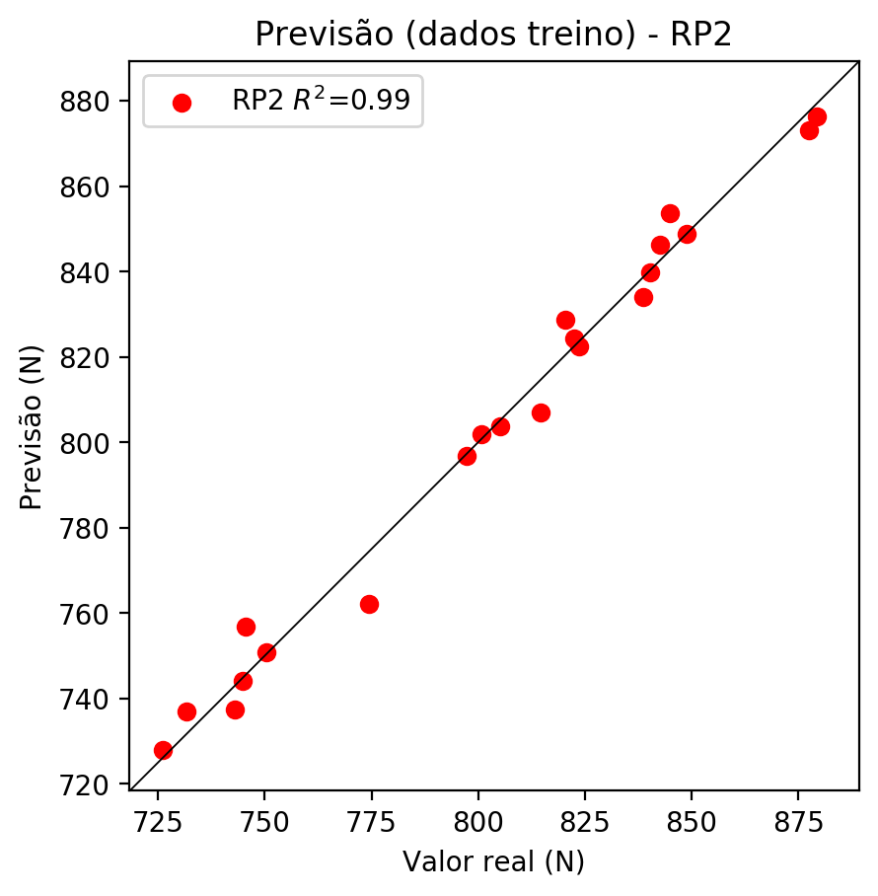

# RP3

# Coeficientes

[ 0. 0.32602669 0.05287045 0.02274433 -0.32991059 0.10958445  
 -0.05547362 -0.01899482 -0.06015259 0.0211445 0.47092744 0.07748962  
 -0.00883738 0.0817492 -0.14102994 -0.05799369 0.07636842 0.03507488  
 0.10273214 0.03285292]

# Erros

**Dados de teste**

* Erro relativo médio: 1.9
* Coeficiente de correlação: 0.95
* Coeficiente de determinação: 0.9
* MSE: 417.71
* RMSE: 20.44

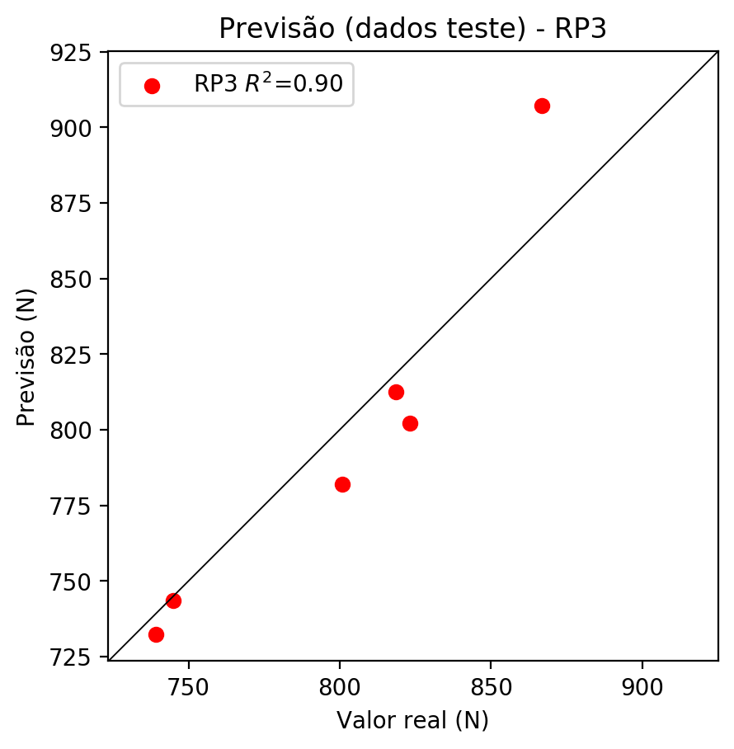

**Dados de treino**

* Erro relativo médio: 0.3
* Coeficiente de correlação: 1.0
* Coeficiente de determinação: 1.0
* MSE: 9.96
* RMSE: 3.16

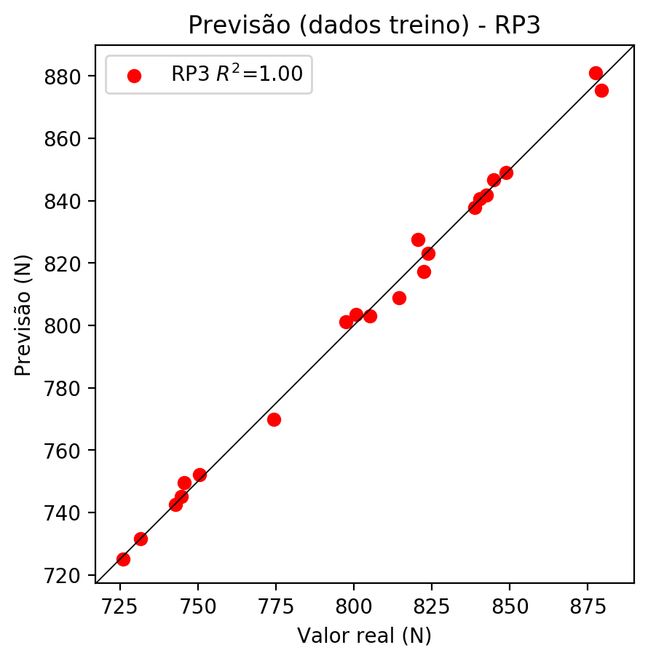

# RP4

# Coeficientes

[ 0.00245537 0.32772575 0.0951388 -0.00490383 -0.21064968 -0.01026196  
 0.02492209 -0.06096332 -0.02252559 -0.04899853 0.47551172 -0.07627791  
 0.03505824 0.08707782 -0.0297381 -0.08810441 0.13106055 0.08588754  
 -0.00425344 -0.00963329 -0.17148347 0.01073704 0.03777376 0.05307895  
 0.20282916 0.09814852 0.06385751 -0.03861172 -0.08057886 -0.08390095  
 -0.04765238 -0.0307658 0.06384675 -0.07014465 -0.06938963]

# Erros

**Dados de teste**

* Erro relativo médio: 2.04
* Coeficiente de correlação: 0.92
* Coeficiente de determinação: 0.85
* MSE: 396.3
* RMSE: 19.91

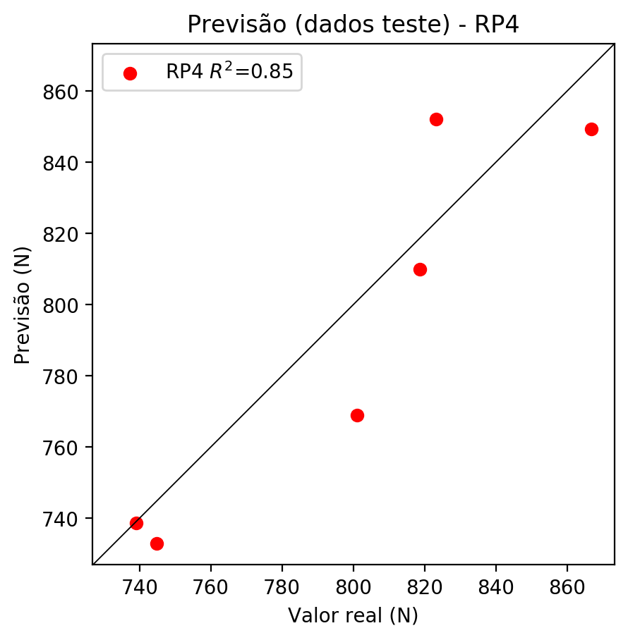

**Dados de treino**

* Erro relativo médio: 0.0
* Coeficiente de correlação: 1.0
* Coeficiente de determinação: 1.0
* MSE: 0.0
* RMSE: 0.0

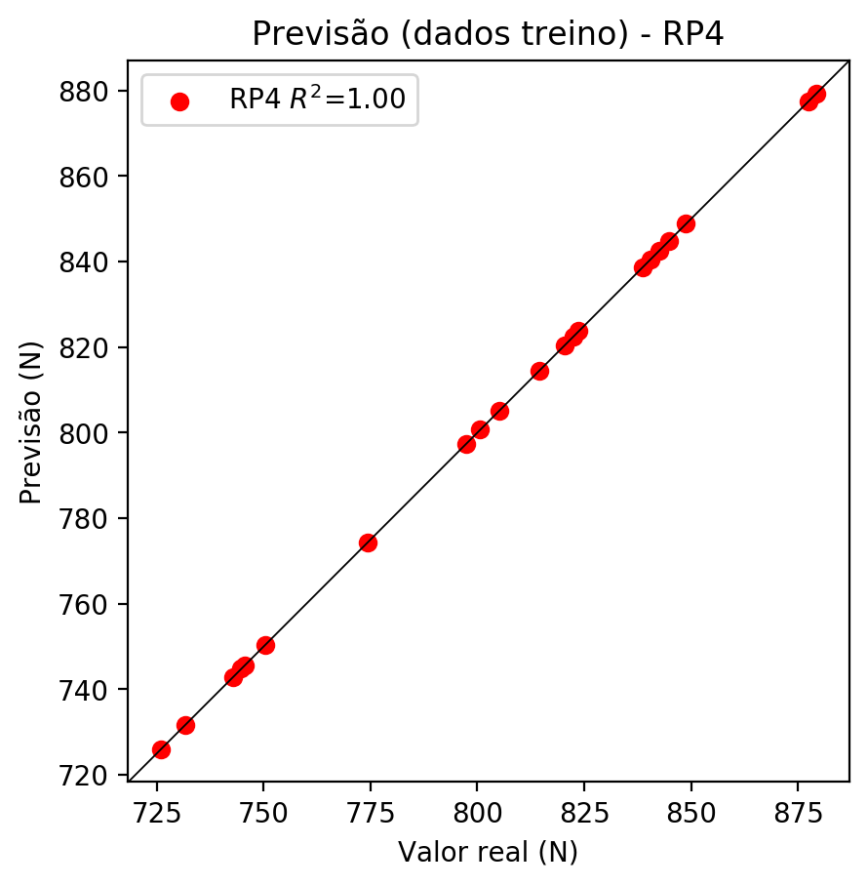

# Geral

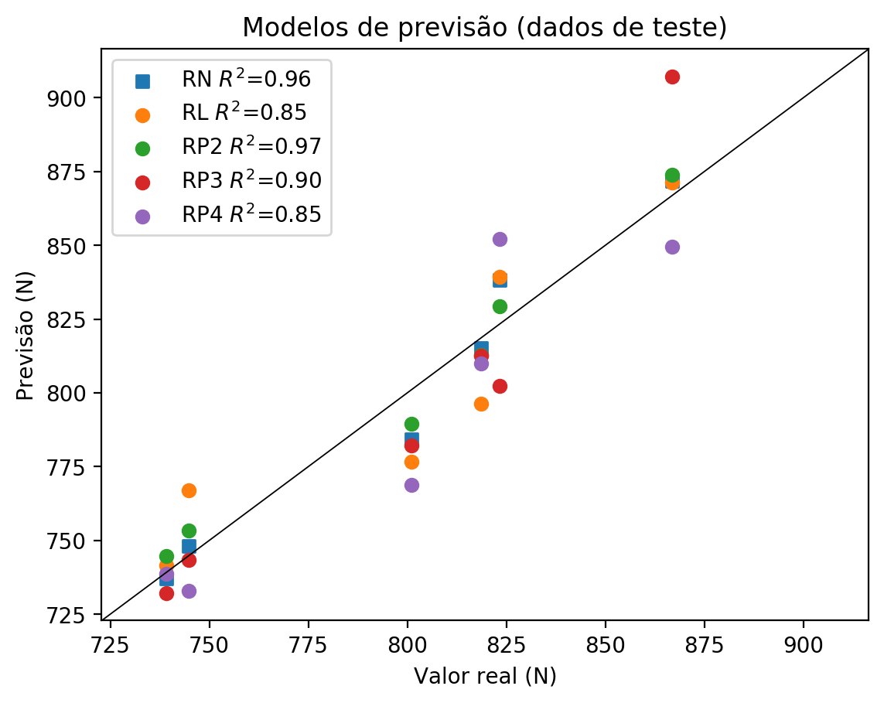

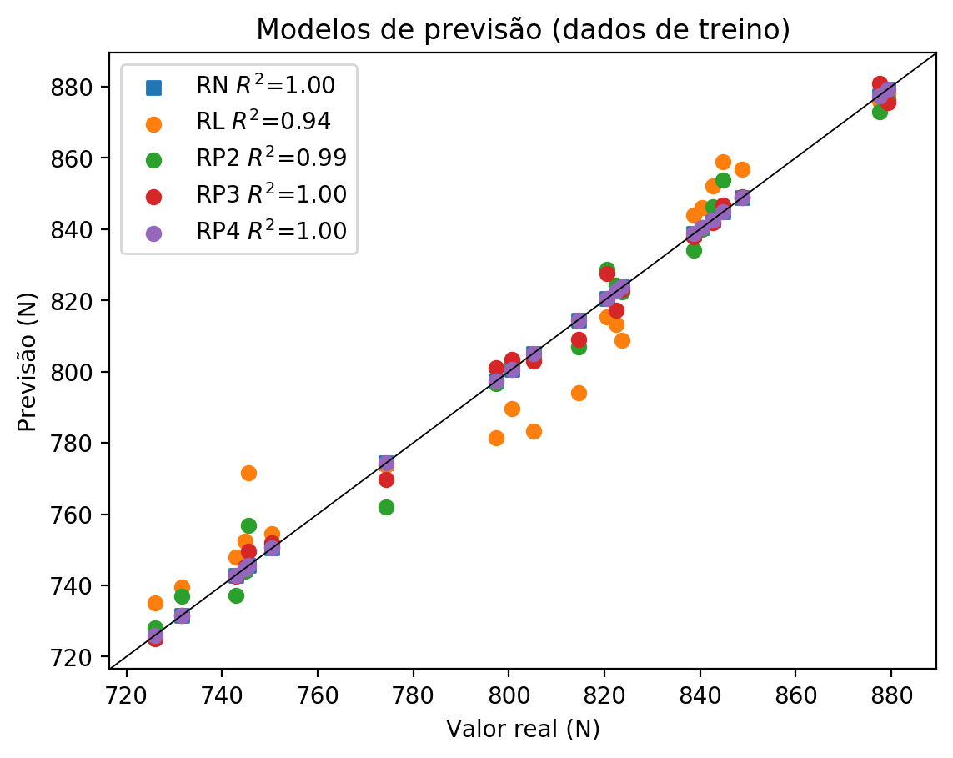

**Dados de teste**

|  |  |  |  |  |  |  |  |  |  |  |
| --- | --- | --- | --- | --- | --- | --- | --- | --- | --- | --- |
| Valor real | RN Previsto | RN Erro (%) | RL Previsto | RL Erro (%) | RP2 Previsto | RP2 Erro (%) | RP3 Previsto | RP3 Erro (%) | RP4 Previsto | RP4 Erro (%) |
| 739.15 | 736.98 | 0.29 | 741.67 | 0.34 | 744.6 | 0.74 | 732.24 | 0.93 | 738.66 | 0.07 |
| 866.89 | 871.82 | 0.57 | 871.37 | 0.52 | 873.74 | 0.79 | 907.1 | 4.64 | 849.39 | 2.02 |
| 818.69 | 815.06 | 0.44 | 796.2 | 2.75 | 812.85 | 0.71 | 812.56 | 0.75 | 810.02 | 1.06 |
| 823.34 | 838.26 | 1.81 | 839.35 | 1.94 | 829.36 | 0.73 | 802.26 | 2.56 | 852.06 | 3.49 |
| 744.79 | 748.05 | 0.44 | 767.09 | 2.99 | 753.31 | 1.14 | 743.47 | 0.18 | 732.84 | 1.6 |
| 800.97 | 784.19 | 2.09 | 776.78 | 3.02 | 789.5 | 1.43 | 782.05 | 2.36 | 768.9 | 4.0 |

**Dados de treino**

|  |  |  |  |  |  |  |  |  |  |  |
| --- | --- | --- | --- | --- | --- | --- | --- | --- | --- | --- |
| Valor real | RN Previsto | RN Erro (%) | RL Previsto | RL Erro (%) | RP2 Previsto | RP2 Erro (%) | RP3 Previsto | RP3 Erro (%) | RP4 Previsto | RP4 Erro (%) |
| 848.8 | 848.8 | 0.0 | 856.71 | 0.93 | 848.81 | 0.0 | 848.96 | 0.02 | 848.8 | 0.0 |
| 814.51 | 814.51 | 0.0 | 794.13 | 2.5 | 806.88 | 0.94 | 808.95 | 0.68 | 814.51 | 0.0 |
| 838.66 | 838.66 | 0.0 | 843.89 | 0.62 | 834.06 | 0.55 | 837.9 | 0.09 | 838.66 | 0.0 |
| 840.39 | 840.39 | 0.0 | 845.96 | 0.66 | 839.88 | 0.06 | 840.5 | 0.01 | 840.39 | 0.0 |
| 822.52 | 822.52 | 0.0 | 813.35 | 1.11 | 824.21 | 0.21 | 817.15 | 0.65 | 822.52 | 0.0 |
| 731.63 | 731.63 | 0.0 | 739.61 | 1.09 | 736.88 | 0.72 | 731.59 | 0.01 | 731.63 | 0.0 |
| 800.67 | 800.67 | 0.0 | 789.59 | 1.38 | 801.85 | 0.15 | 803.52 | 0.36 | 800.67 | 0.0 |
| 879.28 | 879.28 | 0.0 | 877.99 | 0.15 | 876.34 | 0.33 | 875.39 | 0.44 | 879.28 | 0.0 |
| 877.48 | 877.48 | 0.0 | 875.92 | 0.18 | 873.0 | 0.51 | 880.93 | 0.39 | 877.48 | 0.0 |
| 774.39 | 774.39 | 0.0 | 773.7 | 0.09 | 762.01 | 1.6 | 769.83 | 0.59 | 774.39 | 0.0 |
| 745.56 | 745.56 | 0.0 | 771.63 | 3.5 | 756.76 | 1.5 | 749.48 | 0.53 | 745.56 | 0.0 |
| 744.79 | 744.79 | 0.0 | 752.42 | 1.02 | 744.01 | 0.1 | 745.19 | 0.05 | 744.79 | 0.0 |
| 823.72 | 823.72 | 0.0 | 808.8 | 1.81 | 822.44 | 0.16 | 823.09 | 0.08 | 823.72 | 0.0 |
| 797.36 | 797.36 | 0.0 | 781.32 | 2.01 | 796.71 | 0.08 | 801.15 | 0.48 | 797.36 | 0.0 |
| 750.43 | 750.43 | 0.0 | 754.48 | 0.54 | 750.74 | 0.04 | 752.05 | 0.22 | 750.43 | 0.0 |
| 844.82 | 844.82 | 0.0 | 858.77 | 1.65 | 853.64 | 1.04 | 846.64 | 0.22 | 844.82 | 0.0 |
| 742.91 | 742.91 | 0.0 | 747.87 | 0.67 | 737.3 | 0.76 | 742.51 | 0.05 | 742.91 | 0.0 |
| 725.98 | 725.98 | 0.0 | 735.06 | 1.25 | 727.99 | 0.28 | 725.04 | 0.13 | 725.98 | 0.0 |
| 842.59 | 842.59 | 0.0 | 852.16 | 1.14 | 846.29 | 0.44 | 841.7 | 0.11 | 842.59 | 0.0 |
| 820.49 | 820.49 | 0.0 | 815.41 | 0.62 | 828.69 | 1.0 | 827.56 | 0.86 | 820.49 | 0.0 |
| 805.17 | 805.17 | 0.0 | 783.39 | 2.71 | 803.67 | 0.19 | 803.0 | 0.27 | 805.17 | 0.0 |