# Informações do estudo

Referência: Suhail

Grandeza: Rugosidade

Tipo: Ra

Material: AISI 1020

Ferramenta: CNMG 432 TT5100

Número de experimentos: 27

Observações:  
Workpiece: 250 mm long with 50 mm diameter  
Tool holder: PCLNR 2525M/12  
Surface roughness tester: Mahr Perthometer

# Unidades

Velocidade: rpm

Avanço: mm/rev

Profundidade de corte: mm

Rugosidade: μm

# Dados de teste

|  |  |  |  |
| --- | --- | --- | --- |
| Rugosidade | n | f | a |
| 0.93 | 1400.0 | 0.05 | 1.0 |
| 2.72 | 950.0 | 0.15 | 1.5 |
| 1.51 | 1150.0 | 0.05 | 1.0 |
| 1.87 | 1400.0 | 0.15 | 0.5 |
| 1.1 | 1150.0 | 0.05 | 0.5 |
| 1.43 | 950.0 | 0.05 | 1.5 |

# Dados de treino

|  |  |  |  |
| --- | --- | --- | --- |
| Rugosidade | n | f | a |
| 2.72 | 1150.0 | 0.15 | 1.0 |
| 1.51 | 1150.0 | 0.1 | 1.5 |
| 1.99 | 950.0 | 0.1 | 1.5 |
| 2.17 | 1150.0 | 0.15 | 0.5 |
| 1.8 | 1400.0 | 0.15 | 1.0 |
| 0.83 | 1400.0 | 0.05 | 1.5 |
| 1.41 | 1400.0 | 0.15 | 1.5 |
| 3.09 | 950.0 | 0.15 | 1.0 |
| 2.78 | 950.0 | 0.05 | 1.0 |
| 1.29 | 1400.0 | 0.1 | 1.0 |
| 1.22 | 950.0 | 0.05 | 0.5 |
| 1.08 | 1150.0 | 0.05 | 1.5 |
| 1.97 | 950.0 | 0.1 | 1.0 |
| 1.33 | 1150.0 | 0.1 | 0.5 |
| 1.26 | 1400.0 | 0.1 | 0.5 |
| 2.28 | 950.0 | 0.15 | 0.5 |
| 1.0 | 1400.0 | 0.05 | 0.5 |
| 0.7 | 1400.0 | 0.1 | 1.5 |
| 2.26 | 1150.0 | 0.15 | 1.5 |
| 1.53 | 950.0 | 0.1 | 0.5 |
| 1.43 | 1150.0 | 0.1 | 1.0 |

# RN

Número de neurônios: 53

Taxa de aprendizado: 1.000000e-03

Número de épocas: 498

2° camada: False

Função de ativação: relu

# Erros

**Dados de teste**

* Erro relativo médio: 15.07
* Coeficiente de correlação: 0.98
* Coeficiente de determinação: 0.97
* MSE: 0.04
* RMSE: 0.2

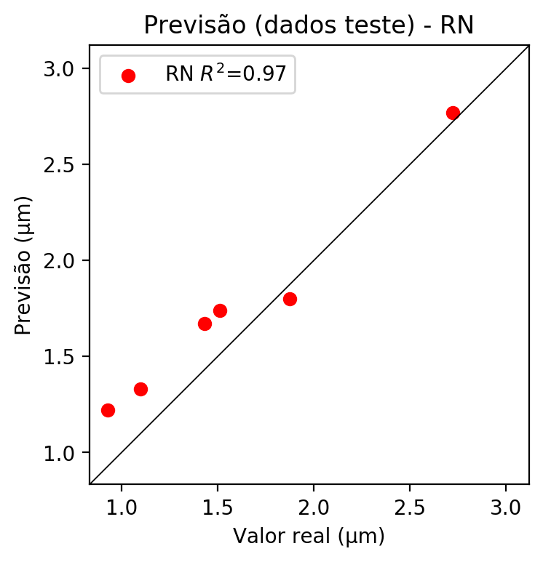

**Dados de treino**

* Erro relativo médio: 6.55
* Coeficiente de correlação: 0.97
* Coeficiente de determinação: 0.94
* MSE: 0.02
* RMSE: 0.14

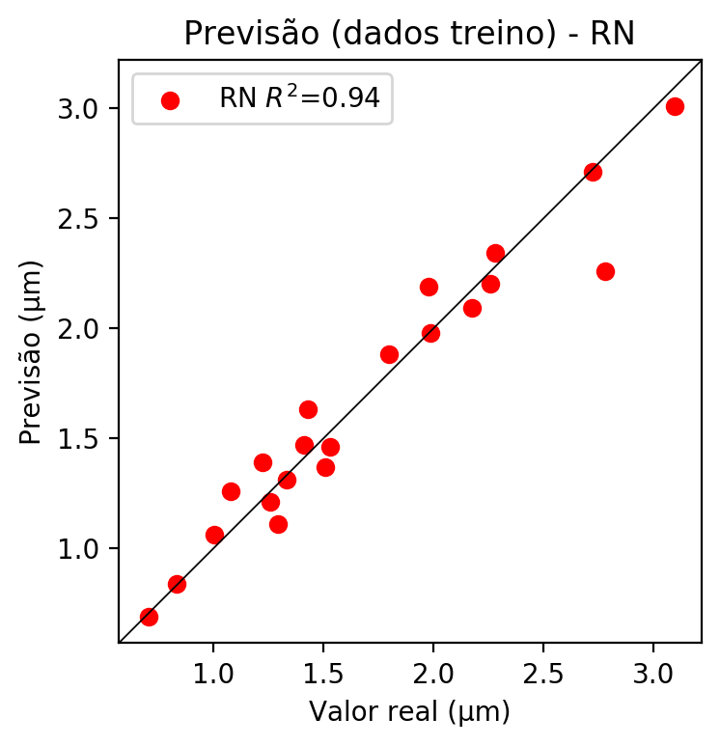

# Pesos

Pesos - camada oculta 1

[[ 1.22034416e-01 -1.07682109e-01 -9.46921036e-02 3.71183962e-01  
 7.34064728e-02 -4.12617214e-02 3.01079303e-01 -3.57631445e-01  
 2.27616340e-01 -2.34906692e-02 -1.52000055e-01 3.80659141e-02  
 -5.63287064e-02 1.64407596e-01 -5.61941862e-02 -1.93640720e-02  
 -1.01762429e-01 1.56216219e-03 -1.08687468e-01 1.57557517e-01  
 1.52189419e-01 8.62149298e-02 8.16088691e-02 1.91039057e-03  
 -2.02021003e-01 -1.04455210e-01 1.83982342e-01 -2.29406461e-01  
 8.12000781e-02 -9.19678137e-02 1.48942813e-01 -1.50498420e-01  
 -7.10239932e-02 -1.06018372e-01 1.50424585e-01 -8.80323723e-02  
 -2.07473248e-01 6.67655095e-02 -6.92804009e-02 2.46542946e-01  
 -1.49766300e-02 5.66945821e-02 1.46737441e-01 1.83513060e-01  
 -2.89895460e-02 -1.70897603e-01 3.57890487e-01 -9.59505737e-02  
 1.74785778e-01 1.60582453e-01 4.03067097e-02 5.06790578e-02  
 -7.10912421e-02]  
 [-2.14733817e-02 -4.69608814e-01 1.36481726e-03 -1.31862998e-01  
 6.60863295e-02 -1.74388736e-01 -1.07448652e-01 5.95375180e-01  
 -8.85356665e-02 -3.66125703e-01 1.86091494e-02 4.87287462e-01  
 -4.65695262e-01 -4.59669121e-02 -7.23967329e-03 -1.80296183e-01  
 -3.96421462e-01 -6.12179525e-02 -1.96057539e-02 -5.56204992e-04  
 -1.21256933e-01 2.71623880e-01 -1.87434077e-01 2.92268813e-01  
 3.33723694e-01 -4.12661830e-05 -3.00358050e-02 4.97765332e-01  
 -4.99011010e-01 -2.22418696e-01 -2.95998566e-02 -6.49459437e-02  
 8.54253769e-02 5.82110323e-03 -6.47266805e-02 -1.36946887e-01  
 5.19654930e-01 -2.67700870e-02 -8.17808807e-02 -1.09382838e-01  
 2.22620666e-01 -2.08467729e-02 -9.82210040e-02 -1.27346843e-01  
 2.26738840e-01 2.53349423e-01 -1.16086945e-01 -1.32405316e-03  
 -8.20154995e-02 4.58940595e-01 -3.95128578e-01 -4.49761361e-01  
 -3.85927409e-01]  
 [-6.72870949e-02 -2.17226103e-01 3.34698777e-03 4.84089464e-01  
 -8.46767500e-02 -3.75329822e-01 5.27413368e-01 2.40669981e-01  
 3.57772499e-01 2.43218139e-01 -1.55677408e-01 -2.63088048e-01  
 -1.92710146e-01 -6.23700321e-01 1.84362531e-02 -4.52376425e-01  
 -2.86988877e-02 -4.65074122e-01 4.50924844e-01 -9.35957506e-02  
 8.01113993e-02 -1.48047760e-01 -6.86379671e-01 -1.71833247e-01  
 2.89919376e-01 -1.09051406e-01 -1.09466389e-01 1.66480646e-01  
 1.50319234e-01 3.05040032e-01 -5.98965049e-01 2.09007144e-01  
 -4.45917875e-01 1.84963029e-02 -4.92953002e-01 -5.28295398e-01  
 1.44022062e-01 -3.49619314e-02 1.09939866e-01 1.98397413e-01  
 2.03100771e-01 1.08005209e-02 5.95308058e-02 -4.36927602e-02  
 1.95678949e-01 -1.30848046e-02 3.94202769e-01 -1.77015692e-01  
 -1.73756197e-01 -3.01053643e-01 1.08927332e-01 1.25454426e-01  
 1.39755696e-01]]

Bias - camada oculta

[-0.09398299 -0.00289419 -0.1220721 0.26850992 -0.10843395 -0.24356428  
 0.2181776 0.11924224 0.15566206 -0.00790504 -0.15309012 0.04396482  
 -0.00505414 0.13482516 -0.09130985 -0.23945129 -0.00946462 -0.07168762  
 -0.14927262 -0.1194179 -0.13761261 -0.03117025 -0.13151799 -0.01240689  
 -0.02843188 -0.1207668 -0.13076799 0.00615259 -0.03745098 -0.16100529  
 0.13643269 -0.19670352 -0.13877416 -0.14762323 0.095764 -0.2663217  
 0.04832916 -0.08418901 -0.17830491 0.15305515 -0.03959889 -0.10640246  
 -0.13307096 -0.13229954 -0.03037977 -0.07903807 0.2736705 -0.11240884  
 -0.10552936 0.01961979 -0.0543997 -0.03402477 -0.00704733]

Pesos - camada saída

[[ 0.12907657 0.21965231 -0.13682766 -0.30393913 0.10454414 -0.03554384  
 -0.2943049 0.35476065 -0.5374885 0.08479333 -0.21122728 0.4110299  
 0.17558892 -0.34915006 -0.06846922 -0.14324874 0.17870733 -0.22790334  
 -0.1623421 0.18841767 0.16667432 0.14005807 -0.40355387 0.16595669  
 0.20609163 -0.1481282 0.22542015 0.39626974 0.15920794 0.03659924  
 -0.35502258 -0.11964168 -0.09572941 -0.14254336 -0.09676336 -0.14554231  
 0.41518635 0.07286611 -0.10901509 -0.46869048 0.08445825 0.08612543  
 0.16339587 0.19449742 0.08753318 0.15080549 -0.33553255 -0.13677937  
 0.17617474 0.24324669 0.12015112 0.13174568 0.11361118]]

# Iterações

|  |  |  |  |  |  |  |
| --- | --- | --- | --- | --- | --- | --- |
| Média | Desvio | n | ln | 2° camada | Função | Épocas |
| -0.6179 | 0.3965 | 10 | 0.1 | False | relu | 38 |
| -0.5479 | 0.3705 | 17 | 0.1 | True | relu | 716 |
| -0.6145 | 0.6153 | 7 | 0.01 | True | tanh | 130 |
| -0.8325 | 0.944 | 19 | 0.001 | False | tanh | 282 |
| -0.4707 | 0.5475 | 29 | 0.001 | False | relu | 469 |
| -1.0024 | 0.622 | 88 | 0.1 | False | tanh | 926 |
| -0.5364 | 0.5169 | 95 | 0.0001 | True | relu | 984 |
| -0.5385 | 0.3812 | 10 | 0.01 | True | tanh | 865 |
| -0.911 | 0.6938 | 58 | 0.001 | True | relu | 8 |
| -0.6738 | 0.4013 | 9 | 0.01 | False | tanh | 514 |
| -0.432 | 0.4104 | 73 | 0.0001 | True | relu | 729 |
| -0.5219 | 0.4945 | 22 | 0.001 | True | relu | 543 |
| -0.7071 | 0.3835 | 25 | 0.1 | True | relu | 562 |
| -0.4071 | 0.4486 | 53 | 0.001 | False | relu | 498 |
| -0.5023 | 0.4721 | 83 | 0.01 | True | relu | 337 |
| -1.2494 | 1.0796 | 99 | 0.01 | False | tanh | 16 |
| -0.5034 | 0.3805 | 23 | 0.01 | False | relu | 472 |
| -0.4951 | 0.4908 | 24 | 0.001 | True | relu | 778 |
| -0.7526 | 0.3095 | 58 | 0.01 | True | tanh | 382 |
| -1.1549 | 0.651 | 35 | 0.1 | False | tanh | 596 |

# RL

# Coeficientes

[ 0. -0.60841752 0.58368767 0.03155009]

# Erros

**Dados de teste**

* Erro relativo médio: 14.8
* Coeficiente de correlação: 0.94
* Coeficiente de determinação: 0.88
* MSE: 0.05
* RMSE: 0.22

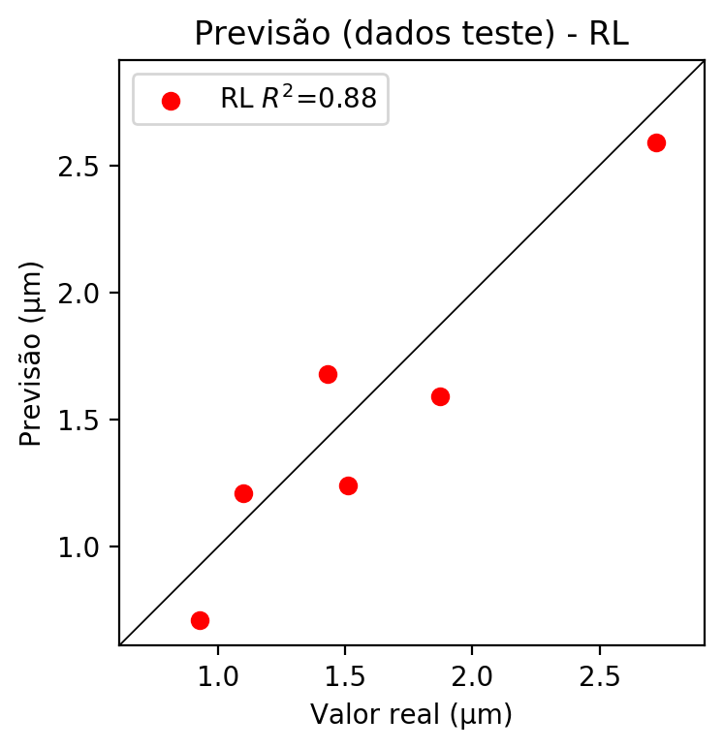

**Dados de treino**

* Erro relativo médio: 19.57
* Coeficiente de correlação: 0.8
* Coeficiente de determinação: 0.64
* MSE: 0.15
* RMSE: 0.39

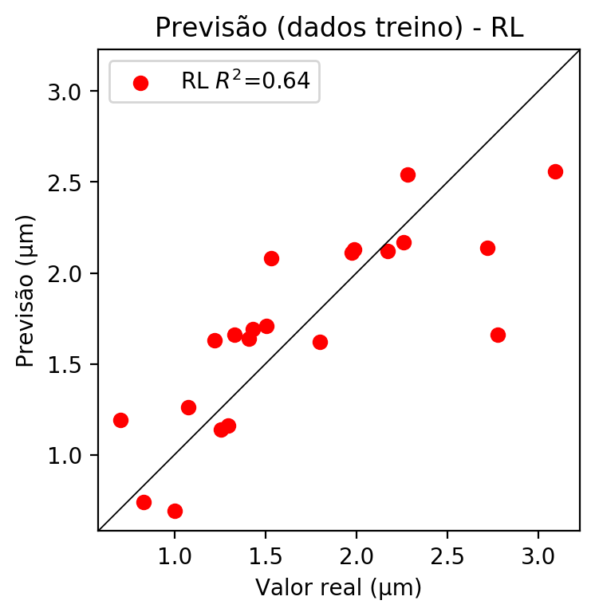

# RP2

# Coeficientes

[ 0. -0.60639147 0.51902034 0.06311694 0.09177089 -0.02161713  
 -0.28917589 0.46913275 -0.03754204 -0.44735692]

# Erros

**Dados de teste**

* Erro relativo médio: 21.56
* Coeficiente de correlação: 0.93
* Coeficiente de determinação: 0.86
* MSE: 0.13
* RMSE: 0.36

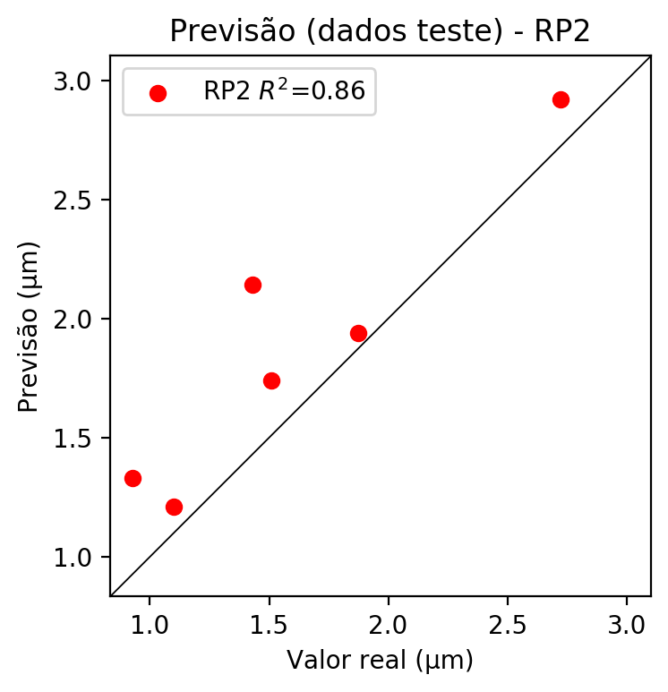

**Dados de treino**

* Erro relativo médio: 10.34
* Coeficiente de correlação: 0.95
* Coeficiente de determinação: 0.9
* MSE: 0.04
* RMSE: 0.2

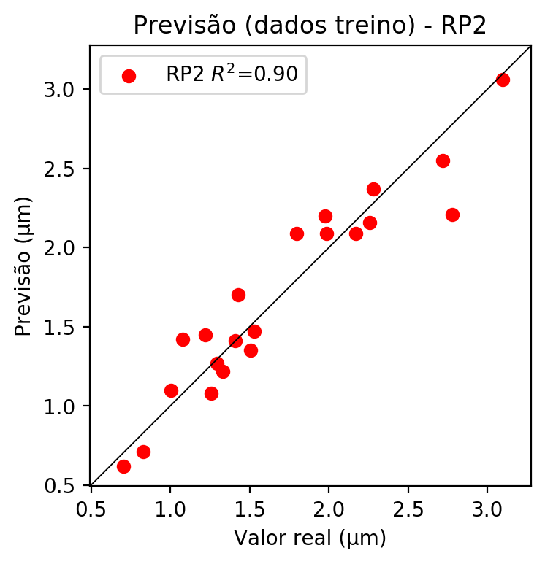

# RP3

# Coeficientes

[ 0. -0.19227557 0.3294887 -0.00732163 0.24970242 0.10606055  
 -0.29888489 0.3783935 -0.16167628 -0.39388383 -0.27773138 -0.48147877  
 0.04060524 -0.21986753 0.18800228 0.08704429 0.47592813 0.19150358  
 -0.05145234 -0.01057569]

# Erros

**Dados de teste**

* Erro relativo médio: 40.48
* Coeficiente de correlação: 0.56
* Coeficiente de determinação: 0.31
* MSE: 0.57
* RMSE: 0.75

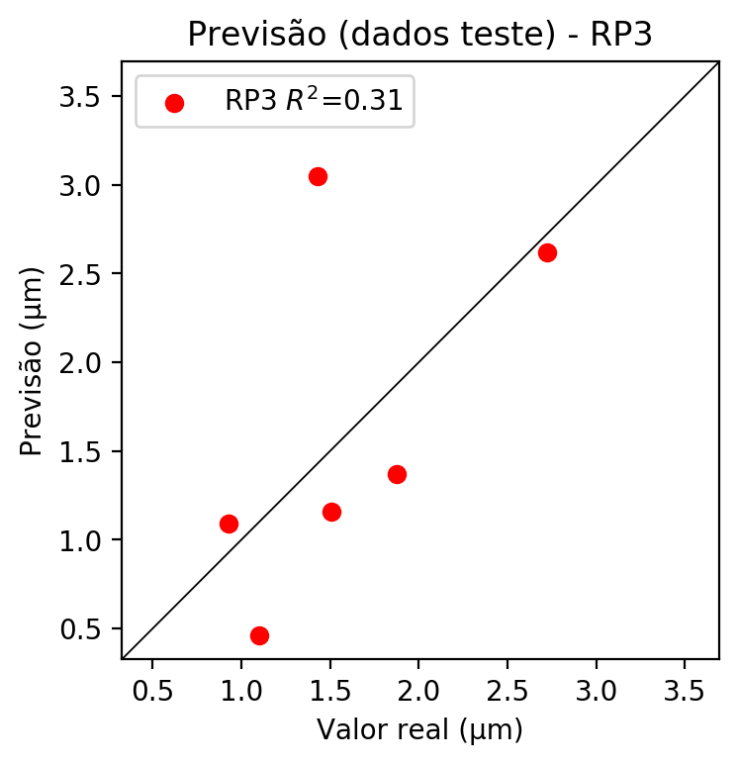

**Dados de treino**

* Erro relativo médio: 6.18
* Coeficiente de correlação: 0.98
* Coeficiente de determinação: 0.97
* MSE: 0.01
* RMSE: 0.1

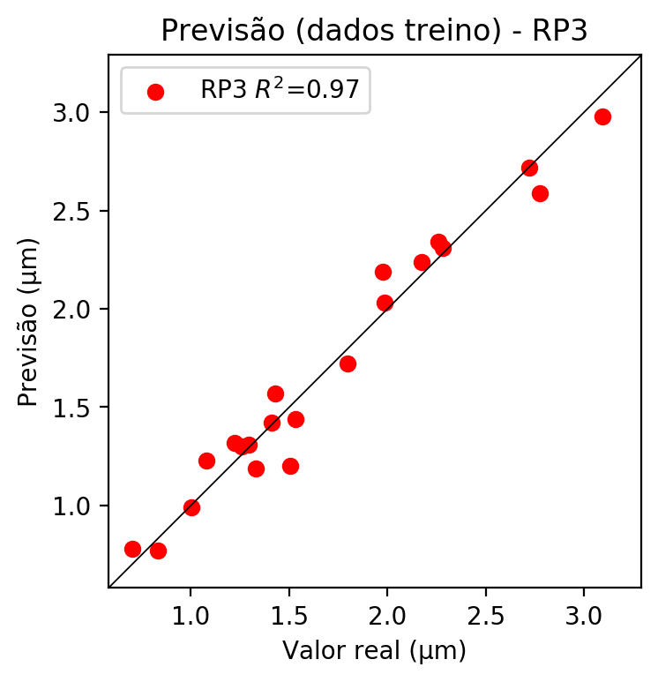

# RP4

# Coeficientes

[ 3.33066907e-16 -1.54577007e-01 2.05938336e-01 3.22172564e-02  
 9.44216590e-02 -4.88168588e-02 -5.21587071e-02 2.71278038e-01  
 -3.59017747e-02 -4.20768108e-03 -2.23277899e-01 -5.05364795e-01  
 -7.66815690e-02 -6.57186526e-02 1.69461920e-01 -2.63009162e-02  
 2.97466485e-01 1.39301404e-01 2.56175952e-01 4.65360370e-02  
 1.16658484e-01 -4.42297394e-02 -7.12285302e-02 8.63959690e-02  
 9.69957742e-02 -1.86856765e-01 -7.05132405e-02 1.42484647e-01  
 1.16847035e-01 -7.53403547e-02 3.91846055e-01 -5.18581190e-02  
 -5.70015199e-01 -5.18581190e-02 -6.07776157e-03]

# Erros

**Dados de teste**

* Erro relativo médio: 61.98
* Coeficiente de correlação: 0.19
* Coeficiente de determinação: 0.04
* MSE: 0.78
* RMSE: 0.88

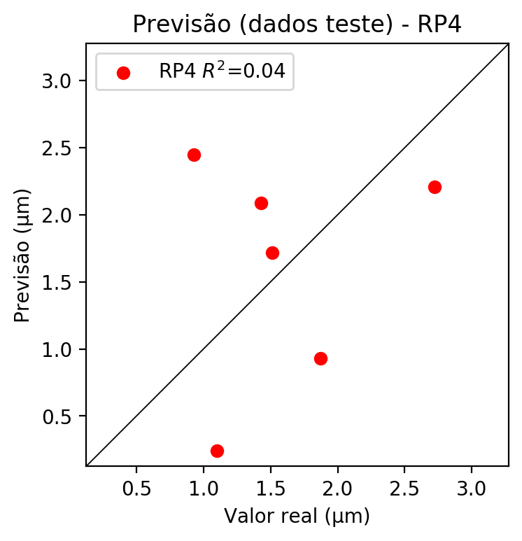

**Dados de treino**

* Erro relativo médio: 0.13
* Coeficiente de correlação: 1.0
* Coeficiente de determinação: 1.0
* MSE: 0.0
* RMSE: 0.0

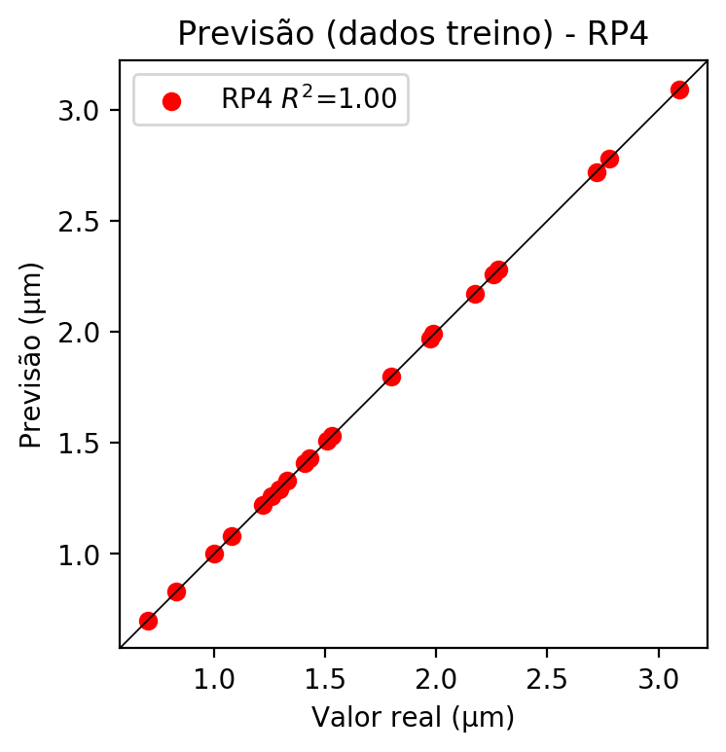

# Geral

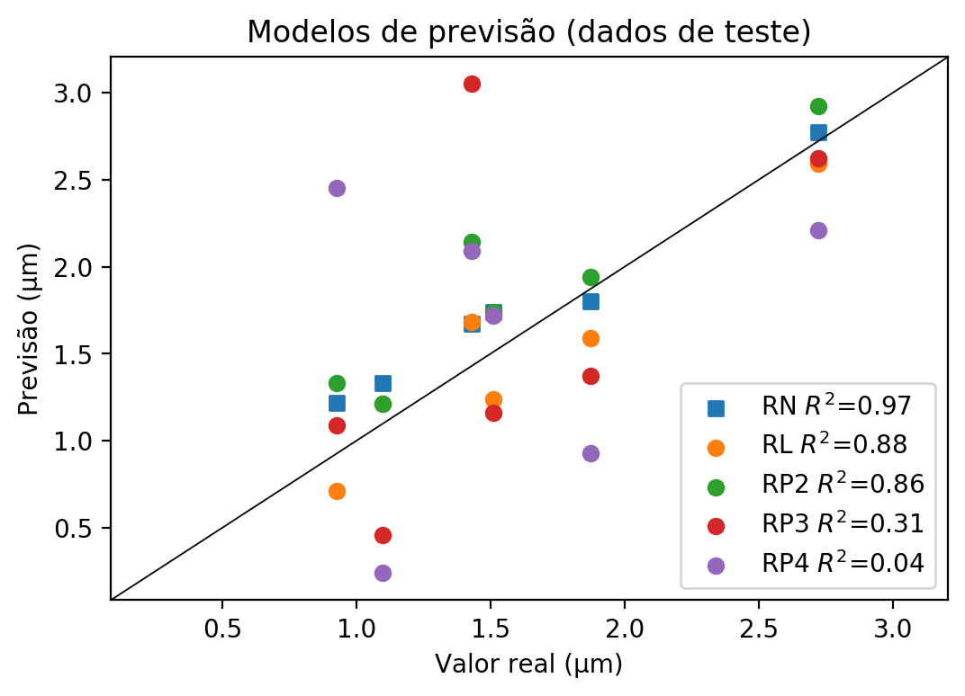

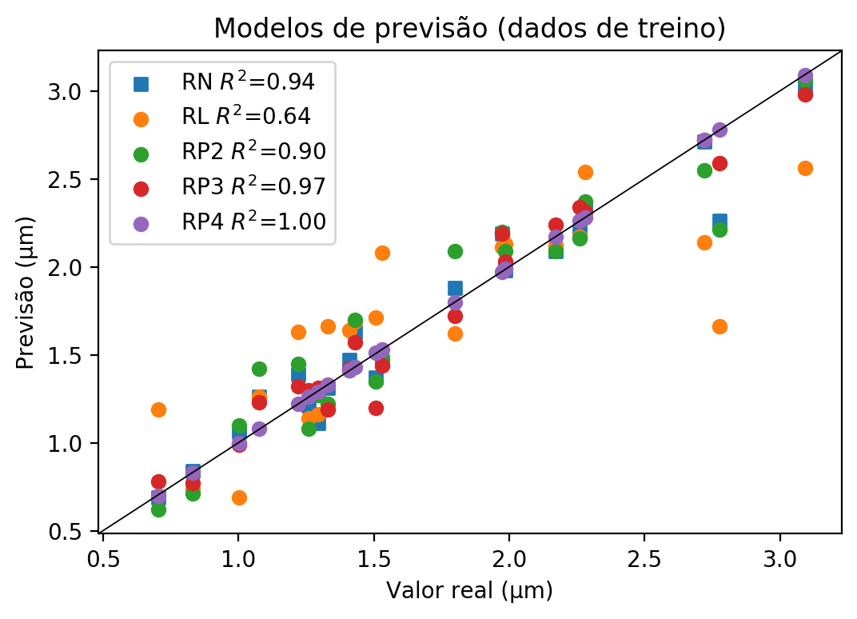

**Dados de teste**

|  |  |  |  |  |  |  |  |  |  |  |
| --- | --- | --- | --- | --- | --- | --- | --- | --- | --- | --- |
| Valor real | RN Previsto | RN Erro (%) | RL Previsto | RL Erro (%) | RP2 Previsto | RP2 Erro (%) | RP3 Previsto | RP3 Erro (%) | RP4 Previsto | RP4 Erro (%) |
| 0.93 | 1.22 | 31.7 | 0.71 | 23.35 | 1.33 | 43.58 | 1.09 | 17.67 | 2.45 | 164.48 |
| 2.72 | 2.77 | 1.75 | 2.59 | 4.86 | 2.92 | 7.26 | 2.62 | 3.76 | 2.21 | 18.82 |
| 1.51 | 1.74 | 15.23 | 1.24 | 17.88 | 1.74 | 15.23 | 1.16 | 23.18 | 1.72 | 13.91 |
| 1.87 | 1.8 | 3.91 | 1.59 | 15.12 | 1.94 | 3.56 | 1.37 | 26.87 | 0.93 | 50.36 |
| 1.1 | 1.33 | 21.02 | 1.21 | 10.1 | 1.21 | 10.1 | 0.46 | 58.14 | 0.24 | 78.16 |
| 1.43 | 1.67 | 16.78 | 1.68 | 17.48 | 2.14 | 49.65 | 3.05 | 113.29 | 2.09 | 46.15 |

**Dados de treino**

|  |  |  |  |  |  |  |  |  |  |  |
| --- | --- | --- | --- | --- | --- | --- | --- | --- | --- | --- |
| Valor real | RN Previsto | RN Erro (%) | RL Previsto | RL Erro (%) | RP2 Previsto | RP2 Erro (%) | RP3 Previsto | RP3 Erro (%) | RP4 Previsto | RP4 Erro (%) |
| 2.72 | 2.71 | 0.37 | 2.14 | 21.32 | 2.55 | 6.25 | 2.72 | 0.0 | 2.72 | 0.0 |
| 1.51 | 1.37 | 9.07 | 1.71 | 13.5 | 1.35 | 10.4 | 1.2 | 20.35 | 1.51 | 0.22 |
| 1.99 | 1.98 | 0.27 | 2.13 | 7.29 | 2.09 | 5.27 | 2.03 | 2.25 | 1.99 | 0.24 |
| 2.17 | 2.09 | 3.78 | 2.12 | 2.39 | 2.09 | 3.78 | 2.24 | 3.13 | 2.17 | 0.09 |
| 1.8 | 1.88 | 4.52 | 1.62 | 9.93 | 2.09 | 16.2 | 1.72 | 4.37 | 1.8 | 0.07 |
| 0.83 | 0.84 | 1.04 | 0.74 | 10.99 | 0.71 | 14.59 | 0.77 | 7.38 | 0.83 | 0.16 |
| 1.41 | 1.47 | 4.3 | 1.64 | 16.37 | 1.41 | 0.05 | 1.42 | 0.76 | 1.41 | 0.05 |
| 3.09 | 3.01 | 2.7 | 2.56 | 17.25 | 3.06 | 1.09 | 2.98 | 3.67 | 3.09 | 0.12 |
| 2.78 | 2.26 | 18.62 | 1.66 | 40.22 | 2.21 | 20.42 | 2.59 | 6.73 | 2.78 | 0.11 |
| 1.29 | 1.11 | 14.18 | 1.16 | 10.31 | 1.27 | 1.8 | 1.31 | 1.29 | 1.29 | 0.26 |
| 1.22 | 1.39 | 13.93 | 1.63 | 33.61 | 1.45 | 18.85 | 1.32 | 8.2 | 1.22 | 0.0 |
| 1.08 | 1.26 | 16.96 | 1.26 | 16.96 | 1.42 | 31.81 | 1.23 | 14.17 | 1.08 | 0.25 |
| 1.97 | 2.19 | 10.92 | 2.11 | 6.87 | 2.2 | 11.43 | 2.19 | 10.92 | 1.97 | 0.22 |
| 1.33 | 1.31 | 1.55 | 1.66 | 24.75 | 1.22 | 8.32 | 1.19 | 10.57 | 1.33 | 0.05 |
| 1.26 | 1.21 | 3.79 | 1.14 | 9.36 | 1.08 | 14.13 | 1.3 | 3.37 | 1.26 | 0.19 |
| 2.28 | 2.34 | 2.63 | 2.54 | 11.4 | 2.37 | 3.95 | 2.31 | 1.32 | 2.28 | 0.0 |
| 1.0 | 1.06 | 5.79 | 0.69 | 31.14 | 1.1 | 9.78 | 0.99 | 1.2 | 1.0 | 0.2 |
| 0.7 | 0.69 | 1.9 | 1.19 | 69.2 | 0.62 | 11.85 | 0.78 | 10.9 | 0.7 | 0.47 |
| 2.26 | 2.2 | 2.6 | 2.17 | 3.93 | 2.16 | 4.37 | 2.34 | 3.6 | 2.26 | 0.06 |
| 1.53 | 1.46 | 4.58 | 2.08 | 35.95 | 1.47 | 3.92 | 1.44 | 5.88 | 1.53 | 0.0 |
| 1.43 | 1.63 | 13.99 | 1.69 | 18.18 | 1.7 | 18.88 | 1.57 | 9.79 | 1.43 | 0.0 |