Master/Detail Module Overview

Master/Detail List Module
This module can be used to create a variety of article-style pages, which are wrapped up into a summary page for easy browsing. It is ideal for things like Press Releases, News Articles, Corporate Biographies, Case Studies, and Blogs. Multilingual support is built-in.
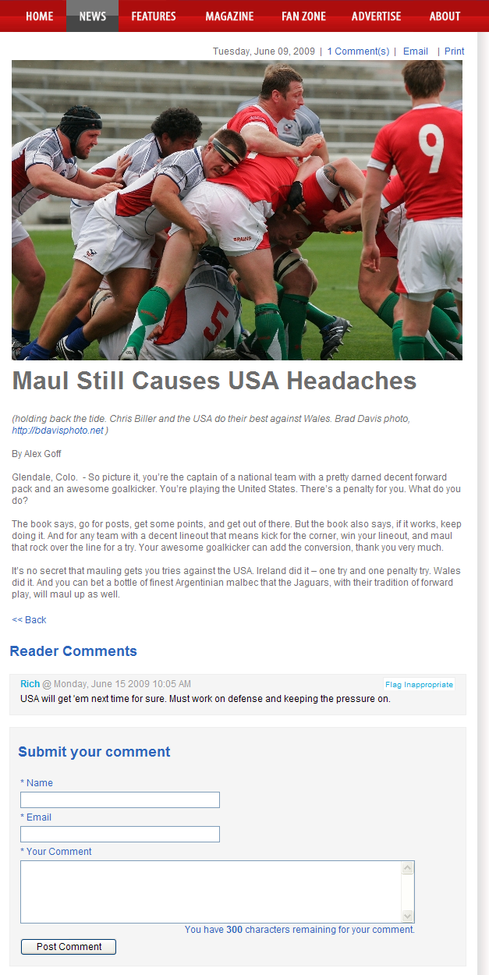
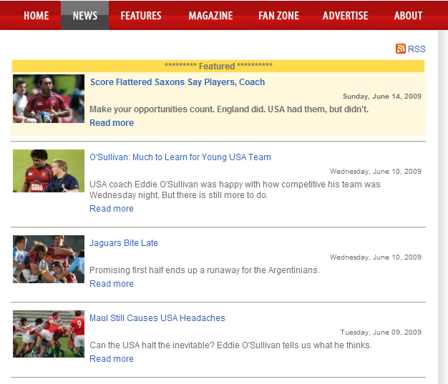
Sample Detail Page w/Comments
Sample Master/Detail Summary List Page w/Comments

Feature Summary:
- SEO friendly URLs, keywords, and descriptions for every detail page.
- RSS feed
- Visible & Featured attributes for each detail page.
- Set Post Date & Remove Date.
- Control number of summary records to display.
- Enable/disable user comments.
- Optionally, require login for user comments.
- Flag inappropriate comments w/admin to remove comments.
- Manage number of summary records to display.
- Show/hide Posting Date of detail items.
- Email and Print-friendly links are available for each article.

Admin: Master/Detail List
Admin: Master/Detail Item
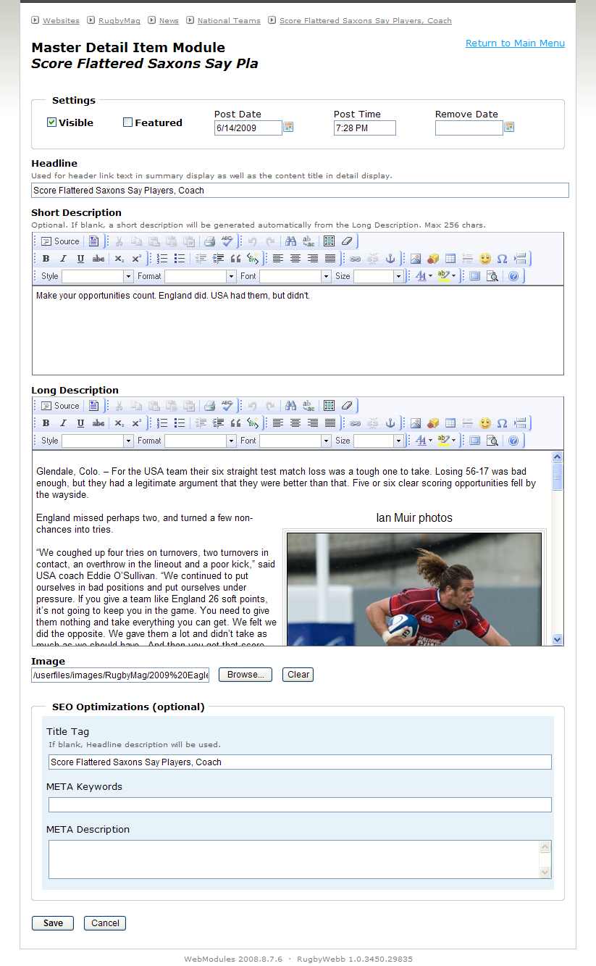
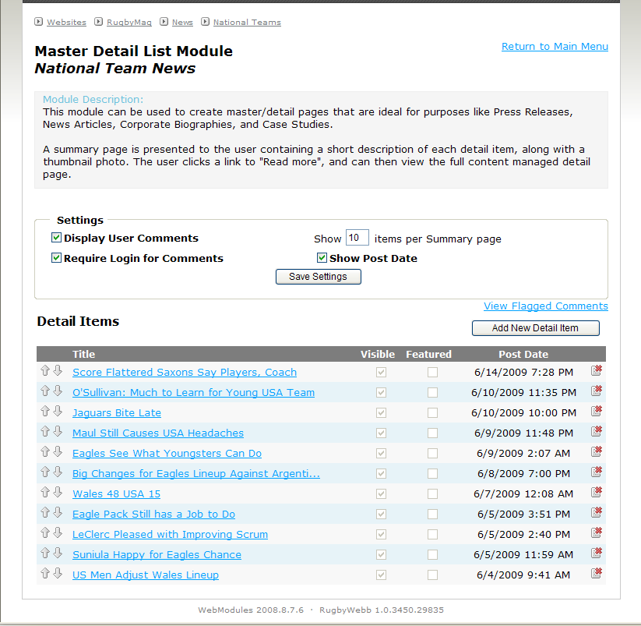

Master/Detail Mini Summary Module
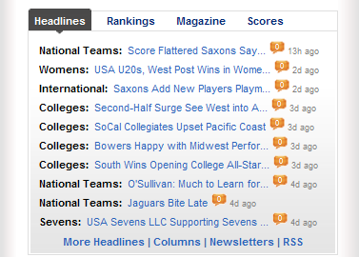
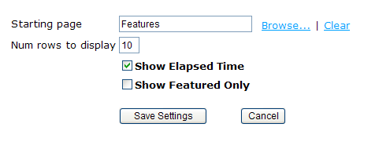
This module displays a brief one line summary for each detail item found below the starting Master/ Detail page specified, and all subpages below it. This display is ideal for placement on a homepage. The one line summary consists of the parent page header, a detail headline, and optional comments count and/or elapsed time display. The detail headline length will automatically adjust to fit the width of the containing div.
Sample Mini Summary display
Mini Summary Admin Options

