OS homework #2 : Multi-thread text analyzer

Guer, Dilber 32169190

- correct the code for prod_cons.c so that it works with 1 producer and 1 consumer

  - The output for file prod_cons1.c
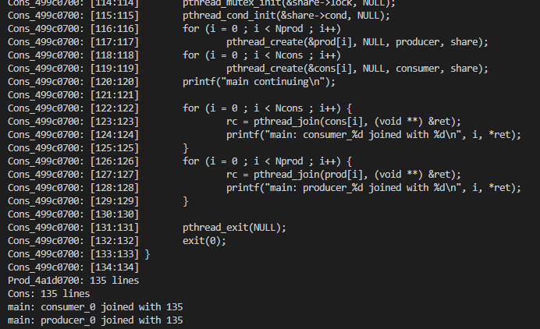

  - What changed?
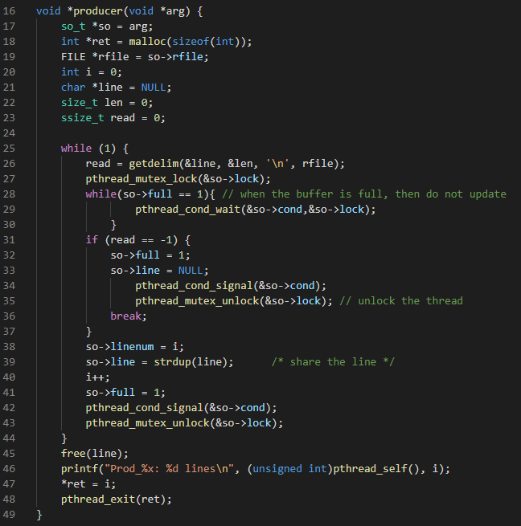
    - Producer & consumer (this picture shows only the producer but the changes are for both)

Line 27: Mutex is a program object that allows multiple program threads to share the same resource. If the mutex is already locked, the calling thread blocks until the mutex becomes available.

Line 28-30: If the buffer is full the it will not update it. Because pthread_cond_wait is used to block on a condition variable. It is called with mutex locked by the calling thread.

Line 34 & 42: The pthread_cond_signal() call unblocks at least one of the threads that are blocked on the specified condition variable cond (if any threads are blocked on cond).

Line 35 & 43:
If one or more threads are waiting to lock the mutex, pthread_mutex_unlock() causes one of those threads to return from pthread_mutex_lock() with the mutex object acquired. If no threads are waiting for the mutex, the mutex unlocks with no current owner.

- enhance it to support multiple consumers.
  - The output for file prod_cons2.c
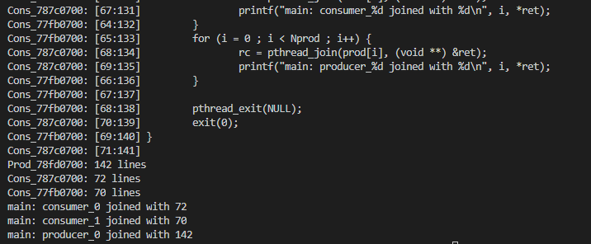

  - What changed?
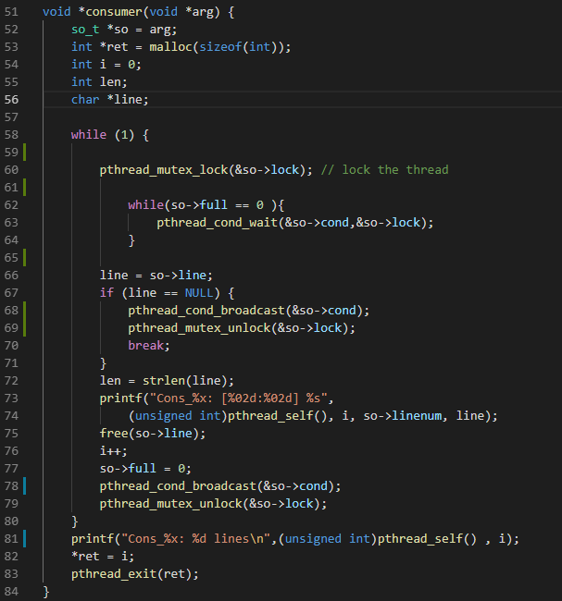
For multiple consumers it needs to lock the thread at first. While the buffer is full the thread have to wait. Pthread_cond_broadcast unblock all blocked threads and after that mutex have to unlock. With this changes it’s possible to have multiple consumers.

