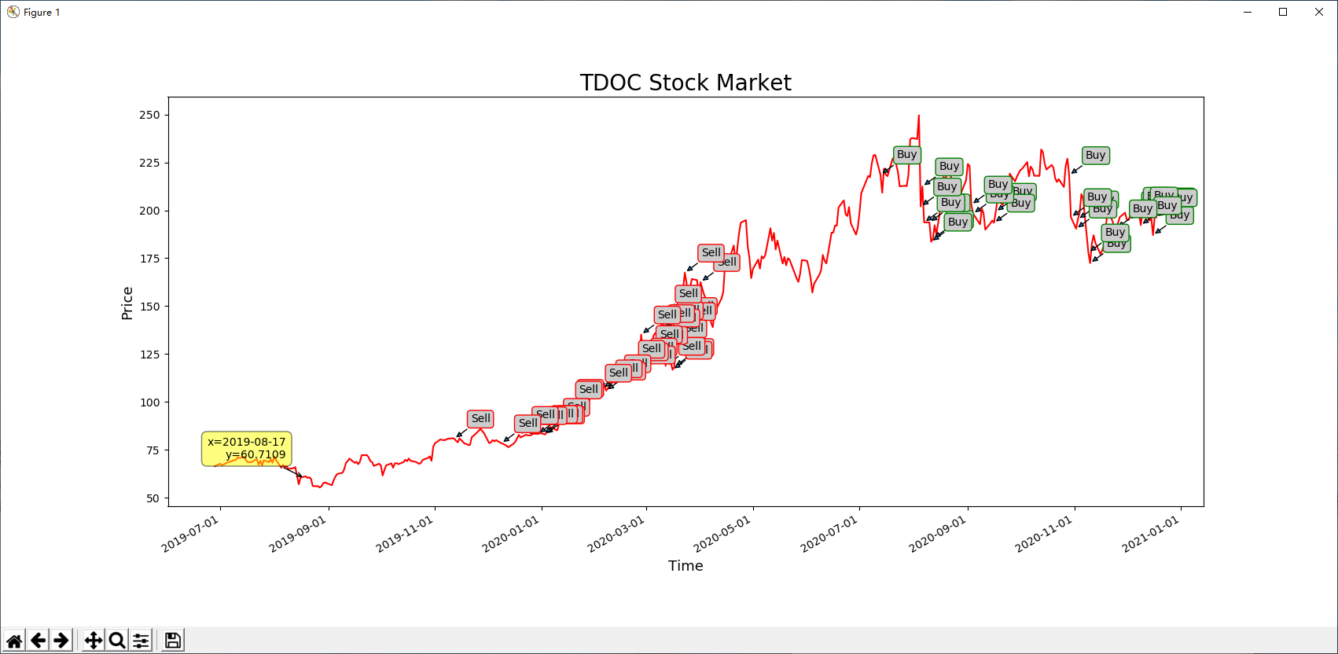

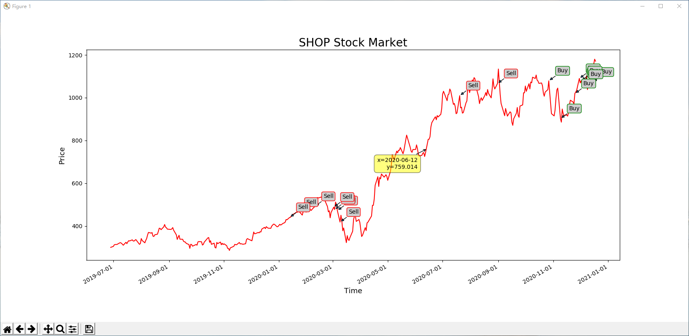

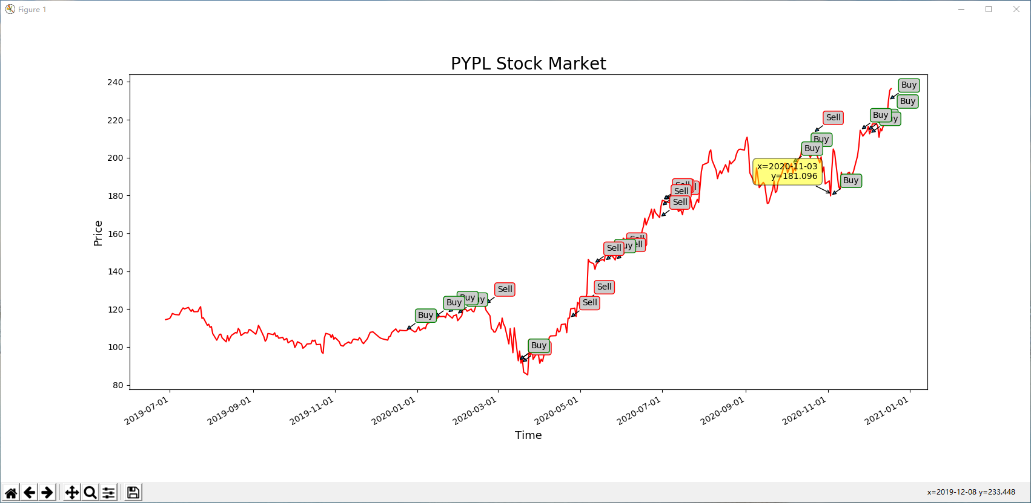

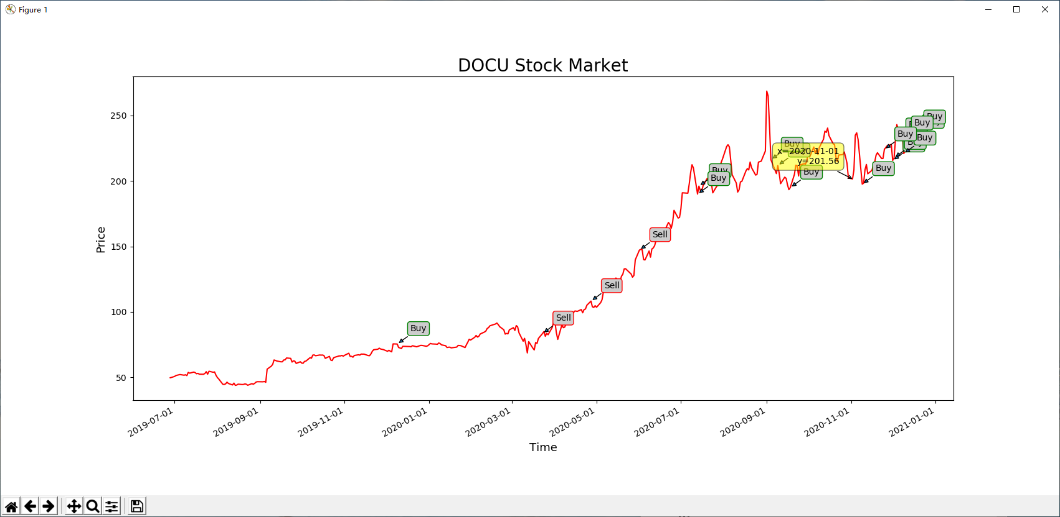

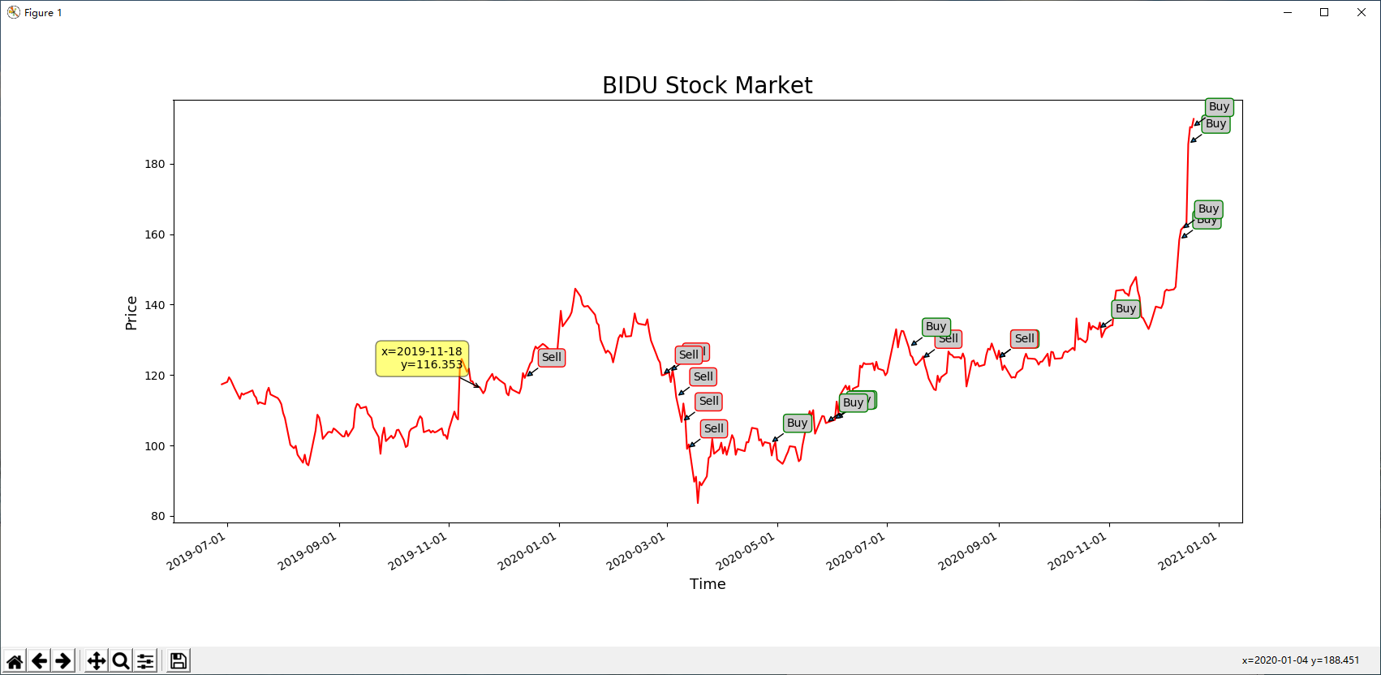

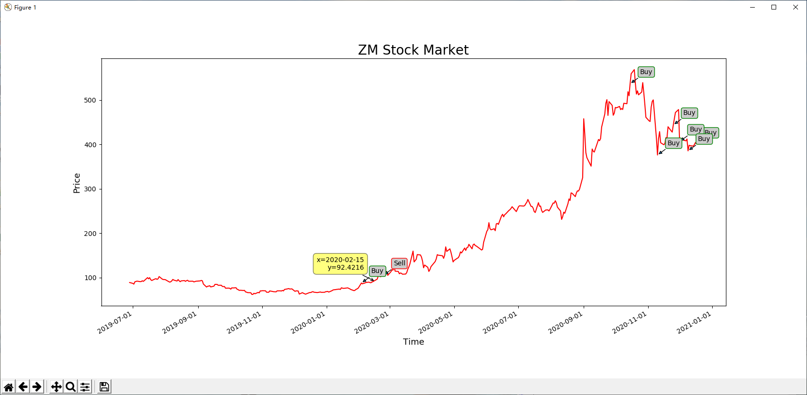

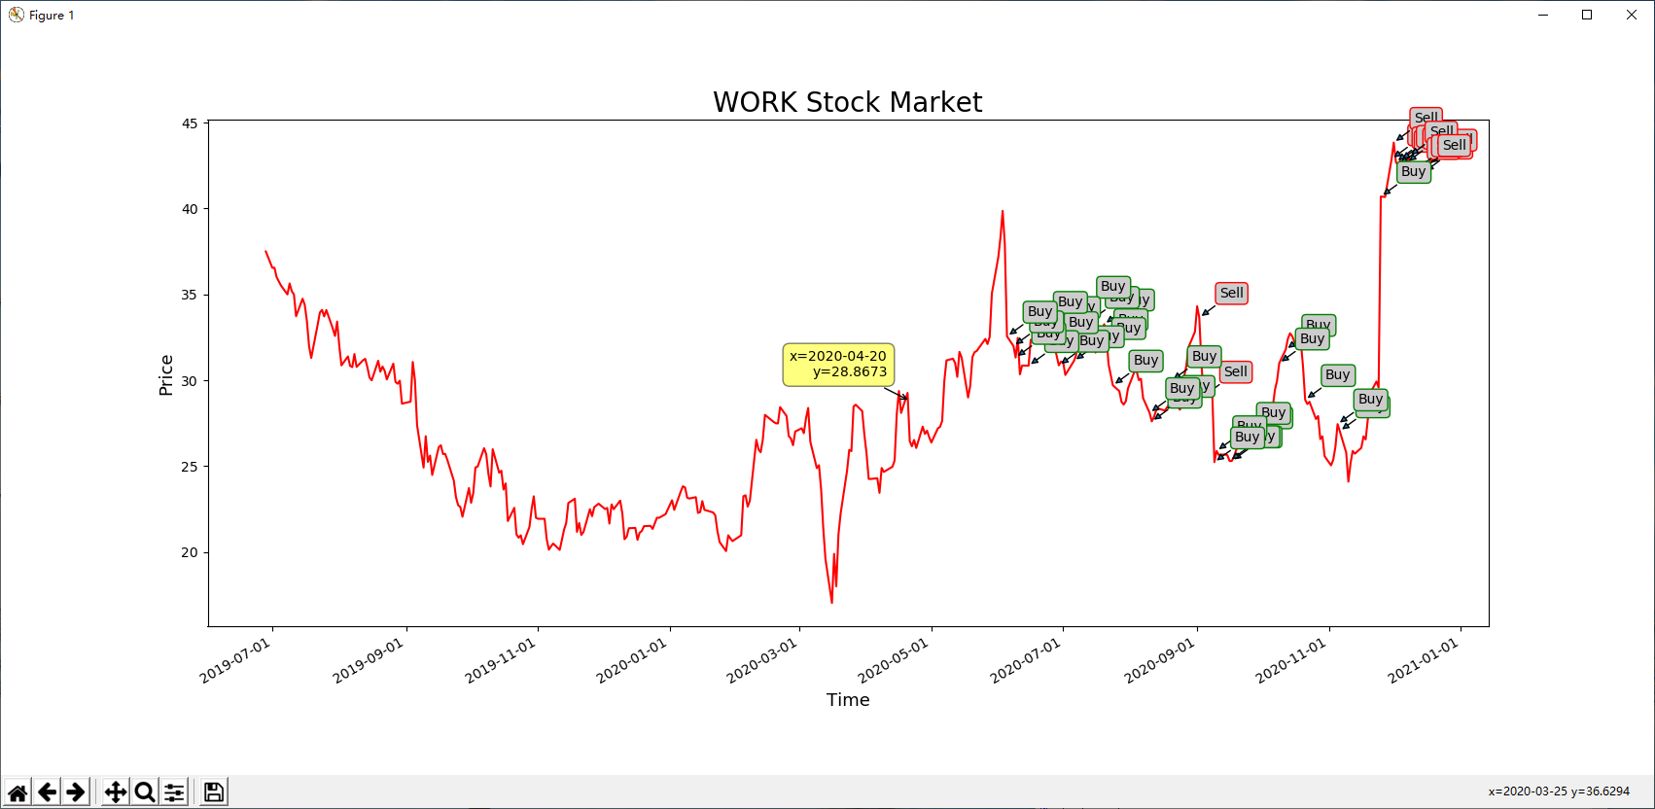

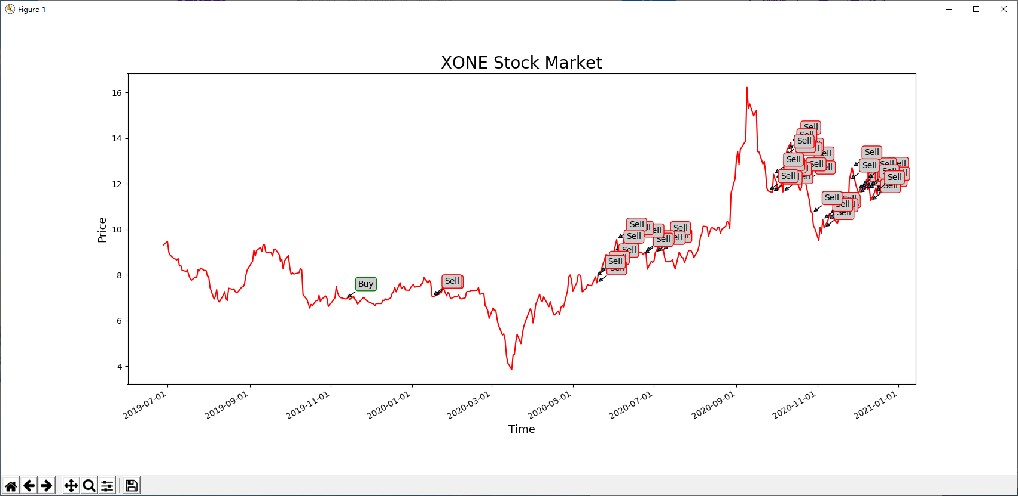

**Description**

The ExOne Company develops, manufactures, and markets three-dimensional (3D) printing machines, 3D printed and other products, materials, and services to industrial customers primarily in the Americas, Europe, the Middle East, Africa, and Asia Pacific regions. The company manufactures and sells 3D printing machines that serves direct and indirect applications, including components and tools to produce a component; and offers pre-production collaboration and print products for customers. It also supplies associated materials comprising consumables and replacement parts; and other services, such as training and technical support services. The company markets its products to industrial customers under the ExOne brand name. The ExOne Company was founded in 2005 and is headquartered in North Huntingdon, Pennsylvania.

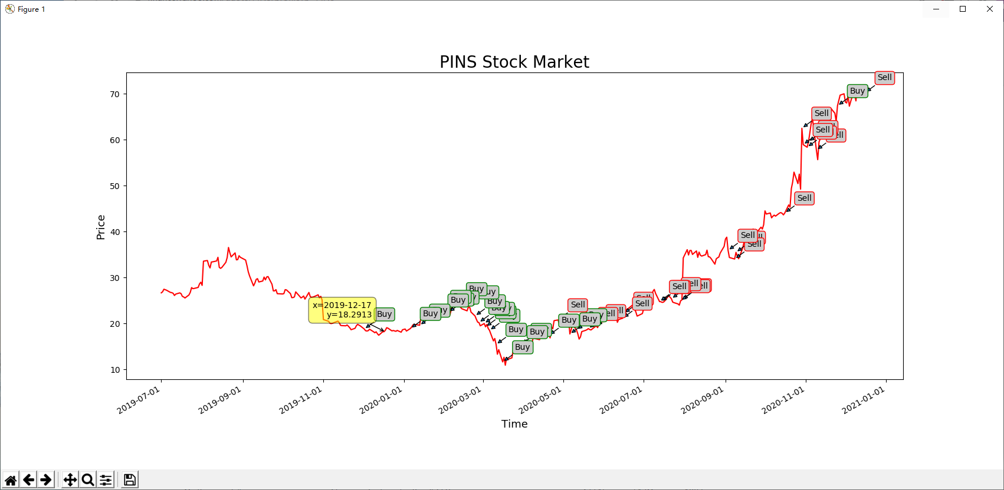

## Description

Pinterest, Inc. provides visual discovery engine in the United States and internationally. The company's engine allows people to find inspiration for their lives, including recipes, home and style ideas, travel destinations, and others. It shows them visual recommendations based on people personal taste and interests. The company was formerly known as Cold Brew Labs Inc. and changed its name to Pinterest, Inc. in April 2012. Pinterest, Inc. was founded in 2008 and is headquartered in San Francisco, California.

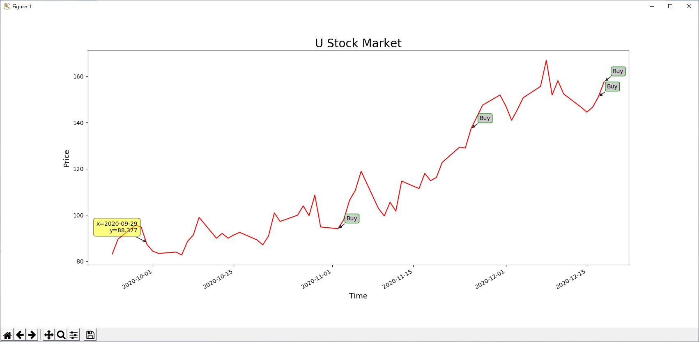

## Description

Unity Software Inc. operates a real-time 3D development platform. Its platform provides software solutions to create, run, and monetize interactive, real-time 2D and 3D content for mobile phones, tablets, PCs, consoles, and augmented and virtual reality devices. The company offers its solutions directly through its online store and field sales operations in North America, Denmark, Finland, the United Kingdom, Germany, Japan, China, Singapore, and South Korea, as well as indirectly through independent distributors and resellers worldwide. The company was founded in 2004 and is headquartered in San Francisco, California.

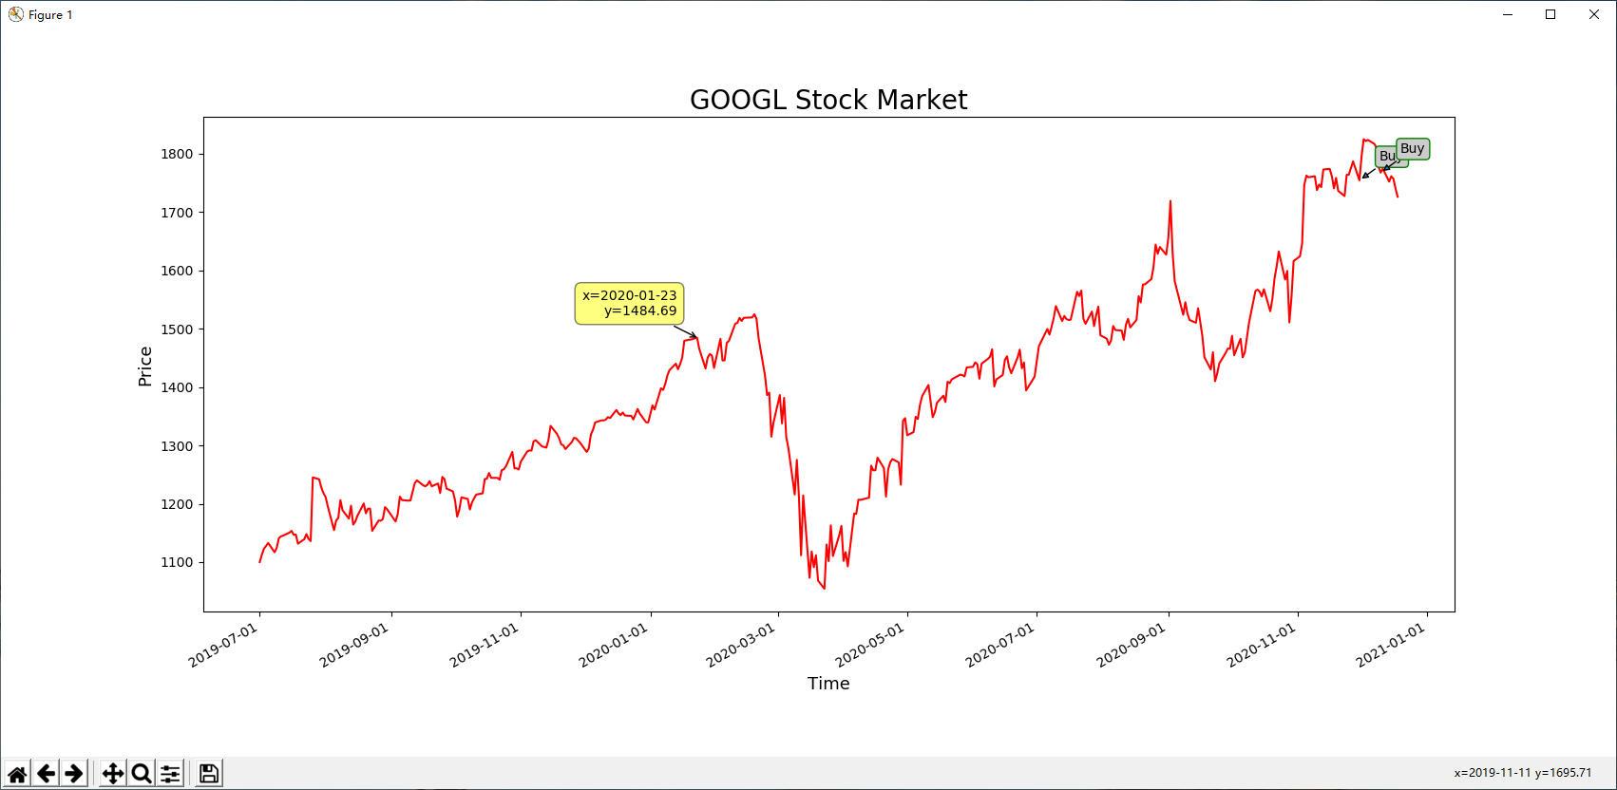

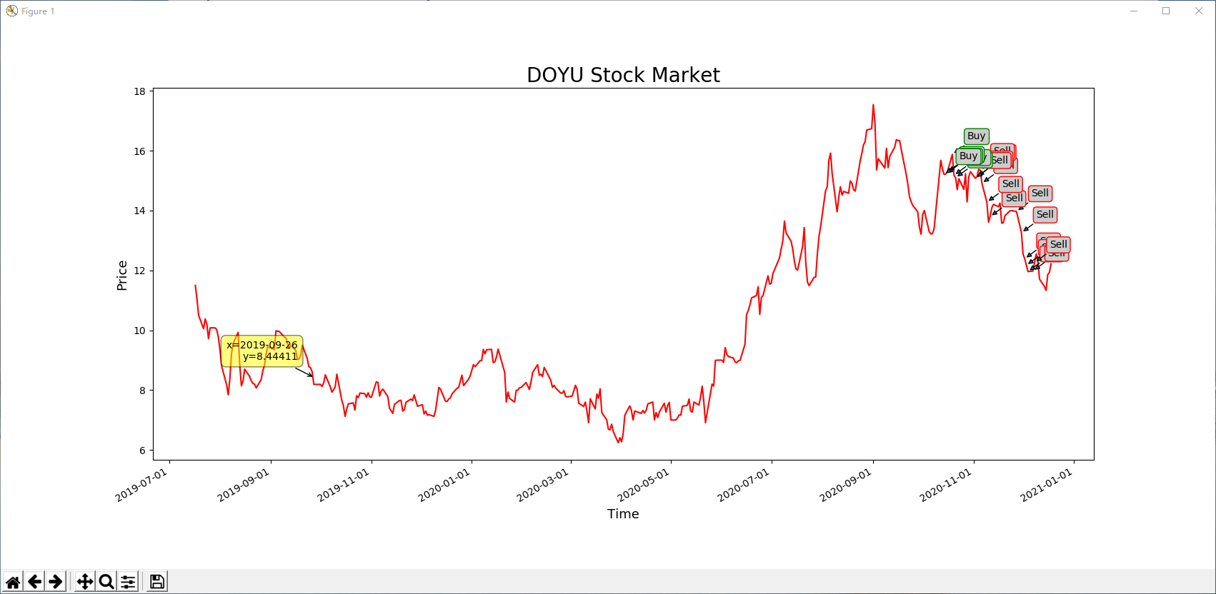

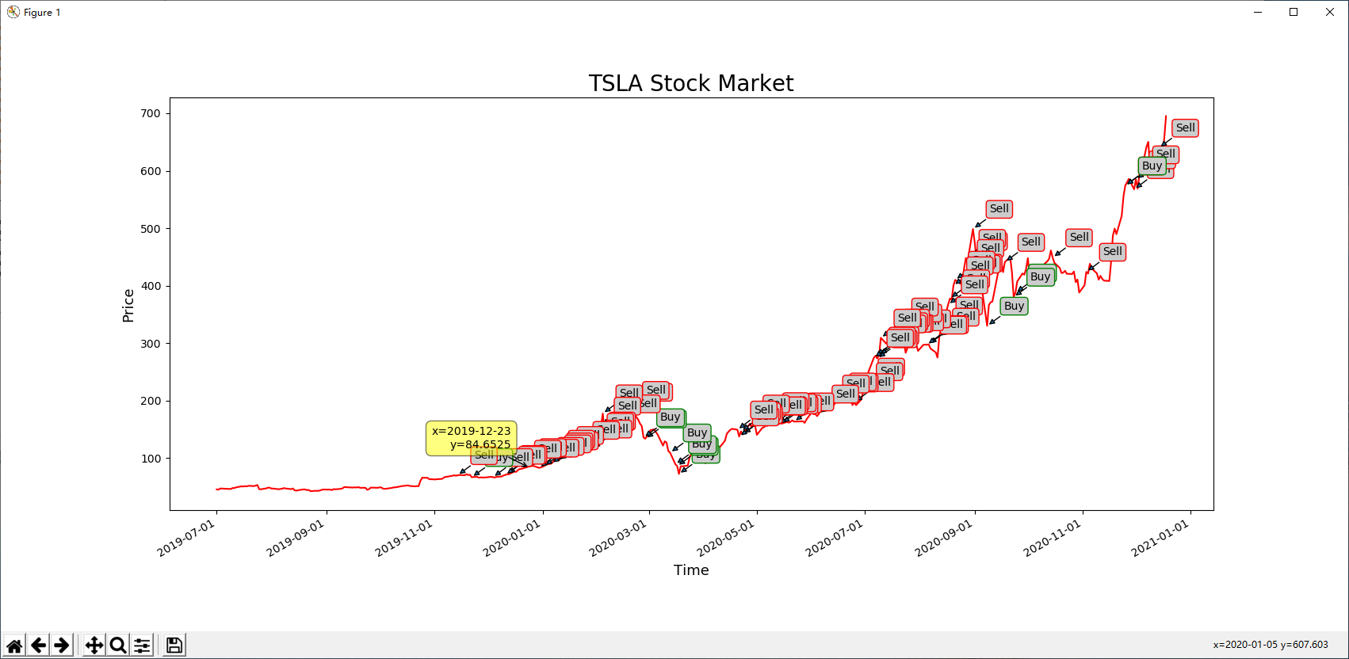

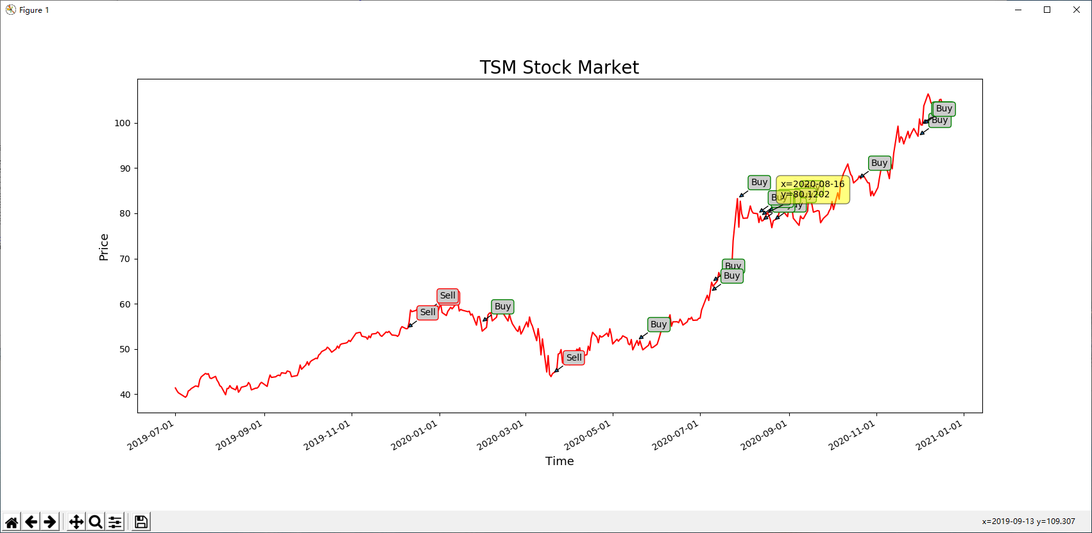

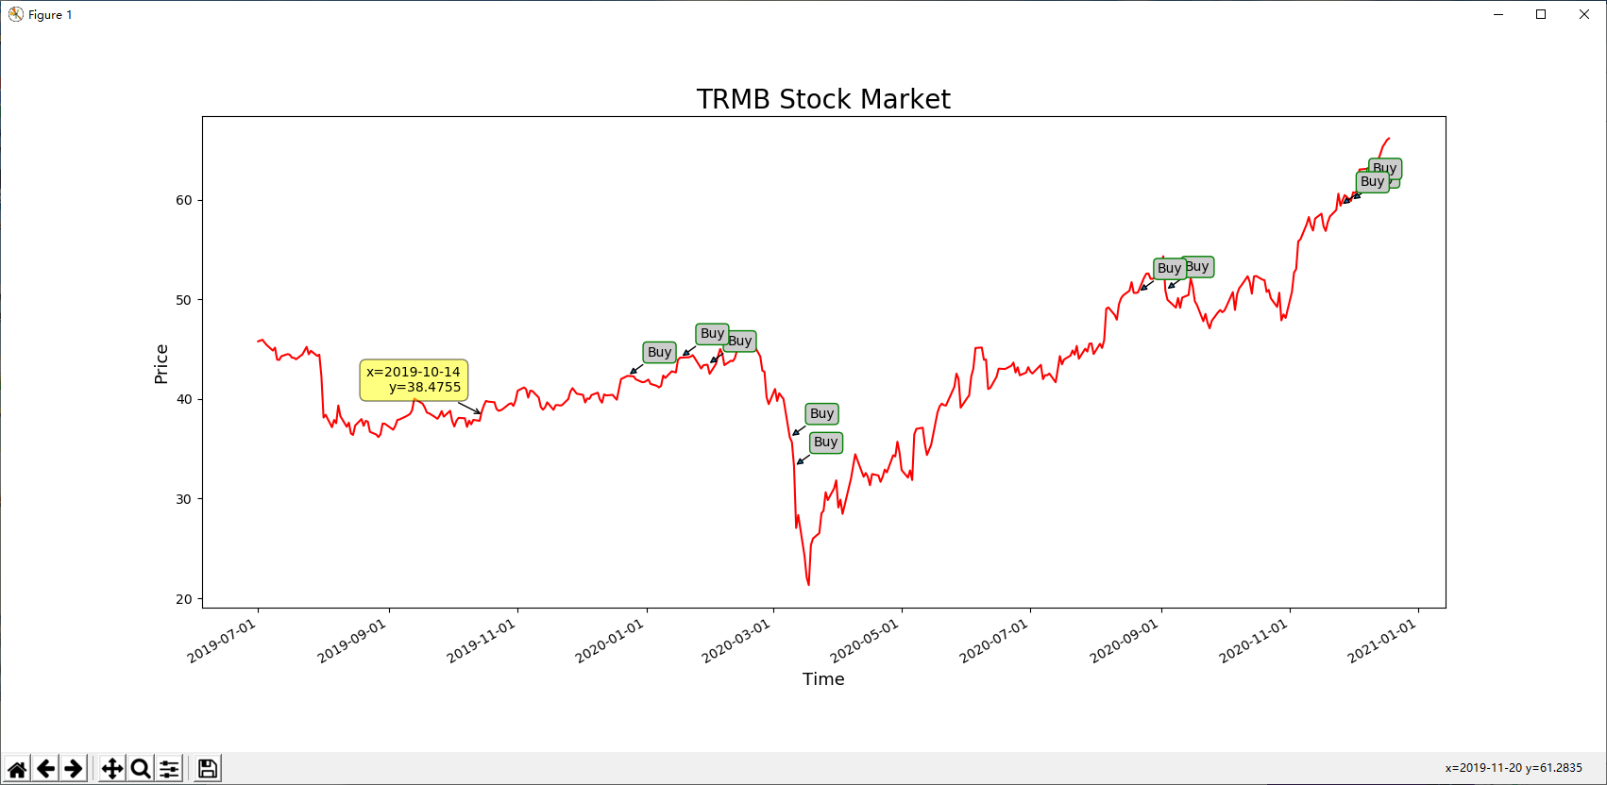

## Description

Trimble Inc. provides technology solutions that enable professionals and field mobile workers to improve or transform their work processes worldwide. It operates through four segments: Buildings and Infrastructure, Geospatial, Resources and Utilities, and Transportation. The Buildings and Infrastructure segment offers field and office software for route selection and design; systems to guide and control construction equipment; systems to monitor, track, and manage assets, equipment, and workers; software to share and communicate data; 3D conceptual design and modeling software; building information modeling software; integrated site layout and measurement systems; cost estimating, scheduling, and project controls solutions; applications for sub-contractors and trades; and an integrated workplace management software.

## 

## Description

Raven Industries, Inc., a technology company, provides various products to customers in the industrial, agricultural, geo-membrane, construction, aerospace/defense, and commercial lighter-than-air markets worldwide. It operates in three segments: Applied Technology, Engineered Films, and Aerostar. The Applied Technology segment designs, manufactures, sells, and services precision agriculture products and information management tools that enable farmers to enhance farm yields.

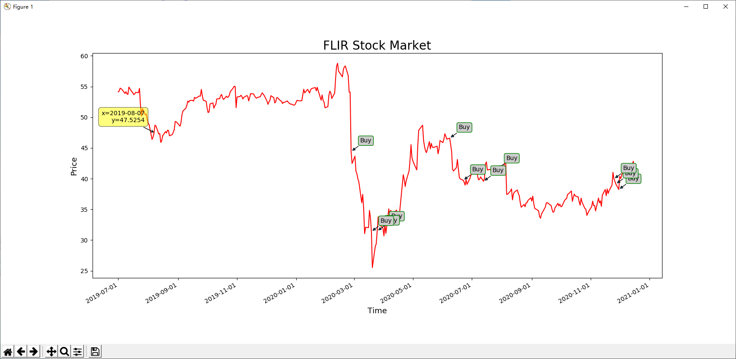

## Description

FLIR Systems, Inc. designs, develops, markets, and distributes thermal imaging systems, visible-light imaging systems, locater systems, measurement and diagnostic systems, and threat-detection solutions worldwide. The company operates in three segments: Industrial Business Unit, Government and Defense Business Unit, and Commercial Business Unit. The Industrial Business Unit segment offers thermal and visible-spectrum imaging camera cores and components for parties that create thermal, industrial, and other types of imaging systems; and products, such as thermal imaging cameras, gas detection cameras, firefighting cameras, process automation cameras, and environmental test and measurement devices.

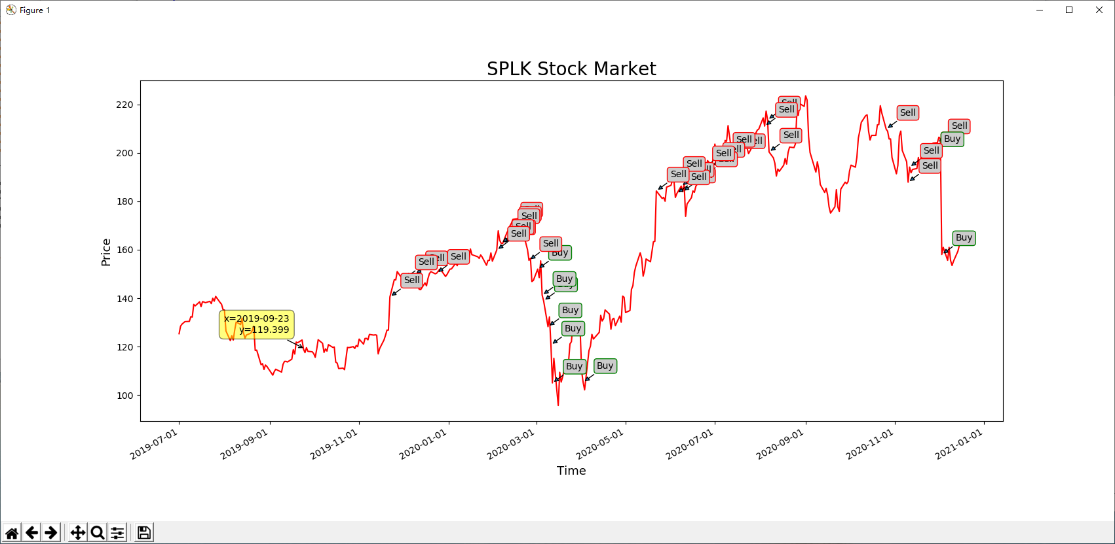

## Description

Splunk Inc. develops and markets software solutions that enable organizations to gain real-time operational intelligence in the United States and internationally. The company offers Splunk Enterprise, a real-time data platform, which include collection, indexing, search, reporting, analysis, alerting, monitoring, and data management capabilities; and Splunk Cloud, a cloud service for machine data. It also provides Splunk Enterprise Security that addresses security threats and information, and event management use cases; SignalFx, which provide real-time observability and troubleshooting for cloud infrastructure and applications; Splunk IT Service Intelligence that monitors health and key performance indicators of critical IT and business services; Splunk Phantom that automates and orchestrates incident response workflows; VictorOps for collaboration

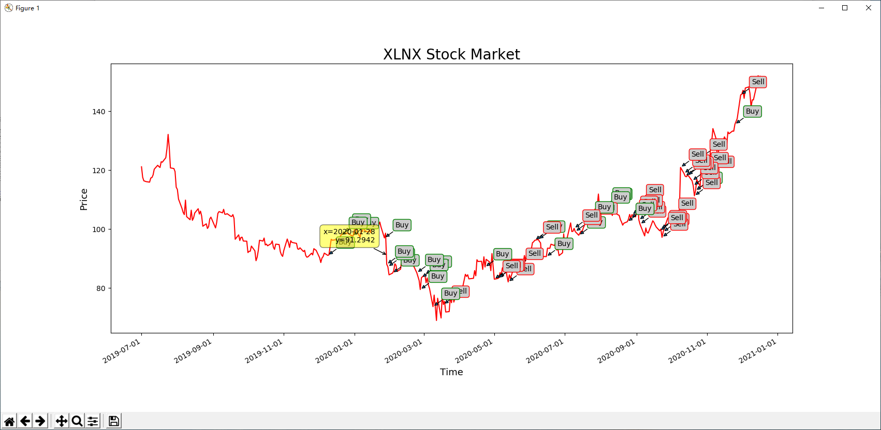

## Description

Xilinx, Inc. designs and develops programmable devices and associated technologies worldwide. The company offers integrated circuits (ICs) in the form of programmable logic devices (PLDs), such as programmable system on chips, and three dimensional ICs; adaptive compute acceleration platform; software design tools to program the PLDs; software development environments and embedded platforms; targeted reference designs; printed circuit boards; and intellectual property (IP) core licenses covering Ethernet, memory controllers, Interlaken, and peripheral component interconnect express interfaces, as well as domain-specific IP in the areas of embedded, digital signal processing and connectivity, and market-specific IP cores.

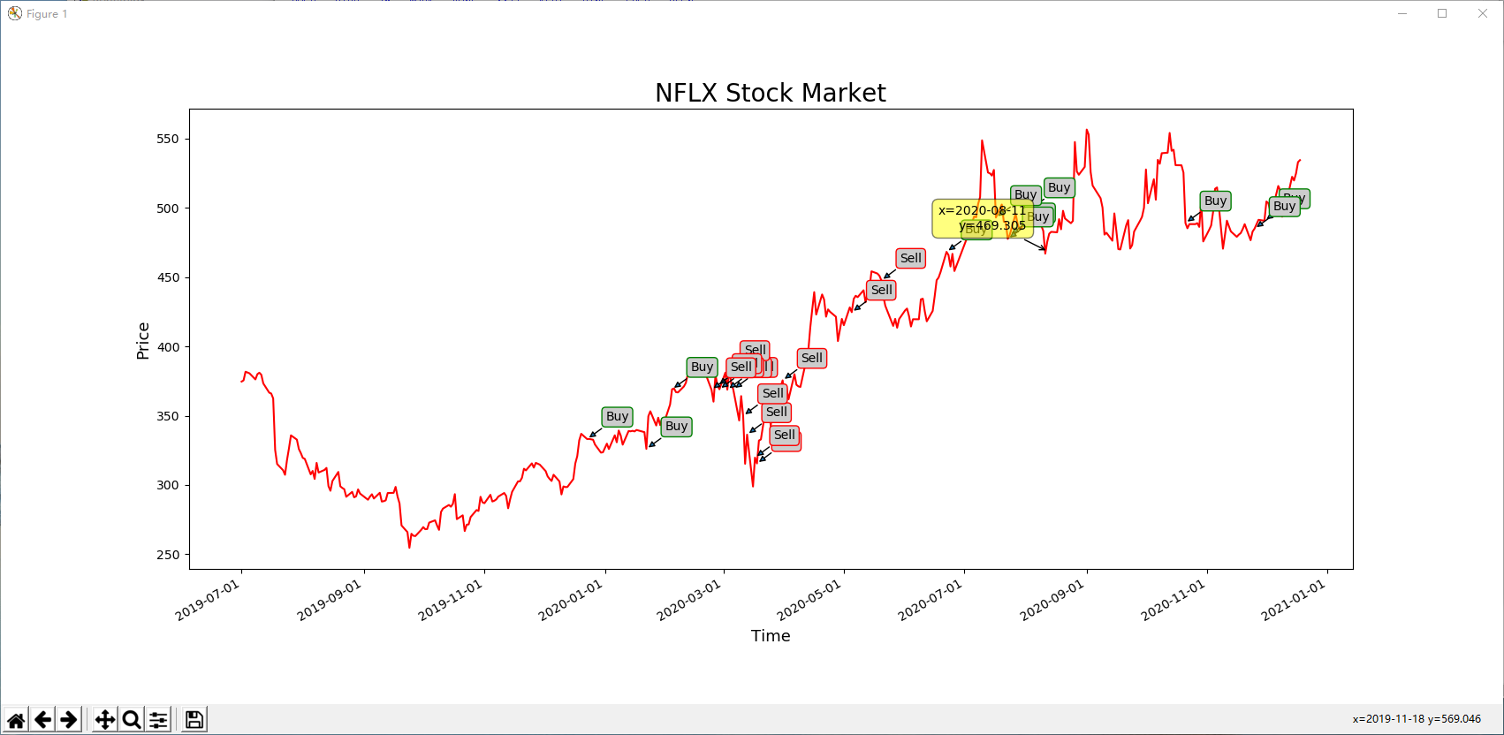

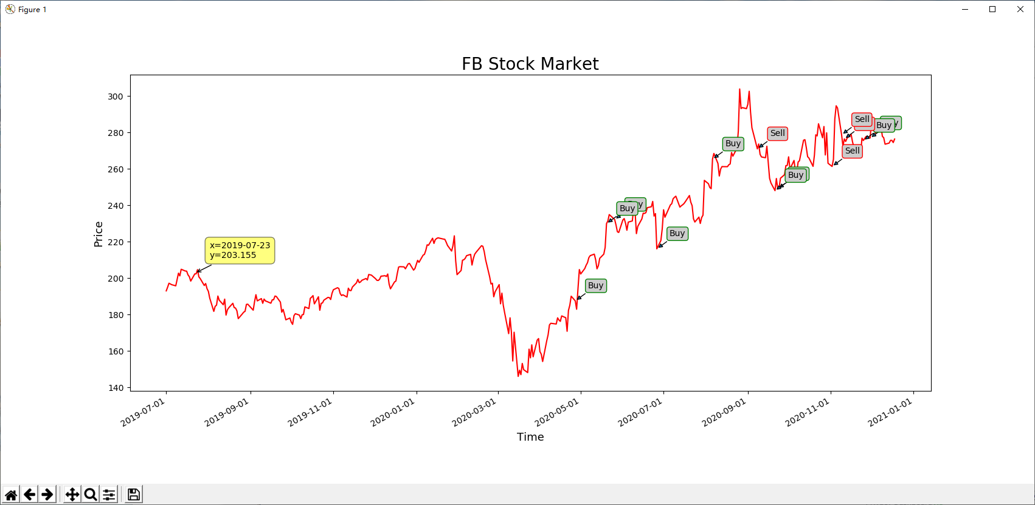

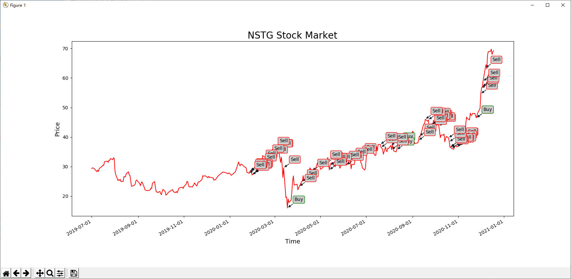

## Description

NanoString Technologies, Inc. provides life science tools for translational research and molecular diagnostic products worldwide. The company offers nCounter Analysis System, an automated, multi-application, digital detection, and counting system. It provides nCounter MAX and FLEX systems that include Prep Station, an automated liquid handling component that processes and prepares samples for data collection; and nCounter Digital Analyzer, which collects data from samples by taking images of the immobilized fluorescent reporters in the sample cartridge and processing the data into output files.

## 

## Description

Twilio Inc., together with its subsidiaries, provides a cloud communications platform that enables developers to build, scale, and operate communications within software applications in the United States and internationally. Its customer engagement platform provides a set of application programming interfaces that handle the higher level communication logic needed for nearly every type of customer engagement, as well as enable developers to embed voice, messaging, and video capabilities into their applications. The company was founded in 2008 and is headquartered in San Francisco, California.

## 

## Description

Workiva Inc., together with its subsidiaries, provides connected reporting and compliance platform worldwide. The company offers Workiva platform that offers controlled collaboration, data linking, data integrations, granular permissions, process management, and full audit trail services; and Wdata, which includes data integration and preparation tools that enables customers to connect data from enterprise resource planning, governance risk and compliance, and customer relationship management platforms, as well as from other third-party cloud and on-premise systems.

## 

## Description

Sea Limited engages in the digital entertainment, e-commerce, and digital financial service businesses in Southeast Asia, Latin America, rest of Asia, and internationally. It provides Garena digital entertainment platform for users to access mobile and PC online games, as well as eSports operations; and access to other entertainment content, such as livestreaming of gameplay and social features , such as user chat and online forums. The company also operates Shopee e-commerce platform, a mobile-centric marketplace that offers integrated payment and logistics infrastructure and seller services.

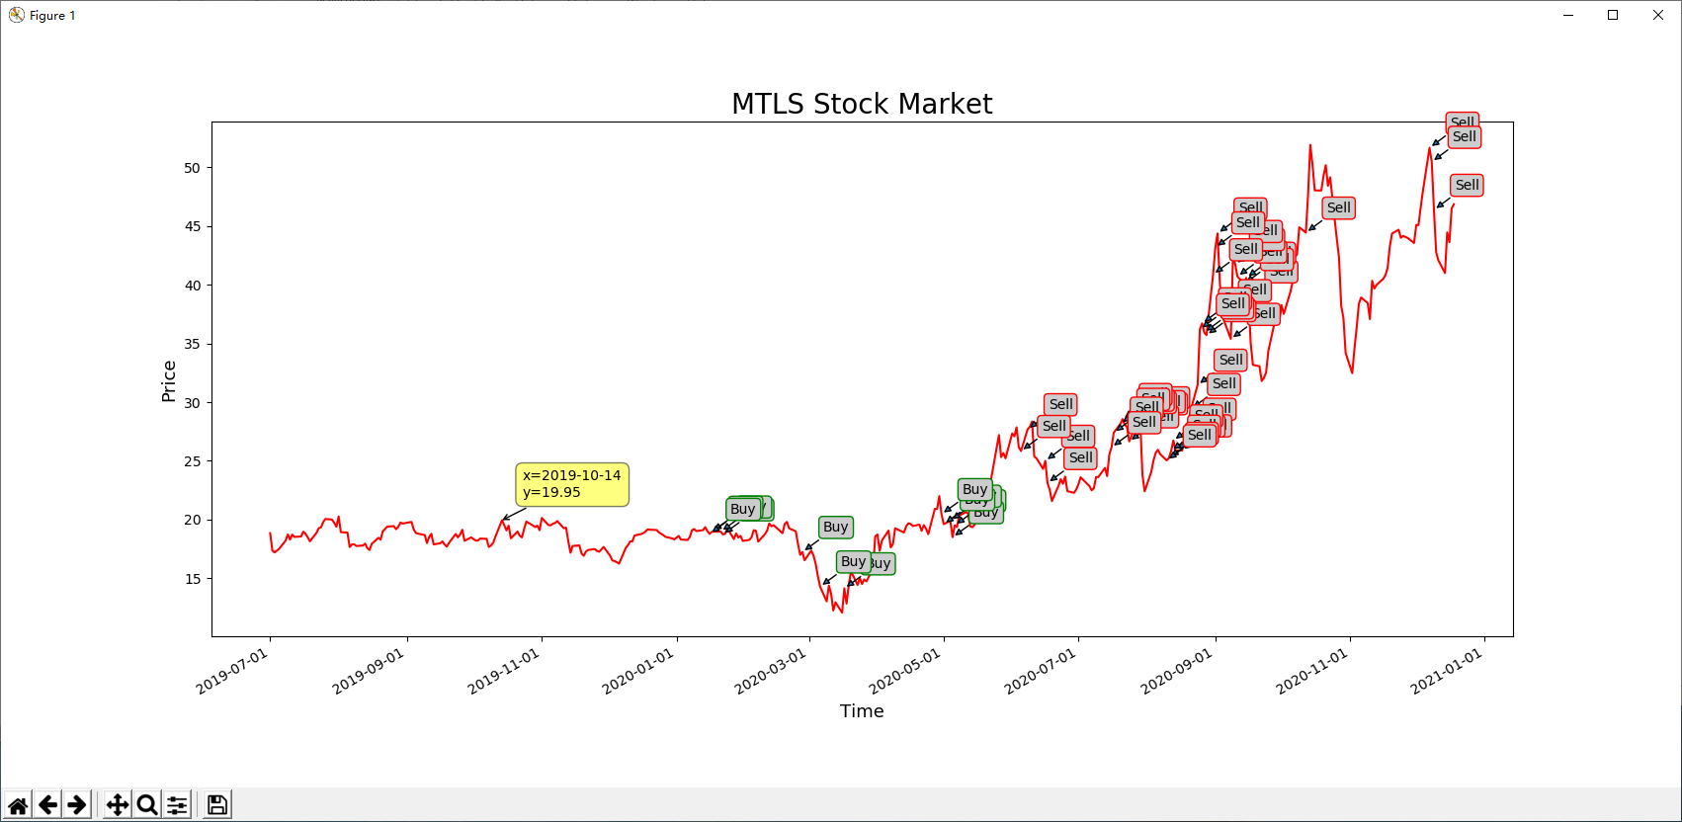

## Description

Materialise NV provides additive manufacturing and medical software, and 3D printing services in Europe, the Americas, Europe and Africa, and the Asia-Pacific.

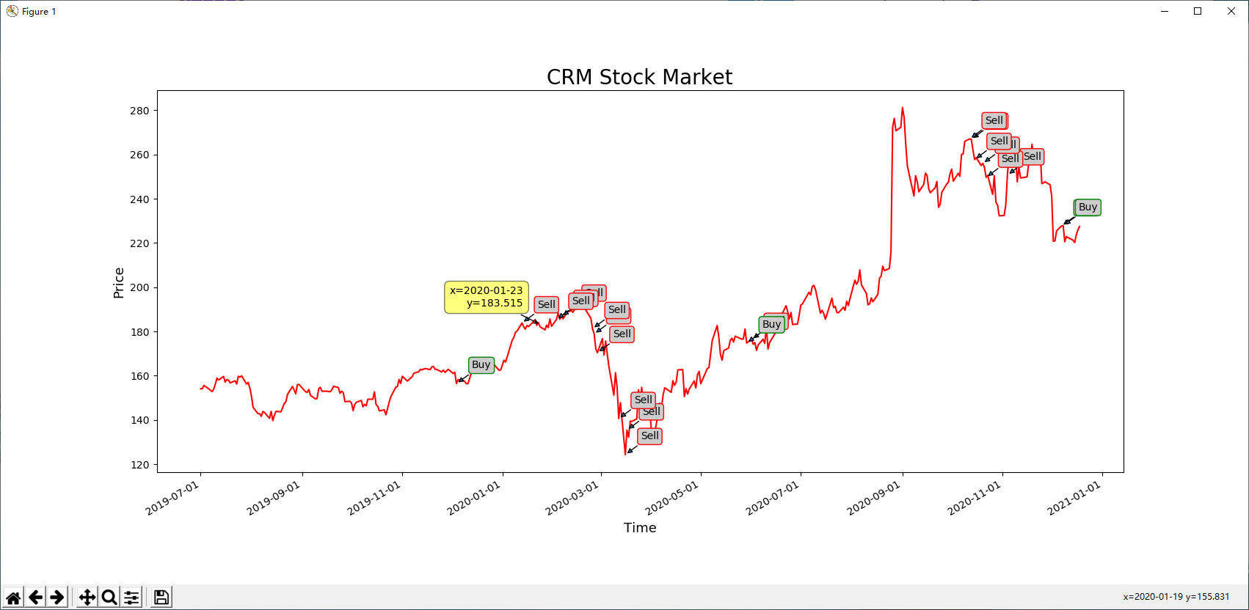

## 

## Description

Niu Technologies designs, manufactures, and sells smart electric-scooters in the People's Republic of China. The company offers NQi, MQi, UQi, and Gova series e-scooters; RQi and TQi series urban commuter electric motorcycles; and NIU Aero series professional mountain and road bicycles under the NIU brand name.

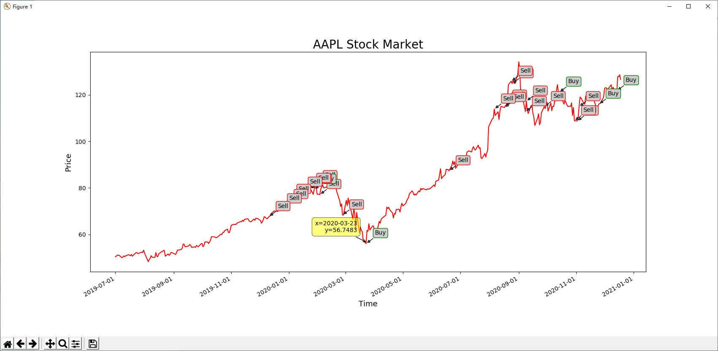

## 

## Description

The Trade Desk, Inc. operates as a technology company in the United States and internationally. The company operates a self-service cloud-based platform that allows buyers to create, manage, and optimize data-driven digital advertising campaigns in various advertising formats, including display, video, audio, native and social, and on various devices, such as computers, mobile devices, and connected TV.