（a）
> ATP=read.table("ATP.txt", header=T)
> head(ATP)
age.youngest atp.youngest age.oldest atp.oldest
1 24 4.18 41 4.81
2 25 5.16 26 4.98
3 19 4.85 27 4.48
4 28 3.43 32 4.19
5 22 4.53 25 4.27
6 7 5.13 23 4.87
Same as webpage.

(b)
> attach(ATP)
> qqnorm(atp.youngest)
> qqline(atp.youngest)
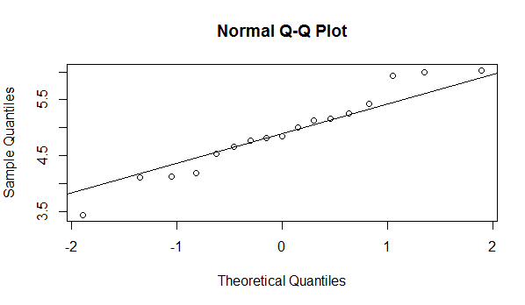

(c)
The values at lower end and upper are not close to the line, therefore the values do not come from a normal distribution. From the graph we can’t really tell if it is right-skewed or left-skewed.

(d)
> qqnorm(atp.oldest)
> qqline(atp.oldest)
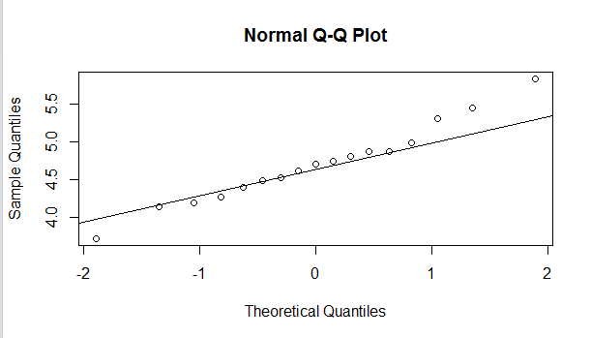

The values are close to the line except for at the end where the points are above and getting further away from the line, therefore the values do not come from a normal distribution.

2.
(a)
First quartile: from the table we find 0.2514 (closest to 25%)hence the first quartile is -0.67;
Third quartile: from the table we find 0.7486(closest to 25%) hence the third quartile is 0.67.

(b)
First quartile: s*z1+mean = 10*(-0.67)+50=43.3
Third quartile: s*z3+mean = 10*0.67+50=56.7

(c)
IQR=Q3-Q1=13.4
This is 1.34 times bigger than the standard deviation.

(d)
= 27/1.34=20.15

3.
（a）
data ATP;
infile '/home/victor.xu/ATP.txt' firstobs=2;
input ageyoungest atpyoungest ageoldest atpoldest;
proc print;

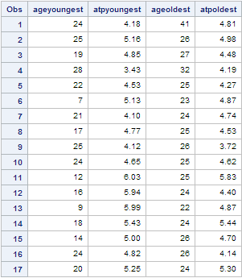

Same as in R, correct.

(b)
proc univariate noprint;
qqplot atpyoungest / normal(mu=est sigma=est);

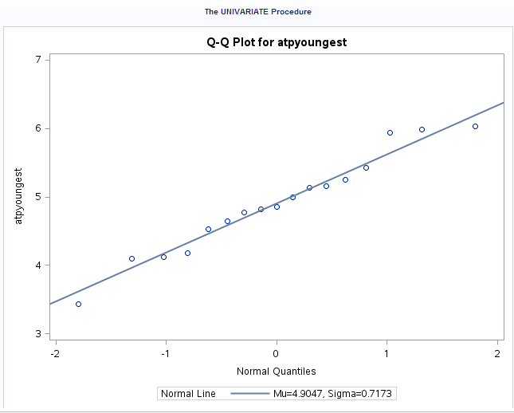

(c)
var atpoldest;

The UNIVARIATE Procedure
Variable: atpoldest
Moments
N | 17 | Sum Weights | 17
Mean | 4.69941176 | Sum Observations | 79.89
Std Deviation | 0.51399745 | Variance | 0.26419338
Skewness | 0.38219906 | Kurtosis | 0.52271953
Uncorrected SS | 379.6631 | Corrected SS | 4.22709412
Coeff Variation | 10.9374849 | Std Error Mean | 0.12466269

Basic Statistical Measures
Location |  | Variability
Mean | 4.699412 | Std Deviation | 0.51400
Median | 4.700000 | Variance | 0.26419
Mode | 4.870000 | Range | 2.11000
 |  | Interquartile Range | 0.47000

Tests for Location: Mu0=0
Test | Statistic |  | p Value
Student's t | t | 37.69702 | Pr > |t| | <.0001
Sign | M | 8.5 | Pr >= |M| | <.0001
Signed Rank | S | 76.5 | Pr >= |S| | <.0001

Quantiles (Definition 5)
Level | Quantile
100% Max | 5.83
99% | 5.83
95% | 5.83
90% | 5.44
75% Q3 | 4.87
50% Median | 4.70
25% Q1 | 4.40
10% | 4.14
5% | 3.72
1% | 3.72
0% Min | 3.72

Extreme Observations
Lowest |  | Highest
Value | Obs | Value | Obs
3.72 | 9 | 4.87 | 13
4.14 | 16 | 4.98 | 2
4.19 | 4 | 5.30 | 17
4.27 | 5 | 5.44 | 14
4.40 | 12 | 5.83 | 11

Therefore the interquartile range is 0.47000.

(d)
proc univariate noprint;
qqplot atpoldest / normal(mu=est sigma=est);
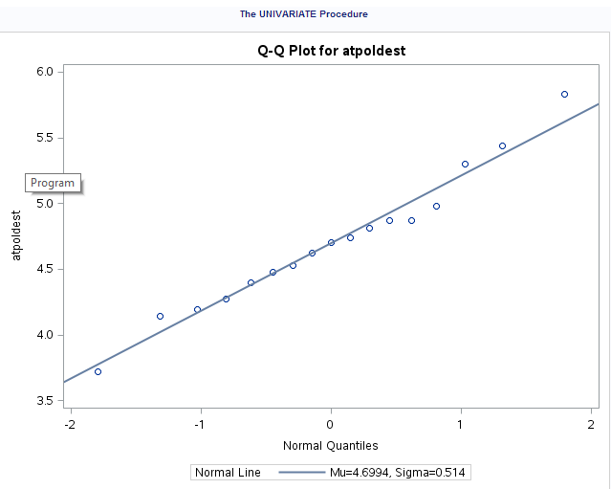

(e)
Sigma=0.47/1.35=0.3481
proc univariate noprint;
qqplot atpoldest / normal(mu=4.70 sigma=0.3481);
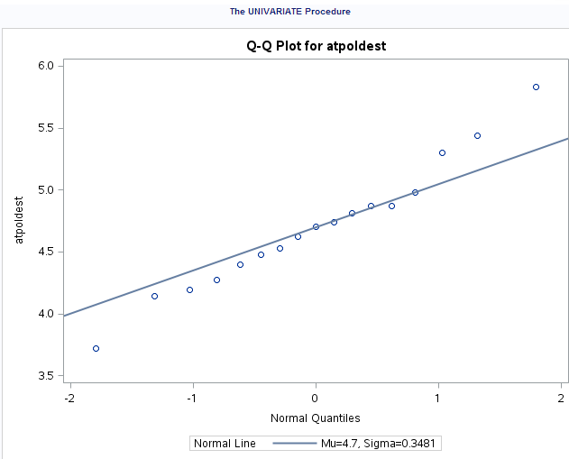

(f)
The values fit the line better (closer to the line) in part (d) than in part (f). This is because part (d) uses mean value and part (f) uses median.
4.
(a)
> friday=read.table("friday.txt", header=T)
> friday
Date F6 F13
1 Oct-89 9 13
2 Jul-90 6 12
3 Sep-91 11 14
4 Dec-91 11 10
5 Mar-92 2 4
6 Nov-92 5 12

Six rows, three columns, one text two numerical as required.

(b)
> attach(friday)
> t.test(F6,F13,paired=T,alternative="less")

Paired t-test

data: F6 and F13
t = -2.9758, df = 5, p-value = 0.01547
alternative hypothesis: true difference in means is less than 0
95 percent confidence interval:
-Inf -1.129997
sample estimates:
mean of the differences
-3.5

P-value is equal to 0.01547 which is smaller than 0.05; therefore we reject the null hypothesis and conclude that admissions on Friday 13th is higher than that on Friday 6th.

(c)
It is suitable because we can match the pairs, Friday 13th and Friday 6th up for the same months.

(d)
t.test(F6,F13,alternative="less")

Welch Two Sample t-test

data: F6 and F13
t = -1.6803, df = 10, p-value = 0.06191
alternative hypothesis: true difference in means is less than 0
95 percent confidence interval:
-Inf 0.2753621
sample estimates:
mean of x mean of y
7.333333 10.833333
The p-value is 0.06191, which is greater than 0.05; therefore we accept the null hypothesis and conclude that admissions on Friday 6th and Friday 13th are the same.

(e)
The two tests give different results because matched-pairs t-test pairs the data (Friday 6th and Friday 13th ) up and compares difference while the two sample t-test looks at the data individually.

(f)
Because the matched-paired t-test pairs the two Fridays up for the same month, and compares difference, which is exactly what the researcher want.

5.
(a)
data friday;
infile '/home/victor.xu/friday.txt' firstobs=2;
input Date $ F6 F13;
diff=F6-F13;
proc print;

Obs | date | F6 | F13 | diff
1 | Oct-89 | 9 | 13 | -4
2 | Jul-90 | 6 | 12 | -6
3 | Sep-91 | 11 | 14 | -3
4 | Dec-91 | 11 | 10 | 1
5 | Mar-92 | 2 | 4 | -2
6 | Nov-92 | 5 | 12 | -7

(b)
proc ttest side=l;
paired F6*F13;

The TTEST Procedure
Difference: F6 - F13
N | Mean | Std Dev | Std Err | Minimum | Maximum
6 | -3.5000 | 2.8810 | 1.1762 | -7.0000 | 1.0000

Mean | 95% CL Mean |  | Std Dev | 95% CL Std Dev
-3.5000 | -Infty | -1.1300 | 2.8810 | 1.7983 | 7.0659

DF | t Value | Pr < t
5 | -2.98 | 0.0155

P-value= 0.0155, same as R.

(c)
proc ttest h0=0 side=l;
var diff;

The TTEST Procedure
Variable: diff
N | Mean | Std Dev | Std Err | Minimum | Maximum
6 | -3.5000 | 2.8810 | 1.1762 | -7.0000 | 1.0000

Mean | 95% CL Mean |  | Std Dev | 95% CL Std Dev
-3.5000 | -Infty | -1.1300 | 2.8810 | 1.7983 | 7.0659

DF | t Value | Pr > t
5 | -2.98 | 0.0155

P-value = 0.0155, same as in part (b)

(d)
proc univariate noprint;
qqplot diff / normal (mu=est sigma=est);
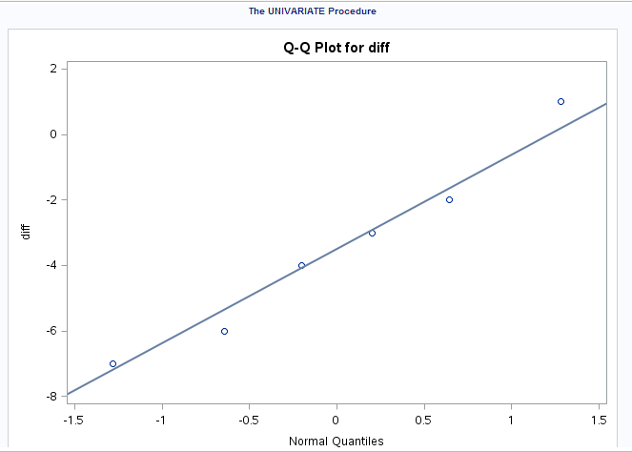

(e)
The values are close to the line therefore the data is from a normal distribution and we can conclude that we can trust the results of the paired t-test.

6.
(a)
> uremia=read.table("uremia.txt", header=T)
> uremia
group morphine
1 chronic 31.5
2 chronic 35.1
3 chronic 32.1
4 chronic 34.2
5 chronic 26.7
6 chronic 31.9
7 chronic 30.8
8 chronic 27.3
9 chronic 27.3
10 chronic 29.0
11 chronic 30.0
12 chronic 36.4
13 chronic 39.8
14 chronic 32.0
15 acute 31.6
16 acute 28.5
17 dialysis 29.3
18 dialysis 32.1
19 dialysis 26.9
20 anephric 26.5
21 anephric 22.7
22 anephric 27.5
23 anephric 24.9
24 anephric 23.4

No, chronic has 14 patients , which is half of the total number of patients.

(b)
> attach(uremia)
> boxplot(morphine~group,data=uremia)
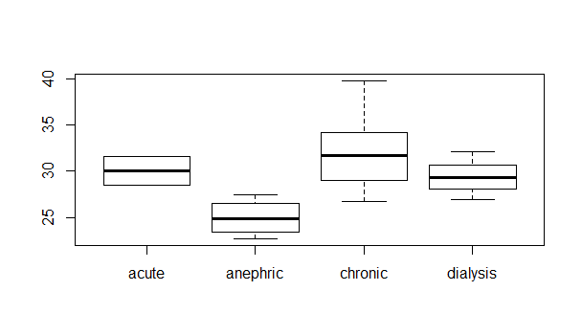

(c)
Chronic has the highest median and maximum value of morphine while anephric has the lowest median and minimum value of morphine; chronic has the largest spread while acute has the smallest spread.

(d)
> uremia.aov=aov(morphine~group)
> summary(uremia.aov)
Df Sum Sq Mean Sq F value Pr(>F)
group 3 167.2 55.73 5.178 0.00824 **
Residuals 20 215.3 10.76
---
Signif. codes: 0 ‘***’ 0.001 ‘**’ 0.01 ‘*’ 0.05 ‘.’ 0.1 ‘ ’ 1

The p-value is smaller than 0.05, therefore we reject the null hypothesis and conclude that there are some differences of means between morphine level by group.

(e)
Since the F-test was significant, we can use tukey to find means that are significantly different from each other.

(f)
> TukeyHSD(uremia.aov)
Tukey multiple comparisons of means
95% family-wise confidence level

Fit: aov(formula = morphine ~ group)

$group
diff lwr upr p adj
anephric-acute -5.0500000 -12.732523 2.632523 0.2848261
chronic-acute 1.6714286 -5.269792 8.612649 0.9056967
dialysis-acute -0.6166667 -8.998987 7.765653 0.9968071
chronic-anephric 6.7214286 1.937523 11.505335 0.0042137
dialysis-anephric 4.4333333 -2.272523 11.139189 0.2802697
dialysis-chronic -2.2880952 -8.130003 3.553812 0.6958049

Therefore we conclude only significant difference is between chronic and anephric.

(g)
Yes it makes sense; the boxplot provides that chronic has the highest median and maximum value, while anephric has lowest median and minimum value. Therefore they are significantly different.

7.
data uremia;
infile '/home/victor.xu/uremia.txt' firstobs=2;
input group $ morphine;

proc print;
Obs | group | morphine
1 | chronic | 31.5
2 | chronic | 35.1
3 | chronic | 32.1
4 | chronic | 34.2
5 | chronic | 26.7
6 | chronic | 31.9
7 | chronic | 30.8
8 | chronic | 27.3
9 | chronic | 27.3
10 | chronic | 29.0
11 | chronic | 30.0
12 | chronic | 36.4
13 | chronic | 39.8
14 | chronic | 32.0
15 | acute | 31.6
16 | acute | 28.5
17 | dialysis | 29.3
18 | dialysis | 32.1
19 | dialysis | 26.9
20 | anephric | 26.5
21 | anephric | 22.7
22 | anephric | 27.5
23 | anephric | 24.9
24 | anephric | 23.4
Same as R, correct.

proc anova;
class group;
model morphine=group;

The ANOVA Procedure
Class Level Information
Class | Levels | Values
group | 4 | acute anephric chronic dialysis

Number of Observations Read | 24
Number of Observations Used | 24

The ANOVA Procedure
Dependent Variable: morphine
Source | DF | Sum of Squares | Mean Square | F Value | Pr > F
Model | 3 | 167.1943452 | 55.7314484 | 5.18 | 0.0082
Error | 20 | 215.2552381 | 10.7627619
Corrected Total | 23 | 382.4495833

R-Square | Coeff Var | Root MSE | morphine Mean
0.437167 | 10.97365 | 3.280665 | 29.89583

Source | DF | Anova SS | Mean Square | F Value | Pr > F
group | 3 | 167.1943452 | 55.7314484 | 5.18 | 0.0082
P-value = 0.0082, same as R.

proc anova;
class group;
model morphine=group;
means group / tukey;
The ANOVA Procedure
Class Level Information
Class | Levels | Values
group | 4 | acute anephric chronic dialysis

Number of Observations Read | 24
Number of Observations Used | 24

The ANOVA Procedure
Dependent Variable: morphine
Source | DF | Sum of Squares | Mean Square | F Value | Pr > F
Model | 3 | 167.1943452 | 55.7314484 | 5.18 | 0.0082
Error | 20 | 215.2552381 | 10.7627619
Corrected Total | 23 | 382.4495833

R-Square | Coeff Var | Root MSE | morphine Mean
0.437167 | 10.97365 | 3.280665 | 29.89583

Source | DF | Anova SS | Mean Square | F Value | Pr > F
group | 3 | 167.1943452 | 55.7314484 | 5.18 | 0.0082
The ANOVA Procedure
Tukey's Studentized Range (HSD) Test for morphine
Note:This test controls the Type I experimentwise error rate.
Alpha | 0.05
Error Degrees of Freedom | 20
Error Mean Square | 10.76276
Critical Value of Studentized Range | 3.95825

Comparisons significant at the 0.05 level are indicated by ***.
group  Comparison | Difference  Between  Means | Simultaneous 95% Confidence Limits
chronic - acute | 1.671 | -5.270 | 8.613
chronic - dialysis | 2.288 | -3.554 | 8.130
chronic - anephric | 6.721 | 1.938 | 11.505 | ***
acute - chronic | -1.671 | -8.613 | 5.270
acute - dialysis | 0.617 | -7.766 | 8.999
acute - anephric | 5.050 | -2.632 | 12.732
dialysis - chronic | -2.288 | -8.130 | 3.554
dialysis - acute | -0.617 | -8.999 | 7.766
dialysis - anephric | 4.433 | -2.272 | 11.139
anephric - chronic | -6.721 | -11.505 | -1.938 | ***
anephric - acute | -5.050 | -12.732 | 2.632
anephric - dialysis | -4.433 | -11.139 | 2.272

Therefore the only significant difference is between chronic and anephric, same as our conclusion in R.

8.
(a)
data nitro;
infile '/home/victor.xu/nitro.txt';
input group $ days SF;

proc print;
Obs | group | days | SF
1 | control | 10 | 143
2 | control | 10 | 169
3 | control | 10 | 95
4 | control | 10 | 111
5 | control | 10 | 132
6 | control | 10 | 150
7 | control | 10 | 141
8 | control | 12 | 179
9 | control | 12 | 160
10 | control | 12 | 87
11 | control | 12 | 115
12 | control | 12 | 171
13 | control | 12 | 146
14 | control | 14 | 76
15 | control | 14 | 40
16 | control | 14 | 119
17 | control | 14 | 72
18 | control | 14 | 163
19 | control | 14 | 78
20 | exposed | 10 | 152
21 | exposed | 10 | 83
22 | exposed | 10 | 91
23 | exposed | 10 | 86
24 | exposed | 10 | 150
25 | exposed | 10 | 108
26 | exposed | 10 | 75
27 | exposed | 12 | 141
28 | exposed | 12 | 132
29 | exposed | 12 | 201
30 | exposed | 12 | 242
31 | exposed | 12 | 209
32 | exposed | 12 | 114
33 | exposed | 14 | 119
34 | exposed | 14 | 104
35 | exposed | 14 | 125
36 | exposed | 14 | 147
37 | exposed | 14 | 200
38 | exposed | 14 | 178
Same as original data, correct.

(b)
proc anova;
class group;
model SF=group;
means group / tukey;

The ANOVA Procedure
Class Level Information
Class | Levels | Values
group | 2 | control exposed

Number of Observations Read | 38
Number of Observations Used | 38

The ANOVA Procedure
Dependent Variable: SF
Source | DF | Sum of Squares | Mean Square | F Value | Pr > F
Model | 1 | 2528.94737 | 2528.94737 | 1.31 | 0.2595
Error | 36 | 69351.26316 | 1926.42398
Corrected Total | 37 | 71880.21053

R-Square | Coeff Var | Root MSE | SF Mean
0.035183 | 33.33053 | 43.89105 | 131.6842

Source | DF | Anova SS | Mean Square | F Value | Pr > F
group | 1 | 2528.947368 | 2528.947368 | 1.31 | 0.2595
The ANOVA Procedure
Tukey's Studentized Range (HSD) Test for SF
Note:This test controls the Type I experimentwise error rate, but it generally has a higher Type II error rate than REGWQ.
Alpha | 0.05
Error Degrees of Freedom | 36
Error Mean Square | 1926.424
Critical Value of Studentized Range | 2.86810
Minimum Significant Difference | 28.88

Means with the same letter are not significantly different.
Tukey Grouping | Mean | N | group
A | 139.84 | 19 | exposed
A
A | 123.53 | 19 | control

P-value is greater than 0.05, therefore we accept the null hypothesis and conclude the percent of serum fluorescence is the same for both groups.
F-value=1.31 which is not significant, hence we conclude mean difference is not significant;

And from tukey’s method we see there is no significant difference (all in A group) therefore it echoes the conclusion form F-test.

(c)
Because first, by looking at the p-value we see that we accept the null hypothesis hence we don’t need to run tukey’s to tell us which groups are significantly different in mean (there is none)

Second, there are only two group therefore we don’t need to run tukey’s to see which groups are significantly different in mean (there are only two groups in total).

(d)
proc sort;
by days;
proc print;

Obs | group | days | SF
1 | control | 10 | 143
2 | control | 10 | 169
3 | control | 10 | 95
4 | control | 10 | 111
5 | control | 10 | 132
6 | control | 10 | 150
7 | control | 10 | 141
8 | exposed | 10 | 152
9 | exposed | 10 | 83
10 | exposed | 10 | 91
11 | exposed | 10 | 86
12 | exposed | 10 | 150
13 | exposed | 10 | 108
14 | exposed | 10 | 75
15 | control | 12 | 179
16 | control | 12 | 160
17 | control | 12 | 87
18 | control | 12 | 115
19 | control | 12 | 171
20 | control | 12 | 146
21 | exposed | 12 | 141
22 | exposed | 12 | 132
23 | exposed | 12 | 201
24 | exposed | 12 | 242
25 | exposed | 12 | 209
26 | exposed | 12 | 114
27 | control | 14 | 76
28 | control | 14 | 40
29 | control | 14 | 119
30 | control | 14 | 72
31 | control | 14 | 163
32 | control | 14 | 78
33 | exposed | 14 | 119
34 | exposed | 14 | 104
35 | exposed | 14 | 125
36 | exposed | 14 | 147
37 | exposed | 14 | 200
38 | exposed | 14 | 178

proc boxplot;
plot SF*days / boxstyle=schematic;
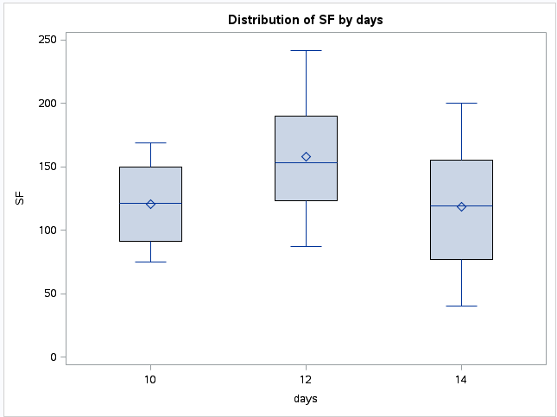

Since the means and the spreads are all close, There is no significant difference. Hence there is no significant correlation between the number of days of exposure matters and serum fluorescence percent.

