1.
(a)
data fall;
infile '/home/victor.xu/fall.txt';
input time height;

proc print;

Obs | time | height
1 | 0.0 | 100
2 | 0.2 | 102
3 | 0.4 | 103
4 | 0.6 | 104
5 | 0.8 | 105
6 | 1.0 | 105
7 | 1.2 | 105
8 | 1.4 | 104
9 | 1.6 | 103
10 | 1.8 | 102
11 | 2.0 | 100
12 | 2.2 | 98
13 | 2.4 | 96
14 | 2.6 | 93
15 | 2.8 | 90
16 | 3.0 | 86
17 | 3.2 | 82
18 | 3.4 | 77
19 | 3.6 | 72
20 | 3.8 | 67
21 | 4.0 | 62
22 | 4.2 | 56
23 | 4.4 | 49
24 | 4.6 | 42
25 | 4.8 | 35
26 | 5.0 | 28
proc gplot;
plot height*time;
run;
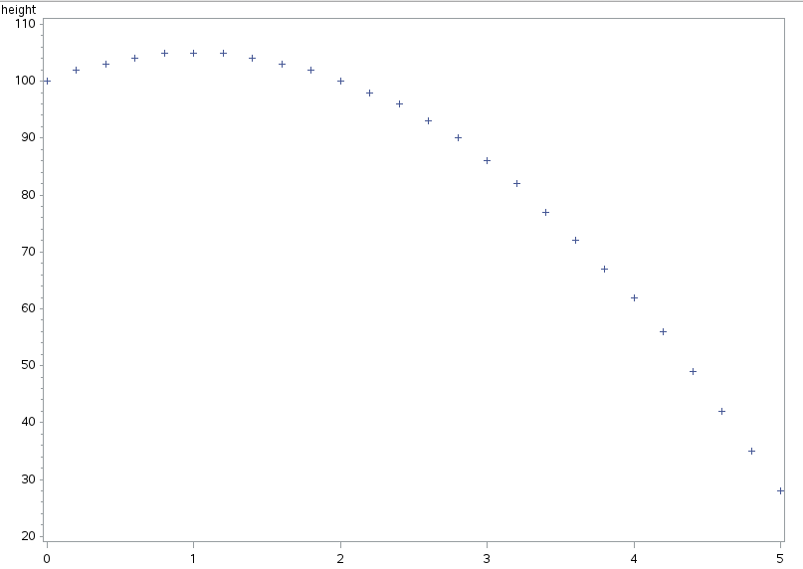

(b)
The form of the graph is a curve; as time goes up, height goes down except in the beginning as time goes up, height goes up; there is a very strong nonlinear relationship between height and time.

(c)
proc reg;
model height=time;
ouput out=heighttime
plot r*p;

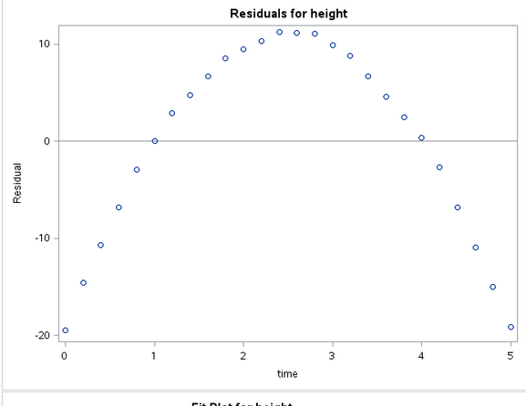

The points have a pattern where they are supposed to be random. Therefore a straight line fits badly.

(d)
timesq=time**2;

proc reg;
model height=time timesq;
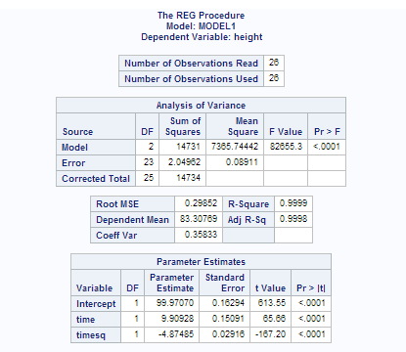

(e) p-value for timesq < 0.0001 < 0.05; therefore it is significant. This does not surprise me, because we see a clear curve from the residual plot.

(f)
From the orginal data, we see that height is 100 when time is 0 ; therefore the height of the observation deck is 100m.

t= Total time = 5 seconds.

Acceleration due to gravity is -9.8 m/s^2

From part (d),

Acceleration= -4.87485*2=-9.75
Initial velocity= u = 9.90928

2.
(a)
mesquite=read.table("mesquite.txt",header=T)
plot(mesquite)

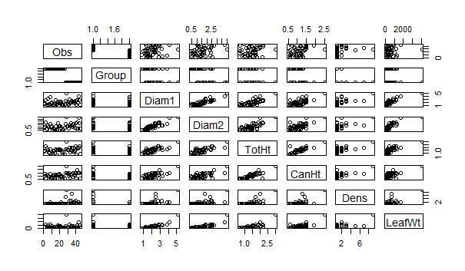
(b) there seems to be a positive relationship between Diam1 and Diam2, Diam1 and TotHt, Diam2 and ToHt, ToHt and CanHt since there is an upward trend both ways;
LeafWt has a not very strong relationship with Diam1, Diam2 and TotHt since there is an upward trend both ways.

(c)
> mesquite1=mesquite[,3:8]
> apply(mesquite1, 2, quantile)
Diam1 Diam2 TotHt CanHt Dens LeafWt
0% 0.800 0.400 0.65 0.5000 1 60.200
25% 1.400 1.000 1.20 0.8625 1 219.625
50% 1.950 1.525 1.50 1.1000 1 361.850
75% 2.475 1.900 1.70 1.3000 2 688.725
100% 5.200 4.000 3.00 2.5000 9 4052.000

(d)
> attach(mesquite)

> boxplot(Diam1,Diam2,TotHt,CanHt,Dens)
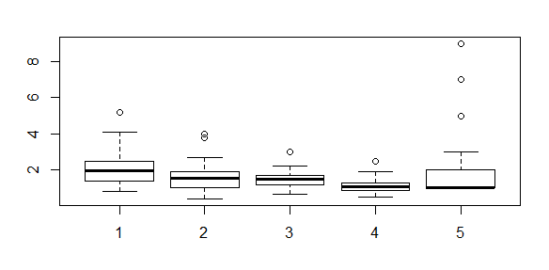
(e)

They all have 1 or more outliers and they have close mean and spread.

(f)
> dim(mesquite)
[1] 46 8
> z=rep(1,46)
> z.lm=lm(z~Diam1+Diam2+TotHt+CanHt+Dens,data=mesquite)
> h=hatvalues(z.lm)
> cbind(mesquite,h)
Obs Group Diam1 Diam2 TotHt CanHt Dens LeafWt h
1 1 MCD 1.80 1.15 1.30 1.00 1 401.3 0.03176992
2 2 MCD 1.70 1.35 1.35 1.33 1 513.7 0.08981562
3 3 MCD 2.80 2.55 2.16 0.60 1 1179.2 0.58981729
4 4 MCD 1.30 0.85 1.80 1.20 1 308.0 0.15904390
5 5 MCD 3.30 1.90 1.55 1.05 1 855.2 0.19761446
6 6 MCD 1.40 1.40 1.20 1.00 1 268.7 0.07002485
7 7 MCD 1.50 0.50 1.00 0.90 1 155.5 0.09897821
8 8 MCD 3.90 2.30 1.70 1.30 2 1253.2 0.25460805
9 9 MCD 1.80 1.35 0.80 0.60 1 328.0 0.11056986
10 10 MCD 2.10 1.60 1.20 0.80 1 614.6 0.05330413
11 11 MCD 0.80 0.63 0.90 0.60 1 60.2 0.09125336
12 12 MCD 1.30 0.95 1.35 0.95 1 269.6 0.05013489
13 13 MCD 1.20 0.90 1.40 1.20 1 448.4 0.08285226
14 14 MCD 1.50 0.70 1.00 0.70 1 120.4 0.06811367
15 15 MCD 2.80 1.70 1.70 1.20 1 378.7 0.10131484
16 16 MCD 1.40 0.85 1.50 1.10 1 266.4 0.07118072
17 17 MCD 1.50 0.60 0.65 0.64 1 138.9 0.13349732
18 18 MCD 2.40 2.40 1.50 1.20 1 1020.8 0.11051371
19 19 MCD 1.90 1.55 1.70 1.20 1 635.7 0.05291006
20 20 MCD 2.30 1.60 1.70 1.30 1 621.8 0.05395073
21 21 MCD 2.10 1.70 1.50 1.00 1 579.8 0.03648040
22 22 MCD 2.40 1.30 1.50 0.90 2 326.8 0.10269126
23 23 MCD 1.00 0.40 1.20 1.00 1 66.7 0.09087520
24 24 MCD 1.30 0.60 0.70 0.50 1 68.0 0.10744979
25 25 MCD 1.10 0.70 1.20 0.90 1 153.1 0.05706602
26 26 MCD 1.30 1.20 0.80 0.60 1 256.4 0.10795370
27 27 ALS 2.50 2.30 1.70 1.40 5 723.0 0.18243805
28 28 ALS 5.20 4.00 3.00 2.50 9 4052.0 0.53643328
29 29 ALS 2.00 1.60 1.70 1.40 1 345.0 0.06768650
30 30 ALS 1.60 1.60 1.60 1.30 1 330.9 0.08860010
31 31 ALS 1.40 1.00 1.50 1.10 1 163.5 0.06066513
32 32 ALS 3.20 1.90 1.90 1.50 3 1160.0 0.11612343
33 33 ALS 1.90 1.80 1.10 0.80 1 386.6 0.09019280
34 34 ALS 2.40 2.40 1.60 1.10 3 693.5 0.11636855
35 35 ALS 2.50 1.80 2.00 1.30 7 674.4 0.40084821
36 36 ALS 2.10 1.50 1.25 0.85 1 217.5 0.04294228
37 37 ALS 2.40 2.20 2.00 1.50 2 771.3 0.07712944
38 38 ALS 2.40 1.70 1.30 1.20 2 341.7 0.06515208
39 39 ALS 1.90 1.20 1.45 1.15 2 125.7 0.03717438
40 40 ALS 2.70 2.50 2.20 1.50 3 462.5 0.10350085
41 41 ALS 1.30 1.10 0.70 0.70 1 64.5 0.12190012
42 42 ALS 2.90 2.70 1.90 1.90 1 850.6 0.28241422
43 43 ALS 2.10 1.00 1.80 1.50 2 226.0 0.15130999
44 44 ALS 4.10 3.80 2.00 1.50 2 1745.1 0.27618888
45 45 ALS 2.80 2.50 2.20 1.50 1 908.0 0.13848106
46 46 ALS 1.27 1.00 0.92 0.62 1 213.5 0.07066646

> b=2*(6+1)/46
> b
[1] 0.3043478

The outliers are row 3, row 28 and row 35; both groups have outliers; their h values are all greater than 0.3043478.

3 3 MCD 2.80 2.55 2.16 0.60 1 1179.2 0.58981729
28 28 ALS 5.20 4.00 3.00 2.50 9 4052.0 0.53643328
35 35 ALS 2.50 1.80 2.00 1.30 7 674.4 0.40084821

(g)
Yes, because we have spotted outliers in (d) and (f), it is a good idea to transform some or all of the variables.

(h)
> Diam1log=log(Diam1)
> Diam2log=log(Diam2)
> TotHtlog = log(TotHt)
> CanHtlog = log(CanHt)
> Denslog = log(Dens)
> LeafWtlog = log(LeafWt)
> mesquitelog.lm=lm(LeafWtlog~Diam1log+Diam2log+TotHtlog+CanHtlog+Denslog+Group)
> summary(mesquitelog.lm)
Call:
lm(formula = LeafWtlog ~ Diam1log + Diam2log + TotHtlog + CanHtlog +
Denslog + Group)

Residuals:
Min 1Q Median 3Q Max
-0.70831 -0.12736 0.02225 0.13924 0.71277

Coefficients:
Estimate Std. Error t value Pr(>|t|)
(Intercept) 4.7680 0.1551 30.747 < 2e-16 ***
Diam1log 0.3938 0.2820 1.397 0.170
Diam2log 1.1512 0.2102 5.477 2.75e-06 ***
TotHtlog 0.3943 0.3129 1.260 0.215
CanHtlog 0.3732 0.2806 1.330 0.191
Denslog 0.1093 0.1219 0.896 0.376
GroupMCD 0.5834 0.1287 4.534 5.37e-05 ***
---
Signif. codes: 0 ‘***’ 0.001 ‘**’ 0.01 ‘*’ 0.05 ‘.’ 0.1 ‘ ’ 1

Residual standard error: 0.3295 on 39 degrees of freedom
Multiple R-squared: 0.8873, Adjusted R-squared: 0.8699
F-statistic: 51.17 on 6 and 39 DF, p-value: < 2.2e-16

> mesquitelog=c(Diam1log+Diam2log+TotHtlog+CanHtlog+Denslog+LeafWtlog)> mesquitelog.pred=data.frame(Group,mesquitelog)
> pred.mesquitelog=predict(mesquitelog.lm,mesquitelog.pred)
> head(pred.mesquitelog)

1 2 3 4 5 6
5.847278 6.130674 6.947547 5.567517 6.751533 5.943203

(i)
In part (h) we see that Denslog has the largest p-value, therefore by backward elimination we remove this term.
> mesquitelog.lm1=lm(LeafWtlog~Diam1log+Diam2log+TotHtlog+CanHtlog+Group)
> summary(mesquitelog.lm1)
Call:
lm(formula = LeafWtlog ~ Diam1log + Diam2log + TotHtlog + CanHtlog +
Group)

Residuals:
Min 1Q Median 3Q Max
-0.75323 -0.15547 0.03622 0.15274 0.69783

Coefficients:
Estimate Std. Error t value Pr(>|t|)
(Intercept) 4.7698 0.1547 30.836 < 2e-16 ***
Diam1log 0.4821 0.2635 1.830 0.0748 .
Diam2log 1.1126 0.2052 5.422 3.07e-06 ***
TotHtlog 0.4240 0.3104 1.366 0.1795
CanHtlog 0.3846 0.2796 1.376 0.1766
GroupMCD 0.5382 0.1181 4.558 4.78e-05 ***
---
Signif. codes: 0 ‘***’ 0.001 ‘**’ 0.01 ‘*’ 0.05 ‘.’ 0.1 ‘ ’ 1

Residual standard error: 0.3287 on 40 degrees of freedom
Multiple R-squared: 0.885, Adjusted R-squared: 0.8706
F-statistic: 61.54 on 5 and 40 DF, p-value: < 2.2e-16

We see that TotHtlog has the largest p-value, so we remove this term.

> mesquitelog.lm2=lm(LeafWtlog~Diam1log+Diam2log+CanHtlog+Group)
> summary(mesquitelog.lm2)
Call:
lm(formula = LeafWtlog ~ Diam1log + Diam2log + CanHtlog + Group)

Residuals:
Min 1Q Median 3Q Max
-0.75089 -0.15652 0.03434 0.15307 0.72143

Coefficients:
Estimate Std. Error t value Pr(>|t|)
(Intercept) 4.8377 0.1480 32.685 < 2e-16 ***
Diam1log 0.5137 0.2653 1.937 0.0597 .
Diam2log 1.1881 0.1997 5.949 5.12e-07 ***
CanHtlog 0.6658 0.1912 3.482 0.0012 **
GroupMCD 0.5691 0.1171 4.860 1.76e-05 ***
---
Signif. codes: 0 ‘***’ 0.001 ‘**’ 0.01 ‘*’ 0.05 ‘.’ 0.1 ‘ ’ 1

Residual standard error: 0.3321 on 41 degrees of freedom
Multiple R-squared: 0.8796, Adjusted R-squared: 0.8678
F-statistic: 74.88 on 4 and 41 DF, p-value: < 2.2e-16

We see that all the p-values are smaller than 0.10, hence we stop here.

(j)
R- squared value for initial model was Multiple R-squared: 0.8873, Adjusted R-squared: 0.8699

And R-squared values for final model is Multiple R-squared: 0.8796 Adjusted R-squared: 0.8678
Both multiple R-squared and adjusted R-squared values decreased, therefore it was ok to remove the variables.

(k)
From my final model the constant is 4.8377 and the slopes are 0.5137, 1.1881, 0.6658, 0.5691.
Therefore:

> Diam1leaflog=log(1.7)
> Diam2leaflog=log(1.5)
> CanHtleaflog=log(1.4)
> groupleaf=0
> leafwt = 4.8377 + 0.5137 * Diam1leaflog + 1.1881 * Diam2leaflog + 0.6658 * CanHtleaflog + 0.5691 * groupleaf
> exp(leafwt)
[1] 335.6403

> mesquite[30,]
Obs Group Diam1 Diam2 TotHt CanHt Dens LeafWt
30 30 ALS 1.6 1.6 1.6 1.3 1 330.9

Hence the prediction is 330.9 and actual leaf weight is 335.6403, they are somehwhat close.

3.
(a)
data tam;
infile '/home/victor.xu/tam.txt';
input price vland vhouse neighbourhood$;
proc gplot;
plot price*vland;
run;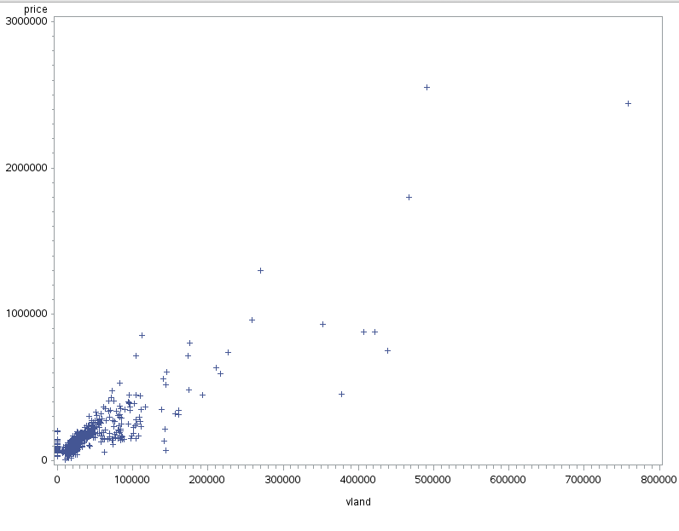
(b)
data tam;
infile '/home/victor.xu/tam.txt';
input price vland vhouse neighbourhood$;

keep price vland;
if vland<150000;

proc gplot;
plot price*vland;

run;
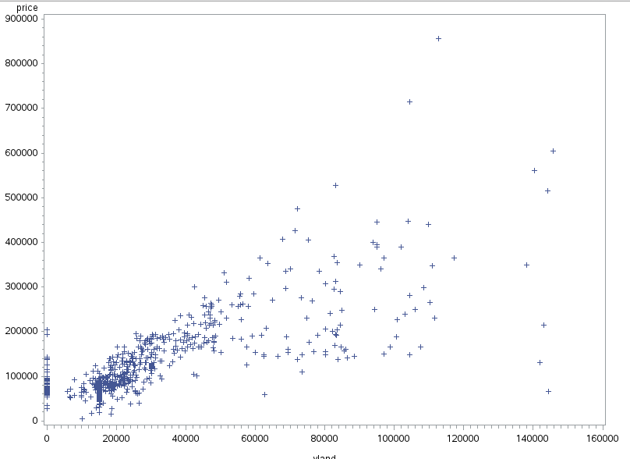
(c)

symbol1 c=black i=rl l=1 v=star;
proc gplot;
plot price*vland;

run;

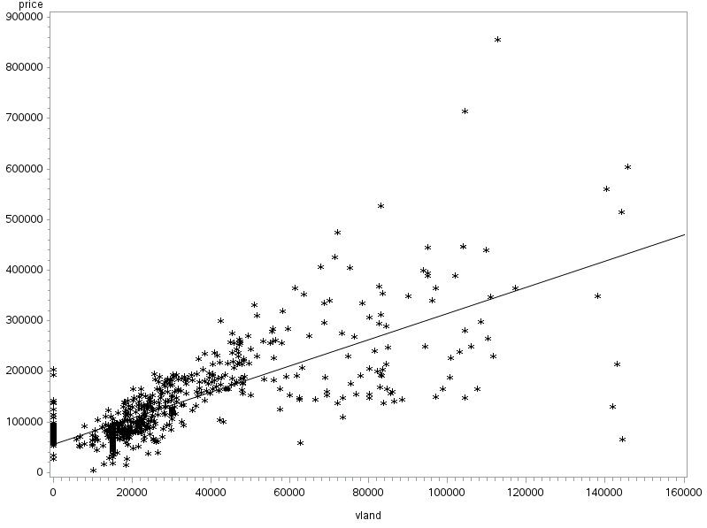
Yes, we see that the group at $0 land value and the group after around 150000 land value are out of line because the points are too far away from the line.

(d)
There are several outliers. For example, the one at around 62000 land value and 50000 selling price.

(e)
We restrict the values so that 10000<vland<120000; also, we find and delete the outliers.

(f)
data tam;
infile '/home/victor.xu/tam.txt';
input price vland vhouse neighbourhood$;

keep price vland;
if vland<120000;
if vland>10000;
symbol1 c=black i=rl l=1 v=star;
proc gplot;
plot price*vland;

run;
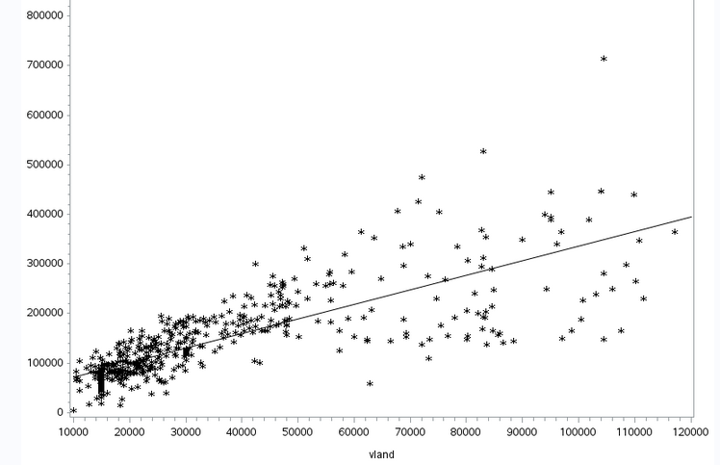
Much better;
Then we find and eliminate the outliers.

4.
(a)
> tam=read.table("tam.txt",header=F)
> colnames(tam)=c("price","vland","vhouse","neib")
> head(tam)
price vland vhouse neib
1 180000 40243 130189 TAMPALMS
2 245100 46550 166277 TAMPALMS
3 85400 100 68030 TAMPALMS
4 87900 100 65405 TAMPALMS
5 84200 100 68555 TAMPALMS
6 85000 100 64880 TAMPALMS
(b)
attach(tam)

plot(price,vland,col=neib)
neibs=levels(neib)
legend("topright",legend=neibs,fill=1:4)
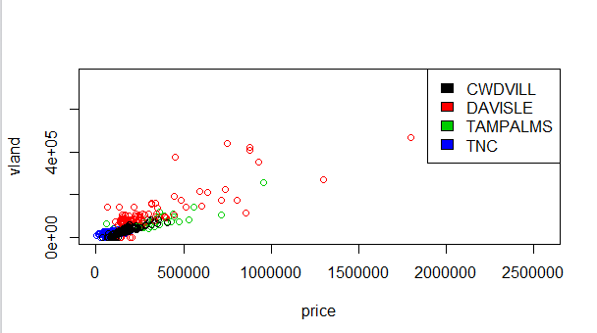

(c)
Yes, TNC has the smallest price spread while Davisle has the largest price spread by far.\

(d)

> tam1=subset(tam,select=c(price,vland,neib),vland>10000)
> head(tam1)
price vland neib
1 180000 40243 TAMPALMS
2 245100 46550 TAMPALMS
8 125000 30000 TAMPALMS
9 124000 30000 TAMPALMS
10 126000 30000 TAMPALMS
11 128500 30000 TAMPALMS

(e)
> pricelog=log(price)
> landlog=log(vland)
> tam2=cbind(tam1, pricelog, landlog)
> head(tam2)

price vland neib pricelog landlog
1 180000 40243 TAMPALMS 12.10071 10.60269
2 245100 46550 TAMPALMS 12.40942 10.74828
8 125000 30000 TAMPALMS 11.73607 10.30895
9 124000 30000 TAMPALMS 11.72804 10.30895
10 126000 30000 TAMPALMS 11.74404 10.30895
11 128500 30000 TAMPALMS 11.76368 10.30895

5 columns as needed.

(f)
plot(pricelog,landlog,col=neib)
neibs=levels(neib)
legend("topright",legend=neibs,fill=1:4)
lines(lowess(pricelog,landlog))

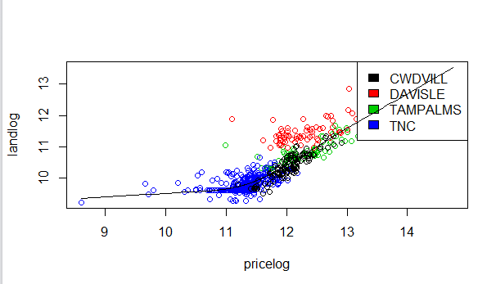

(g)
Yes, because the value of log of landvalue increases as the value of price log increases.

