1.
(a)
= (66+59+70+83+82+71)/6=71.83
= ((66-71.83)^2+（59-71.83)^2+(70-71.83)^2+(83-71.83)^2+(82-71.83)^2+(71-71.83)^2)/(6-1)
=86.18

(b)
6C4=6*5/2=15
Therefore 15 SRS’s of size 4 are possible.

(c)
S1:(66,59,70,83) 1=69.5
S2:(66,59,70,82) 2=69.25
S3:(66,59,70,71) 3=66.5
S4:(66,59,83,82) 4=72.5
S5:(66,59,83,71) 5=69.75
S6:(66,59,82,71) 6=69.5
S7:(66,70,83,82) 7=75.25
S8:(66,70,83,71) 8=72.5
S9:(66,70,82,71) 9=72.25
S10:(66,83,82,71) 10=75.5
S11:(59,70,83,82) 11=73.5
S12:(59,70,83,71) 12=70.75
S13:(59,70,82,71) =70.5
S14:(59,83,82,71) =73.75
S15:(70,83,82,71) =76.5

=((69.5-71.83)^2+(69.25-71.83)^2+(66.5-71.83)^2+(72.5-71.83)^2+(69.75-71.83)^2+(69.5-71.83)^2+(75.25-71.83)^2+(72.5-71.83)^2+(72.25-71.83)^2+(75.5-71.83)^2+(73.5-71.83)^2+(70.75-71.83)^2+(70.5-71.83)^2+(73.75-71.83)^2+(76.5-71.83)^2)/15
=7.18

(d)
3C2*3C2=3*3=9

(e)
(66,59,83,82)
(66,59,83,71)
(66,59,82,71)
(66,70,83,82)
(66,70,83,71)
(66,70,82,71)
(59,70,83,82)
(59,70,83,71)
(59,70,82,71)

Samples cannot occur from part (c):
(66,59,70,83)
(66,59,70,82)
(66,59,70,71)
(66,83,82,71)
(59,83,82,71)
(70,83,82,71)

(f)
(66,59,83,82) 1=72.5
(66,59,83,71) 2=69.75
(66,59,82,71) 3=69.5
(66,70,83,82) 4=75.25
(66,70,83,71) 5=72.5
(66,70,82,71) 6=72.25
(59,70,83,82) 7=73.5
(59,70,83,71) 8=70.75
(59,70,82,71) 9=70.5

E()=(72.5+69.75+69.5+75.25+72.5+72.25+73.5+70.75+70.5)/9=71.83

E(()^2)=5163.167

Var()=5163.167-71.83^2=3.62

2.
(1)
(a)
N=6812+4586+2714+618= 14730

Proportional allocation:

nh(fr)= 6812/14730*200=92
nh(so)=4586/14730*200=62
nh(jr)=2714/14730*200=37
nh(sr)=618/14730*200=8

Nh=92+62+37+8=199

(b) Neyman allocation:

sh(fr)= sqr(0.37*(1-0.37))=0.483 Nhsh(fr)=6812*0.483=3290.196
sh(so)=sqr(0.52*(1-0.52))=0.500 Nhsh(so)=4586*0.500=2293
sh(ju)=sqr(0.68*(1-0.68))=0.467 Nhsh(ju)=2714*0.467=1267.438
sh(se)=sqr(0.84*(1-0.84))=0.367 Nhsh(se)=618*0.367=226.806

NtSt=3290.196+2293+1267.438+226.806=7077.44

nh(fr)= 3290.196/7077.44*200=93
nh(so)=2293/7077.44*200=65
nh(jr)=1267.438/7077.44*200=36
nh(sr)=226.806/7077.44*200=6

Nh=93+65+36+6=200

(c) optimal allocation:

NtSt/sqrCt= 3290.196/sqr3+2293/sqr4.5+1267.438/sqr4.5+226.806/sqr6=3670.595
nh(fr)= (3290.196/sqr3)/3670.595*200=104
nh(so)=(2293/sqr4.5)/3670.595*200=59
nh(jr)=(1267.438/sqr4.5)/3670.595*200=33
nh(sr)=(226.806/sqr6)/3670.595*200=5

Nh=104+59+33+5=201

(d)
700-20=680
From part (c), 3*104+4.5*59+4.5*33+6*5=756

756-680=76
If we take from
Stratum 1: 76/3=25.33=26 n=201-26=175
Stratum 2:76/4.5=16.89=17 n=201-19=184
Stratum 3: 76/4.5=17 n=201-19=184
Stratum 4: 76/6=12.67=13 n=201-13=188

(2)
(a) n(sr)= (1.96^2 * 0.84(1-0.84))/(0.05^2 + 1.96^2 * 0.84(1-0.84)/618) =155

(b)
680*50%=340
340/6=56
e = 1.96 * sqrt((0.84)(1-0.84)/56 * (1-56/618))=0.09

http://statistics.unl.edu/faculty/park/stat414/lab05sol.pdf

3.
(a)
B=(0+1+1+3+5+5+7)/7*102=320.571
P=(0*10+1*2+3*1+4*2+5*1+6*1+8*2)/19*310=652.632
S=(0*9+2*1+4*2+6*1)/13*217=267.077
H=(0*8+1*2+3*1)/11*178=80.989

=320.571+652.632+267.077+80.989=1321.189

Calculating variance with R:
> y=c(0,1,1,3,5,5,7)
> var(y)
[1] 6.809524

> y2=c(0,0,0,0,0,0,0,0,0,0,1,1,3,4,4,5,6,8,8)
> var(y2)
[1] 8.210526

> y3=c(0,0,0,0,0,0,0,0,0,2,4,4,6)
> var(y3)
[1] 4.358974

> y4=c(0,0,0,0,0,0,0,0,1,1,3)
> var(y4)
[1] 0.8727273

Var(B)=6.810
Var(P)=8.211
Var(S)=4.359
Var(H)-0.873
(c)
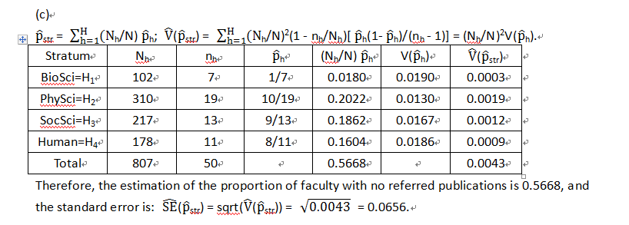
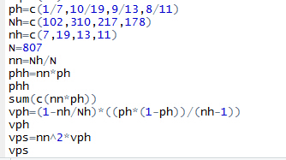

http://statistics.unl.edu/faculty/park/sram/hw3sol.pdf
4.
(a)
> golf=read.csv("golfsrs.csv", header=T)
> attach(golf)
> mean(wkend9)
[1] 20.23667

(b)
(i)
> plot(wkend9,backtee)
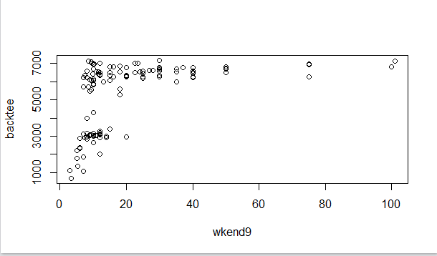

(ii)
> cor(wkend9,backtee)
[1] 0.4621688

(iii)
> wkend9.lm = lm(wkend9 ~ backtee, data=golf)> wkend9.lm
Call:
lm(formula = wkend9 ~ backtee, data = golf)

Coefficients:
(Intercept) backtee
-4.103503 0.004584

Regression model:
y=-4.103503+0.004584x

(c)

(d)

http://statistics.unl.edu/faculty/park/stat414/lab03prob.pdf

http://statistics.unl.edu/faculty/park/stat414/lab03sol.sas
5.
(a)
This is a cluster example because we have the apartment complexes as clusters and 20 clusters have been selected randomly to include in the sample; The observations are obtained from person living in apartments as elements.

(b)

> hotdog=read.table("hotdog.txt", header=F)
> attach(hotdog)
> sum(V2)
[1] 1532
> sum(V3)
[1] 340
> yhat= sum(V3)/sum(V2)
> yhat
[1] 0.2219321

http://statistics.unl.edu/faculty/park/stat414/lab7answers.pdf

