**Question 1:**

(a)

Null hypothesis: H0 : μ = 20 mg/100mL

Alternative hypothesis: HA : μ < 20 mg/100mL

(b)

When H0 is true, n = 20, μ = 20 mg/100mL, σ = 4 mg/100mL

Therefore the probability distribution of the test statistic is: $\overline{X}$ ~ N(μ, σ/ $\sqrt{n}$) $\overline{X}$ ~ N(20, 4/ $\sqrt{20}$)

Reject null hypothesis if $\overline{x}$ ≤ 17.92;

p(type I error) = α = p(reject H0 when H0 is true) = p( $\overline{x}$ ≤ 17.92|μ = 20) = p( $\frac{\overline{X}- μ}{σ/\sqrt{n}}$ ≤ $\frac{17.92-20}{4/\sqrt{20}}$)

= p(Z ≤ -2.325511) = 0.01002233

> z=(17.92-20)/(4/sqrt(20))

> z

[1] -2.325511

> pnorm(z)

[1] 0.01002233

(c)

When μ = 16.7, the probability distribution of the test statistic is: $\overline{X}$ ~ N(μ, σ/ $\sqrt{n}$) $\overline{X}$ ~ N(16.7, 4/ $\sqrt{20}$)

p(type II error) = p(accept H0 when H0 is false) = 1 - β = 1 - p( $\overline{x}$ ≤ 17.92|μ = 16.7) = 1 - p( $\frac{\overline{X}- μ}{σ/\sqrt{n}}$ ≤ $\frac{17.92-16.7}{4/\sqrt{20}}$)

= 1 - p(Z ≤ 1.364001) = 1 - 0.9137164 = 0.08628355

> z2=(17.92-16.7)/(4/sqrt(20))

> z2

[1] 1.364001

> pnorm(z2)

[1] 0.9137164

> 1-pnorm(z2)

[1] 0.08628355

(d)

α = 0.05

p( $\overline{x}$ ≤ 17.92) = p( $\frac{\overline{X}- μ}{σ/\sqrt{n}}$ ≤ $\frac{17.92-20}{4/\sqrt{20}}$) = p(Z ≤ -2.325511) = 0.01002233 < 0.05

Therefore, we reject the null hypothesis: H0 : μ = 20 mg/100mL at significance level 0.05 and conclude that there is a deficiency in prothrombin. there is 8.63% probability of making type II error.

**Question 2:**

(a)

Treatments: Caliper1, Caliper2

Experimental units: ball bearing

Type of design: matched pairs

(b)

Assume that the means of Caliper1 and Caliper2 are μ1 and μ2 respectively, then:

Null hypothesis: H0 : μ1 -μ2 = 0

Alternative hypothesis: HA : μ1 -μ2 ≠ 0

> cli=read.table("caliper.txt",header=T)

> attach(cli)

> t.test(Caliper1,Caliper2,paired=T)

Paired t-test

data: Caliper1 and Caliper2

t = 0.4318, df = 11, p-value = 0.6742

alternative hypothesis: true difference in means is not equal to 0

95 percent confidence interval:

-0.001024344 0.001524344

sample estimates:

mean of the differences

0.00025

The p-value = 0.6742 which is greater than 0.05 and the 95% confidence interval contains zero, therefore we accept the null hypothesis and conclude that there is not a significant difference between the means of the population of measurements represented by the two samples.

(c)

> cli2=stack(cli[,c("Caliper1","Caliper2")])

> colnames(cli2)=c("values","groups")

> cli2

values groups

1 0.265 Caliper1

2 0.265 Caliper1

…

23 0.268 Caliper2

24 0.269 Caliper2

> cli.aov=aov(values~groups,data=cli2)

> summary(cli.aov)

Df Sum Sq Mean Sq F value Pr(>F)

groups 1 3.800e-07 3.750e-07 0.164 0.689

Residuals 22 5.025e-05 2.284e-06

The p-value = 0.689 which is very large, therefore we accept the null hypothesis,.....

(d)

> diff=cli[,2]-cli[,3]

> s=sd(diff)

> mu=mean(diff)

> c(mu,s)

[1] 0.000250000 0.002005674

> n=12

> t=qt(1-0.05/2,n-1)

> t

[1] 2.200985

> se=s/sqrt(n)

> CI=c(mu-t*se,mu+t*se)

> CI

[1] -0.001024344 0.001524344

n = 12, mean difference μd = 0.00025, standard deviation difference sdd = 0.002005674, t(0.975,n-1) = 2.200985

Therefore, 95% confidence interval is:

(μd - t*sdd/, μd + t*sdd/) = (-0.001024344, 0.001524344)

**Question 3:**

N = 65, a = 5, ni = 13 i = 1, 2, 3, 4, 5

$\overline{y}$ = $\frac{\sum_{i=1}^{5}{\overline{yi}} }{a}$ = $\frac{11.54+11.00+11.42+11.44+11.28}{5}$ = 11.336

SSTrt = yij - ..)2 = 2.28176 SSE = yij - i.)2 = 7.9488

MSTrt = SSTrt /(a-1) MSE = SSE /(N-a)

F=METet/MSE = 4.305857 p-value = 0.003963222

> diet=read.table("diets.txt",header=T)

> diet

group mean sd n

1 c 11.54 0.27 13

2 1 11.00 0.47 13

3 2 11.42 0.31 13

4 3 11.44 0.42 13

5 4 11.28 0.31 13

> attach(diet)

> ybar=mean(mean)

> ybar

[1] 11.336

> sstr=sum(n*(mean-ybar)^2)

> sstr

[1] 2.28176

> sse=sum((n-1)*sd^2)

> sse

[1] 7.9488

> N=65

> a=5

> mstr=sstr/(a-1)

> mse=sse/(N-a)

> f=mstr/mse

> f

[1] 4.305857

> pval=1-pf(f,a-1,N-a)

> pval

[1] 0.003963222

|  |  |  |  |  |
| --- | --- | --- | --- | --- |
| Source of variation | Sum of Squares | d.f | Mean Squres | F |
| Treatments | SSTrt=2.28176 | a-1=4 | MSTrt=0.57044 | MSTrt/MSE=4.305857 |
| Error | SSE=7.9488 | N-a=60 | MSE=0.13248 |  |

Total SST=10.23056N-1=64

Since the p-value=0.003963222 which is less than 0.01, we reject the null hypothesis and conclude that there appears to be some differences in means.

**Question4:**

(a)

> def=read.table("defect.txt",header=T)

> head(def)

design defect

1 1 7

2 1 2

3 1 4

4 1 7

5 1 2

6 2 10

> attach(def)

> def.aov=aov(defect~interaction(design),data=def)

> summary(def.aov)

Df Sum Sq Mean Sq F value Pr(>F)

interaction(design) 3 264.2 88.07 19.04 1.57e-05 ***

Residuals 16 74.0 4.63

---

Signif. codes: 0 ?**?0.001 ?*?0.01 ??0.05 ??0.1 ??1

The p-value is very small, less than 0.05, therefore we reject the null hypothesis and conclude that the amount of defects does not present the same for all four designs.

(b)

> def.lm=lm(defect~interaction(design),data=def)

> e.lm=resid(def.lm)

> qqnorm(e.lm)

> qqline(e.lm)

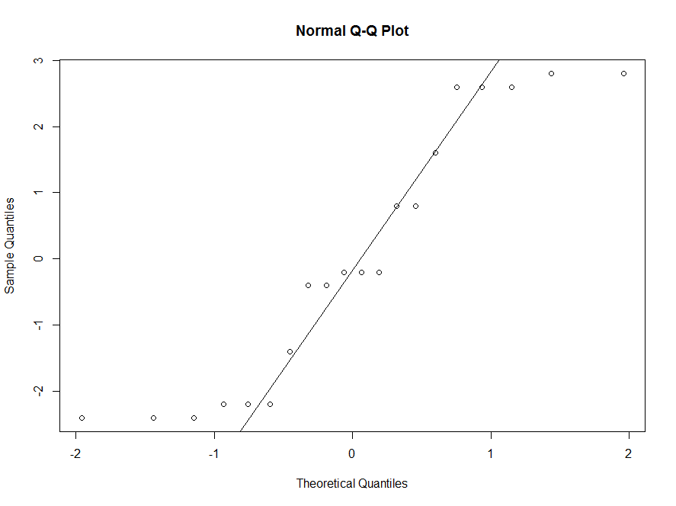

From the qq plot, we can see that some points are not on the line, therefore we conclude that the assumption of normality is violated.

> shapiro.test(e.lm)

Shapiro-Wilk normality test

data: e.lm

W = 0.8751, p-value = 0.01444

The p-value for Shapiro-Wiki's Test is 0.01444 which is less than 0.05, also tells us that the normality assumption is violated.

(c)

> kruskal.test(defect~factor(design))

Kruskal-Wallis rank sum test

data: defect by factor(design)

Kruskal-Wallis chi-squared = 13.3467, df = 3, p-value = 0.003944

The p-value for Kruskal Test is 0.003944, which is less than 0.05, we reject the null hypothesis, therefore it is consistent with ANOVA of part (a).

**Question5:**

(a)

> rats=read.table("hormrat.txt",header=T)

> head(rats)

response treatments

1 106 A

2 101 A

3 120 A

4 86 A

5 132 A

6 97 A

> attach(rats)

> rats.aov=aov(response~treatments,data=rats)

> summary(rats.aov)

Df Sum Sq Mean Sq F value Pr(>F)

treatments 3 6027 2008.9 6.967 0.00215 **

Residuals 20 5767 288.4

---

Signif. codes: 0 ?**?0.001 ?*?0.01 ??0.05 ??0.1 ??1

The p-value = 0.00215 which is smaller than 0.05, therefore we reject the null hypothesis and conclude that there exist differences between the treatments.

(b)

> TukeyHSD(rats.aov)

Tukey multiple comparisons of means

95% family-wise confidence level

Fit: aov(formula = response ~ treatments, data = rats)

$treatments

diff lwr upr p adj

A-a 29.16667 1.726146 56.60719 0.0347107

b-a -12.16667 -39.607187 15.27385 0.6091337

B-a 17.33333 -10.107187 44.77385 0.3170937

b-A -41.33333 -68.773854 -13.89281 0.0022110

B-A -11.83333 -39.273854 15.60719 0.6296725

B-b 29.50000 2.059480 56.94052 0.0323122

We can see that the differences between A & a, b & A, and B & b are significant. because neither of their p-values are greater than 0.05.  
(c)

Two vectors ***x*** and ***y*** whose dot products is ***x******y*** = 0 are said to be orthogonal.

Let "Hormone I vs Hormone II" to be ***c1*** = (1, 1, -1 ,-1)

"Low Level vs High Level" to be ***c2*** = (1, -1, 1 ,-1)

"Equivalence of Level" to be ***c3*** = (1, -1, -1 ,1)

Then we have ***c1c2*** = 1*1 + 1*(-1) + (-1)*1 + (-1)*(-1) = 0

***c1c3***= 1*1 + 1*(-1) + (-1)*(-1) + (-1)*(1) = 0

***c2c3*** = 1*1 + (-1)*(-1) + 1*(-1) + (-1)*1 = 0

Therefore the contrasts are orthogonal to each other.

(d)

> contrmatrix=cbind(c(1,1,-1,-1),c(1,-1,1,-1),c(1,-1,-1,1))

> contrasts(treatments)=contrmatrix

> contrasts(treatments)

[,1] [,2] [,3]

a 1 1 1

A 1 -1 -1

b -1 1 -1

B -1 -1 1

> summary.lm(aov(response~treatments))

Call:

aov(formula = response ~ treatments)

Residuals:

Min 1Q Median 3Q Max

-27.833 -10.292 -2.583 9.125 33.167

Coefficients:

Estimate Std. Error t value Pr(>|t|)

(Intercept) 86.41667 3.46621 24.931 < 2e-16 ***

treatments1 6.00000 3.46621 1.731 0.09885 .

treatments2 -14.66667 3.46621 -4.231 0.00041 ***

treatments3 0.08333 3.46621 0.024 0.98106

---

Signif. codes: 0 ?**?0.001 ?*?0.01 ??0.05 ??0.1 ??1

Residual standard error: 16.98 on 20 degrees of freedom

Multiple R-squared: 0.511, Adjusted R-squared: 0.4377

F-statistic: 6.967 on 3 and 20 DF, p-value: 0.002154

From above we can see that only treatments2 (i.e. Low Level vs High Level) is significant, whose p-value = 0.00041 which is really small, and we conclude that the mean effect on low level of hormones and the mean effect on high level of hormones are very different. For the treatments1(i.e., Hormone I vs Hormone II) and treatments3(i.e., Equivalence of Level), both p-values are greater than 0.05, which implies that these two treatments are insignificant, and we conclude that there is no difference between Hormone I and Hormone, and the difference between the high level and low level of Hormone I is the same as the difference between the high level and low level of Hormone II.