STAT 517 HW2 solutions (total 60 points)

4.2.4

(a)

Use moment generating function



So , which means 

(b)



And   satisfy the following formula.

Is also correct.

(c)

(68.18,165.60)

95% CI in 4.2.2 :(54.95,147.35)

4.2.7

Z ~N(0,1)



4.2.10

(a) 

(b) 

(c)CI in (b) is larger.

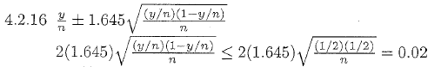

n=6765

