  - Sampling From A Multivariate Normal Distribution And Maximum Likelihood Estimation
(a) The Multivariate Normal Likelihood
Let 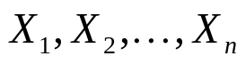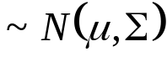 be a random sample from a multivariate normal population. Then, the joint density function of
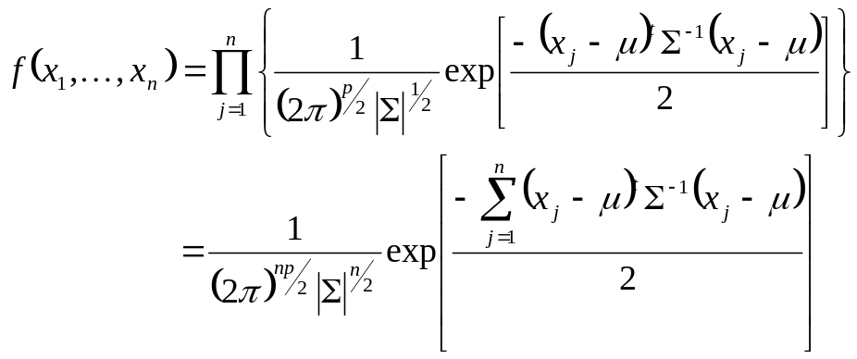.

The following results will be used to obtain the maximum likelihood estimate of  and .

Result:
Let A be a 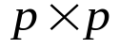 symmetric matrix and x be a 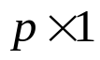 vector. Then,
(a) 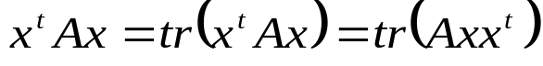, where 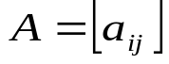 and 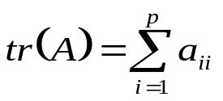.
(b) 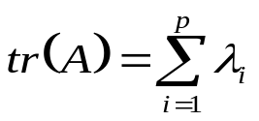, where 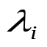 are the eigenvalues of A.

Based on the result, we have
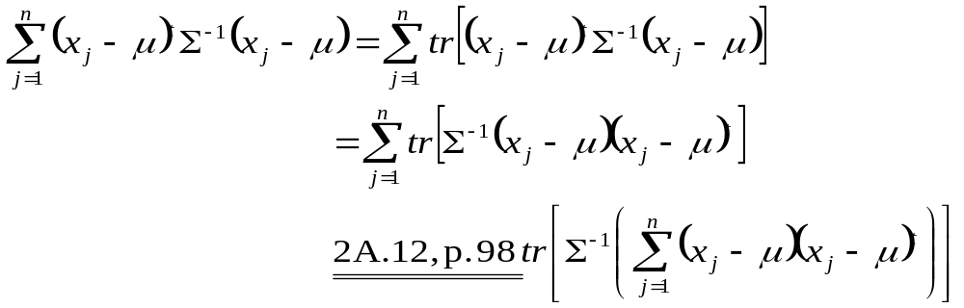
Then,
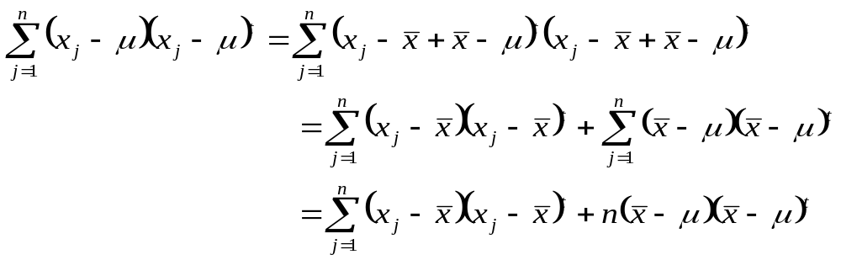
where 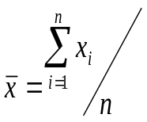. Further,
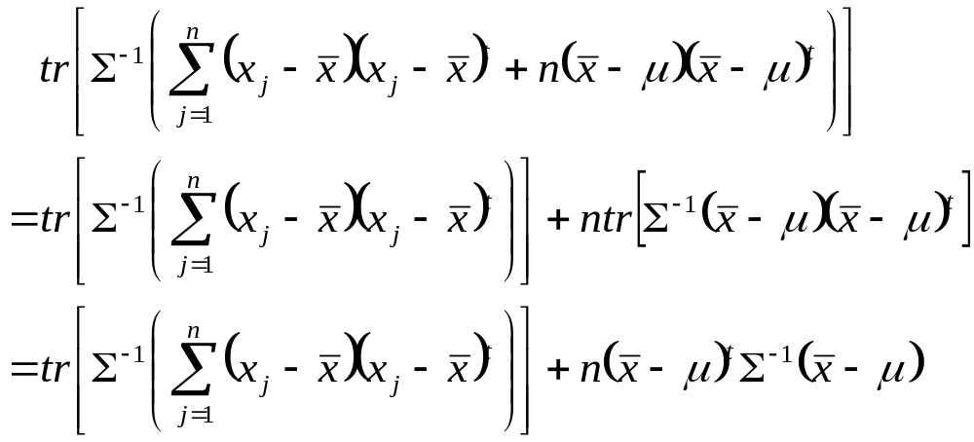

Therefore, the likelihood function of can be simplified to
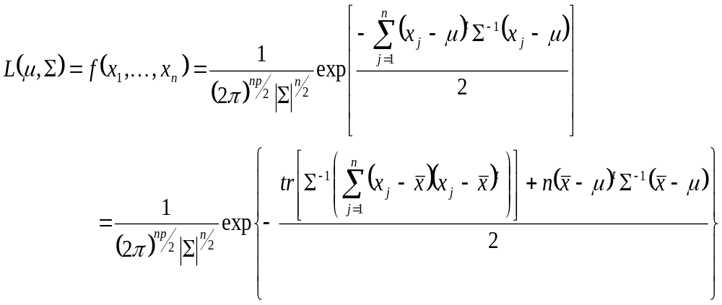.
(b) Maximum Likelihood Estimation of and
To obtain the maximum likelihood estimate, the following result will be used.
Result:
Given a symmetric positive definite matrix B and a scalar 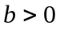, it follows that
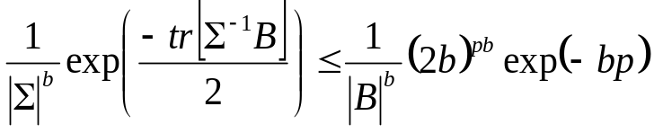
for all positive definite , with equality holding only for 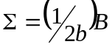.

Import Result (MLE of and )
Let be a random sample from a multivariate normal population. Then,
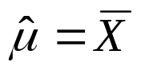 and 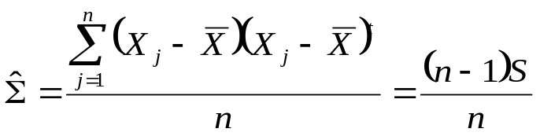
are the maximum likelihood estimators of and , respectively, where
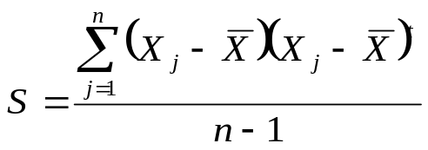
is a unbiased estimate of . Their observed values, 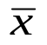 and 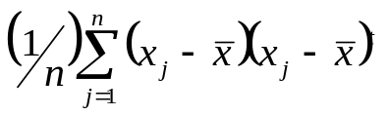, are called the maximum likelihood estimates of and .
[proof:]
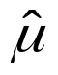 maximizing the function
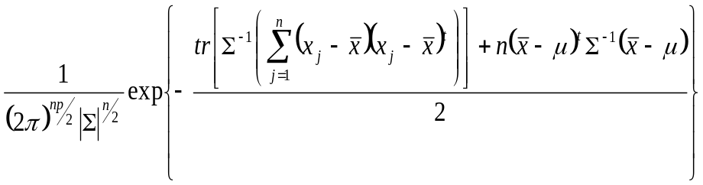
also minimizes the function
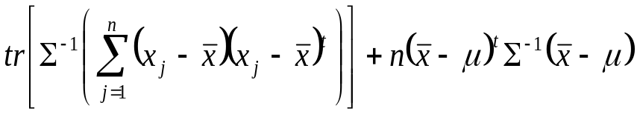.
Since 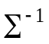 is positive definite, so that 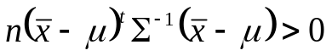. However, as 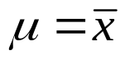, the function
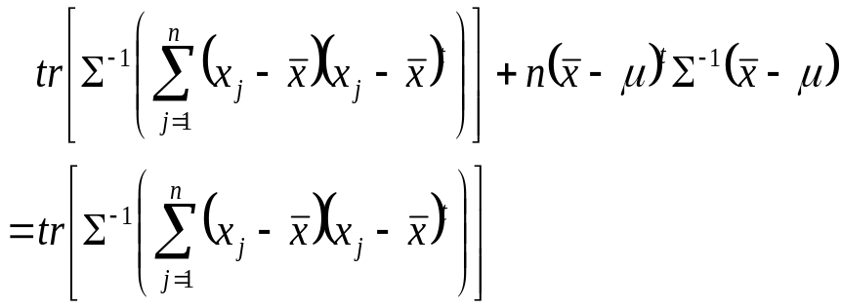
achieves its minimum. It remains to find 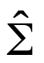 maximizing
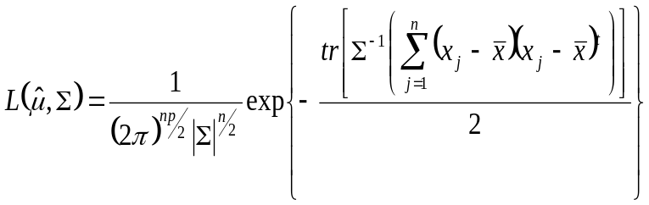
By the previous result with 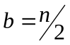 and 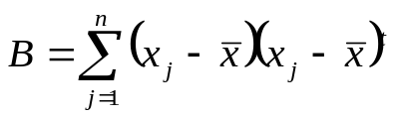, the maximum occurs at 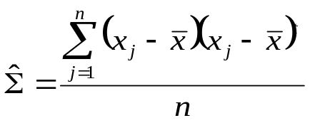.

Note:
Maximum likelihood estimators possess an invariance property. Let be the maximum likelihood estimator of , and consider estimating the parameter 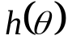, which is a function of , the maximum likelihood estimate of is given by 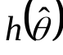. For examples,
- The maximum likelihood estimator of 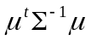 is 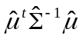.
- The maximum likelihood estimator of 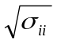 is 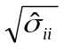, where
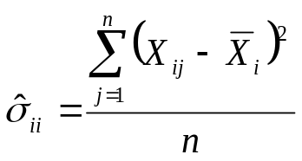.
Note:
Let be a random sample from a multivariate normal population. Then,
and 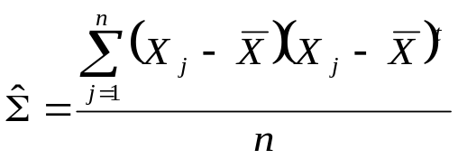
are sufficient statistics.

  - The Sampling Distribution of  and
Definition of the Wishart Distribution:
Let 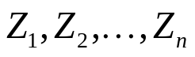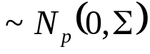 be independently distributed. Then, the random matrix 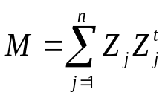 is distributed as a Wishart distribution with n d.f., 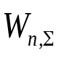. The density of a Wishart distribution with n d.f. is
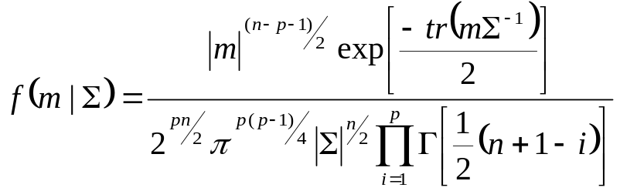.

Properties of the Wishart Distribution:
- If 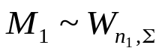 and 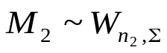, then
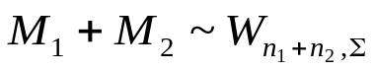.
- If , then 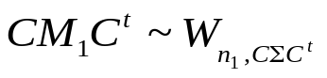.

Import Result:
1. 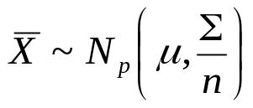.
2. 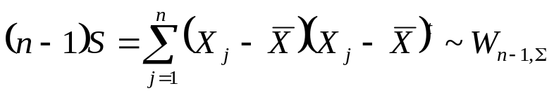.
3. 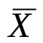 and 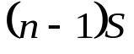 are independent.

  - Large-Sample Behavior of and
Import Result:
Let be a random sample from a population with mean and finite (nonsingular) covariance . Then,
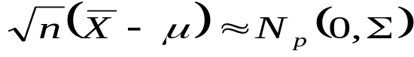
and
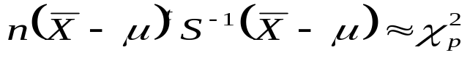
for 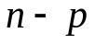 large.

