(a) Describe the three primary cloud service models in cloud computing鈥擨nfrastructure as a Service (IaaS), Platform as a Service (PaaS), and Software as a Service (SaaS). Provide specific examples of how each model can be applied in the context of software development.

answer:
1. Infrastructure as a Service (IaaS): Like "renting a bare-bones server"
Simply put, you don’t have to buy your own servers, storage devices, or other hardware. Instead, you rent a set of "basic hardware resources" from a provider—things like a virtual server, data storage space, network configurations, and even a pre-installed operating system (e.g., Windows, Linux).
But here’s the catch: You don’t need to worry about hardware-related tasks, but you do have to manage everything above the operating system. That means installing middleware, setting up runtime environments, and handling the apps you build yourself. It’s like renting an unfurnished empty apartment—you don’t have to maintain the apartment itself (the hardware), but you’re in charge of installing utilities and arranging furniture (the software setup).
Example in software development: Suppose your team needs to build a high-performance backend API and requires a specific version of Linux. You don’t need to buy a physical server—just use AWS EC2 (an IaaS service). Pick your desired CPU and memory specs, and launch a virtual server with one click. After that, you can install a Node.js environment, a web server, or a database on it yourself. You have full control over this "virtual server" and can configure it however you want.
2. Platform as a Service (PaaS): Like "renting a ready-to-use development & runtime platform"
It’s more hassle-free than IaaS: The provider sets up a complete "development and runtime platform" for you. They handle all the underlying work—managing hardware (servers, storage, networks), updating the operating system, maintaining runtime environments, and overseeing database management systems. You don’t have to deal with those complex low-level configurations; you just focus on writing code and deploying your app.
Think of it as renting a move-in ready apartment—utilities, furniture, and appliances are all pre-installed. You don’t need to maintain any of those things; you just move in and use them. Your only focus is on "living comfortably" (writing good code).
Example in software development: If your team is building a Python Django website, you don’t need to set up a server or configure the environment yourself. Just use services like Heroku or Google App Engine (both PaaS tools). All you have to do is push your written code to a Git repository—then the platform takes care of the rest. It automatically builds the code into a runnable program, deploys it online, scales resources automatically if traffic increases, and handles load balancing. You don’t need to care about which Linux distribution the server uses or how to configure an Nginx server; just focus on perfecting your website’s features.
3. Software as a Service (SaaS): Like "using ready-made software directly"
This is the easiest option: The provider gives you a complete, ready-to-use software. You don’t need to download or install anything, and you don’t have to maintain any hardware or software. You can use it directly through a web browser or a small client app. The provider handles everything under the hood—from hardware and operating systems to updating and maintaining the software itself.
It’s like watching shows via a video app instead of buying a TV and setting up a cable connection. The app is the ready-made software; you just open it and use it. You don’t need to worry about how the app was developed or maintained.
Example in software development: Many tools teams use daily are SaaS. For instance, GitHub (for code hosting and version control), Slack (for team communication), and Jira (for project management and bug tracking). These are all ready-made software—you don’t need to build a similar system yourself (like setting up your own code hosting platform). Just sign up for an account and use them. It saves you a ton of maintenance work, so you can focus on using these tools to boost collaboration efficiency.

(b) What is Docker? Describe a scenario where you would use containerization technologies such as Docker in software development. How does containerization contribute to the development and deployment process of software in this scenario?

answer:
Docker is an open-source "containerization tool". Simply put, it lets developers package an application and all its dependencies (like libraries, configuration files, environment variables) into a standardized unit called a "container". Containers virtualize at the operating system level—they share the host system’s kernel but are isolated from each other. This ensures the application runs exactly the same way no matter which environment it’s in, avoiding the "it works on my machine" problem.
Its most practical use case is solving the "it works on my machine" issue and enabling continuous integration/continuous deployment (CI/CD). For example, take a web app with a React frontend, Node.js backend, and PostgreSQL database. Team members use different operating systems (Windows, macOS, Linux), which often leads to messy environment configurations.
Containerization helps development and deployment in three main ways: First, environment consistency—create separate "container images" for the backend, frontend, and database with Docker, each clearly defining the required runtime environment (e.g., Node.js v16, Python v3.9). No matter which computer a developer uses, they just run the docker-compose up command to get an identical development environment, eliminating arguments like "did you miss installing a library". Second, fast onboarding and isolation—new team members don’t need to spend hours installing and configuring software; they just install Docker, "pull" the team’s pre-built images, and start working. Also, the frontend, backend, and database run in their own containers, so one issue won’t affect the others. Third, simplified deployment with fewer pitfalls—you can use the exact same Docker images for testing and production environments, reducing deployment failures caused by "environment differences". It also integrates with CI/CD pipelines to automate building, testing, and deployment, no more manual file transfers or configuration changes.

IaaS (Infrastructure as a Service) is like "renting a bare-bones server". You don’t need to buy your own hardware (such as servers or storage devices); instead, you rent "basic infrastructure resources" from a provider—like a virtual server, storage space, network configurations, and even a pre-installed operating system (e.g., Windows, Linux). But while you don’t manage the hardware, you have to handle everything above the operating system (e.g., installing middleware, setting up runtime environments, deploying your apps). It’s like renting an unfurnished apartment—you don’t maintain the apartment itself, but you have to set up utilities and buy furniture. For example, if your team needs to build a high-performance backend API that requires a specific Linux version, you don’t buy a server. Just use AWS EC2 (an IaaS service), select your desired CPU and memory specs, launch a virtual server with one click, then install Node.js, a web server, and a database yourself—you have full control over this "virtual server".
PaaS (Platform as a Service) is much more hassle-free than IaaS. The provider sets up a "complete development and runtime platform" for you, managing all underlying hardware (servers, storage, networks), as well as OS updates, runtime environments, and database management systems. You don’t have to worry about these complex configurations; you just focus on writing code and deploying your app. It’s like renting a "move-in ready" apartment—utilities, furniture, and appliances are all ready, no maintenance needed. You just move in and focus on "living comfortably" (writing good code). For example, to build a Python Django website, you don’t need to set up a server or configure the environment. Just use services like Heroku or Google App Engine (both PaaS tools), push your written code to a Git repository, and the platform handles the rest—it automatically turns the code into a runnable program, deploys it online, scales resources automatically when traffic increases, and manages load balancing. You don’t need to care about the server’s Linux distribution or how to configure Nginx.
SaaS (Software as a Service) is the easiest option. The provider gives you a complete, ready-to-use software—no download or installation required, and you don’t have to manage any hardware or software maintenance. You can access it directly via a web browser or a small client app. The provider handles everything under the hood, from hardware and operating systems to software updates and bug fixes. It’s like watching shows via a video app instead of buying a TV and setting up a cable connection—the app is ready-made software; you just open and use it, no need to worry about how it’s developed or maintained. For example, tools teams use daily like GitHub (for code hosting and version control), Slack (for team communication), and Jira (for project management and bug tracking) are all SaaS tools. You don’t need to build a similar system yourself; just sign up for an account and use them, saving a lot of maintenance work.

(c) Deploy n8n (n8n.io) with Docker and capture a screenshot of http://127.0.0.1:5678. Please explain the docker command in detail.

answer:
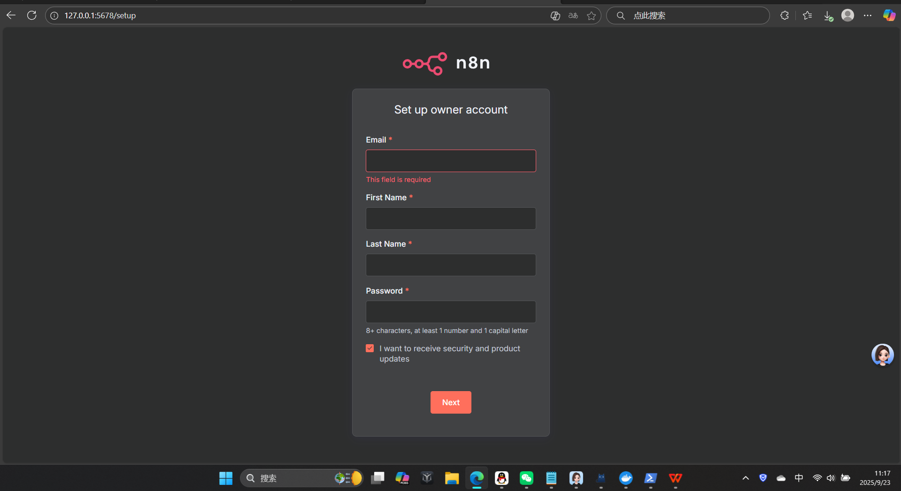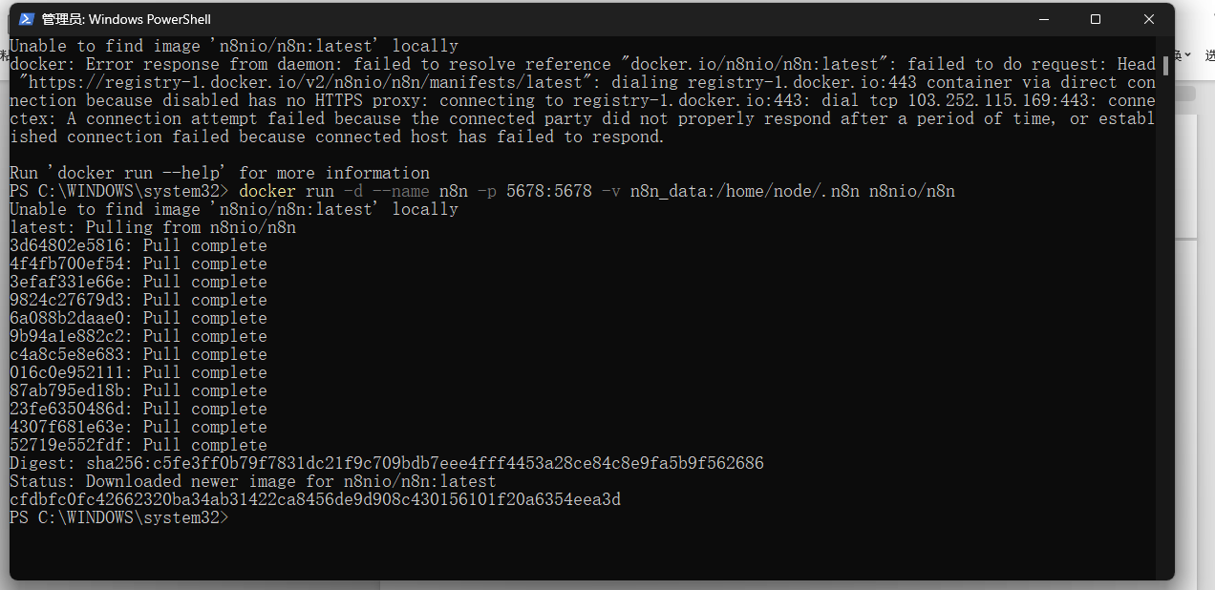
This command instructs Docker to create and start a new container. Let's break down each part:

docker run
This is the core Docker command used to create and start a new container from an image.

-d
This is short for --detach. It tells Docker to run the container in the background (as a daemon). This means you get your command prompt back immediately, and the container continues to run even after you close the terminal window.

--name n8n
This assigns a custom, easy-to-remember name (n8n) to the new container. Instead of using a long, auto-generated container ID, you can now manage this container with simple commands like docker stop n8n or docker start n8n.

-p 5678:5678
This is the port mapping parameter, formatted as -p <host-port>:<container-port>.

The n8n application inside the container is configured to listen on port 5678.
This mapping makes the container's port 5678 accessible on your local machine's (the host's) port 5678.
As a result, you can open your web browser and go to http://127.0.0.1:5678 or http://localhost:5678 to access the n8n web interface.

-v n8n_data:/home/node/.n8n
This is the volume mapping for data persistence, formatted as -v <volume-name>:<container-path>.

/home/node/.n8n is the directory inside the container where n8n stores all its data (workflows, configurations, credentials, etc.).
n8n_data is the name of a Docker volume that will be created and managed by Docker on your host machine.
This mapping ensures that even if you remove the n8n container, your important data remains safely stored in the n8n_data volume. When you create a new container and attach the same volume, all your data will be available again.

n8nio/n8n
This is the name of the official Docker image that the container will be built from. Docker automatically downloads this image from Docker Hub (a public registry) if it's not already present on your local machine.

