Software Requirement Specification

Report Automation Portal

version 0.1

Table of Contents

|  |  |  |
| --- | --- | --- |
| S.No. | Title | Page No. |
| 1. | Introduction | 1 |
| 2. | Overall description | 2 |
| 3. | Specific Requirments | 4 |

**1. Introduction**

The software for report generation is a web application. In this software the input is in the form of an Microsoft Excel file which contains the prerequisite data for processing and the processed reports are also in the Microsoft Excel (.xslx) format which is computed on a particular day’s report and also takes consideration of reports of previous 3 days. It provides the designated users the ability to upload and compute the desired report over the local network. It will also facilitate other users to view and download the reports over the local network.

**1.1 Purpose**

This SRS defines the functioning, performance and attribute requirements of the report generation software. This SRS is intended for:

* Management of the vertical
* Developers for adding new features, or maintaining the current releases
* Documentation writers
* Testers of the software

**1.2 Scope**

This report automation software will be called as Report Automation Portal. This software allows designated users to upload and view different reports pertaining to a particular selected day. These report can be also seen by other users. The administrator level (admin) users will have complete rights to perform administrator level function, add, delete and modify users in the software along with being able to grant or revoke the user access as per need though one admin cannot revoke rights of other admin.

**1.3 Definitions, acronyms, and abbreviations**

|  |  |
| --- | --- |
| Abbreviations/Acronyms | Description |
| ONT | Optical Network Terminal |
| OLT | Optical Line Termination |
| BBNL | Bharat Broadband Network Limited |
| NMS | Network Managment System |

**1.4 References**

The references for the above software are as follows:

1. IEEE SRS Standard 830-1993

**1.5 Overview**

Section 1.0 discusses the purpose and scope of the software.

Section 2.0 describes the overall functionality and constraints of the software and user characteristics.

Section 3.0 details the all the requirements needed to design the software.

**2.0 Overall description**

**2.1 Product perspective**

The Report Automation Portal is a web application and it is used to generate the reports about up and down ONTs and OLTs, that is to say it compiles the reports in Excel format for the different districts in the state. This report is then used to compare to the statistics of the BBNL NMS. In its current form this software is a stand alone software which does not interact with other softwares of the system and it works only in the local network. As per client policy the server will not be accessible through internet.

The hardware for the product is a computer which could run a web server, database software, storage to keep old reports and has a port to connect to the local network like stated above. The software is bound to the restriction that filenames of the reports should be consistent to a set pattern.

**2.2 Product functions**

The software performs the following functions:

* Take daily reports in form of excel sheet from the user and then, store them in the computer’s storage
* To process the reports of the day to provide the requested data
* Store the processed report in its database

**2.3 User characteristics**

There will be different types of users that will be interacting with the software. The catagories of the users include:

* **Regular User** – A person who will download the reports and compare them to the NMS statistics or view the reports.
* **Administrative User** – A person who has administrator rights to the portal like adding or deleting user along with viewing other users.
* **Uploading User** – A person who will be upload, view and download the reports on the portal.

**2.4 Constraints**

The software will be subject to certain development constraints such as:

* Reports with a different format and pattern of filename may not be processed, thus they need to be consistent
* The Report Automation Portal may not be able to connect to the NMS if there is no open Application Programming Interface for it. Thus reports need to be downloaded from the NMS manually.
* Correction of district names may not be 100% accurate if there are too many spelling errors or if there are more than 1 possible match of district names due to the algorithm for spelling correction used.

**2.5 Assumptions and dependencies**

The software can be affected by the following assumptions and dependencies:

* The hardware can run the processes and services like Apache2 or Nginx web servers, MySQL database and Node.js runtime environment.
* The selected Operating System Ubuntu Server can run on the given hardware.
* At this stage no quantitative measures are imposed on software in terms of speed and memory although it is implied that all the functions will be optimized for speed and memory.

**2.6 Apportioning of requirements**

The software in current form will not be connected to the internet as per client policy. The software in future versions could be made to be accessible through internet after properly securing the access to the server through DMZ, firewalls and/or any other forms of protections prevalent at the time of development of this feature as per client requirements.

**3 Specific Requirements**

**3.1 External Interfaces**

3.1.1 User Interface Requirements

The user interface for the portal will have simple and user-friendly interface. The text should be easily readable with background colour contrasting to the text colour.

The pages for a Regular User, Administrative User and Uploading User will have different buttons according to functions.

3.1.2 Hardware interface requirements

The software will interact with the server machine and the server requirements being:

* The RAM should be at least be 8 GigaBytes (8 GB).
* Storage (hard disk drive) required should be at least 100 GigaBytes (100 GB) for over a period of 5 years.
* The CPU should be at least Intel 8th generation Core i5 or equivalent in computational power.
* Capability to connect to the local network.

3.1.3 Software Interface requirements

There are certain software interface requirements that need to be fulfilled which are listed as follows:-

* The web browsers supported should be Mozilla Firefox, Google Chrome, Microsoft Edge.
* Portal can be accessed on Windows or Linux.
* The server Operating System used is Ubuntu Server v.22.04.2 LTS x86_64.
* The Web stack used is ReactJS, Node.js v.18.14.2 LTS, MySQL v. 8.0, Nginx v. 1.23

**3.2 Functions**

3.2.1 Interface functions

The software’s User Interface performs the following functions:

* The first page to welcome the user is the login screen where the user enters his username and password.
* After the login depending upon the type of user, if he is Administrative User then home screen will have a link to ‘list of users’ page and if he is Regular User it will not have a link to ‘list of users’ page.This link could be to the side of the update password link for the user himself.
* On home page there will be a link or tab to go to page for uploading a report for Uploading User and a link to page for output report for all roles. Along with these links, a calendar to select the date for which the Uploading User can upload a report or other users can get output report. Also on the corner of the home page, all types of users will have a link to update their password.
* On the upload screen there will be a button to upload report, a list to select type of report along with a box from which the file to uploaded can be selected. The upload functionality shall be available for all types of users.
* If Uploading User clicks the button on the upload page to upload a report, the system will check if there is an already an uploaded report for that date and type then, it shall prompt the user that the report for the day exists and asks whether the existing report should be replaced with the new report.
* On the output report page, a list shall be present from which the required type of output/report can be obtained. Also, on the output page, there shall be a button to confirm the choice of output and another button to download the displayed report in Microsoft Excel (.xlsx) format. Below these controls, the selected reports output shall be displayed in a table format.
* On the ‘list of users’ page for Administrative User, there shall be a table for displaying the name of the user (username) in one column and in another column option for updating or deleting the particular user.Also at the bottom of the page there shall be a button for adding users which will have two text fields namely new username and password. The new user page will also have a button for confirming the addition of the user.
* On the updating password page when there will be a text field for entering current password, another text field to enter new password and a third text field for confirming the new password.
* On the updating password page accessed by Administrative User from ‘list of users’ page, there will be two text fields namely, enter new password and confirm new password. For Administrative User, there is no need to enter current password to change some user’s password. The restriction on this updation is that one user of Administrative User group can neither update passwords of other users in Administrative User group nor delete them. Here group refers to collection of the users belonging to that particular type.

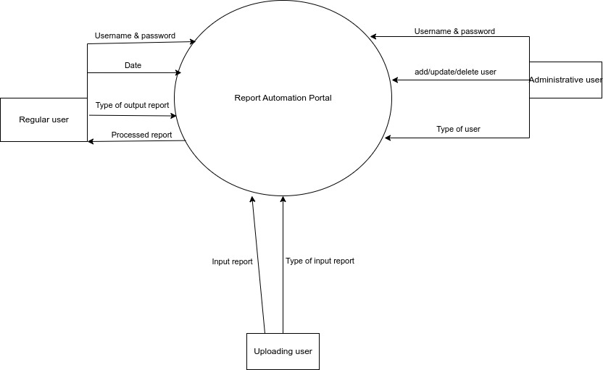Figure 3.1 Data flow to-and-from the system

3.2.2 Validity checks

* The portal’s first validation is that of username and password, where the password stored in the database will be in the form of a hash and along with a given salt, so as to ensure that the password cannot be seen by other individuals.
* The next validity check would be on the home page where it shall be ensured that the date entered for upload/processing of report is either the current date (system date of upload/processing) or a date in the past, that is, no future dates should be processed.
* The next check will be in the upload report page, wherein the system shall ensure that a type of report is selected in the list (that is, no non-selection of type of report) and following this check would be the check for existence of same type of report for the selected date and passing the check if there is no stored report for that date and type. In case a report exists for that date and type, the user should be asked for a confirmation for replacing the already existing report in the software’s storage.
* Next check would be for correct type of report, that is comparing the list of columns in the report and the list of columns the software has in-built, and passing the given upload only in case of match of format.
* For the output page, there should be a check for non-selection of type of report. On updating password pages (both for updation of password for self and others) the value of enter new password and confirm new password fields should be the same.
* On the updating password pages even after pressing the button to change the password there should be a confirmation popup for changing of the password.
* On ‘list of users’ page, if update or delete is clicked for a user, check whether the updation or deletion is not of other users in Administrative User group or even the user itself.
* On clicking of deletion of user link, after the previous check, a confirmation popup should be given for confirming the deletion of the said user.
* Also on ‘list of users’ page when adding a new user check whether the username already exists or not and pass the check only if the username does not already exists.

3.2.3 Error handling or response to abnormal situations

If any of the above validation/sequencing flow does not hold true, appropriate error messages will be prompted to the user for doing the needful. The system errors should be stored in a log file for debugging the portal.

**3.3 Performance requirements**

* The loading of each page shall not take more than 1 second.
* The uploading of the reports shall not take more than 5 seconds.
* The processing of reports shall not take more than 5 seconds.
* At one time at max 10 simultaneous users can access the portal.

Note: The above performance criteria will vary depending upon the computational power of the machine provided to function as web server.

**3.4 Software system attributes**

3.4.1 Reliability

In case of crash of Web Server, backups of the reports and database dumps should be maintained in physically separate media or portable media or different computer.

3.4.2 Availability

The computer on which the web server is running should be on Uninterrupted Power Supply so as to avoid disruptions during power outages.

3.4.3 Security

* The password should be 6 to 14 characters long.
* Password can contain special characters such as hyphens, hash, ampersand, “at the rate of” symbol.

3.4.4 Maintainability

The web server will maintain a log file for system errors which would help in further diagnose the issue and solve it before hand.

**3.5 Business Rules**

**3.6 Other requirements**

None