1. Technical Capability & Understanding of Requirements
This section responds to the three sub-criteria stated by the Procuring Agency: (A) understanding of IPTV acquisition modes, encoding, storage and performance requirements; (B) proposed high-level architecture for CMU streaming and API exposure; and (C) consideration of security, scalability, redundancy and 24×7 operations. Each sub-criterion is addressed point-wise below with concrete, quantitative parameters drawn from BesTel’s in-production Analysys platform (currently operating 125 channels for a Government of Pakistan client).

1.A Understanding of IPTV Acquisition, Encoding, Storage & Performance

1.A.1 IPTV Acquisition Modes
- Satellite (Ku-band / C-band): dish + Integrated Receiver Decoder (IRD) for licensed satellite feeds; outputs ASI or IP (MPEG-TS over UDP).
- IP / Multicast: MPEG-TS over UDP/RTP multicast from telco aggregation networks, ingested via dual-NIC ingest servers with IGMPv3.
- RTMP / RTSP Push: for rights-holder push uplinks rather than pulls.
- Hybrid acquisition by default — the platform does not depend on any single bearer technology.

1.A.2 Encoding / Transcoding
- Video codec: H.264 (libx264) with the ultrafast preset and low-latency tuning; H.265/HEVC available where downstream consumers support it.
- Audio codec: AAC-LC, dual channel, 128 kbps default.
- ABR ladder: 1080p @ 4 Mbps / 720p @ 2.5 Mbps / 480p @ 1 Mbps — configurable per channel.
- Segment length: 4-second HLS segments (configurable down to 2 s for low-latency profiles).
- Hardware acceleration: optional NVIDIA NVENC or Intel Quick Sync for higher channel density per encoder node.
- Output formats: HLS, RTMP, MPEG-TS, and optionally Low-Latency HLS (LL-HLS) / LL-DASH.

1.A.3 Storage
- Rolling buffer: 30-day default per channel — configurable per channel and per category.
- Container format: fragmented MP4 (fMP4) aligned with HLS segments for seamless seek and clip extraction.
- Capacity sizing: approximately 120 TB raw for 124 channels at avg 3 Mbps with 30-day retention; 200–250 TB provisioned for headroom and replication.
- Storage backend: clustered QNAP NAS (or equivalent) with RAID-6 and hot-spare drives; redundant 10GbE network paths.
- Metadata store: MongoDB replica set for channel/source metadata, events, RBAC and audit logs.

1.A.4 Performance Targets
Metric | Target
Platform availability | ≥ 99.9%
Per-channel availability (excluding source-side outages) | ≥ 99.5%
Failover switch-over time | ≤ 2 seconds
Glass-to-glass latency (standard HLS) | ≤ 6 seconds
Glass-to-glass latency (LL-HLS) | ≤ 2 seconds
API p95 latency (metadata endpoints) | ≤ 300 ms
API error rate (nominal load) | ≤ 0.1%
Video wall cold-load | ≤ 5 seconds
Recording continuity | ≥ 99.9% segments persisted

1.B Proposed High-Level Architecture — CMU Streaming & API Exposure
The CMU platform is structured as seven horizontally-scalable tiers, each independently deployable, replaceable and capable of being scaled out without architectural re-design.
# | Tier | Purpose
1 | Acquisition Tier | Satellite IRD + IP/multicast endpoints with redundant network paths
2 | Failover & Probing Tier | Continuous health probing of every source per channel; automatic switch-over to next healthy source
3 | Encoding / Transcoding Tier | FFmpeg-based real-time transcoding to ABR rendition ladders
4 | Streaming Origin Tier | MediaMTX cluster publishing HLS / RTMP / LL-HLS
5 | API & Application Tier | Node.js + Express microservices delivering REST APIs, webhooks, video wall UI and admin console
6 | Storage Tier | Rolling fMP4 recording archive (NAS) + MongoDB metadata store
7 | Observability & Security Tier | Centralised ELK logging, Prometheus/Grafana metrics, WAF, IDS/IPS and audit trail

Figure 1 — High-Level CMU Architecture (7 Tiers)
Figure 1 — CMU 7-Tier Architecture

End-to-End Data Flow (per channel)
- Step 1 — Acquisition: Source A (satellite/IRD), Source B (IP/multicast) and Source C (IP/multicast) deliver the live signal.
- Step 2 — Health Probing: each source is evaluated every 1–2 s against signal-presence, bitrate-floor, PCR continuity and (optionally) blank-frame heuristics.
- Step 3 — Failover: if the active source fails the probe, the orchestrator promotes the next healthy source within ≤ 2 s; downstream URL is unchanged.
- Step 4 — Transcoding: FFmpeg produces three ABR renditions per channel; segment length 4 s (default).
- Step 5 — Publishing: transcoded streams are pushed via RTMP to MediaMTX origin (:1935) and republished as HLS (:8888).
- Step 6 — Distribution: authorised clients retrieve streams over HTTPS via the API gateway with auth, authorisation and rate-limit.
- Step 7 — Recording & Logging: a recorder writes rolling segments to the NAS; every lifecycle event is logged centrally.

Figure 2 — Per-Channel Data Flow with 3-Source Failover
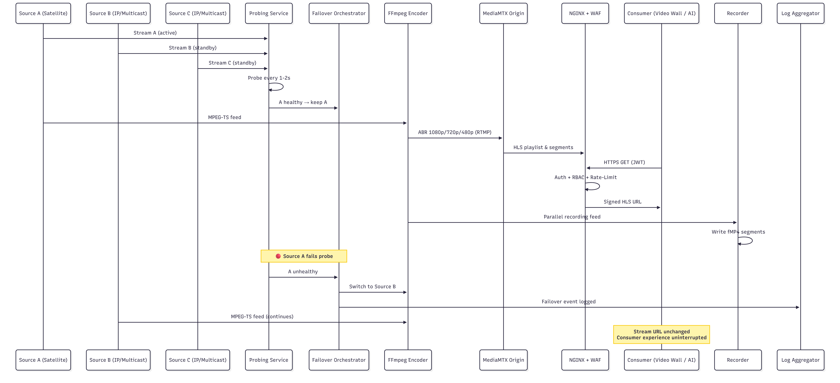
Figure 2 — Per-Channel Data Flow & Failover

API Exposure (REST + Webhooks)
- GET /api/v1/channels — list of all channels with metadata (id, name, language, category, region, current source, status).
- GET /api/v1/channels/{id}/playlist.m3u8 — signed, authenticated HLS playlist URL.
- GET /api/v1/channels/{id}/status — real-time source, last failover, uptime and current bitrate.
- GET /api/v1/recordings — recorded segment lookup by channel and time window.
- GET /api/v1/recordings/{id}/clip — on-demand clip generation.
- GET /api/v1/events — auditable platform events (failovers, access, errors).
- GET /api/v1/metadata/{channel}/transcript — speech-to-text transcript stream.
- Webhook subscriptions — for failover events, content alerts and recording completions; HMAC-SHA256 signed payloads.
- Developer artefacts — OpenAPI 3.1 spec, Postman collection, Node.js and Python SDKs delivered at go-live.

Video Wall
Browser-native React + Vite + hls.js Single Page Application with six or more configurable layouts — 1×1, 2×2, 3×3, 4×4, 5×5, 6×4/8×4 large wall, and a PiP-focus mode. Layouts are saved per user, recalled on login. Closed captions, on-screen channel labels and a synchronised time-strip are configurable globally.

1.C Security, Scalability, Redundancy and 24×7 Operations

1.C.1 Security — Defence-in-Depth
- Perimeter: Next-Gen Firewall + IDS/IPS + WAF + geo-IP filtering + DDoS scrubbing.
- Transport: TLS 1.2+ on every HTTP/HTTPS path; HSTS; modern cipher suites only.
- At-rest encryption: AES-256 on recording storage and database backups.
- Identity: OAuth 2.0 + JWT; optional OIDC federation; MFA mandatory for administrative roles.
- RBAC: predefined roles (Viewer / Analyst / Operator / Administrator / Auditor) with custom roles supported.
- Rate Limiting: per-tenant token-bucket limits per endpoint group; HTTP 429 with Retry-After.
- URL Signing: time-limited signed HLS playlist URLs prevent unauthorised re-sharing.
- Hardening: CIS-aligned OS hardening, auditd kernel audit, fail2ban on management hosts.
- Vulnerability Management: monthly scans, quarterly patch cycle, emergency CVE patching.
- Audit Trail: immutable write-once logging for all administrative actions; exportable to DEMP audit authority.
- Network Segmentation: DMZ / Acquisition / Processing / Storage / Management / DR zones with east-west firewall rules.

Figure 3 — Network Security Zones
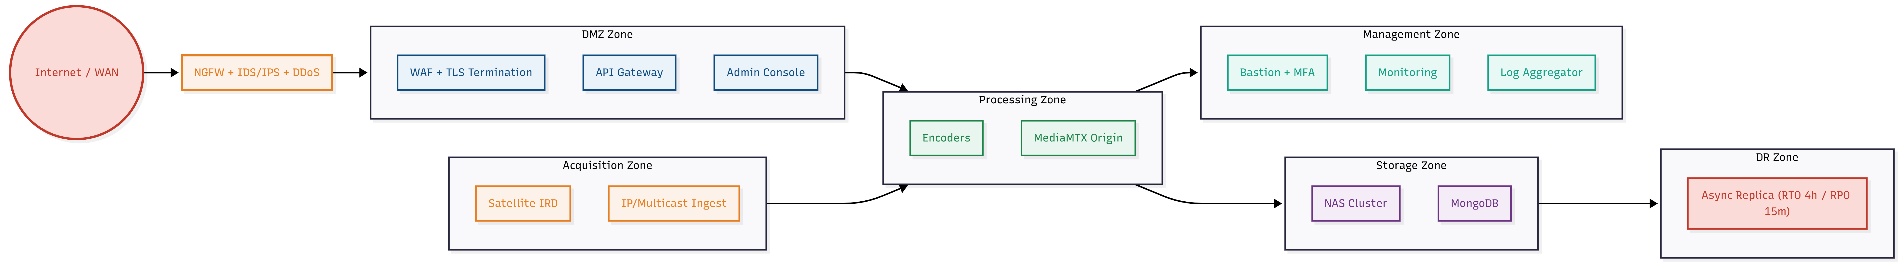
Figure 3 — Security Zones

1.C.2 Scalability
- Horizontal scale-out on every tier — ingest, encoder, origin or API nodes added without architectural redesign.
- Stateless application tier — services can be killed and re-instantiated without data loss; auto-scaling under load.
- Caching tier (optional) — CDN or internal cache layer for high fan-out distribution.
- Capacity headroom built into initial sizing for additional channels beyond 124.
- Docker + Compose / Kubernetes orchestration for consistent, repeatable scaling operations.

1.C.3 Redundancy
- 3-source failover per channel with sub-2-second switch-over.
- Active-active streaming origin — each channel published to ≥ 2 MediaMTX nodes.
- Active-active ingest — dual ingest nodes with health-based traffic steering.
- MongoDB replica set (Primary + Secondary + Arbiter) for metadata HA.
- NAS RAID-6 + hot-spare for recording survivability.
- Asynchronous DR replication to a secondary site — RTO 4 hours; RPO 15 minutes (metadata) / 1 hour (recordings).
- UPS + DG backup at the CMU facility (on-premise mode).
- Backup policy — daily incremental, weekly full, quarterly tested restore drills.

1.C.4 24×7 Operations
- Pakistan-based NOC manned 24×7 by Tier-1 / Tier-2 engineers.
- Dedicated DEMP dashboard: per-channel health, per-node metrics, API throughput, storage utilisation and incident queue.
- Preventive maintenance: monthly OS patching, weekly health audits, quarterly DR drills.
- Change management: maintenance windows scheduled outside prime-time broadcast hours with advance notice to DEMP.
- Monthly Service Review with formal SLA report.

Incident Management SLA
Severity | Definition | Response | Resolution
S1 — Critical | Platform-wide outage / > 25 channels down | 15 minutes | 4 hours
S2 — High | 1–25 channels down or API degraded | 30 minutes | 8 hours
S3 — Medium | Single source failure with failover active | 2 hours | 1 business day
S4 — Low | Cosmetic or feature request | 1 business day | Next maintenance window

2. Compliance with Standards & Interoperability
BesTel’s proposed solution is built on open IETF, ISO/IEC, ITU-T and W3C standards exclusively. Every protocol used is publicly documented, interoperability-tested and supported by multiple independent implementations. There is no proprietary lock-in.

2.A Standards & Protocols Adhered To

2.A.1 Broadcast & Streaming Standards
Standard | Reference | Use in CMU
MPEG-TS over UDP/RTP | ISO/IEC 13818-1 | Primary satellite/IRD and telco multicast ingest
HLS | RFC 8216 | Browser-native delivery and selected ingest
MPEG-DASH | ISO/IEC 23009-1 | Optional ABR delivery
Low-Latency HLS / LL-DASH | Apple LL-HLS / DASH-IF | Sub-2-second latency profiles
RTMP / RTMPS | Adobe RTMP 1.0 | Push uplinks and legacy delivery
RTSP | RFC 7826 | IP camera/encoder uplinks
H.264 / AVC | ITU-T H.264, MPEG-4 Part 10 | Primary video codec
H.265 / HEVC | ITU-T H.265 | Optional high-density video codec
AAC-LC | ISO/IEC 14496-3 | Audio codec
fMP4 / CMAF | ISO/IEC 14496-12, ISO/IEC 23000-19 | Segment container, CMAF-compatible

2.A.2 API Standards
Standard | Reference | Use in CMU
REST architectural style | Fielding, 2000 | Resource-oriented, idempotent verbs
OpenAPI Specification | OAS 3.1 | Published, versioned, machine-readable API contract
JSON | RFC 8259 | All request/response payloads
JSON Schema | draft 2020-12 | Endpoint payload validation
HTTP/1.1 + HTTP/2 | RFC 7230 / RFC 9113 | Transport, HTTPS enforced
Webhook signing | HMAC-SHA256 (RFC 2104) | Signed webhook payloads to subscribers

2.A.3 Security Standards
Standard | Reference | Use in CMU
TLS 1.2 / 1.3 | RFC 5246 / RFC 8446 | Transport encryption on every external path
OAuth 2.0 | RFC 6749 | Token-based authentication
JWT | RFC 7519 | Access token format
OpenID Connect (OIDC) | OIDC Core 1.0 | Optional identity federation with DEMP IdP
Mutual TLS (mTLS) | RFC 8705 | High-trust internal integrations
CIS Benchmarks | CIS Ubuntu / Docker / K8s | OS and container hardening baseline
OWASP Top 10 / API Top 10 | OWASP 2023 | Application security baseline
AES-256 | FIPS 197 | At-rest encryption
SHA-256 | FIPS 180-4 | Integrity & signing

2.A.4 Operational & Observability Standards
Standard | Reference | Use in CMU
Syslog | RFC 5424 | Log forwarding to DEMP SIEM
Prometheus exposition format | Prometheus.io | Metrics scraping
OpenTelemetry | OTel 1.x | Distributed tracing
NTP / PTP | RFC 5905 / IEEE 1588 | Clock synchronisation across nodes

2.B Interoperability Considerations

Figure 4 — Interoperability Map
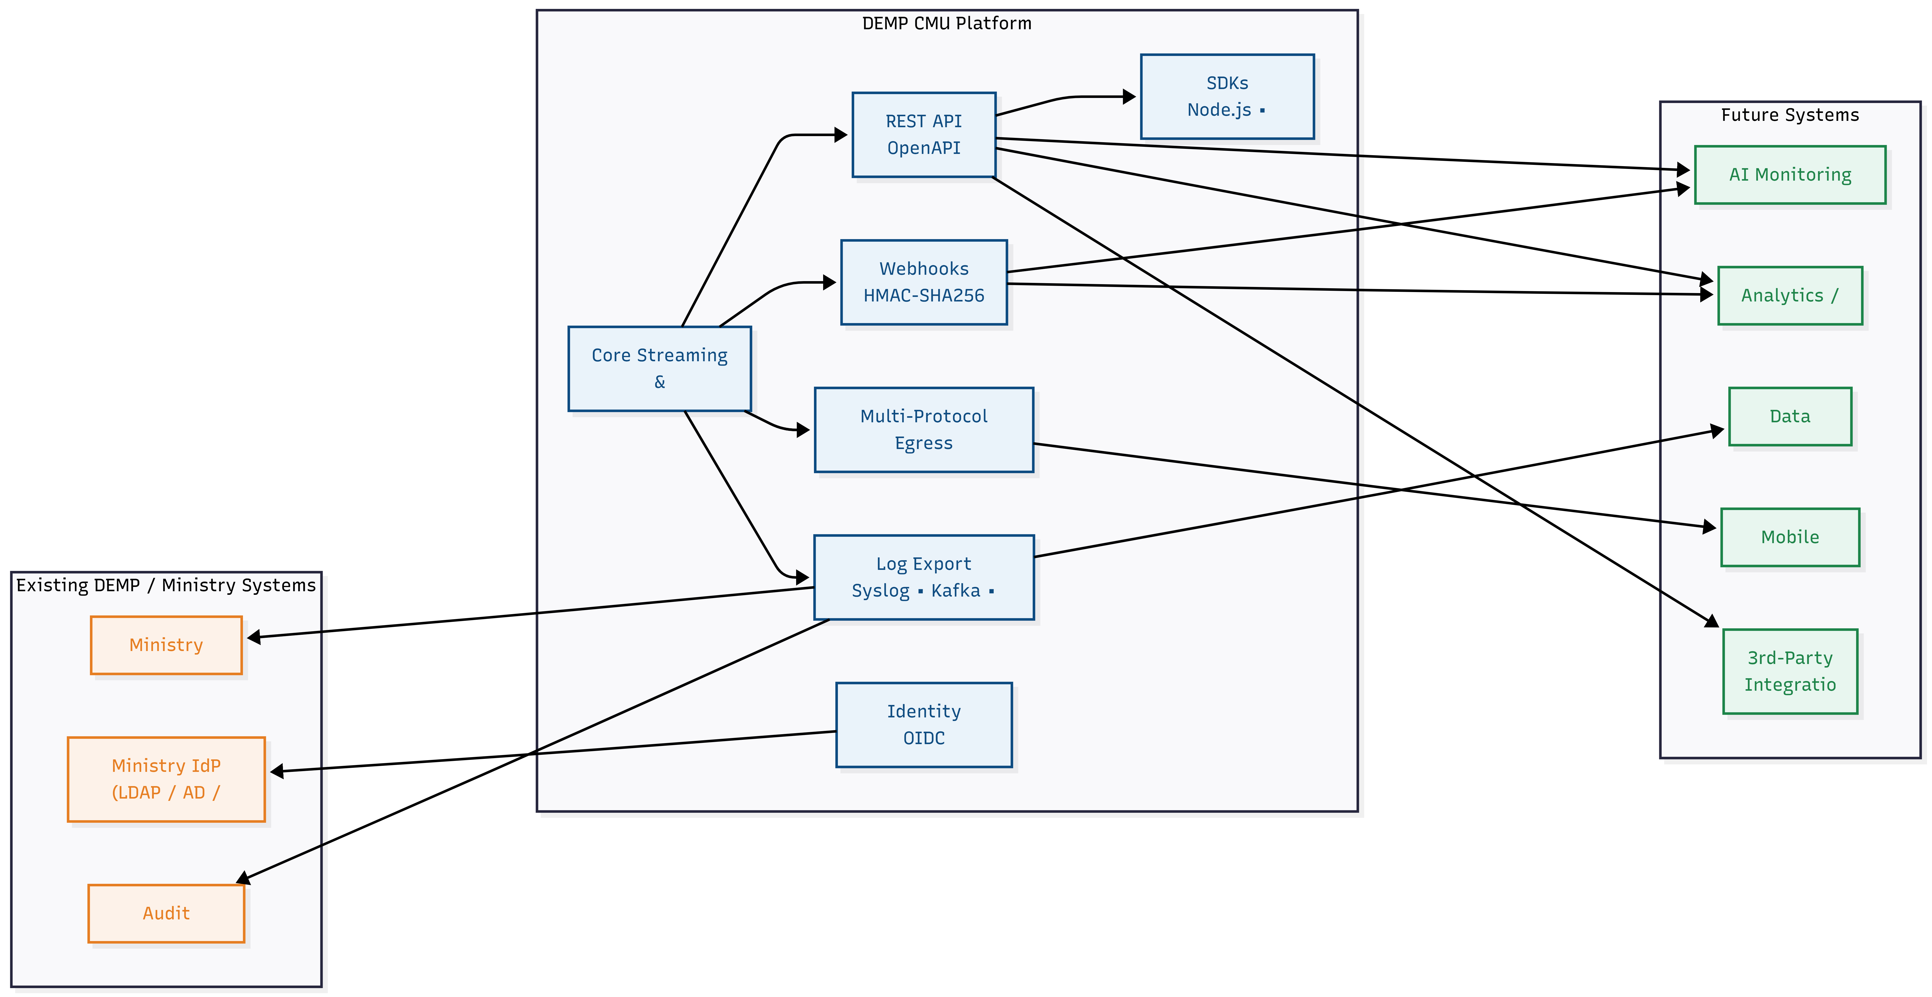
Figure 4 — Interoperability Map

Interoperability Considerations — Point-Wise
- Open-Standards Stack: every protocol used is an open IETF / ISO / W3C / ITU-T standard — zero proprietary lock-in.
- Vendor-Neutral Components: FFmpeg, MediaMTX, NGINX, Node.js, MongoDB, Elasticsearch, Prometheus, Grafana — open source with active communities.
- Hardware-Agnostic: runs on any x86_64 server; not tied to any specific OEM.
- Multi-Codec Output: consumers receive H.264 (universal) or H.265 (where supported); ABR adaptation per device capability.
- Multi-Protocol Egress: the same channel can be delivered simultaneously as HLS, RTMP and LL-HLS for different downstream consumers.
- API-First Design: every platform function is exposed through the REST API — no functionality is locked inside the UI; downstream AI/monitoring apps can drive the platform programmatically.
- SDKs Shipped: Node.js + Python SDKs + Postman collection + sample integration code reduce downstream integration to hours.
- Webhook Subscriptions: push notifications eliminate polling overhead for downstream systems.
- Syslog / Kafka / REST Log Export: logs and events can be streamed to DEMP’s existing SIEM, audit systems or data lake.
- Identity Federation: OIDC integration enables single sign-on with Ministry / DEMP existing identity providers.
- Containerised Deployment: Docker / Kubernetes packaging ensures identical operation on bare-metal, virtualised or cloud infrastructure.
- Deployment Mode Flexibility: the same platform can be delivered as on-premise, SaaS, or hybrid — DEMP retains full strategic choice without re-architecture.
- Forward Compatibility: the API is versioned (/api/v1/) with a deprecation policy; new versions co-exist with legacy versions for staged downstream migration.
- Standards-Compliant Archive: fMP4 / CMAF recording format is readable by any standards-compliant tooling — DEMP is never dependent on BesTel for archive access.

