法一：直接设置

D:\anaconda;D:\anaconda\Scripts;D:\anaconda\Lib;D:\anaconda\Lib\site-packages

法二：cmd中设置

试试手动设置path

运行->cmd

输入set PATH=%PATH%;C:\Python27

再在当前cmd下输入python

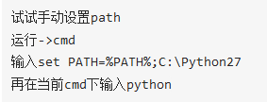

set PATH=%PATH%;D:\anaconda;D:\anaconda\Scripts;D:\anaconda\Lib;D:\anaconda\Lib\site-packages