思维脑图：实现货运订单的功能点

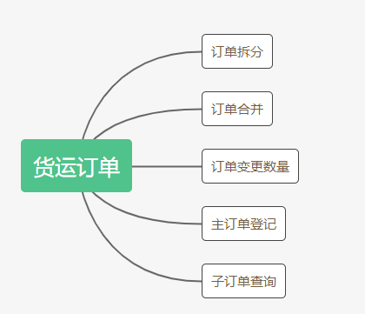

## 流程

创建订单

提供外部的请求API，通过请求接口登记一条主订单信息

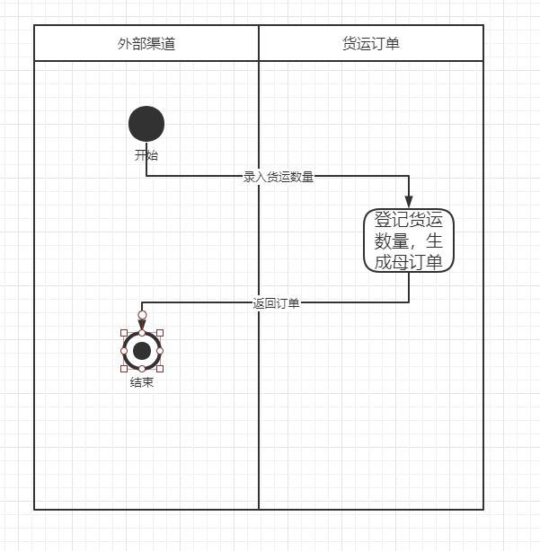

拆分订单

提供外部的请求API，通过请求接口将要拆分的订单号和拆分的数量传入，货运订单处理系统将查找对应订单号，进行校验，并保存拆分后的订单，并关联母订单，更新拆分订单为已拆分

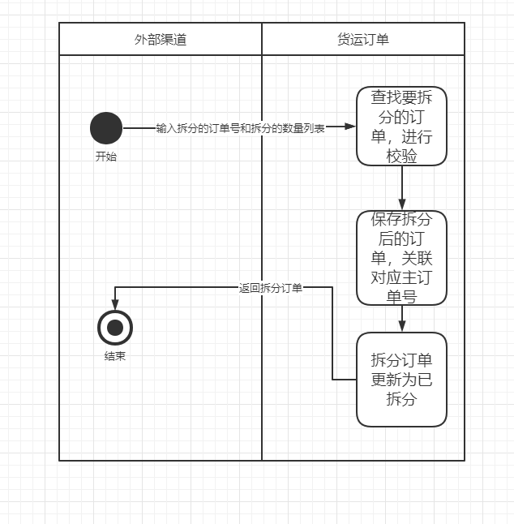

合并订单

提供外部的请求API，通过请求接口将要合并的订单号传入，货运订单处理系统将查找对应订单号，进行校验，并保存合并后的订单，并关联母订单，更新拆分订单为已合并

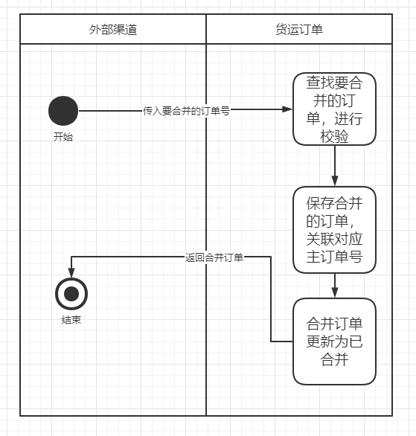

变更订单

提供外部的请求API，通过请求接口将要变更的母订单和增加/减少的数量，货运订单处理系统将查找对应订单号，进行校验，并增加/减少母订单，计算比例，增加/减少子订单货运量，更新

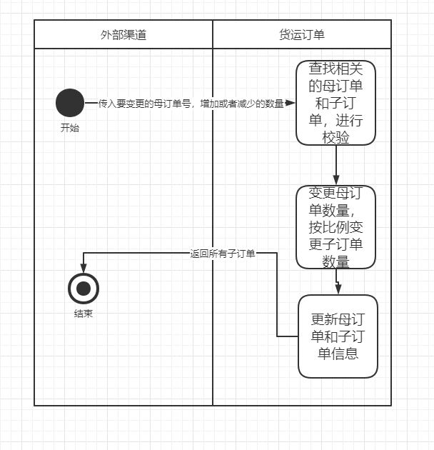

查询订单

输入相对应的母订单号，根据订单状态正常的与关联母订单号查找到相关子订单

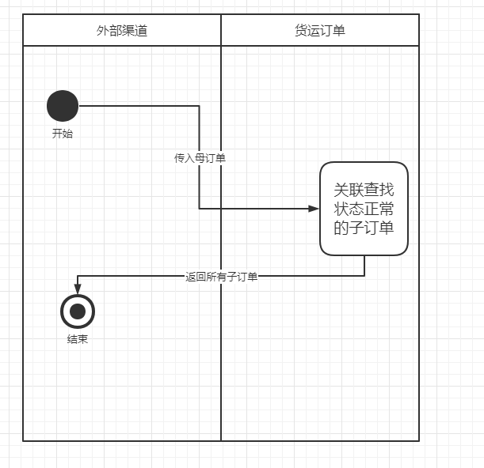

## 数据库设计



ID 订单号

MASTER_ID 主订单号 订单关联的母订单号

QUANTITY 货运数量

ROOT_FLAG 是否主订单 1：子订单/0：母订单

STATUS 订单状态 0：正常 1：已拆分 2：已合并

## 接口设计：

主订单创建

|  |  |  |  |  |  |  |  |  |  |  |
| --- | --- | --- | --- | --- | --- | --- | --- | --- | --- | --- |
| 接口描述 | | 主订单创建 | | | | | | | | |
| Request | | | | | | | | | | |
| **属性名** | | | **说明** | | | | **必填** | **类型** | | **备注** |
| quantity | | | 货运数量 | | | | Y | Long | |  |
|  | | | | | | | | | | |
| Reponse | | | | | | | | | | |
| Content-Type | | | | application/json | | | | | | |
| **属性名** | **说明** | | | | **必填** | **类型** | | | **备注** | |
| code | 返回码 | | | | Y | String | | | 0:交易成功, -1:交易失败 | |
| message | 返回信息 | | | | Y | String | | |  | |
| result | 返回数据 | | | | N | Object | | |  | |
| >orderId | 订单号 | | | |  | Long | | | result | |
| >quantity | 货运数量 | | | |  | Long | | | result | |
| > status | 状态 | | | |  | String | | | result | |
|  | | | | | | | | | | |

拆分货运订单

|  |  |  |  |  |  |  |  |  |  |  |
| --- | --- | --- | --- | --- | --- | --- | --- | --- | --- | --- |
| 接口描述 | | 拆分货运订单 | | | | | | | | |
| Request | | | | | | | | | | |
| **属性名** | | | **说明** | | | | **必填** | **类型** | | **备注** |
| quantity | | | 货运数量 | | | | Y | Long | |  |
| quantityList | | | 货运单拆分列表 | | | | Y | List<Long> | |  |
|  | | | | | | | | | | |
| Reponse | | | | | | | | | | |
| Content-Type | | | | application/json | | | | | | |
| **属性名** | **说明** | | | | **必填** | **类型** | | | **备注** | |
| code | 返回码 | | | | Y | String | | | 0:交易成功, -1:交易失败 | |
| message | 返回信息 | | | | Y | String | | |  | |
| result | 返回数据 | | | | N | List | | |  | |
| >orderId | 订单号 | | | |  | Long | | |  | |
| >quantity | 货运数量 | | | |  | Long | | |  | |
| > status | 状态 | | | |  | String | | |  | |

合并货运订单

|  |  |  |  |  |  |  |  |  |  |  |
| --- | --- | --- | --- | --- | --- | --- | --- | --- | --- | --- |
| 接口描述 | | 合并货运订单 | | | | | | | | |
| Request | | | | | | | | | | |
| **属性名** | | | **说明** | | | | **必填** | **类型** | | **备注** |
| orderIdList | | | 货运合并订单列表 | | | | Y | List<Long> | |  |
|  | | | | | | | | | | |
| Reponse | | | | | | | | | | |
| Content-Type | | | | application/json | | | | | | |
| **属性名** | **说明** | | | | **必填** | **类型** | | | **备注** | |
| code | 返回码 | | | | Y | String | | | 0:交易成功, -1:交易失败 | |
| message | 返回信息 | | | | Y | String | | |  | |
| result | 返回数据 | | | | N | Object | | |  | |
| >orderId | 订单号 | | | |  | Long | | |  | |
| >quantity | 货运数量 | | | |  | Long | | |  | |
| > status | 状态 | | | |  | String | | |  | |

变更货运订单

|  |  |  |  |  |  |  |  |  |  |  |
| --- | --- | --- | --- | --- | --- | --- | --- | --- | --- | --- |
| 接口描述 | | 变更货运订单 | | | | | | | | |
| Request | | | | | | | | | | |
| **属性名** | | | **说明** | | | | **必填** | **类型** | | **备注** |
| orderId | | | 主订单号 | | | | Y | Long | |  |
| flag | | | 变更标识 | | | | Y | List<Long> | |  |
| changeNum | | | 变更货运量 | | | | Y | Long | |  |
|  | | | | | | | | | | |
| Reponse | | | | | | | | | | |
| Content-Type | | | | application/json | | | | | | |
| **属性名** | **说明** | | | | **必填** | **类型** | | | **备注** | |
| code | 返回码 | | | | Y | String | | | 0:交易成功, -1:交易失败 | |
| message | 返回信息 | | | | Y | String | | |  | |
| result | 返回数据 | | | | N | List | | |  | |
| >orderId | 订单号 | | | |  | Long | | |  | |
| >quantity | 货运数量 | | | |  | Long | | |  | |
| > status | 状态 | | | |  | String | | |  | |

根据主订单查找对应的货运子订单

|  |  |  |  |  |  |  |  |  |  |  |
| --- | --- | --- | --- | --- | --- | --- | --- | --- | --- | --- |
| 接口描述 | | 根据主订单查找对应的货运子订单 | | | | | | | | |
| Request | | | | | | | | | | |
| **属性名** | | | **说明** | | | | **必填** | **类型** | | **备注** |
| orderId | | | 主货运单号 | | | | Y | Long | |  |
|  | | | | | | | | | | |
| Reponse | | | | | | | | | | |
| Content-Type | | | | application/json | | | | | | |
| **属性名** | **说明** | | | | **必填** | **类型** | | | **备注** | |
| code | 返回码 | | | | Y | String | | | 0:交易成功, -1:交易失败 | |
| message | 返回信息 | | | | Y | String | | |  | |
| result | 返回数据 | | | | N | List | | |  | |
| >orderId | 订单号 | | | |  | Long | | |  | |
| >quantity | 货运数量 | | | |  | Long | | |  | |
| > status | 状态 | | | |  | String | | |  | |