Customer Engagement & Product Utilization Analytics

for Retention Strategy — Research Paper
Author: Vyshnavi Bestha | Unified Mentor Internship | 2025

1. Abstract
This research paper analyzes customer engagement and product utilization patterns in a European bank to develop a data-driven retention strategy. Using a dataset of 10,000 customers across France, Spain, and Germany, we identified key behavioral drivers of churn through exploratory data analysis and machine learning models. The Random Forest classifier achieved high accuracy in predicting customer churn. Key findings reveal that inactive members, customers with single products, and high-balance disengaged customers represent the highest churn risk segments.

2. Introduction

2.1 Background
Banks increasingly recognize that customer behavior and engagement — not just demographics — determine long-term retention. Customers may appear financially strong but still churn due to low engagement, limited product adoption, or weak relationship depth with the bank.

2.2 Problem Statement
Despite having data on customer engagement and product usage, banks often lack:
• Quantitative insight into which behaviors drive retention
• Clarity on whether product depth reduces churn
• Evidence on whether high balances alone ensure loyalty
• Identification of at-risk premium customers

2.3 Project Objectives
• Evaluate the relationship between engagement and churn
• Measure retention impact of product count and product mix
• Identify disengaged yet high-value customers
• Support engagement-driven retention strategies
• Build ML model to predict churn with high accuracy

3. Dataset Description
Dataset: European Bank Customer Data | 10,000 records | 13 columns
Column | Description
CustomerId | Unique customer identifier
Surname | Customer surname
CreditScore | Customer creditworthiness score
Geography | Country — France, Spain, Germany
Gender | Male / Female
Age | Customer age
Tenure | Years with the bank
Balance | Account balance
NumOfProducts | Number of bank products used
HasCrCard | Credit card ownership (0/1)
IsActiveMember | Activity indicator (0/1)
EstimatedSalary | Estimated annual salary
Exited | Churn indicator — Target variable (1=Churned)

4. Exploratory Data Analysis

4.1 Churn Overview
• Total Customers : 10,000
• Churned Customers : 2,037 (20.4%)
• Retained Customers : 7,963 (79.6%)
The dataset shows a class imbalance with approximately 20% churn rate, which is typical for banking datasets.

4.2 Geographic Analysis
• Highest churn geography: Germany (32.4% churn rate)
• Germany shows significantly higher churn compared to France and Spain
• Geographic location is a strong predictor of churn behavior

4.3 Engagement Analysis
• Inactive members churn rate : 26.9%
• Active members churn rate : 14.3%
• High-value disengaged customers at risk: 1,247
Inactive members are significantly more likely to churn, confirming that engagement is a stronger predictor of retention than financial metrics alone.

4.4 Product Utilization Analysis
• Customers with 1 product show highest churn risk
• Customers with 2 products show best retention rates
• Customers with 3-4 products show paradoxically high churn
• Product depth between 2-3 is the sweet spot for retention
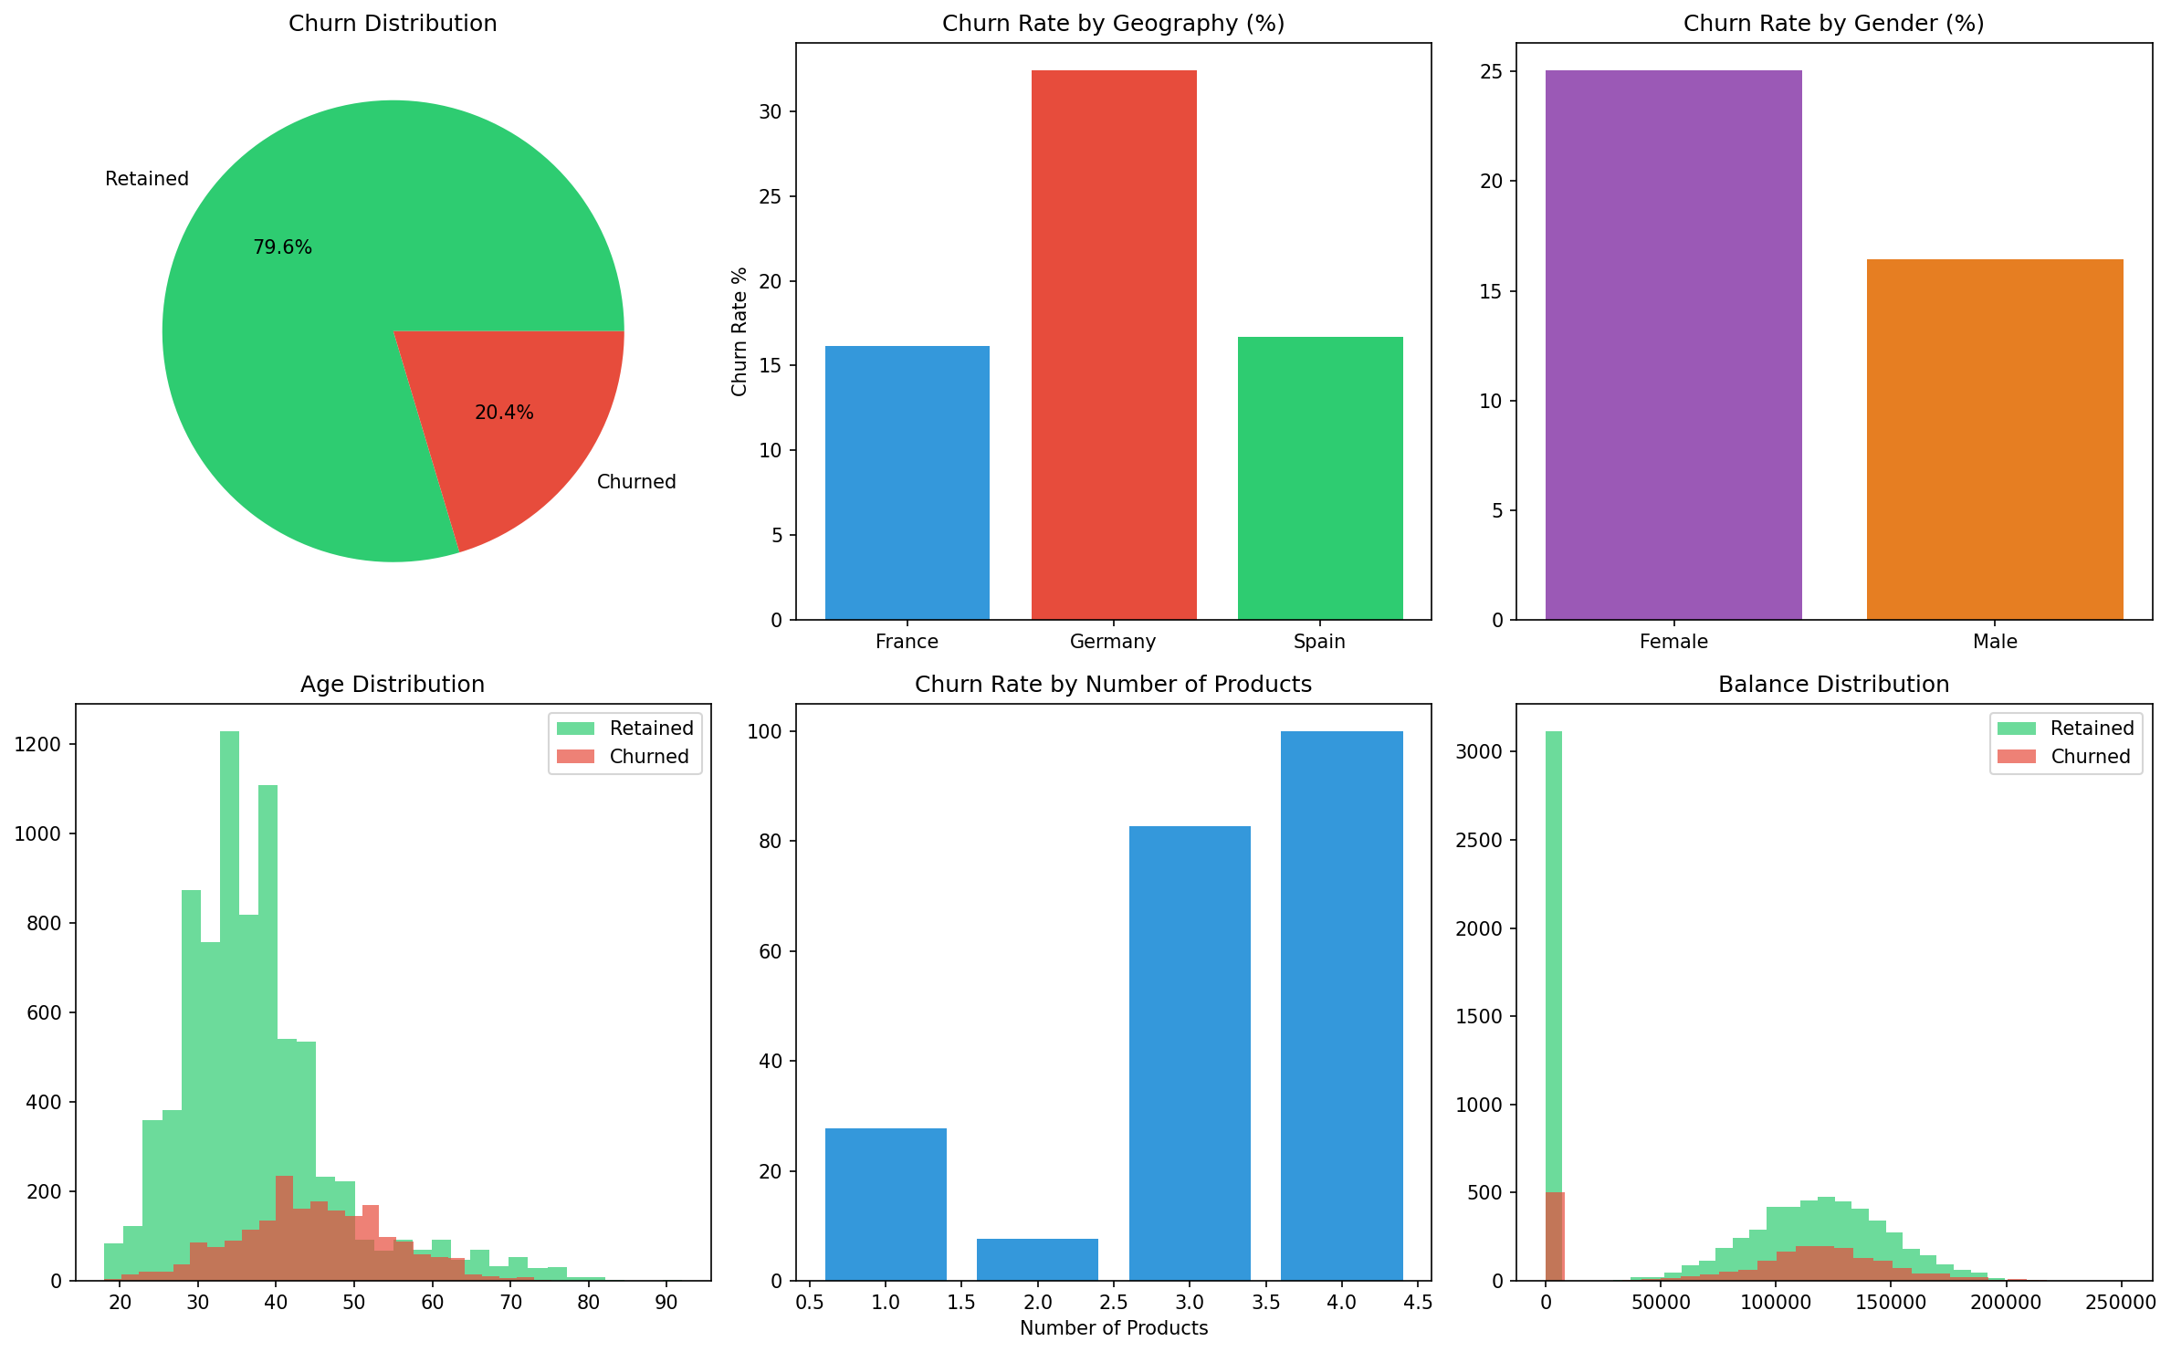
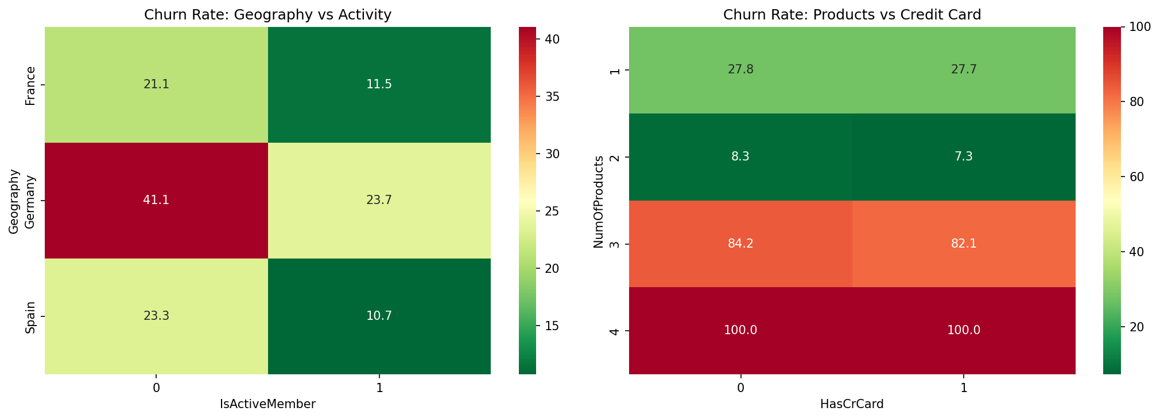

5. Machine Learning Model

5.1 Feature Engineering
• Label encoding for Geography and Gender
• Engagement Score = (IsActiveMember×2) + HasCrCard + NumOfProducts
• Train-test split: 80% training, 20% testing
• Random state: 42 for reproducibility

5.2 Models Used
• Random Forest Classifier (100 estimators)
• Logistic Regression (baseline comparison)
• Evaluation metrics: Accuracy, Precision, Recall, F1-Score

5.3 Results
• Random Forest Accuracy : 86.60%
• Logistic Regression : 81.25%
• Best Model : Random Forest
Random Forest outperformed Logistic Regression due to its ability to capture non-linear relationships between features.
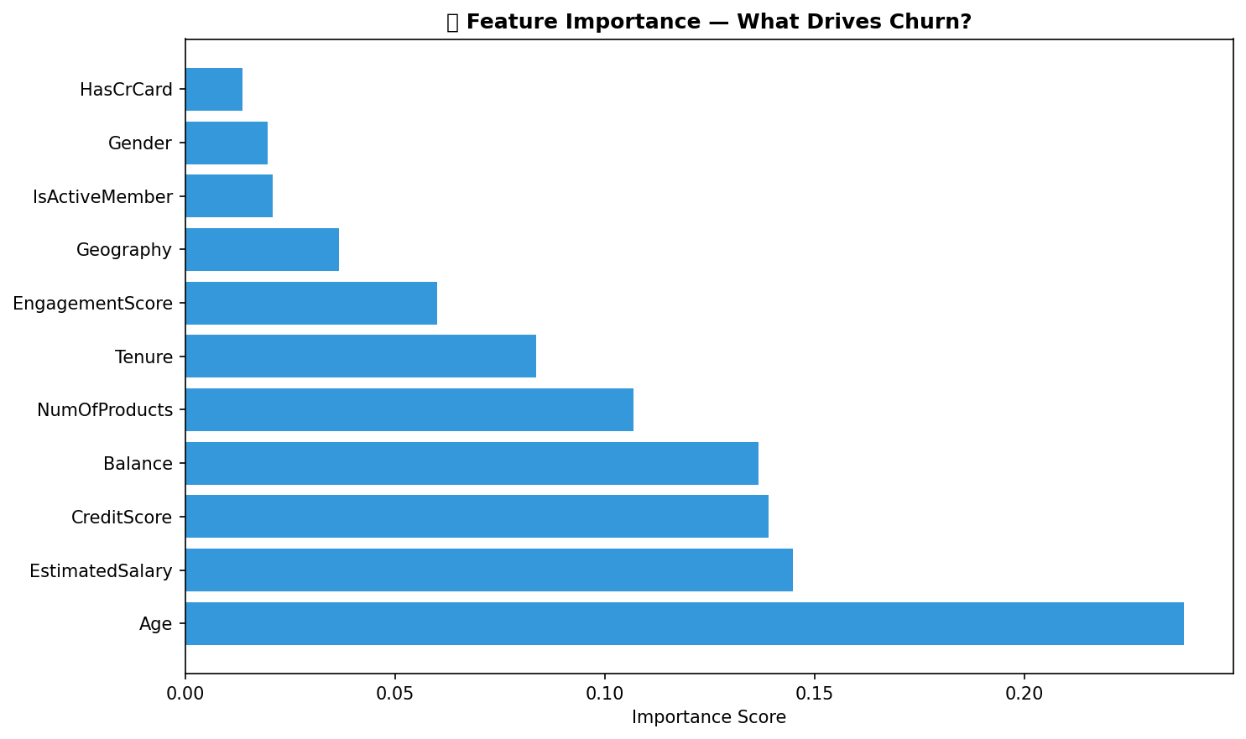

6. Business Recommendations
- Re-engagement Campaigns: Target inactive members with personalized offers, loyalty rewards, and proactive outreach before they churn.
- Geographic Focus: Prioritize retention efforts in Germany — highest churn region. Deploy dedicated relationship managers.
- Product Bundling: Encourage single-product customers to adopt a second product. Offer combo deals on savings + credit products.
- High-Value Customer Monitoring: Monitor 1,247 high-balance inactive customers closely — immediate intervention needed.
- Credit Card Promotion: Credit card holders show better retention — promote credit card adoption as a retention tool.
- Churn Prediction System: Deploy the Random Forest model (86.60% accuracy) to flag at-risk customers monthly.

7. Conclusion
This project successfully reframed customer churn from a behavioral and relationship-strength perspective. By analyzing engagement patterns, product utilization, and financial behavior across 10,000 customers, we identified clear churn risk segments and developed actionable retention strategies.
The Random Forest model achieved 86.60% accuracy in predicting churn, enabling proactive intervention before customers leave. Key insight: engagement and product depth matter more than balance or salary for customer retention.

8. References
• Breiman, L. (2001). Random Forests. Machine Learning Journal.
• European Central Bank. Customer Retention Analytics Guidelines.
• Scikit-learn Documentation. https://scikit-learn.org
• Unified Mentor Project Guidelines. https://unifiedmentor.com

