Form C - free app to easy the work of filling the online form

Respected accommodation manager,

Online Form "C"
Every accommodation in India must fill the Form C for every foreigner.
https://boi.gov.in/content/form-c
The Online Form "C" is very useful, but filling it for many guests is hard, because of many data it requires. The person who works with Form C knows that problem.
Online Form C (this is a copy of the real form):
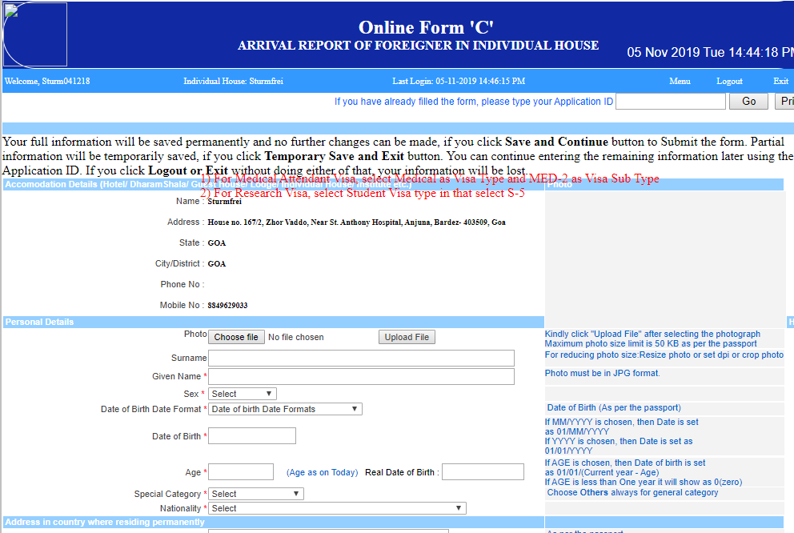
I am a computer programmer and the author of a simple Chrome Extension that helps you to fill this form.
It is open source and completely free to use. It is published on Chrome WebStore and the source code is free to inspect and check there is no malware and no data is transferred over the network:
https://github.com/LucianoBestia/chext_fill_form_from_json
This Chrome extension does only one thing: it fills the form with the data provided in JSON format. The JSON format is a standard web exchange format in clear and readable text. It can be easily copied, saved, modified and read.
I recommend to try it first on one simple example on a copy of the real Form C:
1. First, install the Extension from the Chrome WebStore:
https://chrome.google.com/webstore/detail/fill-form-from-json/gdgkhgfgpfhnmiebaedlcaignonmjobe
2. You need some data in JSON format. Open this:
https://bestia.dev/efrro_form_c_json/example/efrro_form_c.json
and copy all (ctrl+a) to the clipboard (ctrl+c).
3.Then open the web page (a copy of the real Form C):
https://bestia.dev/efrro_form_c_json/example/efrro_form_c.html
4.Start the extension (click on in the right top corner). The extension looks like this:

And here paste (ctrl+v) the text from the clipboard.
5. Click on the button "Fill form".
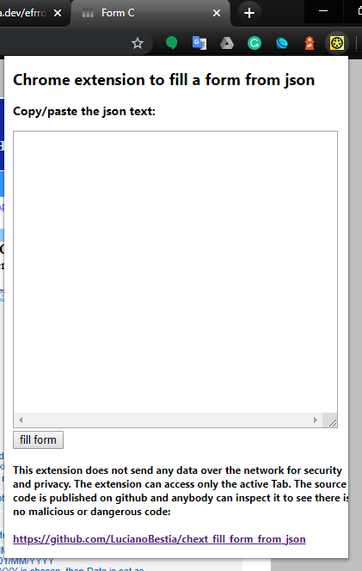
You can now see the data in Form C. As simple as that.
If it does not work the first time, try to close and reopen Chrome and repeat the process.
You can now read the data in the form, probably you will need to add some data or correct and then you can press the Submit button. The Extension does NOT press the Submit button for you. You have your time to check and correct the data prior to submitting or canceling the process.

The guests prepare the JSON data for you
Ask the guest kindly to fill this form in their personal smartphone:
https://bestia.dev/efrro_form_c_json
After finishing the guest sends an email to you with the data in JSON format.
This web page is prepared for modern smartphone browsers (chrome, firefox, safari). It does not work on very old, not updated or unusual browsers because of security and comfort.
It is very easy to use. You can try it first on your smartphone to see how it works. So you can help your guests if they need it.
You can ask them to prepare this data already in the Booking Confirmation email, so they have more time to fill this form before they actually come to the accommodation.
This web page saves the data only in the local storage of the device. No data is ever sent over the network. The action of sending the resulting JSON data is outside of the web page and up to the user to choose his preferred way of communication.
The guest can later use this same data also for other accommodations because it is saved on his own device. So the guest and the accommodation don’t have to fill the form C manually again.
The web page code is open source and free to use to everybody. The source code can be inspected (no malware, no data sent over the network) in the GitHub repository:
https://github.com/LucianoBestia/efrro_form_c_json

Donation and personalization
This web page is completely free, open source, universal and has all the needed functionality. The web page originally does not have any data about a specific accommodation.
If you like this web page, you can send me a small donation of 10usd to my
PayPal account: paypal.me/LucianoBestia
To thank you for the donation I can personalize this web page with an image, email address, links to your website, facebook or Instagram and some text.
It is then more pleasant and informative for the guest to use.
It will look then like this example:
https://bestia.dev/efrro_form_c_json?id=sturmfrei_goa
Send me an email with your data and image.
Use this JSON example and fill your data inside:
{
"name": "Accomodation Hostel",
"email": "accomodation@gmail.com",
"web": "http://accomodation.com",
"applicant_refaddr": "accomodation address, City India",
"applicant_refstate": "Goa",
"applicant_refpincode": "403509",
"text_vector": [
"phone: +91 11111111",
"address:",
"my address, Vagator, Goa 403509",
"whatsapp: +91 11111111"
],
"urls": [
{
"name": "website",
"url": "http://accomodation.com"
},
{
"name": "google maps",
"url": "https://g.page/accomodation"
},
{
"name": "booking.com",
"url": "https://www.booking.com/hotel/in/accomodation.html"
},
{
"name": "tripadvisor",
"url": "https://www.tripadvisor.in/Hotel_Review-g111111-d1111111-Reviews-accomodation-hotel.html"
},
{
"name": "facebook",
"url": "https://www.facebook.com/sturmfreigoa"
},
{
"name": "instagram",
"url": "https://www.instagram.com/accomodation/"
},
{
"name": "hostels.com",
"url": "https://www.hostelworld.com/hosteldetails.php/accomodationGoa/Goa/111111"
}
]
}
I hope this web page and Chrome Extension will help you with your work with foreigners and Form C.
If you have any questions and comments please, contact me on my email:
Luciano.Bestia2@gmail.com

Thank you,
Luciano

