Agent-Based Model of Environmental Migration in Bangladesh

Kelsea Best

# Overview

## Purpose

The purpose of the model is to simulate household migration decisions in Bangladesh under environmental pressure. The model seeks to understand how environmental stress in the form of drought and drought-induced agriculture loss, as well as changing livelihood opportunities, impact mobility patterns. The initial version of the model uses decision-making based on utility maximization. Future versions of the model will include multiple decision-making frameworks. Future versions of the model will also explore how social networks impact migration decisions through the exchange of information and resources between origin and destination locations, including different kinds of destinations.

## Entities, state variables, and scales

This model consists of **individuals** and **household** entities. Individuals have a gender, age, and employment, as well as a household that they are assigned to. Households consist of individuals. Other entities include the **decision class** and **community class**. The household will access the decision method from the decision class in order to decide whether or not to send a migrant. Initially, the decision-making method is a simple utility maximization calculation. Future versions incorporate Theory of Planned Behavior, Mobility Potential, and Protection Motivation Theory.

Each household is connected to a **community** entity. In the simple model, the community represents the origin location. The community has associated employment opportunities. In a later version of the model, destination locations will be incorporated as types of community including Dhaka, Khulna, and another rural location. These destinations will also have associated employment opportunities that individuals can assess. Destinations will also have an associated risk and cost to move. Communities, individuals, and households are all situated within an environment which will stochastically experience a shock at a given time step. An environmental shock will impact community opportunities as well as individual households.

Agents will also keep track of their location where they are residing at each time step. To represent social networks, agents will be able to exchange information about migration histories and wealth histories freely with a random set of other households.

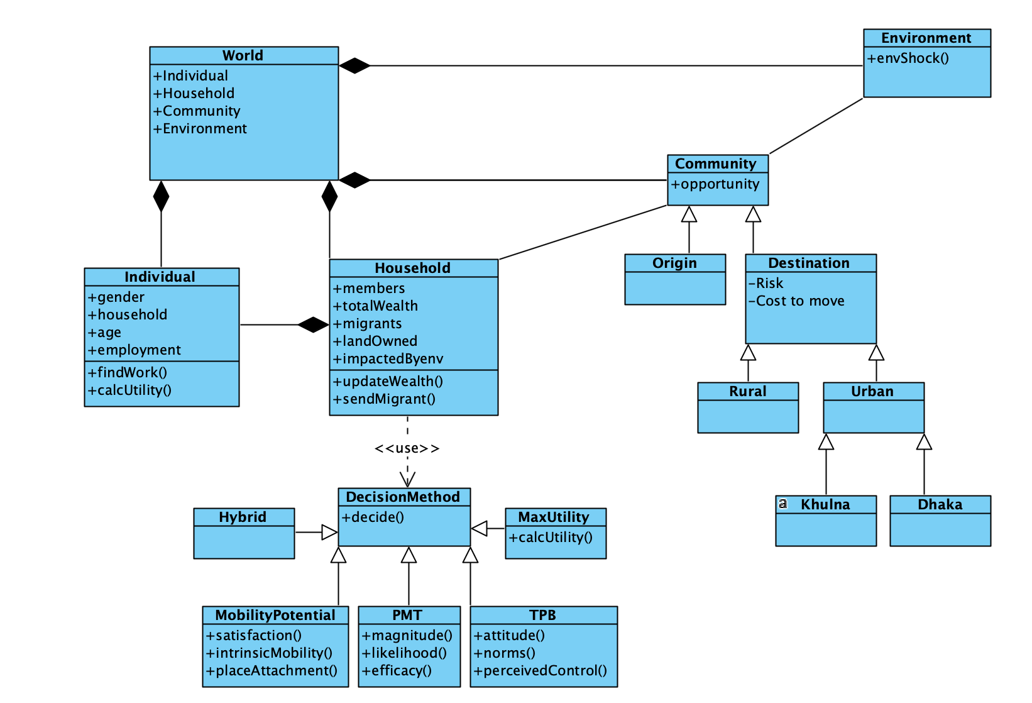

UML diagram of the model structure

### Global variables

* decision – decision method to be used to make migration decision
* shock_method – type of environmental impact simulated, this can be “shock” for a stochastic environmental shock or “slow_onset” for a gradual impact
* mig_util – utility to migrate successfully
* mig_threshold – wealth threshold to migrate
* num_hh – number of households
* num_individuals – number of individuals
* init_time – initialization time (automatically 0)
* tick – tracks time progression in model
* ticks – total number of ticks for model to run
* migrations – tracks overall migrations taken globally
* wealth_factor – factor to initialize household wealth
* ag_factor – productivity factor for land that households own
* origin_comm – origin community (calls community class)
* comm_scale – proportion of community that is impacted by an environmental shock
* data_set – stores data with data_collect() function
* individual_set – stores individuals and data
* hh_set – stores households and data

### Individual class variables

* unique_id
* age
* gender (‘M’ or ‘F’)
* hh – stores idea of household that individual belongs to
* employment
* salary
* employer
* can_migrate –True/ False if inidivdual is eligible to migrate
* head –True/ False if individual is a head of household
* migrated – True/ False if individual has migrated
* wta – Salary that individual is willing to accept from a potential employer

### Household class variables

* unique_id
* wealth – total wealth in household
* hh_size – size of household (integer)
* individuals – data frame that stores individuals that belong to that household
* head – stores individual who is head of household
* land_owned – value of land owned by household
* network
* network_moves
* land_impacted – True/False if household’s land was impacted by environmental shock
* wta – willing to accept
* wtp – willing to pay
* employees – stores employees hired by household
* payments – stores payments household owes to employees
* expenses – stores any household expenses
* total_utility – utility of household summed over individuals
* total_util_w_migrant – utility if household sends a migrant
* num_shocked – tracks how many times a household is impacted by an environmental shock
* land_prod – stores how much wealth a household gains from its land. If a household is not impacted by a community shock, then this is currently ag_factor * land_owned. If a household’s land is impacted, then this is zero.
* secure – True/False if household has enough wealth to pay for basic food. This represents whether or not a household falls beneath a poverty threshold. Currently, this security threshold is based on the World Bank definition of poverty as less than $1.90 USD per person, per day.
* wellbeing_threshold – Calculates the threshold below which a household is not secure. Based on the World Bank definition of poverty as less than $1.90 USD per person, per day, or approximately 20,000 BDT per year per member of household.

### Decision class variables

* outcome – True/ False for outcome of decision

### Community class variables

* impacted – True/False if community is impacted by environmental shock
* scale – Percent of community impacted by environmental shock
* jobs_avail – Number of low-paying non-agricultural jobs available in the community (i.e. construction, rickshaw driver, etc.). This may decrease if the community is impacted by an environmental shock.

## Process overview and scheduling

Each simulation starts with creation of a set of individuals, households, and a community. Individuals are assigned to a household, and households assign a head of household. These individuals and households are stored in data frames. Initial individual and household traits can be set randomly or pre-assigned.

At each step, the origin community will face a probabilistic risk of drought as an environmental shock, if the “shock_method” is set to “shock”, which will impact agriculture and employment opportunities. Households will check to see if their land has been impacted by the environmental shock. Individuals will then update their eligibility to migrate and then assess employment opportunities within the community and select an opportunity based on utility and being able to perform the job (for example, old enough to work in agriculture and owning land). If the “shock_method” is specified as “slow_onset”, then instead the agricultural productivity of the land in community gradually declines by a specified percentage at each step.

After each individual has selected an employment opportunity within the community, the household will aggregate utility across individuals and then, at the household level, the decision to send a migrant or not will be assessed based on the decision-making method implemented by calling the decision class. This decision will be recorded. If a household elects to send a migrant, then that individual will no longer participate in the ABM but will contribute to the household’s wealth at each step of the model (until later versions in which the agent will go to a specific destination and later have the option to return-migrate). Eventually, there will be a probability of the migration failing, in which case the migrant will not contribute to the household’s wealth. Eventually, households can also decide to move based on exchanging information and resources across their networks as well as past experience.

The number of ticks will increase by 1 at each step, and each individual will age by one year. Data will be collected at each tick and stored in data_set.

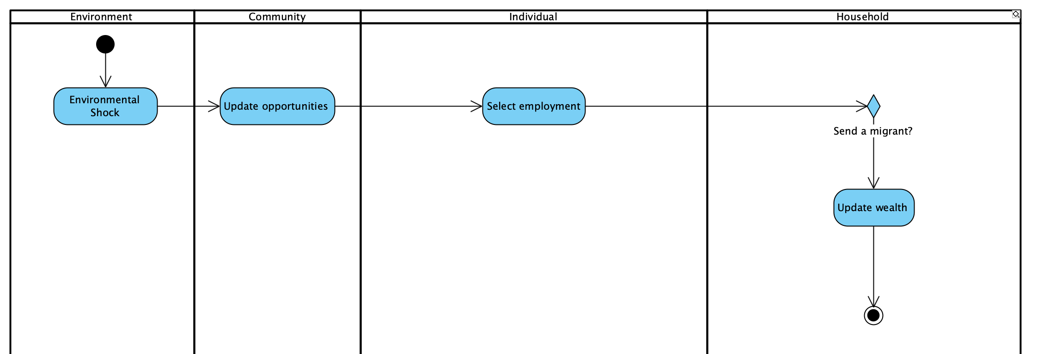

Sequence of actions

# Design concepts

### Basic Principles

This model is based on the literature on environmental migration, which describes both push and pull factors as being important in migration decisions, as well as the importance of social networks. The ABM is used to attempt to reproduce patterns of migration in response to flooding and drought-induced crop failure in rural Bangladesh (Gray & Mueller, 2012). Three key patterns that are identified in this work are:

* As the proportion of a community impacted by crop loss increases, rates of migration also increase, especially above a threshold of approximately 20% of community households impacted. Therefore, community-level impacts are important for household migration, and a critical threshold may exist.
* Households that are directly impacted by crop loss are less likely to migrate, suggesting that a barrier exists to migrating for more vulnerable households.
* Wealthier households are more likely to migrate.

The decision-making elements of the model are based on behavioral theories including Theory of Planned Behavior, Protection Motivation Theory, and Motivation Potential.

### Emergence

Emergence will arise in the form of how rates of migration change throughout the model run. When specific destination locations are included, emergence could also provide insights into where migrants will move and future populations in each destination and origin community. It is also possible that comparisons across networks of agents will show that certain networks are more mobile than others, which will be evident by comparing migration histories.

### Adaptation

Individuals and households adapt to changes in their environment by changing their livelihood choices as opportunities in the community change. In later versions of the model, households may also adapt by updating their beliefs about migration based on past experiences or experiences of other households within their networks, which in turn impacts their likelihood of making a migration trip. Sending a migrant is, of course, another adaptation that households can make.

### Objectives

Agents evaluate an objective based on the decision-making method to maximize utility, minimize risk, or a combination.

### Learning

Agents will learn both from their own experiences as well as the experiences of agents in their network.

### Prediction

Agents do not make predictions about the future, but they may consider risks associated with a decision based on own histories or histories of other agents in their network.

### Sensing

Agents are able to sense all of their own traits and the traits in their current community. They are also able to assess migration histories of agents in their social network.

### Interaction

Households interact by sharing information about their migration histories and wealth histories with other households within their network. Household agents can give and receive information within their network and make decisions based on this information. Households can also transfer resources in the form of remittances across their networks.

### Stochasticity

Stochasticity may be included in the initialization of the model in terms of agent traits and social network connects. Stochasticity is also present in the implementation of environmental shock risk at each step. Stochasticity will be incorporated to determine whether or not a migration trip was successful, based on a probability of failure.

### Collectives

Households connected by social networks can share information about their migration experiences with one-another. They can also share resources.

### Observation

The model records all household migration histories, histories of environmental impact, and tracks wealth over time. On the larger level, the model will also track populations in origin and destination communities over time, total migrations, and the evolution of wealth in the community.

# Details

## Initialization

Currently, the model is initialized with a number of ticks for the model to run, number of individual agents, number of household agents, a decision method to be used, and a migration utility. Agent (household and individual) traits can be randomly initialized based on a parameterization from BEMS data.

## Input data

None.

## Submodels

### Model level functions

### Household class functions

* gather_members Households collect individuals to be in their household. They randomly select the number of individuals given by hh_size from the individual set.
* assign_head Households assign head of household to the oldest male member of the household. If there are no male members, then the oldest female is assigned as head of household.
* check_land Ask households to check to see if their land has been impacted in the case of an environmental shock. If a household’s land is impacted, then their wealth experiences a stochastic decrease, and their land productivity goes to zero.
* migrate Households select a potential migrant from their set of individual household members who are eligible to migrate. Households may then decide, based on the decision method to send a migrant by calling the decision class. If the household does decide to send an individual migrant, then someone_migrated is increased by 1, and the individual no longer participates in the model beyond contributing to household wealth.
* sum_utility The household sums the total utility across all individuals. This is done by asking each individual in the household what his/her salary is, and summing them for the household. Here, the household also checks if it is secure or not (above poverty threshold), based on the total earnings.
* hire_employees If a household’s land has not been impacted, then it updates the number of employees that it can hire based on its land owned and its wtp. Household updates its wtp and wta. wtp is calculated as the household’s land_productivity / (num_employees + 1). wta is calculated as the household’s wellbeing_threshold / hh_size.
* update_wealth At the end of each tick, all households update wealth by summing across the employment of individuals within the household (or migrants that have successfully migrated). Updated wealth is calculated as:

$$Wealth=PreviousWealth+AllSalaries+LandProductivity−Expenses−PaymentsToEmployees$$

### Individual class functions

* age_up Individuals increase their age by 1 after each tick.
* check_eligibility Individuals check to see if they are eligible to migrate (currently, only male individuals older than 14 years old are eligible).
* find_work Each individual will look for work within the community. Individuals with a large amount of land (representing large land owners) may work in agriculture on their own land. If an individual is not part of a household with enough of its own land (small land owners or landless), the individual may seek agricultural employment with another household by entering the internal. labor market. If wtp > wta, then the individual may gain employment with another household. If supply is not greater than demand, then the agent does not find work in agriculture with another household. Individuals who are unable to obtain employment in the labor market may also attempt to seek non-agricultural employment by checking the avail_jobs within the community. There are a specified number of jobs tha are “skilled” and pay more than “unskilled” non-agricultural jobs.

### Community class functions

* shock Probabilistically experience a drought year based on the annual risk. If a drought occurs, then community work opportunities will be updated based on a decline in the utility of agriculture.

### Decision class functions

* decide This part of the model will implement the decision method for households to decide whether or not to send a migrant. If the decision conditions are achieved, then outcome is updated to True. + utility_max - simple utility maximization + push_threshold - utility maximization, plus households that are not secure but have sufficient wealth to migrate will send a migrant, representing a last resort option.

### Model level functions

* double_auction Individuals who are looking for employment and households that are looking for employees can enter the double auction. Individuals will look for households whose wtp is greater than their wta. If they find such a household, their salary will be set as the average between wtp and wta, and their employer will set to that household id. The individual’s id will be appended to the household’s employer list. The double auction will run for a specified number of rounds or until there are no longer any individuals looking for work or households looking to hire. Individuals who are unable to find employment within the double auction may attempt to take a lower paying, non-agricultural job if there are avail_jobs within the community.