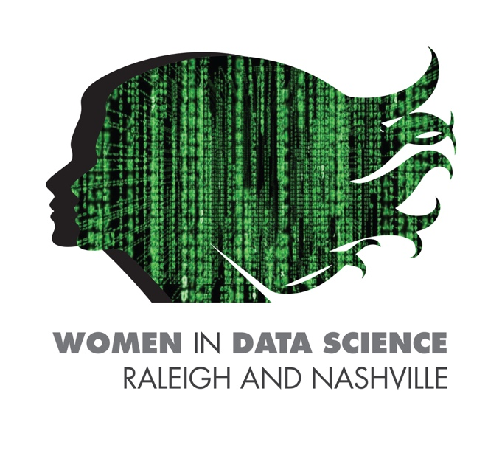

Data Science in Coupled Human and Natural Systems

April 22, 2021

10:00 am - 12:00 pm ET

**AGENDA**

|  |  |
| --- | --- |
| 10:00 | WELCOME & OPENING REMARKS  Kelsea Best, Doctoral Candidate, Vanderbilt University  Zeynab Jouzi, Doctoral Candidate, North Carolina State University |
| 10:10 | Data Science in Human and Natural Systems: From Data Collection to Visualization  Zeynab Jouzi, Doctoral Candidate, North Carolina State University  Kelsea Best, Doctoral Candidate, Vanderbilt University |
| 10:40 | Undergraduate research presentation  Renae Marshall, Honors Student, University of Colorado, Boulder |
| 10:50 | BREAK |
| 11:00 | KEYNOTE  Data Science: An Enabler of Interdisciplinary Research and Education  Dr. Hiba Baroud, Assistant professor and data scientist, Vanderbilt University |
| 11:45 | Q and A? |
| 11:55 | CLOSING REMARKS  Kelsea Best, Doctoral Candidate, Vanderbilt University |
| 12:00 | END OF SESSION |