

Survival Guide

9th Mongolian Regional Meeting
16-19 October 2009
Kyiv, Ukraine

Powered by BEST Kyiv

www.best-kyiv.org/RM


Location:

We will spend RM working days in the village Dernivka,
which is situated 70 km away from Kyiv in the South-East
direction. The name of the place is “Yuvileynyj”. We are
going there by sub-train all together from Kyiv, so make sure
that you will arrive here before 3 pm to join our “party-train”:)
There will be no internet connection, so please download
everything you need in advance.

Transportation:
Let us know when you arrive and depart. If you’re going
separately, contact organizers, so you can receive more detailed
information about getting to RM location by your own (such as
train-schedule and so on). Write about your travel plans to
anna.lanevska@BEST.eu.org

What to bring with you:
- Passport
- Insurance
- Student card (if you want to visit museums before/after RM)
- Photo-camera + cable
- Stuff for International Evening (read futher)
- Warm clothes (it is going to be cold these days)
- Sleeping bag (if you can survive only in very hot conditions)
- Movie for movie-gala + lbg report
- Some cash
- Yourself and sun from your country ☺

International Evening:
For the IE you need to bring following things:

- Traditional food (there are cooking facilities)
- Drinks
- Original clothes (if you have it)
- National flag
- Would be nice to have popular national songs on USB-stick.
- Prepare dance/song/something cultural

Currency:
In Ukraine we use Hryvnas (UAH).
1 euro ~ 12,3 uah

Contacts:

Main organizer: Anna Shepelenko
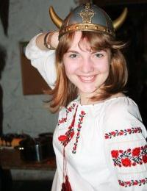
Tel: +380984583449
+380935123888

Regional Advisor: Octav Zlatior
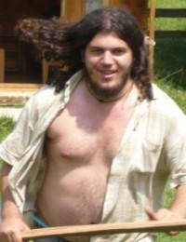
Tel: +380638460698

