**Computer Networks**

**HOMEWORK #4**

**Due date: 2024-05-12**

NOTE: WRITE YOUR ANSWERS IN ENGLISH.

ID#: Name: (Kor.) (Eng.)

**Problem #1:** (20pts) Consider figure below. Assuming TCP Reno is the protocol experiencing the behavior shown above, answer the following questions.

1. Identify the intervals of time when TCP slow start is operating.
2. At the 16th transmission round, is segment loss detected by a triple duplicate ACK or by a timeout?
3. At the 21st transmission round, is segment loss detected by a triple duplicate ACK or by a timeout?
4. What is the initial value of ssthresh at the first transmission round?
5. What is the value of ssthresh at the 18th transmission round?
6. During what transmission round is the 70th segment sent?
7. Assuming a packet loss is detected at the 24th round by the receipt of a triple duplicate ACK, what will be the values of the congestion window size and of ssthresh?
8. Suppose TCP Taho is used (instead of TCP Reno), and assume that triple duplicate ACKs are received at the 16th round. What are the ssthresh and the congestion window size?
9. Again, suppose TCP Taho is used, and there is a timeout event at the 16th round. How many packets have been sent out from the 16th round till the 21st round, inclusive?

**Problem #2:** (15pts)Each of the following addresses belongs to a block. Find the first and the last address in each block

a. 14.12.72.8/24

b. 200.107.16.17/18

c. 70.110.19.17/16

**Problem #3:** (10pts)Consider sending a 2400-byte datagram (including the 20-byte IP header) into a link that has an MTU of 700 bytes. Suppose the original datagram is stamped with the identification number 422. How many fragments are generated? What are the values in the various fields in the IP datagram(s) generated related to fragmentation?

**Problem #4:** (15pts) Create the shortest-path tree and the forwarding table for node B in Figure below.

**(Hint)**

Using Dijkstra’s algorithm. You can either create the tree by drawing the figures step by step or using table to demonstrate steps.

**Problem #5: (40pts) Socket Programming Experience: Simple DNS simulation**

You are going to simulate how DNS servers work as described in the figure below:

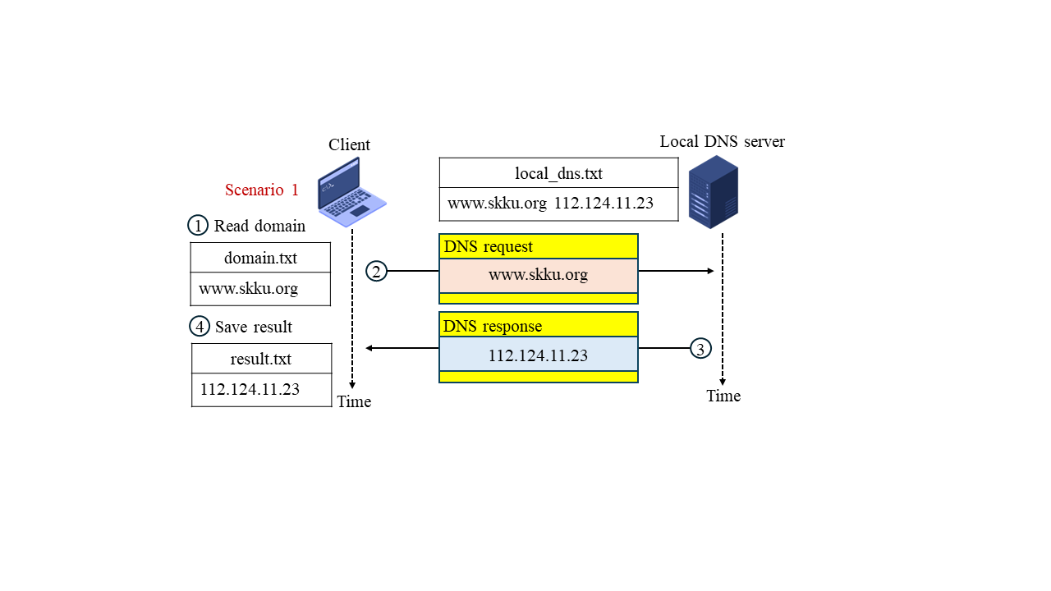

(a) Scenario 1: DNS found in Local DNS server

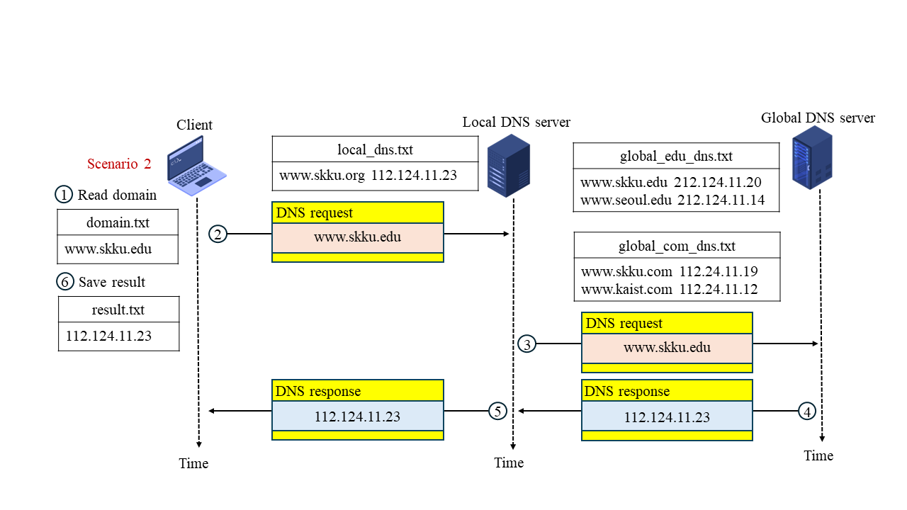

(b) Scenario 2: DNS found in the Global DNS server 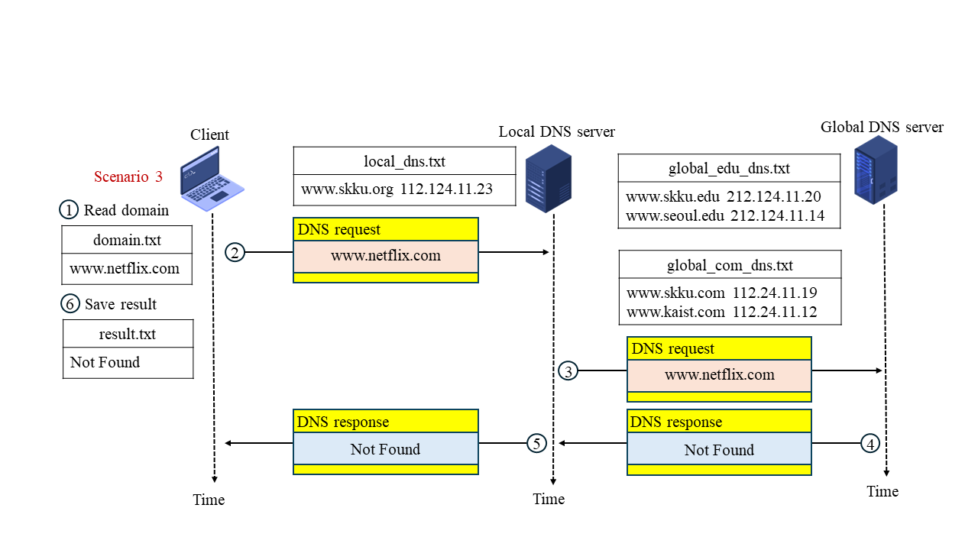

(c) Scenario 3: DNS Not Found in the Global DNS server

As can be seen from the Figure above, there is one client and two DNS servers. When the Client wants to get the IP address of a domain, the following steps are carried out:

1. The Client reads the domain name from **domain.txt** and sends the domain name to the Local DNS server
2. The Local DNS server checks if the domain name is in its database (the text file **local_dns.txt**) or not. If YES, it returns the corresponding IP address of the domain name to the Client (Scenario 1: Fig. a)
3. If the domain name is not in the database of the Local DNS server, it forwards the domain name to the Global DNS and asks for the IP address. At the Global DNS Server, it searches the IP address of the given domain name in two text files **global_edu_dns.txt** and **global_com_dns.txt,** andreturns the corresponding IP address (Scenario 1: Fig. b).
4. If there is no matching domain name, it returns the message “Not found” to the Local DNS server (Scenario 1: Fig. c)
5. After receiving the result from the Global DNS Server, the Local DNS Server forwards the data to the Client
6. The Client writes the result to the text file **result.txt**

**Task:** Your task is using Socket programming with TCP/IP and UDP protocols to:

* 1. Develop the Client
  2. Develop the Local DNS Server which is listening for incoming connections at port 8000
  3. Develop the Global DNS Server which is listening for incoming connections at port 9000
  4. The Client communicates with the Local DNS Server by UDP protocol
  5. The Local DNS Server communicates with the Global DNS Server by TCP/IP protocol
  6. All Client, Local DNS Server, and Global DNS Server run on localhost address (127.0.0.1)

**Input:** The domain name is read from the text file **domain.txt**. The Client program reads the domain name from this text file and sends it to the Local DNS Server (server program). At a time, the client can send only one domain name. The **domain.txt** file is as follows:

|  |  |
| --- | --- |
|  | **domain.txt** |
| Scenario 1 | [www.skku.org](http://www.skku.org) |
| Scenario 2 | [www.skku.edu](http://www.skku.edu) |
| Scenario 3 | [www.netflix.com](http://www.netflix.com) |

The database of the Local DNS server and Global DNS servers is a text file with multiple lines. One line has two parts: domain name and IP address **which are separated by a space**. Examples of the databases are as follows:

|  |  |  |
| --- | --- | --- |
| **local_dns.txt** | **global_edu_dns.txt** | **global_com_dns.txt** |
| [www.skku.org](http://www.skku.org) 112.124.11.23 | [www.skku.edu](http://www.skku.edu) 212.124.11.20  [www.seoul.edu](http://www.seoul.edu) 212.124.11.14 | [www.skku.com](http://www.skku.com) 112.24.11.19  [www.kaist.com](http://www.kaist.com) 112.24.11.12 |

**Output:** Whenever the client program receives the result from the Local DNS Server, it saves the result into the text file **result.txt**. An example of the **result.txt** file is as follows:

|  |  |
| --- | --- |
|  | **result.txt** |
| Scenario 1 | 112.124.11.23 |
| Scenario 2 | 212.124.11.20 |
| Scenario 3 | Not Found |

**What to hand in:**

* **Completed client, local, and global codes** (Write in report).
* **Screenshots:** of all scenarios you have tested(Write in report).
* **Your implemented source codes** (Attach your source codes files).
* **The command line: HOW TO RUN your applications** (Write in the report or comment in your codes).

--------------------------------------------------------------------------------------------------------

**Submission guidelines:**

* You must submit a compressed file named **CN24-HW4-ID-NAME.zip** through i-Campus.

For example: **CN24-HW4-2024970211-Park Chaeyoung.zip** where 2024970211 is student ID and Park Chaeyoung is student NAME

* Your solution must be written in **ENGLISH**. Solutions written in Korean will NOT be graded.
* You must use the .doc template provided on i-Campus.

There will be serious penalties for students who copy each other.