FreeRTOS eZ80F91 Acclaim! Port - Copyright (C) 2016 by NadiSoft All rights reserved

This file is part of the FreeRTOS port for ZiLOG's EZ80F91 Module.
Copyright (C) 2016 by Juergen Sievers <JSievers@NadiSoft.de>
The Port was made and rudimentary tested on ZiLOG's
EZ80F910300ZCOG Developer Kit using ZDSII Acclaim 5.2.1 Developer
Environmen and comes WITHOUT ANY WARRANTY to you!

Developer:
SIE Juergen Sievers <JSievers@NadiSoft.de>

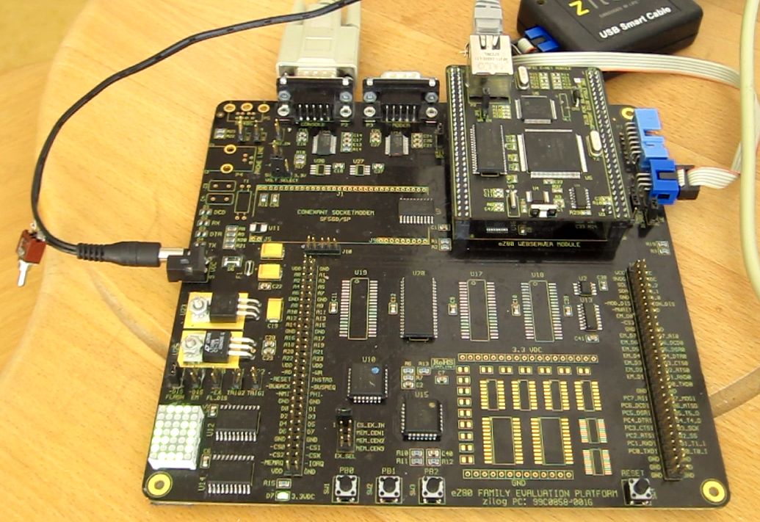
Directories:

+ FreeRTOS/source contains the FreeRTOS real time kernel source code.
+ FreeRTOS/Source/portable/ZDS II/eZ80 contains the EZ80F91 port code.
+ FreeRTOS-Plus/Source/FreeRTOS-Plus-TCP/portable/Compiler/ZDSII_eZ80Acclaim!_5.2.1 contains ZDS II compiler specifics.
+ FreeRTOS-Plus/Source/FreeRTOS-Plus-TCP/portable/NetworkInterface/eZ80F91 contains EMAC Device Driver
+ FreeRTOS/demo contains a pre-configured demo project for my Demo Application running on ZiLOG's EZ80F910300ZCOG Developer Kit using ZDS II Acclaim 5.2.1 Developer Environment

+ See http://www.freertos.org/a00017.html for full details of the FreeRTOS
directory structure and information on locating the files you require.

+ FreeRTOS-Plus contains additional FreeRTOS components and third party
complementary products. THESE ARE LICENSED SEPARATELY FROM FreeRTOS although
all contain open source options. See the license files in each respective
directory for information.

+ FreeRTOS-Plus/Demo contains pre-configured demo projects for the FreeRTOS-Plus
components. Most demo projects run in a Windows environment using the
FreeRTOS windows simulator. These are documented on the FreeRTOS web site
http://www.FreeRTOS.org/plus

Further readme files are contains in sub-directories as appropriate.

The easiest way to use FreeRTOS is to start with one of the pre-configured demo
application projects (found in the FreeRTOS/Demo directory). That way you will
have the correct FreeRTOS source files included, and the correct include paths
configured. Once a demo application is building and executing you can remove
the demo application file, and start to add in your own application source
files.

See also -
http://www.freertos.org/FreeRTOS-quick-start-guide.html
http://www.freertos.org/FAQHelp.html

Prepare to build and use this port.
You need ZiLOG's EZ80F910300ZCOG Developer Kit or equivalents.
Additional ZiLOG's ZDSII Acclaim 5.2.1 Developer Environment. Free download from www.zilog.com

Now lets go:

This Demo is based on FreeRTOS V9.0.0rc2. Some files were modified, because ZiLOG's Dev-Environment isn't able to compile FreeRTOS as it is.

The Project are located at “Z:\ZDSII_eZ80Acclaim!_5.2.1\FreeRTOS_V9.0.0rc2” if you install the project on different location you must change the ZDS II Project file too.

Start the ZDSII eZ80Acclaim! IDE an load the project file at Z:\ZDSII_eZ80Acclaim!_5.2.1\FreeRTOS_V9.0.0rc2\FreeRTOS\Demo\ZDSII_eZ80F91\EZ80F91_PortDemo.zdsproj

There are two configuration included. Debug-Ram and Debug-Flash. Select Debug-Ram to let the IDE map System-Ram to the start area downloading and running the code on Ram (Debugger only). For stand alone system use Debug-Flash.

Debug-Ram settings

RANGE ROM $0 : $07FFFF ; mapped RAM
RANGE RAM $B7E000 : $BFFFFF
RANGE EXTIO $0 : $FFFF
RANGE INTIO $0 : $FF

CHANGE STRSECT is ROM

ORDER .RESET,.IVECTS,.STARTUP,CODE,DATA
COPY DATA ROM

DEFINE __CS0_LBR_INIT_PARAM = $10
DEFINE __CS0_UBR_INIT_PARAM = $1f
DEFINE __CS0_CTL_INIT_PARAM = $a0
DEFINE __CS0_BMC_INIT_PARAM = $02
DEFINE __CS1_LBR_INIT_PARAM = $00
DEFINE __CS1_UBR_INIT_PARAM = $07
DEFINE __CS1_CTL_INIT_PARAM = $28
DEFINE __CS1_BMC_INIT_PARAM = $02
DEFINE __CS2_LBR_INIT_PARAM = $b8
DEFINE __CS2_UBR_INIT_PARAM = $bf
DEFINE __CS2_CTL_INIT_PARAM = $28
DEFINE __CS2_BMC_INIT_PARAM = $02
DEFINE __CS3_LBR_INIT_PARAM = $00
DEFINE __CS3_UBR_INIT_PARAM = $00
DEFINE __CS3_CTL_INIT_PARAM = $00
DEFINE __CS3_BMC_INIT_PARAM = $02
DEFINE __RAM_CTL_INIT_PARAM = $C0
DEFINE __RAM_ADDR_U_INIT_PARAM = $B7
DEFINE __FLASH_CTL_INIT_PARAM = $60
DEFINE __FLASH_ADDR_U_INIT_PARAM = $00

define _SYS_CLK_FREQ = 5000000000

Debug-Flash settings

RANGE ROM $0 : $03FFFF, $100000 : $1FFFFF
RANGE RAM $B7E000 : $C7ffff
RANGE EXTIO $0 : $FFFF
RANGE INTIO $0 : $FF

DEFINE __CS0_LBR_INIT_PARAM = $10
DEFINE __CS0_UBR_INIT_PARAM = $1f
DEFINE __CS0_CTL_INIT_PARAM = $a8
DEFINE __CS0_BMC_INIT_PARAM = $02
DEFINE __CS1_LBR_INIT_PARAM = $c0
DEFINE __CS1_UBR_INIT_PARAM = $c7
DEFINE __CS1_CTL_INIT_PARAM = $28
DEFINE __CS1_BMC_INIT_PARAM = $02
DEFINE __CS2_LBR_INIT_PARAM = $B8
DEFINE __CS2_UBR_INIT_PARAM = $bf
DEFINE __CS2_CTL_INIT_PARAM = $28
DEFINE __CS2_BMC_INIT_PARAM = $02
DEFINE __CS3_LBR_INIT_PARAM = $00
DEFINE __CS3_UBR_INIT_PARAM = $00
DEFINE __CS3_CTL_INIT_PARAM = $00
DEFINE __CS3_BMC_INIT_PARAM = $02
DEFINE __RAM_CTL_INIT_PARAM = $C0
DEFINE __RAM_ADDR_U_INIT_PARAM = $B7
DEFINE __FLASH_CTL_INIT_PARAM = $68
DEFINE __FLASH_ADDR_U_INIT_PARAM = $00
define _SYS_CLK_FREQ = 50000000

Compile and download the Project. I use the USBSmartCable. If you use a different debugger don't forget to change the configuration.
To see the System-Monitor output connect a terminal (PuTTY) to UART 0 (CONSOLE)
Set the terminal to 115200,8,n,1 (RTS/CTS). The System-Monitor uses ANSI-Codes for decorations. So set your terminal-emulation to understand ANSI on 132 columns 42 rows. You may also connect by raw-telnet on port 5010 to one small CLI thread.

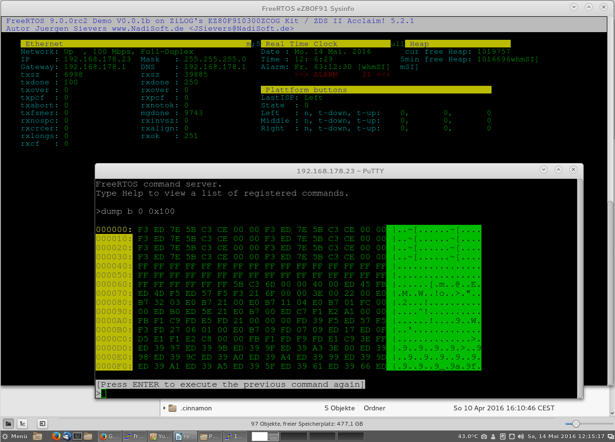

SIE 160526 add FreeRTOS trace
To use trace facility set configINCLUDE_TRACE_FACILITY to 1 on FreeRTOSConfig.h
To douwnload the trace-data start the CLI console (telnet target-ip 5010) and
enter “ihex trace”
The CLI command dumps the trace-data in intel-hex format to the telnet-client.
=~=~=~=~=~=~=~=~=~=~=~= PuTTY log 2016.05.26 21:34:46 =~=~=~=~=~=~=~=~=~=~=~=
FreeRTOS command server.
Type Help to view a list of registered commands.

>ihex trace

# Tracebuffer B7FB8E-B8139E
:0200000400B743
:10FB8E000102030471727374F1F2F3F4A11A04000A
:10FB9E00101800009B070100E8030000FB010000A5
:10FBAE0001000000F401000098010000A25F8B41EB
:10FBBE000100000000000000000000000000000036
…
:10137000C7060703410402085E170608B1035005BB
:10138000EA035005E203A800030088017061000031
:0E13900000000A0B0C0D71727374F1F2F3F48D
:00000001FF

[Press ENTER to execute the previous command again]
>

Save the captured data to an file file.ihex.
On the linux shell enter

srec_cat -Output <file>.bin -Binary <file>.ihex -Intel -offset -<offset>

( replace <file> by the file name the dump has been saved and <offset>
by the first value shown on the first dumped line B7FB8E. See above
# Tracebuffer B7FB8E-B8139E)

After that conversion you can load the <file>.bin on the trace viewer.
See Tracealyzer Trace Recorder Library
-------------------------------------
Percepio AB
www.percepio.com
for more information about this viewer.

Have fun. Hints are welcome, join the project - if you like.

Regrads
Jürgen

