NAVIO EV Trip Planner Platform
  - Project Report
Chapters 1 to 5
Group 14
School of Information Technology
King Mongkut’s University of Technology Thonburi
October 2026

Contents
Chapter 1 Introduction 1
1.1 Background Information 1
1.2 Objectives 2
1.3 Scope 2
1.4 Expected Benefits 4
Chapter 2 Feasibility Study 5
2.1 Introduction 5
2.2 Problem Statement 5
2.3 Related Research and Projects 6
2.4 Requirement Specifications 8
2.5 Implementation Techniques and Feasibility 9
2.6 Implementation Plan 11
Chapter 3 System Analysis and Design 12
3.1 Analysis of the Existing Workflow 12
3.2 User Requirement Analysis 13
3.3 Navigation and Interaction Design 13
3.4 System Architecture 14
3.5 Data Design 15
3.6 Principal Data Flows 17
3.7 Canonical Energy and Battery State 18
3.8 Security and Data Integrity 20
Chapter 4 System Functionality and Evaluation 21
4.1 System Functionality 21
4.2 Implementation Structure 23
4.3 Test Plan 23
4.4 Available Verification Results 25
4.5 Evaluation Limitations and Outstanding Work 26
Chapter 5 Summary and Suggestions 28
5.1 Project Summary 28
5.2 Problems Encountered and Solutions 28
5.3 Suggestions for Further Development 30
References 32

Chapter 1 Introduction

1.1 Background Information
Planning a road trip requires a traveller to coordinate destinations, travel times, accommodation and activities across several days. An electric vehicle introduces additional considerations, including the battery level at departure, the distance between stops, compatible charging connectors and the time required to recharge. The International Energy Agency identifies vehicle deployment and charging infrastructure as related elements of the transition to electric mobility [1]. For an individual journey, however, the existence of charging infrastructure does not by itself establish that a particular itinerary is practical.
Travellers can use mapping applications to inspect routes, itinerary applications to organise activities, charging applications to locate stations, and community discussions to obtain advice. These tools have useful capabilities, but a traveller may still need to transfer information between them. For example, moving an attraction to a different day can change driving distance and the charging stops required later in the trip. A planning interface should therefore connect itinerary changes with their implications for the selected vehicle.
NAVIO is a web-based EV trip planner platform with an initial emphasis on travel in Thailand. It brings itinerary organisation, EV-related planning, shared travel plans and community discussions into one workflow. The planner remains useful for organising an ordinary trip, while vehicle selection enables additional battery and charging information. Explore provides a separate entry point for discovering publicly shared itineraries and copying a suitable plan for personal customisation.
The project treats an energy prediction as a planning estimate rather than a guarantee of the battery level that will occur on the road. Vehicle data may have different measurement bases, while traffic, driving behaviour and operating conditions can affect actual consumption. Similarly, a listed charging station is not a reservation or a guarantee of service. NAVIO consequently distinguishes known specifications, estimated values, user observations and unavailable information. This distinction is important both for presenting useful information and for avoiding misleading confidence in an incomplete prediction.

1.2 Objectives
The primary objective is to design and develop a web application that combines structured trip planning with EV charging considerations and reusable travel information. The specific objectives are as follows.
1. To provide a day-by-day planner for creating, editing and organising destinations, stops, notes and related trip information, with route visualisation and distance and duration estimates.
2. To integrate vehicle selection, charging-station discovery, connector compatibility, battery-state estimation and charging-stop planning into the itinerary workflow.
3. To provide Explore functionality through which users can publish selected trip information, browse shared plans and create independent personal copies.
4. To provide a community forum for travel discussions, EV experiences and conversations associated with shared plans.
5. To evaluate the correctness of the implemented workflows through software testing, and to define further user and route-based evaluation needed to assess practical usefulness.
AI Assistance is a conditional supporting feature. If time remains after the main features are stable, it may assist with itinerary drafts or suggestions while leaving the traveller in control of changes. Completion of the main objectives does not depend on implementing AI Assistance.

1.3 Scope

1.3.1 Main Features
The project comprises four main feature areas: the Base Planner System, EV Integration, Explore and Community Forum. Account management, data persistence and operational infrastructure support these areas rather than constituting separate user-facing main features.
The Base Planner System covers creating trips, specifying dates and destinations, arranging day-by-day stops, modifying their order, attaching planning information and displaying routes on a map. It supports saved account trips and a guest planning experience. Notes, checklists, expenses and map export support itinerary organisation where available in the implemented workflow.
EV Integration covers catalogue and custom vehicle selection, trip-specific vehicle membership, charging-station discovery, compatibility filtering, manual charger insertion and energy-aware charging-stop planning. It also covers a starting battery level for the trip, predicted battery propagation and optional actual battery observations at itinerary stops. Automatic planning is subject to available route and vehicle data and the eligibility rules of the selected energy model.
Explore covers publication of travel plans, public browsing, viewing a shared itinerary and creating a personal copy. Publication is separate from editing the owner's private trip. The receiving user can customise a copy without changing the original. Search and discovery functions should operate on the available shared-plan dataset; they do not imply that every travel destination has a prepared plan.
Community Forum covers browsing discussions and groups and, for authenticated users, creating posts, commenting and participating in supported community interactions. Shared plans can provide context for related discussions. Community content represents user contributions and should not be presented as independently verified charging-station telemetry.

1.3.2 Supporting and Conditional Features
Authentication and ownership controls protect private trips, personal vehicle lists and account operations. Guests may browse public information and use temporary planning facilities, but account persistence and authenticated contributions require sign-in. Reusable custom vehicle definitions belong to the user's personal list, while the vehicles shown in a trip's garage belong to that trip.
AI Assistance is a supporting feature considered only after the main system is stable and sufficient development time remains. A separate place-recommendation experience within Explore is also a possible extension. Neither capability is treated as part of the completed implementation described in this report.

1.3.3 Boundaries
The deliverable is a browser-based application rather than a native mobile application. Thailand is the primary project context, although the location model and external map providers can represent destinations in other countries. Availability of vehicle and charging data may differ between locations.
Automated content moderation, user-report adjudication and automatic replacement of reported plans are outside the current feature scope. Basic access control and administration remain necessary for operating the application. Charging payments, charger reservations, control of physical charging equipment, continuous vehicle telemetry and guaranteed live charger availability are not provided by the planner.
The project does not claim a globally optimal route, experimentally validated battery accuracy or measured reductions in travel cost or anxiety. Such claims require an evaluation beyond implementation tests. Weather-aware prediction, learned consumption calibration and detailed battery charging curves are not assumed in the present nominal model.

1.4 Expected Benefits
NAVIO is intended to reduce the effort required to organise itinerary and EV information in separate tools. A traveller can inspect planned activities and the associated route while considering where compatible charging may be needed. Reusable shared plans can reduce repeated itinerary entry, and an independent copy allows the traveller to adapt an example to different dates or preferences.
Vehicle-specific inputs and explicit handling of missing data are expected to make estimates easier to interpret. A traveller can distinguish an authoritative specification from a provisional range-based estimate and can supply an observed battery level without changing the underlying vehicle definition. Community discussions provide an additional channel for experience and advice.
For the project team, the application demonstrates integration of a stateful web interface, service APIs, relational persistence, geospatial providers and access control. These are expected benefits of the design. Their effect on usability and travel outcomes should be measured through the evaluation described in Chapter 4.

Chapter 2 Feasibility Study

2.1 Introduction
This chapter examines the problem addressed by NAVIO, relevant applications, system requirements and the feasibility of the chosen implementation approach. The project follows an iterative development strategy: establish a functioning planner, integrate the main feature areas, validate their interactions, and consider conditional extensions only after the core workflows are stable.
The feasibility assessment recognises two different questions. Technical feasibility concerns whether the application can retrieve data, maintain trips and calculate consistent estimates. Practical validity concerns whether those estimates and workflows are sufficiently useful under real travel conditions. Software tests provide evidence for the first question, but cannot alone answer the second.

2.2 Problem Statement

2.2.1 Coordination of Itinerary and Charging Information
A multi-day itinerary is more than a route between two coordinates. It includes the order of visits, daily start and end locations, saved alternatives and optional planning notes. A change to one stop can affect the distance to subsequent stops. When charging decisions are made in a separate application, the traveller must reconcile those changes manually.
NAVIO addresses this coordination problem by associating route and vehicle information with the itinerary. The purpose is not to replace every navigation or charging-operator application. Instead, the project provides a planning workspace in which the user can consider activities and charging together before using an appropriate navigation or operator service during travel.

2.2.2 Incomplete and Unequal Vehicle Data
Available vehicle information may include rated range, declared battery capacity, connector types and charging power, but not a suitable direct consumption specification. A declared battery capacity is not necessarily usable capacity. Likewise, a rated-range test standard does not establish the measurement standard of a separate consumption figure.
Treating all such inputs as interchangeable would conceal uncertainty. The system therefore requires a data contract that records provenance and selects an explicit energy model. An unavailable input should lead to a limited or unavailable result, rather than an apparently precise number based on an undocumented assumption.

2.2.3 Charging and Shared Information Limitations
Charger location, connector compatibility and operational availability are different properties. Map-provider data can support station discovery without proving that a connector will be free or working at arrival. User discussions may provide useful context but are not a substitute for verified operator status.
Shared itineraries also need clear ownership and publication boundaries. Editing a private plan should not unexpectedly alter a previously published representation, and copying a plan should not transfer private account data. These requirements make publication and copying more than simple duplication of a database record.

2.3 Related Research and Projects

2.3.1 General Itinerary Planning
Wanderlog provides itinerary organisation, map-based travel planning and route-related information [2]. It is a relevant reference for presenting places, dates and travel details together. Its published product information demonstrates that general itinerary tools already support substantial planning functionality. NAVIO therefore does not claim that itinerary organisation or route planning is new in itself.
The relevant design question is how to combine this style of itinerary interaction with vehicle provenance, chronological battery state and charging-stop decisions. The comparison is based on documented product capabilities rather than an assumption that competing applications have no EV-related functionality.

2.3.2 EV Charging and Route Applications
PugEV's official site describes charging-station discovery, station details, connector information and route-based station browsing in Thailand [3]. These functions are directly relevant to EV travellers. Its published trip-planning capability means it would be inaccurate to describe the application simply as having no trip-planning functions.
Saifah was also considered as an EV-oriented reference during the project's feasibility and design presentations [8]. The project does not rely on an unverified exhaustive comparison of its current feature set. The useful distinction for NAVIO is the intended integration of a multi-day itinerary workspace, reusable shared plans and community context, rather than a claim that EV route applications are merely maps.

2.3.3 Mapping and Place Data
Google Routes provides route computation facilities, while Google Places provides place search and place information [4, 5]. These services support location selection and the calculation of route distance and duration. They are external data sources, not NAVIO's battery model. NAVIO must combine route results with the selected vehicle model and maintain its own itinerary state.
Provider responses may be incomplete or unavailable, so the application must distinguish a routed distance from a fallback approximation. A straight-line distance may help display incomplete information, but must not be silently treated as equivalent evidence for a road-based reachability decision.

2.3.4 Position of NAVIO
NAVIO combines four related workflows: constructing an itinerary, considering EV constraints, discovering reusable plans and discussing travel information. The contribution is this integrated workflow and its handling of vehicle and trip state. The project does not claim that no other platform combines any of these capabilities, or that its estimates are more accurate without comparative evaluation.
Table 2.1 summarises the design references. It is a qualitative comparison of the capabilities relevant to this project, not a benchmark of all features or current commercial performance.
Table 2.1 Related systems and their relevance
Reference | Relevant documented capability | Relevance to NAVIO
Wanderlog | Itinerary organisation, maps and route-related planning | Day-based itinerary presentation and organisation
PugEV | Charger discovery, connector details and stations along a route | EV data presentation and charging discovery
Google Routes and Places | Route computation, place search and place details | External route and location data
NAVIO | Integrated planner, EV model, Explore and community | Project implementation and evaluation subject

2.4 Requirement Specifications

2.4.1 Functional Requirements
The functional requirements describe observable behaviour rather than particular interface layouts. Table 2.2 groups them by the main workflows. Conditional enhancements are separated from the core requirements so that an unfinished optional feature does not obscure evaluation of the base system.
Table 2.2 Core functional requirements
ID | Requirement
FR01 | Allow public browsing and temporary guest planning while protecting account operations.
FR02 | Create and edit a trip with dates, destinations and day-based itinerary blocks.
FR03 | Add, reorder and remove stops and supporting notes or checklist items.
FR04 | Display route geometry and available distance and duration information.
FR05 | Select a catalogue or custom EV and maintain trip-specific garage membership.
FR06 | Preserve vehicle energy provenance and explicit default, range or custom selection.
FR07 | Propagate battery state from the trip start through stops and days, including observations.
FR08 | Discover chargers, inspect available specifications and insert a chosen station.
FR09 | Preview and apply eligible charging-stop changes with version and feasibility checks.
FR10 | Publish a controlled public plan representation and create independent personal copies.
FR11 | Browse community content and support authenticated posts, comments and interactions.
FR12 | Preserve saved trip state and prevent access to another user's private resources.

AI-generated itinerary assistance and an additional place-recommendation mode in Explore are conditional enhancements. If implemented, their outputs must remain editable and must not bypass ownership, route validation or energy-model rules.

2.4.2 Nonfunctional Requirements
The application should remain understandable when data is missing. Unavailable route, energy or charging values must be distinguishable from zero. Validation should reject invalid battery percentages and malformed requests, while failed persistence should not be presented as successful saving.
Security requirements include authenticated writes, resource ownership checks and a restricted public read surface. Catalogue browsing and published plans can be public without exposing a personal garage or private itinerary. Secrets belong in server-side configuration rather than browser-delivered code.
The interface should support desktop and narrow browser layouts, readable contrast, keyboard access and clear form labels. Performance evaluation should record response time and failure rate under a stated environment and workload. The report does not assert a concurrency capacity or response-time guarantee that has not been measured.
Maintainability requires consistent API contracts, automated tests, schema migrations and clear service responsibilities. Operational requirements include deployment checks, health monitoring and a recovery process. A microservice boundary is useful only if its communication and persistence responsibilities remain understandable.

2.5 Implementation Techniques and Feasibility

2.5.1 Frontend and Backend
The client uses Next.js, React and TypeScript. Jotai manages client-side planner state, TanStack Query handles API-backed data, and Zod validates data structures. The current implementation uses Google Maps by default and retains a configurable Mapbox rendering alternative. This differs from treating Mapbox or NOSTRA as the sole deployed mapping solution.
The backend consists of four domain services implemented with Java 25 and Spring Boot 4: User Management, Trip Planning, Mobility and EV, and Community. Spring Cloud Gateway routes API traffic; Config Server and Eureka support configuration and discovery. NGINX serves as the production edge proxy. The separation allows domain-specific code and tests, although it also introduces configuration, deployment and compatibility overhead.

2.5.2 Identity and Storage
Keycloak is the identity provider, with Auth.js supporting the web authentication flow. JWT-based identity is validated at the relevant backend boundary and combined with service-level ownership checks. NAVIO does not use Clerk as its current identity architecture [6, 9].
PostgreSQL, with PostGIS available for geospatial use, provides relational storage. The deployed arrangement uses service-owned schemas within the database environment, rather than requiring a physically separate database server for every service. Flyway manages schema changes. JSONB is used selectively for structured metadata, including vehicle energy provenance and trip snapshots, while relational records represent the principal trip and community entities.
Community media uses an object-storage abstraction with S3-compatible configuration. The report does not assume that MinIO is a separately deployed component. Kafka supports configured asynchronous integration facilities; synchronous itinerary requests still use service APIs and are not all processed as events.

2.5.3 Operational and Economic Feasibility
Docker Compose and GitHub Actions support repeatable packaging and deployment to the project environment. The configuration includes health checks and observability components such as Prometheus, Grafana, Loki, Alloy and Zipkin. These tools assist diagnosis but do not remove the need for service-level validation.
The main costs and constraints are external map requests, infrastructure resources, maintenance effort and the team's time. A conditional AI feature would add model-provider or inference costs. The development plan therefore prioritises a stable main system and treats optional enhancements separately. No fixed operating-cost estimate is claimed without measured traffic and the applicable provider pricing.

2.6 Implementation Plan
The work is organised around deliverables and their dependencies. Table 2.3 presents the sequence used to coordinate the remaining project work. Detailed calendar dates are maintained in the team's project schedule rather than inferred from implementation phases.
Table 2.3 Implementation work packages
Work package | Main output | Completion criterion
Requirements and design | Scope, workflows and service/data boundaries | Main requirements and dependencies agreed
Base planner and infrastructure | Authenticated and guest planning foundation | Core itinerary and persistence workflows operate
Main feature integration | EV planning, Explore and Community | APIs and interface behaviour are consistent
Integration and evaluation | Regression, browser and route-based checks | Findings resolved or limitations recorded
Optional supporting work | AI Assistance or additional place discovery | Core remains stable and time permits
Finalisation | Report, presentation and release preparation | Evidence, deployment and documentation reconciled

The implementation is iterative rather than a single pass through these activities. Changes to a shared contract, such as the vehicle model or a planner snapshot, require corresponding API, frontend and persistence checks. The final evaluation should distinguish completed functionality from outstanding validation and from optional extensions.

Chapter 3 System Analysis and Design

3.1 Analysis of the Existing Workflow
A typical planning workflow begins with choosing destinations and dates. The traveller gathers places from map searches, travel information and shared recommendations, then arranges them into an itinerary. For an EV journey, the traveller also selects a vehicle, considers available battery energy and identifies charging opportunities. These decisions influence one another: a longer detour changes both the daily schedule and the battery required to reach the next stop.
Figure 3.1 presents this relationship at a conceptual level. The fragmentation occurs when itinerary information and vehicle-related decisions are maintained independently, so an edit in one tool is not automatically reflected in another. The figure describes the planning problem; it does not imply that all travellers follow an identical process.
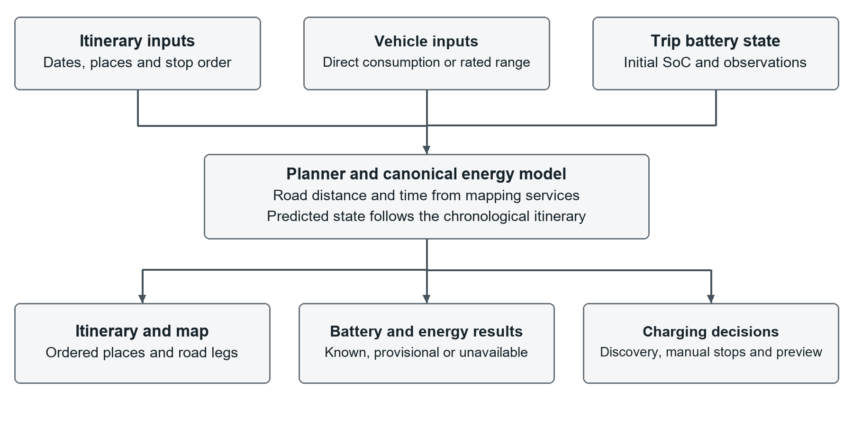
Figure 3.1 Itinerary and EV planning information flow
Existing applications support parts of this workflow effectively. NAVIO's analysis therefore focuses on the coordination points: selecting a place, arranging days, calculating travel legs, applying vehicle assumptions and interpreting shared information. In particular, a charger marker is insufficient evidence for reachability, and a copied itinerary must be recalculated for the receiving traveller's vehicle and starting battery level.

3.2 User Requirement Analysis
The requirements were developed through project design discussions, examination of related applications and iterative implementation review. They represent design requirements, not findings from a completed representative user survey. Claims about user satisfaction or preference require a separate evaluation with a documented method and participants.
Three principal user contexts guide the design. A guest can explore public content and try temporary planning. An authenticated traveller can preserve personal trips, reuse custom vehicles and contribute content. An authorised operator can maintain system resources such as the vehicle catalogue. Public-content browsing should not require access to private user data, and operational roles should not be confused with an automated content-moderation feature.
Travellers need to understand both the itinerary and the status of the information supporting it. The interface should show whether an energy value is a direct specification, a custom average or a rated-range estimate. When a route result changes after editing a stop, dependent predictions should change consistently. When a value is unavailable, the interface should explain the limitation without substituting a fabricated zero.

3.3 Navigation and Interaction Design
The principal navigation areas are Home, Planner, Explore and Community, with account and appearance settings as supporting areas. Planner combines an itinerary workspace with a map. Vehicle settings and charger discovery are contextual parts of the planning workflow rather than separate applications.
Explore supports a discovery-to-planning path: browse a public plan, inspect its itinerary, then create an independent account-owned copy. Community supports a discussion path: browse a group or post, read comments and, when signed in, contribute. An optional AI interaction would be an extension to planning and should not replace the manual workflow.
The interface follows progressive disclosure. Core trip information remains visible, while detailed vehicle specifications, charger information and secondary actions are available when needed. Narrow layouts must allow users to access the same planning information without clipping controls or forcing unrelated horizontal scrolling. This requirement applies to drawer widths as well as overall browser width.

3.4 System Architecture
Figure 3.2 summarises the implemented service boundaries. The browser communicates through the web and API layers. Keycloak supplies identity, while backend services enforce the rules associated with their own resources. External route and place providers are accessed through the mobility integration rather than being treated as the source of NAVIO's vehicle-energy calculations.
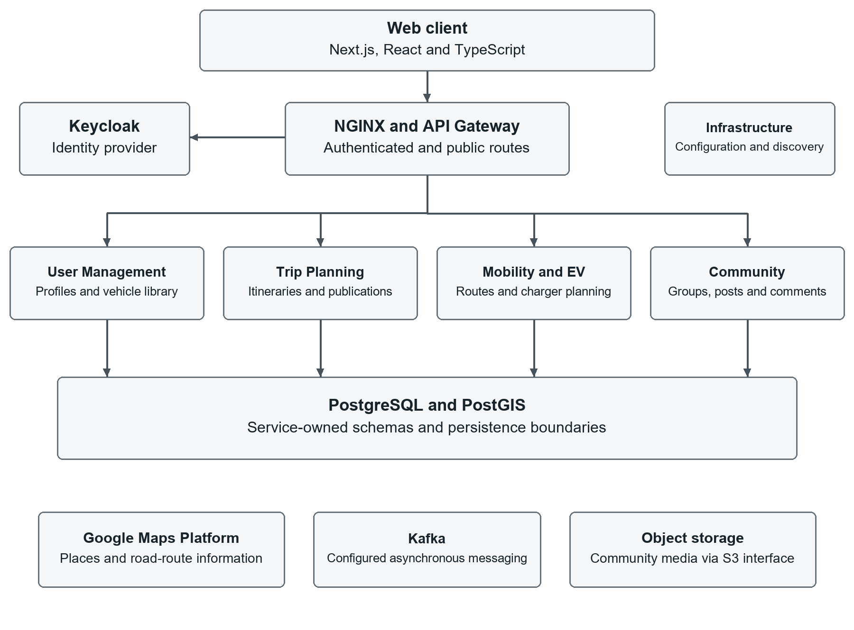
Figure 3.2 NAVIO service architecture
The User Management Service owns user profiles, the reusable personal vehicle list and the vehicle catalogue. The Trip Planning Service owns itinerary persistence, trip battery state, publication and copying. The Mobility and EV Service supplies place and route integration, charger discovery and optimization calculations. The Community Service owns groups, posts, comments, votes and related media facilities.
Gateway, discovery and configuration applications support these four domains. The architecture permits independent service codebases, but the combined application still relies on compatible contracts. A frontend request accepted by one version may be rejected or incompletely interpreted by an older backend; deployment validation must therefore cover the system rather than only individual builds.

3.5 Data Design

3.5.1 Trip and Itinerary Data
The trip schema centres on the trip record. List blocks organise content into itinerary days or saved lists, and block items represent places and other planning content. Supporting records include checklist items, expenses and public-plan publication data. Figure 3.3 shows selected logical relationships relevant to the planner; it is not a complete physical schema.
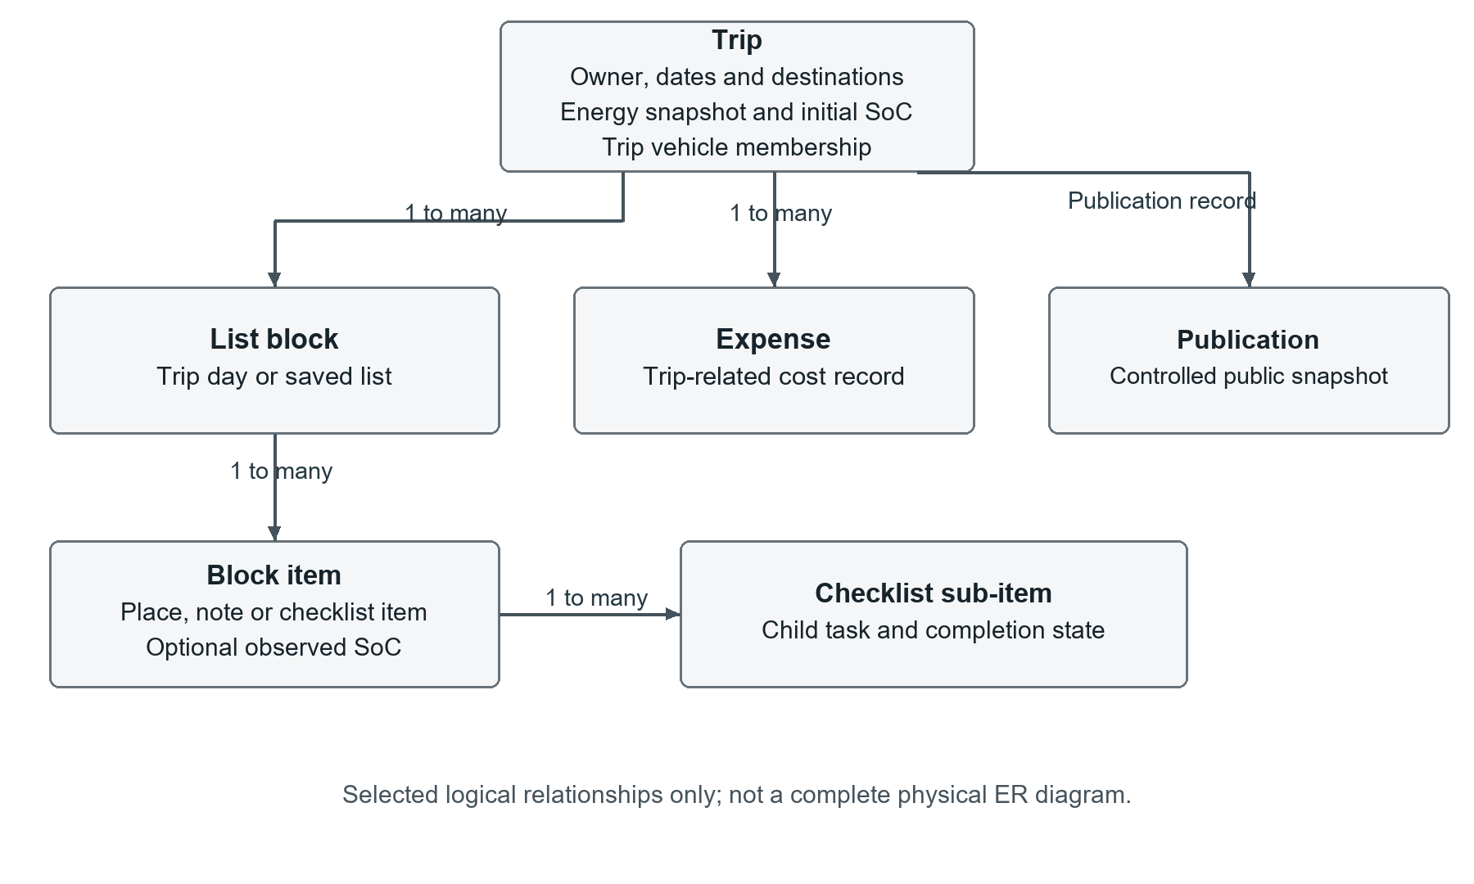
Figure 3.3 Principal trip data relationships
Trip-specific energy fields include the initial SoC, a vehicle snapshot and the garage membership list. A stop can contain an optional observed SoC. This design separates a reusable account vehicle from the state of a particular journey. Changing the battery at the beginning of one trip must not change the vehicle specification or another trip's starting state.
Publication stores a public representation separately from the working itinerary. The publication process uses an allowlist of public fields. Private vehicle membership and observed battery values are not automatically exposed. A copied plan becomes a new user-owned trip rather than another editor of the original record.

3.5.2 Vehicle and Provenance Data
The account vehicle list stores reusable vehicle definitions. Catalogue entries supply known specifications, while a custom vehicle allows a user to enter an unlisted model. A trip records which vehicles belong to its garage and which snapshot is used for its estimates. Catalogue updates should not silently reinterpret a saved trip's historical energy assumptions.
An energy profile identifies the selected model and its provenance. The principal concepts are listed in Table 3.1. Direct-consumption evidence is separate from evidence supporting rated range or battery capacity. A user-entered average establishes user-observed provenance, but does not establish a trip-computer measurement basis unless that basis has been explicitly identified.
Table 3.1 Vehicle energy profile concepts
Concept | Purpose
Model kind | CONSUMPTION, RATED_RANGE or UNAVAILABLE
Selection mode | Catalogue default, user override or unconfirmed legacy value
Consumption | Nullable value in kWh/100 km with source and measurement basis
Consumption standard | Standard associated with the direct consumption specification only
Usable capacity | Nullable usable battery capacity with a separate capacity basis
Rated range | Range in km and its own test standard
Evidence | Source URL associated with the field that the source supports

A legacy consumption number with unknown provenance remains numerically unchanged until the user makes an explicit selection. The system must not infer that the value was user-entered or manufacturer-reported merely because it exists in storage. Similarly, an existing declared battery capacity is not automatically classified as usable capacity.

3.5.3 Community and Supporting Data
Community groups, memberships, posts, comments and votes are represented in the community domain. Comments can refer to a parent comment, supporting threaded discussion. Media records and object-storage references support images without treating binary uploads as ordinary text fields. User identifiers connect domain records logically, while each service remains responsible for authorisation of its operations.
Older design diagrams also contain notification, reporting and AI-related entities. Their presence in a design does not establish a completed workflow. Automated reporting/moderation is outside the present scope, and AI-related storage belongs to a conditional extension. Detailed physical ER diagrams should be generated from the applicable implemented schema for the report version being evaluated.

3.6 Principal Data Flows

3.6.1 Create and Update an Itinerary
The traveller selects dates and destinations, and the planner creates the corresponding day structure. Adding or moving a stop changes the client-side itinerary. Route requests are then generated from the ordered locations. Returned geometry, distance and duration are associated with the relevant legs, while vehicle calculations derive the corresponding battery implications.
For an account-owned trip, the persistence layer saves a validated planner snapshot and receives the server version. Ownership prevents another user from updating that trip. Version checks detect conflicting updates. If the server does not support a newly introduced field, the application should retain the user's recoverable local work and make the incomplete synchronization visible.

3.6.2 Select a Vehicle
The catalogue is the default vehicle-add path, with Custom EV available as an alternative. Public catalogue requests return published vehicle information rather than personal garage records. The selected entry supplies its known specifications and provenance metadata.
A guest selection creates temporary trip vehicle state. An authenticated selection uses the account vehicle service while maintaining separate membership in the current trip. Reusing an existing personal custom EV avoids requiring the same specifications to be entered again. Removing a vehicle from a trip is distinct from deleting the reusable account definition.

3.6.3 Discover and Plan Charging Stops
The user searches for stations and inspects available details such as connector type and charging power. A compatibility filter affects the station list and map representation. A manually selected station becomes an itinerary stop with an associated charging event.
Automatic optimization builds on the ordered itinerary and candidate chargers. The mobility optimizer searches within its configured bounds and verifies candidate movements using route information. A preview describes proposed changes before application. In the current integrated implementation, ownership and version checks exist, while complete server-side energy-policy enforcement and preview-to-reload consistency remain validation and refinement tasks. Numerical feasibility alone must not be confused with permission to apply an estimate automatically.

3.6.4 Publish and Reuse a Plan
The owner chooses publication options and previews the public representation. Publication exposes only permitted fields, and the Explore listing allows other users to discover listed plans. A public reader cannot edit the owner's private itinerary. An authenticated copy creates a separate trip, to which the recipient supplies personal planning and vehicle state.
This flow provides reuse without assuming live collaborative editing. Discussion of a shared plan is handled through the community context. Editing or revoking a publication must respect the publication rules and should not transfer ownership of previously created independent copies.

3.7 Canonical Energy and Battery State

3.7.1 Model Selection
The selected energy model determines which calculations are meaningful. A suitable direct vehicle consumption value is preferred as the catalogue default, and a user-observed average can override it. If direct consumption is unavailable but a suitable rated range exists, NAVIO uses an explicit rated-range model. If neither input is available, energy results are unavailable.
The rated-range model does not convert battery capacity and test range into a stored consumption value. It also does not assign an arbitrary standard-based correction factor to make a number appear more accurate. The range standard remains useful context for the estimate, but is not itself a validated correction for actual driving conditions.

3.7.2 Nominal Calculations
For distance d in kilometres and consumption c in kWh/100 km, nominal driving energy is E = d × c / 100. If usable battery capacity B is known, the corresponding SoC decrease in percentage points is Δs = 100 × E / B. A direct consumption figure can therefore support an energy estimate even when missing usable capacity prevents a battery-percentage prediction.
For the rated-range model with reference range R in kilometres, the nominal SoC decrease is Δs = 100 × d / R. This result is provisional. Energy in kWh can be calculated as B × d / R only when usable capacity is known; it does not become a direct-consumption specification. A declared gross or unspecified capacity is not substituted for B.
As an illustrative arithmetic example, a 100 km leg at 16 kWh/100 km consumes 16 kWh. With 64 kWh of known usable capacity, the nominal SoC decrease is 25 percentage points. These values illustrate the equation and are not a claim about a particular catalogue vehicle or an experimental result.

3.7.3 Chronological Propagation and Observations
The trip starting SoC applies at the beginning of Day 1. Subsequent states follow the itinerary in chronological order, including continuation across days. The system does not reset the battery each morning unless an actual trip event establishes a different state.
For a leg, predicted arrival is the preceding departure SoC minus the calculated depletion. The raw result is retained for feasibility reasoning even if the visual gauge is clamped to its display range. A negative predicted arrival indicates that the preceding leg is infeasible under the model; displaying zero must not conceal this condition.
An observed checkpoint is a value between 0 and 100% supplied at a stop. The predicted arrival and observation remain distinct. For example, if the system predicts 72% at a stop and the traveller records 68%, later predictions continue from 68%, while earlier legs are unchanged. Removing the observation restores propagation from the preceding predicted state. An observation does not itself indicate charging or modify the vehicle's consumption.

3.7.4 Charging and Reserve
A charging event may specify a target SoC. With known usable capacity, the energy required to increase SoC from a to t is B × max(0, t − a) / 100. Under a constant effective charging power P, the nominal duration is 60 × charging energy / P minutes. Missing capacity or power can make this duration unavailable even when a target is known.
The estimate does not model a complete charging curve, changing temperature or station queuing. It should be labelled accordingly. Connector compatibility and available power are independent conditions; a station's advertised maximum does not establish that the vehicle can use that power throughout a session.
Reserve is the minimum desired battery threshold at arrival. It is not a multiplier applied to energy consumption, and it is not a calibrated uncertainty bound. The current model identifies uncertainty as uncalibrated rather than assigning an unsupported percentage. Rated-range results remain provisional and are not approved for automatic charger application in the current policy.

3.8 Security and Data Integrity
Public read operations are narrowly scoped to information such as published catalogue entries, shared plans and permitted community content. Personal vehicle and trip reads and writes remain authenticated. The service layer checks ownership rather than relying only on whether a button is hidden in the browser.
Privacy also applies to derived representations. A public plan should not expose the owner's saved home location, personal vehicle identifiers or observed battery history by copying an entire private snapshot. The publication sanitizer constructs a permitted representation, while the copy workflow creates a new private resource for the recipient.
Schema migrations and API compatibility are part of data integrity. Changes are additive where possible, and database validation checks that entity mappings agree with the actual PostgreSQL schema. Deployment must coordinate the frontend and services so that accepted fields, capabilities and stored state remain consistent.

Chapter 4 System Functionality and Evaluation

4.1 System Functionality
This chapter describes the integrated implementation and the evidence available for evaluating it. The implementation baseline incorporates the planner, EV model, Explore publication and community services. Some cross-service and browser acceptance work remains. The distinction between implemented code and demonstrated end-to-end behaviour is maintained throughout the evaluation.

4.1.1 Access and Account Operations
Visitors can inspect public information and begin a temporary plan without first creating an account. Sign-in is required for account-backed persistence and protected contributions. Keycloak and the web session integration support the authentication flow, while backend services use the authenticated identity to authorise access.
The public catalogue provides convenient vehicle selection for both guests and signed-in users. It does not expose personal vehicle records. Saved account vehicles can be reused, but each trip maintains its own membership and active energy snapshot. This prevents the contents of one trip's garage from automatically becoming the contents of every new trip.

4.1.2 Planner Workspace
The planner displays trip information, dated itinerary blocks, saved lists and a map. Users can change destinations, arrange stops and add supporting planning content. Route segments supply travel distance and duration where the provider returns valid data. Day start and end anchors support journeys in which the first or last location is distinct from a listed attraction.
Changes to the starting battery update trip calculations immediately. Nickname and energy-selection changes are applied through their settings action. The separation prevents a temporary journey condition from being confused with a permanent vehicle specification. Persistence restores saved trip state rather than reconstructing it from an unrelated account default.

4.1.3 EV Planning
Vehicle selection supplies catalogue specifications or custom inputs. Energy Consumption presents Vehicle Default, NAVIO Estimate and Custom. Vehicle Default is unavailable when suitable direct consumption is missing; NAVIO Estimate displays its rated-range basis rather than a fabricated kWh/100 km value.
Charger discovery presents station information and allows manual insertion. Compatibility filtering helps narrow both the list and map. Charging targets and optional observed SoC checkpoints participate in the same chronological trip model, although they represent different events. Trip and daily energy displays consume canonical results and preserve unavailable states.
Automatic route optimization is exposed for authenticated saved trips in the current interface. It produces proposed charger changes and verifies road movements. The integrated optimizer is subject to further consistency and eligibility checks described in Section 4.5; this report does not claim that every automatic planning scenario is fully validated.

4.1.4 Explore
Explore is the main area for discovering publicly shared travel plans. A published plan presents a selected snapshot of an itinerary, and its owner controls whether it appears in the listing. Public viewing does not grant editing access to the underlying private trip.
An authenticated traveller can copy a published plan into a separate account-owned trip and customise it. The recipient's vehicle and battery state are independent of the original author's private state. A separate place-recommendation experience is a possible later extension, not a completed recommendation engine in the present implementation.

4.1.5 Community Forum
The community implementation includes group and post browsing, post creation, threaded comments, votes and image-related endpoints. These functions support discussion of destinations, EV travel and shared-plan context. Account identity and ownership protect write operations.
Community discussions can communicate experience, but the system does not automatically verify statements about a charger or road condition. Automated content moderation is not included in the current scope. The report consequently does not present user discussion as guaranteed real-time operational data.

4.2 Implementation Structure
The frontend separates reusable interface components from planner state and API access. Vehicle mappings and energy selection interpret the provenance contract, while a canonical calculation module produces energy and SoC results. The backend mobility module implements corresponding calculations for route planning. Consistency between these implementations is important because the interface and optimizer must not use conflicting assumptions.
The trip service persists the itinerary and controls publication and optimization application. An optimization result is associated with a trip version, and application checks ownership and recomputes feasibility. Further refinement is required to bind every relevant input to the saved model and to ensure a pending local edit cannot leave a preview apparently current.
Deployment uses versioned repository revisions and submodule references. Database schema checks run against PostgreSQL before release. A successful development push is not equivalent to a production deployment, and operational acceptance requires compatible versions of all participating services.

4.3 Test Plan

4.3.1 Functional Evaluation
Table 4.1 defines the principal acceptance scenarios. These are planned acceptance checks and expected outcomes, not a table asserting that every browser scenario has already passed.
Table 4.1 Main feature acceptance scenarios
ID | Scenario | Expected outcome
T01 | Create a trip and rearrange stops | Dates, order and route requests remain consistent
T02 | Add catalogue and custom vehicles in guest/account flows | Correct specifications and no unauthorised account writes
T03 | Open two trips with different garages | Membership and active snapshots remain isolated
T04 | Change the trip starting SoC and reopen | Immediate calculations and saved state agree
T05 | Add, remove and combine observed checkpoints | Only onward propagation changes
T06 | Filter and manually insert a charger | List/map compatibility and saved stop agree
T07 | Preview optimization after editing the itinerary | Result corresponds to current persisted inputs
T08 | Apply a stale or ineligible optimization | Request is rejected without partial changes
T09 | Publish and copy a plan | Public fields are controlled; copy is independent
T10 | Post, comment and vote in Community | Supported actions persist with correct authorisation

4.3.2 Calculation and Persistence Evaluation
Calculation tests should cover direct consumption, rated-range fallback, unavailable models and missing usable capacity. A zero-distance event must be distinguishable from missing distance. Split-leg tests check that dividing a route into segments does not introduce unexplained consumption differences. Negative raw arrival values must remain visible to feasibility logic.
Checkpoint tests should cover zero and 100%, multiple observations, removal and continuation across day boundaries. An observation after an unreachable predicted leg must not retroactively make that preceding leg feasible. Charging tests should distinguish targets from duration, test connector mismatch and unknown power, and verify that saved targets produce consistent results after reload.
Persistence tests should verify round trips through the API and database, preserve unrelated metadata and retain legacy values without silent conversion. Migration tests must use PostgreSQL for schema and type compatibility, since an alternative in-memory database does not establish production compatibility.

4.3.3 Access Control and Interface Evaluation
Anonymous requests should succeed only for intended public reads. Private garage operations, private trip access and protected community writes must reject unauthenticated or unauthorised callers. Publication and copy tests should inspect the response data, not merely whether a public screen opens.
Browser evaluation should cover guest and signed-in sessions, narrow drawers, keyboard navigation, readable labels and light/dark themes. The same scenarios should be repeated after save and reload. A failed API call should leave recoverable work and an understandable message rather than silently presenting stale data as saved.

4.3.4 Performance and Practical Accuracy Evaluation
Performance testing should specify the environment, dataset and workload, then record response-time distributions and failures. External provider latency should be distinguished from application processing where possible. No completed load-test result is reported here.
Practical energy evaluation should use an independently recorded journey dataset with vehicle identity, distance, starting SoC, observed SoC and charging events. Predicted and observed arrival values can be compared using absolute error in percentage points, with energy error assessed separately where reliable energy measurements exist. Direct-consumption and rated-range cases should be reported separately, and missing observations should not be treated as zero error. The current report does not contain such a completed field dataset.

4.4 Available Verification Results
The integrated development baseline has automated verification records dated 30 September 2026 [9]. Table 4.2 summarises those records. Counts refer to software tests in the indicated suites, not to participants, road trips or independent measurements of prediction accuracy.
Table 4.2 Recorded automated verification
Area | Passed | Skipped | Failed or errored
Frontend regression suite | 113 | 0 | 0
Trip Planning Service | 166 | 0 | 0
API Gateway | 12 | 1 | 0
Mobility and EV Service | 26 | 1 | 0
User Management prior equivalent release tree | 161 | 2 | 0

The frontend planner-model checks and TypeScript check passed, and a production build completed on the integrated source. The User Management result belongs to the previously tested release-equivalent tree and was not rerun during the final integration. These results should not be combined into a single end-to-end pass rate because they represent different suites and execution contexts.
Trip verification includes a real-PostgreSQL upgrade from the published schema to the added energy and garage fields. The test preserved an existing trip and left the new fields unset rather than fabricating historical values. This provides evidence for the tested migration path, but is not an inspection of the live deployment's migration history.
An optimizer stress case initially exceeded its time limit during concurrent test execution and passed in subsequent isolated and full-suite runs. The result supports continued regression testing, not an unconditional production performance guarantee. The final targeted lint review recorded no errors and one unused-import warning in an incoming map component.

4.5 Evaluation Limitations and Outstanding Work
The integrated browser walkthrough remains outstanding. In particular, the new vehicle-selection interface requires updated browser-test selectors and acceptance checks for catalogue/custom flows, trip isolation, observed checkpoints and public sharing. Existing source-level tests do not establish that every user interaction is complete in the deployed environment.
Automatic planning also has identified integration work remaining. Server-side model eligibility must be aligned with the frontend restrictions, preview creation should account for pending edits, and target and duration persistence should preserve agreement between preview, application and reload. These are limitations of the current integrated baseline rather than reasons to claim the entire planner is unavailable.
The route chart currently suppresses its detailed profile when observed checkpoints or unavailable states cannot be represented correctly by the existing chart structure. Numerical propagation and the chart representation are separate concerns. A later chart refinement should distinguish an actual observation from a charging increase rather than draw a misleading continuous history.
Finally, no completed user study or independent real-world battery-accuracy evaluation is reported. Expected benefits such as reduced planning effort or increased confidence remain outcomes to evaluate. The conditional AI and additional place-recommendation features have no implementation results in this report.

Chapter 5 Summary and Suggestions

5.1 Project Summary
NAVIO is a web-based platform that connects day-by-day itinerary planning with EV-related information, shared travel plans and community discussion. Its central design is a trip workspace in which places, routes and vehicle assumptions can be considered together. Explore supports reuse through controlled publication and independent copying, while Community provides a place for travel-related contributions.
The integrated implementation includes the principal service boundaries, account and guest flows, catalogue and custom vehicles, trip-specific garage membership and a canonical model for energy and battery state. The model separates direct consumption from rated-range fallback and distinguishes predicted SoC from user observations. These distinctions avoid presenting every vehicle number as equally authoritative.
Automated verification provides evidence for many calculation, persistence and access-control behaviours. It does not establish complete end-to-end readiness or validated physical accuracy. The project therefore remains subject to integrated browser acceptance, optimizer consistency work and environment-specific release validation. AI Assistance and an additional place-recommendation mode remain conditional extensions.

5.2 Problems Encountered and Solutions

5.2.1 Inconsistent Vehicle Data and Model Interpretation
Vehicle records can contain a consumption value without enough information to determine its origin. Catalogue data can also supply rated range and declared capacity without direct consumption or known usable capacity. Automatically interpreting these inputs as equivalent would hide their differences.
The implemented response is an explicit energy profile containing model selection, source, measurement basis, capacity basis and separate range and consumption standards. Legacy numeric values are preserved rather than silently recalculated. Rated-range fallback leaves direct consumption unset. This supports clearer interpretation, although the availability of trustworthy vehicle data remains an external constraint.

5.2.2 Separation of Account Vehicles and Trip State
A reusable vehicle definition and the state of a journey have different lifetimes. If the garage displayed in every trip simply reflects the complete account list, changes in one context can appear to affect unrelated trips. Similarly, saving a starting battery level as a permanent vehicle specification can carry an inappropriate assumption into another journey.
NAVIO separates the personal vehicle list from trip membership and snapshots. Starting SoC and observed stop values belong to the itinerary. Custom vehicle definitions remain reusable without forcing the same garage contents into every trip. Tests must continue to cover both persistence and independence between trips.

5.2.3 Frontend and Backend Compatibility
During integration, newer vehicle commands could encounter an older service that required a consumption number or did not apply the requested energy selection. A request appearing successful at the transport level was not sufficient evidence that the intended model had been saved.
The response was to align API contracts, allow explicit fallback models without fabricated consumption, and check acknowledgement of the requested selection. Planner capability checks and recoverable local state help handle staged deployment. The remaining requirement is to validate the combined frontend and backend versions in the environment used for demonstration or release.

5.2.4 Database and Routing Integration
Parallel development introduced a database migration-number collision between publication and trip-energy work. The published migrations were preserved, and the additional energy and membership changes were allocated later migration versions. A PostgreSQL upgrade test verified the intended path without altering existing trip values. Environments that previously applied another history still require individual inspection.
Routing integration also required the road verifier and planner calculations to use the same energy semantics. The current verifier uses the canonical model, but complete policy enforcement and preview/application consistency remain refinement tasks. A warning or a frontend-disabled button is not a substitute for server-side enforcement.

5.3 Suggestions for Further Development

5.3.1 Complete Route Planning Validation
The next priority is to complete model eligibility checks, chronological state transfer, pending-edit handling and charge-target persistence across preview, apply and reload. Route tests should include first-charger access, detours, missing road data and incompatible or unknown-power stations. Bounded-search limitations should remain explicit.
After this integration is stable, independent route observations can assess practical accuracy. Any later adjustment factor or uncertainty allowance should be supported by a defined method and evidence, rather than introduced as an unexplained correction. Nominal consumption, reserve and uncertainty should remain separate concepts.

5.3.2 Improve Energy Presentation
The current Trip Energy design can incorporate useful vehicle and daily-planning detail without restoring duplicate summaries or earlier calculation assumptions. A checkpoint-aware chart should display predicted arrival and observed state distinctly. Missing values should remain visibly unavailable, and charging estimates should identify the assumptions that limit them.
Usability evaluation can examine whether travellers understand these distinctions, can change a model confidently and can identify an infeasible leg. Responsive layout and accessibility checks should be repeated after such refinements rather than inferred from desktop appearance alone.

5.3.3 Conditional Extensions
If the main features are stable and time permits, AI Assistance may provide editable drafts or suggestions. It should use the same trip data contract and respect user confirmation and access boundaries. A language model should not be treated as an authoritative source of charger availability or vehicle physics.
An additional place-recommendation mode in Explore may support users who prefer selecting attractions rather than starting from a complete shared itinerary. Its scope should be bounded by available data and evaluation capacity. It should complement, rather than displace, the implemented shared-plan workflow.

5.3.4 Documentation and Release Readiness
The final release should reconcile deployed capabilities, schema history and report claims. Detailed database diagrams should reflect the final implemented schema, and the approved project schedule should accompany the implementation plan. Final evaluation should record the environment, scenarios and unresolved limitations clearly enough for another team member to reproduce the results.
The project demonstrates an integrated approach to EV-aware itinerary planning. Its final assessment should be based on the verified main workflows and clearly documented limitations, with conditional extensions evaluated separately if they are completed.

References
[1] International Energy Agency. Global EV Outlook 2025. 2025. https://www.iea.org/reports/global-ev-outlook-2025. Accessed 1 October 2026.
[2] Wanderlog. Travel planner and itinerary application. https://wanderlog.com/. Accessed 1 October 2026.
[3] PugEV. EV charging discovery and trip-planning product information. https://www.pugev.com/. Accessed 1 October 2026.
[4] Google. Compute Routes Overview. Google Maps Platform documentation. https://developers.google.com/maps/documentation/routes/compute-route-over. Accessed 1 October 2026.
[5] Google. Places API New Overview. Google Maps Platform documentation. https://developers.google.com/maps/documentation/places/web-service/overview. Accessed 1 October 2026.
[6] Keycloak. Documentation. https://www.keycloak.org/documentation. Accessed 1 October 2026.
[7] NAVIO Project Team. CSC498 Design Presentation. Group 14, School of Information Technology, King Mongkut's University of Technology Thonburi, 2026.
[8] NAVIO Project Team. CSC498 Feasibility Study Presentation and CSC499 Alpha Test Status Report. Group 14, 2025–2026. Alpha report dated 14 September 2026.
[9] NAVIO Project Team. Integrated development source and verification records, baseline 30 September 2026. Root repository dev revision 0421513 and its referenced client and service revisions. https://github.com/bestprappy/Navio.

