YumaPro Client Installation Guide

YANG-Based Unified Modular Automation Tools

YumaPro Client Installation

Version 13.04-1

Table of Contents
1 Preface 3
1.1 Legal Statements 3
1.2 Additional Resources 3
1.2.1 WEB Sites 3
1.2.2 Mailing Lists 4
1.3 Conventions Used in this Document 4
2 Introduction 5
2.1 Intended Audience 5
3 Installation Requirements 5
3.1 Supported Platforms 5
3.2 External Packages 6
3.2.1 libxml2 6
3.2.2 libssh2 6
3.2.3 ncurses 6
3.2.4 zlib 6
3.3 YumaPro Client Packages 6
3.3.1 yumapro-modules 6
3.3.2 yumapro-client 6
3.3.3 yumapro-common-doc 6
3.3.4 yumapro-client-doc 7
4 Quick Installation 7
4.1 Ubuntu 7
4.1.1 External Libraries 7
4.1.2 Install the YumaPro Client Packages 7
4.2 Fedora 8
4.2.1 External Libraries 8
4.2.2 Install the YumaPro Client Packages 8
5 Installed Files 8
5.1 yumapro-modules Package 9
5.2 libyumapro-ncx Package 9
5.3 yumapro-client Package 9
5.4 yumapro-common-doc Package 10
5.5 yumapro-client-doc Package 11
6 Next Steps 11
6.1 More Documentation 12
6.2 Running the YumaPro Programs 12
6.2.1 yangcli-pro 12

Preface

Legal Statements
Copyright 2009 – 2012, Andy Bierman, All Rights Reserved.
Copyright 2012 - 2013, YumaWorks, Inc., All Rights Reserved.

Additional Resources
Other documentation includes:
YumaPro Server Installation Guide
YumaPro Quickstart Guide
YumaPro User Manual
YumaPro netconfd-pro Manual
YumaPro yangcli-pro Manual
YumaPro yangdiff-pro Manual
YumaPro yangdump-pro Manual
YumaPro Developer Manual

To obtain additional support you may contact YumaWorks technical support department:
support@yumaworks.com

WEB Sites
- YumaWorks
  - http://www.yumaworks.com
  - Offers support, training, and consulting for YumaPro.
- Netconf Central
  - http://www.netconfcentral.org/
    - Free information on NETCONF and YANG, tutorials, on-line YANG module validation and documentation database
- Yang Central
  - http://www.yang-central.org
  - Free information and tutorials on YANG, free YANG tools for download
- NETCONF Working Group Wiki Page
  - http://trac.tools.ietf.org/wg/netconf/trac/wiki
  - Free information on NETCONF standardization activities and NETCONF implementations
- NETCONF WG Status Page
  - http://tools.ietf.org/wg/netconf/
  - IETF Internet draft status for NETCONF documents
- libsmi Home Page
  - http://www.ibr.cs.tu-bs.de/projects/libsmi/
  - Free tools such as smidump, to convert SMIv2 to YANG

Mailing Lists
- NETCONF Working Group
  - http://www.ietf.org/html.charters/netconf-charter.html
  - Technical issues related to the NETCONF protocol are discussed on the NETCONF WG mailing list. Refer to the instructions on the WEB page for joining the mailing list.
- NETMOD Working Group
  - http://www.ietf.org/html.charters/netmod-charter.html
  - Technical issues related to the YANG language and YANG data types are discussed on the NETMOD WG mailing list. Refer to the instructions on the WEB page for joining the mailing list.

Conventions Used in this Document
The following formatting conventions are used throughout this document:
Documentation Conventions

Convention | Description
--foo | CLI parameter foo
<foo> | XML element foo
foo | program command or parameter
$FOO | Environment variable FOO
$$foo | yangcli-pro global variable foo
some text | Example command or PDU
some text | Plain text

Introduction
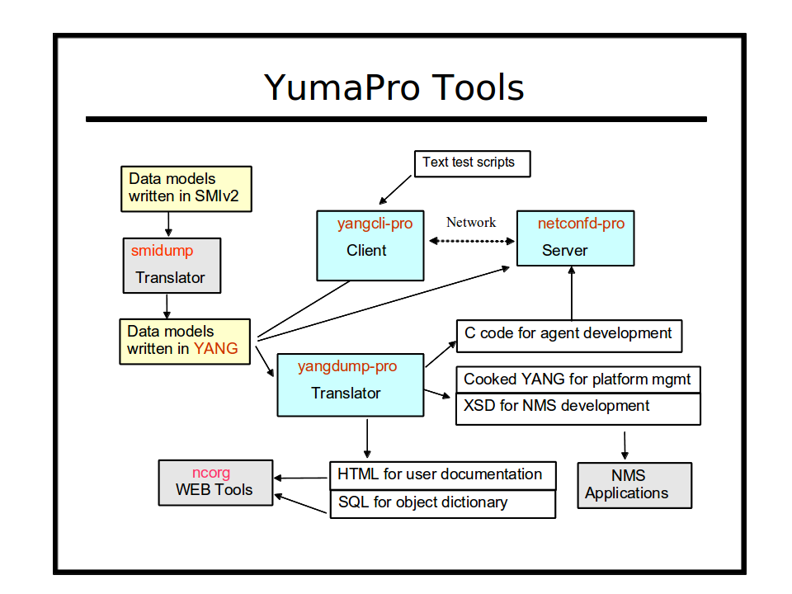

Refer to section 3 of the YumaPro User Manual for a complete introduction to YumaPro Client programs.
This section focuses on the client tools within the YumaPro Client packages.

Intended Audience
This document is intended for users of the YumaPro NETCONF client and server programs. It covers the installation of the YumaPro Client packages.

Installation Requirements
The following requirements must be met for YumaPro Client to be installed.

Supported Platforms
The following platforms are supported at this time for the YumaPro Client binary package:
- Ubuntu version 10.04 LTS or greater (32 bit x86 and 64-bit AMD) [Ubuntu supported versions only]
- Fedora version 16 or greater (32 bit i686 and 64-bit x86_64)
- MacOSX version 10.1 or greater
- Cygwin on Windows

External Packages
The following programs and libraries need to be available for YumaPro Client to work.

libxml2
The libxml2 package is needed by the YumaPro Client package for some of the XML parsing functions. This package is installed by the default Linux installation process.

libssh2
The libssh2 package is needed by the YumaPro Client package for the yangcli-pro program to connect to NETCONF servers using the SSH protocol. This package is called libssh2-1 on Ubuntu platforms. This package is not installed by the default Linux installation process.

ncurses
The ncurses library is needed by the YumaPro Client package for some terminal support. This package is installed by the default Linux installation process.
It is called libncurses5 on Ubuntu systems.

zlib
The zlib1g library is needed by the YumaPro package for some compression support, used by other libraries that YumaPro imports. This package is installed by the default Linux installation process.
To build YumaPro sources, also install the developer version of this package. It is called zlib1g-dev on Ubuntu systems.

YumaPro Client Packages
The YumaPro Client files are split into multiple packages, described below. They should be installed in the order shown.

yumapro-modules
The yumapro-modules package contains the all the YANG modules used by all YumaPro 13.04-1 programs. It must be installed.

yumapro-client
The yumapro-client package contains the binary files, man files, and sample .conf files, needed to run the yangcli-pro program. It must be installed.

yumapro-common-doc
The yumapro-common-doc package contains all the common documentation files. It is only needed if you want the PDF and HTML versions of the documentation installed. Since these files take up a lot of disk space, an optional package is used to install them.

yumapro-client-doc
The yumapro-client-doc package contains all the client documentation files, including this file. It is only needed if you want the PDF and HTML versions of the documentation installed. Since these files take up a lot of disk space, an optional package is used to install them.

Quick Installation
This section describes how to use the platform package manager program to install the YumaPro Server programs.

Ubuntu

External Libraries
First, make sure the external libraries are installed.

mydir> dpkg --list libxml2 libssh2-1 libncurses5 zlib1g

If the library is installed, the status will show 'ii libxml2', as in the example below:

Desired=Unknown/Install/Remove/Purge/Hold
| Status=Not/Inst/Cfg-files/Unpacked/Failed-cfg/Half-inst/trig-aWait/Trig-pend
|/ Err?=(none)/Reinst-required (Status,Err: uppercase=bad)
||/ Name Version Description
+++-==============-==============-============================================
ii libncurses5 5.9-4 shared libraries for terminal handling
ii libssh2-1 1.2.8-2 SSH2 client-side library
ii libxml2 2.7.8.dfsg-5.1 GNOME XML library
ii zlib1g 1:1.2.3.4.dfsg compression library - runtime

mydir>

The following command will install all the support libraries needed:

mydir> sudo apt-get install libxml2 libssh2-1 libncurses5 zlib1g

Install the YumaPro Client Packages
Next, install the YumaPro Client package. Here is an example showing all 4 packages being installed.
The actual hardware platform identifier may be different:

mydir> sudo dpkg -i yumapro-modules-13.04-1.all.deb
mydir> sudo dpkg -i yumapro-client-13.04-1.u1204.i386.deb
mydir> sudo dpkg -i yumapro-common-doc-13.04-1.all.deb
mydir> sudo dpkg -i yumapro-client-doc-13.04-1.all.deb

Fedora

External Libraries
First, make sure the external libraries are installed.

mydir> rpm -q libxml2 libssh2 ncurses zlib

If the packages are installed then a line will be printed for each package showing the version, such as in the following example (your versions may be different)

libxml2-2.7.8-9.fc17.x86_64
libssh2-1.4.1-2.fc17.x86_64
ncurses-5.9-4.20120204.fc17.x86_64
zlib-1.2.5-7.fc17.x86_64

If a package is not already installed, then install it. This example shows how to install all external libraries:

mydir> sudo yum install libxml2 libssh2 ncurses zlib

Install the YumaPro Client Packages
Next, install the YumaPro Client packages. Here is an example. Older versions of Fedora may require the 'yum localinstall' command instead of the 'yum install' command shown.
The actual hardware platform identifier depends on the target CPU (i686 for 32-bit or or x86_64 for 64-bit).
The actual YumaPro Server revision and hardware platform may be different:

mydir> sudo yum install yumapro-modules-13.04-1.noarch.rpm
mydir> sudo yum install yumapro-client-13.04-1.fc17.i686.rpm
mydir> sudo yum install yumapro-common-doc-13.04-1.noarch.rpm
mydir> sudo yum install yumapro-client-doc-13.04-1.noarch.rpm

Installed Files

yumapro-modules Package
This section describes all the files and/or directories installed by the yumapro-modules package:
- /usr/share/yumapro/modules directory contains all the YANG modules:
  - ietf/
  - netconfcentral/
  - yang/
  - yumaworks/
  - test/
- /usr/share/doc/yumapro directory containing the following files:
  - AUTHORS
  - README
  - yumapro-legal-notices.pdf
- /usr/share/doc/yumapro-modules directory (Ubuntu only) containing the following files:
  - copyright
  - changelog.Debian

libyumapro-ncx Package
This section describes all the files and/or directories installed by the libyumapro-ncx package:
- /usr/lib/ directory contains the NCX library:
  - libyumapro_ncx.12.09.so
- /usr/share/doc/yumapro directory containing the following files:
  - AUTHORS
  - README
  - yumapro-legal-notices.pdf
- /usr/share/doc/libyumapro-ncx directory (Ubuntu only) containing the following files:
  - copyright
  - changelog.Debian

yumapro-client Package
This section describes all the files and/or directories installed by the yumapro-server package:
- /usr/bin directory contains the following programs:
  - yangdiff-pro
  - yangdump-pro
- /usr/sbin directory contains the following server programs:
  - netconfd-pro
  - netconf-subsystem-pro
- /usr/lib directory contains the following files:
  - libyumapro_agt.so.12.09 (file extension may vary based on platform)
- /usr/lib/yumapro directory contains the following file:
  - libtoaster.so
- /usr/share/doc/yumapro directory containing the following files:
  - AUTHORS
  - README
  - yumapro-legal-notices.pdf
- /usr/share/doc/yumapro directory (Ubuntu only) containing the following files:
  - copyright
  - changelog.Debian
- /usr/share/yumapro/modules directory contains all the YANG modules:
  - ietf/
  - netconfcentral/
  - yang/
  - yumaworks/
  - test/
- /usr/share/man/man1 directory contains the following files:
  - yangdiff-pro.1.gz
  - yangdump-pro.1.gz
  - netconfd-pro.1.gz
  - netconf-subsystem-pro.1.gz
- /etc/yumapro directory contains the following sample configuration files:
  - yangdiff-pro-sample.conf
  - yangdump-pro-sample.conf
  - netconfd-pro-sample.conf

yumapro-common-doc Package
This section describes all the files and/or directories installed by the yumapro-doc package:
- /usr/share/doc/yumapro directory containing the following files:
  - AUTHORS
  - README
- /usr/share/doc/yumapro/pdf directory containing the following files:
  - yumapro-legal-notices.pdf
  - yumapro-server-installation-guide.pdf
  - yumapro-server-quickstart-guide.pdf
  - yumapro-user-cmn-manual.pdf
  - yumapro-yangdiff-manual.pdf
  - yumapro-yangdump-manual.pdf
  - yumapro-netconfd-manual.pdf
- /usr/share/doc/yumapro/html directory containing the HTML files for all the manuals:
  - index.html
  - (directories for each HTML manual)
- /usr/share/doc/yumapro-doc directory (Ubuntu only) containing the following files:
  - copyright
  - changelog.Debian

yumapro-client-doc Package
This section describes all the files and/or directories installed by the yumapro-doc package:
- /usr/share/doc/yumapro directory containing the following files:
  - AUTHORS
  - README
- /usr/share/doc/yumapro/pdf directory containing the following files:
  - yumapro-legal-notices.pdf
  - yumapro-server-installation-guide.pdf
  - yumapro-server-quickstart-guide.pdf
  - yumapro-user-cmn-manual.pdf
  - yumapro-yangdiff-manual.pdf
  - yumapro-yangdump-manual.pdf
  - yumapro-netconfd-manual.pdf
- /usr/share/doc/yumapro/html directory containing the HTML files for all the manuals:
  - index.html
  - (directories for each HTML manual)
- /usr/share/doc/yumapro-doc directory (Ubuntu only) containing the following files:
  - copyright
  - changelog.Debian

Next Steps

More Documentation
- YumaPro Quickstart Guide:
  - /usr/share/doc/yumapro/pdf/yumapro-quickstart-quide.pdf
- YumaPro Common User Manual:
  - /usr/share/doc/yumapro/pdf/yumapro-user-cmn-manual.pdf
- YumaPro Program Specific User Manuals:
  - /usr/share/doc/yumapro/pdf/yumapro-yangcli-manual.pdf

The unix 'man' program can be used to get documentation about each program. For example:
- man yangcli-pro

Each program also has extensive help information available with the --help CLI parameter. For example:
- yangcli-pro --help

Running the YumaPro Programs

yangcli-pro
There is no further mandatory setup required to use the yangcli-pro program. The following optional steps may be be useful, depending on the development environment.
- If a work directory is used, then the $YUMAPRO_HOME environment variable should be defined. This insures that the tools will find the correct YANG modules and other data files used during development. Refer to the user manual for details.
- If YumaPro is installed in a location other than the default location described above, then the $YUMAPRO_INSTALL environment variable should be defined. Refer to the user manual for details.
- The following development tools are available in YumaPro Client:
  - /usr/bin/yangcli-pro: YANG based NETCONF client tool

