YumaPro Evaluation
Installation Guide

YANG-Based Unified Modular Automation Tools

YumaPro Evaluation Package Installation

Version 13.04-1

Table of Contents
1 Preface 3
1.1 Legal Statements 3
1.2 Additional Resources 3
1.2.1 WEB Sites 3
1.2.2 Mailing Lists 4
1.3 Conventions Used in this Document 4
2 Introduction 5
2.1 Intended Audience 5
3 Installation Requirements 6
3.1 Supported Platforms 6
3.2 External Packages 6
3.2.1 libxml2 6
3.2.2 OpenSSH 6
3.2.3 libssh2 6
3.2.4 ncurses 6
3.2.5 zlib 6
3.3 YumaPro Evaluation Package 6
3.3.1 yumapro-eval 7
4 Quick Installation 7
4.1 Ubuntu 7
4.1.1 External Libraries 7
4.1.2 Install the YumaPro Evaluation Package 7
4.2 Fedora 8
4.2.1 External Libraries 8
4.2.2 Install the YumaPro Evaluation Package 8
5 Installed Files 8
5.1 yumapro-eval Package 8
6 Next Steps 10
6.1 More Documentation 10
6.2 Running the YumaPro Evaluation Server 10
6.3 YumaPro Evaluation Limitations 11
6.3.1 netconfd-pro Limitations 11
6.3.2 yangcli-pro Limitations 11

Preface

Legal Statements
Copyright 2009 – 2012, Andy Bierman, All Rights Reserved.
Copyright 2012 - 2013, YumaWorks, Inc., All Rights Reserved.

Additional Resources
Other documentation includes:
YumaPro Client Installation Guide
YumaPro Server Installation Guide
YumaPro Quickstart Guide
YumaPro User Manual
YumaPro netconfd-pro Manual
YumaPro yangcli-pro Manual
YumaPro yangdiff-pro Manual
YumaPro yangdump-pro Manual
YumaPro Developer Manual

To obtain additional support you may contact YumaWorks technical support department:
support@yumaworks.com

WEB Sites
- YumaWorks
  - http://www.yumaworks.com
  - Offers support, training, and consulting for YumaPro.
- Netconf Central
  - http://www.netconfcentral.org/
    - Free information on NETCONF and YANG, tutorials, on-line YANG module validation and documentation database
- Yang Central
  - http://www.yang-central.org
  - Free information and tutorials on YANG, free YANG tools for download
- NETCONF Working Group Wiki Page
  - http://trac.tools.ietf.org/wg/netconf/trac/wiki
  - Free information on NETCONF standardization activities and NETCONF implementations
- NETCONF WG Status Page
  - http://tools.ietf.org/wg/netconf/
  - IETF Internet draft status for NETCONF documents
- libsmi Home Page
  - http://www.ibr.cs.tu-bs.de/projects/libsmi/
  - Free tools such as smidump, to convert SMIv2 to YANG

Mailing Lists
- NETCONF Working Group
  - http://www.ietf.org/html.charters/netconf-charter.html
  - Technical issues related to the NETCONF protocol are discussed on the NETCONF WG mailing list. Refer to the instructions on the WEB page for joining the mailing list.
- NETMOD Working Group
  - http://www.ietf.org/html.charters/netmod-charter.html
  - Technical issues related to the YANG language and YANG data types are discussed on the NETMOD WG mailing list. Refer to the instructions on the WEB page for joining the mailing list.

Conventions Used in this Document
The following formatting conventions are used throughout this document:
Documentation Conventions

Convention | Description
--foo | CLI parameter foo
<foo> | XML element foo
foo | netconfd-pro command or parameter
$FOO | Environment variable FOO
some text | Example command or PDU
some text | Plain text

Introduction
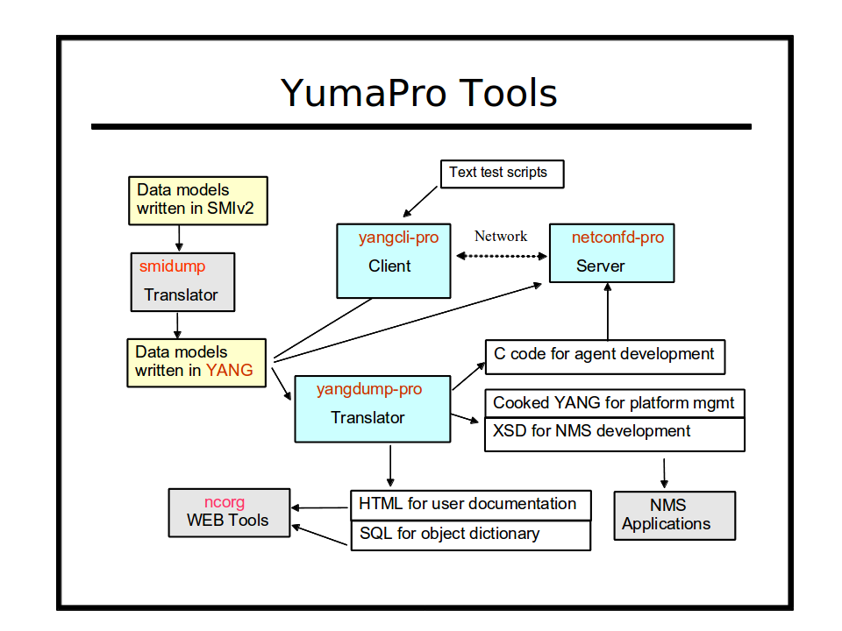

Refer to section 3 of the YumaPro User Manual for a complete introduction to the YumaPro Server programs.
This section focuses on the client and server tools within the YumaPro Evaluation package.

Intended Audience
This document is intended for users of the YumaPro NETCONF client and server programs. It covers the installation of the YumaPro Evaluation packages.

Installation Requirements
The following requirements must be met for YumaPro Evaluation packages to be installed.

Supported Platforms
The following platforms are supported at this time for the YumaPro Evaluation binary package:
- Ubuntu version 10.04 LTS or greater (32 bit x86 and 64-bit AMD) [Ubuntu supported versions only]
- Fedora version 16 or greater (32 bit i686 and 64-bit x86_64)

External Packages
The following programs and libraries need to be available for YumaPro Evaluation to work.

libxml2
The libxml2 package is needed by the YumaPro Server package for some of the XML parsing functions. This package is installed by the default Linux installation process.

OpenSSH
The OpenSSH server is needed by the YumaPro Server package for NETCONF over SSH support. This package may not be installed on some Linux systems.
The package is called openssh-server on Ubuntu systems and openssh on Fedora systems.
Note that the /etc/ssh/sshd_config file must be properly configured and the SSH server restarted before the netconfd-pro server will work.

libssh2
The libssh2 package is needed by the YumaPro Client package for the yangcli-pro program to connect to NETCONF servers using the SSH protocol. This package is called libssh2-1 on Ubuntu platforms. This package is not installed by the default Linux installation process.

ncurses
The ncurses library is needed by the YumaPro Client package for some terminal support. This package is installed by the default Linux installation process.
It is called libncurses5 on Ubuntu systems.

zlib
The zlib1g library is needed by the YumaPro package for some compression support, used by other libraries that YumaPro imports. This package is installed by the default Linux installation process.

YumaPro Evaluation Package
The YumaPro Evaluation files are grouped into a single package.

yumapro-eval
The yumapro-eval package contains shared libraries, binary programs, man files, YANG files, sample .conf files, needed to run all the programs. It must be installed.

Quick Installation
This section describes how to use the platform package manager program to install the YumaPro Server programs.

Ubuntu

External Libraries
First, make sure the external libraries are installed.

mydir> dpkg --list libxml2 openssh-server libssh2-1 libncurses5 zlib1g

If the library is installed, the status will show 'ii libxml2', as in the example below:

Desired=Unknown/Install/Remove/Purge/Hold
| Status=Not/Inst/Cfg-files/Unpacked/Failed-cfg/Half-inst/trig-aWait/Trig-pend
|/ Err?=(none)/Reinst-required (Status,Err: uppercase=bad)
||/ Name Version Description
+++-==============-==============-============================================
ii libncurses5 5.9-4 shared libraries for terminal handling
ii libssh2-1 1.2.8-2 SSH2 client-side library
ii libxml2 2.7.8.dfsg-5.1 GNOME XML library
ii openssh-server 1:5.9p1-5ubunt secure shell (SSH) server, for secure access
ii zlib1g 1:1.2.3.4.dfsg compression library - runtime

mydir>

If the libxml2 library is not installed, then install it with following command:

mydir> sudo apt-get install libxml2 openssh-server libssh2-1 libncurses5 zlib1g

Install the YumaPro Evaluation Package
Next, install the YumaPro Evaluation package. Here is an example showing the being installed.
The actual hardware platform identifier may be different:

mydir> sudo dpkg -i yumapro-eval-13.04-1.u1204.amd64.deb

Fedora

External Libraries
First, make sure the external libraries are installed.

mydir> rpm -q libxml2 openssh libssh2 ncurses zlib

If the packages are installed then a line will be printed for each package showing the version, such as in the following example (your versions may be different)

libxml2-2.7.8-9.fc17.x86_64
openssh-5.9p1-28.fc17.x86_64
libssh2-1.4.1-2.fc17.x86_64
ncurses-5.9-4.20120204.fc17.x86_64
zlib-1.2.5-7.fc17.x86_64

If a package is not already installed, then install it. This example shows how to install both external libraries:

mydir> sudo yum install libxml2 openssh libssh2 ncurses zlib

Install the YumaPro Evaluation Package
Next, install the YumaPro Evaluation package. Here is an example.
The actual operating system and hardware platform may be different:

mydir> sudo yum install yumapro-eval-13.04-1.fc17.x86_64.rpm

Installed Files

yumapro-eval Package
This section describes all the files and/or directories installed by the yumapro-eval package:
- /usr/share/yumapro/modules directory contains all the YANG modules:
  - ietf/
  - netconfcentral/
  - yang/
  - yumaworks/
  - test/
- /usr/share/yumapro/src directory contains some example SIL source code modules:
  - libtoaster/
  - libsystem
  - sil-error
- /usr/share/doc/yumapro directory containing the following files:
  - AUTHORS
  - README
  - YUMA-COPYRIGHT
  - yumapro-eval-license.pdf
  - yumapro-legal-notices.pdf
- /usr/share/doc/yumapro-eval directory (Ubuntu only) containing the following files:
  - copyright
  - changelog.Debian
- /usr/lib/ directory contains the NCX and AGT libraries:
  - libyumapro_ncx.so.13.04 (file extension may vary based on platform)
  - libyumapro_agt.so.13.04 (file extension may vary based on platform)
- /usr/sbin directory contains the following server programs:
  - netconfd-pro
  - netconf-subsystem-pro
- /usr/lib/yumapro directory contains the following file:
  - libtoaster.so
  - libyp_system.so
  - libsil-error.so
- /usr/share/yumapro/modules directory contains all the YANG modules:
  - ietf/
  - netconfcentral/
  - yang/
  - yumaworks/
  - test/
- /usr/share/man/man1 directory contains the following files:
  - netconfd-pro.1.gz
  - netconf-subsystem-pro.1.gz
  - yangcli-pro.1.gz
- /etc/yumapro directory contains the following sample configuration files:
  - netconfd-pro-sample.conf
  - yangcli-pro-sample.conf

Next Steps

More Documentation
- YumaPro Evaluation Installation Guide:
  - /usr/share/doc/yumapro/pdf/yumapro-eval-installation-quide.pdf
- YumaPro Quickstart Guide:
  - /usr/share/doc/yumapro/pdf/yumapro-quickstart-quide.pdf

The unix 'man' program can be used to get documentation about each program. For example:
- man netconfd-pro
- man netconf-subsystem-pro
- man yangcli-pro

Each program also has extensive help information available with the --help CLI parameter. For example:
- netconfd-pro --help
- yangcli-pro --help

Running the YumaPro Evaluation Server
The YumaPro server does not automatically start running when installed. This will be supported in a future release.
The following steps must be taken to start the netconfd-pro server:
- You must modify the /etc/ssh/sshd_config file, and add the 'netconf' subsystem, as described in the user manual. If the YumaPro package was installed in a non-default location, then the path to the netconf-subsystem-pro will be different than the example below. The following commands must be present:

Port 22
Port 830
Subsystem netconf /usr/sbin/netconf-subsystem-pro

- Start the netconfd-pro server, as described in the user manual or quickstart guide. This can be in the foreground or the background. If it is in the background, then the '--log' CLI parameter should be provided, as shown below:

mydir> /usr/sbin/netconfd-pro --log=$HOME/mylog &

- Restart the SSH server. This is a platform-specific task. Refer to the sshd manual page for your system for more details. This step may need to be run as root or with the 'sudo' program.

Fedora 17 version
mydir> sudo service sshd restart

Ubuntu 12.04 version:
mydir> sudo service ssh restart

YumaPro Evaluation Limitations
The YumaPro evaluation programs are limited in functionality.

netconfd-pro Limitations
The netconfd-pro program should work as normal, with the follow exceptions:
- Only 3 sessions can be active at once. After that, a 'resource-denied' error will be generated if a new connection attempt is made.
- Sessions with an active notification subscription are subject to idle timeout.
- The notification replay buffer is limited to 10 events.
- The entire session duration is limited to 60 seconds.
- The --config parameter is not available and the default configuration file will be ignored if found. Parameters can only be entered from the command line.
- The --eventlog-size parameter is disabled.
- The --idle-timeout parameter is disabled.
- The --max-sessions parameter is disabled.

yangcli-pro Limitations
The yangcli-pro program should work as normal with the following limitations:
- Only 3 sessions can be active at once. After that, a 'resource-denied' error will be generated if a new connection attempt is made.
- Only 10 commands can be attempted. After that, a 'resource-denied' error will be generated and only the 'quit' command will be available. Exiting and restarting the program will allow another 10 commands to be attempted.

