YumaPro Server Installation Guide

YANG-Based Unified Modular Automation Tools

YumaPro Server Package Installation

Version 13.04-1

Table of Contents
1 Preface 3
1.1 Legal Statements 3
1.2 Additional Resources 3
1.2.1 WEB Sites 3
1.2.2 Mailing Lists 4
1.3 Conventions Used in this Document 4
2 Introduction 5
2.1 Intended Audience 5
3 Installation Requirements 6
3.1 Supported Platforms 6
3.2 External Packages 6
3.2.1 libxml2 6
3.2.2 OpenSSH 6
3.3 YumaPro Server Packages 6
3.3.1 yumapro-modules 6
3.3.2 libyumapro-ncx 6
3.3.3 yumapro-server 6
3.3.4 yumapro-common-doc 7
3.3.5 yumapro-server-doc 7
3.3.6 yumapro-dev 7
4 Quick Installation 7
4.1 Ubuntu 7
4.1.1 External Libraries 7
4.1.2 Install the YumaPro Server Packages 8
4.2 Fedora 8
4.2.1 External Libraries 8
4.2.2 Install the YumaPro Server Packages 8
5 Installed Files 9
5.1 yumapro-modules Package 9
5.2 libyumapro-ncx Package 9
5.3 yumapro-server Package 10
5.4 yumapro-server-doc Package 11
5.5 yumapro-dev Package 11
6 Next Steps 12
6.1 More Documentation 12
6.2 Running the YumaPro Programs 13
6.2.1 yangdump-pro and yangdiff-pro 13
6.2.2 netconfd-pro and netconf-subsystem-pro 13

Preface

Legal Statements
Copyright 2009 – 2012, Andy Bierman, All Rights Reserved.
Copyright 2012 - 2013, YumaWorks, Inc., All Rights Reserved.

Additional Resources
Other documentation includes:
YumaPro Client Installation Guide
YumaPro Quickstart Guide
YumaPro User Manual
YumaPro netconfd-pro Manual
YumaPro yangcli-pro Manual
YumaPro yangdiff-pro Manual
YumaPro yangdump-pro Manual
YumaPro Developer Manual

To obtain additional support you may contact YumaWorks technical support department:
support@yumaworks.com

WEB Sites
- YumaWorks
  - http://www.yumaworks.com
  - Offers support, training, and consulting for YumaPro.
- Netconf Central
  - http://www.netconfcentral.org/
    - Free information on NETCONF and YANG, tutorials, on-line YANG module validation and documentation database
- Yang Central
  - http://www.yang-central.org
  - Free information and tutorials on YANG, free YANG tools for download
- NETCONF Working Group Wiki Page
  - http://trac.tools.ietf.org/wg/netconf/trac/wiki
  - Free information on NETCONF standardization activities and NETCONF implementations
- NETCONF WG Status Page
  - http://tools.ietf.org/wg/netconf/
  - IETF Internet draft status for NETCONF documents
- libsmi Home Page
  - http://www.ibr.cs.tu-bs.de/projects/libsmi/
  - Free tools such as smidump, to convert SMIv2 to YANG

Mailing Lists
- NETCONF Working Group
  - http://www.ietf.org/html.charters/netconf-charter.html
  - Technical issues related to the NETCONF protocol are discussed on the NETCONF WG mailing list. Refer to the instructions on the WEB page for joining the mailing list.
- NETMOD Working Group
  - http://www.ietf.org/html.charters/netmod-charter.html
  - Technical issues related to the YANG language and YANG data types are discussed on the NETMOD WG mailing list. Refer to the instructions on the WEB page for joining the mailing list.

Conventions Used in this Document
The following formatting conventions are used throughout this document:
Documentation Conventions

Convention | Description
--foo | CLI parameter foo
<foo> | XML element foo
foo | netconfd-pro command or parameter
$FOO | Environment variable FOO
some text | Example command or PDU
some text | Plain text

Introduction
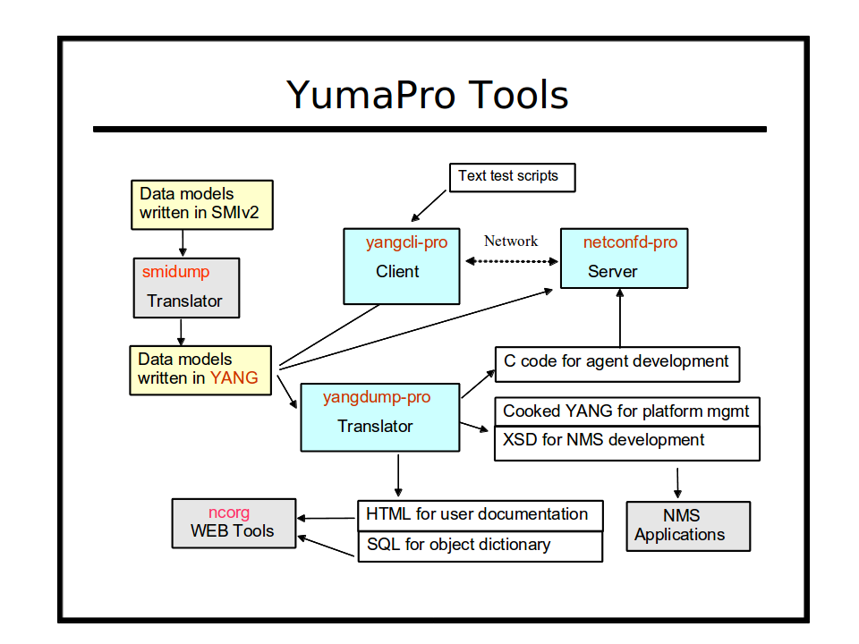

Refer to section 3 of the YumaPro User Manual for a complete introduction to the YumaPro Server programs.
This section focuses on the client and server tools within the YumaPro Server packages.

Intended Audience
This document is intended for users of the YumaPro NETCONF client and server programs. It covers the installation of the YumaPro Server packages.

Installation Requirements
The following requirements must be met for YumaPro Server to be installed.

Supported Platforms
The following platforms are supported at this time for the YumaPro Server binary package:
- Ubuntu version 10.04 LTS or greater (32 bit x86 and 64-bit AMD) [Ubuntu supported versions only]
- Fedora version 16 or greater (32 bit i686 and 64-bit x86_64)

External Packages
The following programs and libraries need to be available for YumaPro Server to work.

libxml2
The libxml2 package is needed by the YumaPro Server package for some of the XML parsing functions. This package is installed by the default Linux installation process.
To build YumaPro Server sources, also install the developer version of this package. It is called libxml2-dev on Ubuntu systems.

OpenSSH
The OpenSSH server is needed by the YumaPro Server package for NETCONF over SSH support. This package may not be installed on some Linux systems.
The package is called openssh-server on Ubuntu systems and openssh on Fedora systems.
Note that the /etc/ssh/sshd_config file must be properly configured and the SSH server restarted before the netconfd-pro server will work.

YumaPro Server Packages
The YumaPro Server files are split into multiple packages, described below. They should be installed in the order shown.

yumapro-modules
The yumapro-modules package contains the all the YANG modules used by all YumaPro 12.09 programs. It must be installed.

libyumapro-ncx
The libyumapro-ncx package contains the common NCX library, needed to run all the programs. It must be installed.

yumapro-server
The yumapro-server package contains the server shared libraries, binary programs, man files, YANG files, sample .conf files, needed to run all the programs. It must be installed.

yumapro-common-doc
The yumapro-common-doc package contains all the common documentation files. It is only needed if you want the PDF and HTML versions of the documentation installed. Since these files take up a lot of disk space, an optional package is used to install them.

yumapro-server-doc
The yumapro-server-doc package contains all the server documentation files, including this file. It is only needed if you want the PDF and HTML versions of the documentation installed. Since these files take up a lot of disk space, an optional package is used to install them.

yumapro-dev
The yumapro-dev package contains all the server instrumentation library (SIL) developer files. It is only needed if you want to add YANG modules to the server, and develop your own server instrumentation library code to load into the netconfd-pro server at run-time.

Quick Installation
This section describes how to use the platform package manager program to install the YumaPro Server programs.

Ubuntu

External Libraries
First, make sure the external libraries are installed.

mydir> dpkg --list libxml2 openssh-server

If the library is installed, the status will show 'ii libxml2', as in the example below:

Desired=Unknown/Install/Remove/Purge/Hold
| Status=Not/Inst/Cfg-files/Unpacked/Failed-cfg/Half-inst/trig-aWait/Trig-pend
|/ Err?=(none)/Reinst-required (Status,Err: uppercase=bad)
||/ Name Version Description
+++-==============-==============-============================================
ii libxml2 2.7.6.dfsg-1ub GNOME XML library
ii openssh-server 1:5.9p1-5ubunt secure shell (SSH) server, for secure access

mydir>

If the libxml2 library is not installed, then install it with following command:

mydir> sudo apt-get install libxml2

Install the YumaPro Server Packages
Next, install the YumaPro Server package. Here is an example showing all 6 packages being installed.
The actual hardware platform identifier may be different:

mydir> sudo dpkg -i yumapro-modules-13.04-1.all.deb
mydir> sudo dpkg -i libyumapro-ncx-13.04-1.u1204.i386.deb
mydir> sudo dpkg -i yumapro-server-13.04-1.u1204.i386.deb
mydir> sudo dpkg -i yumapro-common-doc-13.04-1.all.deb
mydir> sudo dpkg -i yumapro-server-doc-13.04-1.all.deb
mydir> sudo dpkg -i yumapro-dev-13.04-1.all.deb

Fedora

External Libraries
First, make sure the external libraries are installed.

mydir> rpm -q libxml2 openssh

If the packages are installed then a line will be printed for each package showing the version, such as in the following example (your versions may be different)

openssh-5.9p1-28.fc17.i686
libxml2-2.7.8-9.fc17.i686

If a package is not already installed, then install it. This example shows how to install both external libraries:

mydir> sudo yum install libxml2 openssh

Install the YumaPro Server Packages
Next, install the YumaPro Server packages. Here is an example. Older versions of Fedora may require the 'yum localinstall' command instead of the 'yum install' command shown.
The actual hardware platform identifier depends on the target CPU (i686 for 32-bit or or x86_64 for 64-bit).

mydir> sudo yum install yumapro-modules-13.04-1.noarch.rpm
mydir> sudo yum install libyumapro-ncx-13.04-1.fc17.i686.rpm
mydir> sudo yum install yumapro-server-13.04-1.fc17.i686.rpm
mydir> sudo yum install yumapro-common-doc-13.04-1.noarch.rpm
mydir> sudo yum install yumapro-server-doc-13.04-1.noarch.rpm
mydir> sudo yum install yumapro-server-devel-13.04-1.noarch.rpm

Installed Files

yumapro-modules Package
This section describes all the files and/or directories installed by the yumapro-modules package:
- /usr/share/yumapro/modules directory contains all the YANG modules:
  - ietf/
  - netconfcentral/
  - yang/
  - yumaworks/
  - test/
- /usr/share/doc/yumapro directory containing the following files:
  - AUTHORS
  - README
  - yumapro-legal-notices.pdf
- /usr/share/doc/yumapro-modules directory (Ubuntu only) containing the following files:
  - copyright
  - changelog.Debian

libyumapro-ncx Package
This section describes all the files and/or directories installed by the libyumapro-ncx package:
- /usr/lib/ directory contains the NCX library:
  - libyumapro_ncx.12.09.so
- /usr/share/doc/yumapro directory containing the following files:
  - AUTHORS
  - README
  - yumapro-legal-notices.pdf
- /usr/share/doc/libyumapro-ncx directory (Ubuntu only) containing the following files:
  - copyright
  - changelog.Debian

yumapro-server Package
This section describes all the files and/or directories installed by the yumapro-server package:
- /usr/bin directory contains the following programs:
  - yangdiff-pro
  - yangdump-pro
- /usr/sbin directory contains the following server programs:
  - netconfd-pro
  - netconf-subsystem-pro
- /usr/lib directory contains the following files:
  - libyumapro_agt.so.12.09 (file extension may vary based on platform)
- /usr/lib/yumapro directory contains the following file:
  - libtoaster.so
- /usr/share/doc/yumapro directory containing the following files:
  - AUTHORS
  - README
  - yumapro-legal-notices.pdf
- /usr/share/doc/yumapro directory (Ubuntu only) containing the following files:
  - copyright
  - changelog.Debian
- /usr/share/yumapro/modules directory contains all the YANG modules:
  - ietf/
  - netconfcentral/
  - yang/
  - yumaworks/
  - test/
- /usr/share/man/man1 directory contains the following files:
  - yangdiff-pro.1.gz
  - yangdump-pro.1.gz
  - netconfd-pro.1.gz
  - netconf-subsystem-pro.1.gz
- /etc/yumapro directory contains the following sample configuration files:
  - yangdiff-pro-sample.conf
  - yangdump-pro-sample.conf
  - netconfd-pro-sample.conf

yumapro-server-doc Package
This section describes all the files and/or directories installed by the yumapro-doc package:
- /usr/share/doc/yumapro directory containing the following files:
  - AUTHORS
  - README
- /usr/share/doc/yumapro/pdf directory containing the following files:
  - yumapro-legal-notices.pdf
  - yumapro-server-installation-guide.pdf
  - yumapro-server-quickstart-guide.pdf
  - yumapro-user-cmn-manual.pdf
  - yumapro-yangdiff-manual.pdf
  - yumapro-yangdump-manual.pdf
  - yumapro-netconfd-manual.pdf
- /usr/share/doc/yumapro/html directory containing the HTML files for all the manuals:
  - index.html
  - (directories for each HTML manual)
- /usr/share/doc/yumapro-doc directory (Ubuntu only) containing the following files:
  - copyright
  - changelog.Debian

yumapro-dev Package
- /usr/bin directory contains the following programs:
  - make_sil_dir_pro
- /usr/include/yumapro directory contains H files needed to compile SIL code so it can be loaded into the server at runtime:
  - ncx/*.h
  - agt/*.h
  - platform/procdefs.h
- /usr/share/yumapro/src/libtoaster directory is an example of a SIL implementation, with the following contents:
  - Makefile
  - src directory
    - Makefile
    - toaster.c
    - toaster.c.start
    - toaster.h
    - toaster.h.start
  - bin directory
  - lib directory
- /usr/share/yumapro/src/libsystem directory in an example of a user external system API (yp-system) library with the following contents:
  - Makefile
  - src directory
    - Makefile
    - example-system.c
    - example-system.h
  - bin directory
  - lib directory
- /usr/share/yumapro/src/sil-error directory in an example of a SIL library that can be used to force errors during editing transactions to help test corner-case error handling. It has the following contents:
  - Makefile
  - src directory
    - Makefile
    - sil-error.c
    - sil-error.h
  - bin directory
  - lib directory
- /usr/share/yumapro/util directory contains the following files:
  - makefile.sil
  - makefile-top.sil
- /usr/share/doc/yumapro-dev directory (Ubuntu only) containing the following files:
  - copyright
  - changelog.Debian
- /usr/share/man/man1 directory contains the following files:
  - make_sil_dir_pro.1.gz

Next Steps
Refer to the YumaPro Quickstart Guide for information on configuring the OpenSSH server so it will work with the netconfd-pro server.

More Documentation
- YumaPro Quickstart Guide:
  - /usr/share/doc/yumapro/pdf/yumapro-quickstart-quide.pdf
- YumaPro Common User Manual:
  - /usr/share/doc/yumapro/pdf/yumapro-user-cmn-manual.pdf
- YumaPro Program Specific User Manuals:
  - /usr/share/doc/yumapro/pdf/yumapro-netconfd-manual.pdf
  - /usr/share/doc/yumapro/pdf/yumapro-yangdiff-manual.pdf
  - /usr/share/doc/yumapro/pdf/yumapro-yangdump-manual.pdf
- YumaPro Developer Manual:
  - /usr/share/doc/yumapro/pdf/yumapro-dev-manual.pdf

The unix 'man' program can be used to get documentation about each program. For example:
- man yangdump-pro
- man yangdiff-pro
- man netconfd-pro
- man netconf-subsystem-pro
- man make_sil_dir_pro
Each program also has extensive help information available with the --help CLI parameter. For example:
- yangdump-pro --help
- yangdiff-pro --help
- netconfd-pro --help

Running the YumaPro Programs

yangdump-pro and yangdiff-pro
There is no further mandatory setup required to use the yangdump-pro YANG compiler or yangdiff-pro YANG compare function. The following optional steps may be be useful, depending on the development environment.
- If a work directory is used, then the $YUMAPRO_HOME environment variable needs to be defined. This insures that the tools will find the correct YANG modules and other data files used during development. Refer to the user manual for details.
- If YumaPro is installed in a location other than the default location described above, then the $YUMAPRO_INSTALL environment variable needs to be defined. Refer to the user manual for details.
- The following development tools are available, depending on the YumaPro Server packages installed:
  - /usr/bin/yangdump-pro: YANG compiler used to validate YANG modules, translate YANG to other formats, or generate SIL C code stubs.
  - /usr/bin/yangdiff-pro: YANG compare program to show the semantic changes between to revisions of a YANG module.
  - /usr/bin/make_sil_dir_pro: Bash script to create a new SIL work directory and generate SIL C code stubs. Refer to the YumaPro Developer Manual for details.

netconfd-pro and netconf-subsystem-pro
The YumaPro server does not automatically start running when installed. This will be supported in a future release.
The following steps must be taken to start the netconfd-pro server:
- You must modify the /etc/ssh/sshd_config file, and add the 'netconf' subsystem, as described in the user manual. If the YumaPro package was installed in a non-default location, then the path to the netconf-subsystem-pro will be different than the example below. The following commands must be present:

Port 22
Port 830
Subsystem netconf /usr/sbin/netconf-subsystem-pro

- Start the netconfd-pro server, as described in the user manual or quickstart guide. This can be in the foreground or the background. If it is in the background, then the '--log' CLI parameter should be provided, as shown below:

mydir> /usr/sbin/netconfd-pro --log=$HOME/mylog &

- Restart the SSH server. This is a platform-specific task. Refer to the sshd manual page for your system for more details. This step may need to be run as root or with the 'sudo' program.

Fedora 17 version
mydir> sudo service sshd restart

Ubuntu 12.04 version:
mydir> sudo service ssh restart

